Año 4 Número 98 enero 2019
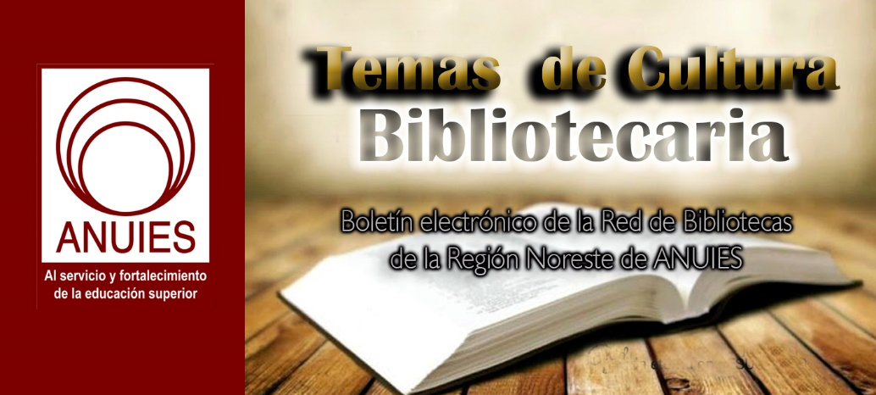

Contenidos de este número

- Peter Potter on Funding OA Monographs
by Lisa Peet
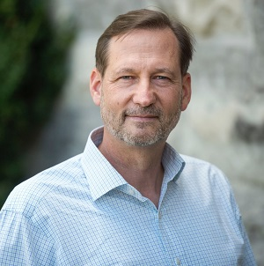Peter Potter, director of publishing strategy for the University Libraries at Virginia Tech, Blacksburg, was appointed by the Association of Research Libraries (ARL) as visiting program officer (VPO) to advance TOME (Toward an Open Monograph Ecosystem), beginning in January 2019. A joint initiative of ARL, the Association of American Universities (AAU), and Association of University Presses (AUPresses), TOME was established to develop a new model to finance peer-reviewed open access monographs. Under the initiative, participating institutions will provide baseline grants to support the publication of a minimum of three high-quality, platform-agnostic, digital works each year.
LJ: How does the TOME model work?
Peter Potter: TOME is an initiative to create a system whereby academic books can be made available open access. It's an attempt to create, from the bottom up, a group of institutions and presses working together to ensure that payment is made on the front end of publication, rather than publishers having to rely on sales income. At the moment we have over 70 participating university presses, [and] 13 participating universities.
The press gets the up-front money. If a press is participating, they're agreeing to publish this book in an open access format. That doesn't prevent them from turning around and selling the book, which they can do. If there are print sales or ebook sales that they can generate, they should continue doing that.
Contribution from a university is a minimum of $15,000 per monograph. We figured that after this five-year pilot we would come back and revisit that amount to find out if that is actually enough to make this worthwhile for presses. We understand the $15,000 is less than what it typically costs to produce a monograph—Mellon did a study a few years ago in which they said it's actually well over $20,000. But the idea is by making a book open access you're not cutting off sale possibilities. The $15,000 jump-starts the book's availability, it enables the press to go ahead and publish the book [in print format], and then they will see sales that will supplement that.
One of the things that's important is that these are university press peer-reviewed books. We want it to be clear to provosts and department heads and deans that these are not second class books—they are books that a university press would have published anyway on the basis of quality. We didn't want the sales potential of the book to get in the way of that. Sometimes decisions get made for a monograph based upon “we don't think we can sell enough copies,” and this is a way to try to address that problem on the front end.
Virginia Tech is one of the participating institutions, and we've had our first book come out under the TOME initiative, by one of our history professors, Donna Agmon [A Colonial Affair: Commerce, Conversion, and Scandal in French India]. It was published by Cornell University Press and it's now available open access. We have several other books currently in production that will be part of the TOME initiative. We're just building the momentum right now.
What will your responsibilities be as VPO?
One of the challenges of TOME has been that it was started by three separate organizations—ARL, AAU, and AUPresses. All of them are working together, but it's kind of a three-headed monster. We all realized that representatives from the three groups and from the participating universities and presses get together periodically to discuss the initiative, but there's been no real [system] at the upper levels to coordinate the activities of all three organizations and to develop a strategy for expanding the TOME initiative. So that's the focus of what I will be doing.
Right now we just have a landing page on the ARL site, so we'll want to develop a website that is fully devoted to promoting what TOME is about. The other thing will be to coordinate with the participating universities and presses to make sure that things are going well, monitor the progress, see where there are issues and things that need to be addressed, and also to recruit new universities to participate in the initiative.
My list of tasks will develop beginning in January when I meet with Judy [Ruttenberg] at ARL and her staff, and as I begin talking to other participants. I want to talk to the participating universities and presses and get a sense of where we need to go, and develop an action plan based on that.
I understand both the library world and the university press world. I do think that a big part of this is communication among the different organizations, and I think I'm in a very good position. I know many of the university press people and I also know many of the library people. Trust among the different participating organizations is important, and I bring a certain amount of credibility based upon my experience.
How are the works to be published chosen?
Each of the participating universities is in charge of determining who they want to participate, or how they're going to select authors. Here at Virginia Tech that's my job, as the director of publishing strategies, to find faculty members who would be candidates.
In most [participating] institutions, they may have a competition where they say, “Twice a year, we're going to accept applications for TOME monograph participants,” and decide from the applications. Again, it varies from institution to institution. At a place like Virginia Tech we don't have as large of a book publishing base as, say, the University of Michigan, so we're going out and recruiting. At a place like Michigan or Cornell they may have more interested authors than they can possibly include. Everybody has to figure out their own way for deciding which books are going to be their TOME books.
How will these monographs be publicized and made discoverable?
That's something that I would do [as VPO]—talk with all the institutions and presses and see about coordinating policy. At Virginia Tech we have a little addendum to the author contract that we ask the press and the author to include in their agreement. It basically stipulates that they're going to make open access versions available. One needs to be in the home institution's repository, and it lists other possible places where they could be placed, like Project MUSE Open.
I'm part of a working group within TOME that has been working with Figshare to develop what we're calling a "referatory," essentially a place where all the books are available [and] it connects all of the existing instances of TOME books that are available on other sites. Over the long run we want this to be the place where we collect the usage statistics, impact, all of that. That's in progress. That's being led by Charles Watkinson at the University of Michigan, and I've been a part of that.
The goal is to create more workflow and organization, make sure that we have protocols in place. On the TOME site, for instance we could have model agreements, documentation of what's expected from the presses, that sort of thing. We do want to institutionalize this as much as possible.
One of the problems right now is that open monographs are not really well integrated into the overall information landscape for scholarly publishing, so books kind of sit outside that. We're trying to make sure that monographs are included.
What is the role for academic libraries with a model like TOME?
Here on [the Virginia Tech] campus the library has been the base of operations for administering the TOME program. The library is a logical place on campus to be coordinating this effort because ultimately it is our goal to have more of our content be open rather than having to deal with paywalls and subscriptions—particularly in monograph publishing, [which] seems endangered, given the low sales. When I started in the mid-1980s, we had print runs of 1,000 copies on average, and when I left in 2016 it wasn't unusual to have a print run of 250, 300 copies, and we might not sell all of those. Now, being in a library, I see the library's perspective on that and we would very much like to be part of an overarching infrastructure where books are made available open access, and we can provide that access. Anything we can do to promote that system and support university presses in the process, we want to try to do that.
Is there still interest in augmented digital monographs with interactive features, embedded datasets, and the like?
I do think there's a lot of room for that. TOME’s basic mission is to keep the monograph publishing business alive. There have been reports saying that in the humanities, the monograph still is the coin of the realm. So at the very least we want to maintain the ability for scholars to be able to publish monographs. As scholars become more conversant with technology, we want to be able to adapt and have books that are more than just print books made digital.
For instance, here at Virginia Tech Publishing, we just put a book up online that came out of a National Endowment for the Humanities–sponsored conference. We made the book available as a print book, as an online PDF, and there will be an Epub version, and we also have an online site where you can access all the data. The idea is that you can go to the site and actually interact with the data visualizations and see how an author did that work. So it's at the center of what digital humanities scholars are doing. In the long run that's our hope, that this will be more than just supporting straight text monographs.
Where would you like to see TOME go beyond the pilot period?
I'd like to see more institutions participating. I think success will look like more, if not all, of the AAU presses participating.
Our mission is not to perpetuate the TOME way of doing this. There are other open access initiatives out there—the University of North Carolina Press, for instance, is starting one—and our goal is to see the system transformed. If we are kickstarting that but it ends up looking different than the way we're approaching it, we're fine with that. So in the long run it doesn't matter to us so much whether our particular approach works. We'd be happy for there to be another system come along and that takes off.

https://www.libraryjournal.com/?detailStory=122018-PeterPotterQA

- Penn State University Libraries Short Stories Pilot Program Launches at State College High School; University Will Lend a Short Story Dispenser to School
Filed by Gary Price on December 19, 2018
From Penn State University
Penn State University Libraries is partnering with the State College Area High School in January 2019 as part of its ongoing outreach and lifelong learning efforts and Penn State’s strategic goal to advance the arts and humanities by loaning one of its Short Edition short story dispensers to the high school.
Starting Jan. 21, a one-month pilot program aims to help meet local high school students’ interest to establish a dedicated Short Edition short story dispenser and creative writing initiative in the school.
“It’s exciting to see how quickly our Libraries Short Stories initiative is growing, not only across Pennsylvania at our commonwealth campuses, but also locally beyond the University itself,” Hailley Fargo, University Libraries student engagement and outreach librarian, said. “We just completed our second Penn State writing contest. Its participation rate grew by more than 30 percent, and its range of involvement expanded among campuses. Last month we opened our Libraries Short Stories website to submissions from Centre County residents. To see State College high school students be motivated to have their own story dispenser is another great sign of support for our effort to encourage engagement with the arts through creative writing.”
[Clip]
The University Libraries’ adoption of short story dispensers in May 2017 made Penn State the world’s first educational institution to partner with Short Edition of Grenoble, France. The Libraries’ innovative agreement enabled the delivery of short, original pieces of Penn State creative writing into the public’s hands, encouraging direct community engagement with and conversation about writing by Penn State faculty, staff and students. Since 2017, other universities and organizations have reached out to the University Libraries to inquire about establishing their own Short Edition and short story writing initiatives.
Learn More About the Pilot Project in the Complete Article
See Also: Penn State Libraries, Short Edition Partner for First University Collaboration (May 18, 2017)
Includes video.

https://www.infodocket.com/2018/12/19/penn-state-university-libraries-short-stories-pilot-program-launches-at-state-college-high-school-university-will-lend-a-short-story-dispenser-to-school/

- MIT Grand Challenges Summit Releases Final White Paper: “A Grand Challenges-Based Research Agenda for Scholarly Communication and Information Science”
Filed by Gary Price on December 18, 2018
From MIT Libraries:
The Grand Challenges Summit has released its final white paper, A Grand Challenges-Based Research Agenda for Scholarly Communication and Information Science. The paper, available on the open authoring and publishing platform PubPub, incorporates input gathered during a community review period in October 2018.
“Broad community engagement with the draft has resulted in a compelling call for research to support a more open, participatory, and diverse knowledge environment,” says Chris Bourg, director of MIT Libraries. “We’re grateful to the everyone who provided feedback on the initial draft — the white paper describes a stronger, more inclusive agenda as a result of community input.”
The summit on Grand Challenges in Information Science and Scholarly Communication, held at MIT In March 2018, convened a diverse group of stakeholders to identify, scope, and prioritize a common vision for specific research challenges related to information science and scholarly communications. The white paper is informed by the summit’s discussions and public commentary.
The “Grand Challenges-Based Research Agenda for Scholarly Communication and Information Science” describes a vision for a more inclusive, open, equitable, and sustainable future for scholarship; characterizes the central technical, organizational, and institutional barriers to this future; describes the areas where research is needed to advance this future; and identifies targeted “grand challenge” research problems for knowledge generation. These “grand challenges” are fundamental research problems with broad applications, whose solutions are potentially achievable within the next decade. Instead of setting a research agenda for a single institution, it identifies areas where a collaborative approach and coordinated leadership have the potential to make the greatest impact.
The Grand Challenges Summit followed from a recommendation of the MIT Task Force on the Future of Libraries report released in October 2016. It was supported by a grant from The Andrew W. Mellon Foundation.
The report was written by Micah Altman and Chris Bourg.
Contributors to the Report (Listed alphabetically)
- Micah Altman
- Chris Bourg
- Philip Cohen
- G. Sayeed Choudhury
- Charles Henry
- Sue Kriegsman
- Mary Minow
- Daisy Selematsela
- Anasuya Sengupta
- Peter Suber
- Ece Turnator
- Suzanne Wallen
- Trevor Owens
- David Weinberger
Resources
Direct to Full Text White Paper: A Grand Challenges-Based Research Agenda for Scholarly Communication and Information Science
Direct to Report (by Section)
1 Introduction
1.1 Preface: Identifying Grand Challenges
1.2 Organization of This Report
2 Towards A More Inclusive, Open, Equitable, And Sustainable Scholarly Knowledge Ecosystem
2.1 Vision
2.2 Broadest Impacts
2.3 Recommendations for Broad Impact
3 Research Landscape
3.1 Challenges, Threats, and Barriers
3.2 Grand Challenge Research Areas
3.3 Recommendations for Research Areas and Programs
4 Targeted Research Questions
4.1 Research Challenge: Legal, economic, policy, and organizational design for enduring, equitable, open scholarship
4.2 Research Challenge: Measuring, Predicting, and Adapting to Use and Utility Across Scholarly Communities
4.3 Research Challenge: Designing and Governing Algorithms in the Scholarly Knowledge Ecosystem to Support Accountability, Credibility, and Agency
4.4 Research Challenge: Integrating Oral and Tacit Knowledge into the Scholarly Knowledge Ecosystem
5 Integrating Research, Practice, And Policy
5.1 The Need for Leadership to Coordinate Research, Policy & Practice Initiatives
5.2 Role of Libraries and Archives as Advocates and Collaborators
5.3 Incorporating Values of Openness, Sustainability, and Equity into Scholarly Infrastructure and practice
5.4 Funders, Catalysts and Coordinators5.5 Recommendations for Integrating Research

https://www.infodocket.com/2018/12/18/mit-grand-challenges-summit-releases-white-paper-a-grand-challenges-based-research-agenda-for-scholarly-communication-and-information-science/

- NYPL Program Helps MLS Students Gain Practical Experience
by Kara Yorio
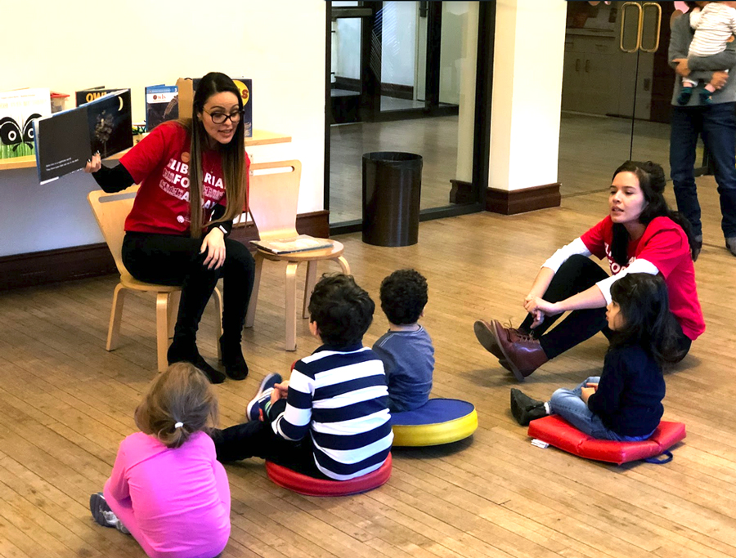
Juliet Sanchez reads to children at St. Agnes branch of the New York Public Library (NYPL).
Photos courtesy of NYPL
The kids scooted closer to Juliet Sanchez on the floor of the St. Agnes branch of the New York Public Library (NYPL). The pre-K storytime on Manhattan's Upper West Side was in full swing. As Sanchez, a Queens College MLIS student, read a book about an owl family and asked questions, kids moved about the room, interjected personal stories, poked at younger siblings, and sometimes even talked about owls and the book.
When conversation and activity threatened to take things too far off track, St. Agnes children’s librarian Jessica Agudelo knew just the right thing to say to return everybody’s focus. Sanchez taught some vocabulary, finished the story, and introduced a craft.
As the kids created their owls from felt and paper, she walked around the room, handing out materials and compliments. Once in a while, she would check in with Agudelo to make sure everything was going OK. Agudelo was Sanchez’s mentor in the NYPL’s new Librarians for Day program that offers MLIS graduate students a chance for practical experience at a branch.
The NYPL’s two-month Librarian for a Day program, which began in September, focused on children’s and youth librarians in this pilot session. (In the future, it may take on difference areas such as reference or cataloging or adult services, says Terry Neal, vice president of human resources at NYPL. Eight graduate students from five schools (Queens College, Valdosta State University, Pratt Institute, Syracuse University, and University of North Carolina–Chapel Hill) took park in the program). Participants received virtual workshops put together by NYPL staff, an NYPL mentor, an in-person day at a branch, and created a final project and present a program to the public.
“The whole experience it was very rewarding,” says Sanchez who works in a small library while pursuing her degree but wanted a chance to experience the larger NYPL system. “It was awesome. I got to do everything that day.”
From circulation to tech services to holds, and storytime, Sanchez was everywhere.
“The work was very intensive,” she says. “We were on our feet the whole day.”
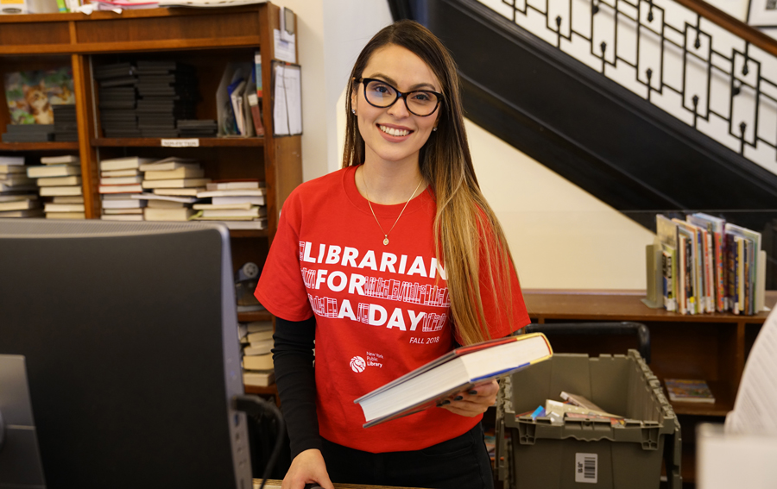The program’s goal was not only to give future librarians this much-needed look into what the profession is really like, but also give the NYPL a better chance to recruit and retain qualified and committed individuals. Sometimes candidates enter the field with misconceptions about what the day-in, day-out of library life will be, or even what a NYPL branch is.
According to Neal, most people—even library students—still only think of the main library building guarded by Patience and Fortitude when they think of the New York City library system. But it’s so much more, and every neighborhood branch has its own personality, its own community, and those patrons need to be served their own way. Each branch experience is so different, it can often only be understood by being a part of it.
“They’re in the community that we serve, the heart of the community, which are very diverse, growing, boiling over the side of the edges of the pot,” says Neal. “That real-life experience is nothing like what you’re going to experience in the classroom.”
In addition to working with the patrons, students work alongside a practicing librarian, learning in real time the kinds of resources, assistance, and support they will need to get the job done, Neal says.
Agudelo helped Sanchez see exactly what the job entails.
“She was explaining to me how they targeted their collections and how they did their story times. It just opened my eyes to see how diverse NYPL is, and how they have to target communities, and how one service might be popular in one branch but not so popular in another,” says Sanchez. “That really opened my eyes to how much work is put into the services.”
For Sanchez, the Librarian for a Day program has been a career-altering endeavor. She entered graduate school hesitant about working with children. At her current library job, she only works on the reference desk in the children’s room, not creating youth programming or interacting with the kids as she would in a storytime situation. Now, she says, after experiencing the NYPL’s youth programs and commitment to early literacy, she has been inspired, despite being so tired.
“I was exhausted, but I was so happy at the end of the day when I got home, I felt fulfilled,” says Sanchez. “I felt like at least the kids would remember the lady who read the owl books. I like to make those connections with the children. I feel like at the end of the day, that’s when I knew I really want to do this. I do want to be a children’s librarian.”
Kara Yorio
Kara Yorio (kyorio@mediasourceinc.com, @karayorio) is news editor at School Library Journal.
https://www.slj.com/?detailStory=NYPL-program-helps-MLS-students-gain-practical-experience
- A "Lonely Planet" for Libraries
by Kara Yorio
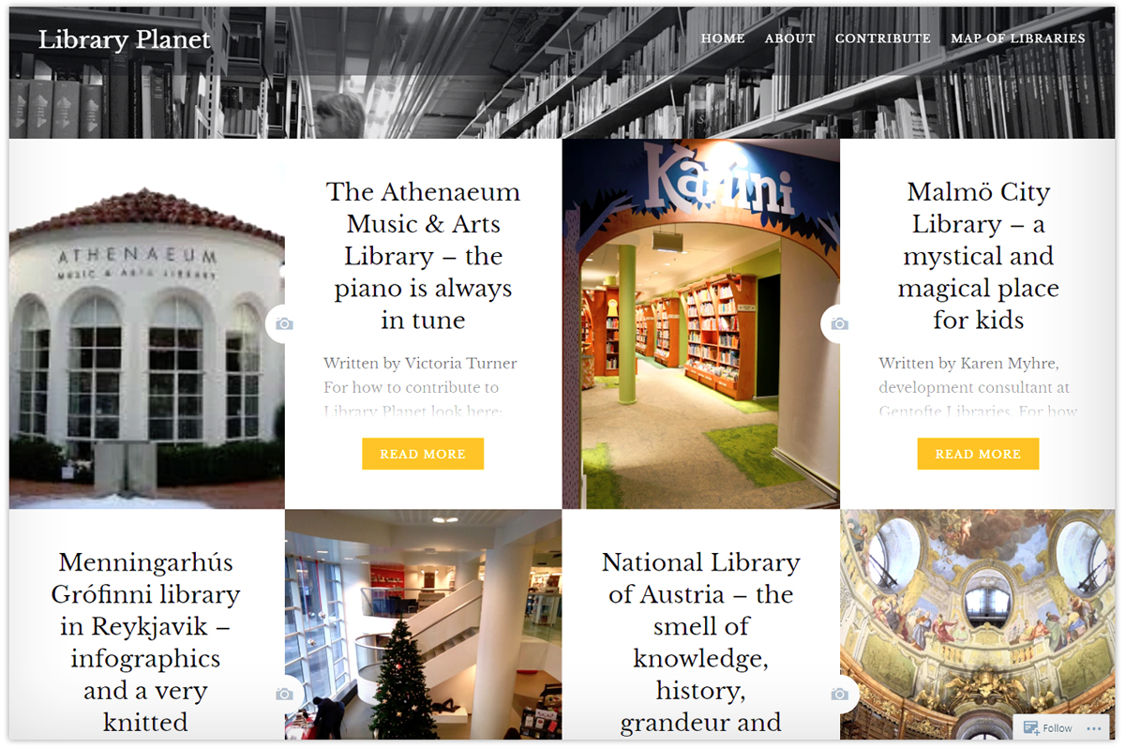

Traveling library lovers, the website of your dreams has arrived.
Christian Lauersen and Marie Engberg Eiriksson launched Library Planet, “a crowdsourced Lonely Planet for libraries,” in early December. The two librarians from Denmark both love to visit libraries when they travel and had talked about how they could share they experience with other people. They also shared a frustration: travel books often only include libraries if they are flagship or historical libraries, Engberg Eiriksson wrote in an email.
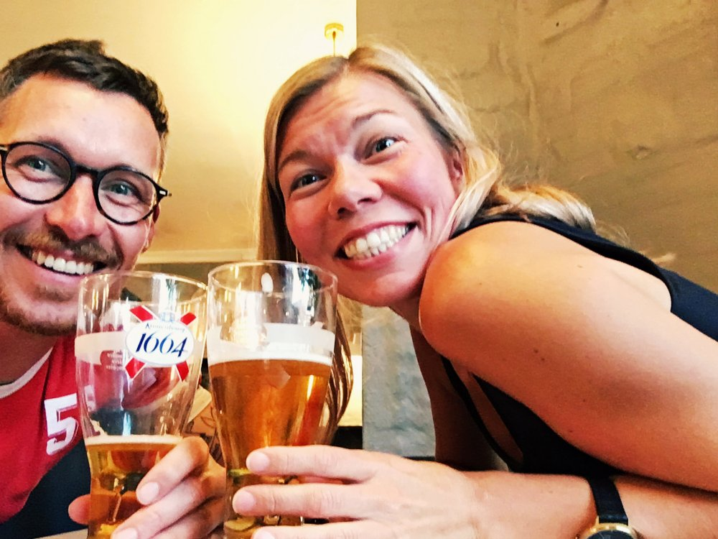
Christian Lauersen (left) and Marie Engberg Eiriksson started Library Planet.
“Sometime during that conversation, one of us just blurted out ‘What we need is a lonely planet for libraries.’ Christian tweeted the idea and so many people loved it,” Engberg Eiriksson wrote.
“A few days later we created the blog, and the submissions have been coming in a steady flow ever since.”
The website is as visual as it is informative, already full of beautiful travel photography centered on the library with submissions about the “beautiful and cool libraries.”
In addition to learning about the spaces themselves, people are writing in about why they love their local library, why they want to visit libraries when they travel, and even go off on library-related tangents about funding and other issues.
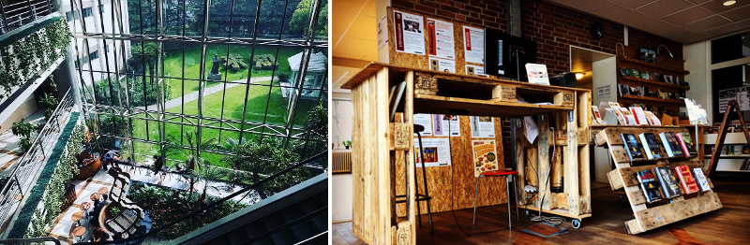
From the left: Shanghai Library (photo courtesy of Library Planet); Hvalsoe public library
“All the emails are full of love and appreciation for libraries, and it makes us so happy every time,” wrote Eiriksson. “All in all, we just feel like we put a few more libraries and a little more library love on the map.”
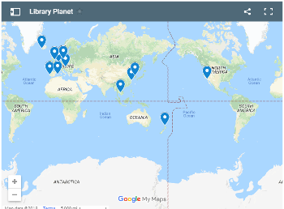
The updating map on the website shows that the majority of libraries are in Europe and Asia. The only North American entry is the Athenaeum Music & Arts Library in LaJolla, CA.
“We would love to have some contributions from the U.S. and Canada, but also, South America and Africa are very high on our wish list,” Lauersen wrote. “We are looking for posts about all types of libraries. National libraries, special libraries, public libraries, and school libraries. From the fantastic, grand, impressive kind to the small, personal, community hub.”
Those who want to contribute should remember that Library Planet is a travel blog seeking to share the reason that a library would be a “cool destination” and why, not an exhaustive walk through every feature of a facility.
The two suggest library lovers consider these questions like these when writing a submission: What is it like to walk in there? Does it support its community in special ways? Does is have any special features, odd collections, or cozy nooks? Is the coffee any good? What about the view? Is there a very good gin bar around the corner?
And they includes a very important reminder: Don’t forget the pictures!
Kara Yorio
Kara Yorio (kyorio@mediasourceinc.com, @karayorio) is news editor at School Library Journal.

https://www.slj.com/?detailStory=a-lonely-planet-for-libraries

- Princeton University’s New Brazil LAB Leads Relief Efforts for Brazil’s National Museum and a Important Anthropology Library Lost to Fire
Filed by Gary Price on December 18, 2018
From Princeton University:
On the morning of Sept. 2, 2018, the world community woke to the news that Brazil’s National Museum in Rio de Janeiro had caught fire, destroying one of Latin America’s oldest and most important scientific and cultural institutions.
[Clip]
The Postgraduate Program in Social Anthropology (PPGAS), based at the National Museum and affiliated with the Federal University of Rio de Janeiro, was particularly hard hit. In the year of its 50th anniversary, the program lost its entire infrastructure — administrative and faculty offices, classrooms, meeting spaces, ethnological collections, and an audiovisual lab with film and editing equipment.
Also destroyed was the Francisca Keller Library, the principal anthropology library in Brazil and among the best in Latin America containing more than 40,000 volumes, as well as research materials collected from over 50 years of fieldwork in Latin America. The loss of the Documentation Center for Indigenous Languages ​​(CELIN), which specialized in collecting text, images and sound of Indigenous languages ​​and varieties of Brazilian Portuguese, was especially devastating since most of the materials never were digitized and are irreplaceable.
[Clip]
After talking to the Brazil LAB’s co-director Pedro Meira Monteiro, the Arthur W. Marks ’19 Professor of Spanish and Portuguese and chair of the department, Biehl reached out to Federico Neiburg, an anthropologist at PPGAS, with whom he has collaborated many times. Their conversations led to an offer of help not only from the Brazil LAB, which was officially launched this semester, but also from the Princeton University Library and Princeton University Press to replace books and research materials.
“This new collaboration is based on previous exchanges headed by João and myself involving workshops in Rio de Janeiro and Princeton and ongoing collaborative research projects,” Neiburg said. “In this sense, Princeton’s solidarity was not surprising. What was surprising, indeed, is the size of the concrete actions being taken and their impact on reconstructing PPGAS.”
The largest immediate impact will come from a donation of 4,000 books spearheaded by Christie Henry, director of Princeton University Press, to restock the Francisca Keller Library.
Henry offered to replace any Princeton University Press edition housed in PPGAS’ library, and she also invited Neiburg and his colleagues to request additional books from the Press’ catalog. She then reached out to her peers at university presses across the United States, who agreed to do the same: “The response has been staggering in all wonderful ways.”
“I thought this would be something I would send to the listserv, and if a handful of people would have responded, I would have been thrilled,” Henry said. “I was completely unprepared — and my email was completely unprepared — for the rapidity of response.”
To date, more than 75 university presses have joined the effort. Princeton University Press’ donation totals about 300 books so far, including physical and digital editions. While some publishers are sending books directly to PPGAS, others are being consolidated and shipped by Ingram Content Group. The company’s chairman, John Ingram, is a Princeton alumnus.
Learn More About Brazil Lab in the Complete Article

https://www.infodocket.com/2018/12/18/princeton-universitys-new-brazil-lab-leads-relief-efforts-for-brazils-national-museum-lost-to-fire/

- Long Island University Awarded Grant for Robert Moses Archive Digitization Project
Filed by Gary Price
From The Island Now:
Long Island University’s project digitizing Robert Moses archives got a $695,000 grant, according to the university.
The Robert Moses Archival Project is digitizing a collection of photographs, letters and architectural drawings and is a partnership between the university and the New York State Archives and the New York State Department of Parks.
[Clip]
“From Huntington to the Hamptons, from Fire Island to Gardiners Island, the history of Long Island is rich and varied,” said Kimberly R. Cline, president of Long Island University. “By working to preserve Robert Moses’s archival heritage, we’re bringing another part of that history to life.”
Moses shaped Long Island through engineering parks and highways, beginning in the 1920s. Early in his career, as Long Island State Park Commissioner, he created Jones Beach State Park.
[Clip]
The university’s Palmer School of Library & Information Science is taking on both projects.
Learn More, Read the Complete Article

https://www.infodocket.com/2018/12/16/long-island-university-awarded-grant-for-robert-moses-archive-digitization-project/

