Año 4 Número 97 enero 2019
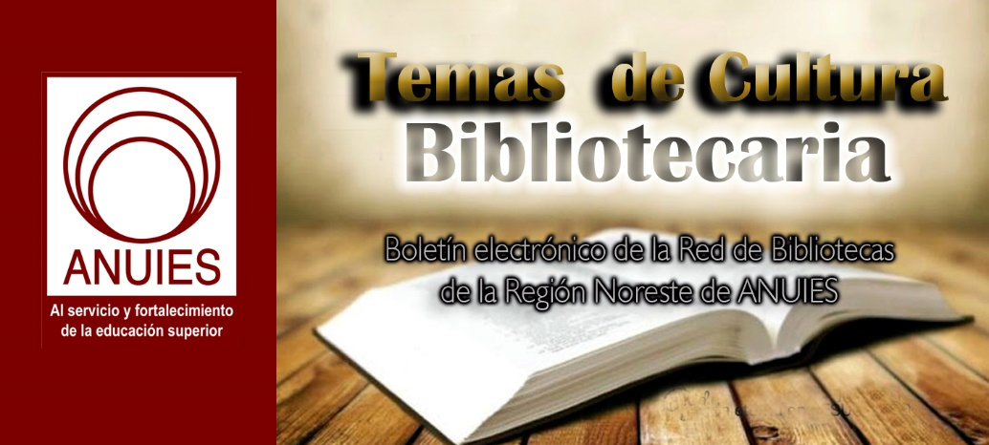

Contenidos de este número

- New from OCLC/Web Junction: “Training Curriculum For Wikipedia + Libraries Now Available Online for Library Trainers”
Filed by Gary Price on August 20, 2018
From OCLC/Web Junction:
Training curriculum, slides, and handouts from the Wikipedia + Libraries: Better Together course are now available on the WebJunction website. These newly released materials provide instruction and resources for trainers to teach library staff how to edit Wikipedia articles, run Wikipedia workshops, and organize community outreach events that incorporate Wikipedia. The curriculum release marks the completion of OCLC’s 18-month grant-funded project to strengthen ties between Wikipedia and US public libraries toward the common purpose of improving access to the world’s knowledge.
Direct to Wikipedia + Libraries Training Materials

https://www.infodocket.com/2018/08/20/new-from-oclcweb-junction-training-curriculum-for-wikipedia-libraries-now-available-online-for-library-trainers/

- OCLC Publishes 2017-2018 Annual Report, WorldCat Grows to 423 Billion Records, 2.6 Billion Holdings
Filed by Gary Price
The OCLC 2017-2018 Annual Report was published today.
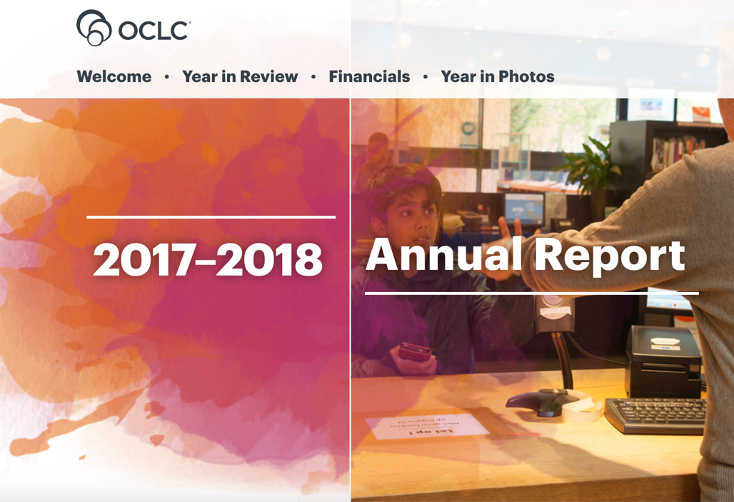
A Few Highlights (via an OCLC Announcement):
- Libraries continued to build WorldCat, the world’s smartest collection of cooperative library data. This past year it grew to 423 million records and 2.6 billion library holdings.
- More than 600 libraries now use WorldShare Management Services to work smarter every day through a shared, cloud-based environment.
- In March 2018, OCLC Wise was introduced in the US as the first community engagement system for US public libraries. We also signed a contract with Cultuurconnect to bring the service to more than 300 public libraries in Belgium.
- And we expanded important research and community partnerships with organizations like Jisc, ALA/PLA, Wikipedia, the Center for Research Libraries, and the Mellon Foundation.
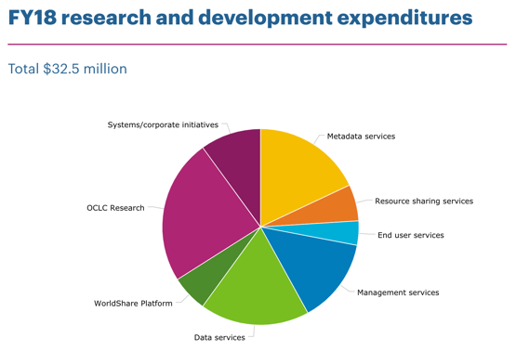
Direct to Full Text of 2017-2018 OCLC Annual Report

https://www.infodocket.com/2018/10/29/oclc-publishes-2017-2018-annual-report-worldcat-grows-to-423-billion-records-2-6-billion-holdings/

- New York Public Library Announces Launch of Special “Knowledge is Power” Library Card
Filed by Gary Price
From the NYPL:
The New York Public Library is releasing a library card with the message “Knowledge is Power.” The black and silver card is available beginning October 29 in any of the Library’s 92 locations in Manhattan, the Bronx, and Staten Island (Brooklyn Public Library and Queens Library are different systems – although any city resident can apply for an NYPL card).
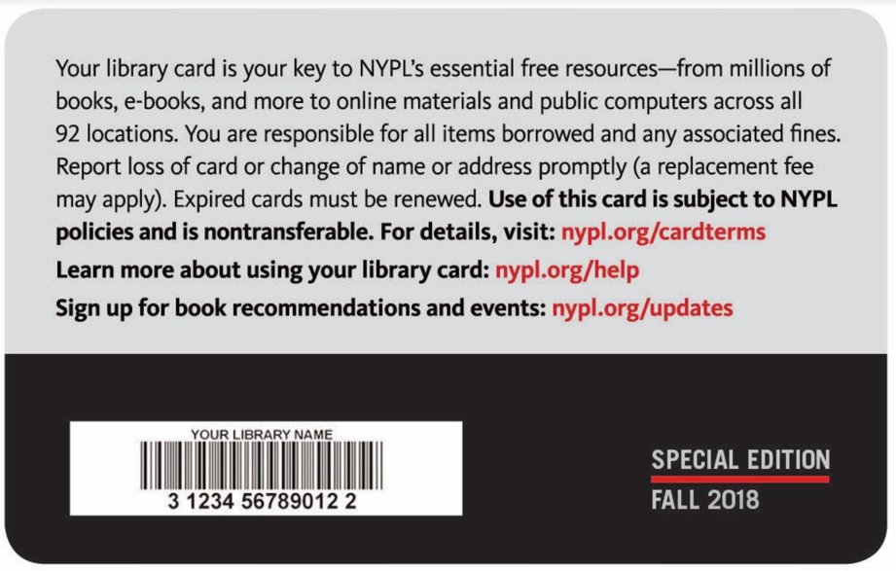
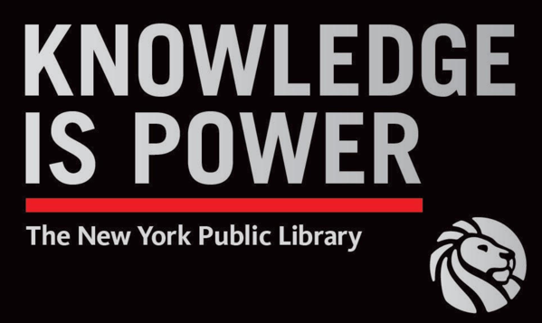
The Front and Back of the New Special NYPL Library Card
NYPL President Anthony W. Marx on Why the Library is Releasing The Card:
Public libraries have always been at the foundation of our democracy of informed citizens: we preserve and make accessible fact. We offer knowledge, education, and opportunity to all. Everyone is welcome in our spaces. We are the great equalizers. Armed with knowledge, all of us have the power to do anything. As we all strive to be active, productive members of civic society, it is so important to remember that knowledge is indeed power, and that we must be informed. Libraries are the place to do just that: to learn, to grow, and to strengthen ourselves and our communities. This card shares that message, and serves as a reminder to visit your local library, get a card, and start your journey now.

https://www.infodocket.com/2018/10/29/new-york-public-library-announcing-launch-of-new-and-special-knowledge-is-power-library-card/

- Caselaw Access Project Announces Official Launch, Free Public Access to 6.4M+ State and Federal Court Decisions
Filed by Gary Price
Congrats to Adam Ziegler and the Caselaw Access Project Team!

Adam Ziegler@abziegler

Thrilled today to announce the launch of https://case.law , a free public access point for 6.4M+ state and federal court decisions spanning our nation's entire history!

1,720
11:14 AM - Oct 29, 2018
Twitter Ads info and privacy

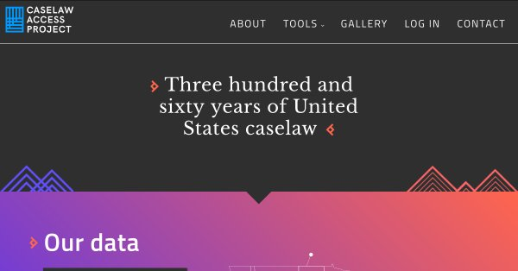
Caselaw Access Project
Explore American Caselaw
case.law

785 people are talking about this

Twitter Ads info and privacy
Make sure to read the complete Twitter thread to learn more about Today’s Launch of the Caselaw Access Project.
What is the Caselaw Access Project?
In Their Own Words:
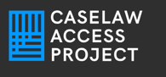The Caselaw Access Project (“CAP”) [a Harvard Law School Library Innovation Lab project] expands public access to U.S. law. Our goal is to make all published U.S. court decisions freely available to the public online, in a consistent format, digitized from the collection of the Harvard Law Library.
CAP includes all official, book-published United States case law — every volume designated as an official report of decisions by a court within the United States.
Our scope includes all state courts, federal courts, and territorial courts for American Samoa, Dakota Territory, Guam, Native American Courts, Navajo Nation, and the Northern Mariana Islands. Our earliest case is from 1658, and our most recent cases are from 2018.
JuneEach volume has been converted into structured, case-level data broken out by majority and dissenting opinion, with human-checked metadata for party names, docket number, citation, and date.
Direct to Complete Overview
Includes info about what is and is NOT available from the Caselaw Access Project.
Direct to Caselaw Project Website
Direct to Caselaw Project Tools, Gallery, CAP API and Bulk Data Download
Follow Caselaw Access Project on Twitter
@caselawaccess
Some Background
Continued Support for Harvard Law’s Caselaw Access Project After Project Partner Acquired by LexisNexis (June 8, 2017)
Caselaw Access Project Scanning Now Complete (January 30, 2017)
Harvard Law School Library Project to Provide Free Online Access to U.S. State, Federal Court Decisions Named “Caselaw Access Project” (August 10, 2016)
40 Million Pages: NY Times Reports on the Harvard Law School Library’s “Free the Law” Digitization Project (October 29, 2015)
Hat Tip/Thanks: Free.Law (Another Wonderful Project/Service)

https://www.infodocket.com/2018/10/29/research-resources-case-law-project-announces-official-launch-free-access-to-6-4m-state-and-federal-court-decisions/

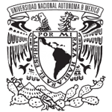
Estimado Colega,
Desde 2015, el Congreso Internacional de Archivos Digitales se ha erigido como el foro de referencia para el análisis, discusión y presentación de investigaciones, desarrollos tecnológicos y propuestas encaminadas a preservar a largo plazo contenidos sonoros y audiovisuales en archivos digitales.
El I Congreso Internacional de Archivos Digitales Sustentables. Conservación y acceso a los sonidos e imágenes del futuro, se ocupó de reflexionar en relación con la preservación digital a largo plazo.
En 2017, el II Congreso tuvo como tema central Conectando los saberes de las Bibliotecas, Archivos, Museos y Galerías (BAMG) para la Preservación Digital a fin de motivar la generación de proyectos y propuestas de colaboración BAMG de preservación digital. En 2019, el tema que se abordará será Forjando el futuro: la inteligencia artificial y el Big data para la preservación digital sonora y audiovisual; con ello, se busca potenciar el uso de estas herramientas tecnológicas en la creación, desarrollo y aprovechamiento social de los archivos digitales en las próximas décadas.
Este 2019 se realizará el III Congreso Internacional de Archivos Digitales, por lo que lo invitamos a revisar la convocatoria en:http://difusion.iibi.unam.mx/CIADIII/page1.html

Registration is now open for the 2019 Public Library Think Tank - The Future Is Theirs: Community Co-Creation with Kids and Teens, presented by Library Journal and School Library Journal, March 7-8 at the Miami-Dade Public Library, Miami, FL.
This content-rich, two-day program will convene public library leaders and directors, youth services and young adult librarians, along with other leading thinkers to explore the co-creation trend in libraries, from input to engagement to full co-creation.
Co-creation brings in new users, delivers more of what they want and need, and fosters a sense of welcome and ownership which results in deeper relationships.
Learn more about this strategic approach, and how to embed it in your organization, empowering kids and teens to build skills and make a difference as they shape a stronger library and community.
Plenty of time will be allotted for networking during a reception and breaks. A Thursday tour is in development.
More information about the program and presenters will be available soon but don't wait, register before January 18 and save 20% on the registration fee! We'll update you with program announcements as information becomes available.
Special group pricing available. Directors are encouraged to attend with their team or send a group for a unique team building experience. Contact us today to learn more.

Group hotel info will be provided soon!

The participants at the Public Library Think Tank are those taking leadership in creating strong and effective programs and libraries, and envisioning the future vitality of libraries to best serve our communities. This includes but is not necessarily limited to: public library children's librarians, public library teen services librarians, school librarians in close collaboration with public libraries, branch managers, and public library directors.
In partnership with

SPONSOR

Questions?
Contact us.

- 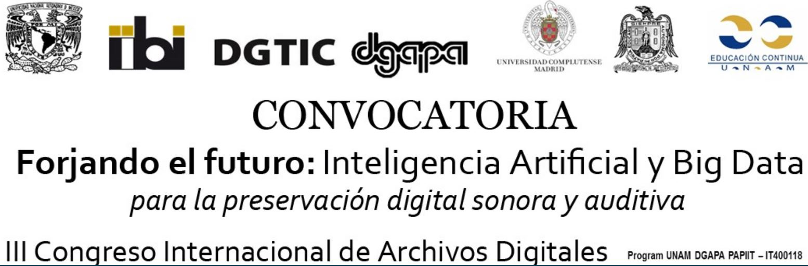
Estimado Colega,
Desde 2015, el Congreso Internacional de Archivos Digitales se ha erigido como el foro de referencia para el análisis, discusión y presentación de investigaciones, desarrollos tecnológicos y propuestas encaminadas a preservar a largo plazo contenidos sonoros y audiovisuales en archivos digitales.
El I Congreso Internacional de Archivos Digitales Sustentables. Conservación y acceso a los sonidos e imágenes del futuro, se ocupó de reflexionar en relación con la preservación digital a largo plazo.
En 2017, el II Congreso tuvo como tema central Conectando los saberes de las Bibliotecas, Archivos, Museos y Galerías (BAMG) para la Preservación Digital a fin de motivar la generación de proyectos y propuestas de colaboración BAMG de preservación digital. En 2019, el tema que se abordará será Forjando el futuro: la inteligencia artificial y el Big data para la preservación digital sonora y audiovisual; con ello, se busca potenciar el uso de estas herramientas tecnológicas en la creación, desarrollo y aprovechamiento social de los archivos digitales en las próximas décadas.

Este 2019 se realizará el III Congreso Internacional de Archivos Digitales, por lo que lo invitamos a revisar la convocatoria en:http://difusion.iibi.unam.mx/CIADIII/page1.html

Será un placer recibir sus propuestas.
Lic. Jorge Castañeda
Difusión

