Año 4 Número 96 enero 2019

Contenidos de este número

- Arizona State University Library Writing the Next Chapter in the ‘Future Of Print'; Experimentation Period Underway with “10 Compelling Ideas”
Filed by Gary Price on October 6, 2018
From the ASU Library:
When Hayden Library, Arizona State University’s largest library, re-opens in 2020, its open-stack print collections will have a whole new look.
The future display, curation and delivery of books at ASU, and how those books interact with the heavily digital-dwelling community in which they are present, is the focus of the Future of Print initiative, an exploration into the behaviors, needs and expectations of 21st-century academic library users.
[Clip]
Shari Laster, head of Open Stack Collections, is now leading the Future of Print into its next phase: experimentation. Here, she discusses these experiments and how they aim to inspire new thinking around the design of inclusive, high-quality and user-focused print collections for research and learning.
An interview (4 questions and answers) with Shari Laster is also part of the ASU Library post. Here’s one of them.
Question: This fall, the library is experimenting with a series of collection experiments. Can you tell us more about them?
Answer: ASU Library has a lot of ideas about how people and books get connected together. We came up with a list we are calling “10 Compelling Ideas” and we’re trying out some of these ideas in different library locations and in other spots on campus. This fall, we have several mini-projects, or experiments, in motion.
Surprise Me! is a collection of poetry and drama at Fletcher Library on the West campus. The books in this collection are being shelved spine-backward in order to invite students to explore an unexpected collection. Another project, Vamos Argentina! Books, Tango and Meteors, is an exciting series of talks and events that will draw attention to the collection of Argentine literature currently housed at Noble Library on the Tempe campus. At the Downtown Phoenix campus, we are featuring Health Humanities Horizons, a collection curated in collaboration with faculty whose research and teaching intersects with the CLAS certificate program in interdisciplinary health humanities.

https://www.infodocket.com/2018/10/06/arizona-state-university-library-writing-the-next-chapter-in-the-future-of-print-experimentation-period-underway-with-10-compelling-ideas/

- How Library Leaders Spend Their Time Can Make a Difference | Leading from the Library
by Steven Bell
There are countless articles and self-improvement posts on time management. It seems we are obsessed with squeezing every productive minute out of our workdays. What should library leaders know about allocating their time to be most useful to their communities and staff?
Library leaders are busy. Directors and department heads routinely juggle myriad meetings with reports, projects, and supervisory responsibilities. The higher up the administrative ladder a leader climbs in librarianship, the more time is consumed by meetings and dealing with a mix of policy decisions and problems. This jumble of activity greatly diminishes time for conversations with staff, direct interaction with community members, and even the simple act of thinking and reflecting. A preferred way to lead and make a difference is envisioning a pathway to a better library and then creating opportunities and allocating resources to colleagues and empowering them to act to bring that vision to fruition. When leaders expend time on low-impact work, their ability to get desired results is jeopardized. That is just one powerful rationale for why leaders should pay attention to how they spend their time and what they accomplish with the time they have.
TIME MYSTERY
There is existing research on the work that library leaders do, what skills make for effective library leadership, and how to manage time. But we know little about how they allocate time to different aspects of their work or what time allocation strategies would support effective leadership. It would hardly surprise if the number one time obligation for deans and directors, along with other library administrators, was meetings. Even then, it would be helpful to have more details about how that time is spent. How is time allocated between meetings with administrators from other departments, administrator councils, library committees, one-on-one meetings with direct reports, and meetings with association committees or other professional obligations? Another chunk of the library leader’s time goes to keeping up with the latest professional developments, along with news and updates from other professional fields and industries. What else are leaders currently spending time on, and how much is allocated to each activity? This strikes me as a useful library leadership research project, and some new research into CEO time allocation may offer a model.
REALLY THAT DIFFERENT?
There are obvious differences between corporate CEOs and library leaders, but the latter may learn some lessons from how the former allocate time and what they know about using it more effectively. In their article, “How CEOs Manage Time,” Michael E. Porter and Nitin Nohria tracked a cohort of approximately 300 CEOs, some as far back as 2006. The study analyzed 60,000 hours of CEO time. Based on my own experience and that of other library deans and directors, one similarity between CEOs and library leaders is that the job can become a 24/7 responsibility. Give our VUCA era, it’s more common for library leaders to be available around the clock to deal with a crisis. On average though, CEOs in the study worked 63 hours a week. I suspect that’s more than library leaders, but not by much. Other findings include:
• CEOs spent 25% of their personal communication time on email—found to be a serious distraction—but a considerable amount, 60%, went to face-to-face meetings;
• CEOs are being seen less at the office. Just over 50% of their work time is off-site;
• CEOs are in meetings the bulk of their time; 72% is spent in meetings vs. 28% of alone time;
• CEO meetings most frequently last between 1 and 2 hours;
• CEOs spend 75% of their time on scheduled activity vs 25% on spontaneous activity;
• CEOs spend 25% of their time on people and relationships; another 25% focuses on functional areas of their operation.
THINKING ABOUT TIME
Library leaders may find that these CEO time trends resonate with them. Lots of time in meetings. Many hours to cultivate personal relationships. Considerable time out of the office. Meetings that run longer than anticipated. Porter and Nohria found that CEOs struggle to gain control over their time owing to the unpredictable nature of their work and the need to deal with situations of a non-routine nature. They also provide suggestions for ways leaders can take more control of their time:
• Get staff thinking more carefully about whether leaders need to be copied on a message;
• Take advantage of online conferencing to eliminate travel when possible;
• Set an explicit daily agenda to help make progress on multiple tasks simultaneously;
• Develop a strategy, follow it, and assemble a leadership team to which some strategic tasks can be delegated;
• Create more alone time
Beyond email the authors say little about the challenges of distraction. In the article “Finding It Hard to Focus” Casey Schwartz discusses how technology makes it difficult to gain control of our attention or avoid the loss of it. Given the demands on their time, leaders must develop strategies for staying focused and avoid technology’s powerful ability to distract. In a companion article to Porter and Nohria’s study, a CEO’s daily allocation of time and activity is analyzed day by day over 13 weeks. Time tracking helped this CEO identify and eliminate many time-wasting distractions. Should keeping a detailed daily activity log seem like overkill or overwhelming, there are apps, software, and productivity tips available that offer simple approaches to better manage time. It need not become an obsession, but leaders who are purposely intentional about their time allocation better position themselves to make the most of each day, and ultimately make the most difference with the time they have.
Steven Bell
Steven Bell, Associate University Librarian, Temple University, Philadelphia, PA, is the current vice president/president-elect of ACRL. For more from Steven visit his blogs, Kept-Up Academic Librarian, ACRLog and Designing Better Libraries or visit his website.

https://www.libraryjournal.com/?detailStory=180823-How-Library-Leaders-Spend-Their-Time-Leading-from-the-Library

- The 13 Ivy Plus Libraries (IPL) Release RFP For a BorrowDirect Shared Index; Open-Source Solutions Will Be Given Priority
From Penn Library News:
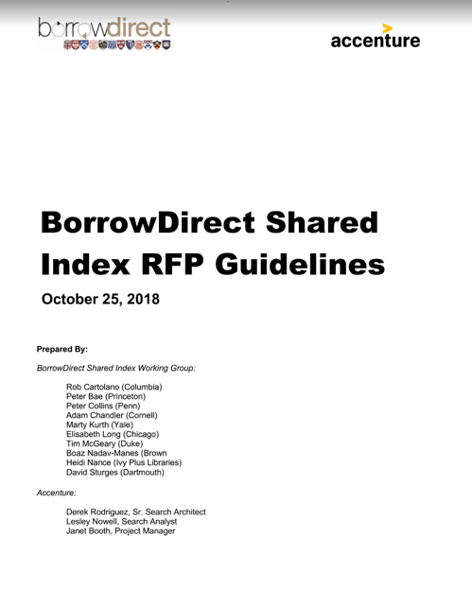The Ivy Plus Libraries (IPL) – which includes Brown University Libraries, Columbia University Libraries, Cornell University Libraries, Dartmouth College Libraries, Duke University Libraries, Harvard University Libraries, Johns Hopkins University Libraries, Massachusetts Institution of Technology (MIT) Libraries, Princeton University Libraries, Stanford University Libraries, University of Chicago Library, University of Pennsylvania Libraries, and Yale University Libraries – collectively hold more than 90 million titles. Through our signature service – BorrowDirect – we share more than 270,000 items per year in a highly automated and load balanced resource sharing system.
[Clip]
Penn Libraries, acting on behalf of the 13 partner libraries, seeks responses to the RFP by November 15, 2018.
Please note that preference will be given to responders offering an open-source solution.
From the Request For Proposal:
The purpose of the BorrowDirect Shared Index project is to replace the Discovery portion of the BorrowDirect system with a Shared Index. The Ivy Plus Partnership is seeking proposals for the development and design of the Shared Index into production and for its ongoing support.
The selected Vendor shall work collaboratively with Ivy Plus staff and representatives to implement the new BorrowDirect Shared Index and related services (BDSI). The anticipated multi-phase project will include deployment and configuration, an operational pilot test, integration with external systems, and a production launch.
Anticipated outcomes of the project include:
- Improved Discovery services across the 90 million + returnable titles in the Ivy Plus collections, including complete and up-to-date information regarding Ivy Plus holdings.
- Ability to search ALL Ivy Plus holdings from local Discovery systems operated by member institutions. Essentially, this will allow patrons at member institutions to search across the Ivy Plus collections from a familiar, locally branded search application.
- Given the rapidly changing resource sharing platform environment, must provide ability to integrate with existing BorrowDirect Fulfilment infrastructure at launch, as well as the ability to integrate with alternate systems in the future, if needed. This should include use of standard, openly-available resource sharing protocols such as NCIP z39.83, z39.50, ISO 10160:2015.
- Continuous support for and integration with existing resource sharing applications, including Relais D2D and OCLC ILLiad, that may use proprietary standards for integration.
- For development in a later phase, lay the foundation for growing the Shared Index beyond returnable physical items described in MARC 21 format. Examples include resources described in non-MARC formats and other types of materials such as electronic resources and special collections materials.
Direct to Full Text RFP
23 pages; PDF.
https://www.infodocket.com/2018/10/26/the-14-ivy-plus-libraries-ipl-release-rfp-for-a-borrowdirect-shared-index/

- Virginia Tech First R1 Library to Adopt Koha ILS
by Matt Enis
The University Libraries at Virginia Tech (VT) this summer became the first R1 research library to implement the Koha open source integrated library system (ILS), migrating more than 1.5 million holdings from its former Sierra ILS. Integration with the CORAL electronic resources management system and EBSCO Discovery Service (EDS) will enable students, faculty, and researchers to discover all library resources using a single interface. ByWater Solutions has been contracted to facilitate the transition with staff training, migration services, and ongoing hosting and development support.
VT University Libraries Assistant Dean and Chief of Staff Michael Kucsak told LJ that the selection of Koha followed a traditional request for proposal process. Koha has been implemented by a growing number of community colleges and small university libraries in recent years, but historically the open source system primarily has been used by public libraries. The implementation by VT illustrates how much the ILS has grown in terms of functionality and scalability since its initial development almost two decades ago.
Industry consolidation has reduced to a handful the number of commercial vendors serving the academic library market in the United States, with Alma by Ex Libris demonstrating the fastest growing market share. During the selection process, “initially, we were very split, as a library, on what we liked,” Kucsak said, with staff preferences typically varying by department or job function. “We didn’t have complete buy-in for any system. But we talked about our expectations in terms of ‘what must a library system do? Can the systems that we are looking at do it? And, then, what is the justification for going beyond…the baseline? What are the justifications for spending more money for these other systems?’”
A selection committee opted for Koha, Kucsak said, deciding that it had the necessary functionality, and that VT could pay ByWater or other third-party developers to create enhancements or new features as needed. For example, prior to VT’s implementation, Koha was not designed to shorten the borrowing period for books that are currently checked out. So an order for a recall feature was included in VT’s initial contract, and ByWater’s developers added it to the ILS before launch. Similarly, support for ILLIAD has been added, along with additional granularity for staff permissions and tweaks to workflows.
“I think the greater challenge was really identifying all of the things that we had just become accustomed to [versus] this is what the system has to have,” he said. “That, to me, is one of the hardest things when you’re going to any new system—identifying what is a business requirement, versus something you prefer or like. And the greatest challenge of all is going to a new system, and avoiding trying to make it work like the old system.”
Another important factor, he said, was “freedom and flexibility. Not only were we looking at an ILS, we were also reconsidering our discovery tool [ultimately selecting EDS]. And not every system gives you the flexibility to use whatever discovery tool you want. We don’t want to be locked in to anything…. One of the systems had a very attractive package when it came to e-resource management, and e-resource integration, but it came with a price—use this system and it works well, use anything else, and it doesn’t work at all. We really didn’t like that.”
There were concerns about being the first R1 university library to implement the system, Kucsak said. But ByWater’s largest customer, the Huntsville–Madison County Public Library system (HMCPL) in Alabama, had a roughly comparable number of records/holdings—including a main branch with more than half a million volumes—and circulates about two million items per year.
“We had more bib records…a million and a half to [HMCPL’s] million, but that wasn’t so great [a difference] as to say this is untested,” Kucsack said. “And circulation, to me, is really key. If you can’t check out books on day one, you’ve really failed as an ILS…. [HMCPL] circulates two million per year, and we circulate 50,000 books, and maybe 100,000 objects a year…. When you look at the numbers…we felt very comfortable that [ByWater] would be able to scale with us, if they needed to scale at all.”
Kucsak—who began his library career more than two decades ago as a systems librarian—has been watching the growth of Koha since its early days, when it was primarily known as a free ILS solution for small public libraries. Koha’s open source nature has enabled it to evolve over the years, with libraries and third-party developers adding new features as needed, many of which are later incorporated into official releases available to all Koha users. With VT now likely to fund the development of features needed by large research libraries via ByWater, Koha appears to be reaching a new frontier in that evolution.
“One of the things that we really like about Koha is that, if we don’t like it, we can change it,” Kucsak said. “Not just in the ILS world, but frankly, in any [commercial] system—from discovery tools to word processors—you can create a ticket and [ask for a feature or a fix, and] maybe five years down the road they’ll implement it if enough people ask for it.”
Now, VT can simply pay companies like ByWater for custom development, he noted, adding that based on the fee structure, it will cost “a fraction of the amount of money that we’ll be saving every year” by opting for an open source solution versus a commercial system. “ByWater can provide us with hosting, expertise, training, and support services for less than it would cost us to hire a single systems admin.”
“There are definitely some things that we are ‘taking one for the team’… if other [major research] libraries follow our lead on this,” he said. “But I don’t know that we accept that there are any limitations right now” regarding how the system can be customized, “and that’s exciting.”
Proving the viability of Koha, an existing open source ILS, in an R1 academic library environment also has the potential to reorient the ILS/Library Services Platform market, Kucsak said.
“This system was good enough for Virginia Tech on day one, and it’s already better today than it was” following implementation a little more than two months ago, with VT-funded features such as recall and ILLIAD support, he said. “That’s the beauty of community-driven software development. We’re capable of evolving this system, and if more people get on the system, it will evolve faster. But even if it doesn’t, and other libraries don’t go this route, I would bet…that they are going to buy whatever system they’re going to buy for less money” due to a new competitor entering the market.
Matt Enis
Matt Enis (menis@mediasourceinc.com, @matthewenis on Twitter, matthewenis.com) is Senior Editor, Technology for Library Journal.

https://www.libraryjournal.com/?detailStory=180814VTKoha

- Full Text: Complaint Filed with EU Competition Authority Regarding “Anti-Competitive Practices” of RELX/Elsevier and the Wider Scholarly Publishing Market
Filed by Gary Price on October 30, 2018
A complaint was filed with the EU Competition Authority and was submitted by Dr. Jonathan Tennant, UK; and Prof. Dr. Björn Brembs, Germany.
The document runs 22 pages (PDF) and begins:
We are writing to you in the capacity of a group of researchers who benefit from the production of scholarly research articles, and also as authors of scientific articles that fall under the scholarly publishing market.
We write to notify you of what we believe to be the anti-competitive practices of RELX Group in the scholarly publishing and analytics industry, based on the following two articles of the Treaty of the Functioning of the European Union (TFEU):
- Article 101 of the Treaty, which prohibits agreements between two or more independent market operators which restrict competition; and
- Article 102 of the Treaty prohibits firms that hold a dominant position on a given market to abuse that position.
This complaint regarding RELX Group, and specifically its daughter company, Elsevier, is based on the following grounds:
- General problems within the scholarly publishing market sector that actively prohibit competition in the common market between EU member states (Article 101); and
- Abuse of a dominant position within this market (Article 102).
The grounds on which we believe these statements to be true are set out below with reference to the primary academic literature that has been studied, the general scholarly publishing landscape in the EU, previous competition inquiries, and financial statements from RELX Group. In 2002, the UK Office of Fair Trading Standards published a report (OFT 396) of its investigation into the market for Scientific, Technical and Medical (STM) journals. Here, the report concluded that the journal market was not functioning well due to inelastic demand, a lack of price competition and sensitivity, and that regulatory intervention would be required should conditions fail to improve. Here, it is our view that the natural interventions proposed in the report (price restraint from commercial publishers; increased buyer power; academic power; and the impact of new Web technologies) have not occurred, and we shall provide evidence to demonstrate that each of these factors is still contributing to what we believe is a dysfunctional market.
The present complaint follows a similar referral of RELX Group to the UK Competition and Markets Authority in 20161, following the recommendation of (then MP) Ann McKechin, previously in a BIS sub- committee hearing in 2013. Here, she advised that RELX Group (at that time known as Reed Elsevier) should be referred to the competition commission if it continued to use non-disclosure agreements, which she termed a “profoundly anti-competitive practice”, and said that if this was happening with public funds “there should be a referral to the Office of Fair Trading”. To date, there has been no formal response to this referral, and, as we shall demonstrate, it is our view that these anti-competitive practices and dysfunctional market conditions continue and do not serve either researchers, institutes, or the public interest effectively.
We focus primarily on Elsevier, its history and present business practices, the ongoing threat it continues to pose to the present scholarly publishing market, and the wider implications that these has on the role of scholarly research in society. Elsevier is the single largest publisher of scholarly research articles, owning more than 2,500 scholarly journals, and between 2012 and 2015, Elsevier published almost 1.4 million journal articles, the vast majority of which are not publicly accessible. In relative terms it is one of the smallest Open Access publishers, publishing just 27,000 OA articles in 2017 out of 436,0002 (around 6.2%). We fully acknowledge that much of what we discuss in this complaint can also be applied to other major players within the wider scholarly publishing market, and discuss some additional details to provide this context.
infoDOCKET first learned of the complaint document via a brief post (in German) on the Project Deal website.
Direct to Full Text of Complaint (via Zenodo)
PDF and DOC versions available.
DOI: 10.5281/zenodo.1472045

https://www.infodocket.com/2018/10/30/full-text-complaint-filed-with-eu-competition-authority-regarding-relx-and-the-wider-scholarly-publishing-market/

- Congressional Think Tank Catches Flak Over Public Access Plans
by Ian Chant
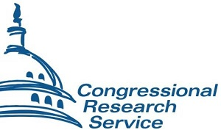After years of nudging, the Congressional Research Service (CRS)—the in-house think tank for the House of Representatives and Senate—is making its records accessible to the public online for the first time.
The American Library Association (ALA), which has been advocating for such access for two decades, cheered the move. But others worry that the current proposal for digital access to reports, white papers, and other informational resources produced by the organization won’t measure up to already available products. Critics say the result could be a bloated and expensive public-facing portal that doesn’t substantially improve public access.
The CRS issues nonpartisan reports on issues of interest to members of Congress. These reports run the policy gamut from big picture studies on Medicare premiums to in-the-weeds analyses of livestock feed costs. CRS staffers also conduct research on international issues like foreign relations and forward-looking reports on topics like on the difficulties legislators can expect to encounter in regulating flying cars.
In the coming months, the Library of Congress (LC) expects to make some of these reports, at least, available and searchable online for the general public, using a version of the same functionality that’s already available to Congressional staffers. It’s a development that advocates like ALA are marking as a big win.
“ALA has called for public access to Congressional Research Service reports for more than 20 years, so we’re pleased that Congress included a provision in the March 23 appropriations lawthat will finally allow the public free online access to CRS reports, including access through local libraries,” said Gavin Baker, ALA Washington Office assistant director of government relations, in a statement to LJ. “It’s important for CRS to consult with users and stakeholders in implementing the law and to move as quickly as possible to provide the greatest possible public access.”
It’s that second part the worries critics, including Daniel Schuman, policy director for the transparency and access focused nonprofit Demand Progress. Demand Progress and other organizations, including legislative watchdog govtrack.us, outlined their concerns about the current plans by LC for providing online access to CRS resources.
“We are glad that the Library of Congress is required to start publishing CRS reports online, but the Library's plan falls far short of what the law requires and what we had hoped,” Schuman told LJ. So where exactly does the plan stumble?
“The Library will not publish all the non-confidential reports, even though it is required to by law, and it will publish only a handful by the September 18th deadline, when it's supposed to publish them all,” Schuman pointed out. “The Library will publish them only as PDFs, which creates problems for the visually impaired and people who want the underlying data.”
With a budget line of $1.5 million, it doesn’t seem to Schuman like the government is getting a lot of value for its money from this new portal. It’s worth noting that Schuman has a dog in the fight: Demand Progress operates everyCRSReport.com, an online tool it developed to make CRS reports available to the public without buy-in from the organization. The site, which has been active since October 2016, serves about 50,000 visitors monthly.
Schuman and his team welcome LC moving in alongside it.
“The value the Library of Congress can add is that the reports it publishes are the official version…. Publication on the Library's website is how you know that you have all the non-confidential reports and that they haven't been altered in any way,” said Schuman. “In addition, the Library can provide stable access: non-profit organizations come and go, but the Library can make sure that the historical repository of reports is maintained for public use for years to come.”
To Schuman, though, the current system being suggested by CRS and LC doesn’t seem likely to make everyCRSreport.com obsolete any time soon.
At press time, CRS had not responded to a request for comment for this story.

https://www.libraryjournal.com/?detailStory=180823-Congressional-Think-Tank-Catches-Flak-Over-Public-Access-Plans

- Baruch College Launches First Digital Portal to Archives from the Institute of Public Administration
Filed by Gary Price on August 22, 2018
From Baruch College:
Baruch College has launched the first digital portal to historic materials on government reform from the Institute of Public Administration (IPA) at www.baruch.cuny.edu/library/ipa.
At a time of widespread disdain for government and public service, the new online archive, funded by Carnegie Corporation of New York, offers fresh insights into model operations of local and national governance in America.
Founded in 1906 as the Bureau of Municipal Research, the IPA with its motto, “An Adventure in Democracy,” represented a revolt against systemic national and local municipal corruption at the dawn of the 20th century, a revolution fostered by titans like Andrew Carnegie, E.H. Harriman, and John D. Rockefeller Jr., and masterminded by a pioneer of public administration, Luther Halsey Gulick III.
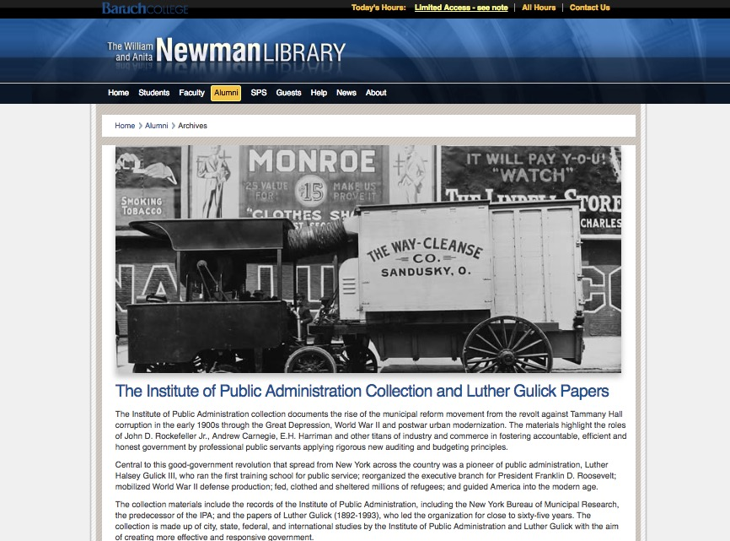
For several years, archivists from the College’s William and Anita Newman Library have been processing and digitizing thousands of pages of city records, files, memorabilia, historic photos, and other documents—most of which have never before been seen by the public.
This new digital library features 175 reports from 1920 to 1959, as the first phase of a longer-term effort to make large portions of the IPA collection accessible online to students and scholars. Highlights of the collection include:
· Rare studies of police practices in crime-troubled cities like Chicago, New Orleans, East St. Louis, Baltimore and New York, and the origins of Uniform Crime Reporting, by the nation’s preeminent expert in policing, Bruce Smith.
· Luther Gulick’s struggle to reorganize the executive branch for Franklin D. Roosevelt, creating the powerful modern Presidency instrumental in battling the Great Depression and World War II.
• Historic reports on New York City financial problems and commercial trends – including a 1941 study of the soon-to-vanish garment industry – charting the city’s path to world metropolis.
“We have begun by digitizing a series of reports produced by the IPA on a wide range of topics, such as snow removal, police reform, and local governance,” said Professor Jessica Wagner Webster, Digital Initiatives Librarian and Director of the Project at Baruch College. “Researchers can keyword search across the full text of all of these reports, allowing them to locate all the material produced on a specific topic or region. We are thrilled to be able to provide access to these materials, and look forward to continuing to digitize this rich collection.”
This project was made possible through philanthropic support from Carnegie Corporation of New York, whose century-long history of generous support for effective and accountable government enabled Baruch College to begin the preservation, organization, and digitization of the IPA Archive for the benefit of the public, scholars and researchers.
The history of the project is told in the Archives’ blog, An Adventure in Democracy.
According to Professor Wagner Webster, the next phase of the project will be the digitization and posting of reports from 1907-1919 as well as records of Luther Gulick’s role in World War II.
Learn More about the Collection, Read the Complete Announcement
Direct to Digital Collection

https://www.infodocket.com/2018/08/22/baruch-college-launches-first-digital-portal-to-archives-from-the-institute-of-public-administration/

