Año 4 Número 103 febrero 2019
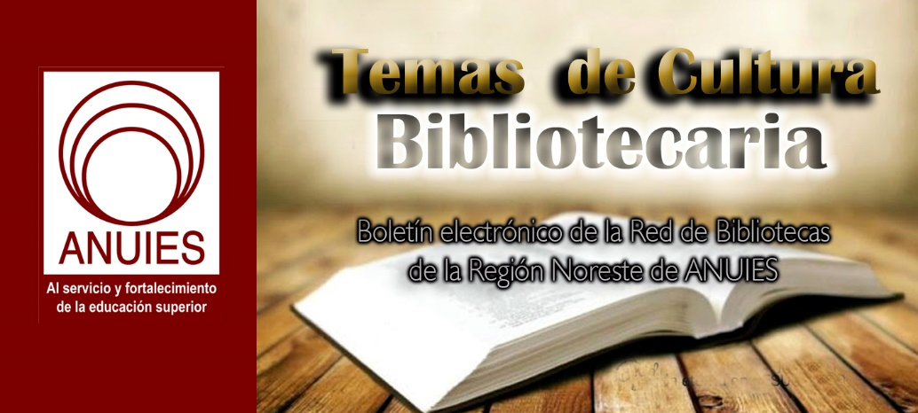

Contenidos de este número
- Announcing a New Project on Teaching with Primary Sources
Danielle Cooper, Rebecca Springer
We are excited to announce a new research project designed to support effective teaching with primary sources. Teaching undergraduates with primary sources promotes student engagement and critical thinking skills and is a key ingredient in the current pedagogical push toward “inquiry-based” or “research-led” learning.* Although leveraging physical collections remains important, technological affordances have additionally transformed possibilities for teaching with primary sources: not only by increasing content availability, but by enabling digital discovery, curation, and annotation. The proliferation of born-digital content has also expanded the definition of what primary sources are and how they can be used as evidence.
For the Primary Sources project, we will be partnering with a group academic libraries who are leading the charge to foster this important pedagogical approach. These libraries will work alongside Ithaka S+R to conduct a deep dive into their faculty’s needs and experiences when teaching with primary sources, and identify opportunities for ways that libraries, archives and special collections, and other stakeholders can support this work.
Academic Libraries and Archives: Essential to Primary Source Pedagogical Support
Academic libraries and archives are ideally placed to support faculty teaching with primary sources by drawing on expertise across the organization – from special collections, to subject liaisons, to instruction – and by employing a variety of support models, including resource provision, consultation, and embedded librarianship. Ithaka S+R’s primary sources project builds on a host of existing initiatives, such as the Digital Library Federation’s pedagogy subgroup on Digital Primary Sources, the Association of College and Research Libraries (ACRL)/Rare Books & Manuscripts Section (RBMS) and Society of American Archivists (SAA) Joint Task Force on the Development of Guidelines for Primary Source Literacy, the Association of Research Libraries (ARL) Research Library Impact Framework, and the recent symposium on Teaching Undergraduates with Archiveshosted by the University of Michigan Bentley Historical Library. Our project will contribute to this growing community knowledge by centering faculty needs and facilitating cross-institutional collaboration to develop a vision for innovation across the support service landscape.
How will the Ithaka S+R Primary Sources project work?
The Teaching with Primary Sources project builds on the success of the Research Support Services projects across a range of subjects including public health and Asian studies, as well as our Teaching Support Services project in business. But whereas our previous projects have highlighted similarities and differences in faculty practices by discipline, this project will explore a common theme in effective teaching across a variety of fields.
This project will follow our unique collaborative model for the qualitative study of faculty support services. We are gathering a cohort of academic libraries from the US and UK to field research teams. Following a two-day training workshop, research teams will conduct interviews of instructors at their institutions, analyze their findings, and produce reports to recommend local support strategies. Additionally, Ithaka S+R will review these interviews and findings to develop a public capstone report. We will also facilitate dialogue toward cross-institutional collaborations among participating institutions.
Interested in getting involved?
We are thrilled that Brandeis University, Brigham Young University, Brown University, California State University Northridge, Dartmouth College, Indiana University Bloomington, Johns Hopkins University, Lafayette College, Northern Michigan University, Pennsylvania State University, Princeton University, Texas A&M University, the University of Miami, the University of Virginia, Washington and Lee University, Williams College, and Yale University will be among the participating institutions for this project.
We are seeking additional partner institutions for the Teaching with Primary Sources project and welcome expressions of interest. Looking ahead, we are also planning to launch studies of teaching support services in data literacy, and research support services in psychology and computer and electrical engineering. If you are interested in having your library participate as a research site for the primary sources project or future projects, please email me at rebecca.springer@ithaka.org.

*For an overview of the relevant literature see Magia G. Krause, “‘It Makes History Alive for Them’: The Role of Archivists and Special Collections Librarians in Instructing Undergraduates,” The Journal of Academic Librarianship 36, no. 5 (2010): 401-11, at 401-2.

https://sr.ithaka.org/blog/announcing-a-new-project-on-teaching-with-primary-sources/

- The Center for Open Science and EcoEvoRxiv Launch Branded Preprint Service

Jan. 15, 2019

Charlottesville, VA
EcoEvoRxiv (EcoEvo“archive”) is a not-for-profit research repository for works related to ecology, evolution and conservation. The EcoEvoRxiv server can be used for freely and legally sharing preprints (manuscripts before submissions to journals), postprints, reports, and datasets.
“I am very excited about launching EcoEvoRxiv (www.ecoevorxiv.org), where ecologists and evolutionary biologists can upload their preprints,” said Shinichi Nakagawa from UNSW in Sydney, Australia, who is leading the effort. “It’s extremely powerful that a preprint at EcoEvoRxiv can seamlessly integrate with a project on the Open Science Framework (OSF). We hope EcoEvoRxiv will encourage more ecologists and evolutionary biologists to put preprints online.”
EcoEvoRxiv is the twenty-third community preprint service built on COS’s flagship platform, OSF, which helps researchers design and manage their project workflow, store their data, generate DOIs, and collaborate with colleagues. COS has leveraged the platform to help research communities in many disciplines discover new research as it happens and to receive quick feedback on their own research prior to publication. COS’s preprints platform provides an easy, robust, and stable solution for organizations that want to launch their own preprints service. COS is currently supporting branded services in marine and earth sciences, psychology, social sciences, engineering, agriculture, imaging, paleontology, sports research, contemplative research, law, library and information science, nutrition, as well as national, multidisciplinary services in Indonesia, France, the Arab nations, and Africa.
Over 2.2 million preprints have been already indexed from a variety of sources and can be accessed by selecting a subject of interest, entering specific search terms, or browsing the preprints most recently added to the service. OSF Preprints uses SHARE to aggregate search results from a variety of other preprint providers like arXiv, bioRXiv, PeerJ, CogPrints and others into its archive. Preprint contributors are also encouraged to include links to their supporting materials, if available.

About Center for Open Science
The Center for Open Science (COS) is a non-profit technology and culture change organization founded in 2013 with a mission to increase openness, integrity, and reproducibility of scientific research. COS pursues this mission by building communities around open science practices, supporting metascience research, and developing and maintaining free, open source software tools. The OSF is a web application that provides a solution for the challenges facing researchers who want to pursue open science practices, including: a streamlined ability to manage their work; collaborate with others; discover and be discovered; preregister their studies; and make their code, materials, and data openly accessible. Learn more at cos.io and osf.io.
Contact for EcoEvoRxiv
All inquiries: Shinichi Nakagawa - UNSW Sydney, Australia
Web: www.ecoevorxiv.com.
Contacts for the Center for Open Science
Media: Rusty Speidel: rusty@cos.io | 434-284-3403
Starting a Branded Preprint Service: Rusty Speidel: rusty@cos.io | 434-284-3403
Web: https://cos.io/preprints
Twitter: @osframework
https://cos.io/about/news/center-open-science-and-ecoevorxiv-launch-branded-preprint-service/

- Sloan Foundation Awards DPLA (Digital Public Library of America) a $1.5 Million, Three-Year Grant
Filed by Gary Price
From a DPLA Announcement (Full Text):
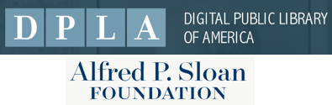The Digital Public Library of America (DPLA) is pleased to announce that the Alfred P. Sloan Foundation has awarded DPLA a $1.5 million grant. The grant will enable DPLA to expand its efforts to provide an improved ebook experience for patrons through their libraries, building on its cultural heritage aggregation program.
Over the course of this three-year grant, DPLA will expand the DPLA Exchange, an open platform and marketplace, from pilot phase to production. DPLA will continue to work with its core partners The New York Public Library and LYRASIS to further the adoption of SimplyE, with the goal of offering libraries a full-service pathway to acquire and deliver e-content through a library-driven marketplace and platforms.
Building on Our Foundation
From its inception, DPLA has been driven by the belief that, as the world’s knowledge becomes increasingly digital, it is imperative that libraries play a role in ensuring that future platforms, and the policies that will guide their use, incorporate and reflect library values. The Sloan Foundation has supported that mission since DPLA’s founding. Our hallmark initiative continues to be the creation of a national network of libraries, archives, and museums, now encompassing over 3,000 institutions in thirty-seven states. Through this network, DPLA makes over 33 million items freely discoverable for all through a one-stop research experience, transforming the landscape of cultural heritage access and discovery.
DPLA applies the same guiding principles and core belief in the civic value of libraries and free, open access to information to its work in the ebooks space. Open Bookshelfmakes thousands of public domain and openly-licensed ebooks freely available to download, read, and keep. The DPLA Exchange was developed to offer libraries a non-profit marketplace to purchase and share e-content at better prices, and on better terms, than previously available.
DPLA built these products and services with support from the Sloan Foundation and will now be able to expand them to reach more institutions, and benefit more readers. Together with cultural heritage aggregation, DPLA’s efforts to improve e-content delivery and spark innovation in the ebooks landscape help DPLA deliver on its mission, and benefit all.
Collaboration is Key
Active, strategic, participatory collaboration is at the core of all of DPLA’s work. Just as DPLA’s cultural heritage aggregation initiatives are powered by a network of partners, DPLA’s ebooks initiatives are shaped and supported by partner libraries and organizations, including The New York Public Library (NYPL) and LYRASIS. The SimplyE app, developed by our partners at NYPL, is an essential element of the DPLA Exchange marketplace and content delivery system. LYRASIS, Califa, and Amigos Library Services provide hosting services that help libraries get up and running quickly and get the technical support they need to be able to deliver content to patrons smoothly. DPLA Exchange pilot libraries Alameda County Library (CA); Carnegie Library of Pittsburgh (PA); Connecticut State Library (CT); Califa Library Group (CA, KS); St. Mary’s County Library (MD) and Yavapai Library Network (AZ) have tested, used, and provided valuable feedback on these services to ensure they are ready for broader adoption and implementation at libraries of all types and sizes.

http://www.infodocket.com/2019/01/15/sloan-foundation-awards-dpla-digital-public-library-of-america-a-1-5-million-three-year-grant/

- Open, Public, Electronic and Necessary (OPEN) Government Data Act Signed Into Law
Filed by Gary Price
From SPARC:
Tonight [Jan. 14, 2019], President Trump signed into law the Open, Public, Electronic and Necessary (OPEN) Government Data Act. The bill requires federal agencies to publish government data in machine-readable and open formats, and to use open licenses.
SPARC, which has worked for more than a decade to broaden public access to research, called it a “truly watershed moment for Open Data in the United States.”
“This bill is a huge win for innovation, transparency and openness – and most of all, for taxpayers who fund the data in the first place,” said Heather Joseph, Executive Director of SPARC, the Scholarly Publishing and Academic Resources Coalition.
“It will make information generated by the federal government more accessible and transparent to researchers, entrepreneurs, and others who can use it – and in doing so, will generate new services and products, build businesses and create jobs. It’s exactly what we should be doing in a 21st century economy.”
The OPEN Government Data Act, which is included as Title II of the broader Foundations for Evidence-Based Policymaking Act:
- Makes permanent the federal government’s commitment to open data and codifies a policy of open by default for all government data, including federally-funded research data, while respecting privacy and national security concerns;
- Calls for government data assets made available by an agency to be machine-readable and under open licenses;
- Provides crucial definitions of key terminology, including a strong definition of open license requirements, which will help to standardize implementation of open data practices across U.S. agencies;
- Directs agencies to support innovative uses of government data, adopt consistent data practices across government, and develop best practices for open data; and
- Codifies key aspects of President Obama’s 2013 Executive Order on Open Data into permanent statute.

http://www.infodocket.com/2019/01/15/open-public-electronic-and-necessary-open-government-data-act-signed-into-law/

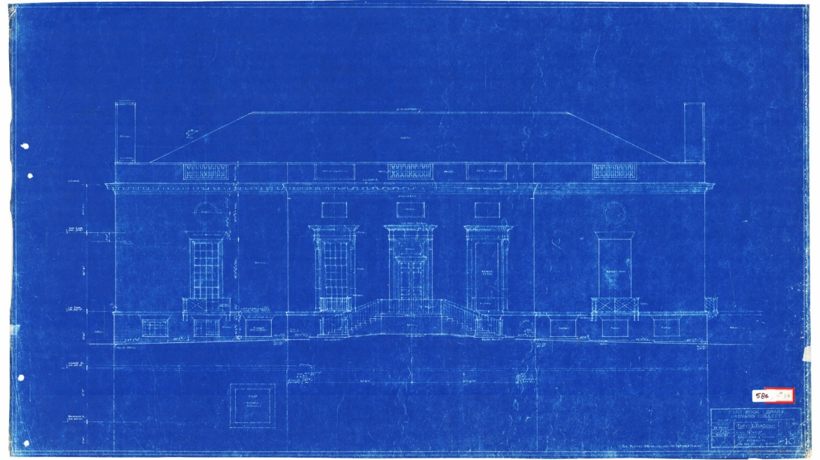
- A new vision for Houghton Library
Houghton Library's original blueprint from 1940 by Perry, Shaw and Hepburn, Architects.
Images courtesy of Houghton Library
Planned renovation will improve research and exhibition facilities
BY Kaitlin BuckleyHarvard Library Communications

An upcoming renovation to Houghton Library will modernize its research and teaching facilities, expand its exhibition galleries, improve physical access to its spaces and holdings, and create a more welcoming, inviting, and accessible environment.
The renovation represents a key component of a larger vision for the rare books library, which celebrated its 75th anniversary last year. It serves as a research center and teaching laboratory for students and faculty across many disciplines that use primary sources, hosting nearly 300 class visits each year and programming a series of exhibitions and events that draw a range of visitors from across Harvard and surrounding communities. To expand its reach vastly, the library’s digitization efforts have placed its collections within reach of researchers around the world.
“We want all of Houghton Library — the collections, the building, and our expert staff — to generate interest in and passion for the humanities, the arts, the social sciences, and more,” said Thomas Hyry, Florence Fearrington Librarian of Houghton Library. “Our efforts to create a more inclusive atmosphere and to increase access to Houghton’s collections and services will ensure the library becomes an even more active and highly valued resource for Harvard and the world at large.”
The renovations were made possible through generous donations, including a major gift from philanthropist and bibliophile Peter J. Solomon ’60, M.B.A. ’63, and his wife, Susan, whose extensive collection of rare and treasured children’s literature and illustrations provided the catalyst for the renovation. The Solomon collection includes a copy of the suppressed first edition of “Alice in Wonderland,” as well as additional works by Lewis Carroll, Beatrix Potter, Edward Lear, and other authors. The Solomons’ promised donation sparked an effort to make Houghton more welcoming to the Harvard community and visitors alike.
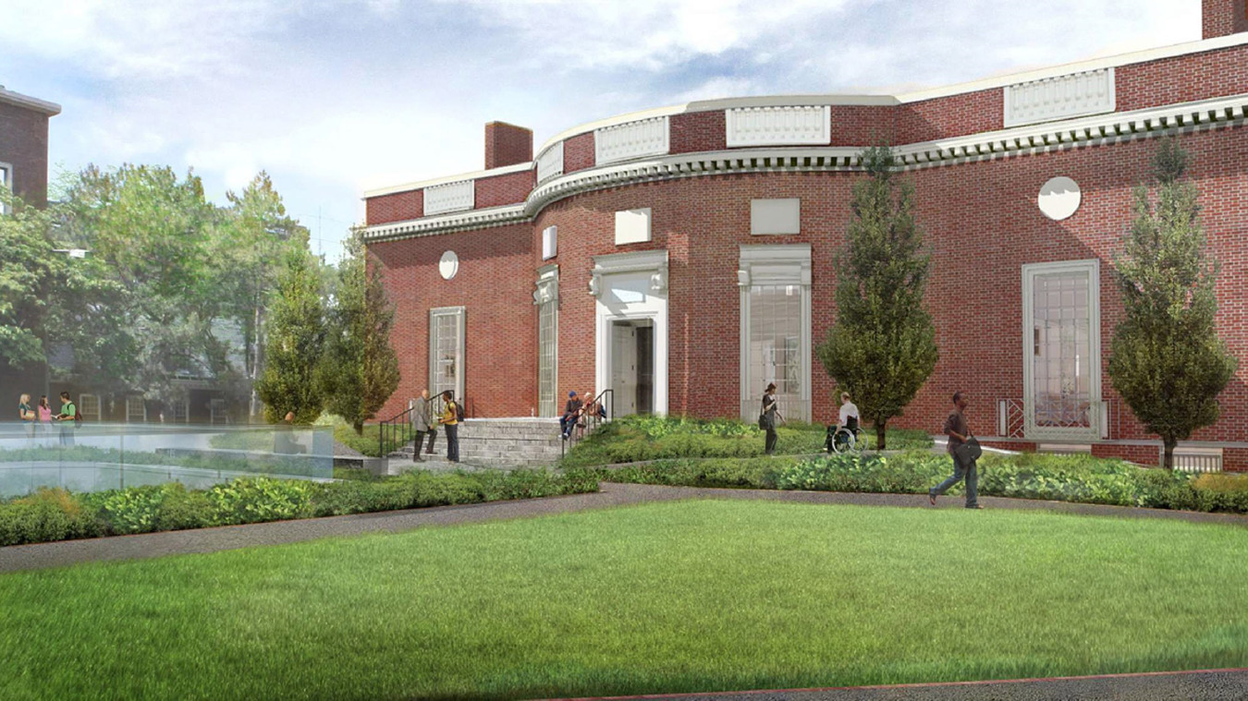
Plans include a fully accessible entrance with ramped walkways and new trees and plantings.
Renderings courtesy of Ann Beha Architects
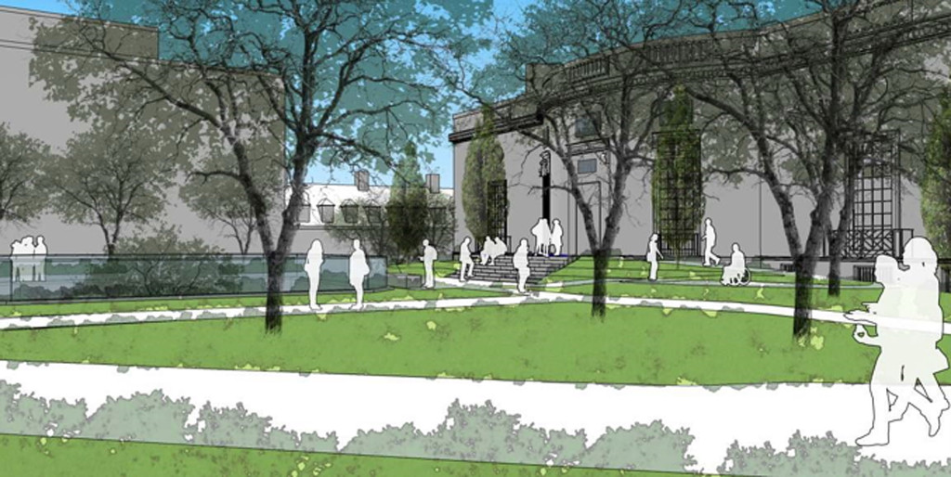
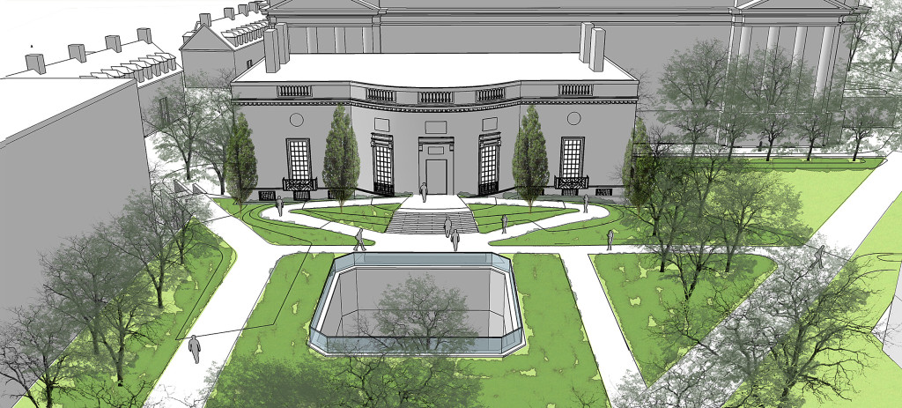
“Peter’s gift is a testament to his profound love of books, his belief in the power of literature to change lives, and the essential role of the library in the life of the University and in society at large,” said Sarah E. Thomas, vice president for the Harvard Library and University librarian and Roy E. Larsen Librarian for the Faculty of Arts and Sciences. “There are so many people his generous support will affect: students, faculty, researchers, and visitors from around the world, and of course the staff who support the critical work of the library. I know our gratitude is deep.”
“We wanted our collection to be where it would join similar holdings and be enjoyed by the widest possible audience,” Solomon said. “Houghton houses extraordinary material and enjoys a prime location within the Yard, but more Harvard students should explore its treasures.
“Redesigning the entrance, integrating the building more prominently into its surroundings, and creating a more dynamic set of interior spaces will encourage greater appreciation of the library,” he added.
Construction will begin next September, and the building will be closed until September 2020. During renovations, the Houghton Reading Room will return to its original location, the Periodicals Reading Room in Widener Library. Classrooms in Widener Library, Pusey Library, and Lamont Library will accommodate courses that use Houghton collections for teaching.
Houghton is working with Ann Beha Architects and partnering with the Faculty of Arts and Sciences’ Office of Physical Resources and Planning on the two-year project. The renovation will include redesigning the landscape between Quincy Street and the library entrance; replacing the daunting main entrance staircases with elegant paths at a wheelchair-accessible gradual incline; and connecting a plaza to the entrance, creating more space for people to gather outside. Natural light will be introduced to the entrance lobby, which will feature a dynamic exhibition gallery displaying materials drawn from the library’s collections. A new elevator will take visitors to the teaching spaces, exhibition gallery, and special thematic rooms on the second floor. Ground-floor restrooms will be remodeled and expanded. Improvements to Houghton’s reading room will include a soundproof entry and help-desk area, and an adjacent room where library users can work with materials in collaboration with library staff.
The plans have the enthusiastic support of the University, the Faculty of Arts and Sciences, and the Harvard Library.
“Today’s libraries are much more deeply engaged in teaching and outreach, and in an era where digital information is so prevalent, connecting people with our special collections and original materials which resonate with the context of their time and form is a key goal of Harvard Library,” said Thomas. “As a member of the Harvard College Library and Harvard Library, Houghton plays an important role in opening up the magic of collections and libraries to all visitors, as well as supporting research and teaching.”

https://news.harvard.edu/gazette/story/2019/01/a-new-vision-for-harvards-houghton-library/?utm_medium=Feed&utm_source=Syndication

- Keach Library Hosts Online Privacy Exhibit
by Matt Enis
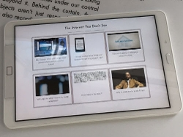
From January 2 through 18, the Nueces County Keach Family Library (KFL) in Robstown, TX, is hosting the Glass Room Experience, a special exhibition designed to spark discussion about personal data and online privacy. The portable exhibit was created by the Tactical Technology Collective (TTC), a Berlin-based non-profit organization focused on issues at “the intersection of technology, human rights, and civil liberties,” with funding provided by Mozilla.
Many people have come to rely on applications and tools that are free on the Internet, said Crystal Drillen, assistant county librarian for the Nueces County Public Libraries. The Glass Room Experience “showcases how the price we pay is our privacy. The exhibition helps people become more informed about the choices [they make] in their online life.”
Exhibits include tablets preloaded with apps including “The Internet You Don’t See,” which takes users “behind the screen to find out how social media, smart devices, and large tech companies collect and use your data,” and a “Fake or Real” game, which tests a user’s knowledge of current smart devices. A print-based “Alphabet Empire” connect-the-dots game illustrates the vast online reach of Alphabet, the parent company of Google. Visitors can even check out a model of Facebook founder Mark Zuckerberg’s house. (In 2010, Zuckerberg famously said that people don’t really expect privacy anymore. In 2012, he bought four houses surrounding his Palo Alto home and tore them down to protect his own privacy.)
Those interested in getting back in control of their personal data can check out the exhibition’s “Data Detox Kit,” a guide that explains, in straightforward language, how people share information about themselves as they surf the web, use social media platforms, install and use smartphone apps, and more. The kit’s “8-Day Detox” program—a series of eight step-by-step exercises each designed to take half an hour or less—walks users through topics such as clearing their personal history on Google’s many platforms; reviewing and restricting publicly available data on social media accounts; understanding and setting permissions to make smartphones leak less data; and using password managers, secure messaging apps, ad blockers, and other related software.
“It’s really exciting that [KFL] is leading the way with this” exhibit in U.S. libraries, said Cindy Fisher, digital inclusion consultant, Library Development and Networking Division, Texas State Library and Archives Commission (TSL). “There is such an opportunity to add this as an additional piece [complementing] technology literacy and proficiency skills in an interactive, fun way.”
Artistic Origin
The Glass Room: Looking Into Your Online Life was an art exhibit originally held in temporary pop-up retail locations in Berlin and New York City in 2016, and then London in 2017 and Warsaw in 2018. Also funded by Mozilla and curated by TTC, these free-to-visit “tech stores with a twist” featured exhibits that, in part, provided visual context to data and privacy issues. For example, visitors were invited to search through an eight-volume set of books listing millions of compromised LinkedIn passwords in alphabetical order, presenting a tangible example of the scope of a data breach. In another exhibit, a set of sensors gathered basic data about the smartphones carried by pedestrians walking by outside and displayed the information on a monitor.
Last summer, TTC and Mozilla announced the Glass Room Experience, a portable version of the exhibit designed to be “set up by anyone with enough space and a willingness to teach others about online privacy,” according to TTC.
Fisher had been following the Glass Room project for a few years, first learning about the exhibit through social media when it was in New York in 2016. When she heard that TTC was taking applications for the new portable version, she applied in an effort to assess the process for the libraries served by TSL. Ultimately, TSL’s application was accepted, and Fisher thought of KFL as a good candidate to host the exhibit.
KFL was at “the top of my list because, for the past three years, they have received grants from the state library to do really cool technology projects…. The librarians there are so forward thinking, and so passionate about serving their community,” Fisher said, adding that Nueces County Public Libraries Director Ida Gonzalez-Garza was immediately on board.
“Privacy is so difficult to talk about,” Fisher said. “Some people sort of snooze; their eyes glaze over and they think ‘I know I should be doing more, but it’s so hard.' ” A hands-on, interactive exhibit, she said, “seems like a great way of getting over that hump.”
While KFL does not currently offer its patrons a course specifically focused on Internet privacy, Drillen said that the topic is regularly a component of KFL’s computer courses, and staff are prepared to help patrons with any questions raised during the exhibit or afterward.
Libraries and other institutions that successfully apply for a Glass Room Experience are asked to provide three tablets to enable visitors to explore the exhibit’s apps and two large televisions or monitors to display videos and animations (although the TVs are not essential). The exhibit requires about 200 square feet of space, and takes about two hours for two staff members to set up. TTC provides a set of posters; a USB stick with the official videos, animations, and a PDF of the Data Detox Kits; assorted equipment such as sticker strips, a magnifying glass, and a dome; and instructions for setting up the exhibit and training staff to host it and help visitors.

https://www.libraryjournal.com/?detailStory=190114_glassroomexperience

- UBC Library Partners with French Department on Revolution Pamphlet Collection
by Lisa Peet
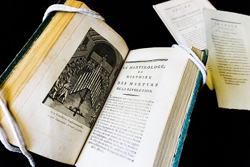
Le martirologe: ou L’histoire des martyrs de la Révolution by Jean-Gabriel Peltier (1760–1825)
Photo credit: UBC Library Communications
At the University of British Columbia (UBC), Vancouver, a partnership between the Department of French, Hispanic, and Italian Studies (FHIS) and the library will provide new levels of access to a growing collection of original pamphlets from the French Revolution.
UBC Rare Books and Special Collections (RBSC) Librarian Chelsea Shriver has been working closely with FHIS associate professor Joël Castonguay-Bélanger to expand the original collection of pamphlets acquired by the library more than 40 years ago. With funds from a former professor’s bequest, RBSC is purchasing more to form a significant corpus.
An upcoming digitization initiative will make the documents available to students, researchers, and the community as a whole, and a January 2019 research seminar will give students the opportunity to work directly with the pamphlets. A small exhibit, mounted around the same time, will allow the UBC and local Vancouver community to see items from the collection in historical context. Castonguay-Bélanger is also hoping to launch a parallel virtual exhibit, with research conducted by students. Historians will be invited to lecture on the subject as well.

BUILDING UBC’S COLLECTION
The first set of 111 pamphlets was purchased in the early 1970s from Hague-based Martinus Nijhoff Antiquarian Book Dealers. These documents, printed and circulated during the period of upheaval from 1789 to 1799, run the gamut from political material to entertainment.
The collection had been entered in the UBC library catalog since its acquisition, but items weren’t listed individually. A couple of years ago, Shriver told LJ, RBSC began thinking about how to make the underutilized collection more visible. She had worked with Castonguay-Bélanger on an earlier exhibition on the history of the book, and reached out to him about the possibility of digitizing and cataloging the material. Castonguay-Bélanger, however, had a larger vision.
There were many aspects of the project that interested him, said Castonguay-Bélanger, including giving visibility to an unknown collection and bringing it in line with French Revolution–era material held at institutions such as Chicago’s Newberry Library, the University of Florida, and Stanford University. “Our collection can contribute to a much bigger conversation that is going on in North America and in the world,” he said. "But why not take it a bit further and actually continue to acquire more material?"
The Dorothy Dallas Centre for Seventeenth and Eighteenth-century French Studies (endowed by former professor Dallas, who taught 17th-century French literature at UBC from 1933 to 1967) has funded speakers, conferences, a graduate fellowship, and research assistantships. Castonguay-Bélanger proposed a five-year partnership: FHIS would use some of the Dallas Centre resources toward the acquisition of more material and digitization of the corpus, and RBSC would provide matching funds. Both sides quickly agreed.

HANDS-ON HISTORY
As Shriver and Castonguay-Bélanger have moved forward with the project, its scope has grown to include an undergraduate seminar and a small exhibit.
The course, which Castonguay-Bélanger will teach in French in January 2019, will serve as an introduction to the French Revolution for many of the students, he noted—a vivid way to understand the decade of violent events. The material, Castonguay-Bélanger told LJ, will help bring that history to life.
“It's always the same challenge,” he said, “how to tell the story and understand an event that lasted so long, that doesn't have a very linear narrative.” It’s difficult to teach the French Revolution from one angle, he added, and working with the original material will offer insight beyond traditional reading.
“We're talking about a collection that is extremely varied in nature,” Castonguay-Bélanger explained. “We have small pamphlets of four pages, others that go up to 60 pages. We have political and very violent-toned pamphlets, we have writings from [Maximilien] Robespierre, [Jean-Paul] Marat, [Honoré Gabriel Riqueti, comte de] Mirabeau—very well-known political actors of the time.”
Notable items include a pamphlet titled La semaine memorable (The Week To Remember), written in July 1989 shortly after citizens stormed the Bastille, and Constitution de la République Française: proposée au peuple français par la Convention nationale (Constitution of the French Republic: Proposed to the French People by the National Convention), a 1795 document advancing the ideas of liberty, equality, safety, and ownership for all people regardless of their class or origin.
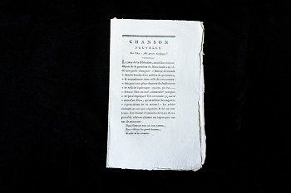
Chanson nouvelle: sur l’air: Ahi povero Calpiggy!published by Lefranc (1790)
Photo credit: UBC Library Communications
In addition to political writing, students will encounter more lighthearted fare, such as popular poems, songs, and plays, as well as satire including the Le Père Duchesne and La Mère Duchesne series, profanity-filled political commentary designed to provoke readers into action. “By encountering those prints they will get an understanding that during even the most bloody episodes of the French Revolution there were still plays being presented in the theaters,” said Castonguay-Bélanger. “The Parisians were trying to live their lives as it was happening.”
Students will not only learn about the collection’s contents but also be able to handle the documents. Such interaction with materials is not unusual, noted Shriver. Although RBSC, housed at the Irving K. Barber Learning Centre, is a closed-stack facility, UBC believes in hands-on access to much of its holdings.
“We are a research library, we're a public institution, and for us having our materials used in teaching and learning is really primary,” she told LJ. “We have undergraduate and graduate students come and handle materials from our 13th-century Bible to our modern archives…for a variety of classes and independent projects. That is something that we really put a lot of emphasis on, because these collections are for the students to use to aid in their learning, just as much as the circulating collections in our main humanities and social sciences library and our science and medicine library."

GROWING THE COLLECTION
Along with these planned events, Castonguay-Bélanger is helping acquire more material for the collection. In less than a year and a half, the partners have doubled the size of RBSC’s French Revolution holdings. “That's the fun part,” he noted. “I'm involved in selecting the material.”
"We rely on faculty to help us decide what is going to have the most impact in terms of teaching and research, what's going to be used immediately, what's most useful for courses for research,” explained Shriver. “This type of collaborative acquisition is a model of what we would do ideally for all kinds of subject areas.” Strong support from both the library and FHIS, she added, has given them a fair amount of autonomy when it comes to decisions about the collection.
While Shriver and Castonguay-Bélanger are advocates of hands-on learning, digitizing the collection will be a major component of the project. The time frame for that phase of the work has yet to be determined; as the collection grows, it will need to be evaluated for conservation prior to scanning, and RBSC will need to schedule the work with UBC’s Digital Initiatives Department. Additional funding may need to be identified, depending on the conservation assessment.
In the meantime, a graduate student is cataloging the collection, with close attention to details such as marginalia—one of the highlights of working with primary source materials like these pamphlets, noted Shriver, although she imagined that not all students felt the same.
“As a special collections librarian I'm always excited to see annotations and marginalia,” she told LJ. “And then when undergraduate students come in here, they look with horror on someone who's written in this 'old thing' because it's been beaten into them at some point that they're not supposed to be writing in their books— often, I suppose, by librarians. So when they come here and I get super excited and try to get them excited about the marginalia, I think they have to realign their thinking a little bit.”
The collection as a whole, both agreed, will help bring the period of the French Revolution, in all its complexity, alive for UBC students and scholars around the world. “I hope going back to the 1789 moment will give them a different experience,” said Castonguay-Bélanger, “and invite them to ask themselves different questions of what it means to talk about the past, what it means to talk about history, how it feels to actually touch an object that is straight from the past."

