Año 4 Número 102 febrero 2019

Contenidos de este número

- Ebooks seem like ‘Netflix for libraries,’ but they’re a drain on budgets
by Bob Fernandez,
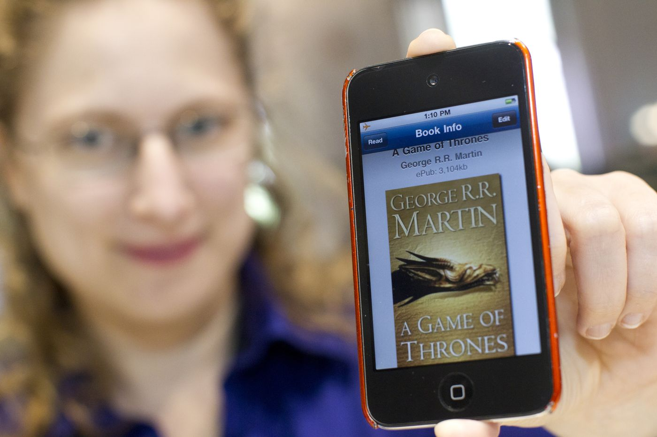
RYAN S. BRANDENBERG / FREE LIBRARY
The book-crammed Free Library of Philadelphia has found a way to stay relevant in the 21st century: ebooks. Last year, 28 percent of the Free Library’s total circulation of more than five million books came from ebooks and other digital content.
But it hasn’t been nirvana for the library and its taxpayer-funded peers.
RELATED STORIES

- What were the most popular ebook downloads at the Free Library of Philadelphia in 2018?
- Philadelphia announces hiring of new library staff, expanded branch hours
- A Philly miracle: Amid closures, this elementary school is reopening its library
As popularity soars, publishers and content providers have adopted “metered access” and per-checkout models for ebooks and other content. Those models are guzzling library cash and resulting in book-lending inefficiencies, library officials warn. A so-called perpetual ebook license for libraries could be four or five times the cost of either the printed book or the digital copies sold to consumers.
And these are only some of the latest clashes over digital licensing as publishers seek to squeeze more profits out of their content as the world moves away from ink and paper.
ADVERTISEMENT
“Digital content is a huge challenge for libraries," said Michael Blackwell, the director of the St. Mary’s County Library in Maryland and project director for ReadersFirst. It’s a loose federation of “nearly 300 libraries" (including the Free Library) dedicated to ensuring readers have access to "free and easy-to-use ebook content.”
“We are trying to be reasonable, but we think the large publishers are not pricing ebooks fairly,” Blackwell said. “I don’t think [publishers] want to look bad to the public, but they also don’t want to explain a lot to us."
With metered access, publishers tie the digital license for an ebook to a time period such as a year or two, or a specific number of checkouts. Once either of those numbers is met, the library must purchase the ebook title again or it vanishes from the digital stacks like a Harry Potter magic trick.
‘Perpetual license’
Publishers also sell ebooks on licensing deals that aren’t metered but priced significantly higher than print editions. This is called a perpetual license. Librarians refer to them as “pretend it’s print.”
Verses for the Dead by Douglas Preston and Lincoln Child, a current top New York Times bestseller, was selling on Wednesday on Amazon for $16.80 for the hardcover book. But the Free Library said the book’s perpetual license was $84. Amazon listed the hardback for Circe, also a New York Times bestseller, at $16.20; its perpetual ebook license was $81.
ADVERTISEMENT
Two big publishers, Penguin Random House and Simon & Schuster, did not respond to emails on the topic. A spokesperson for the Association of American Publishers declined to comment. The association’s most recent data show that ebook revenues declined 2.8 percent through the first 11 months of 2018. Over the same period last year, hardback sales rose 6.5 percent to $2.9 billion. Paperback and mass-market sales rose 2 percent to $2.5 billion.
Librarians say they understand that publishers would like to maximize the revenue from hot titles. But library patrons also would like to read books, magazines, and other content on digital formats. Librarians believe that book lending can boost author exposure, thus helping publishers in the long run.
“Some publishers believe that engaging with libraries lose money for them,” Alan Inouye, senior director of public policy and government relations at the American Library Association, said Wednesday. But “libraries do a lot of marketing for authors,” he added.
And with libraries concerned that relations with publishers are heading in the wrong direction, publishers, library organizations, and other stakeholders launched the Panorama Project last May to gather data from library services such as Overdrive to determine whether libraries hurt or help publishers.
At the Free Library in 2018, the five most popular ebooks were The Woman in the Window(1,482 ebooks circulated), Fire and Fury: Inside the Trump White House (1,448), The Midnight Line: Jack Reacher Series (1,415), The Handmaid’s Tale (1,406), and Come Sundown(1,311).
Metering access
Jennifer Maguire-Wright, the chief of the materials management division at the Free Library, tracks checkouts and holds to help her determine the number of copies of a book to purchase. She said that the metered access ebook copies of The Woman in the Window cost $26.99 with 26 checkouts, or $1.04 per checkout.
After 26 checkouts, the ebook license expires and the library had to purchase another one.
ADVERTISEMENT
A printed copy of The Woman in the Window, meanwhile, cost $16.40 on Amazon on Wednesday. The Free Library negotiates a slight discount to the market price but declined to disclose the discount. An average circulation for a printed book is about 100 checkouts, though that can vary with time and usage. At the maximum number of about 100 checkouts, the book circulates for about 16 cents per checkout.
Maguire-Wright and other library officials acknowledge that publishers had consumer data for pricing that libraries did not. But they also believe that the availability of ebooks for library patrons improved over the years.
“We still need to budget for things that don’t circulate and we just have here for reference material,” Maguire-Wright said, noting that she did not see a day when ebook and digital costs would be a higher percentage of the Free Library’s budget than its share of total circulation (28 percent). The Free Library system, which has 54 branches across the region and more than 640,000 cardholders, had a 2017 materials budget of $4.5 million.
Laverne Mann, director of the Cherry Hill Public Library, said there are many benefits to ebooks and digital content.
ADVERTISEMENT
Any ebook can be transformed into a large-print book on a screen, a big plus for older readers. Content can be downloaded 24/7. And community reading lists can be made easily available to everyone without visiting the library. Thousands of additional titles — magazines, books, and even foreign-language books — are available through digital platforms, she said.
Recently the library reached a deal to make 20,000 digital copies of the New York Times available to Cherry Hill Public Library patrons for 72 hours through a special access code, marking another example of a publisher experimenting with a new economic model. After 72 hours, readers would need a new code.
In 2018, the Cherry Hill Public Library spent $46,000 on digital content out of a total materials budget of $175,000, Mann said. Digital usage rose 5.7 percent in 2018 over 2017 and accounted for about 14 percent of all circulation last year, she added. She expects total digital usage to climb about 2 percentage points a year.
Cherry Hill also makes the Hoopla Digital service available for ebooks, audio books, TV shows, movies, comics, and music at a per-checkout charge that can range from 70 cents to about $4. Tierney Miller, the reference and adult services supervisor at the Cherry Hill Public Library, described Hoopla as “Netflix for libraries” because there are unlimited copies simultaneously available to borrowers.
So that it doesn’t bust the library’s budget, Cherry Hill restricts members to five checkouts a month, with a maximum charge of $3.99.
“It’s a cash guzzler, but we love it,” Miller said. Hoopla is so popular, in fact, that the library caps its daily usage at $100. After hitting the cap, the service shuts off for the day.

Posted: January 17, 2019 - 5:19 AM
Bob Fernandez

http://www.philly.com/news/ebooks-free-library-philadelphia-costs-budget-20190117.html

- MIT’s Grand Challenges Issues Final Report
by Lisa Peet
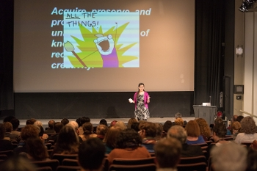
Library of Congress chief of National Digital Initiatives Kate Zwaard gives keynote speech at Grand Challenges Summit
Photo by Bryce Vickmark
In March 2018, the Massachusetts Institute of Technology (MIT) Libraries hosted a working summit on Grand Challenges in Information Science and Scholarly Communication, inviting experts from around the world “to identify critical problems in information science that are solvable within ten years and which have broad implications across the scholarly community.” The Grand Challenges Summit consisted of three consecutive workshops examining scholarly discovery, digital curation and preservation, and open scholarship.
After an open review period, in which summit attendees’ notes were condensed and refined into a public draft and community members were encouraged to comment and provide feedback, the results were distilled into a final white paper, A Grand Challenges-Based Research Agenda for Scholarly Communication and Information Science. The report was released on PubPub, the open platform developed by MIT’s Knowledge Futures Group, on December 18.
The white paper’s preface states, “this report describes a vision for a more inclusive, open, equitable, and sustainable future for scholarship; characterizes the central technical, organizational, and institutional barriers to this future; describes the areas research needs to advance this future; and identifies several targeted ‘grand challenge’ research problems for knowledge generation.” It is less a recap of the summit than an outline of potential areas for change and the possible paths that can put those changes into action within the next decade.
VISION FOR LIBRARIES
The concept of the summit originated with MIT’s Future of Libraries Task Force report, released in October 2016. The 30-person task force, organized by MIT director of libraries Chris Bourg, had gathered input over the previous year on how MIT Libraries should evolve to advance its vision for libraries as open global platforms for knowledge, and itself serve as a leader in the reinvention of the academic research library. Of the recommendations at the report’s conclusion, the final one stated, “The Libraries must become a center for research and development, fueling bold experimentation and new answers to the grand challenges facing research libraries and scholarly communication.”
In other words, Bourg told LJ, “The task force realized that in trying to design a future library and a future for scholarly communications, there are lots of unanswered questions—there's research needed to make smart decisions about which way to go.” And that process would need to start with an event that brought in voices from outside MIT, from a diverse range of perspectives and expertise. (Bourg had been advocating for such an inquiry as far back as her initial job talk at MIT almost five years ago, she added.)
With funding from an Andrew W. Mellon Foundation grant, MIT Libraries convened the Grand Challenges Summit in March 2018 to examine those challenges inherent in the scholarly communications and information science landscape.
The summit was led by coprincipal investigators Bourg and Micah Altman, director of research at MIT Libraries and head/scientist, MIT Program on Information Science, and advised by program committee members Christine Borgman (distinguished professor and Presidential Chair in Information Studies at UCLA), G. Sayeed Choudhury (associate dean for research data management and Hodson Director of the Digital Research and Curation Center, Johns Hopkins University), Charles Henry (president, Council on Library and Information Resources), historian Abby Smith Rumsey, and Ethan Zuckerman (associate professor of practice at the MIT Media Lab). Keynote speakers included Kate Zwaard, chief of National Digital Initiatives at the Library of Congress for the scholarly discovery track; Anasuya Sengupta, codirector of Whose Knowledge?, for digital preservation and curation; and Joi Ito, director of the MIT Media Lab, professor of practice at MIT and coauthor of Whiplash: How to Survive Our Faster Future(Grand Central), for open scholarship. Each of the three tracks brought together approximately 20–25 people from a variety of sectors across the United States, European Union, South Africa, India, and the Global South.
EXAMINING BIASES
Much of the summit’s discussion involved the need to examine and dismantle preexisting biases when it came to the ways information is produced, organized, accessed, gathered, stewarded, and curated.
Program committee member Choudhury was particularly interested in using the lens of equity to look at the ways information is disseminated and discovered. Using as his starting point a definition of information science offered by Carole Palmer, professor and associate dean for research at the University of Washington Information School—“the systematic evaluation of how people absorb information”—Choudhury wanted to address who those people might be, and how they might be absorbing information.
One of the key ideas that came out of the proceedings, he told LJ, was that while the typical audience for scholarly output has consisted of academics, scholars, researchers, and students, “This group has done a very nice job of thinking about other people who need to absorb information, particularly that [which] comes out of the academy, in a time when people don't know what to trust, what to believe, what is fact, what is conjecture. I think that question—who are the people we're seeking to reach with our information?—is a critical part of all of these efforts."
The definition of that content was also a major topic of discussion during the summit. “There's a whole category of information that's produced in higher ed circles that gets disseminated through channels we know about,” said Choudhury, “but there's all this other information that's produced by people in ways we don't typically tap into. At the summit I met people who had amazing viewpoints about local populations, indigenous populations, how they produce knowledge, [and] how they disseminate their knowledge”—and about not placing a value on one method or source over another. For all participants, he noted, the summit was a rich exercise in cross-pollinating disciplines and broadening horizons.
Choudhury wants to include some of this awareness in his work at Johns Hopkins, including linked data projects such as the RMap Project, a prototype service to capture and preserve maps of relationships amongst distributed components, and the ELOKA [Exchange for Local Observations and Knowledge of the Arctic] project, based at the National Snow and Ice Data Center, Boulder, CO, which has been gathering long-term climate change data from indigenous populations. “The author is not just someone who writes a paper,” explained Choudhury. For example, “it is the village elder who tells a story that's been passed down from generation to generation. You may be able to use something like linked data to actually identify people who haven’t published in the formal sense, that actually have the implicit or tacit knowledge that is critical in many ways…. [Academics] don't typically do that. We may put it in the acknowledgments or something like that, but in a machine actionable way through linked data, when you search, you realize, wait a minute, this is all…really important.”
THE MAKING OF A WHITE PAPER
Participants were encouraged to document the proceedings as the summit progressed. "At any given moment there were probably four or five people who were taking notes,” Sue Kriegsman, deputy director of the Center for Research on Equitable and Open Scholarship (CREOS) at MIT Libraries, told LJ. Notes were made accessible to attendees in real time, she added, so “during the meeting and the conversations themselves, we were getting live corrections. There were occasionally some back-channel additions and comments happening.”
At the end of each track, contributors went over the summaries of what had been captured and compared notes. “By end of the summit it was already pretty clear that there were some really strong cross-cutting themes,” said Kriegsman—although these did not necessarily break down into the same three categories as the summit’s tracks. The final report "was going to have a different set of lenses applied to the conversation [than what was discussed at the summit], because we had built those lenses along the way."
Those emerging themes included the needs to include underrepresented voices and communities outside of mainstream publishing and academic institutions, to identify incentives that will motivate people to make changes in their own approaches and processes toward a more open framework, and to identify collaborators and partners from multiple disciplines.
Once participants had weighed in on the notes, the nascent report went to a public comment period during October 2018. Invitations to comment were sent out on a number of channels and Listservs. The process took most of the month.
April Hathcock, scholarly communications librarian at New York University and a 2018 LJ Mover & Shaker, first saw the call on the American Library Association Scholarly Communication (SCHOLCOMM) discussion list. Much of her work centers around issues of diversity, accessibility, and inclusion in scholarly communications, and she was eager to be a part of the conversation, seeing the Grand Challenges as “exciting and very much in line with the work that a lot of people and a lot of places are doing.”
Hathcock first concentrated on the sections that interested her most, in order to get a feel for the conversation, circling around later to the rest of the document. “Anything [on] their work about inclusiveness, equity, I dove into those areas,” she told LJ. “I took a look at the research question section to see what was the underlying basis of the work that they were doing, of what they were exploring. From there I made my way through the pieces I hadn't read.”
She noted with approval the global nature of the conversation, and the deep dive into issues of openness and inclusion. "I appreciated the way they dug into some of the challenges and issues and took a close look at them, and some of the more systemic factors that become a part of the…challenges that they were looking at,” said Hathcock. In addition, she said, it “was helpful for me to read the comments of other people…and see some of the thoughts that were coming through, respond to some of those, as well as adding my own thoughts.”
Some areas, she felt, were lacking in the earliest days of the report—notably, issues around working with different forms of knowledge creation, particularly indigenous communities and traditional knowledge. “In that initial read-through there were places where it was clear that we were still thinking in terms of what we consider to be very traditional mainstream scholarly publishing formats or models. There was quite a bit of pushback about thinking of other ways of knowing. And I really appreciated seeing that pushback, and being able to add to that."
Hathcock invited her graduate assistant, Lingyu Wang, to read and comment as well. As an international student from China, she noted, he had good insights into the global perspective of the issues raised, and contributed some valuable perspective. A number of other Library and Information Science (LIS) instructors reportedly brought the draft to their students, both as an informational document and as a look at some of the big questions that concern the field. Grand Challenges collaborators hope that the final paper can also be used in LIS curricula going forward.
A NEW RESEARCH AGENDA
The final version of the Grand Challenges report lays out in detail the challenges, visions, and recommendations necessary to realize a more inclusive, open, equitable, and sustainable scholarly knowledge ecosystem. One area critical for these changes to happen is the role of libraries and archives as advocates and collaborators. The report states, “Librarians and archivists as professionals, and libraries and archives, as institutions, can go beyond advocacy to contribute and collaborate in the grand challenge research we have described in this paper. Further, these organizations can act as direct agents of change.”
In order for these shifts in library culture to transpire over the next ten years, "there are likely structural changes that would have to happen,” Bourg told LJ, “but I think that prior to that is the change in the definitional scope of what a library is. For us here at MIT that work started with the Future of Libraries Task Force, and has had a thread that has moved all the way through the Grand Challenges, which is to conceive of the library and ensure that the community understands the library as more than just a service."
She added, “Reconceiving of the library as having a role in advocating for, promoting, and convening—and in some cases doing research that would inform—the future of scholarship is a conceptual shift, and the structural changes would follow from that."
While the document is intended to identify research agenda for libraries and archives going forward, said Choudhury, “My hope is that [the white paper] becomes one of those documents that people refer to when having conversations around how we conduct research in information science, how we implement the practices that reflect the research. I hope this becomes a document that's not just cited but used as a roadmap.”
MIT plans to continue the call to action, and will be working to generate both enthusiasm and workable partnerships; there is also an MIT Libraries–based research initiative in the works. Bourg hopes that the whitepaper will find a variety of uses—for example, as material for grant proposals. "That's one of the objectives, actually,” she noted. “We've provided some background source material so that people who want to do research can reference the paper as a way of establishing the relevance and importance of their research."
Ultimately, said Bourg, “We've produced a call to action that motivates people who maybe weren't already participating. I hope that it also gives people who are already engaged, ready to do it, [or] doing some work, a coherence and a framework to find each other and to pull together the stuff that is already going on in the community—a framework to knit it together and start to develop a coherent evidence base."
Lisa Peet
Lisa Peet is Associate Editor, News for Library Journal.

https://www.libraryjournal.com/?detailStory=MIT-Grand-Challenges-Issues-Final-Report

- Informetrics Journal Quits Elsevier, Relaunches as Open Access
by Matt Enis
Citing irreconcilable disagreements with publisher Elsevier’s business model, the editorial board of the Journal of Informetrics (JOI) on January 10 unanimously announced its resignation and subsequently launched a new journal, Quantitative Science Studies (QSS). The open access (OA) journal is owned the International Society for Scientometrics and Informetrics (ISSI), and is published jointly with MIT Press with support from the Technische Informationsbibliothek (TIB) Leibniz Information Centre for Science and Technology, Hanover, Germany, and the Communication, Information, Media Centre of the University of Konstanz (KIM). Elsevier has announced plans to recruit a new editorial board and continue publication of JOI, although ISSI has officially discontinued its association with the journal.
“The scientific community needs to take back control of the means of dissemination of research,” said Vincent Larivière, interim editor-in-chief of QSS and associate professor of information science at the École de bibliothéconomie et des sciences de l'information, l’Université de Montréal, Canada.
In addition to the board’s stated support of OA principles and its argument that journals should be owned by the scholarly community rather than for-profit publishers, Larivière said that citation data had become a key point of friction with Elsevier. Citation data is vital to the informetrics field, and in discussions last fall, the board had asked Elsevier to make the article reference lists of all of its journals freely available. The publisher refused.
In Elsevier’s official response to the QSS launch, Tom Reller, VP of global communications and head of business partnerships, wrote that “Elsevier cannot make such a large corpus of data, to which it has added significant value, available for free,” adding that the publisher makes article metadata, including basic metadata for citation records, available through its Scopus database and Scopus API.
Cassidy R. Sugimoto, ISSI President and associate professor of informatics for Indiana University, Bloomington, told LJ that MIT Press’s standing in the broader scientific community, as well as its support for OA and participation in the Initiative for Open Citations, had made it an ideal publisher for QSS.
The field of informetrics “is small, but we affect all of science. We have a much wider readership than our community,” she said. “Joining in this partnership with MIT Press was really important to us.”
Sugimoto described a dissonance during months of discussions with Elsevier. ISSI members were running the journal, and ISSI members were peer reviewing articles, but “we were outsourcing [publication] to another entity…. They were unwilling to recognize [ISSI member] labor as a form of capital.” Refusing to give the society more control over the publication’s parameters amounted to making these labor practices with ISSI’s editorial team “unethical.”
QSS will be funded with article processing charges (APC), although an announcement released Monday, January 14, indicated that the new journal will have a “comparatively low charge per article,” in contrast to the $1,800 current APC for JOI to publish articles with Gold OA status. In addition, for the first three years of operation, TIB will be paying all APCs for papers accepted for publication by QSS. These funds will be managed by the Fair Open Access Alliance.
“We want to keep APCs as low as possible,” Sugimoto said, adding that the intent of OA is to provide better access to scholars, but ensuring that researchers and institutions are able to contribute to OA publication in a sustainable way is essential for the OA model to work.
In Reller’s response, he wrote that Elsevier believes that “the current APC for JOI is set at an appropriate rate, as it is lower than that of its main competitor and about average overall in the field, while offering above average content quality.” (For comparison, the APC for Springer’s Scientometrics is currently $2,690.)
With three years of APC funding and official ISSI support behind it, QSS is in a strong position for a new journal. Sugimoto said that she hopes it can help create a blueprint for this type of relaunch, assessing the logistics and financing, and ultimately facilitating “more opportunities for small societies like ours” to create OA publications.
Larivière said that “we are lucky in that we have so many partners in this endeavor. All of the editorial board members are participating in this ‘flip,’” and the news is certain to get out to all corners of the informetrics field. Sugimoto, however, added that her biggest concern is the academic diversity of the journal’s submitting group. “There aren’t a lot of PhDs in informetrics,” she said. Scientists from varied fields submit articles to the journal “and then go back to their disciplinary homes…. Insiders will know about the flip, outsiders won’t.” Coverage in Inside Higher Ed and Nature may go some way to mitigate this issue.
The official @QSS_ISSI Twitter account has been gaining traction, and on Tuesday, QSSannounced that its first submission had already been received.
Matt Enis
Matt Enis (menis@mediasourceinc.com, @MatthewEnis on Twitter, matthewenis.com) is Senior Editor, Technology for Library Journal.

https://www.libraryjournal.com/?detailStory=/190117qssgoesoa

- Free Library borrowers face long waits for books, materials — the side-effect of a shrunken materials budget
by TyLisa C. Johnson
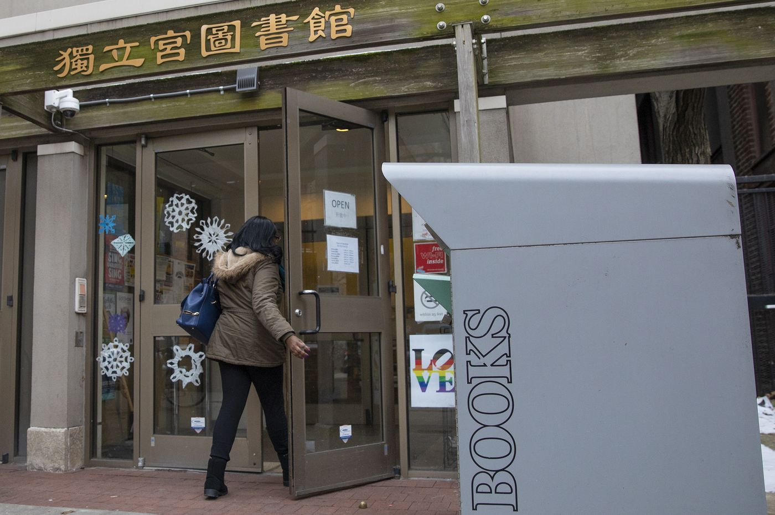
HEATHER KHALIFA / STAFF PHOTOGRAPHER

Weeks before the November release of Michelle Obama’s memoir, Becoming, South Philadelphia resident Carol Pasquarello rushed to throw her name on the Free Library’s book reserve list.
As of Friday, Pasquarello was still waiting to get one of the library’s 128 copies of the print edition — along with more than 600 other Philadelphians. More than 1,500 were waiting to borrow the e-book.
RELATED STORIES

- Ebooks seem like ‘Netflix for libraries,’ but they’re a drain on budgets
- A Philly miracle: Amid closures, this elementary school is reopening its library
- In the city’s poorest neighborhoods, libraries close earlier and more often
Pasquarello said she’s waited weeks and months for books, DVDs, and tax forms from the library. It took her more than three months, she said, to get copies of Bob Woodward’s and Omarosa Manigault Newman’s new titles.
“It’s very frustrating,” Pasquarello said. “Because of the funding issues, [library administrators] don’t purchase enough of these books to accommodate the patrons, so you really do have to settle down, go out and buy the book, and shell out $30. Or, put your name on a waiting list.”
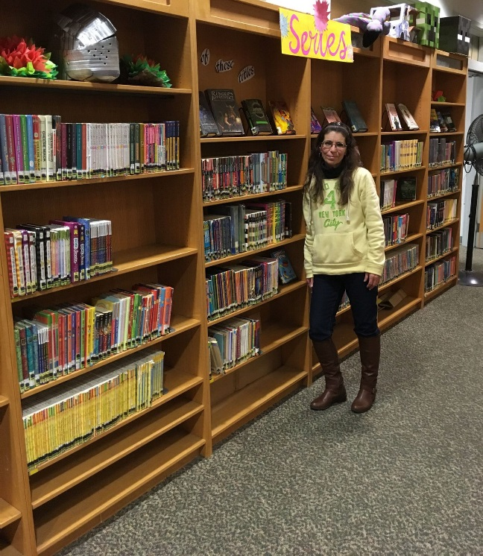
COURTESY CAROL PASQUARELLO
Carol Pasquarello stands next to a book shelf at the Fumo Family branch of the Free Library. Pasquarello has waited weeks, months for books and materials from the library.
Years ago, the library system may have simply bought additional copies of highly demanded items. But that changed a decade ago when – faced with millions in cuts to its overall budget — library administrators began shifting resources for books and materials to other areas of its budget to save jobs.
A state mandate calls for the city’s library system to spend at least 12 percent of its annual operating budget, currently around $48 million, on collection expenditures – including books, materials, and special collections. But since 2010, the 54-branch system has fallen below that threshold — sometimes by more than $1 million, according to a review of Free Library budgets — severely depleting its collections and creating long waits for books and materials for thousands of patrons.
SOURCE: Free Library of Philadelphia
Staff Graphic
Currently, there are more than 38,000 holds on physical materials and nearly 82,000 holds on e-books and digital audiobooks.
The dwindling collection is one of the impacts of a steady drop in funds over the last decade that in recent months became the catalyst for a grassroots campaign by supporters and advocates of the city’s system.
Last fall, hundreds of city residents, library staff, and advocates crowded into the fourth floor of City Hall to rally for Mayor Jim Kenney and City Council to restore library funding to 2008 levels. Advocates, organizing under the hashtag “#FundOurLibraries,” delivered petitions with more than 5,000 signatures to the offices of Kenney and each City Council member, while demanding money to restore staffing, and at least six-day service across the system.
Kenney’s office pledged his administration would explore the budgetary needs of all departments but said it also remains "focused on ways to improve our staffing patterns and management systems to be as efficient and accessible to the public as possible with existing resources.”
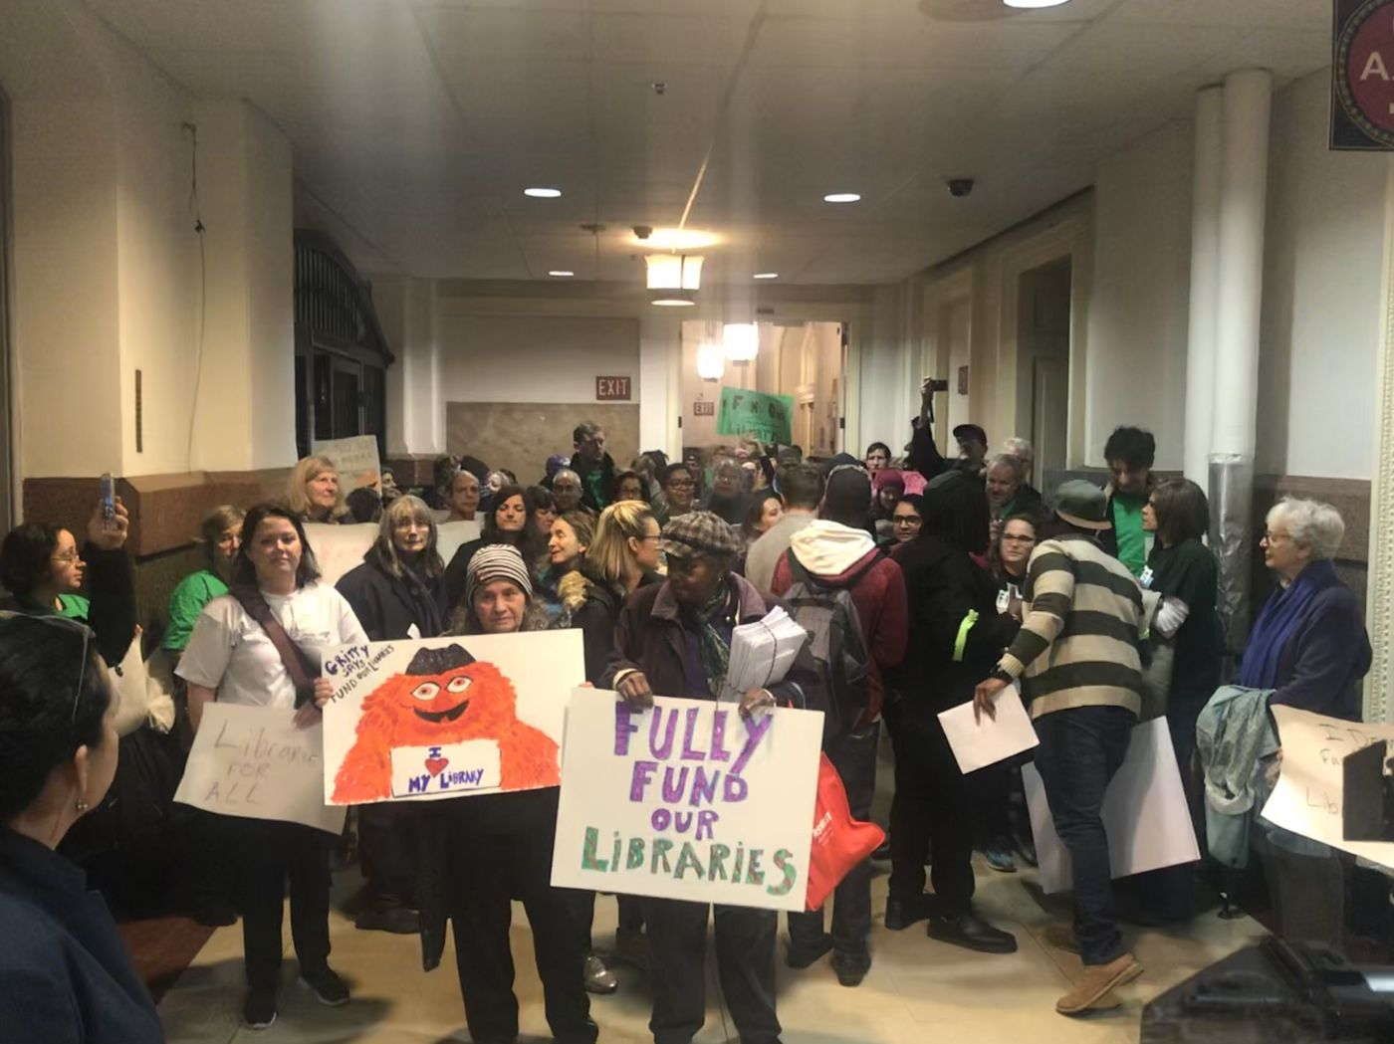
TYLISA C. JOHNSON / STAFF
Free Library of Philadelphia advocates gather outside Mayor Jim Kenney's office in City Hall to deliver petitions with more than 5,000 signatures on Dec. 12, 2018.
» READ MORE: Philadelphia announces hiring of new library staff, expanded branch hours
Advocates analyzed the library budget and maintain that the library system is “critically underfunded” and never recovered from a massive budget slash in 2008. Friends of the Free Library will continue to hold events across the city to advocate for additional funds, leading up to the next budget season.
ADVERTISEMENT
When the materials budget dropped in 2010 from $8.5 million to $4.8 million, the downsizing of collections was “huge,” said Free Library president Siobhan Reardon.
“It was a 50 percent cut to the collections, absolutely,” said Reardon, who took over the system in 2008. “And that decision was to save jobs. ... Unfortunately, it’s jobs or it’s collections.”
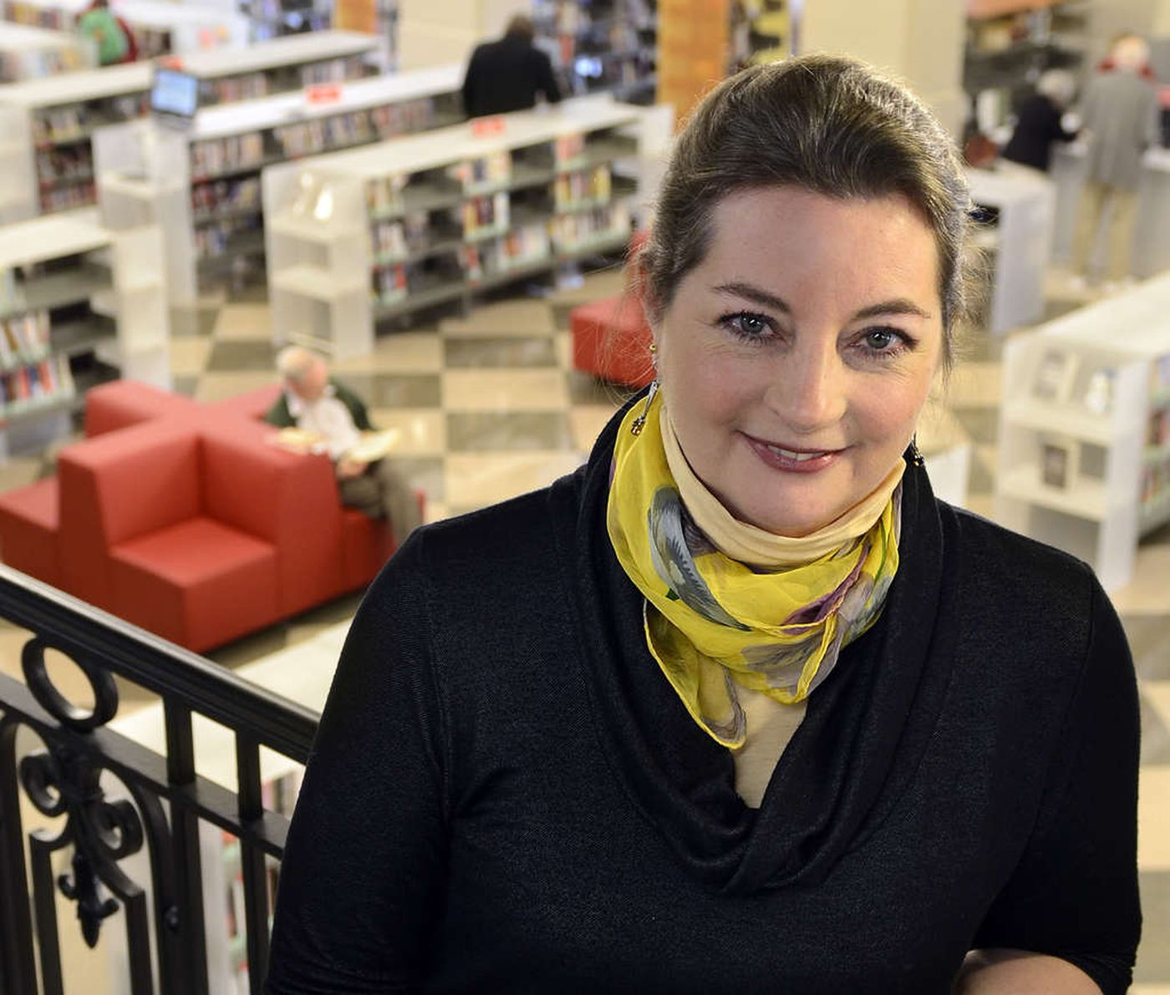
TOM GRALISH / STAFF PHOTOGRAPHER
Siobhan Reardon, head of the Free Library of Philadelphia since 2010, was named 2015 Librarian of the Year by Library Journal.
Reardon said library administrators “ended up prioritizing where … to spend our library’s materials budget, and where the communities are really looking to get at materials.”
The nonfiction collection and reference materials that could be found online were hit the hardest, she said. Administrators worked to safeguard children’s materials, however, to stay in line with the early-learning component of the library’s strategic plan.
ADVERTISEMENT
Adam Feldman, a librarian and Local 2187 Executive Board member, said the system’s need to respond to a staffing crisis also contributed to the draining of the materials budget. And the impact is obvious.
“One complaint we hear [from patrons] is that these newly reopened libraries don’t often have the collections that the neighborhood sometimes expects them to have," he said. “They don’t have as much on the shelf as they’d like.”
On paper at least, inadequately stocked shelves could have repercussions. State aid makes up a decent chunk of the library system’s funding — $8.2 million of its nearly $49 million budget last year — and the state mandates that the system spend at least 12 percent of its operating budget "on collections, excluding costs of an unusual, emergency or nonrecurring nature.”
For Philadelphia, that often means more than $5 million a year; in 2017, the system spent only about $4.5 million on collections.
Failure to meet state standards for spending on materials could result in a partial or complete loss in state aid — although state officials acknowledge no library has ever had to be punished for falling short.
Libraries that can’t reach the requirement can annually apply for a waiver of standards that allows systems to fall below the mandate without repercussions.
Reardon said the library applies for the waiver each year, but the state has no record of such a filing by the Free Library since 2014, the last time a waiver was granted. The same year, there were 62 waiver requests from libraries around the state. Only six were requests to waive the expected collection expenditures.
“I believe that most libraries work really hard to meet this mandate as it can influence their ability to receive state aid,” said Christi Buker, executive director of the Pennsylvania Library Association. “Small independent libraries tend to have the most struggles

http://www.philly.com/news/free-library-philadelphia-books-materials-budget-20190121.html

- Milwaukee PL’s “See Us Differently” Campaign Turns Heads
by April Witteveen
Jan 07, 2019 | Filed in News

At first glance, the image looks like the logo of a well-known shopping site or search engine; a closer look reveals the clever new marketing campaign from Milwaukee Public Library (MPL), WI. “In today’s society, which is built almost entirely on digital experiences, the very idea of a public library was in danger of being perceived as woefully analog,” said Sarah Schmidt, director of earned media with Milwaukee advertising agency BVK. “How do you convince a skeptical generation—some of whom may never have set foot in a public library—that the stodgy old stone building filled with books is actually a portal to today’s digital universe?”
The “See Us Differently” campaign aims to inform Milwaukee residents about the plethora of digital services on offer from MPL: downloadable books, movies, music, and more from library vendors such as OverDrive, hoopla, and Freegal. Brian Ganther, coexecutive creative director at BVK, initially came up with the idea to hijack the logos of brands such as Amazon, YouTube, Netflix, LinkedIn, and Spotify. He had the library on his mind thanks to his friendship with MPL community relations and engagement director Eileen Force Cahill. “I knew she has this strong desire to contemporize the library,” he said. “We had this idea, and I said: ‘We need to call Eileen!’ This is an unusually subversive idea for a public institution, but it’s one that resonates with people whose perception of the library has become outdated.”
Cahill, who has been with the library since 2016, is ready to battle the traditional perceptions of libraries. Initially hired as a consultant on an earlier MPL awareness campaign, she has over 20 years of cross-sector experience in communications and marketing. Her hopes for the campaign are to let residents know “we go beyond basic digital tools” like free Wi-Fi and public computers. “We want to take it a step further,” she says, especially with the area’s millennial population. When Ganther pitched the idea, Cahill was immediately on board.
While the co-opted logos may bring up concerns about trademark infringement, Kyle K. Courtney, copyright advisor for Harvard University, notes that “parody, as expressed in these reimagined library logo designs, is a powerful exception to infringement, for either copyright or trademark…. Under the law, a ‘successful’ parody (not an infringement) must both call to mind and differentiate itself from the original, and communicate some articulable element of satire, ridicule, joking or amusement. The trick with a parody is that you have to use enough of the original for the viewer to recognize that it is a parody.”
Courtney told LJ that other major corporations such as Wal-Mart and Starbucks have also had their logos parodied, and some of these cases have made their way to court. In many instances, “the parody logo was protected and found to be a valid expression for purposes such as satire, ridicule, joking or amusement,” he said.
BVK began work on the advertisements in late spring of 2017 and the campaign launched in September 2018, corresponding with National Library Card Sign Up Month. “The ads were strategically placed in unexpected establishments throughout the city—such as restrooms of buildings close to Central Library and some branches—in an effort to break through the clutter and modernize the way people think about their local library,” Schmidt told LJ. Public transit also provides a great venue for the advertisements, many of which can be seen on routes that run near the library.
The ads carefully avoid library lingo or product names in order to capture new users. “They don’t know what these specific resources are, so words like hoopla or Freegal don’t connect,” noted Cahill. Ganther agreed: “This is less about calling out specific resources and more about changing the perception of the library by using current cultural conversations.” One of the posters with a Netflix-esque design simply states: “We’ve got thousands of movies, too. But ours are all free. A library card is your ticket to endless information and entertainment.”
As of October 2018, year-to-date database usage is up 57 percent, ebook checkouts are up 50 percent, audio book downloads are up 26 percent, and other digital downloads are up 18 percent compared to 2017. And it’s not all remote access; program attendance is up, as is use of the library system’s meeting rooms. “Best of all,” says Schmidt, “new card registration went up 53 percent and card renewal went up 12 percent. Now, three out of every four Milwaukee residents has a library card.”
The See Us Differently campaign fits right into to Cahill’s overarching efforts to rewrite outdated stereotypes, such as her series of Library Loud Days. “Gone is the notion of the sleepy, quiet library, where all you hear is ‘shush.’ We’re changing the Milwaukee Public Libraries into lively, vibrant gathering places,” states the MPL website. Past Library Loud Day events have included a hip-hop concert and a haunted house, both taking place in MPL’s Central Library. In December of 2017 over 300 people attended a free event at the Mitchell Street Branch that featured Milwaukee’s Mondo Lucha, a professional Mexican-style wrestling organization.

https://www.libraryjournal.com/?detailStory=190107-MilwaukeePLSeeUsDifferently

- UC in negotiations with publisher Elsevier for open access to journal articles

BY MATISSE SENKFOR
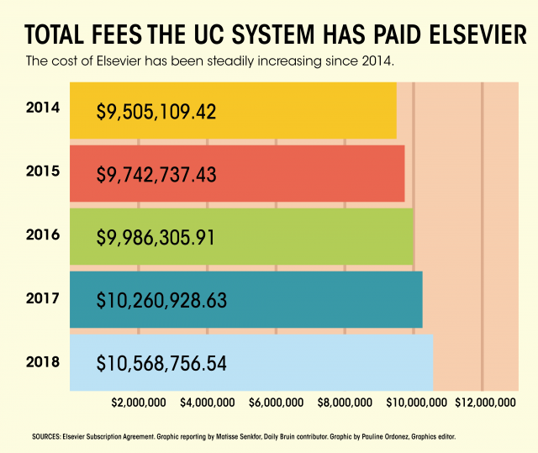
(Pauline Ordonez/Daily Bruin)

SHARE
TWEET

The University of California is negotiating a new contract with an academic publisher due to unsustainable and increasing subscription costs.
The UC’s contract with Elsevier, the owner of over 2,500 journals including Cell and The Lancet, ended on Dec. 31. The UC aims to lower subscription costs and make all of its research available for free to the public in the ongoing contract negotiations.
The contract cost the UC more than $10.5 million in 2018. This is a significant portion of the UC’s approximately $40 million yearly budget for journal subscriptions, according to an email statement from Ivy Anderson, the co-chair of the UC’s Publisher Negotiation Task Force.
UC researchers additionally pay approximately $1 million per year through grants to publish in the subset of Elsevier journals that are open-access, she said. Open-access journals make articles available to the public for free, and instead charge fees to the authors to publish their research.
Jeffrey MacKie-Mason, the university librarian at UC Berkeley and co-chair of the UC Journal Negotiations Task Force, said in an email statement that Elsevier and other publishers have been increasing subscription costs for many years, while library budgets have been decreasing. As a result, libraries are cutting costs by ending journal subscriptions and buying fewer books.
“We can’t continue any longer without serious harm to our campus libraries, and so we are pushing aggressively for a price reduction,” he said.
Additionally, in negotiating a new contract, the UC wants all of its research published as open access, he said. He said the UC would ideally have a “publish-and-read” agreement that combines the cost of subscribing to journals with open access fees to accomplish both goals of lowering costs and providing open access to UC research.
Both Anderson, the associate executive director of UC’s California Digital Library, and MacKie-Mason said they could not discuss the ongoing negotiation in detail. Access to Elsevier publications was extended until Jan. 31 as the negotiation continues.
MacKie-Mason said if a new agreement is not reached by then, UC students and faculty will still have permanent access to most already-existing articles in Elsevier journals, but it is unclear which new articles will be available, if any. He said there are other ways to get new articles without a subscription, such as an interlibrary loan, asking an author directly or purchasing individual articles.
Elsevier offers access to all its journals in a bundle, said Burt Totaro, a professor in the UCLA mathematics department. He said some of its journals are at the top of their fields while others are not equally prestigious, but university libraries have to pay for the whole bundle to get the journals they want.
Edward Walker, a professor of sociology, said he thinks publishers like Elsevier know libraries are a captive market because they have no choice but to pay large amounts of money for a few prestigious journals.
“A lot of the time at universities the faculty and students are not always aware of exactly how much they’re paying for these,” he said.
The UC is not the first institution to take issue with Elsevier’s rising costs and resistance to open access. Recently, Swedish and German institutions canceled their subscriptions with Elsevier, said Joseph Bristow, a distinguished professor of English and chair of the UCLA Academic Senate for 2018-2019. He said skepticism of Elsevier’s business model has been growing.
“They’re relying a lot on the relatively or completely free volunteer labor of professors at universities to produce the content for these journals as well as do the peer reviewing for them,” Walker said.
However, publishing companies benefit the most from the subscription costs that universities must pay to access this content, he added.
In 2017, Elsevier had a profit margin of nearly 40 percent, higher than that of Springer Nature, another large journal publisher, which had profits of around 23 percent. Totaro said 40 percent is an enormous profit margin for any business.
“It seems bizarre that we’re having to buy back our own work at a very high price,” Bristow said.
Totaro said he may have a stronger opinion on Elsevier than most; he has been boycotting the publisher since 2000. However, he said there is a general feeling among faculty members that the current publishing model is flawed.
Bristow, Scott Waugh, the executive vice chancellor and provost, and Ginny Steel, the Norma and Armena Powell University Librarian, sent an email in December asking UCLA faculty to consider not contributing to Elsevier through publishing or reviewing during the negotiation period.
John Villasenor, a professor of engineering, public policy and management, published an article in The Chronicle of Higher Education criticizing the email as an institutional promotion of boycott, which he thinks would set a bad precedent. However, Bristow said this email was not promoting an enforced boycott, since faculty members are still free to decide where to publish their research. He added faculty from certain departments on campus agreed with the email’s sentiment and overwhelmingly support moving toward open access.
Walker said he thinks it is reasonable for UCLA to ask faculty to play a role in helping with the negotiations, since Elsevier’s journals are relying on the faculty’s labor.
The growing pushback against Elsevier is directly connected to the rise of open-access publishing, Walker said. He said researchers are aware of open-access alternatives to paid subscription journals that offer more transparency and reach a wider audience.
“The landscape of scholarly publishing is going through transformation like never before,” Bristow said. “The mechanism of sharing work is changing rapidly.”

http://dailybruin.com/2019/01/08/uc-in-negotiations-with-publisher-elsevier-for-open-access-to-journal-articles/

- Library Leaders Need Feedback Too | Leading From the Library
by Steven Bell
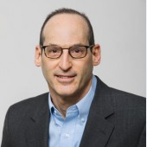There are many ways that leaders can improve, from informal learning to leadership programs. While it seems obvious that honest feedback would contribute to the cause, obtaining it—and effectively responding to negative feedback—is not so simple.
Have you ever heard an educator, perhaps a faculty colleague or a friend, talk about how much they love teaching but hate grading? If you’ve ever been in that position you know exactly what they mean. Giving students informal feedback to help them improve their skills is a part of teaching that most instructors embrace. Grading papers, projects, and exams in order to formally assess student performance is much less fun, but perhaps no less critical to student learning. Great instructors also know how to give negative feedback, as well as receive it, in a way that minimizes discouragement and maximizes growth.
Those leading in any capacity are called upon to evaluate direct reports or those serving on a team. Feedback may be provided formally by an annual performance evaluation or informally in routine meetings, when debriefing after projects, or in response to a “how am I doing” request. Delivering formal feedback is a part of leadership about which leaders, not unlike educators, may be less enthusiastic. Crafting and delivering feedback to reports or colleagues is a skill that is learned over time through experience. Knowing when to deliver feedback outside of formal performance reviews and how to provide it, especially when the feedback is potentially painful, is all part of the leadership skill set.
FEEDBACK AS A POSITIVE
How leaders view this part of their work depends, in part, on the attitude they bring. If they see it as a positive approach to helping their direct reports or colleagues improve their workplace performance or develop as leaders, feedback is perceived as an important responsibility. Those leaders who are open to giving feedback will always find opportunities to deliver it. Leaders who find it a loathsome chore bring an unfortunate mindset to their work. Avoiding this essential responsibility will ultimately prove detrimental to staff seeking their leader’s input on how to improve their performance.
What’s more problematic for leaders is capturing feedback about their own performance from staff and colleagues. In the absence of feedback from direct reports or leadership team colleagues, how is a leader supposed to identify areas where improvement is needed? The leadership literature is a source of suggestions for feedback gathering options, but too few of our library workplaces offer formal feedback mechanisms that work for leaders and managers.
GETTING GOOD FEEDBACK
As a graduate-level educator, I look forward to receiving formal feedback from my students. In my years of teaching I’ve found that I’m likely to get just a few highly enthusiastic evaluations along with an equal number that are highly critical. The vast majority are somewhere between the two extremes, and I find those provide the most useful evaluation feedback. I’ve struggled to find ways to obtain that same type of productive feedback from my direct reports. There are some possibilities, such as crafting my own version of a 360 Review. That might lead to honest and usable feedback, but even an anonymous survey could raise confidentiality concerns. According to Ron Carucci, in his article “4 Ways to Get Honest, Critical Feedback from Your Employees,” there are other approaches. His suggestions are:
- Ask for or encourage push back. Just ask for feedback and encourage dissenting opinions. While this is a refreshing idea, I would be concerned that colleagues would be hesitant to share honestly. However it might be received as an opportunity for open dialog and if done authentically it could, as Carucci believes it will, strengthen a relationship.
- Read nonverbal cues. Leaders may be overlooking nonverbal communication as a source of feedback. Faces and bodies can tell a story if we are open to receiving it. Do staff look away when you speak? Are they unusually silent? When picking up on these nonverbal cues, Carucci advises using them as conversation openers. For example, “How should I interpret your silence?”
- Monitor how you narrate the story. When asked to rate themselves, people tend to aim high, along the lines of a 7 or 8 out of 10. Leaders can do that as well when it comes to how things are going with their reports. While leaders should avoid becoming overly self-critical, Carrucci advises that they take time to step back and assess more realistically their behavior and reactions to it. Aim for a balanced, informed perspective.
- Know your triggers. In a prior column on self-awareness I share the importance of knowing what sets you off and ways to keep those behaviors in check. Carrucci reminds leaders to avoid becoming sarcastic, defensive, or passive-aggressive when things turn out differently than planned or expected. He even suggests openly inviting reports to call out their leader on these behaviors to help build self-awareness.
In other words, focus more energy on communication skills, primarily listening and observing. Of course a 360 Review can be informative, but if that’s not a viable option or it provides limited feedback, consider other ways to obtain useful feedback from colleagues.
HANDLING FEEDBACK FOR BETTER LEADERSHIP
Ideally all the feedback a leader receives would be positive. But even if that unlikely outcome occurs, it could be unfortunate, signaling that staff are reluctant to offer feedback for fear of retribution or assuming change is unlikely to happen. In a healthy library organization, direct reports and team members should feel they can bring honest, constructive criticism to their leaders. Library leaders need to establish that tone by creating opportunities for the generation and hospitable receipt of feedback. If library leaders seek to truly improve, however that’s defined, they must be open to and able to receive critical or negative feedback. It helps to receive criticism without getting defensive or angry. Library leaders should liken themselves to the libraries or teams they lead. If a part of the operation were underperforming or worse, every leader would be eager to hear about it in order to make the necessary corrections and improvements. Shouldn’t leaders do the same for themselves? Criticism is always hard to take. Owning it, reflecting on it, and then committing to improve is another essential skill that library leaders need to make a difference for their staff, organizations, and community members.
Steven Bell
Steven Bell, Associate University Librarian, Temple University, Philadelphia, PA, is the current vice president/president-elect of ACRL. For more from Steven visit his blogs, Kept-Up Academic Librarian, ACRLog and Designing Better Libraries or visit his website.

https://www.libraryjournal.com/?detailStory=122018-Bell-LibraryLeadersNeedFeedbackToo

