Año 4 Número 101 febrero 2019
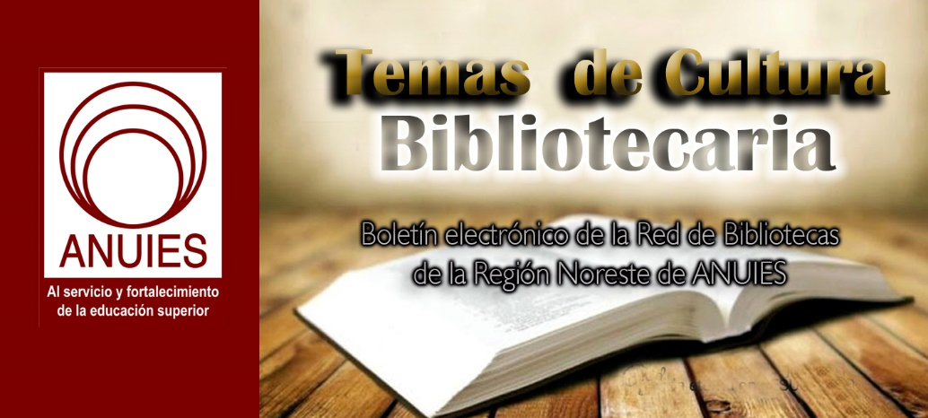

Contenidos de este número

- UCSB Library Digitizes Works by Renowned Chinese Author Kenneth Pai
Original, handwritten manuscripts by an author who has been called a Nobel Prize contender and compared to Ernest Hemingway are now available for everyone around the world to see.
Pai Hsien-yung, also known as Kenneth Pai, was a professor of Chinese literature at UCSB from 1965 to 1994. “Kenneth Pai is probably the most famous contemporary writer in the Chinese diaspora, often mentioned in conversation among Chinese intellectuals as a potential candidate for the Nobel Prize,’ said Kuo-Ch’ing Tu, a UCSB professor of Taiwan studies and co-editor of Taiwan Literature, published by the Forum for the Study of World Literatures in Chinese at UCSB.
Three of Pai’s handwritten drafts for his novel Crystal Boys — he was meticulous about rewriting, and actually revised the novel five times — are part of a newly digitized UCSB Library collection of his works that also includes his short stories and prose, a total of 57 manuscripts comprising 2,644 pages. Crystal Boys, published in 1983, is the first Chinese fictional work to address gay culture.
Retired from teaching but still active as a writer and arts advocate, Pai is one of the most-translated contemporary Chinese authors in the world, and a founder of the influential Chinese literary magazine Modern Literature.
Describing the importance of preserving Pai’s work, Cathy Chiu, former East Asian Studies Librarian at UCSB Library, and a key contributor to the digitization project, said Pai is “almost like Ernest Hemingway in Chinese literary circles.”
Michael Berry, a professor of contemporary Chinese cultural studies at UCLA, during a weeklong celebration of Pai’s work at UCSB in 2017, said the author has made “an indelible impact on the cultural life of Chinese people both in mainland China and Taiwan, Hong Kong, and overseas.”
Scholars “come to UCSB from all over to see the Pai collection, whether they’re studying Chinese politics or society or literature,” Chiu said. The digitized items — just part of the entire collection of his works held by the Library’s Special Research Collections (SRC) — open up his materials to scholars who can’t make the physical trip to UCSB.
In 1997, Pai, who lives in both Santa Barbara and Taiwan, donated an extensive archive of his works to the UCSB Library that includes manuscripts of his novels and short stories in Chinese and English; videos, photographs, and posters from film and theater adaptations of his works; correspondence; and academic articles.
Amy O’Dowd, a UCSB Library donor and Pai supporter, said the digitized transcripts “provide a great opportunity for students, scholars, and the local community to understand and have access to Dr. Pai’s renowned literary works … and the huge impact and influence he has had on modern Chinese history.”
Pai, born in Guilin, China, in 1937, is the son of a prominent general in the Chinese Nationalist government. His family moved to Hong Kong and then Taiwan after Chinese Communists took over the mainland in 1949.
He studied English literature at National Taiwan University and earned an M.F.A. from the Iowa Writers’ Workshop at the University of Iowa in 1965 before coming to UCSB.
His works reflects the lives of those, like his family, who retreated from mainland China to Taiwan after World War II.
“He is a witness of that generation,” said Chiu. “He had real-life contact with people in that circle, and actually observed how they lived.”
In addition to his skill as a writer, Chiu said, what comes across in Pai’s works is “his compassion. The way he describes characters, you feel like he really has compassion toward not just aristocrats, but all classes.”
Other universities approached Pai about donating his manuscripts and other materials, he said, but he chose the UCSB Library out of loyalty to the University and because he believed the collection would be “in very good hands with the Library. It’s a relief to me that it is so well organized and cared for, and can serve as an academic resource for students and researchers.”
Pai said he recently received a phone call from a Ph.D. candidate in China who is writing his thesis about one of Pai’s works and wanted to view English translations of his novels and short stories. “He was overjoyed to receive the link [to the digitized collection] as this was a great help to him,” Pai said.
Pai hopes students who study his work will gain better understanding of the historical background and social turmoil in Taiwan since 1949.
“I think my work is a reflection of the refugee experience of the many people who fled to Taiwan and started a new life there,” he said. Plus, “most novels and fiction written at this time also did not include gay themes.”
The title of his novel Crystal Boys refers to the former gay culture in Taiwan called the “glass community,” and the individuals who were part of that community, called “glass boys” or “Crystal Boys.” Some of his short stories addressed gay themes as well.
Most of the materials in the digitized collection, focused mainly on Crystal Boys and Pai’s short story collections Taipei People and New Yorkers, are in Chinese. Some of the English-language items include letters and notes from editors and translators of Pai’s work.
What can scholars glean from an original handwritten manuscript? By observing crossed-out words, comparing revisions, and studying different endings and dialogue changes, they can gain further insight into an author’s mind, motives, and writing process.
The manuscript for one digitized short story by Pai, for example, includes an editor’s explanation for changing the translation of the title from “A Sky Full of Blazing Stars” to “A Sky Full of Bright, Twinkling Stars,” a modification that potentially alters the meaning and symbolism in the story.
Looking back on his handwritten manuscripts, Pai said he kept revisiting his seminal novel because “I was not satisfied and thought I could still improve the text. I guess I am fastidious about my work.”
Posted on: 01/14/2019 - 10:57
Topics: Area Studies, Special Research Collections

https://www.library.ucsb.edu/news/ucsb-library-digitizes-works-renowned-chinese-author-kenneth-pai

- What Library Leaders Can’t Fake | Leading from the Library
by Steven Bell
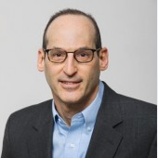
One school of thought in leadership suggests those who do it well can role play some area of their work for which they are less than authentically passionate. While that may be a useful leadership skill for unique situations, there are some things leaders should never fake.
From frontline reference librarian to library director, I’ve had the great experience of serving in a wide range of positions in academic libraries of different types. For the most part I avoided suffering extended bouts of impostor syndrome, a fairly regular topic of discussion in our profession. However early in my career, in my first reference librarian position at a top ten business school library, the first year was one of self-doubt. There was little discussion of impostor syndrome back then, though it’s likely that I was experiencing it. For the first six months as a library director, I occasionally gave in to thoughts of being unqualified and unlikely to succeed as that library’s leader. But in these and other positions, as I achieved small successes my confidence grew, and I came to believe more strongly that I was the right person for the job. A recent webinar on impostor syndrome I attended, wanting to better understand how this affects librarians, got me thinking about what it means for library leaders. Leaders need to recognize how impostor syndrome impacts their own progress, but they should also recognize and support staff who may be experiencing it.
FAKING IT
An often-shared piece of advice for those suffering from impostor syndrome is “fake it until you make it,” meaning that in situations of doubt or fear do your best to play through it, even it if takes a bit of acting. Imagine a leader, for example a college provost or president, who has an incredible number of responsibilities and expectations for regular public appearances, going to all types of events, day in and out. It’s quite likely these leaders, even with their tremendous spirit and enthusiasm, are hardly enthusiastic for every activity. One strategy is to show up for a short period, say a few words, be the cheerleader, and then make a quick exit for that next “high priority” meeting. As followers, we may even sense some inauthenticity, but we are nonetheless enthused by their participation. This particular strategy, faking it to play an expected role, is rarely shared in leadership books. But talk to these leaders and you’ll find they must occasionally role play as institutional cheerleader or sympathizer for the greater good. Does that make them bad leaders? It’s clearly less than authentic, but is it all that much different than the impostor syndrome sufferer who fakes their level of confidence as an educator, meeting leader, or research consultant? It’s what we do to make it through for now, until we gain the true confidence, skill, or authentic mindset to put faking behind us.
WHAT CAN’T BE FAKED
None of this is to suggest any leader could survive for long as an impostor. The occasional, well-intentioned role adoption, used artfully in the right place and time, has its purpose. But there are leadership qualities and practices that are simply beyond the scope of fakery. Any current or aspiring leader who thinks they can be faked is not worthy of being followed, and is likely to experience a short and troubling tenure. They include:
- Listening. It’s easy to fake it while being distracted or just uncaring. Great leaders are great listeners. Asking good questions to get others talking is an authentic practice that allows leaders to learn. It’s easy to fake listening, but also easy for others to sense their words are going unheard.
- Respect. Without respect for their workers, leaders create a dysfunctional workplace where mistrust and low morale run rampant. In our professional literature and on social media the toxic boss is mentioned far more frequently than the admired leader. How much of this is owing to leaders who pay lip service to respect for library workers but act in ways that demean and demoralize them?
- Empathy. Not all leaders are naturally empathic. They may need to work at developing their sensitivity and ability to empathize. Building the capacity for empathy is a path to authentic leadership. Empathy is easy to fake, by feigning interest in others and their concerns. When it really matters though, in situations where true empathy makes a difference, fakers reveal their true colors.
- Appreciation. Another simple and seemingly obvious leadership quality that is faked only at a leader’s peril. It’s more likely the case that toxic leaders fail at this by taking credit for success rather than crediting their staff colleagues. Worse yet are leaders who show staff appreciation only when they are in the limelight, for public or external appearances, but rarely or never make a personal show of their appreciation directly to staff.
Readers no doubt have their own examples where leaders fake it in situations when authenticity, honesty, and humility are an absolute necessity. I’d like to think those leaders eventually get weeded out of the profession. It’s more likely the unfortunate case that they persist as leaders in name only, creating a toxic workplace wherever they land.
ALL PART OF LEARNING
When a library leader is authentic where it counts, the occasional absence of authenticity in less-critical areas of leadership need not be a barrier to success. While hardly an ideal situation, there’s little to gain by being overly self-critical where deficiencies exist. In an essay on impostor syndrome Sindhumathi Revuluri offers this advice: “Instead of wallowing in vague self-doubts, reframe them more specifically—as 'I have something to learn about…' ” That gets to the essence of Leading From the Library. Few of us are born leaders, naturally gifted with all of the essential attributes for greatness. It’s a process of continual learning. Leaders, rather than lamenting over real or imagined inadequacies—not feeling good enough, smart enough, or leaderly enough—need to take Revuluri’s advice. Use self-awareness to acknowledge weaknesses but commit to learning how to better lead by building strength in those areas. The greatest of leaders may never need to fake it, but for the rest of us it’s important to distinguish between what we can fake and what we never should.
Steven Bell
Steven Bell, Associate University Librarian, Temple University, Philadelphia, PA, is the current vice president/president-elect of ACRL. For more from Steven visit his blogs, Kept-Up Academic Librarian, ACRLog and Designing Better Libraries or visit his website.

https://www.libraryjournal.com/?detailStory=What-Library-Leaders-Cant-Fake-Leading-from-the-Library

- ProQuest Launches ProQuest One Academic
by Matt Enis
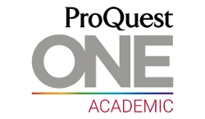
ProQuest yesterday announced the launch of ProQuest One Academic, a new resource that utilizes a single user interface to offer access to the full collection of journals, newspapers, magazines, and other content in the ProQuest Central database; every ebook in the Academic Complete collection; the 66,000 streaming videos included in Alexander Street’s Academic Video Online collection; and nearly five million graduate works in the ProQuest Dissertations and Theses Global database.
“Some of the key difficulties related to the research process are getting started, defining a topic, finding appropriate resources, determining the credibility of those resources, and integrating information from them,” Rafael Sidi, SVP and general manager, ProQuest Information Solutions, told LJ. By streamlining access to these four major databases through one platform, “students and faculty will save tremendous time by finding the most comprehensive and curated content without the need to go to different platforms to find videos or books for teaching or learning.”
Switching between different platforms to search for different content has traditionally been a “pain point” for researchers, Sidi said. Less experienced researchers may be unfamiliar with the content available in multiple databases and could be frustrated with the need to navigate a variety of user interfaces. And even seasoned researchers are forced to use multiple windows and tabs when conducting a comprehensive search of these different resources.
ProQuest Central, Academic Complete, Academic Video Online, and ProQuest Dissertations and Theses Global will still be available for licensing individually, noted Brie Betz, global director of product management for ProQuest. But the work that the company’s developers have done to simplify access and present integrated search results with the ProQuest One Academic platform is a key benefit. Libraries and database providers “are competing against the open web,” Betz said. Users “expect to be able to find the right information as quickly as possible.”
Sidi described “extensive research with students and faculty” to design the layout of the search results page. Features include a sidebar that presents the most relevant ebooks and videos related to a search, making it “easier for users to discover content they might not otherwise have engaged with,” he said.
Also, user testing and analytics indicates that “researchers usually improve the relevancy of their results when they use the various filters on the search results page. But while more advanced researchers had no trouble with these filters, less-experienced researchers were either unaware of them or didn’t use them,” Sidi said. So, following user testing with undergraduate students, ProQuest’s developers took the most-used filter—which enables users to limit results by source type—and placed it directly above the search box on the basic search page.
There will be no loss of administrative functionality on the back end, Betz said—library staff will have access to the same management and reporting features for each platform, as well as features such as media upload capabilities in Academic Video Online, for example. However, Betz said that ProQuest One Academic will ease administrative burdens by consolidating licensing, configuration, management, and training onto a single platform.
In an official announcement on January 23, the company described ProQuest One Academic as the first product in a larger ProQuest One initiative, which will be “a series of solutions that will enable libraries to serve broad, evolving learning and research mandates faster and more powerfully, ultimately improving outcomes for their institutions.”
Sidi added that ProQuest One Academic “is just the beginning of the innovation that we will be bringing to our aggregation business. We will continue to enrich our content and develop new solutions with the best user experience and workflow tools.”
Matt Enis
Matt Enis (menis@mediasourceinc.com, @MatthewEnis on Twitter, matthewenis.com) is Senior Editor, Technology for Library Journal.

https://www.libraryjournal.com/?detailStory=190123_ProQuestOneAcad

- Engineering for Impact: Practices of Civil and Environmental Engineering Scholars
Rebecca Springer
The latest installment in Ithaka S+R’s series of Research Support Services projects investigates the research practices and support needs of civil and environmental engineering scholars. Today we are excited to publish the project’s capstone report. The field of civil and environmental engineering tackles pressing issues relating to our built and natural environments – from climate change to urban drinking water, bridge and highway upkeep to natural disaster planning. The need for research solutions to these problems makes understanding the work of civil and environmental engineering scholars crucial. It also poses unique challenges – and opportunities – for stakeholders including academic libraries, universities, technology developers, research funders, and professional societies, who can help position the field to effectively respond.
This project was carried out with the generous support of the American Society of Civil Engineersand in partnership with researchers at eleven academic libraries in the United States and Canada. Each library wrote a report and made recommendations to improve support for civil and environmental engineering scholars at their own institutions. Ithaka S+R’s capstone report complements these findings by stepping back to evaluate the broader research support ecosystem in which civil and environmental engineering scholars operate. Although previous projects have studied other fields with a strong applied component, including agriculture and public health, our report shows that the field of civil and environmental engineering is unique in its close relationship with industrial partners, including government agencies, NGOs, and private companies.
Industry is not just a recipient of academic civil and environmental engineering research – it is a research partner. Far from simply providing project funding, industry organizations and individuals provide crucial data, contribute expertise, and shape future research directions. Although industry-academia partnerships can pose ethical concerns in some fields, interviewees overwhelmingly spoke of industry partners as positive actors. Moreover, good industry-academia partnerships are mutually beneficial and self-perpetuating. Industry partners gain research-based solutions to technical problems and innovation needs, while scholars gain funding, access to data, and the opportunity to see their work effect real improvements, whether in their local communities or around the world.
Although many of these industry-academia partnerships are thriving, our findings suggest that scholars face significant challenges in communicating their research to industry. Many civil and environmental engineering scholars publish in trade magazines, writing construction “standards” and government reports, attending professional conferences, and delivering workshops. However, university tenure and performance evaluations place little value on these activities, preferring to reward instead only peer-reviewed academic articles. It is therefore difficult for some researchers, especially those who have not yet attained tenure, to justify the time and effort required to communicate their research findings to industry partners effectively. Our recommendations urge universities and others to systematically incentivize innovative and effective industry communications in order to strengthen essential academia-industry partnerships.
Another implication of the close relationship between civil and environmental engineering researchers and industry is that open access publishing – whether “green” or “gold” – is unlikely to be a panacea for research impact. Although civil and environmental engineering scholars are concerned about shaping public narratives around infrastructure, the environment, and climate change, their primary “public” remains engineers and engineering organizations – groups who don’t typically read academic journals. If the goal is to put civil and environmental engineering research into the hands of practitioners, we recommend investing in new and better forms of practitioner-facing research communication – videos, searchable research digests, smartphone apps. Universities must also recognize these types of communications as valuable scholarly outputs.
Industry partnerships are not the only area in which research support services for civil and environmental engineers can be improved. In fact, many of the challenges interviewees identified resonate with the experiences of scholars in other applied, interdisciplinary, and STEM fields. Our findings suggest potential interventions to help scholars collaborate more effectively and more often; to increase uptake of library services and information technologies; to improve lab group workflows and data management; to train graduate students in essential research skills; and to enable more efficient data sharing. These recommendations point to the innovations necessary to support civil and environmental engineering scholars’ research.
Ithaka S+R’s Research Support Services program illuminates the unique practices and needs of scholars in a variety of disciplines – as well as the common challenges they face. Research teams for our language and literature project recently began conducting interviews; a project on Indigenous studies, employing Indigenous methodologies, is also underway; and we are looking ahead to future projects in psychology and computer and electrical engineering. In parallel with these studies of faculty research needs, we are also conducting a new series of Teaching Support Services projects. Our first iteration of this series, on instructional support needs in undergraduate-level business teaching, will be followed by projects on teaching with primary sources and teaching data literacy.

https://sr.ithaka.org/blog/engineering-for-impact-practices-of-civil-and-environmental-engineering-scholars/

- Celebrating Skye Patrick, Librarian of the Year | ALA Midwinter 2019
by Lisa Peet
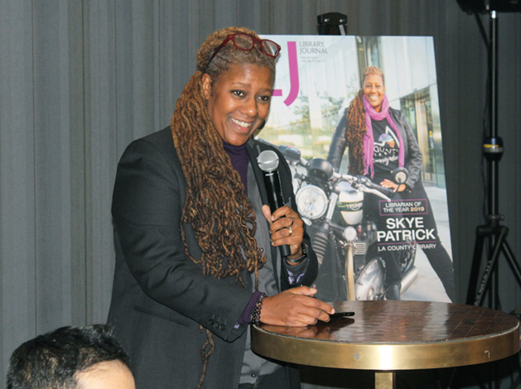
Spirits were high on the evening of Friday, January 25, when LJ celebrated 2019 Librarian of the Year Skye Patrick with a reception at Seattle’s Hotel Theodore. The award, sponsored by Baker & Taylor, recognizes Patrick’s dynamic work as director of LA County Library—one of the largest library systems in the United States, with 87 library facilities serving 3.4 million people—as well her trailblazing career as LA County’s first African American and openly LGBTQ+ library director. (In her previous role as director of the Broward County Library, FL, Patrick was the second African American, first openly LGBTQ+, and first woman to hold the position.)
The event drew library luminaries from around the country. In addition to her wife and daughter, Patrick was celebrated by LA County staff members; John Szabo, city librarian at the Los Angeles Public Library; Kelvin Watson, current Broward County, FL, director; LJ’s 2018 Librarian of the Year Lance Werner, director of the Kent District Library, MI; and many more friends and fans.
LA County has much to celebrate. In addition to her Librarian of the Year award, LA County Library won LJ’s Marketer of the Year award in 2018. Patrick also pointed to numerous programs and initiatives the library has instituted since she arrived—three years ago to the day of the party, she said, including The Great Read Away, LA County Library’s fine forgiveness program; Turns the Tables DJ Workshop for local youngsters; initiatives to reach at-risk youth and young adults of color; an expanded Career Online High School program; ten Maker mobiles and five early literacy mobiles; a full-service library at Los Padrinos Juvenile Hall in partnership with the Los Angeles County Probation Department; and an additional 15,000 service hours that incurred no additional taxpayer costs.
“I could have a hundred million great ideas, but if I have no one to help me revise [and] execute those ideas, it means nothing,” Patrick said about her team. She applauded those in attendance—Chief Deputy Yolanda De Ramus, CIO Binh Le, Assistant Director of Capital Projects Pat McGee, and Assistant Director of Public Services Jesse Walker-Lanz—and her board (“my five bosses”). She also gave a heartfelt thank you to her wife, Dawn Robinson-Patrick, and their daughter, Kaia-Skye. Some notable library leaders who guided her career got a shout-out as well, among them Szabo, Jill Bourne (San José, CA, LJ’s 2017 Librarian of the Year), Siobhan Reardon (Free Library of Philadelphia, 2015 Librarian of the Year), Luis Herrera (formerly San Francisco, 2012 Librarian of the Year), Brian Bannon (Chicago Public Library, a 2009 LJ Mover & Shaker), Vickery Bowles (Toronto Public Library), Nick Buron (Chief Librarian, Queens Library, NY), and Dale McNeill (assistant director for public service, San Antonio Public Library).
Patrick also made a point of highlighting her lineage as an African American library director, pointing out other leaders who paved the way: Rhea Brown Lawson (Houston PL), Jo Anne Mondowney (Detroit PL), Eva Poole (Virginia Beach PL), Marcellus Turner (Seattle PL), Scott Hughes (Bridgeport PL, CT), Cyndee Sturgis-Landrum (Evansville Vanderburgh PL, IN), Felton Thomas (Cleveland PL), Rose Dawson (Alexandria Library), Tracie D. Hall (formerly vice president of strategy and organizational development at Queens Library), and Librarian of Congress Carla Hayden, LJ’s 1995 Librarian of the Year, and, Patrick noted, the last African American to receive the honor. She also acknowledged that there are others poised to make their mark, among them Watson, Kim Johnson (Tulsa City-County Library), Floyd Council Sr. (Tulsa), Edward Melton (Harris County, TX), and Roosevelt Weeks (Austin, TX).
"And there are many, many other powerful directors out there. I'm just one of them,” Patrick said. “I call upon all of you all the time. You hold me down, you keep me up, and I thank you for that, each one of you.”
“I think we're going to see a lot more of Skye,” said LJ Editorial Director Rebecca T. Miller. “I look forward to continuing to see your career thrive, and the gifts that you're going to give to all of us in our work, because we're learning from you all the time."
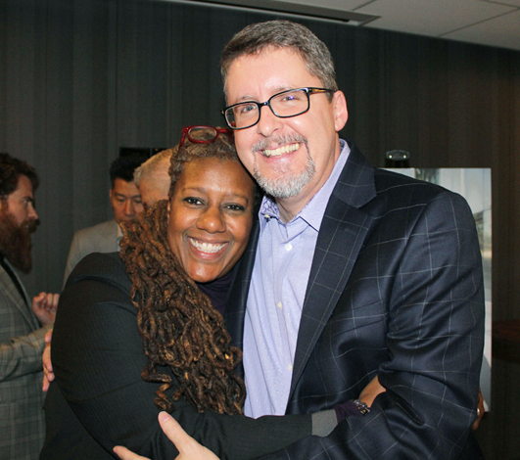
Patrick and John Szabo, City Librarian, Los Angeles Public Library
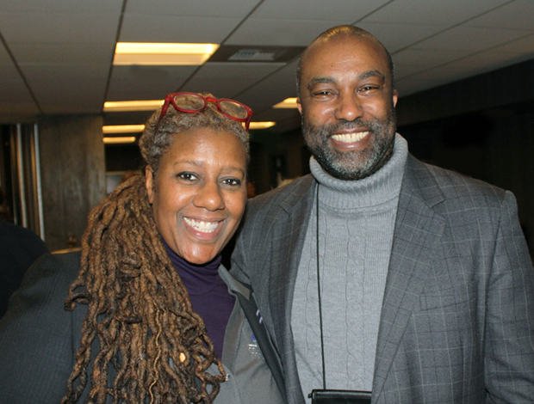
Patrick and Marcellus Turner, Director of Seattle Public Library
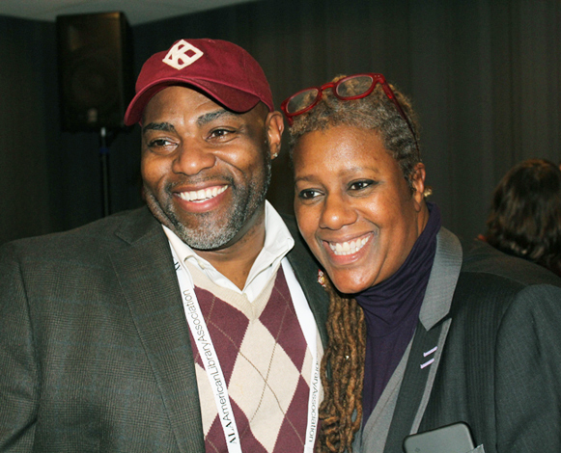
Kelvin Watson, Director of Broward County Library, FL, and Patrick
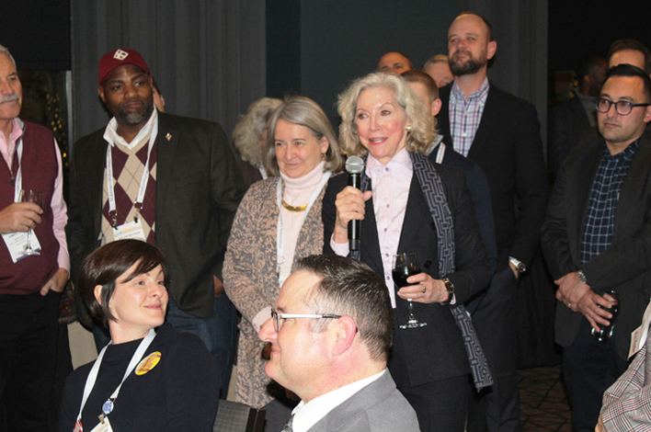
Susan Benton (center r.), President and CEO of Urban Libraries Council, offers her testimonial (with Indianapolis Public Library CEO Jackie Nytes, l.)
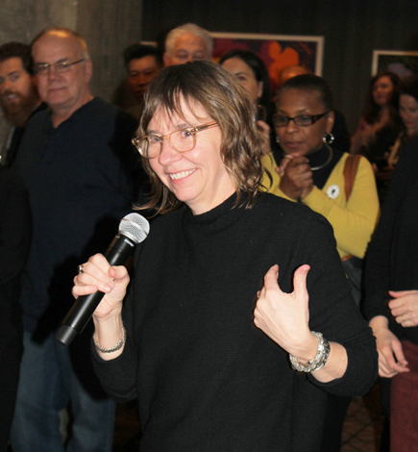
Vailey Oehlke, Director of Multnomah County Library District, OR
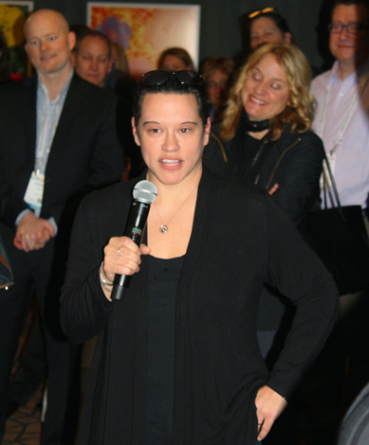
Michele Gorman, Assistant Director of Public Services at Fort Worth Public Library, TX
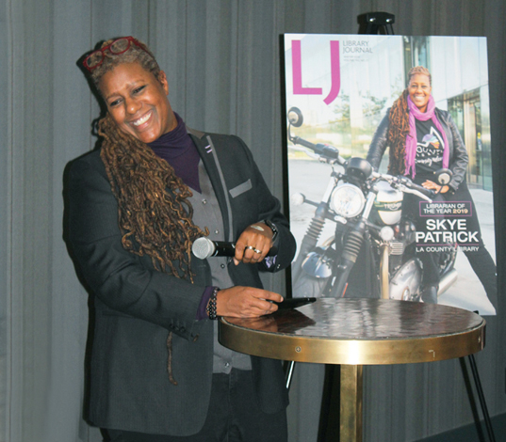
Skye Patrick thanked her supporters, staff, family, and many role models
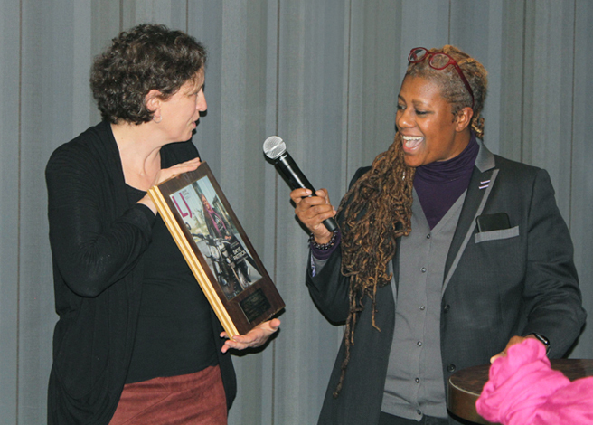
LJ Editorial Director Rebecca T. Miller presents Patrick with one of two plaques commemorating her Librarian of the Year award
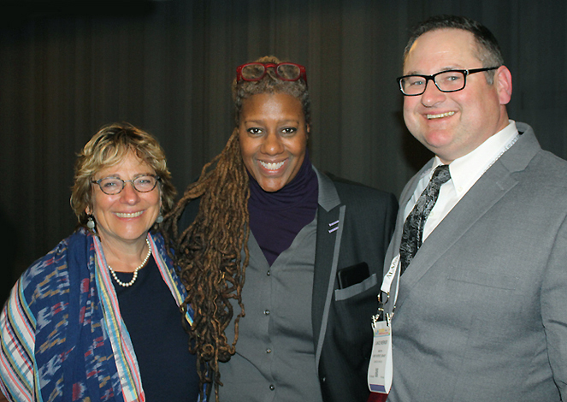
Three Librarians of the Year: Deborah Jacobs (1994), recently director of the Bill & Melinda Gates Foundation's Global Libraries initiative; Patrick; and Lance Werner (2018), Director of Kent District Library, MI
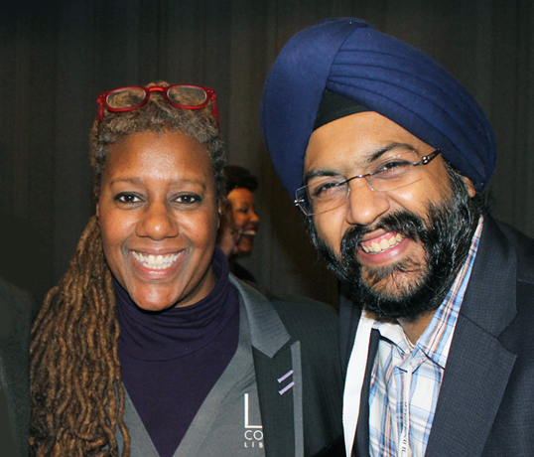
Patrick and Aman Kochar, Executive Vice President of Public Library Sales and Technology, Baker & Taylor
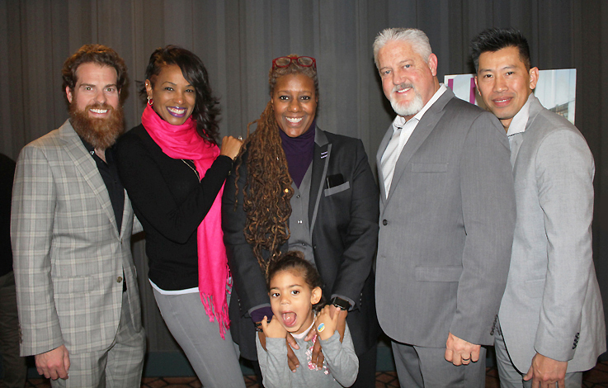
Patrick with daughter Kaia-Skye Patrick and the LA County team: Assistant Director of Public Services Jesse Walker-Lanz, Chief Deputy Yolanda De Ramus, Assistant Director of Capital Projects Pat McGee, and CIO Binh Le
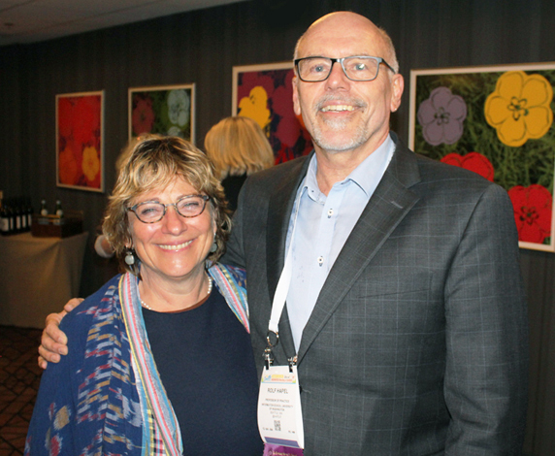
Jacobs and Rolf Hapel, Distinguished Practitioner in Residence, University of Washington Information School
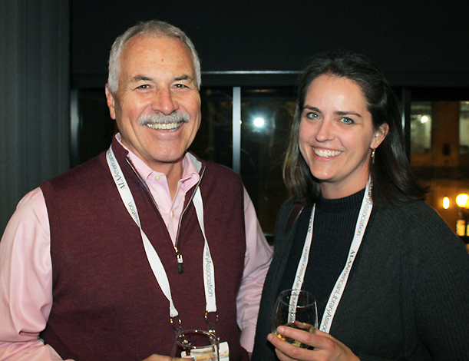
Jim Cooper, Director of Salt Lake County Library Services, UT, and Gretchen Caserotti, Director of Meridian Library District, ID
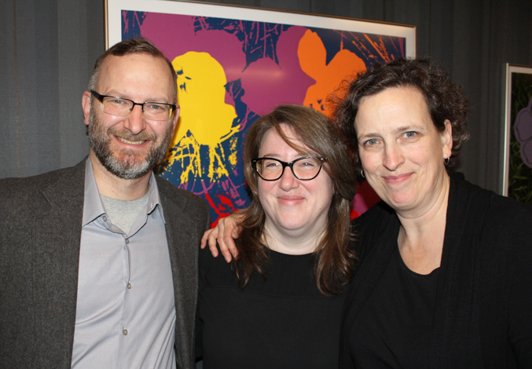
NYLA Sustainability Initiative cochairs Matthew Bollerman, Director of Hauppauge Public Library, NY, and Rebekkah Smith Aldrich, Executive Director at Mid-Hudson Library System, NY, with Miller

https://www.libraryjournal.com/?detailStory=Celebrating-Skye-Patrick-Librarian-of-the-Year-ALAMW-2019

- Berkeley PL Launches Cards for Patrons Without Fixed Address
by Lisa Peet
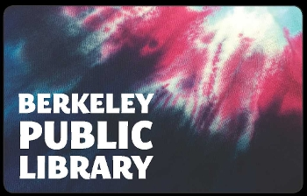
On December 1, 2018, Berkeley Public Library (BPL), CA, rolled out its new Easy Access Cards, designed for library customers without a fixed address. These include patrons who are experiencing homelessness, lack current documentation, are in transition between addresses, or are in the foster care system. Easy Access cardholders may check out three books or other materials at a time, put holds on three items, use library desktop computers, or check out laptops for use in the library at any of BPL’s locations.
The Easy Access cards replace two other types of BPL library cards for patrons without fixed addresses: a temporary card, which gave applicants 45 days to provide proof of address, and a shelter card, which required a letter from the shelter where the cardholder was staying. Those cards were automatically rolled into BPL’s new Easy Access cards.
COMMITTING TO EQUITY
As of last December, more than 140 public libraries across the United States had signed the Urban Libraries Council’s (ULC) Statement on Race and Social Equity, committing their organizations to help build a more equitable society. BPL was among them, and acting director of library services Elliot Warren was looking for ways that the library could do its part to remove barriers to service.
At the same time, Berkeley was moving forward with a citywide strategic plan. The library had chosen several of the city’s long-term priorities to focus on in the next year, including championing and demonstrating social and racial equity. “Our staff has been doing a lot of work trying to identify how, in the next six to nine months, we can implement practices, policies, and services that satisfy that citywide long-term goal,” said Warren.
One solution was to go fine-free for adult, teen, and children’s cards, which BPL did in July, as well as implementing automatic renewal. This includes materials circulated through the LINK+ Union Catalog, a borrowing consortium of 59 libraries in California and Nevada, and everything except laptops and the tools borrowed from BPL’s Tool Lending Library.
“As part of addressing the ULC statement, explained Warren, “We did some analysis that showed very disparate patterns in our different zip codes. The zip codes where wealthy people tend to live showed very few blocked patrons, whereas the communities that are lower income showed much higher rates of patrons being suspended because their fines were over ten dollars…. It seemed extremely unfair."
For years, staff had been hearing from people who said that they didn’t let their children check out more than one book at a time because of potential fines. The library’s analysis was the final argument necessary to move away from fines, and Warren says in the past half year physical circulation is up five to ten percent. “That's not a trend people are seeing in the country as a whole,” he noted. “We do believe that [going fine-free] is drawing more people back."
REDUCING FRICTION
Another area for improvement, they decided, would be to reduce barriers for people who could not get full-access cards. Berkeley, a city of about 120,000 people, has a homeless population of at least 1,000, many of whom use the library regularly. A number of them held temporary or shelter cards, but even applying for those can be a source of friction for some patrons.
“The shelter card basically required people to get a signed letter from the shelter they're staying at, and most of our homeless people aren't sheltered,” Warren told LJ. “Even if they are, very few people used it because…it was…patronizing to expect an institution to vouch for a person."
BPL looked at several libraries in the area that provided similar plans, such as San Francisco Public Library’s Welcome cards, or the accommodations San Mateo County Libraries offer for homeless card applicants. Then, said Warren, he consulted with library leadership, staff, and even BPL’s Joint Labor-Management Committee, which proposed that the card include the capacity for users to place holds and pick up materials at the branch of their choice, as homeless patrons might not be able to move between locations easily. BPL’s Board of Library Trustees (BOLT) supported the card as well.
Simultaneously, the library consolidated and simplified its circulation policy, which hadn’t previously covered cards. BPL rewrote it as a straightforward two-page document that lays out card access rules, fine and renewal practices, book fees, and cards for minors.
At press time, BPL had 579 active Easy Access cards. Since instituting them, said Warren, he’s received kudos from patrons, the community, and staff. Ease of computer use in particular is a hit; without a library card, anyone wishing to use library computers would have to return to the reference desk every hour for a new code. Patrons who don’t have access to computers at home can now take the time they need to research or fill out job and benefit applications. Warren has seen in-house laptop use go up ten times since BPL’s Central Library instituted laptop vending machines, and has recently reconfigured the space to devote less room to desktop computers and more to comfortable seating.
Applicants still need to provide some form of photo identification, but those rules have relaxed as well. Prior to launching the Easy Access Card, BPL required a California ID or passport. Now, users can present a California ID or driver’s license; a government picture ID (including a passport, military ID, green card, or out of state ID); a student (high school or college) ID; or another form of credible picture ID, including bank cards, transit cards, or Costco cards. Easy Access Cards must be renewed yearly (full access cards are good for four years). Visitors from out of town can still get a temporary pass.
Some community members have expressed trepidation about the requirement, noting that people without fixed addresses often don’t have the needed ID, or are unable to get it. Although there are public agencies that can help them get IDs, “Many individuals don’t have the capacity to obtain them or they may refuse to for various privacy reasons,” David Stegman, executive director of the Dorothy Day House, which runs several shelters in Berkeley, told Berkeleyside. Warren says the photo requirement isn’t negotiable, although he also notes that there is some discretion left to the library’s circulation manager.
Still by all accounts, this is a step forward in BPL’s mission to support both its pledges through the ULC statement and the library’s strategic plan.
“We brainstormed and came up with something we believe provides good balance between easy access and responsible oversight of library material,” said Warren. “I’ve had circ staff who come to me and say, ‘This is great—it really feels good to be able to provide people access.’”
Lisa Peet
Lisa Peet is Associate Editor, News for Library Journal.

https://www.libraryjournal.com/?detailStory=Berkeley-PL-Launches-Cards-for-Patrons-Without-Fixed-Address

- The Jan/Feb 2019 Issue of Library of Congress Magazine Focuses on the Library’s Film Collections and Film Preservation Work
Filed by Gary Price
From LC:
With a new look for 2019, this issue features the robust film collections of the Library of Congress and our efforts at preserving historical and contemporary cinema of all kinds for generations to come.
Articles in this issue include:
- Happy Birthday, Film Registry
- Red Tape to The Rescue
- Reel Treasure
- Saving Film in a Nuclear Bunker
- The Sound of Silents
- ‘Native Son,’ Uncensored
- At Mostly Lost, Found Again
- Saving Cinema
- Real Life, Caught on Camera
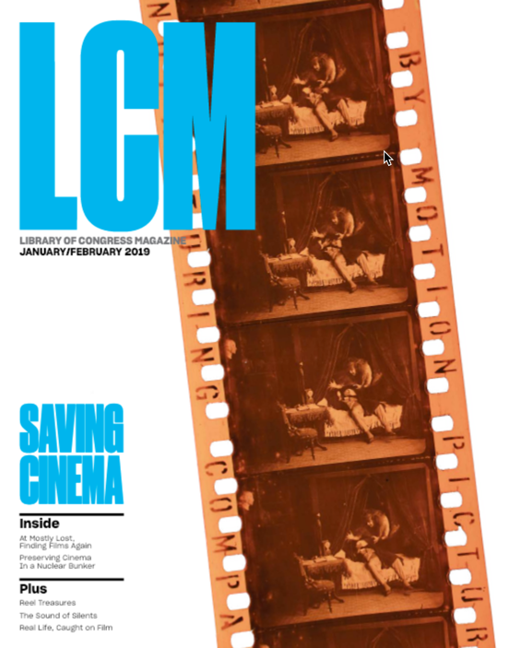
Direct to Full Text
32 pages; PDF.

https://www.infodocket.com/2019/01/17/the-janfeb-2019-issue-of-library-of-congress-magazine-focuses-on-the-librarys-film-collections-and-film-preservation-work/

