Año 4 Número 100 febrero 2019
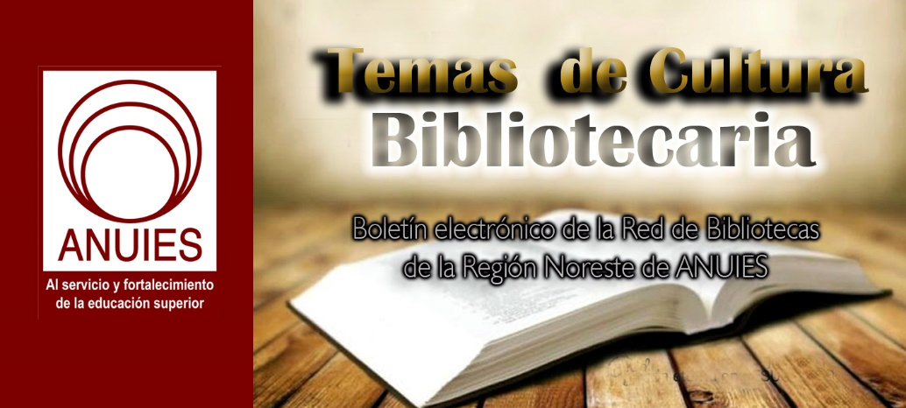

Contenidos de este número

- Dutch Universities and Elsevier Announce a Six-Month Extension To Current License Agreement
Filed by Gary Price
From VSNU:
Agreements about subscription fees for academic journals are made with academic publishers on behalf of all Dutch universities. The VSNU is currently negotiating with these publishers on the universities’ behalf. The universities are only willing to renew the subscription agreements on the provision that publishers accept 100% open access. During the next six months the VSNU and Elsevier will continue their negotiations in the joined hope that a future-proof contract will be concluded. The VSNU will report any new developments as soon as they arise.
The Association of Universities in the Netherlands (VSNU) and information analytics business Elsevier are to extend their current agreement by six months. These six months will be used to continue discussions. The VSNU continues to strive to secure commitment to 100% open access by 2020, as set out in the National Open Science Plan.
During the meetings which took place over the past months between VSNU and Elsevier, topics discussed have included open science, how a new licensing agreement contributes to an aspired future open science infrastructure for the Netherlands, and the implications of Plan S. Extending the current agreement by six months will enable the continuation of these discussions.
The current agreement with Elsevier is set to expire on 31 December 2018. During the six-month extension, access will continue under existing terms. Elsevier and VSNU will also continue their gold OA pilot, broadening this to include additional open access journals.
Further details on the current agreement can be found here.

https://www.infodocket.com/2018/12/13/dutch-universities-and-elsevier-announce-a-six-month-extension-to-current-license-agreement/

- White House Releases Five-Year STEM Education Plan
by Kara Yorio
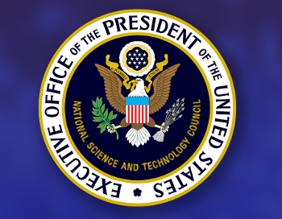
The Trump Administration revealed its five-year strategic plan for STEM education: Charting a Course for Success: A Federal Strategy for STEM Education.
The plan stresses the need for “ecosystems” that unite communities toward a common goal and recommends four pathways to success: Develop and enrich strategic partnerships, engage students where disciplines converge, build computational literacy, and operate with transparency and accountability.
The plan also calls for more inclusive STEM programs and utilizing partnerships between schools, businesses, and nonprofit organizations to leverage resources and expertise and get children connected to real-life STEM experience earlier.
The report was based on input from educators, business and community leaders, and representatives from all 50 states who attended a June federal STEM Summit at the White House.
It discusses many ways that the federal government should partner with and support educators by providing resources and opportunities. But according to U.S. News and World Report, one challenge in fulfilling the mission of the report is a lack of K–12 STEM teachers.
One of the initiative's goals is to “build strong foundations for STEM literacy.” Here it specifically discussed the way educators could implement the plan.
“Educators at all levels could increasingly augment hands-on instruction with online content and virtual experience, bringing the world to the classroom,” it reads. “Curriculum developers and teacher preparation professionals could work to accelerate the use of digital learning tools and their integration into curricula, informed by research on best practices.
“Private and public sector employers, through work-based learning partnerships, could provide the most authentic lessons in digital ethics, online information analysis, and cyber safety. Elected officials along with community nonprofits and professional organizations are well positioned to heighten the urgency of this priority among constituencies and members.”
There was no mention in the report of how much money would be needed to implement any or all of the recommendations.
Not everyone is thrilled with the emphasis being placed on these partnerships, even alliances with with nonprofits, and large digital platforms. In a recent incident, it was the students who objected. In November, nearly 100 students walked out of classes at the Secondary School for Journalism in Brooklyn, NY, protesting the Summit Learning web-based curriculum designed by Facebook engineers and funded by the Chan Zuckerberg Initiative, a nonprofit started by Facebook CEO Mark Zuckerberg and his wife, Priscilla Chan. The students said that the "personalized learning" platform was not teaching them effectively and they were concerned about the privacy of their data.

Kara Yorio
Kara Yorio (kyorio@mediasourceinc.com, @karayorio) is news editor at School Library Journal.

https://www.slj.com/?detailStory=white-house-releases-five-yearstem-ed-plan

- Duke University Receives $10 Million For Renovation and Expansion of Lilly Library
Filed by Gary Price
From Duke University:
Duke University Libraries has received $10 million in support of the planned renovation and expansion of Lilly Library, one of Duke’s oldest and most architecturally significant buildings, President Vincent E. Price announced Thursday.
The donation to Duke is comprised of three gifts: a $5 million grant from Lilly Endowment Inc., $2.5 million from Irene and William McCutchen and the Ruth Lilly Philanthropic Foundation, and $2.5 million from Virginia and Peter Nicholas.
“Duke Libraries offers our community a wealth of information and resources to further educational growth and learning,” Price said. “We are so grateful for the generosity of the McCutchen and Nicholas families and Lilly Endowment, which will renew one of our most treasured campus buildings and enhance the experience of everyone who comes through its doors.”
[Clip]
The planned renovation and expansion will update facility needs — including enhanced lighting, technology infrastructure and furnishings — to meet today’s standards of safety, accessibility, usability and service. Anticipated changes will also extend to the elegant Thomas, Few and Carpenter reading rooms while maintaining the charm and character of these favorite spaces.
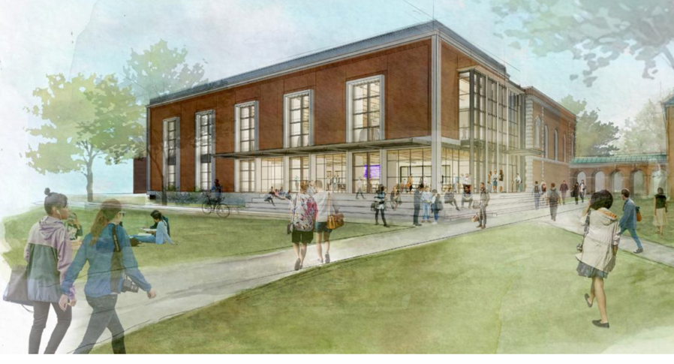
Source: Duke University Libraries
The proposed renovated building will also feature several new spaces for collaborative research and academic services, such as tutoring space for the Thompson Writing Program, event space for the Duke FOCUS Program, a student-testing facility and an exhibit gallery. An anticipated added entrance and commons space holds promise to become a crossroads environment to encourage informal interactions and allow students and faculty to gather.
[Clip]
Lilly Library opened in 1927 as Duke University’s first library on East Campus while West Campus was being constructed. It had a collection of 4,000 books and was designed to serve a population of some 600 students. For more than four decades it served as the Woman’s College Library. When the Woman’s College merged with Trinity College of Arts & Sciences in 1972, the library was renamed the East Campus Library until 1993, when it was rededicated in honor of Ruth Lilly.
Read the Complete Announcement
Direct to Lily Library Expansion and Renovation Information Page
https://www.infodocket.com/2018/12/07/duke-university-receives-10-million-for-renovation-and-expansion-of-lilly-library/
- Music: Punk is Alive and Well, Thanks to Emory Class and Stuart A. Rose Manuscript, Archives, and Rare Book Library
Filed by Gary Price
From Emory University:
The Stuart A. Rose Manuscript, Archives, and Rare Book Library’s punk rock collection, which covers 1980-2009, is essential to the class’s investigation. It allows Fritsch’s students to look extensively at punk history and culture in Atlanta and across the United States. Students spent an entire class period in October in the Rose Library interacting with the punk collection. “Students were having a great time looking through materials, picking up things they didn’t expect to see – like clothing,” Fritsch says.
For student Maggie O’Mahoney, the visit revealed just how extensive an archive can be. “When we visited the Rose Library, we looked at artifacts from zines to photographs and even concert t-shirts. It was extremely eye-opening to see that the Rose considered a wide array of objects for the exhibit,” she says.
Other students found the collection of clothing, posters and fanzines remarkably personal. “Each one of the donors for the various items had some connection to the punk movement in its earlier days, and were willing to display their souvenirs for other visitors to see,” says Yufei Han.
Read the Complete Article
See Also: Randy Gue: Passion For Punk Sparks New Library Collection (via Emory University, 2016)
See Also: Finding Aid: Atlanta (Ga.) Punk Rock Collection, Circa 1980-2009 ||| Related Finding Aids

https://www.infodocket.com/2018/12/09/music-punk-is-alive-and-well-thanks-to-emory-class-and-stuart-a-rose-manuscript-archives-and-rare-book-library/

- MIT’s Grand Challenges Issues Final Report
by Lisa Peet
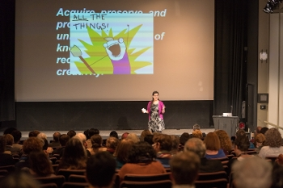
Library of Congress chief of National Digital Initiatives Kate Zwaard gives keynote speech at Grand Challenges Summit
Photo by Bryce Vickmark
In March 2018, the Massachusetts Institute of Technology (MIT) Libraries hosted a working summit on Grand Challenges in Information Science and Scholarly Communication, inviting experts from around the world “to identify critical problems in information science that are solvable within ten years and which have broad implications across the scholarly community.” The Grand Challenges Summit consisted of three consecutive workshops examining scholarly discovery, digital curation and preservation, and open scholarship.
After an open review period, in which summit attendees’ notes were condensed and refined into a public draft and community members were encouraged to comment and provide feedback, the results were distilled into a final white paper, A Grand Challenges-Based Research Agenda for Scholarly Communication and Information Science. The report was released on PubPub, the open platform developed by MIT’s Knowledge Futures Group, on December 18.
The white paper’s preface states, “this report describes a vision for a more inclusive, open, equitable, and sustainable future for scholarship; characterizes the central technical, organizational, and institutional barriers to this future; describes the areas research needs to advance this future; and identifies several targeted ‘grand challenge’ research problems for knowledge generation.” It is less a recap of the summit than an outline of potential areas for change and the possible paths that can put those changes into action within the next decade.
VISION FOR LIBRARIES
The concept of the summit originated with MIT’s Future of Libraries Task Force report, released in October 2016. The 30-person task force, organized by MIT director of libraries Chris Bourg, had gathered input over the previous year on how MIT Libraries should evolve to advance its vision for libraries as open global platforms for knowledge, and itself serve as a leader in the reinvention of the academic research library. Of the recommendations at the report’s conclusion, the final one stated, “The Libraries must become a center for research and development, fueling bold experimentation and new answers to the grand challenges facing research libraries and scholarly communication.”
In other words, Bourg told LJ, “The task force realized that in trying to design a future library and a future for scholarly communications, there are lots of unanswered questions—there's research needed to make smart decisions about which way to go.” And that process would need to start with an event that brought in voices from outside MIT, from a diverse range of perspectives and expertise. (Bourg had been advocating for such an inquiry as far back as her initial job talk at MIT almost five years ago, she added.)
With funding from an Andrew W. Mellon Foundation grant, MIT Libraries convened the Grand Challenges Summit in March 2018 to examine those challenges inherent in the scholarly communications and information science landscape.
The summit was led by coprincipal investigators Bourg and Micah Altman, director of research at MIT Libraries and head/scientist, MIT Program on Information Science, and advised by program committee members Christine Borgman (distinguished professor and Presidential Chair in Information Studies at UCLA), G. Sayeed Choudhury (associate dean for research data management and Hodson Director of the Digital Research and Curation Center, Johns Hopkins University), Charles Henry (president, Council on Library and Information Resources), historian Abby Smith Rumsey, and Ethan Zuckerman (associate professor of practice at the MIT Media Lab). Keynote speakers included Kate Zwaard, chief of National Digital Initiatives at the Library of Congress for the scholarly discovery track; Anasuya Sengupta, codirector of Whose Knowledge?, for digital preservation and curation; and Joi Ito, director of the MIT Media Lab, professor of practice at MIT and coauthor of Whiplash: How to Survive Our Faster Future(Grand Central), for open scholarship. Each of the three tracks brought together approximately 20–25 people from a variety of sectors across the United States, European Union, South Africa, India, and the Global South.
EXAMINING BIASES
Much of the summit’s discussion involved the need to examine and dismantle preexisting biases when it came to the ways information is produced, organized, accessed, gathered, stewarded, and curated.
Program committee member Choudhury was particularly interested in using the lens of equity to look at the ways information is disseminated and discovered. Using as his starting point a definition of information science offered by Carole Palmer, professor and associate dean for research at the University of Washington Information School—“the systematic evaluation of how people absorb information”—Choudhury wanted to address who those people might be, and how they might be absorbing information.
One of the key ideas that came out of the proceedings, he told LJ, was that while the typical audience for scholarly output has consisted of academics, scholars, researchers, and students, “This group has done a very nice job of thinking about other people who need to absorb information, particularly that [which] comes out of the academy, in a time when people don't know what to trust, what to believe, what is fact, what is conjecture. I think that question—who are the people we're seeking to reach with our information?—is a critical part of all of these efforts."
The definition of that content was also a major topic of discussion during the summit. “There's a whole category of information that's produced in higher ed circles that gets disseminated through channels we know about,” said Choudhury, “but there's all this other information that's produced by people in ways we don't typically tap into. At the summit I met people who had amazing viewpoints about local populations, indigenous populations, how they produce knowledge, [and] how they disseminate their knowledge”—and about not placing a value on one method or source over another. For all participants, he noted, the summit was a rich exercise in cross-pollinating disciplines and broadening horizons.
Choudhury wants to include some of this awareness in his work at Johns Hopkins, including linked data projects such as the RMap Project, a prototype service to capture and preserve maps of relationships amongst distributed components, and the ELOKA [Exchange for Local Observations and Knowledge of the Arctic] project, based at the National Snow and Ice Data Center, Boulder, CO, which has been gathering long-term climate change data from indigenous populations. “The author is not just someone who writes a paper,” explained Choudhury. For example, “it is the village elder who tells a story that's been passed down from generation to generation. You may be able to use something like linked data to actually identify people who haven’t published in the formal sense, that actually have the implicit or tacit knowledge that is critical in many ways…. [Academics] don't typically do that. We may put it in the acknowledgments or something like that, but in a machine actionable way through linked data, when you search, you realize, wait a minute, this is all…really important.”
THE MAKING OF A WHITE PAPER
Participants were encouraged to document the proceedings as the summit progressed. "At any given moment there were probably four or five people who were taking notes,” Sue Kriegsman, deputy director of the Center for Research on Equitable and Open Scholarship (CREOS) at MIT Libraries, told LJ. Notes were made accessible to attendees in real time, she added, so “during the meeting and the conversations themselves, we were getting live corrections. There were occasionally some back-channel additions and comments happening.”
At the end of each track, contributors went over the summaries of what had been captured and compared notes. “By end of the summit it was already pretty clear that there were some really strong cross-cutting themes,” said Kriegsman—although these did not necessarily break down into the same three categories as the summit’s tracks. The final report "was going to have a different set of lenses applied to the conversation [than what was discussed at the summit], because we had built those lenses along the way."
Those emerging themes included the needs to include underrepresented voices and communities outside of mainstream publishing and academic institutions, to identify incentives that will motivate people to make changes in their own approaches and processes toward a more open framework, and to identify collaborators and partners from multiple disciplines.
Once participants had weighed in on the notes, the nascent report went to a public comment period during October 2018. Invitations to comment were sent out on a number of channels and Listservs. The process took most of the month.
April Hathcock, scholarly communications librarian at New York University and a 2018 LJ Mover & Shaker, first saw the call on the American Library Association Scholarly Communication (SCHOLCOMM) discussion list. Much of her work centers around issues of diversity, accessibility, and inclusion in scholarly communications, and she was eager to be a part of the conversation, seeing the Grand Challenges as “exciting and very much in line with the work that a lot of people and a lot of places are doing.”
Hathcock first concentrated on the sections that interested her most, in order to get a feel for the conversation, circling around later to the rest of the document. “Anything [on] their work about inclusiveness, equity, I dove into those areas,” she told LJ. “I took a look at the research question section to see what was the underlying basis of the work that they were doing, of what they were exploring. From there I made my way through the pieces I hadn't read.”
She noted with approval the global nature of the conversation, and the deep dive into issues of openness and inclusion. "I appreciated the way they dug into some of the challenges and issues and took a close look at them, and some of the more systemic factors that become a part of the…challenges that they were looking at,” said Hathcock. In addition, she said, it “was helpful for me to read the comments of other people…and see some of the thoughts that were coming through, respond to some of those, as well as adding my own thoughts.”
Some areas, she felt, were lacking in the earliest days of the report—notably, issues around working with different forms of knowledge creation, particularly indigenous communities and traditional knowledge. “In that initial read-through there were places where it was clear that we were still thinking in terms of what we consider to be very traditional mainstream scholarly publishing formats or models. There was quite a bit of pushback about thinking of other ways of knowing. And I really appreciated seeing that pushback, and being able to add to that."
Hathcock invited her graduate assistant, Lingyu Wang, to read and comment as well. As an international student from China, she noted, he had good insights into the global perspective of the issues raised, and contributed some valuable perspective. A number of other Library and Information Science (LIS) instructors reportedly brought the draft to their students, both as an informational document and as a look at some of the big questions that concern the field. Grand Challenges collaborators hope that the final paper can also be used in LIS curricula going forward.
A NEW RESEARCH AGENDA
The final version of the Grand Challenges report lays out in detail the challenges, visions, and recommendations necessary to realize a more inclusive, open, equitable, and sustainable scholarly knowledge ecosystem. One area critical for these changes to happen is the role of libraries and archives as advocates and collaborators. The report states, “Librarians and archivists as professionals, and libraries and archives, as institutions, can go beyond advocacy to contribute and collaborate in the grand challenge research we have described in this paper. Further, these organizations can act as direct agents of change.”
In order for these shifts in library culture to transpire over the next ten years, "there are likely structural changes that would have to happen,” Bourg told LJ, “but I think that prior to that is the change in the definitional scope of what a library is. For us here at MIT that work started with the Future of Libraries Task Force, and has had a thread that has moved all the way through the Grand Challenges, which is to conceive of the library and ensure that the community understands the library as more than just a service."
She added, “Reconceiving of the library as having a role in advocating for, promoting, and convening—and in some cases doing research that would inform—the future of scholarship is a conceptual shift, and the structural changes would follow from that."
While the document is intended to identify research agenda for libraries and archives going forward, said Choudhury, “My hope is that [the white paper] becomes one of those documents that people refer to when having conversations around how we conduct research in information science, how we implement the practices that reflect the research. I hope this becomes a document that's not just cited but used as a roadmap.”
MIT plans to continue the call to action, and will be working to generate both enthusiasm and workable partnerships; there is also an MIT Libraries–based research initiative in the works. Bourg hopes that the whitepaper will find a variety of uses—for example, as material for grant proposals. "That's one of the objectives, actually,” she noted. “We've provided some background source material so that people who want to do research can reference the paper as a way of establishing the relevance and importance of their research."
Ultimately, said Bourg, “We've produced a call to action that motivates people who maybe weren't already participating. I hope that it also gives people who are already engaged, ready to do it, [or] doing some work, a coherence and a framework to find each other and to pull together the stuff that is already going on in the community—a framework to knit it together and start to develop a coherent evidence base."
Lisa Peet
Lisa Peet is Associate Editor, News for Library Journal.

https://www.libraryjournal.com/?detailStory=MIT-Grand-Challenges-Issues-Final-Report

- Harvard Library and MIT Libraries provide recommendations for Plan S implementation
By MIT Libraries on January 16, 2019 in Scholarly communication
155
Plan S is an initiative for open access that was launched in September 2018. It requires that, from 2020, scientific publications that result from research funded bycOAlition S members must be published in compliant open-access journals or platforms, or deposited in compliant open-access repositories. cOAlition S, a group of national research funding organizations and charitable foundations who have agreed to implement the 10 principles of Plan S in a coordinated way, has solicited public feedback on its guidance for implementation. Harvard Library and the MIT Libraries have jointly issued the following recommendations in response.

Harvard Library and the MIT Libraries are committed to fostering a scholarly communications environment which advances the values of openness, equitable access, transparency, responsible stewardship, and flexible reuse. Aligned with these commitments, we are in broad support of Plan S and its goals to ensure that publicly funded research is made openly available to a global audience. We applaud the clear, unmistakable intention behind Plan S: to provide strong, meaningful incentives to make new research open access.
To support the Plan S coalition in realizing its intention, we recommend certain adjustments to the implementation details. We’d like to see Plan S make better use of the global network of open-access repositories. We’d like to see Plan S reinforce and expand – rather than neglect or unintentionally hinder – the power of open-access repositories to democratize access to science and scholarship. We offer these suggestions out of our long experience implementing open-access policies and managing open-access repositories on our campuses.
Suggestions for the Green Open Access (Repository) Compliance Option
We commend the Plan S recommendation that “all publications and also other research outputs [be] deposited in open repositories.” However, the current Plan provides an incomplete picture of the benefits of OA repositories, indicating that “Deposit of research outputs in open repositories is recommended to ensure long-term archiving, research management, and to support maximum re-use.” We recommend that Plan S add “open access” to this list of benefits. OA repositories can provide bona fide open access. Suggesting otherwise is simply inaccurate, and more importantly, limits the coalition’s ability to grow the total corpus of OA research.
Along the same lines, we recommend that Plan S broaden the green OA option (OA through repositories), to make it less onerous and more viable for researchers. In its current form, the Plan S green option is needlessly and even harmfully narrow and difficult.
There are two good reasons to broaden the green road. First, green OA is a workable and inexpensive path to OA in all academic fields and regions of the world. Second, barriers to green OA put researchers, particularly early-career researchers, in an untenable situation. A reasonable green OA option will let researchers publish where they must in order to advance their careers, and still satisfy their funders by making their work OA. Without a reasonable green OA option, early-career researchers will be torn between the demands of their funders and the demands of their promotion and tenure committees.
A good green OA option enables authors to submit new work to the journals of their choice, and thereby answers an objection based on academic freedom. If an author’s journal of choice is not OA (or does not satisfy the Plan S criteria for eligible OA journals), then a green option would let the author comply with Plan S by making the work OA in a repository. Plan S has already expanded its original green OA option by allowing deposit of the Author’s Accepted Manuscript or the Version of Record (AAM or VOR), and by making the green OA option permanent rather than limiting it to a transition period. These are important ways to support a viable green OA option. By adjusting a few other conditions on green OA, Plan S could fully realize its vision of openness to science and scholarship while avoiding needless and damaging barriers to those who create that science and scholarship.
With this aim in mind, specifically, Harvard Library and the MIT Libraries recommend that Plan S:
- Change four required features of OA repositories to recommended features:
  - Automated manuscript ingest facility
  - Open API to allow others (including machines) to access the content
  - QA process to integrate full text with core abstract and indexing services (for example PubMed)
  - XML format for repository contents (more on this below)
- Be more explicit and clear on the distinction between repositories and platforms.The existing language is likely to leave readers with the view that the rules about “platform OA” apply to repository (or green) OA.

- Reduce the barrier to meeting the green OA requirements by allowing Creative Commons licenses other than CC-BY and CC-BY-SA.

- Clarify what we understand to be Plan S’s intent: to require green OA “without publisher embargoes.” This language should supplant the existing requirement that the work “be fully available OA at the time of publication.” While immediate OA is a laudable goal, the existing language leaves no room for inevitable logistical delays in obtaining and depositing articles.

- Reduce the requirement that green OA texts be in XML to a recommendation. As a requirement, this would generate high and frequently insurmountable barriers to meeting Plan S’s green OA requirements. Making it a recommendation, rather than a requirement, would also mirror the Plan S’s rules for goldOA texts.

- Add a rights-retention requirement to facilitate the green option. There are several ways to do this.

  - One model for this approach exists in the US, where there is a standing “federal-purpose license” that makes it unnecessary for federal agencies to ask authors to retain rights. (For complicated reasons, the NIH does not currently use that standing license, but instead requires that grantees retain sufficient rights to post the works in accordance with the NIH’s Public Access Policy.) The Wellcome Trust uses a method similar but not identical to the NIH.
  - We recommend that coalition members check to see whether there are comparable standing licenses in their own countries. Even if there are not, we recommend that they build the retention of nonexclusive rights into the language of their funding contracts. That would give them all the rights they need to meet Plan S requirements. It would streamline the rights-retention or license-acquiring part of the policy and avoid trapping authors in situations where publishers balk at allowing authors to retain sufficient rights.

- Clarify that authors are not required to make double deposits. The current language says the Accepted Author Manuscript or the Version of Record (AAM or VOR) must be available on a certain timetable, “including the early view version.” This language could be interpreted to mean that authors must always deposit a preprint, even when they are also depositing the AAM or VOR. This is unnecessary and adds a needless burden for researchers.
Suggestions for the Gold Open Access (Journal) Compliance Option
- Require both DOIs and ORCIDs. The implementation guidelines require eligible journals to use DOIs, but merely recommend that they use ORCIDs. ORCIDs and DOIs are both critical infrastructure that can help us realize the potential of the digital age to improve access to science and scholarship, and Plan S should capitalize on the opportunity to widen use of both. Requiring ORCIDs would align with the view of several members of the Plan S coalition who signed an open letter (December 6, 2018) calling on funders to user ORCIDs and committing to using ORCIDs themselves.
- Provide financial support for no-fee OA journals, as coalition members are already willing to do for fee-based (APC-based) OA journals. The implementation guidelines acknowledge the existence and value of no-fee OA journals (“cOAlition S explicitly acknowledges the importance of a diversity of models and non-APC based outlets”). Providing support for no-fee OA journals will avoid the perverse effect of giving no-fee journals an incentive to start charging fees. While the coalition thinks about the best specific ways to support no-fee OA journals, it could offer financial support in general terms, as it does now for OA infrastructure.
We appreciate the opportunity to comment on Plan S, and look forward with great optimism regarding its potential to advance equitable access to science and scholarship for all.
Sincerely,
Chris Bourg, Director, MIT Libraries
Amy Brand, Director, MIT Press
Greg Eow, Associate Director for Collections, MIT Libraries
Ellen Finnie, Head, Scholarly Communications and Collections Strategy, MIT Libraries
Peter Suber, Director, Office for Scholarly Communication, Harvard University

https://libraries.mit.edu/news/harvard-library/29052/
7. Tulane University joins VCU Libraries' Image Portal project
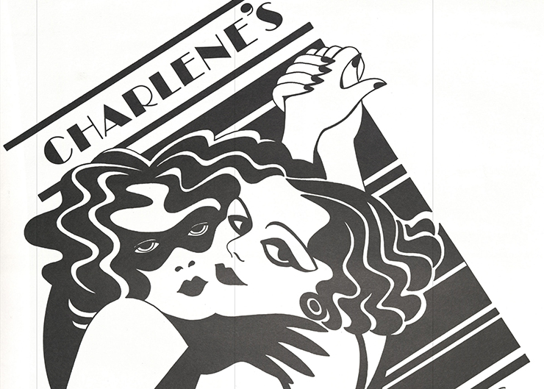
"Charlene's, New Orleans 1977 - 1999” Marilyn McConnell papers, Newcomb Archives, Newcomb College Institute, Tulane University
VCU Libraries welcomes Tulane University as a partner in the Social Welfare History Image Portal.
The Image Portal presents archival materials related to the history of social reform and social welfare in the United States. These images include photographs, pamphlets, placards, handbills, and comics pages drawn from the collections of VCU Libraries and other participating institutions. The site was awarded the 2018 Center for Research Libraries Primary Source Award for Access.
“The Image Portal is strengthened as each new partner increases the connections people can make between institutions’ collections,” said Alice Campbell, project manager. “Tulane University has such a fantastic range of materials of both local and national significance. Their collections include civil rights, labor, LGBTQ issues, charity organizations, and all the complex mix of people and cultures found in New Orleans.”
Howard-Tilton Memorial Library, the main library for Tulane University, is an integral part of the Tulane experience, providing access to more than 4.5 million books, 81,000 electronic and print journals, and almost 1 million e-books. In addition to its core holdings of books and journals, Howard-Tilton hosts a wide range of events and services tailored to meet the needs of their students, faculty, and community.
Several specialized academic libraries are managed by Howard-Tilton, including the Rudolph Matas Library of the Health Sciences, the Latin American Library, the Architecture Library, and the Math Library.
Howard-Tilton has deep and rich archives within its distinct Special Collections areas which include The Hogan Jazz Archive, the Louisiana Research Collection, and the Southeastern Architectural Archives.
The materials for Tulane University’s contributions to the Social Welfare History Image Portal come from the multiple Special Collections within Howard-Tilton as well as from two other collaborating archives on campus, the Newcomb College Institute’s Newcomb Archives and the Amistad Research Center.
Jeff Rubin, Digital Initiatives & Publishing coordinator at Howard-Tilton Memorial Library noted, “The Social Welfare History Image Portal is an extraordinary project to be involved in for Howard-Tilton, Newcomb, and Amistad. The broad scope of the Image Portal is the perfect project to share a large and diverse group of materials covering the deep history of social welfare and social advocacy in New Orleans and Louisiana. Our library and campus partners are thrilled to be able to share materials that might not normally be seen by the public in the larger context of social welfare.”
Welcome to the Image Portal, Tulane University!

