Año 3 Número 94 diciembre 2018

Contenidos de este número

- UCLA Library Launches International Initiative to Save At-Risk Cultural Heritage Materials with $5.5. Million Grant from Arcadia
Filed by Gary Price on October 9, 2018
From the UCLA Library:
The UCLA Library has launched Documenting Global Voices with a $5.5 million grant from Arcadia, a charitable fund of Lisbet Rausing and Peter Baldwin. This ambitious new international initiative will preserve at-risk cultural heritage materials and make them publicly available online on a UCLA-hosted website.
Through Documenting Global Voices, the library will award grants to archives and cultural heritage organizations around the world. The program will focus on regions with limited capacity for preservation and where archival materials may be in danger of being lost.
“Arcadia’s visionary funding for Documenting Global Voices enables the library to directly support UCLA’s mission to create, disseminate, preserve and apply knowledge for the betterment of our global society,” said Ginny Steel, Norman and Armena Powell University Librarian. “We are deeply grateful to Arcadia not only for this gift but for its exemplary leadership in preserving cultural heritage and promoting open access.”
Documenting Global Voices complements the British Library’s Endangered Archives Programme, also funded by Arcadia, which provides grants to preserve materials from the pre-industrial era. The new initiative’s contents will include rare and unique materials of historical, cultural and social significance dating from post-industrialization to the present.
[Clip]
Further information about this new initiative is available on the Documenting Global Voices website. The first call for proposals opens December 1, 2018.
This project continues the partnership between the UCLA Library and Arcadia, which share a steadfast dedication to making recorded history freely and openly available. Arcadia’s support of the library includes gifts to develop the International Digital Ephemera Project, an initiative to digitize, preserve and provide public access to materials produced worldwide; publish open access monographs; and digitize and make openly accessible rare and unique manuscripts held by St. Catherine’s Monastery in the Sinai.
Read the Complete Announcement
See Also: More About the Endangered Archives Program at the British Library ||| Endangered Archive Program Grants
See Also: UCLA Library to Host Digital, Open Access Archive of Ancient Arabic and Syriac Manuscripts (August 14, 2018)
See Also: UCLA Library Builds Worldwide Digital Archival Network (International Digital Ephemera Project (IDEP))(April 23, 2018)
See Also: Azerbaijan National Library and UCLA Library Sign Memorandum of Understanding (January 10, 2018)

https://www.infodocket.com/2018/10/09/ucla-library-launches-international-initiative-to-save-at-risk-cultural-heritage-materials-with-5-5-million-grant-from-arcadia/

Atypon, Elsevier and Digital Science Collaborate to Provide Article-Level Data From Mendeley, Dimensions, ReadCube, and Papers
Filed by Gary Price on October 9, 2018
From a Joint Announcement:
Scholarly publishers will soon be able to receive usage reporting from Mendeley, Elsevier’s leading Scholarly Collaboration Network (SCN), and Digital Science’s literature discovery tools, ReadCube, Papers, and Dimensions. These industry firsts are made possible by a collaboration led by Elsevier, Atypon, Digital Science and COUNTER to develop a new standard for Distributed Usage Logging (DUL).
[Clip]
As researchers increasingly access journal content through off-library and off-campus platforms outside of standard COUNTER reporting channels – assessing true usage is extremely difficult. Most libraries evaluate their subscribed content using standard COUNTER reports that provide only a partial picture, which can lead to inaccurate assessments of the value of content under both subscription and open access business models.
To help address this issue, Mendeley and Digital Science will begin providing publishers with article-level usage on scholarly content accessed and shared via their tools. Developed with technical support and infrastructure from Crossref, and fully aligned with COUNTER’s Code of Practice Release 5, this data will be provided back to the original publisher and anonymized to the institution-level ensuring individual user privacy is preserved.
Beginning in early 2019, Atypon’s Literatum will be able to receive the article-level usage data generated from Mendeley and Digital Science to share with over 200+ of their publishing clients. Elsevier will also be incorporating DUL data into the COUNTER-compliant reports available to their customers.
Read the Complete Announcement
See Also: Release 5 Code of Practice (via Project Counter)

https://www.infodocket.com/2018/10/09/atypon-elsevier-and-digital-science-collaborate-to-provide-article-level-data-from-mendeley-dimensions-readcube-and-papers/

- Cornell University: “Students Use Library Portal To Talk Global Health Care”
Filed by Gary Price on October 9, 2018
From the Cornell Chronicle:
Using the Cornell Portal outside Olin Library, Emma Wagner ’21 talked with two young people from Kigali, Rwanda, who told her health care is better in urban areas than rural ones and explained the country’s universal health care system. The Rwandans also asked Wagner about the MeToo movement in the U.S.
“The most surprising thing to me was how similar we all were,” Wagner said. “I was in the portal with three other guys, and the conversation was just so easy and natural. We all pretty much listen to similar music, watch the same shows and even have very similar hobbies.”
Wagner’s conversation about health care was part of an assignment for her Ethical Issues in Health and Medicine class, taught by Kim Overby of the Department of Science and Technology Studies. Each of the 130 students in the class had to choose a session and have a conversation inside the Cornell Portal, a gold-painted shipping container equipped with innovative audiovisual technology and life-sized screens that allows for conversations with other portals around the world.
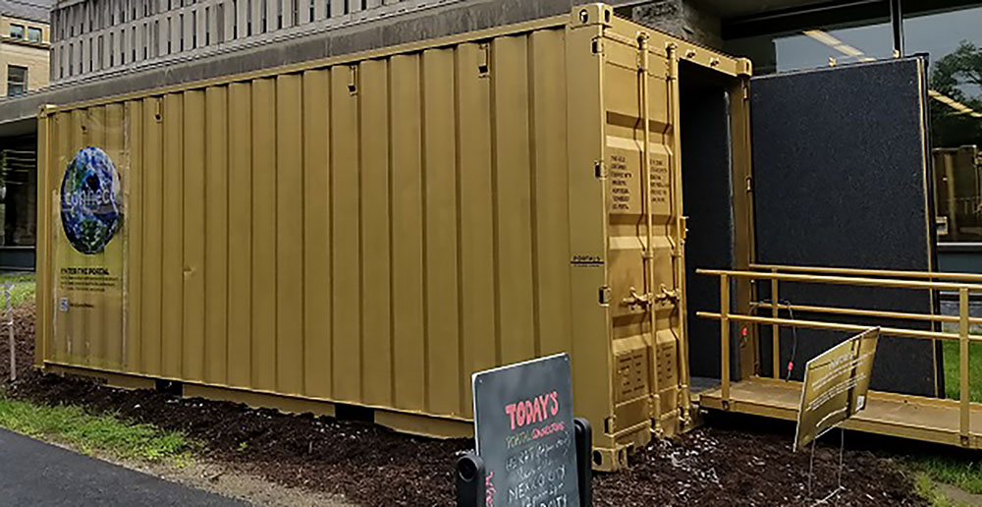
Portal at Cornell Source:Cornell University Library
Read the Complete Article
See Also: Global Engagement: Immersive Audiovisual Technology Will Be a Part of New Cornell Library On-Campus Portal Made From a Shipping Container (October 26, 2017)
See Also: Cornell Portal FAQs (via Cornell University Library)

https://www.infodocket.com/2018/10/09/cornell-university-students-use-library-portal-to-talk-global-health-care/

- Adam Matthew Launches Quartex Digital Library Platform
by Matt Enis
Oct 24, 2018 | Filed in Technology

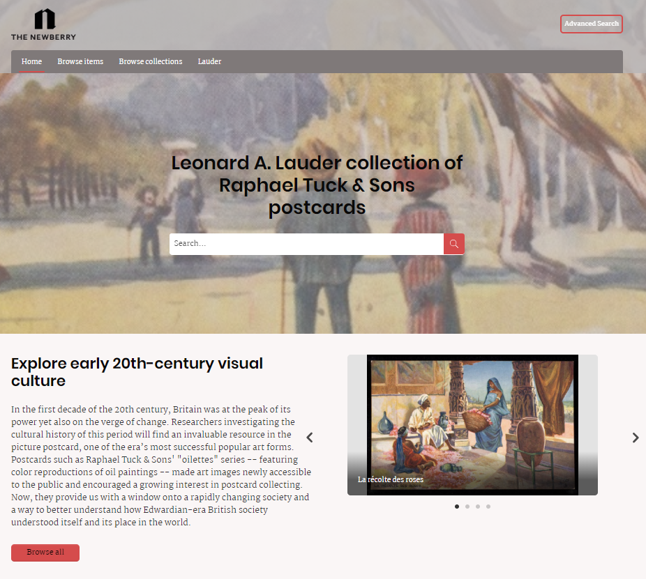
Adam Matthew Digital, a SAGE company, has launched Quartex, a digital asset management solution designed to help libraries showcase archival collections. Informed by the white label platform that the company initially developed in 2012 to create its own digital collections and products, Quartex is a Software as a Service (SaaS) platform that includes cloud-based hosting and preservation of master files.
Company representatives emphasized that while the in-house platform served as a starting point, Quartex was built from the ground up with input from libraries. At launch, Quartex features include tiered back-end access management for staff workflows; simple migration of existing digitized assets and metadata from other platforms and repositories; International Image Interoperability Framework (IIIF) support; advanced in-platform cataloging options with support for most metadata standards; customizable dashboards to generate reports on asset types, status, and storage; and support for all major image types, audio, and video files.
Once collections are uploaded, Quartex generates Web Content Accessibility Guidelines (WCAG)–compliant websites with tablet- and smartphone-ready responsive design, branding and styling options, usage statistics and site analytics for each published collection, an IIIF-compatible image viewer, the option of federated search across all Quartex-published content including content at other institutions, and more.
“Libraries want an out-of-the-box solution that will enable them to present content really professionally without needing a team of people with technical expertise,” Khal Rudin, managing director of Adam Matthew, told LJ. “The main challenges [libraries] face is finding something that they can use that looks professional without requiring a bespoke built system” using open source solutions such as Omeka, DSpace, or Fedora.
Quartex can also utilize integrated optical character recognition (OCR) capability to make collections of printed works full-text searchable. With additional per-image fees, it can also go a step further, enabling Handwritten Text Recognition (HTR) to make a library’s digitized handwritten holdings, including manuscripts, letters, and more, full-text searchable as well. Launched last fall by Adam Matthew Digital, HTR is a proprietary artificial intelligence technologythat utilizes neural networks to “train” its software to recognize a range of handwritten characters in linguistic context (currently all Western European languages), bringing the search functionality of OCR to digitized handwritten collections.
“For the end user, one of the key [benefits] is going to be search functionality,” Martin Drewe, head of platform services for Adam Matthew Digital, told LJ. “It should be easy to discover content and find relevant content…. Any content that you publish through Quartex can be made full-text searchable.” An upcoming release scheduled for December will include the ability to create in-platform transcripts of audio and video files, and to edit those transcripts, Drewe added.
In the process of developing Quartex, features have been incorporated in response to the varied needs of Adam Matthew’s customers. This will continue as the platform is refined.
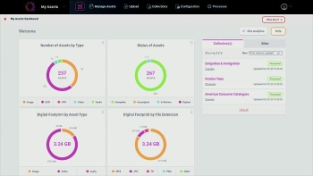
“Everyone has different needs,” Drewe said. “We’ve been in discussion with a lot of the archives that we regularly partner with, and over the course of the last couple of years, we’ve been taking on board various customer requirements. And we’re able to respond pretty quickly to…external customer requirements and build those in,” ranging from simple requirements such as persistent URLs to the IIIF-compliant image viewer that launched with the platform.
Other customer-inspired functionality includes the ability to publish any individual digital asset to multiple digital collections. And the company is in the process of integrating support for the Mirador image viewer, which will enable end-users to view related content published or hosted in repositories around the world that support IIIF APIs.
“I think it’s key for anyone developing a product such as this…. It’s the outreach that’s important. You’ve got to have listening briefs,” Drewe said. “That’s the way we’ve developed the platform and will continue to do so.”
Going forward, new features created in-house for Adam Matthew Digital will also be integrated into Quartex.
“When we develop a feature now, we want that to sit in a suite of features that is available for use across the Quartex platform,” Drewe said. “So, whether that’s a certain type of data visualization or mapping tool [for example], the idea now is that when we publish something through our commercial collections, we’ll be adding to the suite of features that can then be used across any of our collections, but also will be made available to Quartex users.”
Throughout development, Adam Matthew Digital has focused on ease of use, both by library staff and end users, Drewe said. “It’s easy to get your content and metadata in…and create collections. It’s easy to style and configure and brand those and then publish. On the front end the flexibility around being able to publish or edit content, you can do that in minutes. You don’t have to go through an IT team."
Pricing is negotiated based on factors including Adam Matthew subscriptions and archive size (minimum of 100 gigabytes), as well as additional fees for OCR and HTR capabilities.
Matt Enis
Matt Enis (menis@mediasourceinc.com, @matthewenis on Twitter, matthewenis.com) is Senior Editor, Technology for Library Journal.

https://www.libraryjournal.com/?detailStory=181024Quartex

- GSU E-Reserves Case Goes On After Publishers Win Second Appeal
First filed in April of 2008, the suit alleges that GSU administrators systematically encouraged faculty to offer students unlicensed digital copies of course readings as a no-cost alternative to traditionally licensed course-packs.
by Andrew Albanese |
Oct 22, 2018
Comments
Elbert P. Tuttle Courthouse in Atlanta, home of the 11th Circuit Court of Appeals.
For a second time, publishers have won an appeal in the long-running Georgia State University (GSU) e-reserves lawsuit. However, the case was once again remanded to the district court, giving district court judge Orinda Evans yet another crack at deciding the case.
In a concise 25-page decision filed on October 19, a three-judge panel of the 11th Circuit Court of Appeals unanimously vacated Evans' latest decision in part, and upheld it in part, and once again sent the case back to her with instructions for weighing what would be her third verdict. The appeals court also threw out the award of attorneys fees against the publishers.
RELATED STORIES:
- More in Digital -> Copyright
Want to reprint? Get permissions.
FREE E-NEWSLETTERS

PW Daily Tip Sheet
More Newsletters

The appeals court decision is the latest twist in the now decade-old copyright case. First filed in April of 2008 by three academic publishers (Oxford University Press, Cambridge University Press and Sage Publications, with support from the Copyright Clearance Center and the AAP) the suit alleges that GSU administrators systematically encouraged faculty to offer students unlicensed digital copies of course readings (known as e-reserves) as a no-cost alternative to traditionally licensed course-packs.
In 2012, Evans first ruled against the publishers, finding that GSU's copying was fair use in all but five of 48 instances presented at trial. In October, 2014, however, the 11th Circuit reversed for the first time, and sent the case back to Evans with instructions to re-balance her four-factor fair use analysis in more “holistic” manner and to give the fourth fair use factor (market effect) “additional” weight in her overall analysis.
“
The law, Pryor wrote for the panel, precludes Evans from revisiting issues already decided and affirmed.
”
In her March, 2016, remand decision Evans did give the fourth factor more weight—but she also went back and re-did parts of her fair use analysis for each claim in the suit, including a closer look at the pricing and actual permissions revenue at stake for each claim in prior years. In Friday’s opinion, the appeals court held that Evans erred in doing so.
“The district court interpreted our earlier decision to instruct it to change its fourth-factor analysis for the 31 excerpts for which digital permissions were available, but the district court misinterpreted our mandate,” the decision, written by Judge William Pryor, reads. “The only error we identified in the district court’s treatment of the fourth factor was that, in weighing and balancing the relative importance of the factors, it undervalued the ‘severe’ threat of market harm posed by the University’s ‘non-transformative’ copying. We did not instruct the district court to revisit its earlier findings that factor four favored infringement when we instructed it to reweigh the factors on remand.” The law, Pryor wrote for the panel, precludes Evans from revisiting issues already decided and affirmed.
The decision did not come as a surprise, as Pryor raised this very issue during the appeal hearing in July of 2017.
In addition, the Appeals court also held that Evans once again employed an inappropriate, mechanistic approach to weighing the four factors of her fair use test. “Although the district court heeded our instructions in Cambridge II when it recognized that some factors are more important than others,” the opinion states, “it failed to break free of its erroneous ‘arithmetic approach’ and to give each excerpt the holistic review the Act demands.”
Judge William H. Pryor.
The court did, however, uphold Evans’ decision not to reopen the record in the case after the last appeal, as the publishers had requested. After the first appeal decision, the publisher plaintiffs sought to introduce new evidence that digital permissions were in fact available for a number of works considered at trial, which, the Appeals court held, Evans was within her rights to reject.
The case now heads back to Evans with instructions that will almost guarantee she returns with more infringement findings in her third opinion.
"The district court must reinstate its earlier findings that factor four strongly disfavors fair use for 31 of the 48 excerpts," the opinion states. "The district court must eschew a quantitative approach to the weighing and balancing of the fair-use factors and give each excerpt the holistic, qualitative, and individual analysis that the Act demands. And the district court must omit any consideration of price from its analysis of the third factor."
Barring a settlement, the decade-old case could still be far from a resolution.
In a statement, The Association of American Publishers (AAP) said it was "gratified" by the decision. "In reversing the district court’s erroneous findings and vacating the award of attorney’s fees," the statement reads, "the appellate panel for the second time rejected what it called a ‘mathematical formula’ of fair use in favor of a ‘qualitative consideration of each instance of copying in the light of its particular facts.’"
In a post on the blog In the Open, Kevin Smith, Dean of Libraries at the University of Kansas, who has followed the case closely from the beginning, says the latest decision seems mostly to point out out how "trivial" the case has become.
"After working on it for one year, two months, and three weeks, the court produced a decision in only 25 pages, which sends the case back, yet again, for new proceedings in the district court," Smith writes. "The saddest thing about this case is that, after ten years, it continues to chew over issues that seem less and less relevant. Library practices have evolved during that time, and publishing models have changed. Open access and the movement toward OERs have had a profound impact on the way course materials are provided to students. So the impact of this case, and of any final decision, if one ever comes, will be negligible. The plaintiff publishers actually lost a long time ago, they simply lack the wisdom to recognize that fact."
We will update this story with more reactions as they come in.

https://www.publishersweekly.com/pw/by-topic/digital/copyright/article/78401-gsu-e-reserves-case-goes-on-after-publishers-win-second-appeal.html

- Librarians Run for Office
by Kara Yorio
Oct 18, 2018 | Filed in News & Features

Update: Mary Kunesh-Podein won re-election in Minnesota's District 41B.
Jolene Armstrong lost in Oklahoma's 13th.
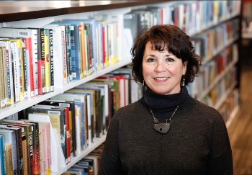
Election Day is less than three weeks away and, this year, ballots across the country were impacted by an influx of educators seeking political office.
“I’m really encouraged by that,” says Mary Kunesh-Podein, library media specialist at Robbinsdale Middle School, in Minneapolis, MN, and state representative in District 41B. “Teachers are becoming empowered. They’re the ones that are boots on the ground, and they’re the ones that take the real issues to the legislature.”
Kunesh-Podein (left) was ahead of the curve, winning her state representative seat in 2016. She is running for reelection this year, the veteran among a handful of librarians and library media specialists who took the initiative for the first time in 2018. She agrees that the walkouts and support around the country helped motivate teachers to campaign, but she also cites another motivating movement.These teacher-candidates from both parties entered races riding the momentum of the spring teacher walkouts and surrounding public support. Many also feel an urgency to have a voice not only on local and national education legislation, but also on the other issues that most impact their profession and students. While some lost in primaries, others have made it to the general election on November 6.
Bringing a Special Skill Set
Library professionals could bring an important skill set to political office. In all the skills, one particular aptitude stands out—especially in this era of Fake News and political statements that are often repeated without challenge of accuracy.
“Being a library media specialist is different than being in any other profession in the world,” says Spoon. “We have access to databases, and it takes me three seconds to pull this information up. It’s documented—it’s not just Google.”
Bechard agrees.
“The No. 1 skill that helps me as a librarian—knowing how to research,” says Bechard. “Knowing what good information is—knowing how to find good facts, knowing not to just take a person’s word for it, but to do that research myself.”
They can also debate a topic confidently. When someone argues a certain subject, Spoon is proud she presents the facts without getting caught up in the emotion.
“I’m very calm—these are the facts, this is what was passed, this is what has been said, and that’s the end of it,” she says.
A librarian candidate also often comes with a community of fellow researchers ready to support them.
“If I had a question about anything, I would put it out there for the librarians,” Spoon says. “‘Hey everyone, do you have an expert resource on this?’ It was like boom! Listserv mania.”
Her inbox would immediately light up with results to help her support her statements or discuss the issue accurately and intelligently.
In many schools and public libraries, teaching, or at least managing, technology is part of the job as well. Knowing the latest education technology and what schools actually do and do not have would be useful in governing as well.
Beyond the research and tech skills, working in a library requires dealing with unhappy parents, administrators, or patrons complaining or asking for more.
“Being a politician would not be very different,” says Spoon. “I’m always negotiating something with someone who is very upset.”
Librarians know how to collaborate, but they also won’t back down or compromise their teaching as they juggle a building (or more) of students, and multiple tasks and responsibilities.
“People come in [to the library] and say, ‘We need this for our class today,’” Spoon says. “And I say, ‘No, I’m doing a lesson over there, and I’ve got a makerspace going with origami, and I’m teaching a class about how you can’t just steal people’s intellectual property. I’m teaching about citing sources and another class over here is working on decorating pumpkins for their book report.”—K.Y.
“I think the majority of teachers are women, and I think the #MeToo Movement has really energized and empowered women,” says Kunesh-Podein. “When they’re getting together, they are saying, 'we’ve got to do something.'”
Jolene Armstrong, librarian at Okmulgee (OK) Primary School, is on the ballot for a state House of Representatives seat in Oklahoma’s District 13. Melanie Spoon, library media specialist at James L. Capps Middle School in Warr Acres, OK, ran to represent District 81 in the state’s House of Representatives. Staci Bechard, librarian at the Montana School for the Deaf and Blind, was a Democratic candidate for Montana’s District 25. Spoon and Bechard lost their primaries after making late decisions to run.
“This is the first time I’ve had the guts to say, 'I’m going to run for office, I’m going to throw my hat in the ring,'” she says. “I’m going to do it because I believe in women.”For Spoon, becoming a candidate was an extension of her political activism over the years. It started when her mom took her on the teachers walkout when she was 14. A lifelong Republican who idolized First Lady Barbara Bush and was motivated to get her MLS and move from the classroom to the library by George W. Bush’s wife, Laura Bush, she has made calls and written letters to government officials and the Republican National Committee for years. But this year was different.
In Montana, Bechard decided she could no longer just yell at the TV and criticize politicians from afar.
“I had heard a number of people say, 'this is the time we need your voice, this is the time for regular citizens to stand up to make a stand for what we believe in,'” she says. “I live and breathe the issues of the Democratic platform. One of my daughters has a chronic healthcare issue. My other daughter is special needs. So I wanted to be a person who got up at the front lines and stood up for folks, especially with healthcare, disability, with education. Those are all very important to me.”
So important, in fact, that she was willing to make herself uncomfortable and learn on the fly.
“I wasn’t the most polished person out there,” she says. “It didn’t come naturally to me to knock on doors, but I felt so strongly about it that I pushed through. When I actually started talking to people face-to-face, it inspired me to know I was doing the right thing. Here are people who have issues that are so important, such as healthcare, the opioid epidemic. We needed that person to stand up for them.”
National decisions, local action
While many may have considered Bechard, a Democrat, a long shot in “red state” Montana, she says people are wrong to judge her homestate that way.
“There is a lot of independent thinking here and a lot of strong people, especially women,” she says. “I was so incredibly inspired and motivated to come out of my shell by the people I met, by the legislators I met who were already serving and the candidates who were running. A lot of them were really strong, exceptional women.”
Bechard and Spoon express a common belief that middle ground can be found in their states.
Bechard speaks with a potential voter.
“I’m very passionate about finding a way for us to come together, compromising the political platform just enough so we can get something done,” says Spoon.
After their primary losses, neither woman has decided if she will run again, but they didn't drop out of these midterm elections completely. Bechard is now knocking on doors for Democrat in a different district.
“Jackie and I met at a candidate forum, and we hit it off, because we just have the same goals,” says Spoon (left), who added that Oklahoma doesn’t have the bitter political party divide that other areas in the country do. Spoon is working for the candidate she thinks will best represent the district. In this election, that means the long-time Republican is now helping Democrat Jackie Phillips.
Still, some people—especially her fellow Republicans—have asked her about Phillips’ opinion on national issues. To those potential voters, Spoon stresses that this is a local election with a candidate who wants to “do what’s best for our district, our region in our state.”
That said, Spoon herself was motivated to run in part by a national decision and the fallout from it.
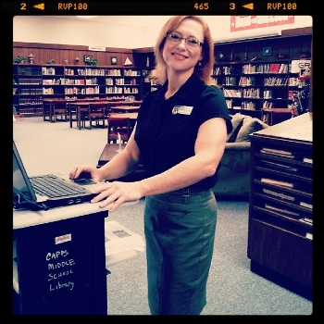
Spoon in her library at Capps Middle School.
“When they appointed Betsy DeVos as our education secretary, that was just a huge slap in the face,” she says. “This woman does not represent public schools. We don’t understand why she has that position being in charge of public education. And that’s me, a Republican.”
Kunesh-Podein singles out the union-limiting Supreme Court decision in Janus v. American Federation of State, County and Municipal Employees. It was another kick to those who feel as if they are constantly being asked to do more with less.
“As an educator for these last 20-something years, I’ve seen the cycle of underfunding education, unfunded mandates to school districts that drain whatever funds they have available,” she says. “I felt like I have an opportunity here to voice some of the concerns and work on these issues to ensure that we are providing the best educations we can for our students and, at the same time, creating a positive academic environment for teachers and administrators to thrive and continue to do their very best work.”
Who better than educators?
In her two years as a state representative, Kunesh-Podein realized that educators need to be there—if for no other reason than to properly inform the vital education legislation. Her first year, she was stunned by what she heard in education committee meetings. She couldn’t believe what the representatives thought were important issues in schools and their ideas for solutions.
“At first, I was not sure how I was to respond, but at one point I just said, 'I can’t sit here quietly. I cannot sit idly by and let people think this is the reality when indeed it was not at all,'” she says. “So I started speaking up more and more and going to talk to some of the legislators who were proposing things that weren’t worth our time or efforts in the legislature. Often times I would find out that some lobbyist brought it to them.”
Like Bechard, with her very personal connection to healthcare, Kunesh-Podein and Spoon have personal experiences they brought with them as candidates. Both have been single moms, taking multiple jobs and at times worrying about making ends meet. They know the struggles families face. Kunesh-Podein needed public assistance when her new teaching job couldn’t cover the bills and the cost of raising children. She wants to be there—in the state house and her school library—for those families struggling like she once was.
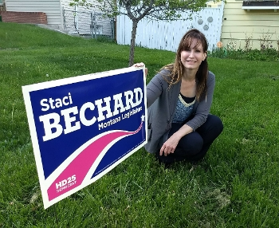
Perhaps most importantly, these women and all of the educators in races across the country this year have spent years creating relationships with students and families, learning their struggles, seeing the importance of a good education first hand and know the impact societal issues such as poverty, trauma, hunger, and a lack of resources can have on a child and community.
“Who knows families and kids better than teachers?” says Kunesh-Podein. It’s about finding solutions to more than poor test scores, she says. “Mental health issues, financial struggles, homelessness, parents working more than one job and not being able to give the students the attention sometimes that they need. How can we meet those needs without taking over but at the same time being really supportive of the family and the student?”
Says Bechard, “Teachers and librarians are well-versed in a number of issues that affect all of us. They see it daily in classrooms. Teachers see the big picture, and that’s why they make good candidates.”

https://www.slj.com/?detailStory=librarians-run-for-office

- National Science Foundation (NSF) Awards $78.2 Million (225+ New Projects) to Support Cybersecurity, Privacy Research Including Award for Center for Trustworthy Machine Learning (CTML)
Filed by Gary Price on October 24, 2018
From NSF:
The National Science Foundation (NSF) Secure and Trustworthy Cyberspace (SaTC) program announces new support for a diverse, $78.2 million portfolio of more than 225 new projects in 32 states spanning a broad range of research and education topics, including artificial intelligence, cryptography, network security, privacy, and usability.
The new portfolio is headlined by an award for the Center for Trustworthy Machine Learning (CTML), which will address grand challenges in cybersecurity science and engineering that have the potential for broad economic and societal impacts. CTML is a Frontier project, a large-scale, multi-institution effort with work that crosses disciplines.
[Clip]
Recent advances in machine learning have vastly improved the capabilities of computational reasoning in various domains, exceeding human-level performance in many tasks.
Despite these advances, significant vulnerabilities remain. Image recognition systems can be easily deceived, malware detection models can be evaded, and models meant to catch problems can be left vulnerable if they are attacked and manipulated while they’re being “trained.” The new Frontier CTML will work to develop an arsenal of defensive techniques for building future systems in a safer, more secure manner.
“This Frontier project will develop an understanding of vulnerabilities in today’s machine learning approaches, along with methods for mitigating against these vulnerabilities to strengthen future machine learning-based technologies and solutions,” Kurose said.
The $10 million, five-year CTML award will allow the center to focus on three interconnected and parallel thrusts of machine learning:
- Investigating methods to defend a trained model from adversarial inputs.
- Exploring rigorously grounded measures of model and training data robustness.
- Identifying ways adversaries may abuse generative machine learning models and developing countermeasures for defending against such attacks.
[Clip]
In addition to Penn State University, the CTML collaborating institutions include Stanford University, University of Virginia, University of California-Berkeley, University of California-San Diego, and the University of Wisconsin-Madison.
Review List of 225 New Projects Receiving Funding
Read the Complete Release

https://www.infodocket.com/2018/10/24/national-science-foundation-nsf-awards-78-2-million-225-new-projects-to-support-cybersecurity-privacy-research-includes-award-for-center-for-trustworthy-machine-learning-ctml/

Humanizing queer history
Oct 23, 2018
This post is an excerpt, authored by Claudio Garcia, a student worker in Noble Library and a classics major at ASU. Here, Garcia examines the need to preserve LGBT history in Arizona and its impact on queer youth.
Growing up queer for me was, as it is for many others, an intensely lonely experience. Being in the closet left me isolated from the friends and family to whom I was meant to be closest. The shame of hiding a secret and the fear of losing those relationships by revealing myself prevented these relationships from reaching a place of true security and trust, and as a result left me with little deep connections.
Being Mexican-American only pushed this loneliness further, as I was distanced from my own culture - a culture of intense machismo and masculinity - by my own femininity. Coming out of the closet did little to alleviate this loneliness. Although I was blessed with an accepting and compassionate family, my distance from the hyper-masculine culture of my own family was irreversible.
For many years, I remained unaware of a thriving queer culture and history that was far more compatible with my personality. For too long, queer people have been erased from history, at best, or been demonized by educators and historians, at worst. Despite working for ASU Library, I did not become acquainted with the work of special collections until I found the Arizona LGBT History Project, a collaboration between ASU Library and Phoenix Pride, the largest LGBT organization in the state.
Immediately, I was captivated by the project. I had the luck of studing queer history in college, but I knew that many did not have the same opportunities. I could only imagine how I might have been affected - how much loneliness and disconnection I might have been spared - if I had known about such a project in my own youth.
[Read: ASU Library partners with Phoenix Pride to preserve LGBT history in Arizona]
While many queer youth, tragically, still lose their culture and their families, projects like this make it possible for them to find a new culture to connect to. Anyone with an internet connection can quickly find themselves immersed in a rich history of defiance and resilience, inspiring them to be themselves.
Yet, what is history without the people that participate in it? More than anything, it was the accompanying archival evidence - of fliers, photographs and periodicals that made that history come alive for me. These materials are a testament to the presence of queer people throughout history, evidence of a strong culture, and evidence of a people willing and able to carve out a better future for themselves.
My work here with special collections digitizing the BJ Bud Memorial Archvies has enabled me to take part in this tradition. I sepnd most of my days analyzing and digitizing images of gay life in Arizona. These photographs include typical bar nights, Halloween parties, gay rodeos, birthday parties and many other events. In these images, the history of queer people comes to life.
So often, we view queer history as nothing more than a political story of oppression, struggle and resistance. While this is certainly an integral and important part of queer history, for many queer individuals, life was about having a drink with a friend after work, or watching the joy on a friend's face as they blow out their birthday candles.
It is in these surprisingly common and all too human moments that the real soul of queer culture reveals itself: loving life and all the little joys that come with it.
- Claudio Garcia

https://lib.asu.edu/librarychannel/Humanizing-queer-history

