Año 3 Número 91 octubre 2018

Contenidos de este número

- Yale University: New Digital Humanities Lab to Open
Filed by Gary Price
From the Yale Daily News:
Digital humanities research projects have been on the rise at Yale, a phenomenon that coincides with the installation of the Franke Family Digital Humanities Laboratory in Sterling Memorial Library.
While the University has boasted a digital humanities lab for three years, the renovation of the Franke Family Reading Room, which is set to be completed in October, will provide an upgraded workspace for members of campus who wish to utilize resources to complete projects relating to the field.
[Clip]
The new lab will provide an open space of roughly 4,000 square feet to be used as a workspace and as a meeting space for workshops and consultations. The lab will include workstations, monitors and a research cube for computing.
Read the Complete Article

https://www.infodocket.com/2018/09/27/yale-university-new-digital-humanities-lab-to-open/

- University of Rhode Island Opens AI Lab in Library
by Matt Enis
Sep 26, 2018 | Filed in News

On Tuesday, the University of Rhode Island (URI) opened an Artificial Intelligence (AI) lab on the first floor of the Robert L. Carothers Library and Learning Commons. While many universities have launched AI labs in recent years, URI officials believe this is the first such facility located in a university library, and designed to be open to all students and faculty, as well as researchers from the Rhode Island community.
“We want to facilitate discussion about AI,” Chief Technology Officer for University Libraries Bohyun Kim told LJ. AI labs in other universities are “usually in research facilities. So they are created for scientists and researchers. The goal [of those labs] is not necessarily educational.”
By contrast, URI’s lab, prominently located near the Maker space in the university’s main library, will encourage cross-disciplinary collaboration and integration with undergraduate and graduate-level courses from all fields.
“Our goal is outreach and education,” said Kim, noting that a recent survey of incoming URI students indicated that AI was a top area of interest. “The explicit mission of our AI lab is to help students and faculty learn about and navigate all of the discussions and issues around AI. The goal is a lot broader than just pure scientific research.”
Funded by a $143,065 grant from The Champlin Foundation, the lab is powered by an Nvidia DGX-1 high-performance GPU server supporting a Dell workstation and six Lambda Tensorbooks pre-installed with deep learning frameworks including TensorFlow, Keras, PyTorch, Caffe, Caffe2, and cuDNN. A project bench area currently includes an Nvidia Jetson TX2 Developer Kit and Internet of Things (IoT) devices such as an Amazon Echo and Google Home Mini, with plans to add more, including programmable robots and drones.
According to a recent post on URI’s College of Engineering website, “a physical model of Rhode Island will be developed. The model will contain distributed sensors and actuators so students can design intelligent algorithmic projects to control city environments such as lighting, traffic, transit and parking.”
Prior to launch, instructors and faculty teaching about 20 to 30 courses had already expressed interest in using the lab for coursework, Kim said, adding that the logistics are still being worked out. Currently, the lab’s webpage indicates that 406 students enrolled in current courses in the Colleges of Engineering Arts and Sciences will be working in the lab, citing examples such as an engineering course on wearable IoT, in which students will use the lab to enhance devices designed to collect data on health and fitness; a neural engineering course, in which the lab can help explore the use of the brain’s electrical activity to control robots; and an intro to philosophy course, in which students “will undertake foundational programming exercises, allowing [them] to engage in discussions related to relationships between man and machine.”
URI is also starting a new Bachelor’s degree program in data science, Kim noted, which coincides well with the AI lab’s launch.
The library is hiring a consultant to provide basic instruction and advice for students and faculty interested in using the AI lab. When the lab isn’t being used as part of an integrated course, Kim hopes that the environment will eventually resemble a Maker space, with people working on collaborative projects and offering peer-to-peer instruction.
“Students find it a lot more accessible and easier to approach new technology when there are other students [using it],” Kim said. “They develop resources for one another…. We will invite visitors to explore, learn from one another…initiate [projects] that they want to work on, and find other people who are like-minded.”
Kim expects student interest in AI to continue to grow, given its impact on a wide range of fields and its visibility in the news.
“Things are happening in science, but also industry, in ways that affect our lives,” Kim said, citing examples such as self-driving cars, which have been in the news frequently due to rapid advancements in data analytics and AI, as well as controversies generated by accidents. “Students are, in general, interested in new technology trends.”
Commentators often question how AI technology will impact jobs, how faulty algorithms can generate biased results with bad consequences, or how the data collection that enables many AI applications could impact personal privacy. But despite such concerns, the practical applications that employ AI, such as voice activated assistants, have become ubiquitous in recent years—Apple’s Siri launched in fall 2011, so many incoming freshmen had these features on their first personal phones.
Partly as a result, Kim conjectured that incoming students were likely more comfortable with AI technology than previous generations. “I think they have much more affinity for interacting with machines,” she said.
According to URI’s official announcement, Karim Boughida, dean of URI Libraries, said during a ribbon cutting ceremony on Tuesday that the lab would also facilitate discussion about AI’s potential and the challenges it will pose.
“Our goal is to make it accessible, to have many conversations around it,” Boughida said. “There are two sides to this lab—the technology side and the side that will address ethics, fairness, and biases in artificial intelligence development. Social justice is a critical part of these discussions.”
URI President David M. Dooley also emphasized this aspect of the lab. “We are grateful that this lab will be more than just a technology center,” he said. “It will be a place of ideas, discussion and debate. Society, families, the workplace, hospitals, schools, research enterprises, and many more aspects of the 21st century are going to be affected by artificial intelligence in ways we can barely imagine.”
Matt Enis

https://libraryjournal.com/?detailStory=180926URIlibraryAIlab

- LOC Debuts its National Screening Room
BY JOYCE VALENZA
Nearly 300 motion picture treasures representing a century of cinema history are now easily available through the Library of Congress’s new National Screening Room.
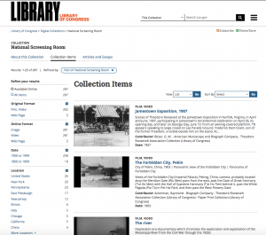
Curator of the Library’s Moving Image Section, Mike Mashon shared:
The goal of this digital project is to present the public with a broad range of historical and cultural audio-visual materials that will enrich education, scholarship and lifelong learning. The National Screening Room is designed to open up the Library’s collections, making otherwise unavailable movies freely accessible to viewers nationwide and around the world.
Ranging from 1890 through 1999, the collection of fiction and nonfiction films are searchable by keyword, format, date range and location. Most of the National Screening Room’s content is in the public domain and fully downloadable. Copyrighted films, included with permissions, are available for streaming.
Among the items in the growing collection are George Gershwin’s home movies featuring celebrities of days past; such landmarks in narrative cinema as The Great Train Robbery; views of San Francisco before and after the 1906 Earthquake and fire; as well as short films director by D. W. Griffith, including A Corner in Wheat.
You’ll also find a series of 33 mid-century newsreels from All-American News, which were produced for African-American audiences.
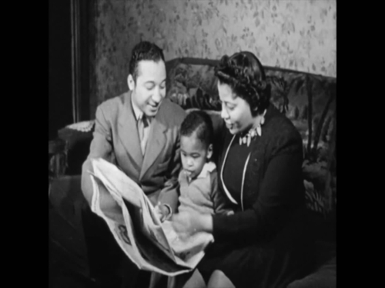
There’s young Frank Sinatra lecturing a group of young boys about antisemitism and racial prejudice in a musical short from 1945 featuring the classic song, The House I Live In
You’ll find the controversial 1964 Daisy Girl political advertisement which contributed to Lyndon Johnson’s landslide victory over Barry Goldwater, considered by many as a turning point in both political and advertising history.
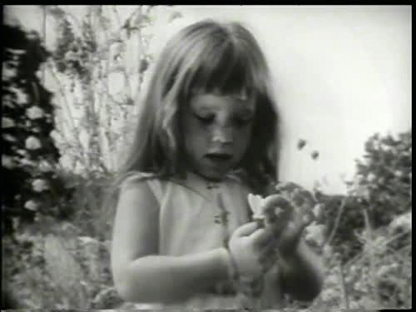
And there’s The Second Largest Minority, footage of one of the earliest (1968) gay pride parades in Philadelphia,
New titles will be added to the Screening Room each month. Keep an eye on this collection for its value in explorations of history, social issues, and the arts.
And the Library of Congress announcement promises instructional support for using these resources:
Mashon is also working with the Library’s team of educators to develop lesson plans for the classroom and other educational initiatives. Some primary source sets will examine the Harlem Renaissance, Industrial Revolution, Dust Bowl, Jim Crow and segregation, scientific data, Spanish-American War, World War I, Mexican-American communities, immigration, women’s history, children’s lives at the turn of the 20th century, symbols of the U.S. and many more.

http://blogs.slj.com/neverendingsearch/2018/09/28/loc-debuts-its-national-screening-room/

- With $11.4 Million Renovation of Billings Library, an Architectural Gem Takes Rightful Place on UVM Campus
Co-location of Special Collections, Holocaust Center, Humanities Center and Center for Research on Vermont Makes Building a "Vital Academic Center"
option2-800x400(1).jpg
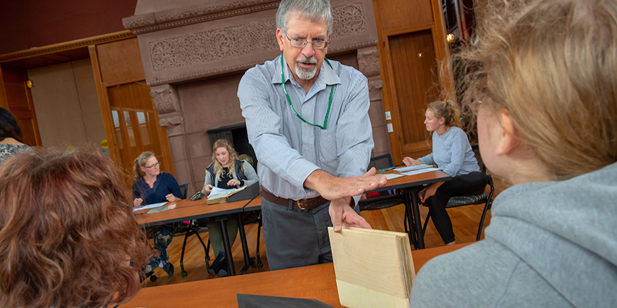
Special Collections director Jeff Marshall teaches a class in the Marsh Room of the renovated Billings Library using materials from the collection. (Photo: Sally McCay)
Over the years, the Billings Library, the University of Vermont’s most architecturally important building, has been home to a variety of university functions, some more suited to the cathedral-like grandeur of its interior than others.
Designed by H. H. Richardson, the great 19th American architect, the building began life in 1885 as the university’s library.
In 1961, with demand for its services far exceeding Billings’ capacity, the university built a large new library and, in 1963, converted Billings’ somber interior space to an unlikely – and as time went on, lightly used – student center.
In 2007 a much-needed modern student center opened on the UVM campus, and Billings became a sublime setting for a series of mostly everyday lectures, meetings and campus events.
Thanks to a recently completed $11.4 million renovation, Billings will again house university departments whose academic import match its majestic design.
UVM Libraries' Special Collections department took up residence in August, returning the building to its roots as a library. In September the Miller Center for Holocaust Studies, the UVM Humanities Center and the Center for Research on Vermont moved into their new offices on the fourth floor of the building.
“The co-location of these important areas of scholarship will make Billings one of the most vital academic and intellectual centers on the UVM campus, as it once was,” said UVM president Tom Sullivan. “It is heartening to see this architectural masterpiece returned to its former glory.”
Philanthropy key to original Billings – and to the renovation
The original Billings Library was financed through a philanthropic gift from railroad magnate and UVM alumnus Frederick Billings.
The renovation, launched in June 2017 and completed this past summer, has also been made possible by philanthropy.
Among the most important gifts was the first, in 2006, a $5 million gift from the late Leonard (’51) and late Carolyn Miller to establish a Holocaust studies center at UVM to honor and expand the legacy of Raul Hilberg, the late UVM political science professor and renowned Holocaust scholar.
Of the total, $3 million went toward the Billings renovation, where the center – called the Carolyn and Leonard Miller Center for Holocaust Studies – would be permanently located. The remainder was set aside for endowed professorships in Holocaust studies.
“The Miller family’s gift puts valuable endowment funds into place for the Miller Center for Holocaust Studies, which has a worldwide reputation and is one of the most significant scholarly enterprises at the university," Sullivan said. "The gift also sparked the Billings renovation. For both reasons, we are eternally grateful to the family for its generosity.”
A $3 million gift from Jack (’64) and Shirley Silver was also critical to the Billings Library renovation, giving considerable momentum to the project.
“Jack and Shirley were far sighted in their inspiring support of this important campaign priority," Sullivan said. "We are deeply appreciative to them for so significantly enhancing this vital part of the university.”
“When I was a student at UVM, I always knew Billings was something special,” Silver said. “It’s thrilling to be part of the building’s renovation and to see it restored to its original function as a library and academic center of the university.”
In honor of the Silvers, the collection has been named the Jack and Shirley Silver Special Collections Library.
A gift of $1 million was made to the renovation by Richard [’63] and Pamela Ader, who appreciated the architectural significance of the building and the many purposes the renovated Billings Library would serve. Additional gifts totaling $1.5 million from approximately 200 donors rounded out the $8.5 million in private support for the project.
Tens of thousands
It was a busy summer for Special Collections staff.
From mid-July to mid-August, staff oversaw the transport of tens of thousands of rare books, manuscripts, maps, photographs and documents, moved via truck in carefully packed boxes and foam-lined carts from Special Collections’ former location in the basement of Bailey-Howe Library to the second floor of Billings, where temperature- and humidity-controlled stacks had been built in an area formerly occupied by a dining hall.
The new location will significantly enhance Special Collections’ contribution to the academic life of the university, said Jeff Marshall, director of the Silver Special Collections Library.
“Housing these materials in one of UVM’s premier buildings at the center of campus demonstrates the value the university places on Special Collections and will raise awareness of our holdings among faculty, students and the outside community,” he said.
There are practical benefits, as well, he said. “We have improved security and climate control, as well as work spaces that are much more inviting and comfortable for both visitors and staff.”
The renovation also fits the moment in higher education: special collections are playing an increasingly large role in undergraduate education nationally.
To facilitate the use of special collections materials in teaching, the renovated Billings will feature two dedicated, technology-enabled classrooms, a large one in the Marsh Room on the third floor and a smaller one on the second, both major improvements over the former space, where classes were held in the middle of the reading room.
“Collaborating with faculty to give students access to primary source materials – from manuscripts to maps to blueprints – has become a central strategy for engaging students in disciplines ranging from the humanities, social science and the arts to science, math and engineering,” said Prudence Doherty, special collections librarian. “The new classrooms will greatly enhance our ability to deliver this kind of teaching.”
The classrooms will also be used for public events and presentations sponsored by the Silver Special Collections Library.
Also following national trends, the Billings renovation contains two dedicated display areas – in the apse on the third floor and in an area outside the central reading room on the second – to draw in students and the university community and engage them in Special Collections’ holdings.
Billing’s North Lounge will also see a return to its past. The space will become a reading/study room, as it was in the original library, with long tables, comfortable chairs and nooks for private study along the walls.
The co-location of the Miller Center for Holocaust Studies, the Center for Research on Vermont and the Humanities Center in Billings, makes the building a “powerful nexus for the humanities on the UVM campus,” Sullivan said.
“The centers have a vital role to play in and of themselves,” he said. “In addition, we expect that the co-location with the Silver Special Collections Library will amplify their impact by enabling closer collaboration and synergy, both among the centers and with Special Collections.”

https://www.uvm.edu/uvmnews/news/114-million-renovation-billings-library-architectural-gem-takes-rightful-place-uvm
- National Technical Information Library (NTRL) is Now an Open Access Resource
Filed by Gary Price
From the California Digital Library News (CDLINFO News):
The National Technical Reports Library (NTRL) has become an open access resource, following a decision made by the National Technical Information Service (NTIS).
[Clip]
Open NTRL includes the following advanced search capabilities –
- Search by title words
- Search by source agency
- Search by author
- Search can be limited by year of publication
- Search can be limited to documents available in full text
Direct to Source Announcement
Hat Tip and Thank You: FreeGovInfo/James A. Jacobs
See Also: TRAIL (Technical Report and Image Library; via CRL)

https://www.infodocket.com/2018/10/01/national-technical-information-library-ntrl-is-now-an-open-access-resource/

- How libraries can start and support academic-led journals to further the open access movement
by Scholastica

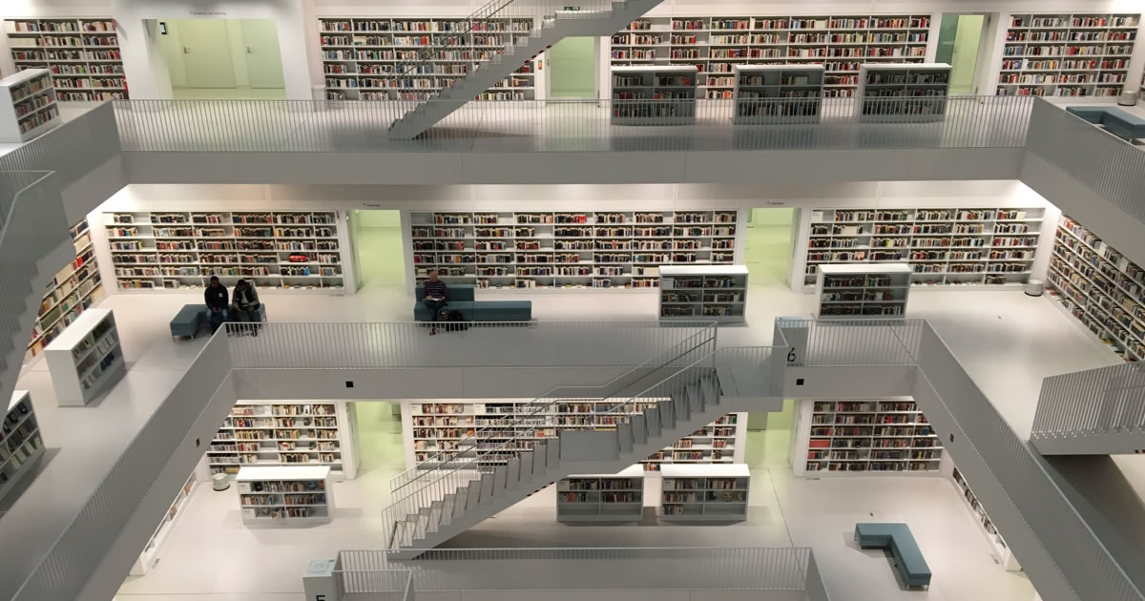
Image Credit: Tobias Fischer on Unsplash
In the last 3 years, over a dozen university libraries have either canceled or boycotted academic journal big deals. Libraries are moving away from the big deal subscription model to embrace open access publishing and they are looking for the most affordable ways to do it. Due to rising article processing charges among corporate publisher, many libraries are creating and supporting academy-owned publishing initiatives. Using a variety of available tools and services, today it is possible to run an academic-led journal much more affordably than most corporate titles. In fact, for the cost of just four articles at Elsevier’s self-reported average APC of $1,980, a library could fund an academic-led journal for an entire year!
Here at Scholastica, we work with many academic-led journals and have created resources to help support academic-led publishing, like our Essentials of America-Led Publishing Guide. In this article, we are going to expand upon sections from that guide and look at ways libraries are publishing and supporting academic-led journals, as well as steps you can take to start or build out your library’s publishing program.
Be your own publisher!
There are publishing options for libraries of every size, from publishing one or a small portfolio of journals, to creating an entire library publishing program or press. You may be thinking “My library doesn’t have the budget, people, or time to publish open access journals” - don’t worry! Even with limited resources you can still get involved in open access journal publishing in a variety of ways.
One example of a library that publishes just one journal is the University of Buffalo Library, which publishes The Reading Room: A Journal of Special Collections. The journal was created by two librarians at The University of Buffalo Library to not only introduce a publishing platform for research on special collections, but also as a way to provide the library with practical, hands-on experience implementing an open access journal. The University of Buffalo Library maintains a website for the journal, and they use Scholastica for peer review management.
If your library already has a publishing program set up, then you may want to look at larger models, like Michigan Publishing, that your library can work towards. Michigan Publishing is unique in that it provides the services of a publisher while giving its journals the freedom to choose their own funding and publishing model. Journals can either publish through Michigan Publishing or use any one of the many services they offer like indexing support, copyediting, journal website hosting and more.
Support academic-led journals
You may be thinking “That all sounds great...but still, my library just doesn’t have the support/time to publish, even one small journal!” If your library doesn’t have the resources to start your own publishing program, no need to fret! You can still back academic-led publishing initiatives by lending administrative or financial support to an academic-led journal or academic-led organization.
Examples of academic-led journals that are supported by libraries are Discrete Analysis andAdvances in Combinatorics, two journals that were launched by Fields Medal winning mathematician, Sir Timothy Gowers. Discrete Analysis receives a grant from Cambridge University, and when the journal was first created, also had administrative and indexing support from the Cambridge University Library. In the summer of 2018, Gowers announced the launch of a new journal called Advances in Combinatorics. This journal’s minimal costs are being paid for by the library at Queen’s University in Ontario, which is also providing administrative support to the journal. Both of these journals are publishing using Scholastica’s Open Access Publishing Platform.
Your library can also get involved in academic-led publishing networks and organizations. Gowers’ journals are members of the Free Journals Network (FJN). FJN is a network for academy-owned journals, designed to help journal editors coordinate their efforts and share publishing best practices. FJN promotes journals that follow the Fair Open Access Principles.
Be an expert on what publishing tools are out there
Whether you're publishing one or more journals, or you're supporting academics running journals, you should make sure to familiarize yourself with the journal management tools out there and understand what situations they will work best for. Your library or the journals you’re supporting should seek tools that are easy to manage and designed to keep up with the evolving digital publishing landscape.
Some key considerations to keep in mind when looking at journal management tools and services for your library or the journals you work with are:
- The learning curve for peer review and publishing software and tools - the tools you choose should ideally be intuitive and easy for your staff and journal editors, authors, and reviewers to use.
- Understanding not only the upfront costs of the tools you're using but also "hidden" costs of your organizations' technical resources like time costs and operational costs.
- Available technical support for library staff and journal editors - if you don’t have internal tech support, you’ll need to make sure your software comes with support!
- How well you will be able to scale your publishing efforts - if you feel strapped for time now, you may want to look for more efficient tools that won’t limit your growth potential.

Thinking about these four considerations will help you make sure you are picking the right tools for your publishing program. If you already have a program, be sure to assess your current software and tools to make sure they are the best fit for your needs now and in the future. A great resource to help you find new software and tools is the Library Publishing Coalition Publishers and Service Providers List.
Ready to get started?
These are just a few examples of publishing models and ways libraries can support academic-led journals to further the open access movement. In addition to Scholastica's resources, there are many other organizations out there with tools to help your library get involved. Here are links to just a few:
- SPARC Declaring Independence
- Free Journal Network
- Fair Open Access Alliance
- Essentials to Academic-Led Publishing Guide
We hope this post was useful for you! If you have questions about Scholastica or want to discuss how our peer review and publishing tools can be used to help the academic-led journals you work with contact us to schedule a call.
SPONSORED BY

- New Data: SPARC Documents and Reports Over $1 Billion in Savings Through Use of Open Education Resources (OER) Around the World
Filed by Gary Price
From a SPARC Blog PostNicole Allen:
Five years ago at the 2013 Open Education Conference, we issued a challenge to the OER community to save students $1 billion by 2018.
Over the past three months, SPARC and our member libraries have worked to document OER adoptions over time. More than 100 organizations and individuals contributed to this effort, resulting in information on OER use at more than 4000 institutions, primarily in the U.S. and Canada but also all around the world.
Today we are thrilled to share that the data show that the OER movement has saved students, parents, schools and governments at least $1 billion dollars. While we continue to process the data and numbers will eventually be higher, we have documented at least the following savings:
- U.S. & Canada Higher Ed: $921,783,169
- U.S. & Canada K-12: $45,051,066
- International: $38,500,000
- Total: $1,005,334,235
Learn More, Read the Complete Blog Post by Nicole Allen
See Also: Students Save $1 Billion Web Page
A Few Recent OER-Related Items
- New Research Resources: SUNY Geneseo’s Milne Library Announces Official Launch of OASIS, an OER Search Too
Over 160,000 resources.
- OER/Open Textbooks: LibreTexts Awarded $5 Million Federal OER Pilot Program Grant
- U.S. Congress Renews $5 Million Open Textbook Pilot For Second Year

https://www.infodocket.com/2018/10/12/new-data-sparc-reports-over-1-billion-in-savings-via-oer/

