Año 3 Número 87 octubre 2018
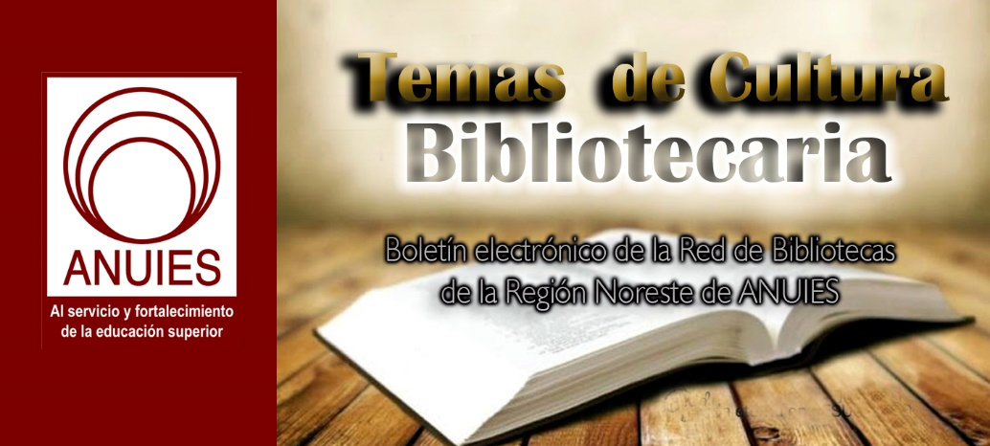

Contenidos de este número

- Gale Launches Digital Scholar Lab
by Matt Enis
Sep 17, 2018 | Filed in News

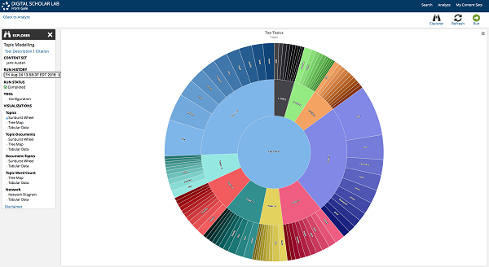
Following two years in development, Gale last week launched its Digital Scholar Lab (DSL), a cloud-based text mining and natural language processing solution that facilitates analysis of raw text data (optical character recognition/OCR text) from 160 million pages of Gale Primary Sources content. Combining commonly used open source algorithms and programs such as MALLET (MAchine Learning for LanguagE Toolkit) with proprietary tools, DSL is designed to enable students and researchers to generate data sets, utilize integrated data visualization tools, download and share those data sets and visualizations, and organize research for long-term projects.
When researchers start a text analysis project, one of the first challenges is often finding an appropriate content set, noted Marc Cormier, Gale’s director of product management for the humanities.
“There are a number of open source content sets that you can use, but picking open source and freely available doesn’t really reflect the nature of the content need you might have…. In this case, we wanted to break down that barrier by providing all of the raw data from Gale’s content and digital collections in this one place,” he said. “Users, including scholars, librarians, graduate students, etc., can now search for and find content from Gale Primary Sources, create a custom corpus of that content that suits their research needs, and then process that content through some of the open source tools that we’ve included in [DSL] that drive visualizations that they interpret and publish.”
Introduced in 2016 as a proof-of-concept version primarily targeted at high-level researchers and postdocs, Gale began adding visualization tools and making DSL more user friendly in 2017. This year, extensive UX testing in the United States and markets including Australia and the United Kingdom helped refine the production version launched this week. Throughout the development process, a primary goal was creating a platform that makes text mining and data visualization approachable.
“We heard along the way…how much [faculty] would like to use it in the classroom,” Cormier said. DSL “does, to a great degree, make sense of some of the difficulties that a digital scholar runs into along the way. It’s not just about the difficulty in creating content sets, it’s more about ‘where do I start?’”
DSL’s home page features a prominent search bar, as well as three callouts inviting returning users to “Build your corpus,” “Analyze your documents,” and “Manage and share” documents and visualizations. Users can be authenticated via their Google Drive or Microsoft OneDrive accounts. “We didn’t want to pass on yet another set of credentials for a user to remember…. They also serve as saving mechanisms for content that you create in [DSL].”
A basic search—which searches all content text fields including captions, titles, body text, etc. excluding front and back matter—directs users to a search results page similar to Gale’s other Primary Sources products, where users can apply search limiters, search within their results, or browse the OCR text surfaced in each result. Throughout the interface, users can access context-sensitive modal boxes that present detailed definitions/explanations of key topics such as OCR, for example.
Specific results or a range of results (using limiters such as publication type or date range) can be selected to create a custom content set, and then analyze the set using DSL’s integrated tools, which enable sentiment analysis, topic modeling, parts of speech tagging, Ngram analysis, named entity recognition, clustering, and term frequency analysis.
These tools generate tabular output, as well as a variety of visualization options appropriate to each type of analysis, including graphs, sunburst wheels, tree maps, network diagrams, and more. Here, the informational modal boxes will offer users a description of the tool and underlying algorithm that was used to generate their results, as well as an explanation of sentiment analysis as a concept, for example.
While the Digital Scholar Lab can facilitate complex analysis, Cormier said that Gale believes the platform’s ease of use will also help reintroduce library resources to both faculty and students. They’ve aimed to create “not only something that a postdoc would find useful, but also one that a postdoc could use to teach digital humanities courses and text mining to undergrads,” he said.
“The conversation always comes down to content. If you think about content in the library today, one of the biggest barriers to that content being used in digital scholarship is raising awareness of [those resources] with faculty, students, etc.,” Cormier said. “It’s a different type of use case entirely—data visualization and textual analysis versus close reading, which is what we’ve typically supported with Gale Primary Sources.”

https://www.libraryjournal.com/?detailStory=180917galedigitalscholar

- Attorney Sues for Access to Tanton Papers in Closed Archive
by Lisa Peet
John Tanton
Hassan Ahmad, a Virginia-based immigration attorney, has filed a Freedom of Information Act (FOIA) request and a lawsuit to view the papers of John Tanton held at the University of Michigan’s (UM) Bentley Historical Library (BHL). Tanton, a retired ophthalmologist from Petoskey, MI, founded several groups that sought to constrain immigration to the United States, and is considered by the Southern Poverty Law Center (SPLC) to be the “racist architect of the modern anti-immigrant movement.” Ahmad has argued that the material should be openly available, as organizations founded by Tanton have ties to members of the Trump administration and are relevant to current controversies over immigration policies.
The papers in question are part of a 25-box archive of correspondence and documents dating from 1960 to 2007, donated by Tanton to UM beginning in 1984. Boxes 1–14 are open to researchers without restriction, but boxes 15–25 are closed until April 6, 2035, as per Tanton’s donor agreement with the library.
After a December 2016 FOIA request to view the material was denied, as was a subsequent appeal, Ahmad—founder and principal of the HMA Law firm, which specializes in immigration and criminal defense—filed a lawsuit in June 2017 charging that the papers should be made public. In his October 2017 court filing, Ahmad stated in response to UM’s motion to dismiss that Tanton's documents "meet the statutory definition of 'public records' and should be released under FOIA since they deal with the ‘affairs of government.’" In November 2017 Stephen Borrello, a judge with the Michigan Court of Claims, ruled that the records, as a private donation that is not possessed by UM for any public purpose, should remain closed.
Ahmad appealed the case and on August 15 appeared before a three-judge panel at the Michigan Court of Appeals in Detroit. Philip Ellison, Ahmad’s attorney, claimed in court that UM had no right to enter into an agreement with Tanton that would exclude his papers from FOIA requests, and that the university can’t use donor agreements to keep important documents private. The court is scheduled to rule on the case in late September or early October—a decision that could have repercussions for archives at public institutions across the country.
IMMIGRATION REFORM TIES
In 1979 Tanton was a founding chairman of the lobbying group Federation for American Immigration Reform (FAIR), which seeks to reduce both legal and illegal immigration. He was also influential in establishing the Center for Immigration Studies (CIS) think tank, begun as a spinoff of FAIR in 1985, and the organization Numbers USA, both of which support research that calls for stricter immigration policies in the United States. Tanton also founded the Social Contract Press, which publishes on immigration reduction and population control, and U.S. English, a group that opposes bilingual education.
According to SPLC—which has deemed FAIR a hate group—Tanton “carried on correspondences with some of the key leaders of the white nationalist movement, meeting and even vacationing with some of them, and pushing many of their central ideas.” He has been quoted in a leaked 1986 memo, later published in the Arizona Republic, alluding to Hispanic immigrants as the “Latin onslaught.” He referred to eugenics and sterilization in his writing, and has expressed his preference for a “European-American majority” in correspondence. Tanton has denied that he promotes racism.
Opening the sealed files would provide critical information on anti-immigration ideology, according to Ahmad. “The organizations founded by Dr. John Tanton are currently informing U.S. immigration policy," he told the Detroit Free Press in October 2017. "I think the public interest is served by investigating the connection between his thought and the current immigration policies. The rise of white nationalism, as we've seen in Charlottesville, seem to make this all the more important.... It's important for us to be aware of how his thought may be poisoning our policies."
FAIR has current ties to a number of Trump associates, including senior adviser Kellyanne Conway, whose firm did polling for FAIR; transition aide Lou Barletta, who sat on FAIR’s national board of advisers, and Julie Kirchner, who served as FAIR’s executive director from 2007 to 2015, and was named the Department of Homeland Security’s Citizenship and Immigration Services Ombudsman in May 2017. Kansas Secretary of State Kris Kobach, vice chair of Trump’s Commission on Election Integrity, served as counsel to FAIR’s legal arm, the Immigration Reform Law Institute, from 2004–16. In 2010 Kobach helped draft Arizona’s controversial SB-1070, which allowed law enforcement to arrest people without a warrant if they were thought to have committed offenses for which they could be deported. FAIR currently is working to end the Deferred Action for Childhood Arrivals (DACA) program.
According to Ahmad, the sealed archives include FAIR meeting minutes, nine folders labeled “Pioneer Fund,” a white superiority group that funds studies on race and genetics and has provided significant backing for FAIR, Tanton’s private correspondence, documents on immigration issues, and other information on the groups Tanton founded.

https://www.libraryjournal.com/?detailStory=180918-Tanton-Papers

- How a Unified Research Platform Can Improve the Efficiency of Academic Libraries
by Ex Libris A ProQuest Co.
England’s Lancaster University is one of the top 10 research institutions in the United Kingdom and among the top 150 worldwide. To maintain the university’s status as a premier research institution, the Lancaster University Library supports the efforts of some 1,200 faculty members throughout the research lifecycle, says Masud Khokhar, assistant director of digital innovation and research services.
For instance, Khokhar says, library staff increasingly help faculty design compelling research questions. They write Data Management Plans (DMPs) for grant applications. They help preserve research assets and ensure that metadata are applied consistently to those assets. They advise faculty on the publication of research results. They manage Article Processing Charges (APCs) for open access publications. And they help measure the impact of the university’s research outputs.
At the moment, researchers and library staff accomplish these tasks using a variety of tools from different vendors.
“One of the problems we face is the lack of interoperability,” Khokhar says. “We have a grants management system, a separate costing system, a system to manage research publications, and a system to manage the research data. We have a different system to look at the impact of research, and our Current Research Information System is being bent out of shape to do things it wasn’t meant to do.”
Having to use separate systems for each of these functions creates operational inefficiencies. The university ends up spending more in licensing costs, and staff must spend more time than necessary in trying to navigate multiple systems and coordinate efforts.
What’s more, these various processes are handled separately by different teams—often “without any real understanding of how they work together to form a coherent research support service,” Khokhar says.
In one example, open access outputs are stored in Lancaster University’s institutional repository, while the data collected during these research projects are maintained in a research data repository. While these systems are the same at the moment, they will become different shortly. This will raise the issue of outputs not being easily linked with the data they derive from. When these objects are stored in separate repositories managed by different teams, linking them together becomes challenging and includes more potential for errors.
In addition, the fund used to pay Article Processing Charges for open access outputs is managed with spreadsheets compiled by different library staff altogether. And yet another team is tasked with validating whether these outputs comply with open access requirements. “This operation is often conducted by the library’s metadata team,” Khokhar says. “The metadata team is different from the research support or scholarly communications team, and there is no unified workflow between these teams to manage validations, APC payments, or open access reporting.”
Having a single, cloud-based platform that ties together the various aspects of the research lifecycle would solve many of these problems. This is what Lancaster University and four other leading research institutions are hoping to achieve in teaming up with Ex Libris to create a new research services platform called Esploro.
“At the moment, there is a gap in the market that is not covered,” Khokhar says. “What is missing is a product that delivers an entire ecosystem of services around the research process. Esploro aims to bridge this gap by bringing all of these operations under a single product, which will reduce the management needed with multiple systems, improve workflows and communication, and increase compliance rates.”
Khokhar believes Esploro will improve the efficiency of library operations not only by streamlining research workflows, but also by automating certain tasks. For instance, the software is designed to capture as much metadata as possible automatically from PDF files and other research assets as these are deposited into the system.
“This goes back to the user-centric design of the product,” he says. “It reduces the workload on the administration team who are managing the metadata on the back end. They can have confidence that most of the metadata fields will be filled automatically, and there are a very limited number of additional fields they will have to fill.”
Improving efficiency will allow Lancaster University Library to support the efforts of researchers in new and more valuable ways.

https://www.libraryjournal.com/?detailStory=how-a-unified-research-platform-can-improve-the-efficiency-of-academic-libraries

- National Book Awards Longlists Offer Fresh Voices, Cutting-Edge Content
by Barbara Hoffert
Rolled out from September 12 through September 14, this year’s National Book Award (NBA) longlists show the National Book Foundation (NBF) maintaining its focus on diverse, socially conscious works from publishers small and large. The big news this year is the inaugural longlist in translated literature, established to acknowledge literature’s global reach, the NBF’s growing purview, and America’s status as a nation of immigrants. Nine languages are represented: French, Spanish, Arabic, Tamil, Norwegian, Italian, Japanese, Polish, and Russian. Norwegian is the one repeater, with Hanne Ørstavik’s Love (tr. by Martin Aitken, Archipelago) and Gunnhild Øyehaug’s Wait, Blink: A Perfect Picture of Inner Life (tr. by Kari Dickson, Farrar). Dunya Mikhail’s The Beekeeper: Rescuing the Stolen Women of Iraq (tr. by Dunya Mikhail and Max Weiss, New Directions) is the one nonfiction title, and Tatyana Tolstaya’s Aetherial Worlds (tr. by Anya Migdal, Knopf) is the one short story collection. Not surprisingly, this year’s Man Booker International Prize winner, Olga Tokarczuk’s ambitious Flights (tr. by Jennifer Croft, Riverhead), made the list. The judges include Harold Augenbraum, a former NBF executive director and LJ reviewer.
Including just one previous NBA nominee, Lauren Groff, this year’s fiction longlist offered many fresh new voices. Groff’s Florida (Riverhead) is one of three story collections, along with Jamel Brinkley’s A Lucky Man (Graywolf) and Nafissa Thompson-Spires’s Heads of the Colored People (37 INK: Atria), both debut collections. Also debuting: Daniel Gumbiner, whose The Boatbuilder (McSweeney’s) deals with the opiate addiction crisis, and Tommy Orange, whose There There (Knopf) is a portrait of Oakland’s urban Native American community. Pairing up with Orange’s work, Brandon Hobson’s Where the Dead Sit Talking (Soho) offers a Native American coming-of-age story set in rural Oklahoma. Jennifer Clement’s Gun Love (Hogarth: Crown) addresses the danger of firearms in this country; Tayari Jones’s An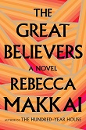American Marriage (Algonquin), the impact of wrongful incarceration; Rebecca Makkai, The Great Believers (Viking), the long-term consequences of AIDS; and Sigrid Nunez’s The Friend (Riverhead), facing down grief, with the help of a Great Dane.
Current events dominate the nonfiction longlist. Works include National Book Critics Circle (NBCC) Award winner Carol Anderson’s One Person, No Vote: How Voter Suppression Is Destroying Our Democracy (Bloomsbury), Pulitzer Prize winner Steve Coll’s Directorate S: The C.I.A. and America’s Secret Wars in Afghanistan and Pakistan(Penguin Pr.), Syrian freelance journalist Marwan Hisham and illustrator Molly Crabapple’s Brothers of the Gun: A Memoir of the Syrian War (One World: Penguin Random), debuter Sarah Smarsh’s Heartland: A Memoir of Working Hard and Being Broke in the Richest Country on Earth (Scribner), NBCC Award winner Rebecca Solnit’s Call Them by Their True Names: American Crises (and Essays) (Haymarket), and UCLA School of Law professor Adam Winkler’s We the Corporations: How American Businesses Won Their Civil Rights (Liveright: Norton). Also exciting: Jeffrey C. Stewart’s study of a Harlem Renaissance great, The New Negro: The Life of Alain Locke (Oxford Univ. ) and two books on science, Victoria Johnson’s American Eden: David Hosack, Botany, and Medicine in the Garden of the Early Republic (Liveright: Norton ) and David Quammen’s The Tangled Tree: A Radical New History of Life (S.& S.).
From Pulitzer Prize winner Rae Armantrout’s Wobble (Wesleyan Univ.), eye-openly spare as ever, to debut author Jenny Xie’s elusively written cultural study, Eye Level (Graywolf), the poetry longlist is forward-looking in form and content. Debut author Jos Charles’s feeld (Milkweed), a radical reframing of language to capture the trans experience, ends up sounding like medieval English but with an eerily modern feel. Pulitzer Prize winner Forrest Gander’s Be With (New Directions) offers sometimes multilingual poetry in condensed, oblique 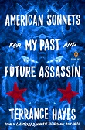language, ranging in subject from Alzheimer’s to St. John of the Cross. Raquel Salas Rivera’s lo terciario / the tertiary (Timeless, Infinite Light) takes on colonialism as reflected in the political-economic crisis in Puerto Rico. Diana Khoi Nguyen's Ghost Of (Omnidawn) uses on-the-edge visual experimentation to tell a tragic family story, while Justin Phillip Reed’s Indecency (Coffee House) challenges the dominant culture of white supremacy in concrete language. As an added fillip, NBA winner Terrance Hayes offers American Sonnets for My Past and Future Assassin (Penguin), which includes 70 masterly sonnets inspired by the late Wanda Coleman’s American Sonnets.
Finally, the longlist for Young People’s Literature features a range of top-notch writers, many who have already been honored with big awards. M.T. Anderson, nominated with Eugene Yelchin for The Assassination of Brangwain Spurge (Candlewick Press) was longlisted in 2015, a finalist in 2002, and a winner in 2006, while Elizabeth Partridge (Boots on the Ground: America’s War in Vietnam) was a finalist in 2002. Also in the mix: Newbery and Coretta Scott King honoree Christopher Paul Curtis’s The Journey of Little Charlie (Scholastic), one of two middle-grade works nominated. The other is Leslie Connor’s The Truth as Told by Mason Buttle (Katherine Tegen Bks: HarperCollins).
Finalists in all five categories will be announced on October 10. Winners will be announced at the 69th National Book Awards Ceremony and Benefit Dinner, to be held at Cipriani Wall Street in New York City on Wednesday, November 14. For the complete longlists, see nationalbook.org.

https://www.libraryjournal.com/?detailStory=180918nbalonglist

- A James Madison University Libraries & Association of Research Libraries (ARL) Partnership Receives IMLS National Forum Grant on Open Access Collecting Strategies
From the Association of Research Libraries (ARL):
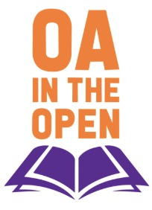James Madison University (JMU) Libraries, in partnership with the Association of Research Libraries (ARL), has been awarded $89,000 by the US Institute of Museum and Library Services (IMLS) to convene a national forum of experts and stakeholders to address key opportunities and challenges in building a collective collection-development system for open access (OA) content. This “OA in the Open” forum will engage participants in creative thinking around how a new collective funding model could be designed to minimize the creation of new membership organizations while simultaneously building community stakeholdership.
Learn More, Read the Complete Announcement & Visit the OA in the Open Website

https://www.infodocket.com/2018/09/19/a-james-madison-university-libraries-and-arl-partnership-receives-imls-national-forum-grant-on-open-access-collecting-strategies/

- OCLC Research and Canadian Association of Research Libraries (CARL) Partner on Survey to Measure Trends and Priorities in Research Libraries
Filed by Gary Price
From OCLC Research:
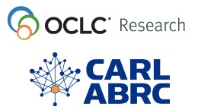OCLC Research, in partnership with the Canadian Association of Research Libraries (CARL), is currently conducting a survey on innovation trends and priorities in research libraries. The survey is being sent to library directors at 31 institutions in Canada.
The goal of the survey is to gain intelligence regarding trends, capacities, and priorities within the research library community. This will help CARL, OCLC and the OCLC Research Library Partnership to identify strategic opportunities and may reveal areas for possible future collaborations between the partnering organizations. This will inform future joint activities between OCLC and the research library community in Canada, and scope the opportunity space for OCLC Research and the RLP.
“CARL is pleased to participate in this international research effort to explore research libraries’ preoccupations and priorities. We believe the results will be useful to our members individually and to CARL’s strategic planning for the coming years,” stated Donna Bourne-Tyson, University Librarian at Dalhousie University and CARL President.
This survey follows a similar survey that was sent to library directors at 238 institutions in the UK, the Netherlands, Germany, Austria, Switzerland, Denmark, Spain, France, and Italy in 2017. OCLC Research will also survey research libraries in Australia and New Zealand, under a partnership with the Council of Australian University Librarians (CAUL).
“OCLC Research gathers critical information from these surveys that help guide us in our work,” said Rachel Frick, Executive Director, OCLC Research Library Partnership. “Working with our partners at CARL, this survey will help us gauge top priorities and areas of interest in research libraries in Canada. When we compare these findings to those from other parts of the world, we will be able to identify regional priorities, allowing us to focus our research and outreach efforts in ways that are most beneficial to research libraries worldwide.”
OCLC Research will be responsible for administering and analyzing the survey results and will share findings with CARL for dissemination to its members. Additionally, OCLC Research will share the data gathered in this survey, so that others can make their own interpretations.

https://www.infodocket.com/2018/09/13/oclc-research-and-canadian-association-of-research-libraries-carl-partner-on-survey-to-measure-trends-and-priorities-in-research-libraries/

- Transparent Language Online
World Language Learning for Patrons of All Ages
Transparent Language Online features a scientifically proven methodology, the widest variety of high-quality learning materials, and seamless integration of real-life language used by native speakers, all packaged together in an easy-to-use interface. This is simply the most complete language-learning solution available anywhere. And with 100+ languages to choose from, there is something for every language learner.

100+ Languages: From Afrikaans to Zulu, the number of languages available to learners is constantly growing.
Children’s Language Learning: Kids learn popular languages through total immersion using games and music via KidSpeak
The Welcome Lesson: Game dynamics are used to teach learners a few key words and to guide them through a quick lesson on using the program.
Flexible Learning Path: Users can follow the plan or blaze their own trail. All learners are given a starting point, but they can then choose what they'd like to learn.
Extensive English Collection: With English materials for speakers of more than 25 languages, an intermediate-level immersion course, and more, there are tools for every English learner.

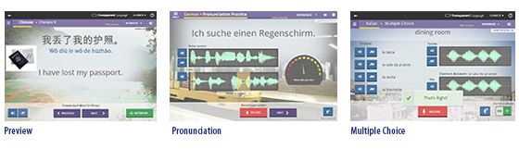
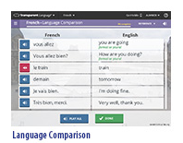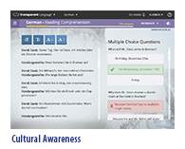

Transparent Language Online Is More Than Just an Online Course!
- Smart Insight and Review: Learned Items tell users how much they've learned and when it’s time to review.
- Core Skill-Building Activities: Language learners get a robust program that builds all four core skills: listening, speaking, reading, and writing.
- Practice Activities: Listening, reading, speaking, and writing skills are honed with learning materials and over a dozen challenging activities in each lesson.
- Alphabet Lessons: Students can’t learn to read or write if they don’t know the alphabet. Learners get started on the right foot with the Alphabet course, which is available in most of the languages.
- Typing Activities: Beginners start with Easy Typing to input foreign characters. Intermediate learners then type with the program's fully mapped native keyboard.
- Speaking Practice: The Transparent Language proprietary EveryVoice™ technology allows learners to compare their pronunciation to that of a native speaker with speech-enabled classic learning activities like Multiple Choice and Pronunciation Practice.
- Got Grammar? And much more! An extensive collection of videos and written explanations covers hundreds of grammar topics, providing learners with a foundation to build upon.
- Essentials™ Courses: With 40 to 80 hours of learning material, each Essentials course provides what every learner needs to get started.
- Supplemental Vocabulary: Learners build proficiency by absorbing thousands of useful words and phrases categorized by topic and presented in an engaging, memory-building format complete with native speaker pronunciation.
- Other Great Resources: Language and culture blogs, word of the day, and interactive social communities help learners expand upon the basic learning material by connecting them with others and allowing learners to practice using language in the real world.
English Learning for 25+ Native Languages:
- The English Essentials series is a set of language courses designed to help beginners to advanced beginners prepare for practical, everyday interactions. The courses are fun, easy, and a quick way to get started learning English.
- The Intermediate Immersion course is a full immersion-style course targeted at intermediate-level learners. Starting with authentic dialogues, the content is broken down into contextual learning activities to help learners further develop their knowledge of vocabulary terms and grammatical concepts, while using English to learn more English.
- “Which Is English?” is a fun and addictive game that helps build the vocabulary, grammar, and understanding of the idiomatic expressions that an intermediate English learner needs to flourish. Transparent Language Online includes over 2,000 supplemental English vocabulary items, ideal for learners of all levels.
- Business Lessons help English learners enhance their careers by building their knowledge of business-specific English terms. The Business English materials include over 100 lessons for speakers of Spanish, Chinese, and Turkish.
Library staff will appreciate real-time statistics with continuously updating usage reports to measure return on investment.
Customizable patron interface with library branding, plus the following:
- Free patron support
- Free staff training
- Complimentary marketing services
- Free MARC records
For more details, call 877-828-2833 or email us at rbdigital@recordedbooks.com.

http://www.recordedbooks.com/Our-Products/Education/Transparent-Language-Online

