Año 3 Número 86 septiembre 2018

Contenidos de este número

- Library of Congress Launches OFFICIAL Congressional Research Service Reports Portal
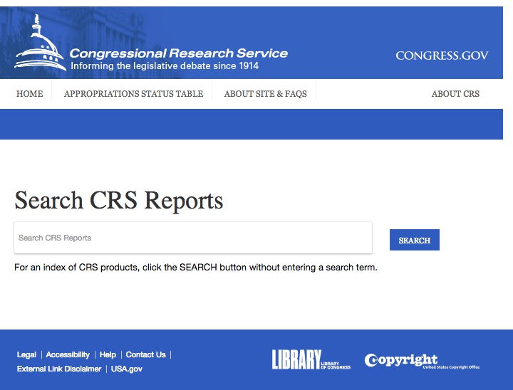
Filed by Gary Price
Long awaited public access to Congressional Research Service reports are now available online.
The new OFFICIAL PORTAL launched today at CRSReports.Congress.gov

Official/Formal public access can after years of hard work by a number of people and organizations. Kudos to those involved.
Daniel Schuman at Demand Progress (a person and an organization deeply involved in making today’s news a reality provides background in this post from March 22, 2018 when the U.S. House passed the needed legislation.
Another person who deserves a lot of credit for today’s news is Steven Aftergood at the Federation of American Scientists who has worked hard to make official public access a reality.
More about Daniel and Steven in a moment.
Searching the New Portal
Search is about as straight forward as it gets. Enter your keywords and press search.
You can also run an empty/null search and review all items in the database (last in, first out) as seen below.
Limit (if needed) using the facets on the left side of results pages.
Note: A basic/default search is not searching the full text of a report but you can expand to a full text search by selecting the “Include Full Text” box (green arrows). It’s also possible to bulk download search results. All reports are PDF files.
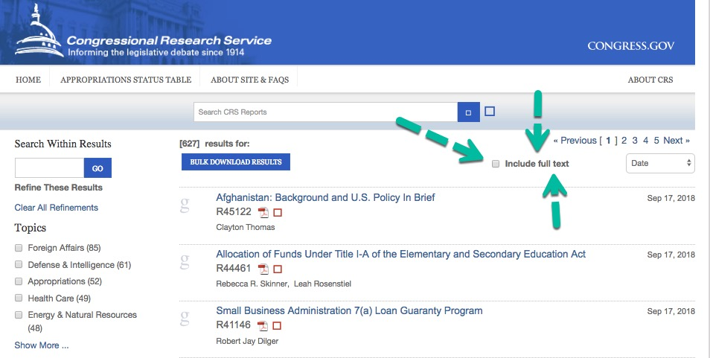
Not Available via the New Portal
It’s important to note that not every CRS report that could be provides is currently available via the new portal but will CONTINUE to be accessible from the sources listed below.
Schuman tells infoDOCKET:
CRS is publishing only one type of its non-confidential reports and not all of them, as required by law. They’re also only publishing reports issued or updated since the law was enacted, not all the non-confidential reports on their website.
From an Official LC Blog Post by Librarian of Congress, Carla Hayden:
Moving forward, all new or updated reports will be added to the website as they are made available to Congress. The Library is also working to make available the back catalog of previously published reports as expeditiously as possible.
More details about this process can be found on the site’s Frequently Asked Questions page.
Read the Complete Blog Post
FAS and EveryCRS Report
As we mentioned a moment ago the work of Steven Aftergood, Daniel Schuman, and others in and around the library and government info community is worthy of a salute. Well done!
It’s also important to note that Aftergood shares news of new CRS reports in his wonderful Secrecy News newsletter/site and has built an archive of past reports on the FAS site.
Aftergood/FAS provides will continue to provides access to materials that the official portal does not offer. For example: CRS Legal Sidebar, CRS Insight, CRS In Focus.
Daniel Schuman and Demand Progress also provide access to new and archived CRS reports available in SEVERAL FORMATS via EveryCRSReport.com, a service that launched about two years ago.
EveryCRS also provides RSS alerts, something that the Congress.gov site does not provide (at least at this time). We also love the fact that EveryCRS provides access to previous versions of reports and provides a hint to the percentage of info that has changes from one version of a report to the next.
It’s infoDOCKET’s hope that both Aftergood/FAS and Schuman/EveryCRS continue to provide their valuable services (and perhaps work with Congress.gov) even as the official portal becomes available.
Direct to CRSReports.Congress.gov.

https://www.infodocket.com/2018/09/18/library-of-congress-launches-official-congressional-research-service-reports-portal/

- Wikimedia and Libraries User Group Publishes First Annual Report
Filed by Gary Price on September 17, 2018
From the Annual Report:
Our first annual report of the Wikimedia and Libraries User Group covers the year 2017-2018. Prepared by the steering committee, we include the user group’s activities and organizing within and outside the Wikimedia community.
Activities discussed in the report include:
- Recognition as a Wikimedia User Group (June 2017)
- 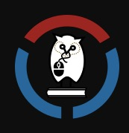Wikimania Montréal
- Open user group meeting
- User group rename
- Steering committee election
- Participation in #1Lib1Ref (twice)
- User group priorities — survey
- Ongoing meetings and activities
Direct to Full Text Report

https://www.infodocket.com/2018/09/17/wikimedia-and-libraries-user-group-publishes-first-annual-report/

- Journal Article: “Stepping Beyond Libraries: The Changing Orientation in Global GLAM-Wiki”
Filed by Gary Price on September 15, 2018
The following article (in English) was recently published by the Italian Journal of Library, Archives, and Information Science (JLIS).
Title
Stepping Beyond Libraries: The Changing Orientation in Global GLAM-Wiki
Authors
Alexander D. Stinson
Wikimedia Foundation
Sandra Fauconnier
Wikimedia Foundation
Liam Wyatt
Europeana
Source
Italian Journal of Library, Archives, and Information Science (JLIS)
Vol. 3, No. 9 (September 2018)
doi: 10.4403/jlis.it-12480
Abstract
Wikipedia and its community has seen an increasingly close relationship between library communities, with both communities sharing overlapping values and practices related to public access to knowledge, a desire for openness, defence of freedom of speech, representing marginalized communities, and broad shared interest in reliable factual information and citations. This is best in evidence from the IFLA’ Wikipedia and Libraries Opportunity Papers and the substantial growth and ubiquity of the #1lib1ref campaign. However, the relationships between cultural heritage organizations (known as GLAMs-Galleries, Libraries, Archives and Museums) and the Wikimedia communities working on Wikipedia, Wikimedia Commons and other Wikimedia projects, began in its relationships to Museums and Archives: partnerships like that with the British Museum in 2010 led to a collective effort to encourage GLAM organizations to contribute to and participate in Wikimedia Communities.
Though early partnerships in the GLAM-Wiki space focused on batch uploads of digital content to Wikimedia Commons, embedding Wikimedia-designated experts called Wikipedians in Residence, and editing activities, like editathons, which write expert advised content into Wikipedia, in the last 6 years, the landscape in which partnership with cultural heritage institutions has shifted radically. Two major trends have developed in the Wikimedia community: a shift towards facilitating linked open data with Wikidata and the expansion of GLAM-Wiki projects to support institutions that not only have large digital capacity and funding, but also institutions with limited resources, collections focused on marginalized knowledge, and collections in parts of the world with limited digital expertise. In this transition, Wikimedia communities have become change agents in bringing both linked open data and open digital practices to institutions around the world. In this paper, we will explore how GLAM-Wiki tactics, opportunities and collaboration are changing the GLAM use of Wikimedia projects from being viewed as just a platform for exposing collection to a broader public audience, into a growing part of the heritage professional toolkit.
Direct to Full Text Article
19 pages; PDF.

https://www.infodocket.com/2018/09/15/journal-article-stepping-beyond-libraries-the-changing-orientation-in-global-glam-wiki/

- DOAJ News: “The Long-Term Preservation of Open Access Journals”
Filed by Gary Price on September 17, 2018
From Directory of Open Access Journals (DOAJ) News:
The long term preservation of open access journals is one of the 7 criteria for the DOAJ Seal because DOAJ believes that it is an extremely important business process which a publisher of academic content should commit to. This couldn’t be more applicable than in the Global South where financial support and rigorous standards around journal publishing aren’t always available and, sadly, journals tend to just disappear from the Internet without warning. This is a huge problem for the academic footprint of the Global South, not to mention the hundreds of authors whose published papers just aren’t online any more and cannot be retrieved or ever cited.
When DOAJ established its criteria for the Seal in 2014, we were conscious that anything with a cost associated with it effectively put up a barrier to those low income or financially unstable journals to getting the Seal.
The DOAJ news item continues as a “guest post” by Craig Van Dyck, the Executive Director of the CLOCKSS Archive.
Direct to Complete DOAJ Post

https://www.infodocket.com/2018/09/17/doaj-the-long-term-preservation-of-open-access-journals/

- Library (ACRL, ALA, ARL) and Education Organizations File Amicus Brief in Support of Net Neutrality
Filed by Gary Price on August 27, 2018
The amicus brief (49 pages; PDF) was filed today by the organizations listed below re: Mozilla Corporation, et al v. Federal Communications Commission and United States of America (No. 18-151).
Library Organizations
- American Library Association (ALA)
- Association of College & Research Libraries (ACRL)
- Association of Research Libraries (ARL)
Education Organizations
- American Council on Education (ACE)
- Accreditation Council for Pharmacy Education (ACPE)
- American Association of Colleges for Teacher Education (AACTE)
- American Association of Colleges of Nursing (AACN)
- American Association of Community Colleges (AACC)
- American Association of State Colleges and Universities (AASCU)
- Association of American Universities(AAU)
- Association of Jesuit Colleges and Universities (AJCU)
- Association of Public and Land-grant Universities (APLU)
- College University Professional Association for Human Resources (CUPA-HR)
- Consortium of Universities of the Washington Metropolitan Area (CUWMA)
- EDUCAUSE
- Middle States Commission on Higher Education (MSCHE)
- National Association for Equal Opportunity in Higher Education (NAFEO)
- National Association of Independent Colleges and Universities (NAICU)
- Student Affairs Administrators in Higher Education (NASPA)
- Thurgood Marshall College Fund (TMCF)
Direct to Full Text Amicus Brief (49 pages; PDF)
Statements
- ACRL Joins Amicus Brief in Support of Net Neutrality Protections
- ALA Files Amicus Brief In Support Of Net Neutrality Protections
- ARL: Library and Higher Education Groups File Amicus Brief Supporting Net Neutrality
MORE TO COME
All Documents
Access Case Docket and All Documents in Case (via CourtListener)

https://www.infodocket.com/2018/08/27/library-acrl-ala-arl-and-education-organizations-file-amic/

- Utah Library Workers Take Leadership to Task Over LGBTQ Display, Buttons
by Lisa Peet
Aug 21, 2018 | Filed in News

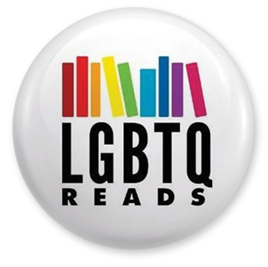
When workers at the Hurricane branch of the Washington County Library System (WCLS), UT, were told to change signage on LTBTQ-themed displays and stop wearing buttonspointing library visitors to LGBTQ resources, they brought their concerns to the local press. Director Joel Tucker stated that promoting LGBTQ materials was sending a message of advocacy on the part of the library, which he wanted to maintain as a neutral space. Library staff, however, saw the policy as discriminatory and directly in conflict with the American Library Association (ALA) Bill of Rights.
In June 2017, WCLS employee Natalie Daniel created an exhibit for Pride Month titled “Got Pride?” featuring a collection of LGBTQ-themed material. Some patrons reportedly complained, according to Tucker, as did an unnamed county official; also, Tucker told LJ, he wanted to avoid similarities to the “Got Milk?” advertising slogan. Tucker, who is in charge of WCLS’s eight branches, instructed workers to change the display midmonth to “June is Pride Month,” and to remove additional LGBTQ resources to outside organizations from the display. Although the rest of the display remained in place throughout the month, Tucker issued a directive that future displays should not be LGBTQ-themed. Some patrons would interpret such signage as “advocating for that point of view” on the part of the library, he told the press.
This year, library staff was again instructed not to create a display specifically pointing to LGBTQ-themed material. Instead, the display addressed the broader theme of diversity, featuring material on race, religion, sexual orientation—including LGBTQ materials—and other topics, with signage reading “Libraries are for everyone.”
To supplement the display, some employees had buttons made that said “Ask me about LGBTQ Reads,” which features LGBTQ-themed material, author interviews, guest blogs, and more. Again, claimed Tucker, patrons complained, and he directed employees to take their buttons off—also citing the library’s dress and appearance policy, which called for a “business casual” appearance. “Buttons of any kind are not in line with that professional appearance,” he told LJ.
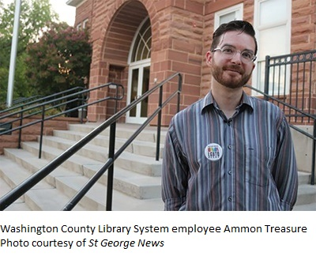
SUPPORT FROM THE MEDIA AND MORE
Ammon Treasure, a clerk at the Hurricane branch, was one of the library workers who spoke out against Tucker’s actions. Treasure first went to the WCLS human resources department, but was dissatisfied with the response, which he described as repeating Tucker’s justification. So he reached out to a local paper, The Spectrum; the story was then picked up by a number of media outlets, including Good4Utah.com, St George News, The Advocate, and the Associated Press.
Treasure explained that highlighting LGBTQ resources in the library is not the same as promoting an agenda—and forbidding such displays undermines the library’s role as a safe space. "There are a lot of people who have yet to come out of the closet, or are unsure of the environment we're in, whether or not they're going to be ridiculed,” Treasure told Good4Utah. “We wanted to be able to provide all of our community with information that they need.”
The library had built displays around other holidays and topics, Treasure noted, such as Black History Month and St. Patrick’s Day. "My hope is that by coming forward we can start an important conversation about inclusion and work toward eliminating the stigma that still surrounds this topic," he told The Spectrum.
Representatives from advocacy group Equality Utah convened a public forum at the St. George branch library on August 9, where they met with library officials and staff. There, Tucker explained that LGBTQ displays have been banned at all of Washington County’s libraries, noting, "If you put up a display that says LGBTQ, you're pushing away a segment of our society."
When Tucker acknowledged that he did not consider Black History Month displays controversial, Mark Chambers, a former town councilman, state senate candidate, and member of Equality Utah, stated, “When you say Black History Month is not controversial, but our month is, you are dismissing us.”
“I would liked to have found more common ground,” Tucker told St George News after the forum. “I strive to be accepting to all people and all perspectives, and the LGBTQ community is a part of that. I want them to feel included and a part of the library.”
However, he told Good4Utah.com, if that common ground could not be reached he considered banning all displays throughout the WCLS system.
ALA weighed in as well. James LaRue, director of ALA’s Office for Intellectual Freedom, told Good4Utah, “Libraries providing robust services and lots of information about the world is just business as usual—that’s our whole purpose in public life…. We very much believe that the kinds of displays that go on in Pride Month…are just part of the human condition, and it makes perfect sense for them to be in libraries.”
The National Coalition Against Censorship (NCAC), joined by members of Lambda Legal, the National Council of Teachers of English, the Utah Library Association (ULA), and ALA, sent Tucker an open letter on August 16. The letter read, in part, “Not only is suppressing LGBTQ displays likely to be a violation of the First Amendment, it further marginalizes a vulnerable minority group and would set a dangerous precedent of intolerance to purportedly controversial ideas. Such a culture of prejudice is toxic in any community forum, especially the library where everyone should be equally welcome and guaranteed freedom to read, think and explore new ideas.” It also pointed to resources such as ALA’s Exhibit Spaces and Bulletin Boards guidelines and NCAC’s “Museum Best Practices for Managing Controversy.”
ULA IS THERE TO HELP
ULA posted its own Statement on Exhibits, recognizing “the importance of having a collection development policy that includes a process for responding to challenges to our materials, exhibits, and use of space.” Helping WCLS put such policy in place is one of ULA’s primary concerns, and the organization has been working directly with Tucker and his staff.
In addition to offering resources and guidance, said ULA president Rebekah Cummings, digital matters librarian at the University of Utah’s Marriott Library, Salt Lake City, “We see great value in having a variety of voices represented in our collections and our exhibits—but we do want to make sure that, more than anything, the director in Washington County and all the other librarians in the state use this as a learning experience to know how to deal with these challenges going forward.” For directors such as Tucker, who do not have an MLIS and may not have studied library values statements such as ALA’s Library Bill of Rights or the Freedom to Read Statement, working with an association like ULA can help define those guidelines.
“All of our policies conform with the Library Bill of Rights,” Tucker told LJ on August 20, “and seek to further our mission of providing people with materials, information, and the space to promote ideas, inspire lifelong learning, and strengthen communities.”
Cummings and ULA advocacy chair Peter Bromberg, executive director of the Salt Lake City Public Library, UT, recently penned an op-ed column for Utah’s Deseret News. As well as emphasizing the values posted on the WCLS website—to “provide open, non-judgmental access to collections and services,” “advocate and support the First Amendment Rights and the Library Bill of Rights,” and “serve the total community by providing free and open access to the ideas and information available on all subjects,” the piece points out some important statistics: “LGBTQ youth have higher rates of mental health challenges and risk of suicide, which research shows is driven by social isolation and exclusion. Considering that 86 percent of LGBTQ youth report harassment and bullying at school, and that suicide is the leading cause of death among Utah youths ages 10–17, it becomes clear that displays of LGBTQ materials that promote education, awareness and respectful dialogue can help support positive health outcomes for our youths and our community.”
It’s not only the WCLS community that can learn from this situation, noted Cummings—ULA can use this as an opportunity to improve communication with its stakeholders as well. “It's made us realize that there is this need out there, that we can't take it for granted that every librarian in the state has a policy in place to deal with challenges,” she noted, and that ULA should “have those values firmly rooted so we know how to address them when they happen."
In addition, she said, she hopes that library workers like those at WCLS know that ULA is available to support them and listen to their concerns. “I'm not unhappy at all that they reached out to the press,” Cummings told LJ. “I'm glad that the story is out there and it's a chance to raise awareness,” but she would have liked the opportunity to help Treasure and his coworkers from the beginning. “We would have validated his concerns,” she said. “We would have let him know that he's not wrong."
Tucker and WCLS are reportedly moving ahead on drafting the needed policy, reported Ammon on August 20. “I've been informed that our library system will be forming a committee to create new policies about displays—in which they will be working closely with state librarians experienced with the library Bill of Rights and upholding intellectual freedom,” he told LJ. “I hope that we will have good news to share regarding new displays soon. While I have not been assured yet that any LGBTQ displays will not be censored in the future, I'm confident that with new policies in place we will be able to negotiate their return.”

https://www.libraryjournal.com/?detailStory=180821-Utah-LGBTQ-Display

- ALA Rolls Back Inclusion of Hate Groups in Bill of Rights Revision
by Lisa Peet & Kara Yorio
Aug 20, 2018 | Filed in News

This story has been updated with the results of the Council poll.

An online American Library Association (ALA) Council poll, held August 9–16, voted 140–4 to rescind the controversial meeting room interpretation of the Library Bill of Rights adopted at ALA's Annual Conference in New Orleans in June. The wording will revert to the 1991 version that had previously been in effect. ALA's Intellectual Freedom Committee (IFC) has established a working group to draft a new meeting rooms interpretation and share it prior to October 1, in anticipation of Council’s vote at the 2019 ALA Midwinter Meeting in Seattle.
Ninety of ALA's 179 councilors were required to vote, with 75 percent of those voting needed to approve the measure. A total of 146 councilors, representing 82 percent of the eligible voters, took part in the poll.
IFC's new working group new working group includes Shauntee Burns-Simpson, New York Public Library, chair, Committee on Diversity; Sara Dallas, Southern Adirondack Library System, NY, chair, Committee on Professional Ethics; Martin Garnar, University of Colorado, Colorado Springs, chair, Office for Diversity, Literacy and Outreach Services (ODLOS) Advisory Committee; Ray James, Institutional Survey, Intellectual Freedom Committee; Emily Knox, University of Illinois at Urbana-Champaign, vice president, Freedom to Read Foundation and member, Association of College and Research Libraries Professional Values Committee; Johana Orellana, North Richland Hills Library, TX, IFC; Kim Patton, Kansas City Public Library, KS, IFC; Brooke Sheets, Los Angeles Public Library, Public Library Association liaison to the IFC; John Spears, Pikes Peak Library District, CO, IFC; Julia Warga, Kenyon College, OH, chair, IFC. Staff liaisons to the working group include Jody Gray, director of ALA's Office for Diversity, Literacy and Outreach Services and James LaRue, director of the Office for Intellectual Freedom (OIF).
“I would like to express my gratitude to ALA members and staff for their collaboration and feedback as we work to respond to language found within updates to the Library Bill of Rights,” said ALA President Loida Garcia-Febo. “The ALA continues to strive to provide resources that support Equity, Diversity and Inclusion and intellectual freedom. We can only do so when all of our voices are heard. Today’s vote does not end conversations regarding the interpretation of the Library Bill of Rights, but rather continues our exploration regarding how we can support the profession’s needs.”
A CONTROVERSIAL REVISION
The June revision, proposed by IFC regarding the purpose of public library meeting rooms, stated:
"Public libraries are bound by the First Amendment and the associated law governing access to a designated public forum. A publicly funded library is not obligated to provide meeting room space to the public, but if it chooses to do so, it cannot discriminate or deny access based upon the viewpoint of speakers or the content of their speech. This encompasses religious, political, and hate speech.
"If a library allows charities, non-profits, and sports organizations to discuss their activities in library meeting rooms, then the library cannot exclude religious, social, civic, partisan political, or hate groups from discussing their activities in the same facilities.”
The inclusion of hate groups—wording which was not in the draft of the proposed interpretations—had librarians taking to Twitter in opposition and asking people to contact ALA and demand it change the language. Many tweeted using the hashtag #NoHateALA.
"@ALALibrary this is not what our profession stands for & we should never welcome hate in the name of being neutral. #NoHateALA" librarian Katie Quirin Manwiller wrote.
"Support Both Principles"
Library Journal asked Martin Garnar, co-chair of ALA's Equity, Diversity, and Inclusion Implementation Working Group, his thoughts on the revision and the ensuing debate. He emailed his response:
My concern is that this debate is being framed in a way that makes it impossible to support both principles: either you support free speech or you support marginalized communities.
Yes, under the First Amendment, we have to let everyone use our facilities if we make them open to the public and if they’re following the rules.
Yes, we can continue to engage with those who have been historically (and are currently) oppressed through intentional programming, outreach, and services.
From my perspective, this is how we solve the dilemma: We support both principles. We continue to support free speech and fight the laws that target marginalized communities.
We continue to confront and dismantle the structural inequality in our profession and our society, and continue to work with marginalized communities to improve their access to information. And we continue to have thoughtful discussions about how to make this a “both and” situation as opposed to “either or.”
On the same day that Council adopted the revised Meeting Rooms interpretation, it also adopted the revised interpretation on Library-Initiated Programs as a Resource, which includes the following statement: "As stated in 'Equity, Diversity, Inclusion: An Interpretation of the Library Bill of Rights,' Socially excluded, marginalized and underrepresented people, not just the mainstream majority, should be able to see themselves reflected in the resources and programs that libraries offer.
"Libraries should actively seek to include a variety of programming options representing diversity of genres, formats, ideas, and expressions with a multitude of viewpoints and cultural perspectives that reflect the diversity in our communities."
Both interpretations reflect principles of the association, and our challenge is to find a way to uphold them at the same time.
LaRue said that nothing was new in IFC's interpretation. Rather, the wording was changed to specifically define the meeting rooms section after being asked if a library had to allow a KKK meeting in its building. The Public Library Association didn't accept the OIF's original clarification which read as if it too closely tied religion to hate groups, according to LaRue. So the organization sought the widest term for what was being discussed.
"We said the generic term we need here is hate groups," he told LJ. "The honest truth of it is we inserted it because of a question in the field and we felt like we wanted to address the issue head on instead of dance around it."
He spent hours on Twitter responding to reaction, citing court cases and the First Amendment and, after a lot of thought, he said, his main comment on the situation came down to this: "ALA is about diversity and intellectual freedom, not just one or the other."
In a July Twitter thread, Baltimore County Public Library librarian Tyler Vachon explained his opposition. In part, it read:
“Libraries don't exist in a thought experiment. We're buildings with real people in them. People who see a branch willing to grant space and legitimacy to hate groups and recognize that they're no longer safe in that building. Librarians no longer have their backs. “We are way past the point of there being room to discuss things in abstract like "gosh should the Klan be able to use our meeting space? Should fascists?" These movements are gaining momentum and any institution willing to grant them quarter shares responsibility for that.
“Many of us serve communities that are already terrorized by these groups. Show up for them. Be willing to fight back when they may not feel safe to do so. Don't let this toxic worship of neutrality and inertia enable fascism in your community."
The IFC is charged with recommending “such steps as may be necessary to safeguard the rights of library users, libraries, and librarians, in accordance with the first amendment to the United States Constitution and the Library Bill of Rights as adopted by the ALA Council.” ALA includes a page on free speech protections on its website, which reads in part: “The First Amendment to the United States Constitution protects speech no matter how offensive its content. To be clear, the First Amendment does not protect behavior that crosses the line into targeted harassment or threats, or that creates a pervasively hostile environment. But merely offensive or bigoted speech does not rise to that level, and determining when conduct crosses that line is a legal question that requires examination on a case-by-case basis.”
But what if the groups make employees or other patrons feel threatened or uncomfortable?
"We’ve talked about this and this has been a theme for ALA for a while, which is to say, how do you model civil and civic discourse? How do you establish an environment in which people do feel welcome?" said LaRue. "I think it's a stretch to say you build a safe environment by forcing everybody to shut up if somebody claims to be offended. I don’t think that’s a safe environment."
The press release on the revisions was sent out several days before the social media outcry, and LaRue felt people didn't get all the details before voicing their opposition. "Particularly on Twitter, I notice a tendency to pull things out of context and I think we need to remember in ALA nothing gets decided quickly," he said. "There were lots and lots of discussions about this. And there were lots of public librarians and school librarians and academic librarians looking at this. The fact that it generated so much energy...means it’s an important topic. So let’s talk about it, but let’s try not to savage each other in the process. Let’s assume that we share values."
In a July 10 OIF blog post, LaRue stated: "ALA does not endorse hate groups. It does not seek to normalize hate speech, but it recognizes that hate groups is a remarkably elastic term prone to be thrown about by both sides of the political spectrum. It’s been attached to book discussion groups, Black Lives Matter and others."

https://libraryjournal.com/?detailStory=free-speech-debate-erupts-with-alas-inclusion-of-hate-groups-in-revision-of-bill-of-rights-interpretation

