Año 3 Número 84 septiembre 2018

Contenidos de este número
- El Dr. Sergio López Ruelas, bibliotecario homenajeado en la FIL Guadalajara 2018
Asociación Mexicana de Bibliotecarios AC
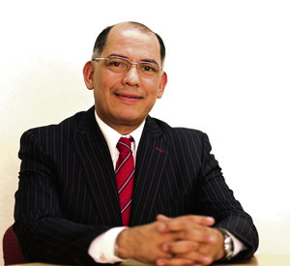 | La Asociación Mexicana de Bibliotecarios, A.C., se congratula por la merecida designación, en virtud de su trayectoria académica y profesional, del Dr. Sergio López Ruelas como bibliotecario homenajeado por la Feria Internacional del Libro de Guadalajara.  El reconocimiento al Dr. López Ruelas por las acciones que ha realizado en favor de la profesionalización de los bibliotecarios y las bibliotecas, como es la organización del Coloquio de Bibliotecarios, y su contribución al establecimiento de la red de bibliotecas de la Universidad de Guadalajara, es un aliciente para el gremio bibliotecario en su esfuerzo cotidiano por mejorar la atención y servicios a los usuarios.

- Ban Extended for 3-D Printed Gun Plans
by Matt Enis
Aug 29, 2018 | Filed in News
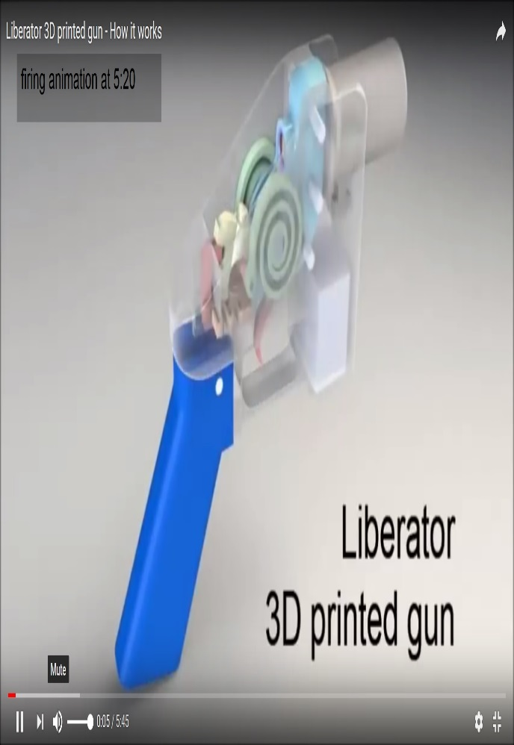
U.S. District Judge Robert Lasnik on Monday extended a ban on the online publication of digital blueprints that can be used to manufacture guns with 3-D printers and computer numerical controlled (CNC) milling machines. The ban will remain in place until a lawsuit filed by 19 states and the District of Columbia against computer aided design (CAD) gun blueprint provider Defense Distributed is resolved.
Since a growing number of U.S. public and academic libraries provide access to 3-D printers and CNC milling machines as part of Maker spaces and fab lab workshops, the case has drawn attention from the library field, raising concerns about how staff should respond to potential requests to use library equipment to create weapons. In Florida, home to a large number of shooting deaths, Broward County Library (BCL) has suspended access to its 3-D printers until it formulates such a policy.
The American Library Association (ALA) has encouraged libraries to establish policies governing the use of 3-D printers and other Maker space equipment since the trend began gaining tractionin libraries a few years ago. ALA maintains a recently updated best practices web page, with links to sample policies and resources for policy development.
A public or academic library Maker space is currently a very unlikely place for someone to attempt to manufacture a functioning gun that they plan to use. However, establishing a clear policy for 3-D printers, CNC milling machines, and other Maker space equipment would enable staff to deny such requests quickly and authoritatively, and, if created with the assistance of legal counsel, could help protect the library from gun activist lawsuits.
“While I definitely think libraries need policies, the current excitement about Defense Distributed and 3-D printing guns is…vastly overblown,” Jason Griffey, library consultant, affiliate fellow at the Berkman Klein Center for Internet and Society at Harvard University, and author of 3-D Printers for Libraries, 2017 Edition, told LJ . “The likelihood of someone actually using a gun that was printed in a library is infinitesimal...but using the threat of it as a media hook, in order to push other agendas, is very likely.”
Griffey pointed to an article posted to Slate.com earlier this month by Andrew Sellars, lecturer and clinical instructor at Boston University (BU) School of Law, and director of the BU/Massachusetts Institute of Technology (MIT) Technology and Cyberlaw Clinic. Sellars explains that even when it comes to the “Liberator” handgun—“the most famous of the designs and the one whose plans have been kicking around the seedier corners of the Internet for a half-decade—the CAD files are much more like an unauthorized sequel to The Anarchist Cookbookthan a self-executing firearm producer.”
Basically, he explains, creating a usable gun with a 3-D printer is much more complicated than simply downloading the files and running a printer for a few hours. Philip Bump at The Atlanticwrote about trying and failing to create a functioning version of the Liberator handgun in 2013, Sellars notes. In that article, Bump also explains that Defense Distributed itself estimates that the lifespan of a successfully printed Liberator is a single round, due to the internal damage to smaller parts that will likely be sustained by firing the weapon just once. Andy Greenberg at WIRED had more success creating an AR-15 rifle in 2015—using a $1,500 CNC milling machine to create a “lower receiver” out of aluminum and assembling the gun with a lot of separately purchased, unregulated parts and components.
As Sellars states, “a gun that conservatively costs more than $1,000 in capital investment to 3-D print (given that the output has to be of a relatively high quality to actually work) could instead be obtained for a couple hundred dollars lawfully, or even unlawfully at a still-cheaper markup.”
However, practicality doesn’t appear to be the primary goal for Defense Distributed. At one point the company described its mission as “facilitating global access to, and the collaborative production of, information and knowledge related to the 3-D printing of arms; and to publish and distribute...such information and knowledge in promotion of the public interest.” And when the Department of State initially demanded that the organization remove its CAD files from its website in 2013, citing violations of International Traffic in Arms Regulations, founder Cody Wilson responded with a lawsuit on first amendment grounds that he appealed all the way to the U.S. Supreme Court, which declined to hear the case.
In a July interview with WIRED, Wilson explained that Defense Distributed wanted to have a portion of its Austin, TX headquarters designated as a public library, which would potentially give the organization access to the U.S. military’s public archive of gun data for inclusion in its Defcad.com design database.
"Ninety percent of the technical data is already out there,” Wilson explained. “This is a huge part of our overall digital intake strategy. Hipsters will come [to Defense Distributed’s library] and check out movies, independent of its actual purpose, which is a stargate for absorbing ancient army technical materials."
PROACTIVE POLICY
BCL director Kelvin Watson told LJ that the library's 3-D printers almost certainly are not capable of creating a functioning gun. This is likely the case with most models of consumer-grade 3-D printers currently owned and operated by the majority of public library Maker spaces. And no patrons had requested to use BCL’s 3-D printers for making guns or gun parts. Still, BCL made national news recently by taking its 3-D printers temporarily offline until the library could craft a policy that would insulate it from such requests.
“We didn’t have an adequate policy in place to protect us if someone wanted to do that,” Watson said. “Basically, anybody could come in and ask us to print anything they wanted on our 3-D printers…. Without the proper policy in place, you’re putting staff in an uncomfortable position” and potentially leaving the library and county exposed to a lawsuit from a gun activist, he said.
After assessing BCL’s relevant programs and consulting with an attorney, the library began working on a policy that focuses, in part, on the use of 3-D printers for STEM (science, technology, engineering, mathematics) activities. Watson said this week that the policy will be in place soon, and BCL expects to have its 3-D printers back online in September.
“Our goal is to totally enhance our creation stations and Maker spaces, and offer interactive learning [opportunities] with 3-D printing,” he said.
As for Defense Distributed, Gizmodo.com reported yesterday that the company is already exploiting a loophole in the injunction, which states that its CAD files can’t be uploaded to the Internet, but can be emailed, mailed, or securely transmitted. So, in exchange for suggested donations of $10, Wilson is mailing plans on thumb drives or emailing the plans to individual addresses.
“I can sell them anywhere I like in the U.S.,” he told Gizmodo.

https://libraryjournal.com/?detailStory=180829-3D-Printers-and-Guns

- Closed Georgia Libraries Win Reprieve
by Bob Warburton
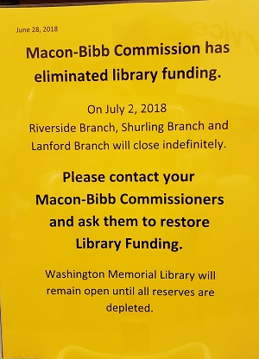
It’s been a whirlwind few weeks for Middle Georgia Regional Library System (MGRLS) and its director Jennifer Lautzenheiser.
On August 16, three branches were closed and a fourth in danger of shutting down due to lack of funding. But a few days after county commissioners voted August 21 to approve a spending plan that fully restored funding to all four libraries in Macon-Bibb County, a relieved Lautzenheiser was happy to report that all were open, fully funded, and busily finalizing their fall programming.
AN IMPASSE...
In early July, Lautzenheiser had watched helplessly as county officials reached a budget impasse that forced her to close three of the libraries indefinitely. Weeks later, the fourth branch stood precariously close to a shutdown as well.
On August 14, she appeared at a meeting of the Economic and Community Development Committee for Macon-Bibb County to request emergency funds for the county’s four library branches. If that money was not forthcoming, Lautzenheiser told the committee, she had no choice except to ask the regional system’s board of trustees to remove Macon-Bibb libraries from the six-county network.
The four Bibb County facilities belong to MGRLS, a network that extends into five more Georgia counties with nine other libraries. These 13 libraries share an important link that left Lautzenheiser confronting another dilemma as the Macon-Bibb budget impasse stretched into August. As Lautzenheiser explained, the regional system’s bylaws allow noncompliant counties to be expelled to preserve overall network compliance, as outlined by the Georgia Public Library Service. Without public funding, the four Bibb branches were technically noncompliant. It was Lautzenheiser’s duty as regional director, she told LJ, to protect the nine other libraries.
“We just couldn’t allow all the residents of the other five counties to lose access,” she said. That included participation in the statewide Public Information Network for Electronic Services (commonly known as PINES), which allows cardholders to check out or return books at any of 300 participating libraries.
“While we are all committed to library service for every person in our state, we are also concerned with the commitment of every county to fairly and adequately support library service,” said Georgia State Librarian Julie Walker. “In Georgia, public libraries are primarily a local government responsibility, with state funding allocated for on-behalf services that facilitate resource-sharing and enhanced services and programs. The state works in partnership with our local governments, and it’s critical that all parties maintain appropriate funding levels.”
Committee members seemed to appreciate the libraries’ predicament; they voted that night to recommend an emergency appropriation from the county’s general fund.
On August 15, a notice posted at the Washington Memorial Library warned that the facility would be forced to close the next day. But then, with patrons nervously following every twist and turn on social media (lending support on hashtag #savemaconlibraries), the library crisis finally broke, all in a few dizzying days.
...AND A REPRIEVE
On August 16, the Macon-Bibb County Commission approved $238,000 in emergency library funding.
Lautzenheiser walked away from the meeting with a check literally in hand—given to her in full view of local news cameras—that would cover a month’s worth of operations for all four libraries. Luckily, there was still time to get to the bank that afternoon, she recalled in an interview with Library Journal.
A few days later, on August 21, there was even better news. The County Commission finally passed its budget for FY19, which started on July 1. The $161.7 million spending plan included $2.87 million for regional library operations, identical to 2018 levels. That amount funds the main Washington Memorial Library facility and the smaller Lanford, Riverside, and Shurling branches.
“We were the only agency to not have any cut to funding,” Lautzenheiser said. “Everyone else got a cut of between 10 and 50 percent. We’re steady and we’re very grateful for that.”
The final budget, which amended an interim spending plan pushed through in early July, featured a 3 mill property tax increase for county residents and slashed budgets for the transit authority, parks, health department, and other agencies. The millage rate was set at 20.642 removing a huge roadblock toward a budget agreement.
District 8 Commissioner Virgil Watkins Jr., chair of the Operations and Finance Committee, did not return messages seeking comment. A county spokesman described Watkins as an integral voice toward protecting library funds during the budget process.
The Riverside Library in Macon welcomed patrons back on August 27, the first time in almost two months that all four Macon-Bibb branches were open simultaneously. The Washington Memorial Library, the regional network’s central branch, managed to stay in business through the budget crisis by using reserve funds, although that pool was running dry midway through August.
“It’s very exciting, isn’t it?” Lautzenheiser said. “We really felt like it was quite a victory. Our patrons are thrilled, of course.”
“I’m relieved and happy that the Macon-Bibb County commissioners voted to restore library funding,” Walker told LJ. “I’m also pleased that the community made their voices heard in response to the possible loss of their well-used and appreciated public libraries. I think the statement was very clear: libraries play a vital and valued role in society and family life in Macon, as they do in every community in Georgia.”
Lautzenheiser made it clear she bore no ill will toward the Macon-Bibb County Commissioners. “It really wasn’t about the value of the library,” she said. “All of the commissioners understood the value of the library. … It was more a discussion of about who was responsible to pay for it. Those kind of things don’t always come out in a headline.”

https://libraryjournal.com/?detailStory=180829-Closed-Georgia-Libraries-Win-Reprieve

- IMLS Public Library Survey: Program Attendance, Collection Size, Digital Materials Up; Visits, Circ Down
by Lisa Peet
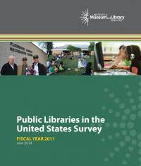The Institute of Museum and Library Services (IMLS) issued its most recent Public Libraries Survey (PLS) Report on August 2, offering a look at public library use, financial health, staffing, and resources in the country’s 9,068 active public libraries in FY 2015. At the same time, IMLS also released a set of state profile reports, which give snapshots, through tables and infographics, of public library data for each of the 50 states and the District of Columbia.
Among the survey’s many findings are a total of 1.39 billion public library visits to in 2015—4.48 visits per capita, which was slightly down from 2014’s 4.64. There were 255.88 million reference transactions or 0.82 transactions per capita, down from 0.86 in 2014. Libraries offered 4.7 million programs, which were attended by nearly 107 million people—five million more than in 2014. “That means that in 2015, for every 1,000 people in a library’s service area, 341 patrons attended a public library program, up from 332 people the previous year,” explained Marisa Pelczar, program analyst with the IMLS Office of Digital and Information.
Libraries made 1.31 billion collection items available, an increase from 3.78 to 4.28 materials per capita from the previous year. Overall circulation varied by library locale—higher in cities and suburbs than town and rural areas—for a total of 7.3 per capita, down from 7.5 in 2014.
While video material usage has remained relatively flat—and print materials continue to comprise most of the collections—e-resources, including audio, video, and ebooks, have seen substantial growth, with large increases in ebooks and audio materials (53.16 percent and 44.16 percent, respectively). Ebook use grew from 0.7 per person in 2014 to just over one ebook per person in 2015, and libraries provided patrons access to over a quarter of a million computers with Internet access.
CALL IT A COMEBACK
PLS data is gathered through a federal-state cooperative system, and regularly reaches response rates of over 95 percent. In FY 2016, that number rose to 98 percent, representing more than 17,000 central libraries, branches, and bookmobiles in more than 9,000 public library systems.
The U.S. Department of Education first established the PLS in 1988. IMLS took over its administration in 2007. Because PLS collection dates back three decades, it offers a long-term view of the changing roles of public libraries. Among other insights, the new report includes a ten-year analysis of how libraries are still working to rebound from the Great Recession of 2009 even as they expand programming and access to meet their stakeholders’ needs.
While both operating revenue and expenditures per person increased from FY 2014 levels, continuing positive trends that began in FY 2012, they have yet to reach 2009 levels of nearly $13 billion—although FY 2015’s operating revenue hit $12.42 billion, and total operating expenditures $11.62 billion. Staffing is relatively flat, having declined over the past 13 years by almost one staff FTE per 25,000 people served since FY 2006’s 12.17 FTE; FY 2015’s average is 11.19 staff per 25,000 people.
Ebooks and audio materials, on the other hand, have increased by over 2,600 percent and 250 percent respectively since 2006. Ebooks now make up 25 percent of all collection materials, as opposed to one percent in 2006.
“In today’s rapidly changing information environment, public libraries are flexing and responding to their communities,” said IMLS Director Kathryn K. Matthew in a statement. “We see this across indicators of resources, services, and usage. Our findings show robust use of reference services, the addition of more e-books and audio visual materials to collections, and increased use of public access computers, for example. Libraries are offering more programs on everything from early childhood to workforce resources, and public participation is also rising.”
IMPROVING THE SURVEY
In addition to the report, public datasets, statistical tables, and state profiles, earlier this summer IMLS Labs released a beta version of a new Library Search & Compare tool that uses data from the FY 2016 PLS. IMLS is incorporating feedback from testers and making iterative improvements to the platform.
“The new components to this report make its stories, trends, and insights faster and easier to access,” said Benjamin Sweezy, deputy director of the IMLS Office of Digital and Information Strategy, in a statement. “The expanded state profiles, data graphics, and comparison tables make this rich source of library data accessible to new audiences and actionable for government and library leaders across the country.”
Current plans to improve data collection, noted Pelczar, include looking at ways to reduce the burden on respondents; IMLS will be studying the role of data sampling, as well as improving the quality of training for state partners.
The agency is also preparing to conduct a third-party study that will explore ways to introduce and modify data elements and statistical indicators. The first year of any new data element’s life cycle is a trial collection year, in order to allow states time to add that element to their own state surveys and train libraries to collect the new data; a new data element for 2018, for instance, will be website visits, representing the annual number of sessions initiated by all users from inside or outside the library to a library’s website.

- LC Announces Winners of 2018 Library of Congress Literacy Awards
Filed by Gary Price
The Library of Congress announced the recipients of the 2018 Literacy Awards on August 31, 2018.
From LC:
Three organizations working to expand literacy and promote reading in the United States and worldwide were awarded the 2018 Library of Congress Literacy Awards at the National Book Festival gala, Librarian of Congress Carla Hayden announced tonight.
Hayden and philanthropist David M. Rubenstein awarded the top prizes to: Reading Is Fundamental of Washington, D.C.; East Side Community School of New York City; and Instituto Pedagógico para Problemas del Lenguaje of Mexico City.
The Literacy Awards, originated by Rubenstein in 2013, honor organizations doing exemplary, innovative and replicable work, and they spotlight the need for the global community to unite in working for universal literacy.
“Literacy empowers people around the world, giving them the chance for learning, fulfillment and participation in civic life,” said Librarian of Congress Carla Hayden. “Thanks to the generosity of David Rubenstein, the Library of Congress is proud to honor these innovative and exemplary organizations working to raise reading levels. We look forward to their ongoing progress in building a culture of reading.”
Prizes and Recipients
David M. Rubenstein Prize ($150,000)
Reading Is Fundamental, Washington, D.C.
Reading Is Fundamental (RIF) works to create a literate America by inspiring a passion for reading among all children, by providing quality content and engaging communities in the solution to give every child the fundamentals for success. Founded in 1966, RIF is a national nonprofit focused on children’s literacy and, in partnership with a grassroots network of volunteers in schools and communities nationwide, has distributed more than 415 million books and affected the lives of more than 40 million children. Signature programs and resources include: Books for Ownership, enabling children to select age-appropriate books to own; Read for Success, an intervention program addressing literacy backslide during the summer months; Literacy Central, a free digital site for supplemental learning resources aligned with favorite children’s books; Literacy Network, a portal for local literacy partners; and the Reading Log App, used to track and share time spent reading.
American Prize ($50,000)
East Side Community School, New York City
East Side Community School is a 6-12th-grade Title I public school in New York City. During a time when the national focus on high-stakes standardized tests has caused many schools to focus on test prep and quick fixes that may affect students’ interest in reading, East Side has responded differently by creating and sustaining an independent reading program where students read on average over 40 books each year, improve literacy skills, address their social-emotional and political needs through literature, and fall in love with reading. Strong reading instruction, daily extended time to read inside and outside of school, exposure to appealing books and choice, book clubs, author visits, constant conversations around books and a full commitment from all stakeholders has made East Side a national model for the capacity of schools to create a powerful culture of reading.
International Prize ($50,000)
Instituto Pedagógico para Problemas del Lenguaje, Mexico City
Instituto Pedagógico para Problemas del Lenguaje (IPPLIAP) is a nonprofit organization founded 50 years ago that is dedicated to supporting deaf children and children with language and learning disabilities, primarily from impoverished families, through educational programs and after-school support. IPPLIAP carries out its mission through specialized programs that guarantee full access to education for these children with literacy at their core, by holding continual reading and writing workshops with children and striving for them to learn the joys of reading, writing and how to become lifelong learners. IPPLIAP believes that literacy is the vehicle to guide any child, to build rational and critical thinking, and to reach a better understanding of themselves and of the complex world in which they live.
The Library of Congress Literacy Awards program also is honoring 15 organizations for their implementation of best practices in literacy promotion. These organizations are:
- America SCORES, New York City
- Fundación A Mano Manaba, Jama, Ecuador
- Learning Ally, Princeton, New Jersey
- Mango Tree Literacy Lab, Lira, Uganda
- Minnesota Literacy Council, St. Paul, Minnesota
- Philadelphia Office of Adult Education, Philadelphia
- Project Read, Provo, Utah
- ProLiteracy Worldwide, Syracuse, New York
- Reach Education, Inc., Washington, D.C.
- Resources for the Blind, Quezon City, Philippines
- Sesame Workshop India Trust, New Delhi, India
- Transformemos Fundación Para El Desarrollo Social, Cundinamarca, Colombia
- Umuhuza, Kigali, Rwanda
- Visual Language and Visual Learning (VL2), Washington, D.C.
- World Possible, Irvine, California
Rubenstein is the co-founder and co-executive chairman of The Carlyle Group. He is a major benefactor of the Library of Congress and the chairman of the Library’s lead donor group, the James Madison Council.
The Library of Congress Literacy Awards are administered by the Library’s Center for the Book, which was created in 1977 by Congress to “stimulate public interest in books and reading.
See Also: Library of Congress Literacy Awards FAQ
See Also: Library of Congress Literacy Awards Winners (2013-2017)

https://www.infodocket.com/2018/08/31/lc-announces-winners-of-2018-library-of-congress-literacy-awards/

- Slide Presentations from “Advocacy in Action! Success For Library Advocacy Worldwide” Meeting Now Available Online
Filed by Gary Price on September 3, 2018
“Advocacy in Action! Success For Library Advocacy Worldwide” took place at the National Library of Malaysia on August 23, 2018.
This “satellite meeting” was organized by the Management of Library Associations Section (MLAS) of the International Federation of Library Associations (IFLA) ahead of the 2018 World Library and Information Congress (WLIC).
Slide presentations from “Advocacy in Action! Success For Library Advocacy Worldwide” are now available on the meeting webpage and also linked below.
Event Description
While advocacy is a key role for many library associations, it can vary widely in terms of goals, scope, scale, style, method, reach and impact. This one-day workshop will feature a selection of library association advocacy programs from across the world that are inspiring and have been influential — whether advocating for the role of libraries in social development, education and literacy; for the support, resourcing and development of library strength and capacity within a country; or for the rights, freedoms and principles that enable equitable access to information in a complex, diverse and digital world.
Speakers will highlight successes, challenges and outcomes, sharing lessons and practices that could benefit any library association looking to strengthen its advocacy effectiveness. There will also be opportunities for attendees to showcase their own innovative uses of media, social media, promotional materials, member engagement, champions, other advocacy means; and the agenda will provide ample opportunity for participant questions and table discussions.
Presentations (All PDFs)
- Successful Advocacy in U.S.A
Michael Dowlin
American Library Association
- Advocacy Actions of Laroc
Hau Ren Ke
Library Society of China (Taipei)
- Advocating Virtually
Susan Haigh
Canadian Association of Research Libraries
- Kenya Library Association Advocacy Plan
Constantine Matoke Nyamboga
Kenya Library Association
- Social Media – Cheap and Powerful
Rauha Maarno, Finnish Library Association

https://www.infodocket.com/2018/09/03/slide-presentations-from-advocacy-in-action-success-for-library-advocacy-worldwide-now-available-online/

- Research Article: “The More Things Change, The More They Stay the Same: Educational and Disciplinary Backgrounds of American Librarians, 1950-2015″
Filed by Gary Price on September 3, 2018
The article linked below (full text) is the author’s accepted manuscript version to be published in an upcoming issue of the Journal of Education for Library and Information science (JELIS).
Title
The More Things Change, The More They Stay the Same: Educational and Disciplinary Backgrounds of American Librarians, 1950-2015
Authors
Rachel Ivy Clarke
Syracuse University
Young-In Kim
College of St. Rose
Source
via SURFACE (Syracuse University Research Facility and Collaborative Environment)I
ISSN: 0748-5786
Abstract
Discussions of diversity in American librarianship usually focus on gender or ethnicity, but historical studies also show a lack of diversity in educational and disciplinary backgrounds. Librarians traditionally hail from the humanities, especially English and history. But as current educational attention shifts to science, technology, engineering and math (STEM) fields, are librarians reflecting this change? Anonymized data from ALA-accredited graduate programs from the last five years was collected, coded, and classified to determine librarians’ educational and disciplinary backgrounds and in what ways, if any, they differ from the past 65 years and from the contemporary U.S. general population. Unsurprisingly, we found that contemporary librarians still hail predominantly from English and history—a stark contrast from the business and health undergraduate degrees earned by the general U.S. population. Backgrounds in STEM fields remain lacking in librarianship, but librarians with undergraduate education in the arts are on the rise, perhaps supporting the creativity, flexibility, innovation and risk-taking necessary in 21st century libraries.
Direct to Full Text Article
27 pages; PDF.

https://www.infodocket.com/2018/09/03/research-article-the-more-things-change-the-more-they-stay-the-same-educational-and-disciplinary-backgrounds-of-american-librarians-1950-2015/

