Año 3 Número 83 septiembre 2018
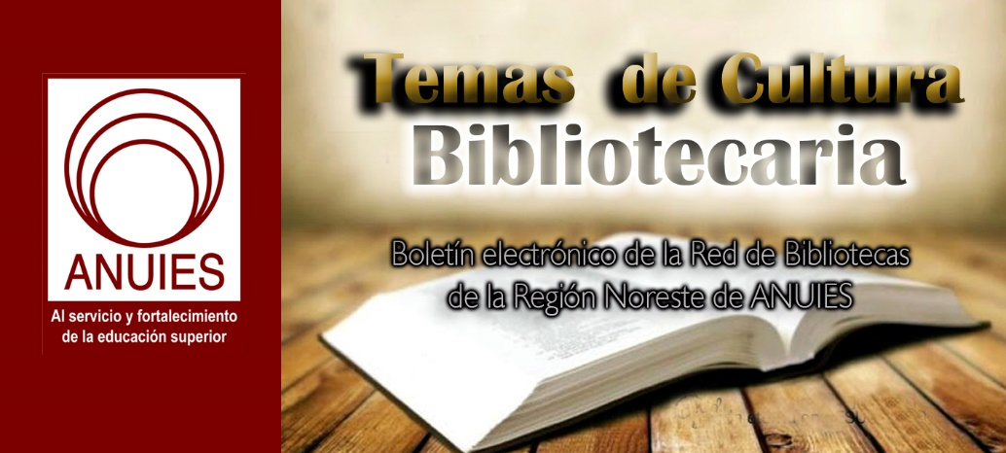

Contenidos de este número

- Linguistic Diversity in Libraries | BackTalk
By Felicia A. Smith
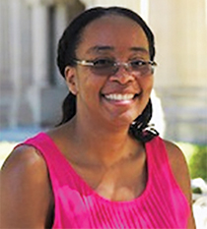Racial literacy requires critical thinking to assess situations or texts for inequalities, which is part of comprehensive information literacy skills. As society is making more of an effort to value underrepresented groups’ experiences, we need to make that same type of progress in libraries.
Many diversity discussions highlight gross disparities in wages and leadership positions. I will focus on the diverse array of vernaculars spoken by library patrons and staff, or “linguistic diversity.” I suggest that we make libraries more welcoming for marginalized patrons by breaking down barriers between diverse librarians and the privileged gatekeepers who may not understand the inherent value of adding linguistic diversity as part of a larger racial literacy endeavor. This is not a proposal to take anything away from traditional approaches to library services but instead to add language and experiences from others to it.
OUTREACH TO #OWNVOICES
We must be sensitive not to make a mockery of this inclusion through the use of stereotypes or cultural appropriation. The safest method is to have people from underrepresented groups assist with coming up with proposed ideas. If you cannot find such staffers, this would make a nice outreach project to underrepresented student groups.
Linguistic diversity can benefit all conversations. Let’s face it, urban vernacular is more colorful and has got mad swagger! Yeah, I said it. While we can encourage people to speak the same language, we don’t need to limit that language to so-called “proper English.” Why should minorities be the only ones required to code-switch?
(As I type this, I realize we desperately need linguistic diversity in Microsoft’s spell-check as well because my dictionary is being hella micro-aggressive. Just sayin’.)
SPEAKING THE LANGUAGE
I do my part to increase linguistic diversity in my areas of instruction and outreach. There are lots of ways to incorporate racially different language into daily library functions. Below are three examples that are fast and free.
- I begin workshops by demonstrating our chat service to show students how quick and easy it is to ask a librarian for help. I explain that the only reason I identify myself is so librarians can ignore me if they are busy. I confirm that students can remain anonymous. I end my chat by sending darker skin–toned emojis, then typing “Bye.”The librarians type a farewell to the class, “Bye students. Chat if you need help!” The librarians bid one last farewell, in all capitals, “BYE FELICIA!” This results in boisterous laughter and inquisitive looks to ascertain if I understand what that means. Mos Def! I intentionally use this icebreaker to signal that this is a different type of workshop than expected (i.e., dreaded). If some students/professors do not understand the joke, there are students more than happy to “Blacksplain” it. This knowledge sharing expands both student and professor exposure to this increasingly international phrase.
- During February’s so-called “Black History Month” (every month should include black history), the library could allow the Black Student Union to contribute to social media websites. Students would surely be able to add linguistic panache to posts/tweets announcing that the library has extended hours for studying.
- I created an Ask-a-Librarian poster that posed an age-old question: “Is your research a Hot Mess?” Naturally this became affectionately known as the Hot Mess poster. We received positive responses after posting it on Twitter, including praise specifically for our usage of African-American Vernacular English (AAVE). Other reactions were:
- Students at the reference desk explicitly stated their research was indeed a Hot Mess.
- Students took selfies with the poster.
- People (including library administrators) approached me stating “Hot Mess” as they all laughed. This was problematic because I kept forgetting about the poster and thought they were calling me a hot mess. Dem’s fighting words. So, yes, there are potential hazards involved, but I contend they are worth it.
That poster served its purpose as an attention grabber, and people were clearly amused by it. It proves that our intended audience is receptive to a little linguistic flair.
Racial literacy and linguistic diversity are essential for an inclusive academic environment and meaningful information literacy. Language diversity is a multifaceted resource that should be cultivated rather than viewed as a threat to academic cohesion and scholarly identity. There is nothing to lose, but much to gain, by making space for underrepresented people’s experiences and language. Adding diverse words to mainstream traditional discourse does not remove the existing language. It does not replace standard terminology but rather adds to it. Although, personally, there are some terms I would love to replace, starting with AACR. “Anglo-American Cataloguing Rules. For why?”

Felicia A. Smith is Head of Learning & Outreach, Stanford University Libraries, Palo Alto, CA

https://lj.libraryjournal.com/2018/07/opinion/backtalk/linguistic-diversity-in-libraries-backtalk/

- Books on Borders | Collection Development
BY REBEKAH KATI
The migrant situation at the United States-Mexico border is complicated, fluctuating, and has its origins in many areas including history, politics, and economics. This list aims to provide guidance to librarians and general readers with resources to contextualize current events. For more resources on immigration, see The Long Journey.
History
Chacón, Justin Akers & Davis, Mike. No One Is Illegal: Fighting Racism and State Violence on the U.S.-Mexico Border. Haymarket. 2018. 448p. pap. ISBN 9781608468492. $19.95.
Chacón and Davis examine the history of the immigration rights movement from a labor activism perspective. The book opens with an exploration of racist violence against migrant laborers during the settlement of California. The authors also chronicle economic relations between the U.S. and Mexico and the impact on migrant workers and immigration policy. The 2018 updated edition contains a new introduction that addresses current events.
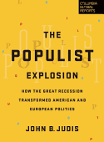Judis, John B. The Populist Explosion: How the Great Recession Transformed American and European Politics. Columbia Global Reports. 2016. 184p. ISBN 9780997126440. $12.99; ebk. IBSN 9780997126457.
Current immigration policy has been shaped by populist politics. Judis tracks the history of populist movements in both the United States and Europe, arguing that populism emerged in the United States in the 1800s and has continued to evolve as both a left- and right-wing ideology through the present day. Additionally, populist movements have appeared throughout Europe, including the United Kingdom, Austria, France, and the Netherlands.
Lew-Williams, Beth. The Chinese Must Go: Violence, Exclusion, and the Making of the Alien in America. Harvard. 2018. 360p. ISBN 9780674976016. $39.95; ebk. IBSN 9780674919921.
Exclusion of a migrant group based on their country of origin is not new policy in the United States. Lew-Williams chronicles escalating tensions and violence against Chinese immigrants in the 1850s that culminated in the Chinese Exclusion Act, which lasted until from 1882 to 1943. Despite being an academic text, the book is readable by a general audience.
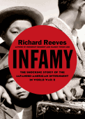Reeves, Richard. Infamy: The Shocking Story of the Japanese American Internment in World War II. Holt. 2015. 368p. ISBN 9780805094084. $32; ebk. ISBN 9780805094084.
After the bombing at Pearl Harbor, the United States detained Japanese families in internment camps. In contrast to Jan Jarboe Russell’s The Train to Crystal City, Reeves focuses his account specifically on Japanese internment. He describes the racism and perceived justification for internment, and details daily life in the camps. (LJ 2/15/15)
Russell, Jan Jarboe. The Train to Crystal City: FDR’s Secret Prisoner Exchange Program and America’s Only Family Internment Camp During World War II. Scribner. 2015. 416p. ISBN 9781451693669. $30; ebk. IBSN 9781451693683.
Also during World War II, the United States government rounded up German, Italian, and Japanese immigrants, spouses, and American-born children and sent them to a family internment camp in Crystal City, TX. President Roosevelt deported some of the detainees and their families as part of a prisoner exchange program with Germany and Japan. Here, Russell interviewed former detainees about their experiences in the camp and after deportation. (LJ1/15)
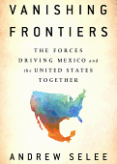Selee, Andrew. Vanishing Frontiers: The Forces Driving Mexico and the United States Together. PublicAffairs. 2018. 336p. ISBN 9781610398596. $28; ebk. IBSN 9781610399029.
Selee explores the ways that America and Mexico have become intertwined economically and culturally. Although Mexican migration to the United States has decreased, Mexican companies are operating in the United States and influencing American consumers. Selee argues that Mexican and American culture are interconnected, and speculates on the future relationship between the two countries.
Carlisle Indian Industrial School: Indigenous Histories, Memories, and Reclamations. ed. by Jacqueline Fear-Segal & Susan D. Rose. Univ. of Nebraska. 2018. 414p. pap. ISBN 9781496207692. $30; ebk. ISBN 9780803295070.
From 1879 to 1918, the United States government removed Native children from their families and forced them to attend the Carlisle Indian Industrial School, where they were compelled to assimilate into “white” culture. In 2012, a symposium acknowledged students who attended the school, including those who died while attending and were unable to be buried according to their tribal custom. This book collates the proceedings of the symposium and includes prayer, poetry, and remembrances.
Borders, Walls, and Immigration Policy
Arce, Alberto. Blood Barrios: Dispatches from the World’s Deadliest Streets. Zed. 2018. 160p. pap. ISBN 9781786990495. $15.95
Journalist Arce reported from Tegucigalpa, Honduras for the Associated Press. Here, he writes about the challenges of living and reporting in a country that has a high murder rate and is run by a corrupt government. His perspective is that of a foreigner and he struggles to maintain his own sense of normalcy after seeing bodies in the street day after day.
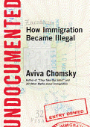Chomsky, Aviva. Undocumented: How Immigration Became Illegal.Beacon. 2014. 256p. pap. ISBN 9780807001677. $16; ebk. ISBN 9780807001684.
Chomsky presents a critique of the United States immigration system. She argues that the concept of illegality in immigration is fairly recent, and that much of the United States’ economy depends on the low-wage labor that immigrants provide. Stories of undocumented immigrants are told throughout to accent Chomsky’s points.
Di Cintio, Marcello. Walls: Travels Along the Barricades. Soft Skull Pr. 2013. 288p. ISBN 9781593765248. $16.95; ebk. ISBN 9781593765651.
Before Donald Trump called for an expansion of the border wall between Mexico and the U.S., Di Cintio travelled to eight regions separated by walls, including the U.S.-Mexico border. He recounts the history and political context of each wall as well as the effects the wall has on those who live near it.
Jones, Reece. Violent Borders: Refugees and the Right To Move.Verso. 2017. 224p. pap. ISBN 9781784784744. $27.95; ebk. ISBN 9781784784720.
Presented as a rebuttal to conventional government policy regarding borders, Jones asks if borders are truly a natural phenomenon. He argues that the presence of a border produces violence by creating a barrier to economic and personal mobility. In his view, rich countries build borders to protect their assets and he reminds readers that historical borders have been more porous than the present. The 2017 paperback edition is updated to include Jones’ thoughts on Brexit and the 2016 U.S. presidential election.
Martinez, Óscar. A History of Violence: Living and Dying in Central America. Verso. 2016. 288p. ISBN 9781784781682. $24.95; ebk. ISBN 9781784781699.
Many of the migrants crossing the U.S.-Mexico border are seeking asylum from murder and violence in their home countries. Salvadorian journalist Martinez interviews officials, gang members, civilians and others in Honduras, Guatemala, and El Salvador to learn what life is like in what has been called the most violent region in the world. (LJ 1/16)
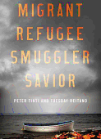Tinti, Peter & Tuesday Reitano. Migrant, Refugee, Smuggler, Savior.Oxford. 2017. 288p. ISBN 9780190668594. $29.95; ebk. IBSN 9780190668617.
The authors address human smuggling services that fuel the European migrant crisis. They look at the reasons for demand for smugglers, the relationships between migrant and smuggler, and the operations of the smuggling networks. Lessons learned from this research may also shed light on human smuggling from Central America to the United States.
The Shadow of the Wall: Violence and Migration on the U.S.-Mexico Border. ed. by Jeremy Slack, Daniel E. Martinez, & Scott Whiteford. Univ. of Arizona. 2018. 280p. pap. ISBN 9780816535590. $35; ebk. IBSN 9780816538409.
This edited volume presents the results of the Migrant Border Crossing Study in order to apply evidence to the immigration debate. Topics covered include family separation, coyotes, migrant kidnapping, and border militarization. Although intended for an academic audience, the title will be useful for readers seeking context and statistics.
Migrants, Families, and Communities
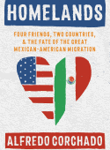Corchado, Alfredo. Homelands: Four Friends, Two Countries, and the Fate of the Great Mexican-American Migration. Bloomsbury. 2018. 304p. ISBN 9781632865540. $27; ebk. ISBN 9781632865564.
In 1987, Corchado met three men of Mexican heritage, who would become good friends. Though the four led very different lives, they all struggled to reconcile their identities as Mexican and American. Corchado also discusses relations between Mexico and the United States. (LJ 6/1/18)
Garcia, J. Malcolm. Without a Country: The Untold Story of America’s Deported Veterans. Hot Books. 2017. 248p. ISBN 9781510722439. $22.99; ebk. ISBN 9781510722446.
Garcia interviews U.S. military veterans who have been deported to Mexico after committing crime. The author reflects on the vulnerability of non-citizens as they are allowed to enlist in the military and participate in combat.
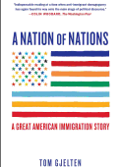Gjelten, Tom. A Nation of Nations: A Great American Immigration Story. S. & S. 2015. 405p. pap. ISBN 9781476743868. $17; ebk. IBSN 9781476743875.
In 1965, the United States’ immigration system removed quotas that favored European ancestry and immigrants from more diverse backgrounds immigrated into the country. Gjelten looks at the experiences of five families from Bolivia, Korea and Libya now living in Fairfax County, VA to show the changes that the 1965 act had on the community and its’ members. (LJ 9/1/15)
Guerrero, Diane. In the Country We Love: My Family Divided. Holt. 2017. 272p. ISBN 9781627795272. $26; ebk. 9781627795289.
Guerrero, an actress on Orange is the New Black, describes her childhood as an American daughter of undocumented Colombian immigrants. At age 14, she came home from school to find that her parents had been deported. She details the profound affect of growing up without her family.
Noorani, Ali. There Goes the Neighborhood: How Communities Overcome Prejudice and Meet the Challenge of American Immigration. Prometheus. 2017. 319p. ISBN 9781633883079. $25; ebk. IBSN 9781633883086.
Noorani, the director of the National Immigration Forum, traveled around the U.S. to speak to community members about immigration. He interviews liberals and conservatives, and discovers that views on immigration can shift over time. Noorani suggests that honest dialogue from can yield results on a complicated issue.
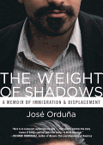Orduña, Jose. The Weight of Shadows: A Memoir of Immigration & Displacement. Beacon. 2016. 240p. pap. ISBN 9780807074015. $17.95; ebk. ISBN 9780807074022.
After becoming an American citizen in 2011, Orduña reevaluates the immigration policies of his new country by analyzing his own experiences navigating the United States’ immigration system to obtain his citizenship. Along the way, he critiques common media portrayals of undocumented persons. (LJ 2/1/16)
Ramos, Jorge. Stranger: The Challenges of a Latino Immigrant in the Trump Era. Vintage. 2018. 224p. pap. ISBN 9780525563792. $15; ebk. ISBN 9780525563808.
Ramos reflects on the anti-immigrant sentiment that he has experienced during his time living in U.S. as a journalist and anchor for Univision. Although ostensibly a response to Trump’s presidency, Ramos is also critical of Obama’s immigration policies. Ramos offers commentary on many current policy proposals, including the border wall, deportations, and DREAMers. (LJ3/1/18)
Rebekah Kati is the Institutional Repository Librarian at the University of North Carolina at Chapel Hill. She is a frequent reviewer for Library Journal.

https://reviews.libraryjournal.com/2018/07/collection-development/books-on-borders/

- Free Speech Debate Erupts with ALA’s Inclusion of Hate Groups in Revision of Bill of Rights Interpretation
By Kara Yorio and Lisa Peet
This story has been updated with comments from ALA OIF director James LaRue and Martin Garnar, co-chair of ALA’s Equity, Diversity, and Inclusion Implementation Working Group.
At the American Library Association’s (ALA) Annual Conference in New Orleans, the organization’s Council adopted three revisions to the Library Bill of Rights that were proposed by the Intellectual Freedom Committee (IFC). 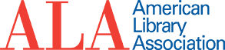The specific working in the revision regarding the purpose of meeting rooms started an ongoing, emotional debate among library and ALA staff.
The revision states:
“Public libraries are bound by the First Amendment and the associated law governing access to a designated public forum. A publicly funded library is not obligated to provide meeting room space to the public, but if it chooses to do so, it cannot discriminate or deny access based upon the viewpoint of speakers or the content of their speech. This encompasses religious, political, and hate speech.
“If a library allows charities, non-profits, and sports organizations to discuss their activities in library meeting rooms, then the library cannot exclude religious, social, civic, partisan political, or hate groups from discussing their activities in the same facilities.”
The inclusion of hate groups—wording which was not in the draft of the proposed interpretations—has librarians taking to Twitter in opposition and asking people to contact ALA and demand it change the language. Many are tweeting using the hashtag #NoHateALA.
“@ALALibrary this is not what our profession stands for & we should never welcome hate in the name of being neutral. #NoHateALA” librarian Katie Quirin Manwiller wrote.
“SUPPORT BOTH PRINCIPLES”
Library Journal asked Martin Garnar, co-chair of ALA’s Equity, Diversity, and Inclusion Implementation Working Group, his thoughts on the revision and the ensuing debate. He emailed his response:
My concern is that this debate is being framed in a way that makes it impossible to support both principles: either you support free speech or you support marginalized communities.
Yes, under the First Amendment, we have to let everyone use our facilities if we make them open to the public and if they’re following the rules.
Yes, we can continue to engage with those who have been historically (and are currently) oppressed through intentional programming, outreach, and services.
From my perspective, this is how we solve the dilemma: we support both principles. We continue to support free speech and fight the laws that target marginalized communities. We continue to confront and dismantle the structural inequality in our profession and our society, and continue to work with marginalized communities to improve their access to information. And we continue to have thoughtful discussions about how to make this a “both and” situation as opposed to “either or.”
On the same day that Council adopted the revised Meeting Rooms interpretation, it also adopted the revised interpretation on Library-Initiated Programs as a Resource, which includes the following statement:
“As stated in ‘Equity, Diversity, Inclusion: An Interpretation of the Library Bill of Rights,’ Socially excluded, marginalized and underrepresented people, not just the mainstream majority, should be able to see themselves reflected in the resources and programs that libraries offer.
“Libraries should actively seek to include a variety of programming options representing diversity of genres, formats, ideas, and expressions with a multitude of viewpoints and cultural perspectives that reflect the diversity in our communities.”
Both interpretations reflect principles of the association, and our challenge is to find a way to uphold them at the same time.
ALA Office of Intellectual Freedom (OIF) director James LaRue says nothing is new here, they are just specifically defining the meeting rooms section after being asked specifically if a library had to allow a KKK meeting in its building.
The Public Library Association didn’t accept the OIF’s original clarification which read as if it too closely tied religion to hate groups, according to LaRue. So the organization sought the widest term for what was being discussed
“We said the generic term we need here is hate groups,” he says. “The honest truth of it is we inserted it because of a question in the field and we felt like we wanted to address the issue head on instead of dance around it.”
He spent hours on Twitter responding to reaction, citing court cases and the First Amendment and, after a lot of thought, he says, his main comment on the situation comes down to this: “ALA is about diversity and intellectual freedom not just one or the other.”
In a Twitter thread, librarian Tyler Vachon explained his opposition. In part, it read:
“Libraries don’t exist in a thought experiment. We’re buildings with real people in them. People who see a branch willing to grant space and legitimacy to hate groups and recognize that they’re no longer safe in that building. Librarians no longer have their backs.
“We are way past the point of there being room to discuss things in abstract like “gosh should the Klan be able to use our meeting space? Should fascists?” These movements are gaining momentum and any institution willing to grant them quarter shares responsibility for that.
“Many of us serve communities that are already terrorized by these groups. Show up for them. Be willing to fight back when they may not feel safe to do so. Don’t let this toxic worship of neutrality and inertia enable fascism in your community.”
The IFC is charged with recommending “such steps as may be necessary to safeguard the rights of library users, libraries, and librarians, in accordance with the first amendment to the United States Constitution and the Library Bill of Rights as adopted by the ALA Council.”
ALA includes a page on free speech protections on its website.
“The First Amendment to the United States Constitution protects speech no matter how offensive its content. To be clear, the First Amendment does not protect behavior that crosses the line into targeted harassment or threats, or that creates a pervasively hostile environment. But merely offensive or bigoted speech does not rise to that level, and determining when conduct crosses that line is a legal question that requires examination on a case-by-case basis.”
But what if the groups make employees or other patrons feel threatened or uncomfortable?
“We’ve talked about this and this has been a theme for ALA for a while, which is to say, how do you model civil and civic discourse? How do you establish an environment in which people do feel welcome?” says LaRue. “I think it’s a stretch to say you build a safe environment by forcing everybody to shut up if somebody claims to be offended. I don’t think that’s a safe environment.”
The press release on the revisions was actually sent out days before the uproar and LaRue believes people didn’t get all the details before voicing their opposition.
“Particularly on Twitter, I notice a tendency to pull things out of context and I think we need to remember in ALA nothing gets decided quickly,” he says. “There were lots and lots of discussions about this. And there were lots of public librarians and school librarians and academic librarians looking at this.
“The fact that it generated so much energy, I think means it’s an important topic. So let’s talk about it, but let’s try not to savage each other in the process. Let’s assume that we share values.”
A blog post LaRue put up on Tuesday put it this way: “ALA does not endorse hate groups. It does not seek to normalize hate speech, but it recognizes that hate groups is a remarkably elastic term prone to be thrown about by both sides of the political spectrum. It’s been attached to book discussion groups, Black Lives Matter and others.”

https://www.slj.com/2018/07/industry-news/free-speech-debate-erupts-alas-inclusion-hate-groups-bill-rights-revision/

- Higher Ground: Getting College Ready in the Library
By Carly Berwick on July 2, 2018 Leave a Comment
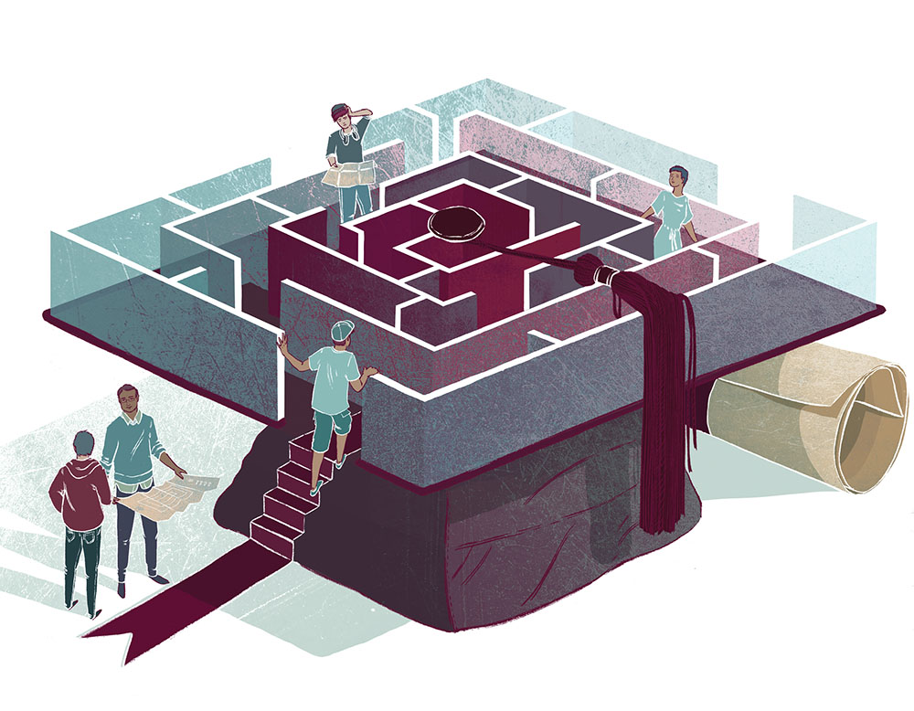
Illustration by Cat O’Neil
When Trameka Pope was a senior in high school, she wasn’t sure that she wanted to leave home for college. Statistically, it was unlikely that Pope—whose daughter was a baby at the time—would go to college at all, much less successfully navigate the academics once there. She not only got there, however, she finished her bachelor’s degree in public health at Western Illinois University in three years and is applying for a master’s program.
Also read:
“A School Librarian’s Mock Interview Program Preps Teens for ‘Face Time'”
At Wendell Phillips Academy on Chicago’s South Side, Pope found the critical support she needed at the daily college readiness class offered by the high school’s librarian, K.C. Boyd, who also researched many of the scholarships that made it financially feasible for Pope to go to school.
“She was really there for me,” Pope says of Boyd, “especially when I was trying to decide how far to go because I had a daughter.”
From specialized scholarships to budgeting for book fees, Boyd gave her students the information they needed to succeed. It was information Pope would later learn many others weren’t getting.
“The way that she pushed our class with college information and making sure we were prepared, my friends I met in college didn’t have that,” says Pope.
Boyd, a Library Journal Mover & Shaker, is now a library media specialist at a Washington, DC, public middle school. Her college readiness efforts at the Chicago high school were part of a larger phenomenon of librarians working alongside guidance counselors to help students not only get to college but thrive once they are there. Librarians have long offered resources, such as SAT prep materials and college guidebooks. But today, many are doing much more, helping students through the increasingly byzantine process of selecting, applying to, getting aid for, preparing for, and persevering in college.
That process is particularly onerous for low-income students, 68 percent of whom enroll in two- or four-year college after high school, according to the National Center for Educational Statistics, compared to 83 percent of high-income students. Only 14 percent of low-income students receive a bachelor’s degree, compared to 60 percent of high-income students.
Librarians are crucial contributors to college readiness in schools strapped for resources, which makes it even more painful that librarians are being cut in many of those districts and schools. There are 19 percent fewer librarians in schools today than in 2000, and schools serving majority minority students have lost the most, according to SLJ research.
HELP WITH ESSAYS, RÉSUMÉS, AND SCHOLARSHIPS
In Bensalem, PA, where 47 percent of students are low-income, Bensalem High School librarian Tiffany Emerick tries to make the college application process low-stress but comprehensive. To start the conversation, she’ll ask students about their postgraduation plans. Many of these teens start working or join the military after graduation. But if they mention college, that’s “the gateway,” Emerick says, to offering more support toward that goal.
Some students ask her to read essays. Others use library resources to scan documents for financial aid forms or register for the SAT, because they don’t always have Internet access at home. Last year, a student whose essay Emerick had helped edit presented her with a card: “I couldn’t have gotten into my dream school without you,” it said. The school was Stanford University.
School librarians often work alongside guidance departments for college applications and preparation, but in schools such as Emerick’s, the ratio of students to counselors can be 400 to 1. In some schools, that ratio balloons to 2,000 to 1, says Sandra Hughes-Hassell, professor at the School of Library and Information Science at the University of North Carolina and president of the Young Adult Librarian Services Association (YALSA).
“I love my guidance department, but I can’t guarantee that they have the time [to help]. I do,” says Susan Altman, a librarian at Eau Claire High School in Columbia, SC. Many of her students would be first-generation college students, she says, and she tries to provide support by reading over personal statements, helping with résumé creation, and researching schools and scholarships. “There may be an obscure program out there that may have a great opportunity for our students that they may otherwise not know about.”
The number of librarians taking on these informal duties in some cases comes down to district economics. In less well funded or less affluent districts, librarians often pitch in with every aspect of the college planning process, as guidance departments may be squeezed by low staffing and a need to focus on career planning and working with students who have experienced trauma.
“I would say it’s what librarians do naturally—which is being open to anyone in need and offering resources, opening conversations, and saying, ‘Can I help you at all?’” says Emerick. “Some [students] are comfortable coming for help but not everyone is, especially if they are new or don’t have adults they trust. The librarian can have that role—I’m not giving them a grade, I’m just here to help.”
At Williamsport Township (PA) High School (WTHS), students can find librarian Kimberly Brosan’s extensive libguide on applying to college, with subsections on testing, applications, choosing a school, and paying for higher education. She developed the guide after talking with her guidance department and seeing where she could step in.
EARLIER PREPARATION, MAKER PORTFOLIOS
Librarians also prepare students for college, of course, by getting them ready for college-level work. Williamsport has a strong career and technical education program, and many students participate in dual-enrollment classes with nearby Penn College of Technology. Brosan helps them with college-level research while they are still in high school. Nearly half of students from the school eventually enroll in college, and 51 percent of WTHS students are low-income.
“There are lots of youth in small, rural, and tribal areas that don’t have access in their school to college- and career-ready resources,” says Hughes-Hassell. “There are ways we can support kids to think about the college and career process that are more than at that application time or writing the college essay.”
To that end, YALSA launched its Future Ready program two years ago (ala.org/yalsa/future-ready-library). It takes a step back and starts preparation even earlier—in middle school—through partnerships with school and local libraries that encourage college readiness.
In Bolivar, TN, for instance, Bolivar-Hardeman County Library director Baillee Hutchinson is using a Future Ready grant to go into schools and meet with teens. Meanwhile, in Charlotte-Mecklenburg, NC, the local library system partners with schools to offer College 101 workshops and has organized a post secondary trade school fair, says Hughes-Hassell.
In affluent districts, however, children are often coached on college options from the time they are very young, and high schools may have dedicated college counselors within the guidance department. In these districts, the librarian might focus more on college-level research skills, such as citation and bibliography formats and seeking credible sources.
“They do so much of this at home,” says Michelle Luhtala, librarian at New Canaan (CT) High School (NCHS). Ironically, she says, “one of the things I try to do is not talk to the kids about where they are [in the college process], because there are so many pressures and constraints that it is onerous. We try to give them diversions and stress release instead.”
At NCHS, the virtual reality lab in the library’s makerspace is in use all day, says Luhtala. Here, students are developing skills and products they might use to apply to college. “They come in to slice things in half then we have classes that use it for anatomy and immerse themselves in pulling skeletons and the body apart and reassembling it.” Nearly half of high schools surveyed recently by SLJ host makerspaces in their libraries.
The experience of making can be profound for students of all backgrounds—and maker immersion is something that some students showcase in their applications. While colleges overall say portfolios are less important than other factors, some, including MIT, Tufts, and Carnegie Mellon, consider “maker portfolios” by students interested in computer science or engineering, according to the 2017 State of College Admissions report from the National Association for College Admission Counseling.
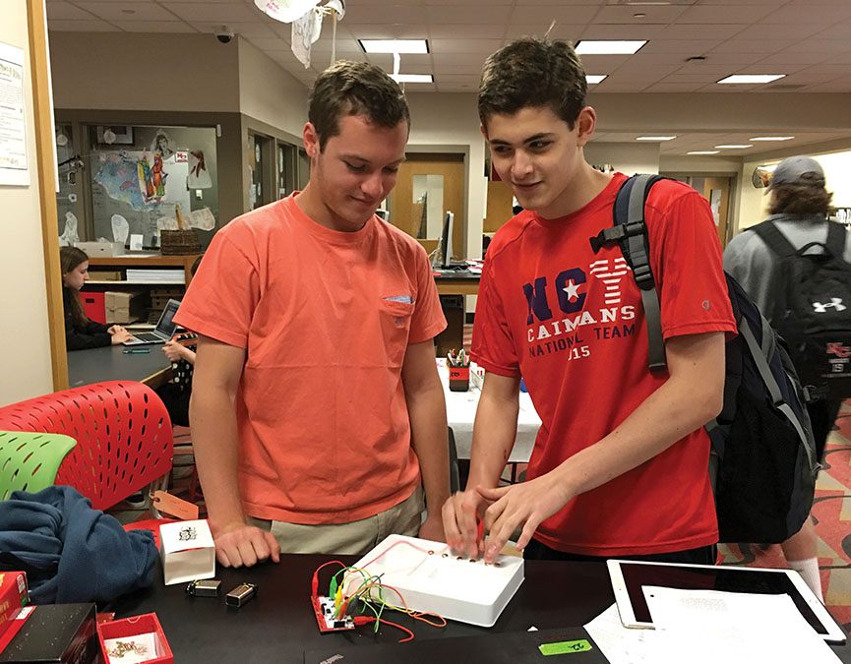
Former NCHS student Miles Turpin received his Duke University acceptance letter with a comment that the admissions committee noted his interest in makerspaces. Photo courtesy of Michelle Luhtala
Former NCHS student Miles Turpin received his Duke University acceptance letter with a comment that the admissions committee noted his interest in makerspaces. Turpin had included a link to his website with a portfolio and written about his experience initiating a program for students to get credit for makerspace projects. “I felt like I did something meaningful that lasted,” he says of both his maker projects and the program he created for students after him.
“So many [students] find that home with the maker mentality,” says Heather Moorefield-Lang, associate professor of library science at the University of South Carolina and a technology specialist. “It gives them a new focus whether they want to do circuitry or arts, music, culinary, or farming. It opens a whole new door or opportunity.”
Still, makerspaces require funding, and when librarians are cut, fewer will be able to double as digital stewards in schools. In Williamsport Township next year, Brosan will split her time between the middle school and high school. She asked her high school students how the change might impact them, and they singled out her instruction on how to use databases and their need to learn how to do research. But Brosan sees a silver lining. Their experience with her has taught them there is another person they can seek out for help soon: the college librarian.

Carly Berwick is a freelance journalist and English teacher in New Jersey.

https://www.slj.com/2018/07/teens-ya/higher-ground-getting-college-ready-library/

- Virginia Tech is Leading a Grant-Funded Project to Make Web Archives More Valuable to Researchers
Filed by Gary Price on July 10, 2018
From VT:
The Institute of Museum and Library Services recently awarded a $248,451 grant for a collaborative two-year project, Continuing Education to Advance Web Archiving, that will create materials to teach librarians and archivists across the world how to collect, extract, and analyze archived information from the world wide web.
Zhiwu Xie, director of digital library development for the University Libraries at Virginia Tech, is leading the team of library and archive experts to create a curriculum surrounding the technology of web archiving and challenges related to how archivists and librarians can gather the most useful information from archived internet sites and social media.
[Clip]
More than tens of petabytes of web content have been collected and archived by memory institutions. All of the project collaborators, including Xie, Fox, Martin Klein from Los Alamos National Laboratory, Michael Nelson from Old Dominion University, Justin Littman from George Washington University, Ian Milligan from University of Waterloo, and Jefferson Bailey from the nonprofit archiving organization Internet Archive, are pioneers in web archiving technology and infrastructure.
[Clip]
“Suites of open source tools are available to assist researchers conducting analyses and extracting knowledge,” said Xie. “However, these tools require the user to be proficient in big-data processing and analysis. Very few librarians or archivists have been trained to understand, utilize, maintain, and manage these tools.”
By the end of the project, the collaborators will provide a collection of educational resources, a series of in-person and online training workshops, and cyberinfrastructure for deploying tools to support the curriculum and workshops — including source code.
Read the Complete Article
Direct to Complete Project Proposal RE-70-18-0005-18
& Preliminary Proposal RE-70-18-0005-18 (via IMLS)

https://www.infodocket.com/2018/07/10/virginia-tech-is-leading-a-grant-funded-project-to-make-web-archives-more-valuable-to-researchers/

- Research Tools: Arcadia Awards Impactstory (Providers of Unpaywall), Internet Archive, and British Library $850,000 Grant to Build a Free, AI-Powered Search Engine of Open Access Scholarly Articles
Filed by Gary Price on July 8, 2018
News just-in from a partnership consisting of Impactstory, Internet Archive, and British Library.
From the News Release (Full Text);
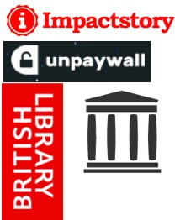Nonprofit startup Impactstory today announced new funding of $850,000, received as a grant from Arcadia, a charitable fund of Lisbet Rausing and Peter Baldwin, to build a free search engine designed to help the public find, read, and understand peer-reviewed research on any topic.
Impactstory will partner with the Internet Archive and the British Library for the project.
The new search engine will be built on an open index of 20 million open access (OA) scholarly articles, and will incorporate an interface layer using artificial intelligence to annotate, summarize, and link articles using plain language.
The backbone of the new search engine will be Impactstory’s existing database of OA articles, called Unpaywall. Launched late 2016, Unpaywall offers a free Chrome extension now used by 150,000 readers, and a free API that is used in thousands of academic libraries and handles over 1.5 million unique uses daily. Other users include Clarivate Web of Science, Digital Science Dimensions, national science evaluations in the UK, Switzerland, and elsewhere.
However, despite heavy use of the database, most integrations to date have not sought to engage the the general public. Indeed, few projects have met the need for a single, comprehensive search engine for OA aimed at the nonspecialist reader.
“Students, patients, citizen scientists, scholars in the developing world: there are so many who need to find, access, and understand the scholarly literature,” notes Impactstory cofounder Heather Piwowar. “Today there’s a unique opportunity to meet that need, by leveraging two trends: growth in Open Access, and dramatic improvements in AI-powered translation, summarization, and recommendation.”
The future of scholarly publishing does increasingly appear to be Open Access. A 2013 White House Office of Science and Technology Policy memo requires US federally-funded research be made Open Access, while in Europe an ambitious mandate requires 100% of European-funded research be OA by 2020. Nearly half of research literature is OA already, and studies show rapid increase in this percentage in recent years.
However, actually getting research literature into the hands of non-specialist readers has remained challenging. “OA literature is scattered all over the place,” observes Jason Priem,
Impactstory’s other co-founder, “and so despite the promise of OA, we haven’t had a place where we can tell lay readers ‘here’s where you can read free, trustworthy research about anything.’ With this new grant, we’re making that place. And we’re adding an AI-powered interface that makes the articles people find more understandable as well.”
[Our emphasis] A beta version of the search engine will be launched in the fall (early adopters can sign up for advance access at http://gettheresearch.org). The beta version will include support for multiple languages, an open API, and integrated altmetrics. Although the focus will be on non-specialist readers, the team will also explore ways to engage scholarly users, particularly those with incomplete subscription access.
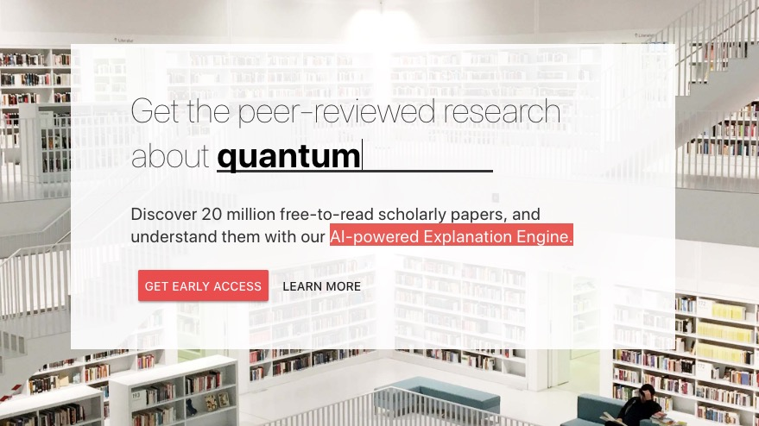
By partnering with established institutions, Impactstory gains experienced collaborators to take on the technical and social challenges of the project. “The Internet Archive and British Library share our passion for helping people access knowledge, and we’re thrilled to be working with them,” says Piwowar.
“At the British Library we believe in making the world’s knowledge available to people from all backgrounds.”, says Torsten Reimer, Head of Research Services. “We are excited to work with Impactstory to make scholarly publications more accessible.”
“The Internet Archive shares Impactstory’s mission of enabling open access to research outputs. Pairing our capacity for archiving at scale with Impactstory’s fantastic discovery and OA services such as Unpaywall promises to enable free, easy access to published knowledge,” says Jefferson Bailey, Director of Web Archiving & Data Services.
Impactstory is a nonprofit with a long history of building tools to make science more open. Their start came at a hackathon in 2011, where Piwowar (then a Duke postdoc) and Priem (a PhD student at the University of North Carolina-Chapel Hill) stayed up all night building a prototype website to help scholars learn about their open science impact. Since then they’ve built several production tools including Depsy and Impactstory Profiles. Previous funders include the US National Science Foundation, the Alfred P. Sloan Foundation, the Shuttleworth Foundation and the Open Knowledge International.
Arcadia is a charitable fund of Lisbet Rausing and Peter Baldwin. It supports charities and scholarly institutions that preserve cultural heritage and the environment. Arcadia also supports projects that promote open access and all of its awards are granted on the condition that any materials produced are made available for free online. Since 2002, Arcadia has awarded more than $500 million to projects around the world.
A Quick Comment From infoDOCKET Founder/Editor, Gary Price:
The Unpaywall browser extension, API and other tools and services have made accessing open access material much simpler and faster for many users particularly those with limited or no online research skills.
With this in mind we’re VERY excited to see what Impactstory, Internet Archive, and British Library will release this Fall when the Get the Research “AI-Powered Explanation Engine” goes live.
We’re also interested to read that the focus is on developing this resource for the general public/nonspecialist reader. Good idea!
The challenge will NOT ONLY developing what you would expect (info retrieval algorithms and AI that work well, user interfaces, etc.) BUT also the marketing and promotion of Get the Research to the general public which will likely be an equal if not greater challenge than the developing the technology.
For example:
- Creating general product/name awareness in today’s busy world. A myriad of new products/services competing for awareness.
- User education (why do I need this product?; what can it do for me?; how does it work? etc.)
- Changing established user behavior (aka good enough is fine with me, no time to learn something new).
Stay tuned! We will be following this project very closely.
Mega congratulations to ALL partners!

https://www.infodocket.com/2018/07/08/research-tools-arcadia-awards-impactstory-providers-of-unpaywall-internet-archive-and-british-library-850000-to-build-a-free-ai-powered-search-engine-of-open-access-scholarly-articles/

- A New MIT Libraries Initiative Aims to Highlight MIT’s Women Faculty by Acquiring, Preserving, and Making Accessible Their Personal Archives
Filed by Gary Price on July 6, 2018
From MIT News:
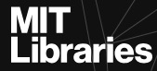A new MIT Libraries initiative aims to highlight MIT’s women faculty by acquiring, preserving, and making accessible their personal archives. The Institute Archives and Special Collections (IASC) launched the project last year with the generous support of Barbara Ostrom ’78 and Shirley Sontheimer.
The first year of the project has focused on reaching out to faculty who are ending the active phase of their careers. Four faculty members added their personal collections, comprising 234 boxes and 50 gigabytes of material.
[Clip]
Acquisitions of MIT administrative records provide additional context to the personal archives and a broader view on issues of gender equity and the challenges faced by women in academia. In the next phase of the project, archivists will continue to manage donations, prepare collections for use, and enlarge this core group by reaching out to female faculty who were tenured in the 1960s, ’70s, and ’80s.
Ultimately, the collections will provide not only rich resources for researchers, journalists, teachers, and students, but also, as Sontheimer says, inspiration for generations of women to come. “I’m hoping the project will encourage more women to become engaged in science, technology, and engineering,” she says.
Learn More About the Project and FourNew Collections

https://www.infodocket.com/2018/07/06/a-new-mit-libraries-initiative-aims-to-highlight-mits-women-faculty-by-acquiring-preserving-and-making-accessible-their-personal-archives/

