Año 3 Número 81 agosto 2018
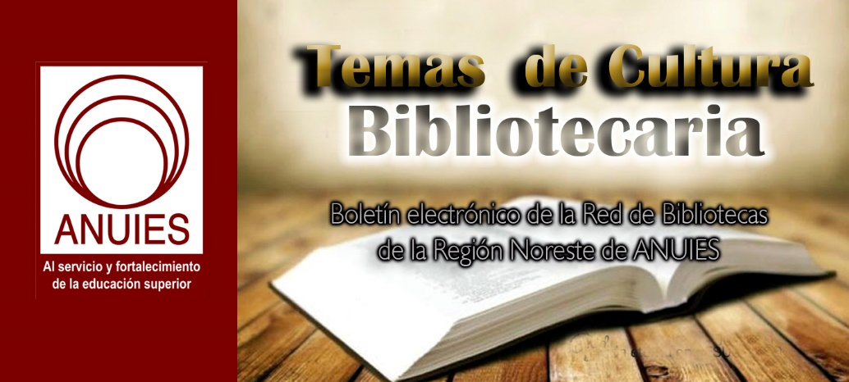

Contenidos de este número

- New Online Collection: NYU Fales Library Releases Flaherty Seminar Recordings, Unveiling Fifty Years of Cinematic History; More than 700 Audio Recordings Available Online For the First Time)
Filed by Gary Price
From New York University:
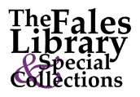New York University’s Division of Libraries today announced the public release of more than 700 audio recordings from the Flaherty Seminar, the longest continuously running film event in North America
New York University’s Division of Libraries today announced the public release of more than 700 audio recordings from the Flaherty Seminar, the longest continuously running film event in North America, named in honor of seminal filmmaker and ‘father of documentary film’ Robert Flaherty.
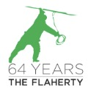The annual event’s fifty-year history is captured through recordings of various activities and discussions, joining collections in the Tamiment Library and Robert F. Wagner Archives and the University Archives chronicling the evolution of the moving image in the 20th century.
The Flaherty Seminar recordings are held within the special collections of NYU’s Fales Library.
[Our emphasis] This release marks the first time a major audio collection will be accessible to the public online through a Fales Library finding aid.
The digitization of the Seminar recordings—which include reel-to-reel tapes and audio cassettes—has been underway since 2012, with recordings previously made available on CD, and only to researchers on site in Fales Library.
Founded in 1955, the Flaherty Seminar began before the era of film schools and has since been established as a one-of-a-kind institution that seeks to encourage filmmakers and other artists to explore the potential of the moving image through new cinematic techniques and approaches. The recordings provide scholars and students with unabridged access to candid discourse that championed unique and diverse voices and helped to shape the film industry.
The recordings captured in-depth discussions with the cinematic firebrands of the time, including Satyajit Ray, Agnès Varda, Mira Nair, John Cassavetes, and Yasujiro Ozu. These were boundary-breaking filmmakers who shed light into the corners of humanity, revealing and documenting global communities and culture.
[Clip]
The release of the Flaherty Seminar recordings is a coordinated effort by NYU Special Collections, which include Fales Library, Archival Collections Management, Barbara Goldsmith Preservation and Conservation Department, and Digital Libraries Technical Services.
Resources
- Direct to Finding Aid, Listen to Digitized Audio Series I of the The Flaherty Film Seminar Finding Aid
- Direct to Flaherty Seminar Web Site

https://www.infodocket.com/2018/05/29/new-online-collection-nyu-fales-library-releases-flaherty-seminar-recordings-unveiling-fifty-years-of-cinematic-history-more-than-700-audio-recordings-available/

- Arizona State University: “Hayden Library Reinvention Breaks New Ground”
Filed by Gary Price
From ASU:
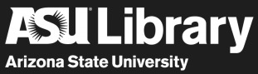The Arizona State University community celebrated the progressing transformation of its largest library at a groundbreaking ceremony Friday morning.
Speaking at the ceremony, ASU President Michael Crow said the redesign of Hayden Library is one step in many to ensure that the library remains at the center of the ASU knowledge enterprise.
[Clip]
“There will always be at the heart of every great learning organization a library,” said Crow. “In the core of the core of the core of this enterprise is the library — the place of mediated, articulated, verifiable and quantifiable knowledge, not random dither. You cannot have a core of a learning enterprise without that.”
Currently under comprehensive renovation with completion scheduled for January 2020, Hayden Library’s five-story tower will feature new classrooms, state-of-the-art learning labs, engaging print collections, and study space to accommodate more than 2,000 students.
“The library will take many forms: physical, digital and philosophical,” said Crow. “Who knows how libraries will end up in the next hundreds of years, but they’re not going away.”
[Clip]
“Libraries are books, and much, much more beside,” said University Librarian Jim O’Donnell. “Libraries are central to the educational enterprise — the critical link connecting students to the university and to the world of knowledge.”
Features of the Hayden Library “reinvention” include:
- An above-ground entrance with multiple points of access
- Six classrooms and more than 1,000 additional seats for students to study, collaborate and learn
- Actively curated and community-led print collections on every floor
- Rotating exhibits that showcase the university’s innovations and scholarly work
- Main-floor access to ASU Library’s distinctive and special collections, especially rich in documenting and illustrating the history and cultures of Arizona and all its peoples
- A suite of learning and research spaces specializing in data analysis, creativity and maker culture, technology learning, research support and geographic information systems
- Student support services integrated on every floor
[Clip]
“Everybody knows what a library is — or thinks they do,” said O’Donnell. “At ASU our library transforms old collections and services with new kinds of information, new ways of finding information, and new ways to use what we have.”
Read the Complete Report (approx. 900 words)

https://www.infodocket.com/2018/05/26/arizona-state-university-hayden-library-reinvention-breaks-new-ground/

- Are You Making the Most of Every Phase of Your Materials Lifecycle?
Download this free report to learn more about how to go beyond managing your library's circulation to manage the entire lifecycle of its materials.
At each stage of the materials lifecycle, how can you ensure that you use staff time wisely to manage these valuable resources? Tech Logic’s product suite expedites the materials handling process from distributing new materials and streamlining circulation to shelf management and selling weeded items.

Are You Making the Most of Every Phase of Your Materials Lifecycle?
Download this free report to learn more about how to go beyond managing your library's circulation to manage the entire lifecycle of its materials.
At each stage of the materials lifecycle, how can you ensure that you use staff time wisely to manage these valuable resources? Tech Logic’s product suite expedites the materials handling process from distributing new materials and streamlining circulation to shelf management and selling weeded items.

Are You Making the Most of Every Phase of Your Materials Lifecycle?
Download this free report to learn more about how to go beyond managing your library's circulation to manage the entire lifecycle of its materials.
At each stage of the materials lifecycle, how can you ensure that you use staff time wisely to manage these valuable resources? Tech Logic’s product suite expedites the materials handling process from distributing new materials and streamlining circulation to shelf management and selling weeded items.
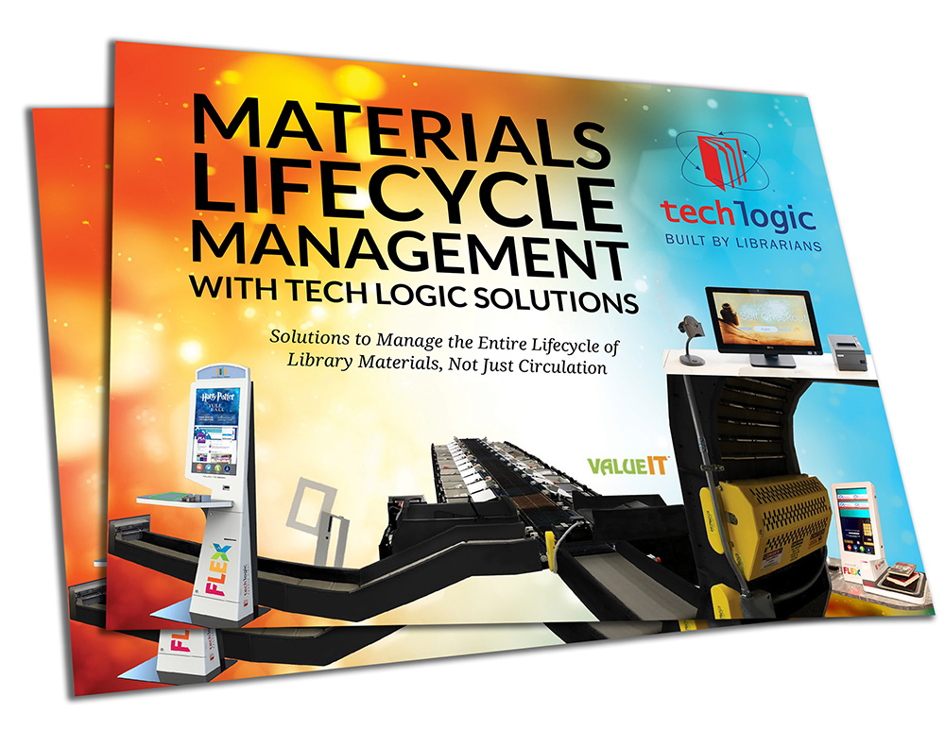
http://www.tech-logic.com/land/mlm-report

- New Digital Collections From UNLV Libraries: “Raising the Curtain”: A Large-Scale Digitization Project Featuring Historical Photos, Records of the Las Vegas Entertainment Industry
Filed by Gary Price
From the University of Nevada, Las Vegas Special Collections Blog:
Fabulous production shows were a staple of the Las Vegas entertainment industry and made the showgirl a Las Vegas icon.
Today, researchers from around the world can explore this glamorous world and see behind the scenes via new digital collections from UNLV Special Collections and Archives.
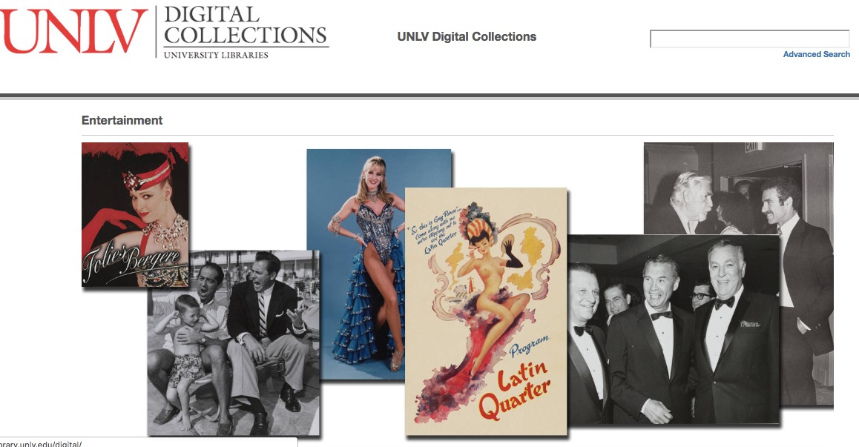
Historical photographs provide visual documentation of individual entertainers on stage and in publicity shots around the hotels, as well as images of dancers and showgirls and the production shows that made them famous. Manuscript collections feature the publicity records of entertainment departments which provide insight into the business of entertainment on the Las Vegas Strip and personal papers of noted Las Vegas show producers, such as Jerry Jackson, provide insight into the rarified world of the production show with its feather and rhinestone-clad showgirls and fantastic stage technology. Included in these collections are hundreds of costume design sketches from Las Vegas production shows.
UNLV Digital Collections is currently completing the digitization of three manuscript collections for public online access: the Sands Hotel Public Relations Records, the Jerry Jackson Papers, and the Donn Arden Papers. Digitized photographs, costume and set drawings, scrapbooks, correspondence, and other records from these collections are now available in the Entertainment digital collection.
Learn More About the Project + a Few Collection Highlights in the Complete Blog Post
Direct to UNLV Libraries Entertainment Digital Collection

https://www.infodocket.com/2018/06/21/new-digital-collections-from-unlv-libraries-raising-the-curtain-a-large-scale-digitization-project-featuring-historical-photos-records-of-the-las-vegas-entertainment-industry/

- Multilingual Glossary for Today’s Library Users
Language Table
Definitions
Acknowledgments
Understanding library jargon can be difficult for anyone who is not a regular user of the library. The difficulty of understanding library terms is compounded for English as a second-language (ESL) speakers who must process these specialized terms in a language that is not their native one. This Multilingual Glossary is designed to assist ESL speakers, as well as the librarians who work with them. It consists of commonly used terms in academic libraries today.
The Glossary is divided into two parts: (1) the Language Table, which presents a list of these terms in seven languages, and (2) the Definitions, which give explanations in English for each of the terms.
Librarians can use these two parts separately, or in conjunction, when working with ESL speakers. Sometimes showing ESL speakers the library term in their native tongue is enough to help them understand its meaning and significance, and the Language Table will help to do this. At other times, the ESL speaker needs to read the meaning of the term to understand its application; in this case, the Definitions will be helpful. Cross-references within the Definitions will take users from one term to another.
The Glossary was compiled by members of the Instruction for Diverse Populations Committee of the ACRL Instruction Section. The languages for the Language Table were selected by consulting statistics from the Institute of International Education on the number of foreign students from various countries in the United States (see http://opendoors.iienetwork.org/). The terms to be defined were selected by polling academic librarians and by consulting the library literature—notably the glossaries included in information literacy textbooks and the research articles on student understanding of library jargon. The Glossary is not meant to be an exhaustive list of every term a librarian might need to use with an ESL speaker but rather a listing of the terms that are most likely to be used in such a context. Definitions were written by members of the committee after consulting a number of sources including the following:
- Feather, John, and Paul Sturges, eds. 2003. International Encyclopedia of Information and Library Science. London: Routledge.
- Prytherch, Ray. 1995. Harrod’s Librarians’ Glossary and Reference Book. 10th ed. Aldershot, England: Gower.
- Reitz, Joan M. 2004-2007. ODLIS: Online Dictionary for Library and Information Science. Libraries Unlimited.
The committee acknowledges that these resources are not comprehensive, nor do they reflect the many dialects and nuances within each language. Due to these known limitations, we encourage users of the Multilingual Glossary to adapt this resource to meet the needs of your community.
If you are interested in contributing to future development or revision of this resource, please contact the committee chair. The committee is currently seeking contributions for new terminology to add to the glossary, and volunteers to review the language translations.

https://acrl.ala.org/IS/instruction-tools-resources-2/pedagogy/multilingual-glossary-for-todays-library-users/

- Michigan State University Professor Oversees Massive Digitization Project of Rare Film Collection
Filed by Gary Price
From Michigan St. University:
Once threatened by chemical decay and decomposition, an important and rare film collection from the early years of cinema is now available to the public online thanks to a massive preservation and digitization project overseen by Joshua Yumibe, director of the Film Studies Program and associate professor in Michigan State University’s Department of English.
The collection consists of 23,491 original 35-millimeter nitrate film clippings, usually two to three frames each, dating mostly from 1897 to 1915. It is the collection of Italian film historian Davide Turconi, who acquired the extensive collection from the films amassed by Josef-Alexis Joye, a Jesuit priest from Basel, Switzerland, at the beginning of the 20th century.
[Clip]
Yumibe took over management of the digitization project in 2003 while still a doctoral candidate at the University of Chicago. The collection served as one of the key studies for Yumibe’s research into early color cinema. In 2011, after 12 years, the Turconi Collection Database was completed.
The Turconi Collection Database is the largest of its kind currently available and is a primary source for the study of early cinema and color technology. It is available for free online with the financial support of the George Eastman Museum, the Le Giornate del Cinema Muto and the Cineteca del Friuli.
[Clip]
For the first time, the public can see this rare collection in person, which is now on display at the George Eastman Museum thanks to the efforts of Yumibe, who curated the Dreaming in Color: The Davide Turconi Collection of Early Cinema exhibit, and the MSU Foundation, a key sponsor, which helped with funding through a Humanities and Arts Research Program grant.
Read the Complete Article

https://www.infodocket.com/2018/06/20/michigan-state-u-professor-oversees-massive-digitization-project-of-rare-film-collection/

- Reports: Two Projects from Research Libraries Working to Save Audio Recordings of Native Americans
Filed by Gary Price
Reports about two projects linked below.
From Indiana University Libraries Archives of Traditional Music:
Indiana University Preserves 90 Year Old Standing Rock Recordings
In 1928 researchers made 195 wax cylinder recordings at Fort Yates, North Dakota on the Standing Rock Indian Reservation. Thanks to a national effort to preserve America’s sound recording heritage, the Native American music preserved on those cylinders is now part of the National Recording Registry.
IU Libraries Archives of Traditional Music safeguards the delicate cylinders, now nine decades old, and recently digitized them in collaboration with the University’s ambitious Media Digitization and Preservation Initiative with funding from the National Endowment for the Humanities. This collection at IU is one of 25 historically and culturally significant recordings added to the National Recording Registry this year.
Read the Complete Report
From the U. of California Berkeley Library
In the imaging lab, Stephanie Battle slides two fingers into a small brown cylinder, lifting against its smooth center. She’s careful to avoid the surface, whose priceless grooves could melt slightly under her touch.
Battle is the digital imaging specialist for Project IRENE, a campuswide effort to scan and digitize nearly 3,000 wax cylinders held in UC Berkeley’s Phoebe A. Hearst Museum of Anthropology. There are over 77 Native languages from California represented in the collection, some of which have transformed or faded away.
“These cylinders are degrading every day,” Battle says. “We have to take this moment to capture them.”
The objects are artifacts of Thomas Edison’s 1877 phonograph, the first device capable of audio playback. A grandfather to the record player, the machine translated soundwaves into movement. Vibrations sent a small cutter bobbing up and down, carving patterns into tinfoil (and later wax, in Edison’s sequel) that a stylus could retrace.
Read the Complete Article, View Video
About Gary Price
Gary Price (gprice@mediasourceinc.com) is a librarian, writer, consultant, and frequent conference speaker based in the Washington D.C. metro area. Before launching INFOdocket, Price and Shirl Kennedy were the founders and senior editors at ResourceShelf and DocuTicker for 10 years. From 2006-2009 he was Director of Online Information Services at Ask.com, and is currently a contributing editor at Search Engine Land.

https://www.infodocket.com/2018/06/20/reports-two-projects-from-research-libraries-working-to-save-audio-recordings-of-native-americans/

