Año 3 Número 79 junio 2018
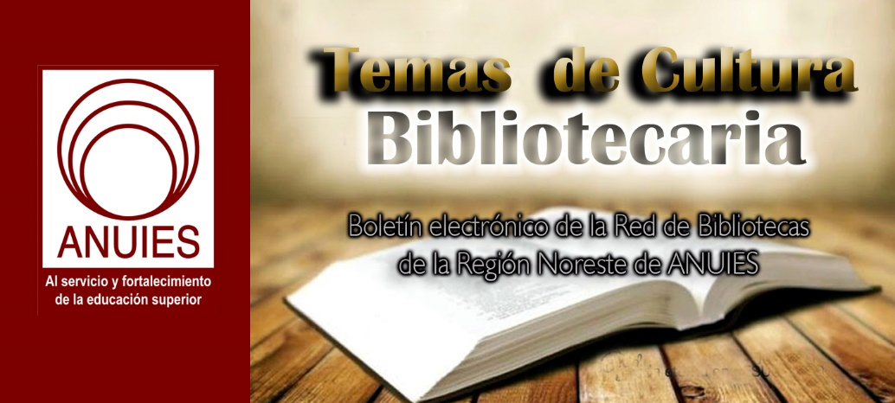

Contenidos de este número

- ASU Launches Sun Devil Shelf Life
By Lisa Peet on June 7, 2018 Leave a Comment
When a school is as large as Arizona State University (ASU)—one of the largest public universities in the United States, with nearly 59,000 undergraduates and more than 13,000 postgraduate students currently enrolled, as well as more than 3,000 academic staff, all spread out across five campuses in the Phoenix metropolitan area—it is not always easy to find books written by members of the university community. To that end, ASU Now, the university’s internal news site, has developed Sun Devil Shelf Life, a new online platform providing information and access to works by ASU faculty, staff, alumni, and students.
Sun Devil Shelf Life—named after the school’s mascot—is searchable by title, author name, genre, division of ASU, or keyword, and provides data for each book—publication information and ISBN, genre, an author bio and the author’s ASU unit, and a synopsis—plus links to borrow or purchase a copy, as well as social media share buttons.
Links to the ASU Library online catalog are provided whenever they are available; library staff members have enthusiastically embraced the site and plan to help to promote it. Among other features, Shelf Life allows individual university units to pull any book entries tagged with their unit onto their website’s newsfeed, if they wish.
SHELF LIFE’S EARLY LIFE
“The goal was for ownership of this site to be shared across the university,” said Penny Walker, ASU Now director of news and strategic communications. “Once we knew the site was 99 percent ready for launch—and after several bookish beta testers had given it a whirl—an email went out to the university’s communications staff at each school, college, and department with upload directions and the hoped-for launch date.”
The site began life as a “wouldn’t it be cool if…” idea a couple of years ago, according to Walker. In summer 2017 the ASU Now team decided to make it a reality. They met with colleagues in web development to design a database and website, and also spoke with people involved with publishing and book production across different units of the university. ASU’s Center for Science and the Imagination was particularly helpful, said Walker, steering the team toward examples of publishers’ sites for inspiration. A university developer built the Drupal-based site in-house based on the team’s wish list; no extra funding was required.
After a year of on-and-off work—“We fit it in around our regular work of writing and publishing news about the university,” explained Walker—Shelf Life launched in the first week of June. Books are filed by the university’s various divisions and units; the site currently holds about 250 books, and will continue to grow as units add entries.
How each unit chooses to gather book information has varied. Several enterprising units set up Google docs for faculty to upload the details, Walker reported, and some are still working through internal lists. So far it has been the communications staff more than the authors who are uploading the book entries, she added, noting that “We haven’t even scratched the surface yet.”
ASU’s social media accounts have promoted the site since its launch, and ASU Now will include Shelf Life promotional materials in community events come fall, and send reminders to faculty via internal newsletters to make sure their books are included. A note in the ASU alumni magazine will encourage the university’s alumni to submit their work as well.
Current faculty, staff, and students can contact the communicator at their school or college to submit their book information. A link at the bottom of the site’s home page allows alumni and former faculty and staff to submit their work.
Shelf Life is very much a work in progress. A number of recent novels are included, such as Adrienne Celt’s Invitation to a Bonfire (Bloomsbury), Tayari Jones’s An American Marriage (Algonquin), and Kelly DeVos’s Fat Girl on a Plane (Harlequin Teen), as well as academic titles like Serendipity in Rhetoric, Writing, and Literacy Research (Utah State Univ.), edited by Maureen Daly Goggin and Peter N. Goggin, or Julie Codell’s Genre, Gender, Race, and World Cinema (Blackwell’s). But ASU alumna Temple Grandin, who has published extensively on animal science, animal ethics, and autism, has not yet been added to the database.
The Shelf Life team welcomes ideas for input, however. “It will take time to get to a place where we feel like we’re ‘nearly there’ with having the bulk of the books uploaded,” Walker told LJ. “Early users have been great in giving feedback—no digital launch is without its minor bugs—and overall reactions have been positive.”
She added, “The hope is that it leads readers to interesting books they might not have found otherwise, and that it helps build a better understanding of the people who make up the university, past and present.”
About Lisa Peet
Lisa Peet is Associate Editor, News for Library Journal.

https://lj.libraryjournal.com/2018/06/academic-libraries/asu-launches-sun-devil-shelf-life/

- Digital Archiving: Washington State University Vancouver to Lead Archiving of Electronic Literature
Filed by Gary Price
From Washington St. University:
The Andrew W. Mellon Foundation has awarded $42,000 to migrate the Electronic Literature Organization’s archives to an open-source repository system. Much of the archiving and documentation will take place at WSU Vancouver’s Electronic Literature Lab, under the leadership of professor Dene Grigar, director of the lab.
[Clip]
The university also is a partner in the project, titled “A Comprehensive Online Portal for Electronic Literature Works.” Other partners are the ELO, the Electronic Textual Cultures Lab at the University of Victoria (Canada), and Compute Canada.
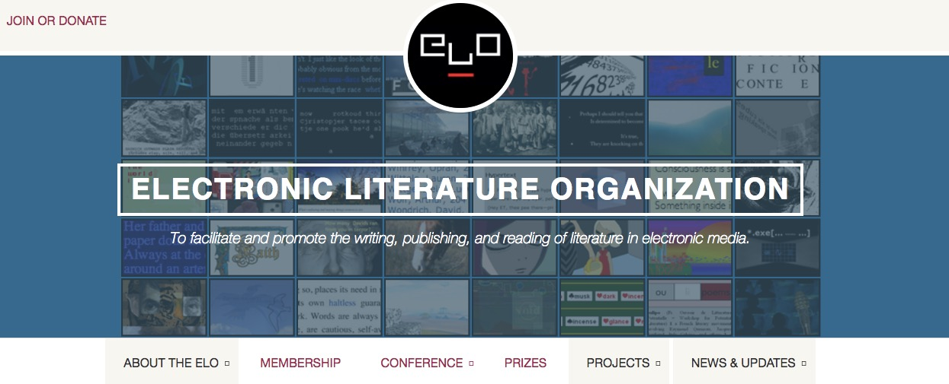
[Clip]
The ELO’s digital archives consist of seven collections of original digital literature –– typically referred to as electronic literature or e-lit. The project addresses the need for improved access, discovery and preservation for these works so that they will be available to scholars of the present and future.
Learn More, Read the Complete Announcement
About Gary Price
Gary Price (gprice@mediasourceinc.com) is a librarian, writer, consultant, and frequent conference speaker based in the Washington D.C. metro area. Before launching INFOdocket, Price and Shirl Kennedy were the founders and senior editors at ResourceShelf and DocuTicker for 10 years. From 2006-2009 he was Director of Online Information Services at Ask.com, and is currently a contributing editor at Search Engine Land.

https://www.infodocket.com/2018/06/06/washington-state-university-vancouver-to-lead-archiving-of-electronic-literature/

- LGBT Pride Month Brings Extra Challenges for Librarians
By Kara Yorio on June 14, 2018 1 Comment
In many places around the country, June brings celebratory parades and an increased show of rainbow flags, not to mention rainbow bagels, rainbow jewelry, and rainbow-covered clothing.In libraries, however, LGBT Pride month often means dealing with more challenges. While staff try to spotlight books with LGBT characters and themes, as well as those written by authors in the LGBT community, they have been facing more opposition from patrons and superiors during the last two years.
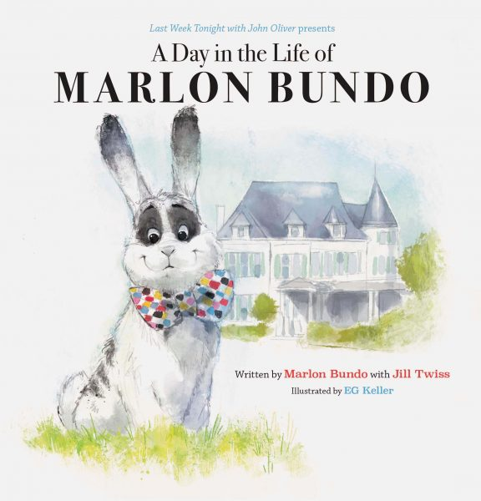The American Library Association’s Office for Intellectual Freedom (ALA OIF) has noticed a few trends since 2016. Half or more of the most-challenged books on the annual list are there because of LGBT characters or themes. This year, according to OIF director James LaRue, A Day in the Life of Marlon Bundo, a book about vice president Mike Pence’s pet bunny marrying another male bunny, is getting extra attention from critics.
Not only have challenge numbers risen around LGBT issues, more and more often, patrons’ complaints are going beyond books. Less than halfway through June, the OIF had heard of challenges to four LGBT displays and two Drag Queen Story Hours.
“We noticed that probably as a trend that started about a year and a half ago—books are still a primary things that are challenged, but there’s a big swing toward exhibits, speakers, [and] displays. And again the theme has been very much LGBT stuff.”
LIBRARY ADMINISTRATORS AND SELF-CENSORSHIP
The third trend noted by LaRue is self-censorship. In some cases, displays and programming aren’t happening because library superiors are trying to avoid controversy and complaints.
“It seems like the tendency is lots and lots of staff members are saying, ‘It’s important we do this, it’s important that we talk about it,’” says LaRue. “And increasingly, more and more shy administrators say, ‘Gee, we’re going to get some push back on this, let’s find a way not to do it.’”
An LGBT theme becomes a summer theme instead, and staff objections are ignored. This kind of self-censorship, or any censorship, goes against the basics tenets of librarianship. More conversation is better than less, says LaRue, and librarians must maintain their role despite increased opposition in certain cases. That doesn’t and shouldn’t mean situations get acrimonious.
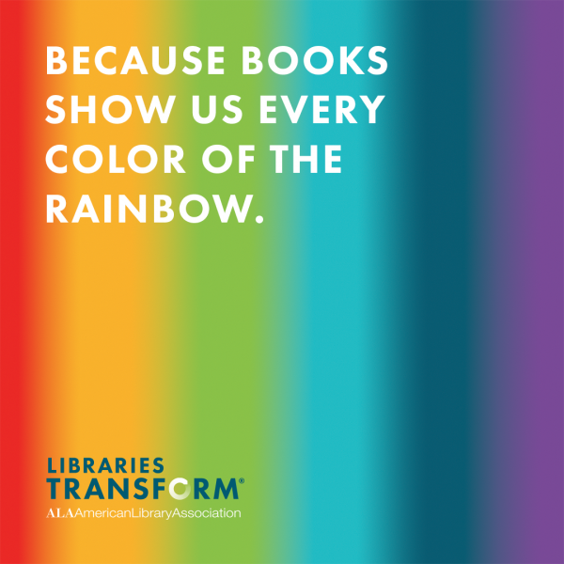“It’s important that we stand up, that we demonstrate courage within our communities for the values that define us as librarians,” he says. “But it’s also the case that we don’t have to be strident about it. We’re not doing this to irritate people. We’re doing this to celebrate human diversity.”
When it comes to non-book challenges, librarians may not know how to respond. A plan and a policy is usuallyin place for titles, but what should they do when a patron or organization demands a display taken down or program cancelled?
“We suggest that the [book] reconsideration tool is already the best practice for responding to challenges,” says LaRue, meaning use that same policy for any challenge from the initial form to taking the complaint to a committee, the director or school administrator’s decision, and a possible appeal to the board. “That’s very sturdy and it makes sure everything stays transparent. People can ask questions. And instead of just reacting to pressure from groups, you’re having a thoughtful interpretation of your policies.”
Librarians and library staff should also contact OIF by emailing oif@ala.org or going to the website’s page to report challenges. From there, the OIF staff can offer a range of possible responses to assist. First, they look at a policy to see if it has been followed. If needed, they also help coach staff on how to have these conversations with their supervisors about policy and censorship and the importance of representation. They can help library staff organize support for board meetings and social media campaigns, as well as writing their own letters to the editor or to the board or library director on behalf of the ALA. Finally, says LaRue, “I’m not above picking up the phone and calling the director and saying, ‘What’s up? What’s going on?’”
Fighting these trends in June, and year round, is important, but according to LaRue, the most essential part of the process begins with the youngest patrons.
“The single most important things we do is invest in early literacy,” says LaRue. “That means you come to this public place where everybody treats you well. You are read stories about lots of different people from lots of different backgrounds.”
It makes an impact that lasts a lifetime.
“What we’ve learned from that early exposure to human story is that A) it builds your brain, right? You have a better vocabulary….You grow up smarter being exposed to all that language,” he says. “But the other thing we’ve learned is that you become more empathetic. The more exposure you have to story, the kinder a person you become, the easier it is to understand what somebody else is going through. It increases empathy.”
As people get older, that investment in a range of human stories when they were younger means, “We become better people. We build stronger communities. People are healthier and happier—and more tolerant.”
About Kara Yorio
Kara Yorio (kyorio@mediasourceinc.com, @karayorio) is news editor at School Library Journal.

- Confederation of Open Access Repositories (COAR) and DuraSpace Announce Partnership
Filed by Gary Price on June 6, 2018
Full Text of a Joint DuraSpace and Confederation of Open Access Repositories (COAR) Announcement:
Both organizations believe in a strong role for innovative open technologies to promote long-lasting and open access to digital data and information. In addition, we are jointly committed to supporting the adoption of repository platforms that are interoperable, compliant with international standards and protocols, and reflect the vision of next generation repository.
By working together, DuraSpace and COAR will leverage their unique strengths and communities to pursue our common goals. In particular, the partnership will focus on building capacity in the repository community by delivering and participating in training events, with a special emphasis on developing countries; and promoting the value of open repositories with other communities internationally.
“At COAR, we are looking forward to working with the DuraSpace team to help enhance the skills of repository managers and support the adoption of the most up-to-date versions of repository platforms,” says Kathleen Shearer, Executive Director of COAR.
“We feel this collaboration will lead to practitioner empowerment and sustainability of the services built on the open repository platforms we steward. Working with Kathleen and the COAR community will help us tap into the incredible talent and enthusiasm in open source communities as well as help us deliver on our mission of supporting projects and advancing services to help ensure that current and future generations have access to our collective digital heritage” says Erin Trip, Interim CEO of DuraSpace.
“Our organizations have worked toward this partnership for so long. I am very pleased and grateful for this collaboration as I return to the community as a practitioner in repositories,” says Debra Hanken Kurtz, outgoing CEO of DuraSpace.
Might Also Be of Interest
Data Publishing and Curation Alliance: California Digital Library & Dryad Digital Repository Announce Strategic Partnership (May 30, 2018)

Gary Price

- National Institutes of Health (NIH) Releases Its First Strategic Plan for Data Science
Filed by Gary Price
From NIH:
Storing, managing, standardizing and publishing the vast amounts of data produced by biomedical research is a critical mission for the National Institutes of Health. In support of this effort, NIH today released its first Strategic Plan for Data Science that provides a roadmap for modernizing the NIH-funded biomedical data science ecosystem. Over the course of the next year, NIH will begin implementing its strategy, with some elements of the plan already underway. NIH will continue to seek community input during the implementation phase.
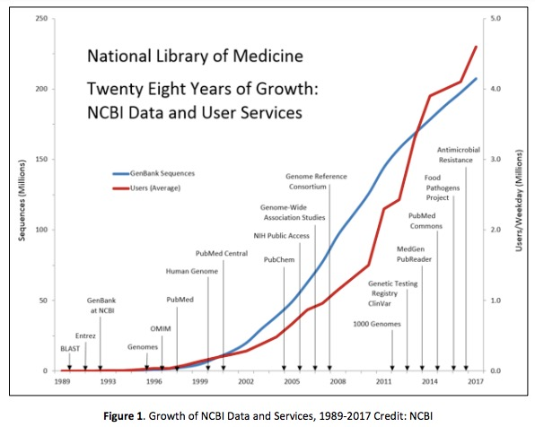
Source: NIH Strategic Plan For Data Science (2018)

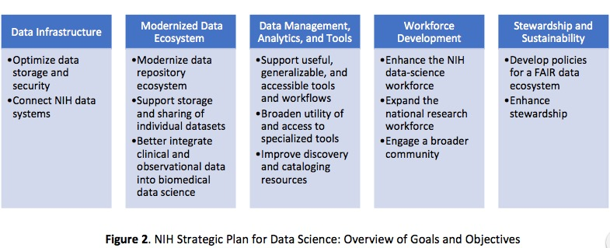
Source: NIH Strategic Plan For Data Science (2018)
Direct to Full Text of NIH Strategic Plan for Data Science
22 pages; PDF.
About Gary Price

https://www.infodocket.com/2018/06/04/national-institutes-of-health-nih-releases-its-first-strategic-plan-for-data-science/

- 2018 Gale/LJ Library of the Year: San Francisco Public Library
By John N. Berry III on June 5, 2018 Leave a Comment
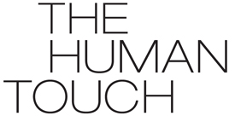A model and inspiration for public libraries worldwide, the San Francisco Public Library (SFPL)—with its committed staff, transformational leadership, amazing array of programs, partnerships, popularity, and community connections—is the 2018 Gale/LJLibrary of the Year. SFPL’s aggressive yet compassionate approach and the resulting services, outreach, alliances, and innovation offer new directions public libraries everywhere can apply to their services.
“SFPL’s overall impact on its community is obvious as it creates exceptional programs touching all parts of the city’s diverse population. The size and scope of services is a tour de force of what library programming aspires to,” writes award judge Kent Oliver, director, Nashville Public Library, the 2017 Gale/LJ Library of the Year.
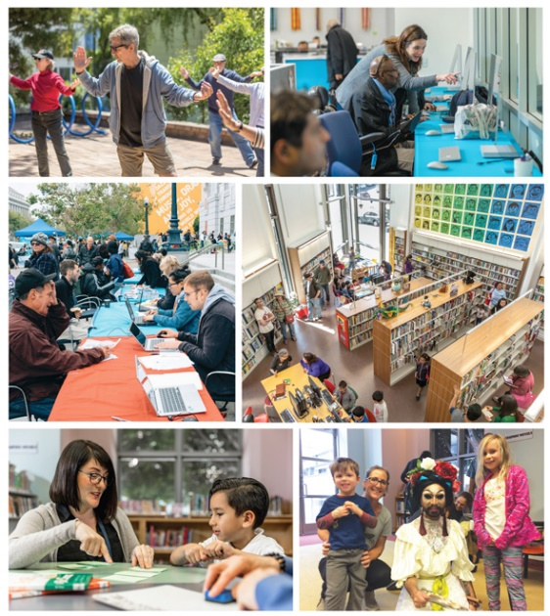
SOMETHING FOR EVERYONE (Top row l.–r.): Tai Chi for Seniors class at Eureka Valley Branch; Bridge at Main literacy and learning center with manager Kate Eppler and adult learners at the Tech Lab . (Middle row l.–r.): Pop-up Care Village outside the Main Library; the North Beach Library. (Bottom row l.–r.): SFPL Learning Differences Librarian Laura Lay working with a FOG Readers learner/tutor pair in the Main Library Children’s Center; Drag queen story hour at the Main Library. Top row and bottom left photos ©2018 Jason Doiy; all other photos courtesy of SFPL
ALL ARE WELCOME
Inclusion has long been a focus at SFPL, but it gained new urgency in the current political climate, something from which the leadership doesn’t shy away. “The day after the 2016 election we had our Future of the Library Forum meeting. [Then-director] Luis Herrera recognized that people in the room were hurting. We discarded the agenda we had prepared and had a dialog with the staff. ‘What are we going to do in the library to address equity in our community? How can we be more inclusive?’ were the questions discussed,” says Acting City Librarian Michael Lambert.
From that dialog, SFPL formed its Immigrant Services Task Force, which in turn quickly developed a slate of programs. The SFPL All Are Welcome initiative was born, providing information on how to settle in the United States, how to learn or improve English proficiency, how to become a citizen, and other critical resources, delivered in six languages and via YouTube video. The initiative’s “Know Your Rights” program has been a smash hit, and SFPL has joined with the city’s Office of Civic Engagement and Immigrant Affairs, which calls the library “a critical partner,” plus an immigration law firm, to give one-on-one advice on citizenship applications. The library also offers workshops on how to become an ally to immigrants. A Respect and Love toolkit and resource guide addresses issues of bias and discrimination.
GRAPPLING WITH RACE
SFPL is taking steps to address racial injustice internally and externally alike. According to Lambert, the two are intertwined. “We want to do a better job of serving impacted communities in San Francisco, and we want all SFPL staff to go through [anti]bias training. These efforts will improve our recruiting from communities of color and make the SFPL workforce even more reflective of the city,” he says.
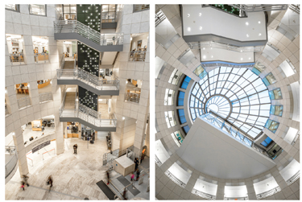
THINGS ARE LOOKING UP The atrium at the Main Library. Photos courtesy of SFPL
SFPL’s librarian at the African-American Center Shawna Sherman and the Community Engagement manager Alejandro Gallegos just joined the Government Alliance for Racial Equity. They will lead an effort to develop a Racial Equity Plan for SFPL this year.
To help patrons address these issues, SFPL designed a new four-part series of programs to help parents, educators, and caregivers discuss race with youngsters. Participants were given tools to address race, racism, inequity, and injustice, and practiced conversations with and for kids on how to nurture racial justice. Librarian of Congress Carla Hayden joined the program to introduce a workshop for families and educators.
EMBEDDED IN OFFERINGS
SFPL excels at incorporating its equity mission into all of its programming. Last year’s Digital Inclusion Week, for example, worked with more than 20 organizations to bridge the digital divide. (This year it has been renamed Connecting with Tech Week.) SFPL also allied with Radar Productions to present the first Drag Queen Story Hour in the nation in 2015. Many libraries have since tried these programs; SFPL has expanded Drag Queen Story Hour to branches outside of the traditionally LGBTQIA neighborhoods.
For its version of the One City, One Book program, in 2017 SFPL chose Joshua Bloom and Waldo E. Martin Jr.’s Black Against Empire: The History and Politics of the Black Panther Party (Univ. of California). More than 700 people participated in over 20 author talks, bike tours, film screenings, panel discussions, and other activities. More than 1,200 patrons checked out the book.
In 2017, SFPL launched “We Love Diverse Books,” more than 50 programs featuring titles that counteract stereotypes and showcase the array of cultures in books, including the Black Comix Arts Festival, cultural cooking classes, bookmaking, and poetry workshops. Authors and artists shared stories.
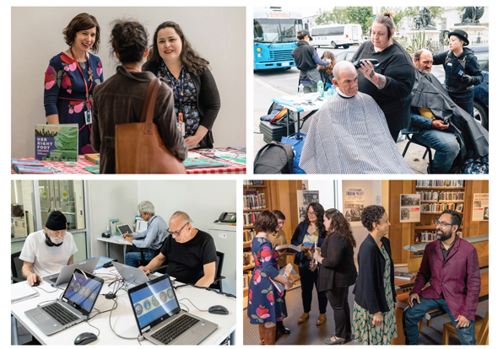
INNOVATION IN ACTION AT SFPL (Top row l.–r.): Youth services manager Christy Estrovitz and early learning coordinator Maricela Leon-Barrera doing outreach; free haircuts courtesy of Pop-Up Village Care. (Bottom row l.–r.): The Bridge Learning Center’s Veterans Resource Center; African American Center librarian Shawna Sherman (2d from r.) and community engagement manager Alejandro Gallegos (r.) inside the African American Center. They will lead development of SFPL’s Racial Equity Plan. Top row photos courtesy of SFPL; bottom row photos ©2018 Jason Doiy
Every year programs created by SFPL’s Cultural Awareness Committee (CAC) highlight multiple themes across all ages and communities. Recent programs included Middle Eastern Heritage, Pride! SF, Made in SF, Asian Pacific Heritage, VIVA! Latino/Hispanic Heritage, LIVE! at the Library, and for more than a month Black History, Culture, and Heritage.
SFPL wasn’t the only literary organization in San Francisco city to feel the 2016 presidential election as a wake-up call. Chief of community programs and partnerships Michelle Jeffers tells how an organization called Litquake, an SFPL partner for 20 years on author visits, writing workshops, and similar events, decided to bring authors into SFPL to engage people who felt the impact of the election.
“Litquake wanted to find new ways to make their voices heard. Cutting-edge programs were created and brought to SFPL every other month. We discussed how many voices were being excluded, and we started the SFPL ‘No Shadow Without Light’ Series,” Jeffers reports. “It grew really fast, there was such an outpouring of interest in hearing from these writers and having a free venue and welcome for them. They were noted voices on immigration, women’s rights, and environmental issues.”
ENRICHING AND SAVING LIVES
In 2009, as collaborator with the Department of Public Health, SFPL placed a social worker in the library—the first U.S. public library to do so. Nearly a decade later, the social worker is augmented by a social service team of a leader and six health and safety associates (HASAs), many of whom have been homeless. They serve all patrons who need assistance, especially the indigent, homeless, or those living with mental illness, chronic health issues, or substance abuse. HASAs get peer counseling and training and grow in their new careers working with others. The team has partnered with community organizations such as Project Homeless Connect and Lava Mae, a nonprofit that provides mobile showers in front of the Main Library every week, and says its “work with the library embodied our highest hopes.” SFPL hosts a monthly Pop-Up Care Village outside the Main Library, providing food, clothing, backpacks, health care, haircuts, showers, and more to about 350 people. They offer referral services to homeless patrons every day. More than 6,500 people got resources from HASAs last year. Since 2010, 150 people have been placed in permanent housing with help from SFPL.
SFPL frontline staff asked management to have SFPL stock Narcan and give them training on its use to save lives. More than 120 employees have completed the voluntary training. In February, SFPL staff administered Narcan and saved the lives of two patrons.
“Having to face tough urban issues like homelessness and the opioid epidemic has redefined the collaborative and expansive role that libraries play in spearheading social policy,” says Lambert.
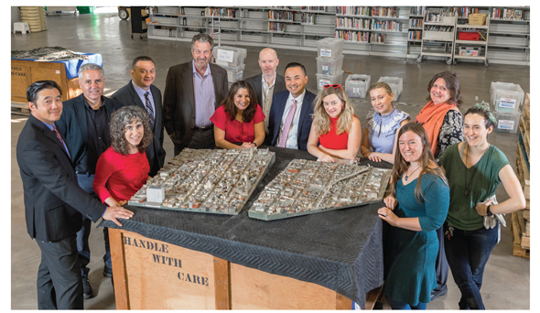
IT TAKES A VILLAGE SFPL’s leadership team partnered with SFMOMA to restore a historic scale model of the city. (Clockwise): Michael Liang, chief of information technology; Mark Hall, assistant chief of Main; Mindy Linetzky, manager, communications & public affairs; Omar Castillo, safety and security manager; Roberto Lombardi, facilities director; Michelle Jeffers, chief of community programs & partnerships; Randle McClure, chief analytics officer; Michael Lambert, acting city librarian; Stella Lochman, SFMOMA associate curator; Maureen Singleton, chief of finance; Shellie Cocking, chief of collections & technical services; Elicia Epstein, SFMOMA education assistant; and Cathy Delneo, chief of branches. Photo ©2018 Jason Doiy
A MUSEUM LIBRARY BRANCH
While the San Francisco Museum of Modern Art (SFMOMA) was closed for renovation 2013–16, it was doing what was called “the museum on the move, the museum on the go,” pop-up exhibitions in other cultural institutions in the city, according to Jeffers. SFPL was one participant, hosting what Jeffers calls “this cool nontraditional exhibit” on a South African music festival from 1957.
“It was a great partnership, and we loved working with them,” says Jeffers. “SFMOMA found that working with SFPL made a point they wanted to emphasize, that museums often feel so exclusive they don’t reach all sectors of the community. They saw that SFPL was a place that attracted people from the entire community [and] wanted to continue a partnership” even after the renovation was complete.
SFPL’s community engagement would bring more visibility to the museum. SFPL hoped the connection would bring more visibility to the library. When SFMOMA reopened it included a space for what was called a current education center. It’s a big open room, and SFPL folks joked that it would make a great branch. Now the joke has come true: there are SFPL programs, a collection of books, a spot where people can hang out with records to listen to, even a piece of SFPL’s Julia Morgan–designed card catalog. SFPL’s SFMOMA branch is busy now.
EXHIBITS FOR DIVERSITY
SFPL doesn’t only have a piece of the library in the museum, it also continues to have a little bit of museum in the library. Though the SFMOMA pop-up is gone, two full art galleries in the Main Library get heavy use, and there is broad interest in exhibitions and displays throughout the branches. The library develops exhibitions that highlight library resources but also illuminate the diverse communities and interests of San Francisco and tie into themes developed by the SFPL CAC. Recent exhibitions include an annual wit and humor show taken from a unique special collection to multiple photography displays that have highlighted Palestinian immigrants, nationally recognized poets, and homeless residents. The library often joins with local artists and community organizations, providing a venue where they can showcase their work. Over the past two years, two exhibitions created by SFPL and its partners have traveled to other museums and libraries: an exhibit on the impact of climate change on wildflowers and a show highlighting native Ohlone elders and youth.
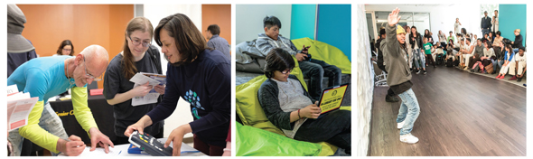
IN THE MIX SFPL’s Tech Expo; the teen-designed space The Mix; a performance program at the teen-designed The Mix. Left and right photos courtesy of SFPL; middle photo ©2018 Jason Doiy
CULTIVATING CULTURE
The SFPL story begins with the transformational leadership of City Librarian Luis Herrera, the 2012 LJLibrarian of the Year, who retired this past February after 13 years.
“I feel as though I’ve had an Ivy League education working with Luis Herrera. Luis was a transformational leader. He created an amazing culture of service and innovation here, but it is also a family culture for the staff. We care about one another, and we celebrate each other,” Lambert says. Herrera’s legacy includes collaboration with the union, a relationship that can elsewhere be adversarial. The effectiveness of SFPL’s innovations at meeting community needs is measured by an in-house analytics team headed by a chief analytics officer, itself an innovation.
“We have an incredible talent pool at SFPL,” Lambert continues. “Four years ago we set out to be the premier urban library in the country, and our staff have bought in. We launched an initiative called Service Excellence, and every staff member, custodian, page, security staff, our librarians, our managers, everybody goes through service excellence training. People have committed themselves to the patron focus service model, and they have committed to being a safe and welcoming library, a preferred destination [for] all San Franciscans,” says Lambert proudly.
That welcome is anything but one-size-fits-all. Susan Hildreth, who served as San Francisco city librarian prior to Herrera and, after a stint running the Institute of Museum and Library Services, is now professor of practice at the University of Washington iSchool, cites several offerings tailored to the needs of specific patron populations. “Over the last several years, many new services have been developed including the Bridge at Main, an adult literacy and learning center located at the Main Library featuring a computer lab, technology classes, and a veteran’s resource center…the Deaf Services Center, the Library for the Blind, and mobile and homebound services through the Library on Wheels.” A recent innovation allows hospital patients to access library materials without coming in for a card.
Another underserved population SFPL is addressing is children who need extra help with reading. SFPL is the first public library in the country to hire a learning differences librarian, who is developing a program of one-on-one tutoring and reading remediation called FOG (Free Orton-Gillingham) Readers.
DIVERSITY OF BOOKMOBILES
According to Mindy Linetzky, SFPL’s manager of communications and public affairs, the four libraries on wheels Hildreth mentioned visit more than 60 locations, providing library service to schools, senior centers and residences, day-care centers, community and cultural events, and even Treasure Island, located in San Francisco Bay between the two sections of the Oakland Bay Bridge. SFPL has also put its own unique twist on the mobile outreach vehicle with the environmentally friendly SFPL Green Bookmobile, which runs on 20 percent biodiesel and is specially equipped with four solar panels, Fantastic Vents for green AC, skylights for natural light, sustainably forested wood, carpets containing recycled content, and a hybrid generator. The fleet also includes an early literacy mobile and one focused on seniors.
Library of the Year 2018 Judges
LJ thanks the following individuals who volunteered their valuable time to help select the 2018 Library of the Year:
Kent Oliver, Director, Nashville Public Library; 2017 Gale/LJ Library of the Year
Brian Risse, VP–Public Library, Wholesale, & Large Print Sales, Cengage Learning
Felton Thomas Jr., Executive Director, CEO, Cleveland Public Library; Past President, Public Library Association
Julie Todaro, Dean of Library Services, Austin Community College, TX; Past President, American Library Association
Lance Werner, Executive Director, Kent District Library, MI; 2018 LJ Librarian of the Year
The panel also includes LJ’s Matt Enis, Rebecca T. Miller, Kiera Parrott, Lisa Peet, and Meredith Schwartz.

LJ editor panelists select up to six finalists from among the total pool of entries and invite external judges to participate, including one representative from Gale Cengage Learning, the award’s sponsor; the judges each choose their first-, second-, and third-place candidates from that field and convey their vote to the coordinating LJ editor. Each vote is assigned a corresponding point value, and each vote is given equal weight. The cumulative totals determine each year’s award winner and honorable mentions; any ties are broken by LJeditors.
TEENS IN “THE MIX” & STRONG SUPPORT
Another target population for SFPL is teens. Many libraries have teen advisory boards, but few of them take it as far as SFPL, which allowed its teens to design not only programs but the space that houses them. “The Mix” at SFPL, launched in 2015, “was their vision,” says Lambert. “Architects worked with the SFPL Board of Advising Youth and came up with the conceptual design and programs and services they wanted. We repurposed prime space…. It has transformed the space and the experience. There’s a Maker space, audio booths, and a video production studio. There is a performance garden, beautiful books, and all kinds of comfortable seating where the young can study, chat, or just hang out. There are computers where they can edit their content and then showcase that content on the SFPL website.”
SFPL’s award-winning excellence today doesn’t come cheap: it has deep roots and a long history of support. “SFPL was not a leading library two or three decades ago. That all changed in 1994, when residents banded together under the partnership of the Friends and Foundation of SFPL,” says Lambert.
A petition initiative went on the ballot and was passed in 2000, creating the Library Preservation Fund. It allowed SFPL to invest in all 27 branches, and funding increased hours and collections. (As of 2017, all branches are now open seven days and at least 50 hours per week.) Renewed in 2007, it must again be renewed in 2023.
“We’ll be gearing up with our Friends and Foundation to embark on a new campaign to get that renewal very soon. We even hope in the next round that we’ll have a longer time,” Lambert reports.
The result is an annual SFPL budget of $126 million, or $144 per capita. About 65 percent of the budget covers the cost of 872 staff, of which 30.3 percent are professional librarians. More than 11 percent of the budget goes for materials and collections, which last year drove a 6.33 percent increase in circulation.
Says Herrera of this award, “The support from the people of San Francisco was what made this possible. Even in difficult economic times, they put their money where their mouth is…. The people of the community knew and expected that when needs arise, the libraries come to the fore.”
And so they did. Says author Dave Eggers, “The SFPL is nimble, creative, and always inclined to find a way to make things happen. They always say yes first, then find a way. I love them for that.”
THE CASE FOR SFPL
Comments from judge Julie Todaro, past president of the American Library Association and dean of library services at Austin Community College in Texas, sum up why SFPL deserved to win this award: “With a strong focus on employees and partnerships, SFPL exemplifies best practices…. They present a number of firsts in their program design and delivery (the first social work librarian, unique story time performers) and have taken many risks. SFPL has excelled at hiring and training staff who focus on expanding what libraries “do” and illustrated how libraries who can’t afford these hires can focus on these areas, for example, ‘learning differences librarian.’ The impact is broad and deep.
“Many of their ‘firsts’ have already inspired the profession to look differently at what they do and, most important, what they can do.”
That, says Herrera, was the point. “Our work was very intentional. We wanted to create a model urban library. We wanted to demonstrate what the library of the future would look like. We learned that it always has to be a work in progress.” We look forward to seeing the progress still to come.
LIBRARY OF THE YEAR 2018 SPECIAL MENTION
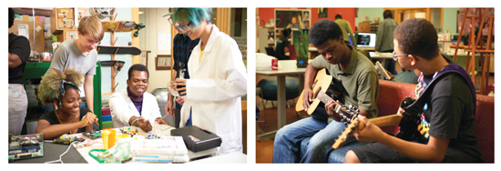
CHICAGO PUBLIC LIBRARY
Brian Bannon, Commissioner & CEO
The Chicago Public Library (CPL) is consistently one of the top exemplars in the United States, and it is no coincidence that CPL appears here as a special mention for the second year in a row. Like winner SFPL, where Chicago CEO Brian Bannon (a 2009 LJ Mover & Shaker) cut his teeth as chief of branches, Chicago’s story is marked by expanded hours, branch renovations, and field-leading innovations that have gone on to see wide adoption, perhaps most famously the YouMedia teen space, now nationally replicated under Institute of Museum & Library Services funding, and the design thinking toolkit that CPL developed with Denmark’s Aarhus Library and groundbreaking design firm IDEO.
Newer innovations perhaps headed for a similar fate include Learning Circles, built with Peer 2 Peer University, which pair massive open online courses (MOOCs) with in-person support from peers and staff facilitators, leading to a dramatic retention rate three to five times that of a purely online course, and an ambitious, STEAM-focused summer learning challenge that combines massive scale with rigorous documentation of impact.
As with SFPL, partnerships are deeply embedded in CPL’s model of innovation, both inside libraryland, via communities of practice, and outside it with the MacArthur and Knight foundations and many more. This deeply collaborative approach inspired MIT’s Media Lab to create the Public Library Innovation Exchange and particularly impressed judge Felton Thomas, who cited “their stated and shown commitment to sharing their best practices nationally and internationally.” One of CPL’s newest partners is also the most exciting: see News+, p. 10, for CPL’s plans to open a branch inside Chicago’s forthcoming Obama Presidential Center, itself an innovative and unusual take on a presidential library.

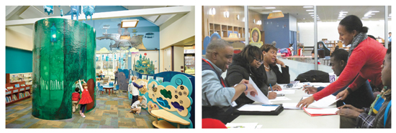
CUYAHOGA COUNTY PUBLIC LIBRARY, OH
Sari Feldman, Executive Director
Cuyahoga County Public Library (CCPL) has long been known as a model of library service. But, as judge Julie Todaro says, “Although Cuyahoga has had a reputation for transformation and meeting community needs, its vast resources have driven—in many people’s minds—the existence, delivery, and success of services.” While the system is well supported, however, many librarians may not know that doesn’t mean the community is affluent. As it turns out, nearly half of all workers in Cuyahoga County—some 44 percent—have literacy skills far below the national standard. As a result, says judge Kent Oliver, “CCPL is laser-focused on adult education, workforce development, and literacy.”
Over the last year, CCPL has emphasized ramping up services to serve job seekers better, launching a Benefits Navigator partnership with the county’s Job & Family Services department to help adults with limited digital skills and access successfully get the help to which they are entitled. In turn this lets the library connect them to other library services, particularly GED/high school equivalency prep. The library’s new Families Learning Together program allows parents to study for a GED for free while their kids take part in literacy and art activities. CCPL’s CuyahogaWorks Job & Career Service is staffed by counselors and coaches who help with résumés, search strategies, and interview preparation, plus office hours from the local county workforce board. In 2016, 68 percent of those helped by the service got a job within three months. Through the Aspire Greater Cleveland program, the library connects to local employers to provide training, such as ESOL for hotel housekeeping and maintenance staff and food production workers. The Key Advanced Entrepreneurs program, in partnership with a local bank, helps those who want to start their own business. Meanwhile, a complementary focus on family engagement, early literacy, STEM, and grade-level reading help prepare the next generation for success.
This article was published in Library Journal. Subscribe today and save up to 35% off the regular subscription rate.
About John N. Berry III

https://lj.libraryjournal.com/2018/06/awards/2018-galelj-library-year-san-francisco-public-library

- New “Overlay” Journal in Mathematics Launches With Help from COAR and Queen’s University Library
Filed by Gary Price on June 4, 2018
From COAR (Confederation of Open Access Repositories):
Today, a new journal in mathematics was launched by Timothy Gowers and Dan Kral. The journal, called ‘Advances in Combinatorics’, is an overlay journal, built entirely on articles contained in the arXiv repository. It is free to read and will not charge authors to publish. The relatively low costs of running the journal are being covered by Queen’s University Library in Ontario, Canada, which is also providing administrative support.
COAR and Queen’s University Library were very keen to participate in the launch of this journal as it offers a model of overlay services on top of repositories, a model that could eventually be generalized beyond arXiv. “This aligns really well with our vision for next generation repositories”, says Kathleen Shearer, executive director of the Confederation of Open Access Repositories (COAR), “on top of which we can build services such as peer review”.
[Clip]
Martha Whitehead, vice-provost (digital planning) and university librarian at Queen’s University says, “As libraries, we need to nurture and invest in new models that will contribute to a more sustainable and inclusive system for research communications. We are delighted to be able to support this innovative approach to journal publishing.”
Read the Complete Post
Read the Complete Comments by Timothy Gowers, Journal Co-Founder
Advances in Combinatorics is set up as a combinatorics journal for high-quality papers, principally in the less algebraic parts of combinatorics. It will be an arXiv overlay journal, so free to read, and it will not charge authors. Like its cousin Discrete Analysis (which has recently published its 50th paper) it will be run on the Scholastica platform.
About Gary Price
Gary Price (gprice@mediasourceinc.com) is a librarian, writer, consultant, and frequent conference speaker based in the Washington D.C. metro area. Before launching INFOdocket, Price and Shirl Kennedy were the founders and senior editors at ResourceShelf and DocuTicker for 10 years. From 2006-2009 he was Director of Online Information Services at Ask.com, and is currently a contributing editor at Search Engine Land.

https://www.infodocket.com/2018/06/04/new-overlay-journal-in-mathematics-launches-with-help-from-coar-and-queens-university-library/

