Año 3 Número 78 junio 2018
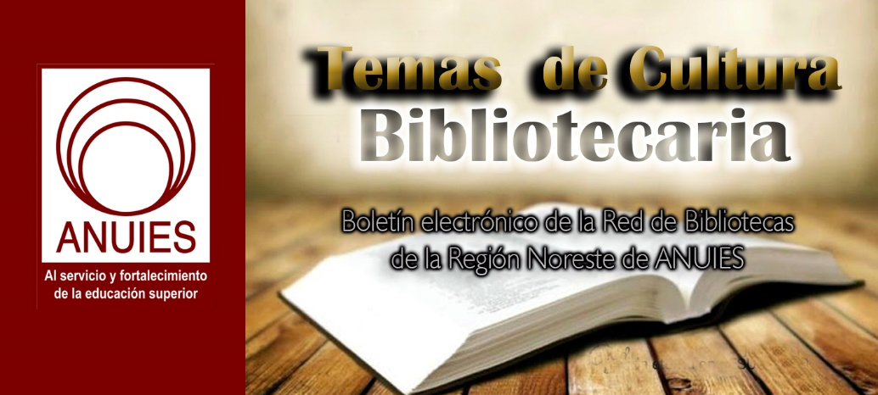

Contenidos de este número

- Fund Your Library: Tools and Tactics for Getting to Yes!
In this multi-faceted online course, you’ll design a plan to get your budget passed, with personal coaching from fundraising experts—from libraries and beyond.
Live Interactive Sessions on Thursday June 7 & Tuesday June 19 at 2 PM ET
Bridged with Homework, Online Workshops, Resources, and Discussions.Certificate of Completion Provided.
Also available On Demand! Can’t make a live session? All sessions will be available to you ‘on demand’ following the initial broadcast.
Whether you’re going to voters, city councils, school boards, college board of directors, or any other funder, the fundamental issues are the same: how do you convince the stewards of a limited budget that the library is their best investment?
In this workshop, you’ll gain a thorough understanding of how to best pitch your library to stakeholders and members of your community in order to get your library fully funded. Topics will include deep community engagement, finding your impact, identifying and activating your target audience, grant funding, and more.
As a participant in the course, you will view live sessions and join the conversation via live chat. (All sessions are recorded for on demand access.) Most important, you’ll work with a dedicated adviser in an online coaching environment to gather resources and best practices and connect with peers from across North America (and beyond).
When you attend this interactive online course, you’ll learn from experienced industry leaders how to:
- Align your strategic plan, outreach, and marketing with community goals
- Gain visibility in your city and connect deeply with community members and stakeholders
- Develop a strong message in support of why library funding matters to the whole community and learn how to effectively convey it to decision makers
- Tell your library’s story to bolster your fundraising efforts
- Find and access alternative forms of fundraising, including grants
- Create compelling marketing materials
- Identify and activate your target audience, mobilizing them to campaign on behalf of your library
- Cultivate a transparent and authentic approach to fundraising
The course features live guest speakers in interactive sessions with Q&A. You’ll work in small groups with facilitators experienced in fundraising to complete assignments and field research in your library that will fuel your fundraising ideas.
Group discounts are available!
Register in groups for a unique team-building experience and get everyone working together. Contact us to learn more.
Who should take this course?
Any library leader—whether high level manager, trustee, friend or foundation member, or passionate staff—who needs to learn how to more effectively advocate for funding their library. Whether you are facing a referenda on the ballot or line items in the boardroom, this course can help you find the funds to come back from recession cuts, increase staffing levels and salaries, make capital improvements, and grow needed hours and services.
Online Course Features
- Instructor-led online courses feature personalized interaction over three weeks
- Real-time guest speakers and conversation via live webcast (with recordings available afterward)
- Homework assignments to help you make progress on your goals
- Individualized attention from course facilitators who work with you in a coaching environment to help sort out challenges
- Ongoing group conversation via discussion forums
- Articles, videos and other resources
- Access all course content for 6 months after the course ends
Inspiring Live Guest Speakers + Project-Based Learning
Engage with presenters via live video stream, visual presentations, and chats, and workshop practical ideas in groups, with guidance from an advisor, to map out your own fundraising plan.
https://learn.libraryjournal.com/courses/fund-your-library/?utm_source=ljsnewsletter&utm_medium=newsletter/&utm_campaign=funding/

- Rolf Hapel: Toward a Global Instruction and Practice
By Lisa Peet
Rolf Hapel, Director of Citizens’ Services and Libraries in Aarhus, Denmark since 2006, will be stepping into the role of Distinguished Professor of Practice in Residence at the University of Washington Information School (UW iSchool), Seattle. Hapel was a driving force in the creation of Aarhus’s Dokk1 library and cultural center, which opened in June 2015 and was named Public Library of the Year by the International Federation of Library Associations and Institutions in 2016.
Prior to becoming director of Aarhus Public Libraries in 1994, Hapel worked in several cities throughout Denmark as a librarian, deputy manager, and director of public services. He holds a master’s degree in digitization and public administration from Aarhus University.
Hapel succeeds Susan Hildreth, who completed her two-year term as the inaugural Professor of Practice at the end of the 2017–18 school year. The position is funded by a ten-year, $1.4 million grant from the Bill & Melinda Gates Foundation, and will bring up to five professors of practice to the iSchool to offer new perspectives on library instruction.
In addition to his teaching and curriculum development duties at the iSchool, Hapel will serve on the Master of Library and Information Science program committee and the advisory committee for the iSchool’s Technology and Social Change Group, a key partner in the Gates Foundation’s Global Libraries initiative. LJ caught up with him before his move to find out more about what he has planned for his time at the iSchool.
LJ: You’re coming into the professor of practice role with a fresh viewpoint not only from outside academia, but from outside of the United States. What do you see as some emerging global challenges and opportunities for libraries?
Rolf Hapel: Smart cities are a really big thing in Europe now, also in Asia—all kinds of sensors, big data, and the Internet of Things. The idea is that cities will become smarter and smarter, facilitating the citizens. And to me that is a strong concept where libraries have a special role to play. Libraries are the places where digitization data has a human face, where you actually are able to create useful democratic discussion of what is going on in the digital arena—what are the choices that we have as citizens? Libraries are the places that can engage the citizens in that kind of democratic discussion, and ultimately also the choices that are connected to that kind of development. So for me, public libraries are vehicles for democracy, will always be.
I’m also really interested in how digitization and these new paradigms…are impacting the physical library, the library as a physical space—how does that actually translate into physical buildings? I think that is one of the big challenges, that a lot of libraries have been built up through the last century and in the beginning of this [one] that have not really taken that transition in. I’ve seen so many libraries with enormous collections of physical books that have to be transformed into something else, and that something else is a place for people—not a place for books alone. That transition is extremely interesting, to see how that spells out in physical buildings. What shall that be in the future, and how can we find the economy to actually change them into something more useful? That’s a really big thing for library practitioners, and of course library managers, to look into.
It’s not only about digitization, it’s about whatever goes on in society that librarians can identify as moments where there is a possibility for the library to be a coplayer, or maybe a corrective to an unwanted development. For me librarianship is very much about developing democracy and developing an ongoing conversation around how should our community or our society develop, and in which direction. So in that sense you could say that the public libraries are building social capital, trust, coherence in between the citizens. That is what I hope to bring to the table when I’m engaging in discussion with the students and the faculty members.
How do you think that global vision will translate into instruction for largely North American students?
I feel it’s an interesting [opportunity] for me to have that ongoing conversation and be able, hopefully, to facilitate the learning processes of students. I think that my approach will not so much be instruction as it will be facilitating a discussion and to be able to enhance the language, the viewpoints. And also dealing with facts, of course. Hopefully I can use some examples and draw on my own experience, and try to open up their minds [to] what is going on somewhere else. One of the things that I’ve learned is that innovation and ingenuity are not about physical resources. It’s much more about thinking and approach than it’s a matter of money. That’s one of the discussions I’ve had with a lot of library leaders. Of course you need to have some resources, but it’s much more about thinking and energy and the ability to communicate with people.
Do LIS students in the United States face different challenges than their European counterparts?
It’s exactly the same. When I went to library school we had periods of practice in education, and then eventually over years that education changed to become much more academic, which was good—you got much more theory behind your practice—but you lost the practice element. That meant that when you came out [of school] as a new librarian you had to learn how to relate, you had to learn how to work with people, you had to learn from your colleagues. Which is not entirely bad, but I think in Danish library education—and I’ve been discussing that with the former headmaster of our information school here in Denmark—we need kind of a new element of practice, or understanding of practice, built into the education, because of the transition that is happening in libraries. These transitions that are happening in libraries right now can be hard to put into a teaching frame[work] if you don’t know enough about them. So the element of practice, it’s really interesting to see how we can build that into the teaching and the learning processes of the students.
In Denmark about half of the people who get [LIS degrees] will be occupied in private companies, often as information architects, and half of them will be occupied in libraries. And not all of those who will [work in] libraries will have physical contact or meet the users of the libraries directly.
Do you see differences in LIS instruction between the United States and Europe?
One of the differences between European university teaching and what I [see] from looking at curricula in [the United States] is that American teaching is much more structured than we are used to in Europe. In Europe, in other words, much more is left to the students to actually find out and do.
Apart from the structure I think there aren’t probably that many differences. It [covers] the same topics—design thinking is big all over the place, a much more user-oriented approach in general, the understanding…that libraries aren’t just entities that have dropped down from heaven but that there’s always a motive and ideas behind [them], the urge to develop…futures for the physical and digital library—I think it’s the same as I experience it, not only in Europe and the U.S. but also in Asia. I think the advantage of the library field, if you compare it with so many other subject fields, is that it is a true global thing…. Information moves fast in the field and that means that [librarians worldwide] are, if not aligned, then sort of on the same level.
You were instrumental in helping develop the Design Thinking for Libraries toolkit in partnership with Chicago Public Library and the design firm IDEO. Will you be incorporating design thinking into your work at the iSchool?
I look forward to teaching design thinking methods. [Dokk1] was ultimately created in a—maybe it’s too far to say in a cocreation process with the stakeholders and citizens of Aarhus, but they certainly played a big role in a lot of the choices that have been made along the way, and that have ultimately resulted in the success of our library. All the methods and the use cases [are] part of what I can bring [to the iSchool]. So I think we will probably embark in a lot of practice around design thinking, and of course also discussions around what works and what doesn’t, and why.

https://lj.libraryjournal.com/2018/06/buildings/rolf-hapel-toward-global-instruction-practice/

- Libraries Address #MeToo
By Jennifer A. Dixon
Somerville Public Library’s Books and Brews book club discusses a #MeToo author
Photo credit: Cassandra Graesser
The #MeToo movement—originated by activist and community organizer Tarana Burke in 2006 and gaining new traction since October 2017—has sparked intense and important global conversation about sexual harassment, assault, and violence. With waves of reports bringing to light abuses in industries like entertainment, literature, and politics, libraries are uniquely situated to offer trusted spaces for learning and discussion on these issues.
EMPOWERING THROUGH INFORMATION
For many libraries, developing resource guides and educational events fits well into their overall mission of information access. In Stockbridge, MA, the Stockbridge Museum, Library and Archives recently partnered with a local domestic violence and sexual assault services organization, the Elizabeth Freeman Center, to present a two-part discussion series in honor of Sexual Assault Awareness Month in April. The theme of the programming, “embrace your voice,” focused on listening to survivors and vocally acknowledging them and offering support. The presentations covered resources about sexual assault and its impacts, and addressed how individuals could become change agents.
According to Stockbridge Library Association director Katie O’Neill, the events attracted a small but engaged group, and included “a different set of people from those who usually attend our programs.” She said, “even if we connected one of two of those people with resources that they needed,” the events were a success. “The more that we can talk about [sexual assault] and make people aware…this doesn’t just impact women; it’s not about just one person.” The library also committed to engaging with the topic through an April book display, including titles like The Rape Recovery Handbook: Step-by-step Help for Survivors of Sexual Assault (New Harbinger) and Jon Krakauer’s Missoula: Rape and the Justice System in a College Town (Anchor).
The King County Library System (KCLS) in Washington has also developed a centralized #MeToo resource guide that connects patrons with information they need. The guide acknowledges that “it’s not always easy to know where to turn for resources on such a difficult topic,” and lists “Where to turn” contacts for local and national support and advocacy organizations. The guide also suggests a handful of titles written by survivors of sexual harassment, like Hunger by Roxane Gay (Harper Perennial), with a focus on including multiple perspectives and marginalized voices. “Our hope…was to reach out to residents in the KCLS service area who might not otherwise feel comfortable coming to the reference desk at the libraries to ask for help,” said Tess Mayer, KCLS director of library outreach, programs, and services. She characterized the library’s goal as creating “communities of belonging.”
Public libraries are not the only institutions developing programming to address #MeToo. The Schlesinger Library at the Radcliffe Institute for Advanced Study at Harvard University, for example, organized a February event entitled “metoo: Truths and Consequences,” featuring a panel of Harvard scholars. The Harvard Crimson also reported that the Schlesinger Library team has plans to document and archive materials related to the #MeToo movement. The Kraemer Family Library at the University of Colorado, Colorado Springs hosted a “Just Talk: #MeToo” conversation event. At these and other libraries, library leaders have teamed up with local experts or organizations to foster well-informed and respectful conversations.
HANDLING TOUGH CONVERSATIONS
Adding new offerings, and spotlighting existing ones, is not the only ways that #MeToo impacts libraries: there’s also the issue of what to do about titles by the accused harassers and events featuring them, especially those acquired or arranged before the news broke. For example, the “Books and Brews” book club through the Somerville Public Library in Massachusetts recently selected Aziz Ansari’s Modern Romance: An Investigation (Penguin Pr.) as its February read. The book was announced as the winner of a significant majority in an online vote just days before the release of an article accusing Ansari of sexual misconduct.
According to Lilly Sundell-Thomas, outreach and programming librarian, a member of the club’s Facebook group posted a link to that article and asked if the selection would change. She said, “We initially weren’t sure what we were going to do. We talked it over with our administrators and with each other, and then decided we didn’t want to change the title.” Doing so would have overruled the majority selection of the book club and would place the librarians in the position of dodging a controversial topic while censoring patrons’ reading choices.
Ultimately, approximately 40 people attended the Modern Romance book club meeting and were very interested in discussing it. Although the librarians did let attendees know to approach them if the conversation made them uncomfortable, the conversation stayed civil and engaged throughout the event. Cassandra Graesser, also an outreach and programming librarian, recalled, “One person even said they were bragging to their friends that their book club talks about real issues.”
Graesser noted, “We were surprised that people still did really want to talk about the content of the book. It’s not like they just sat down immediately and started talking about the article.” The conversation prompts did include questions about the impact of the article on their perception of Ansari and his book. They included “How did the recent Babe.net article affect how you read this book? Had the story not come out, would you have enjoyed the book more?” and “Do you think that art can—or even should—be separated from the artist? Is it possible to avoid having an artist’s biography influence the way we see his or her work? Or does doing so excuse inappropriate and sometimes reprehensible behavior?” The librarians overseeing the meeting went into the discussion prepared, having discussed concerns with patrons and colleagues as well as connecting with a health services coordinator and local resources

https://lj.libraryjournal.com/2018/06/academic-libraries/libraries-address-metoo/

- The Unique Value of MathSciNet®
Posted on February 20, 2018 Leave a Comment
Librarians and researchers understand the value of a subject-specific database like MathSciNet®: they are focused and authoritative. Still, while most databases provide abstracting and indexing, MathSciNet® also provides users with 3rd party reviews of the published literature created by over 21,000 PhD reviewers. This approach dates back 75 years to the database’s origin as the publication Mathematical Reviews launched in 1940 by Otto Neugebauer.
“We spend a lot of time getting things right,” says Edward Dunne, Executive Editor, Mathematical Reviews at AMS. Dunne expects their reviewers to answer the following questions: What is the context? What is the content? What might this lead to?
Specificity in searches matters in large part due to the sheer volume of research being published. Over the last 30 years, the mathematics literature has grown at a rate of approximately 3.6% per year with the entire body of work doubling every 19 years. By 2036, we can expect to have 250,000 mathematics articles published per year.
MathSciNet® offers an alternative to pure machine learning approaches to indexing the scholarly literature. “Part of what we do is human-aided computing and part is computer-aided human endeavor,” says Dunne.
Dunne provides us a few examples of how MathSciNet® helps researchers and librarians:
- Andrea Bertozzi, a professor at UCLA, specializes in partial differential equations and their applications. In particular, some of her influential work is in the area of the mathematics of swarms. An example of one of her papers on swarms is Topaz, Chad M.; Bertozzi, Andrea L.; Lewis, Mark A., A nonlocal continuum model for biological aggregation. Bull. Math. Biol.68(2006), no. 7, 1601–1623, is findable in MathSciNet, but doesn’t have swarm in the titles. Here the reviewer connects “continuum model for biological aggregation” with “swarm”.
- Another example of the value of searching with reviews is a paper that discusses cryptocurrencies where the title does not mention blockchains, the fundamental idea underlying all cryptocurrencies. However, this key term can be found in the review text. A mathematician might be interested in blockchains, which is where the mathematics is, more than the currencies. Blockchains can also be used for contracts, as explained in the paper and the review, and other transactional settings where security and verification are issues, explains Dunne.
- An important active topic in mathematics is the Minimal Model Program, an area of algebraic geometry that has seen dramatic results in the last five years or so. A natural search is for the phrase “minimal model”. However, the constituent terms have a wide variety of meanings depending on context. For instance, a search in Web of Science for the phrase “minimal model” results in 4,541 matches. But 917 are in Endocrinology, 451 are in Physics: Particles and Fields, and 404 are in Mathematics. If you do the same search in MathSciNet, there are 1,685 matches. So, the subject-specific database not only covers more articles, but just as importantly, the researcher is confident that all of the matches have something to do with mathematics.
“As someone with a mathematics background and an appreciation of librarians, I am proud to be part of this effort to ensure the searchability and accuracy of the database of the mathematics literature,” says Dunne, who adds, “In many ways, mathematics literature is the wild, wild west, but if you want to efficiently and accurately tame the literature, MathSciNet® is the right tool for doing that.”
Edward Dunne is the Executive Editor for Mathematical Reviews. He has worked for the American Mathematical Society (AMS) since 1997. For the first seventeen years, he was an Editor for the AMS Book Program. Prior to coming to the AMS, he held academic positions at Oklahoma State University, Oxford University, and Rice University. For a time, he worked for Springer-Verlag in Heidelberg, Germany. He has PhD from Harvard and a BS from Santa Clara University.

https://lj.libraryjournal.com/2018/02/digital-resources/unique-value-mathscinet/?utm_source=ljsnewsletter&utm_medium=newsletter&utm_content=sponsoredcolumn&utm_campaign=mathscinet

- Refugee Writers on Refugee Lives | BookCon 2018
By Stephanie Sendaula
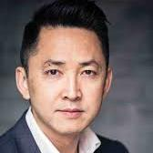
Ingrid Contreras Viet Thanh Nguyen Thi Bui Joseph Azam

On Saturday, June 2, an attentive crowd at BookCon joined moderator Ingrid Rojas Contreras to attend the panel Refugee Writers on Refugee Lives and hear more about the recently published collection, The Displaced: Refugee Writers on Refugee Lives (Abrams). Contreras, author of the forthcoming The Fruit of the Drunken Tree (Doubleday), is among several contributors to the volume, alongside Pulitzer Prize–winning author Viet Thanh Nguyen (The Sympathizer); Thi Bui, author of the acclaimed illustrated novel The Best We Could Do (Abrams); and corporate attorney Joseph Azam.
The International Rescue Committee announced that 10% of the book’s profits will assist them in providing humanitarian and aid relief. They also noted that the United States is on track to accept 22,000 refugees this year, a sharp decrease from previous years.
Nguyen began by asking, “What defines a refugee?” There are approximately 65 million displaced people in the world, yet only 22.5 million are classified as refugees. His family left Vietnam in the 1970s, and he described the difficulty of finding a sponsor for his entire family. In the end, one family sponsored his parents while he and his ten-year-old brother were each sponsored by different families.
He noted that the distinction between refugee and immigrant is not always clear. “Even people who don’t like immigrants like the idea of immigrants. Refugees are unwanted where they come from and where they go.”
In talking about the fear of refugees, Nguyen mentioned a fear of contamination, and the idea that one is coming from a failed state. The word refugee can also be racially coded, he cautioned. After Hurricane Katrina, the Bush administration referred to some survivors as refugees. He added that the word itself reminds us that the world is failing at something; in particular, he noted how Puerto Rico has been treated since Hurricane Maria landed in September 2017.
Bui’s family came to the United States in the second wave from Vietnam (contrasted to Nguyen who arrived in the first wave). She would most likely be considered an example of what the current administration refers to as chain migration since she was sponsored by a relative. In addition to being a writer, she also works with refugees who were formerly incarcerated. Her memoir describes the limited items her family took with them when they left Vietnam: ID cards, a change of clothes for each person, some limes, and a bag of sugar. (The limes and sugar were for making lemonade when they arrived in the U.S.)
Lastly, Azam, who was born in Afghanistan, described his journey to New York as a child via India and Germany. He and his family left Afghanistan in the 1980s, each traveling separately to their adopted country. He discussed the privilege he has experienced as someone who is fair-skinned, and how that has given him “opportunity and anonymity,” both of which he often feels guilty about. Sometimes he feels like a refugee; sometimes he doesn’t.
Empathy must be conjoined with action and social movements, Nguyen added; literature about the plight of refugees cannot change the world alone. In response to a question about whether we can put our trust in a country that doesn’t trust us, Bui commented that it’s more survival than trust. All three panelists talked about having more faith in people and institutions than the current administration.
Nguyen reminded the audience that xenophobia is not new; America has a history of genocide and slavery. But he has faith in the ability of people to fight back, noting the history and eventual repealing of the Chinese Exclusion Act.
Responding to a comment about how books being published on Vietnam only focus on the war, Bui agreed that there is more to Vietnam that the war, but “it’s the event that put us all here,” and the next step in the country’s history should not be built on denial.

https://lj.libraryjournal.com/2018/06/events-category/refugee-writers-refugee-lives-bookcon-2018/

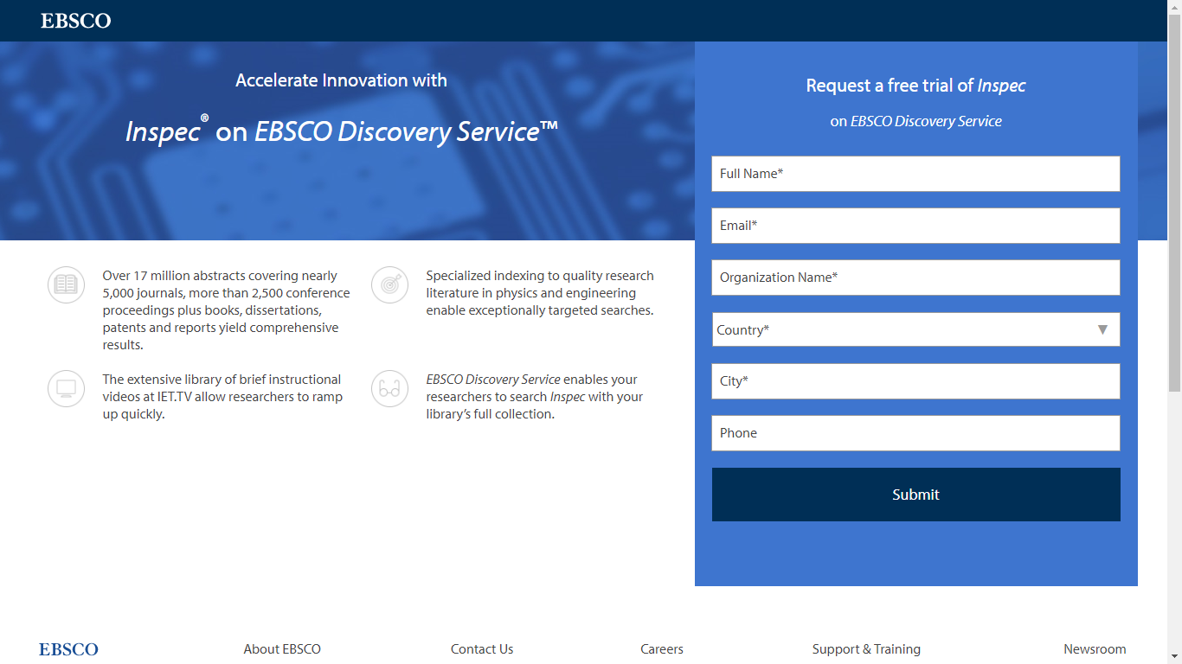
https://www.ebsco.com/promo2/engineers-trust-inspec

- Champion of Confidence | Office Hours
By Michael Stephens
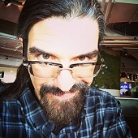I chatted recently with New Zealand librarian Sally Pewhairangi, who shares her unique approach to encouraging library professionals on a new website called The Library Boss. Pewhairangi helps librarians embrace things digital and flourish at work. Her ideas should inspire LIS students, new librarians, and seasoned professionals.
Stephens: Office Hours has often covered the struggles we encounter when responding to evolving information behaviors. Many of our internal struggles are born of confusion about going forward into a landscape that seems new and frightening. What have you observed?
Pewhairangi: Doubt. The things you say to yourself when you know you can get by but feel as if you don’t know what you’re doing. “I wish I didn’t feel so out of my depth when a library member asks me to help them with their Facebook profile.” Or it may be an experience outside your comfort zone: “If I was more confident in my presentation skills I would run classes on how to spot fake news.” It’s a little whisper that shows up when you aren’t sure.
I’ve given myself pep talks on occasion, before a big presentation or in the depths of a research project, because of that little whisper. It also feels like a twist on imposter syndrome: like my colleague or library user will realize I may not know what I am doing! Doubt and its relation to user service is critical. It might be reluctance to use a tablet on the library floor because you doubt your tech skills or constantly referring questions “up the chain” because you’re doubtful of your ability to solve the problem. How do we counteract doubt?
Library training overlooks the importance of confidence. Every workshop or training program I have ever attended emphasized competencies through a step-by-step process, with some time to practice and maybe an opportunity to apply it. The process works well but doesn’t always achieve the desired results. Learning how to flourish in a digital world requires both competence and confidence. Believing that you are capable is vital because if you don’t believe you can, whether you are able to or not doesn’t matter.
When you add technology and digital literacy to the mix, the opportunities for self-doubt increase. Having the confidence to try things and fail is probably more important than the step-by-step competencies you mention.
Right. For example, if I had more confidence I would create a video to accompany this column in which viewers could see and hear my enthusiasm for librarians embracing things digital. It would be awesome! But I am afraid to try. Even though I know how to make a video (and actually have), I have no confidence in my video-making abilities. This sounds irrational. But that doesn’t make it any less real.
There are lots of reasons why you might lack confidence. Most of them boil down to fear: of failure, not being good enough, and what others may think. (Mine is the latter.) But if you can overcome your fear, the benefits are huge:
More free time: When I am confident in my abilities, I don’t worry about every detail and that frees up time to spend on other things.
Clear decision-making: When I lack confidence I question myself on every decision, and as a result it takes forever. But when I believe in myself and my abilities, the decision seems obvious.
Healthy risk-taking: I am less willing to take risks when I am unsure. Confidence turns thoughts into actions.
The role of managers and supervisors, then, should be to encourage confidence and offer support for learning how to make videos or whatever the task may be. Knowing that the higher-ups “have your back” surely instills confidence.
Next time, we’ll continue this conversation, and Pewhairangi will share six qualities that can help boost your digital literacy confidence.
This article was published in Library Journal. Subscribe today and save up to 35% off the regular subscription rate.
About Michael Stephens
Michael Stephens (mstephens7@mac.com) is Associate Professor at the School of Information, San Jose State University, CA

https://lj.libraryjournal.com/2018/06/opinion/michael-stephens/champion-confidence-office-hours/

- PEN America Presents: Can Free Speech Be Saved? | BookExpo 2018
By Stephanie Sendaula on June 4, 2018 1 Comment
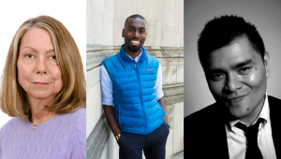
Image via PEN America; L-R: Jill Abramson, DeRay Mckesson, Jose Antonio Vargas
PEN America assembled a trio of author-advocates to talk about the past and present state of free speech in the United States at BookExpo on Thursday, May 31. Moderated by Katy Glenn Bass, Director of Free Expression Policy and Research for PEN America, the panel, Can Free Speech Be Saved? included former New York Times executive editor Jill Abramson, author and activist DeRay Mckesson, and Pulitzer Prize-winning journalist Jose Antonio Vargas.
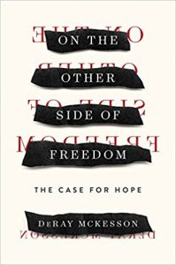Mckesson, author of On the Other Side of Freedom: The Case for Hope (Sept. ’18, Viking) plainly stated, “There’s no way to think about free speech without thinking about the severe imbalance in power,” especially when black and brown bodies are on the line. He referred to Charlottesville, where we saw white people physically push police officers, and reminded the audience that could be a fatal decision for black men. “In some ways, we are drowning in free speech,” maintained Abramson, author of The Merchants of Truth: The Business of Facts and the Future of News (Jan. ’19, S. & S.). She worries quality discourse is being drowned out, and that we’re going to make mistakes in the rush to relegate and reform fake news.
Vargas, author of Dear America: Notes of an Undocumented Citizen(Sept. ’18, Dey St.) passionately shared details about his life as an undocumented immigrant. “I’ve been in the country since I was 12, and I can’t leave.” Books are a method of freedom for him. “Our freedom to express ourselves is a kind of citizenship.”
Upon finding out he was undocumented, the first thing Vargas did was rid himself of his Filipino accent. He explained his decision to attend Tea Party events, where many have never met an undocumented immigrant before. Explaining the frequent misconceptions and lies about immigrants, he cautioned us not to underestimate how lies can easily be misunderstood. The most common question he receives is, “What do you mean you can’t just become legal?” He is still surprised how many people equate “Mexican” with “illegal,” noting that most Mexicans are here legally. Vargas reminded the audience that immigration is often framed in the mainstream media as a political issue.
Abramson agreed, adding that we have a media that thrives on conflict and a society where people on opposing ends of the spectrum don’t want to hear each other; people exist in their self-selected echo chambers that rarely challenge what they already believe. “People are more in love with the idea of resistance than the work of resistance,” said Mckesson. He also mentioned the careful use of language phrasing; for example, using the term police violence rather than police brutality since violence sounds consistent while brutality sounds episodic. Speaking to the relevant coverage on Twitter and breaking news, Mckesson stated, “If we had not told our stories, nobody else would have.”
Vargas asked why white people can just move while brown people can’t. “I’m staggered by how much media there is on immigration, but nothing on why…I bend over backwards to understand why people think my presence is a threat to American democracy.” In response, Mckesson mentioned the historical roots of whiteness white supremacy.
Vargas: People don’t always know what whiteness is.
Mckesson: You don’t have to know what it is to benefit.
Vargas: They don’t know what they’re benefiting.
The discussion became heated when discussing the Times’ reluctance to call Trump’s actions racist. Abramson stated that they did call him racist once, and called the decision brave. Mckesson responded, “Bravery is calling him racist every time, not one time,” generating much applause. Vargas brought up the issue of trust, especially in relating to local news. He showed how most people who get deported don’t go to NPR; they do to Univision or Telemuno. As a result, there are numerous stories that never make the mainstream media. A lot of white people have gotten too comfortable, he maintained, and that we should all share the discomfort. Responding to a question of whether speech is free, Mckesson asked, “Free for who?”
Watch a video of the full panel here.

https://lj.libraryjournal.com/2018/06/events-category/pen-america-presents-can-free-speech-saved-bookexpo-2018/

