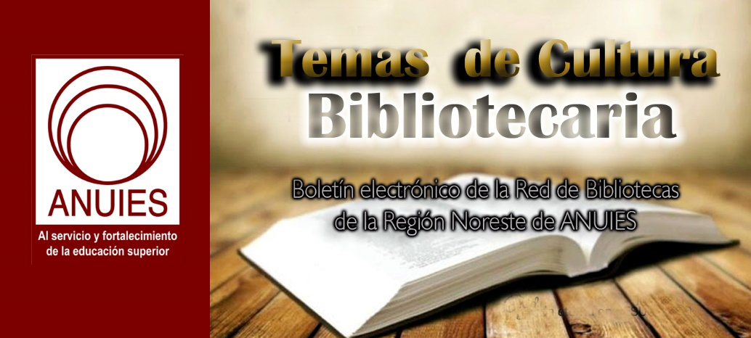
Año 3 Número 77 junio 2018

Contenidos de este número

- Coloquio Internacional sobre Información y Comunidades Indígenas
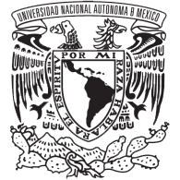
Distinguido Colega,

El Instituto de Investigaciones Bibliotecológicas y de la Información (IIBI), en colaboración con el Programa Universitario de Estudios de la Diversidad Cultural y la Interculturalidad (PUIC), el Laboratorio Nacional de Materiales Orales (LANMO) de la Escuela Nacional de Estudios Superiores, Campus Morelia (ENES, Morelia) y el Programa de Posgrado en Bibliotecología y Estudios de la Información (entidades académicas y de investigación de la Universidad Nacional Autónoma de México (UNAM)), lo invitan al
Coloquio Internacional sobre Información y Comunidades Indígenas:
“La importancia de la información en las culturas originarias”
(Programa UNAM DGAPA PAPIIT - IG400417)
Auditorio “Mario de la Cueva”
26 al 28 de septiembre de 2018
En este diálogo las voces de bibliotecarios, documentalistas, archivistas, analistas de información, responsables de bibliotecas, centros de información y de documentación, investigadores, académicos y estudiantes interesados en los estudios e investigaciones inherentes al binomio información y comunidades indígenas, presentarán ponencias y trabajos que nos permitirán comprender los retos y fenómenos vividos por las comunidades originarias, acercándonos cada vez más a puntos de convergencia con soluciones y propuestas reales.
En la siguiente liga, usted encontrará mayor información: http://132.248.242.8/ciici/
Regístrese hoy mismo y aproveche la promoción de pronto pago.
Atentamente
Dr. Cesar Augusto Ramírez Velázquez
Coordinador del Seminario Información y Comunidades Indígenas
Investigador del IIBI-UNAM

- Five Libraries Take 2018 IMLS Top Honors
By Christina Vercelletto on May 25, 2018 Leave a Comment
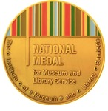Representing every region of the country, five libraries have been honored by the Institute of Museum and Library Services (IMLS) with a 2018 National Medal for Museum and Library Service: Georgetown Public Library, TX; Orange County Library System, FL; Pueblo City–County Library District, CO; Reading Public Library, PA; and Rochester Public Library, MN.
The winning institutions are ones that bring about positive change, both for individual patrons and in the community as a whole. “Through their programs, services, and partnerships, these institutions exemplify the many ways that libraries and museums are positively transforming communities across the nation,” IMLS director Kathryn K. Matthew said in a statement.
Choosing from among the 29 outstanding finalists was, of course, difficult. “For 2018, IMLS was particularly interested in programs that build community cohesion and serve as a catalyst for positive community change, with programs that provide services for groups that include veterans and military families, at-risk children and families, the unemployed and underemployed, and youth confronting barriers to STEM-related employment,” Matthew told Library Journal.
Despite considerable differences in community needs, geography, and size, the five public libraries that came out on top all have one thing in common: they’re changing lives every day.
Georgetown Public Library
Georgetown, TX
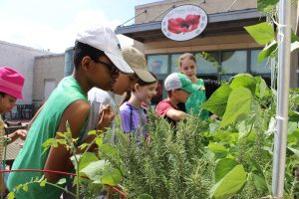
Tween Garden Club meets on the patio outside the library coffee shop, led by librarian Toni Nietfeld, at Georgetown Public Library
“Shouts of joy were heard all over the library” from the Georgetown staff when director Eric Lashley told them they’d won a National Medal, he reported, adding, “I gave every staff member a ‘gold’ medal on a ribbon.”
What set Georgetown apart from the pack, Lashley offered, was the exceptional level of trust the library has in the community—and vice versa. “We do not have any security gates. In my opinion, security gates tell your visitors they can’t be trusted.” In 2017, the meeting rooms at Georgetown—where the total population is 67,000—were used more than 1,600 times, including “after the library closes and before the library opens. Our policies are patron-centric, not staff-centric,” said Lashley.
As they enter the building, patrons see three words prominently displayed, which sum up the mission statement of Georgetown: Engage. Enlighten. Empower. “If the parking lot is full, we’re having a good day at the library,” said Lashley.
Orange County Library System (OCLS)
Orlando, FL
ESOL [English for Speakers of Other Languages] training. Career Online High School. The lauded Melrose Center for Technology, Innovation, and Creativity. Inspired Children’s STEM education. Those are just some of the distinguishing services that landed OCLS on the IMLS short list.
“This award is an acknowledgment of the fact that our libraries provide people with an opportunity to engage in truly meaningful learning experiences that they won’t find anywhere else,” said OCLS director and CEO Mary Anne Hodel. Case in point: Orlando resident Terhys Persad, who learned video editing at the Melrose Center, which enabled her to create Where Art Thou, a travel web series that explores the world through art. The Melrose Center is the only library facility in the country with audio, video, and photography studios and simulation labs, and classes to support related instruction, all in one location.
Another program that sprung from OCLS staff’s determination to address needs specific to their community are the popular sewing classes. Participants are getting jobs with the nearby theme park costume departments and as alteration specialists. To help the influx of new residents into the Orlando area from Puerto Rico after Hurricane Maria, ESOL classes were expanded to 11 branches.
“We think about our community and its needs, then we try to figure out how we can help,” said Hodel. “Maybe we can’t solve an entire problem, but we can do something that is consistent with our mission.”
Pueblo City–County Library District (PCCLD)
Pueblo, CO
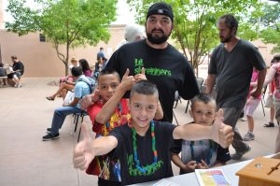
The 2017 Summer Reading Kickoff event at the PCCLD Rawlings branch
A large municipality consisting of ten libraries, PCCLD serves a range of community members with a variety of needs. Meeting them requires an equally diverse slate of services, a lofty goal the library has met and exceeded.
“We have worked strategically over the past several years to align our services with the needs of our community,” Jon Walker, executive director of PCCLD, told Library Journal. That work has paid off in the form of skyrocketing checkouts, use of digital resources, visits to libraries, and attendance at library-sponsored programs and events. Among those is the All Pueblo Reads series, which attracted more than 39,000 participants in 2017; gang intervention programming with licensed social workers in at-risk neighborhoods; Accessible Avenues services for customers with special needs; and community gardens and a seed lending library. Many others were equally successful.
Yet “nothing we do is more important than our support for early childhood literacy,” insisted Walker. That support is demonstrated in PCCLD’s Supporting Parents with Early Literacy through Libraries, reaching socioeconomically challenged families with early literacy support; a partnership with local schools to automatically issue library cards to students; and an award-winning summer reading program. “I was among hundreds joyfully marching in our season-ending kids’ parade, celebrating a successful summer of reading,” recalled Walker. What could top that? Winning the IMLS National Medal comes pretty darn close, he said. “It truly is a once-in-a-lifetime occurrence.”
Reading Public Library
Reading, PA
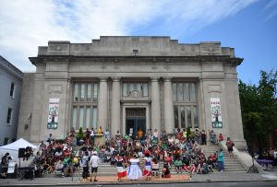
Storytelling Through Dance 2017 at Reading Public Library
Photo credit: Reading Eagle
Reading, a city of 90,000 people in southeastern Pennsylvania, is one of the poorest in the United States. “So we offer programs and services to help residents bridge the literacy divide in five areas…basic literacy, civic and social literacy, information literacy, health literacy, and financial literacy,” Bronwen Gamble, Reading Public Library executive director, explained to Library Journal.
Reading Public takes its programs, such as “Returning Citizens” for those coming out of incarceration, outside its walls, including to homeless shelters. “By taking library services out into the community, we learn what our residents need, what they dream about, and the stumbling blocks they face,” said Gamble.
As with many places in America, the opioid crisis has hit close to home in Reading. “After five overdoses and one death inside the main library, rather than wringing our hands, we organized an Opioid Crisis Panel which brought medical personnel, victims’ families, and concerned officials together,” said Gamble.
Providing digital access is a major focus. “All four branches provide Wi-Fi 24/7. We see patrons sitting outside with their mobile devices long after the buildings are closed. We provide an eCard, allowing access to all our digital media and equipment, to anyone who lives, works, or goes to school in Reading.”
Gamble was not expecting the call with the news of the library’s win. “I honestly thought she was letting me down gently,” recalled Gamble. “I was speechless for a few seconds.” The staff was treated to a celebration breakfast, which they thought was for another reason, until the board president announced the real cause for celebration. “What a great moment!” said Gamble.
Rochester Public Library
Rochester, MN
Removing barriers by serving as a welcoming space is the mission of Rochester Public Library. “We strive to listen and respond, so that every member of our community has the opportunity to succeed,” said library director Audrey Betcher.
Community member James Arnold has experienced firsthand the life-changing influence that Rochester Public Library can have. Arnold first discovered his talent for writing at the library. “I started out as an incredibly awful poet, but luckily the writing group we started at the library was there to help me grow,” Arnold told LJ. “We shared our writing, critiqued each other, and laughed a lot.” Arnold wound up winning a library writing contest. “This gave me quite a bit of an ego boost, but also helped me to realize that maybe it was something I should pursue.” And when Arnold, who is headed to the University of Minnesota Twin Cities in the fall, first identified as transgender, the library was a safe place to explore his identity. “The library, and, more specifically, the librarians, are the entire reason I’m going to college,” Arnold shared. “I never planned on going.” The librarians at Rochester, though, always wanted what was best for him, and encouraged him to apply. “Eventually I did, and I had an incredible support system throughout the whole process.”
The museums spotlighted by IMLS with a 2018 National Medal are the Children’s Museum of Denver at Marsico Campus; the Detroit Historical Society; the El Paso Museum of Art, TX; the History Museum at the Castle in Appleton, WI; and the University of Oregon’s Museum of Natural and Cultural History.
The ten awards were presented at the U.S. Institute of Peace in Washington, DC, on May 24. StoryCorps, a nonprofit dedicated to recording the stories of Americans, will visit each winning institution to gather stories from community members whose lives have been bettered by that library or museum. The resulting collections will be preserved at the American Folklife Center at the Library of Congress.
The deadline for nominations for the 2019 National Medal is October 1, 2018.

https://lj.libraryjournal.com/2018/05/industry-news/five-libraries-take-2018-imls-top-honors/

- Project STAND Highlights Student Activism Archives
By Lisa Peet on May 24, 2018 Leave a Comment
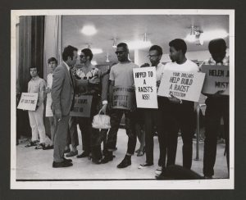
Cox Hall Protest, 1969
Courtesy of Emory University
Fifty years after the campus uprisings of 1968, college students are again raising their voices in activism—although as Project STAND, the online student dissent archive portal, demonstrates, those voices never went away. Project STAND (Student Activism Now Documented), launched in June 2017 by a coalition of Ohio academic archivists, offers researchers centralized access to historical and archival documentation of student protests spanning more than 175 years. Its collections highlight digital and analog primary sources documenting the actions of student groups who have gathered, marched, protested, sat, occupied, leafleted, and stood up for the concerns of marginalized communities across the country and in Canada—as well as the faculty, staff, and administrators who support them.
Lae’l Hughes-Watkins, university archivist and assistant professor at Kent State University (KSU), OH, oversees the University Archives program and manages the Kent State Shootings May 4 Collection and Oral History project, which documents the shootings of 13 student activists on the campus in 1970 by members of the Ohio National Guard. When Hughes-Watkins began working with the KSU archives in 2013, one of the queries she received most often was: Where were the black students in the existing documentation?
“I was asked that question so many times,” she recalled, realizing that “in the photographs that I had seen as a grad student, and then again as a university archivist, there was an absence as far as students of color in most of the images gathered and published at that time. So I decided to dig deeper, and realized that there was this movement taking place in parallel to the anti-war movement—which was primarily a white movement at Kent State.”
KSU’s Black United Students movement, founded in 1968, had counterparts on campuses nationwide as the Black Campus Movement, which helped spur the shift toward more equity for students of color, culturally sensitive programming, and Black Studies departments and programs. In the archives, Hughes-Watkins discovered documentation from Black United Students leadership advising students of color not to attend the May 4 rally because they felt black students would be targeted, in light of events such as the 1968 Orangeburg massacre at South Carolina State University (SCSU), where three African American protesters demonstrating against segregation were killed and 27 others injured. The message from Black United Students leaders, said Hughes-Watkins, was essentially: “[The anti-war movement] isn’t our fight. Our fight is the other issues of injustice that are taking place on our campus.”
But where were the records of those fights, she wondered, and how could she help other researchers find them? Student activism across the country was growing in the aftermath of the 2012 shooting of teenager Trayvon Martin in Florida and the mobilization of the Black Lives Matter movement. Mainstream media outlets like the Atlantic and the New Yorker were taking notice. The 2016 presidential election further galvanized students around political issues.
“With…my interest growing about student activism in academia, specifically traditionally marginalized student populations, I wanted to know what those narratives looked like across regions, geographically—what were those stories at other institutions?” What was missing, she realized, was a centralized location where those narratives could be easily found.
BUILDING BRIDGES
In fall 2016 Hughes-Watkins reached out to Tamar Chute, university archivist and head of archives at Ohio State University (OSU), with an idea. She was considering creating a centralized hub for academic archives that focused on activist student voices at the margins.
Aggregating these resources could be a valuable resource for researchers, scholars, and historians, drive more traffic to underutilized digital and analog collections, and help point up where gaps in the record lay, Hughes-Watkins explained—and she wondered whether Chute thought it was viable.
Chute thought it was a great idea, adding that such an archival “clearing house” could help build bridges to student organizations, specifically those for underrepresented groups, that might have records of their own, and to help position archivists as allies.
OSU has a large number of student organizations, Chute noted, many of which fall through the cracks when it comes to collecting for the school’s archives. “Particularly for students that are on the activism side, they may not look at the university as a place to deposit their material—we’re sort of the Big Brother,” she told LJ. “Looking at some of our collections from the 1960s and 1970s, we’re missing pieces. And I thought this could be a great opportunity to bring those [organizations] in Ohio together as a resource, but…also then give us an opportunity to share that with other people and [show] we really are serious about collecting these voices.”
The two decided to initially contact schools in Ohio, and the reception was enthusiastic from the beginning. The first conference call meeting in December 2016 drew archivists from the University of Cincinnati, Oberlin College, Case Western Reserve University (CWRU), and Bowling Green State University (BGSU), and participants discussed everything from their own best practices to guidelines for the new portal to outreach.
Together, they circulated an Excel spreadsheet listing collections to be included from their institutions, agreed on a template for the site—inspired loosely by the University of Chicago’s Black Metropolis Research Consortium (BMRC), according to Hughes-Watkins—and decided early on that institutions wishing to be included would first fill out an on-site assessment survey on their holdings: collection size and its state of digitization, as well as any copyright or privacy concerns. Standards for social media archives, which come with their own set of privacy concerns, would be based on those used by Documenting the Now, which collects Twitter feeds around social justice issues.
The project officially kicked off on June 16, 2017, with a face-to-face meeting at OSU. An advisory board of archivists was established that fall, which currently includes Hughes-Watkins, Chute, Anna Trammell (University of Illinois), Jarrett Drake (Harvard), Andrea Jackson (BMRC), Helen Conger (CWRU) Elizabeth Smith-Pryor (KSU), Ken Grossi (Oberlin), and Michelle Sweetser (BGSU). Eira Tansey, digital archivist/records manager at the University of Cincinnati, built the bones of the site, which is financially supported by CWRU.
STAND BRANCHES OUT
As word about Project STAND spread, the list of potential partners grew. Since the site’s launch nearly 200 surveys have been completed, and the more than 40 participating institutions have spread far beyond Ohio, including Arizona State University (ASU); Atlanta University Center’s (AUC) Woodruff Library; Chicago State University; Jackson State University, MS; ; Miami University, OH; Michigan State University; Purdue University, IN; the University of Iowa; South Carolina State University; Wright State University, OH; the University of Akron; the University of California San Diego (UCSD); and the University of Rhode Island. Collection materials include primary manuscripts, publications, photographs, and born digital content.
The WordPress site serves as a portal, linking out to various collections, although the team would like someday to include infrastructure such as an internal database. Much of the material is centered around African American movements, followed by global movements, women’s rights, Latinx rights, environmental activism, LGBTQ rights, religious minorities, disabled rights, and Native American rights.
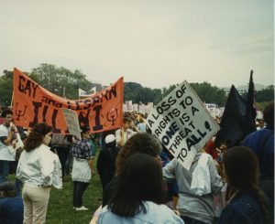
National March on Washington for Lesbian and Gay Rights, 1987
Courtesy of University of Illinois
The 1970s are the best represented decade, with the 1960s close behind. More contemporary collections, from 2000 to the present, are growing rapidly, noted Hughes-Watkins. The oldest material, documenting the anti-slavery movement at Oberlin, dates to the 1840s. Among the many collections featured are the Chicano Research Center at ASU, Stanford University’s Stories from the Archives, and the Orangeburg collection at SCSU, as well as KSU’s efforts to archive its black student movement of the 1960s and 1970s.
Partners continue to reach out to other institutions, encouraging them to connect with current students and organizations as well as alumni who may be holding onto artifacts. Chute recalled her own days as the president of a student group, having inherited a box of memorabilia from the previous president: “I threw it under my bed, and gave it to the next woman who was president and I’m sure she threw it under her bed. It didn’t occur to us at the time that maybe the archives might be a place for this. Part of the challenge is connecting with those students, making them understand that we really do value what they have.”
“I feel like this project has hit the pulse of what people, and archivists, are wanting to do right now,” Hughes-Watkins told LJ. “I think that’s why it’s been able to grow so quickly because this was on the minds of so many—wanting to have a place to create a network of other colleagues in the profession who are thinking along the same lines, documenting the voices that have been on the margins, and looking for ways to do this work well.”
THE CONVERSATION CONTINUES
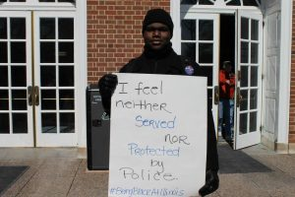
#BeingBlackatIllinois Protest 2014
Courtesy of University of Illinois
Project STAND has applied for funding from the Institute of Museum and Library Service (IMLS) to conduct four symposia in 2019 that will help further publicize the project; AUC Woodruff, the University of Rhode Island, the University of Chicago, and Arizona State have offered to host, and Bergis Jules, one of the founding partners of Documenting the Now, will participate as well.
Among the many topics the STAND team hopes to see covered at the forums, the challenges of documenting student activism in the age of social media and the ethical issues involved are on everyone’s mind.
Privacy is an ongoing concern, particularly for students of color. Archiving protest work means that the actions of those documented—from student leaders to participants—may follow them throughout their college career and after graduation. At the same time that archivists are trying to build bonds and community with student activists, noted Hughes-Watkins, “We don’t want…that content to be weaponized against them when they’re looking for a job, or to get their lives started after they graduate. So we have to be very careful how we build this project. We have to keep those ideas and those concerns at the forefront of our work.”
One solution, noted Chute, is to offer an embargo on sensitive content. “We don’t close material,” she told LJ. “We’ll restrict it for a certain amount of time but we won’t restrict it forever, because otherwise what’s the point of having it in an archive? But if [institutions] feel more comfortable giving it to us and restricting it for ten years, I would rather do that than not have it at all.”
But concerns and challenges aside, Project STAND’s partners are excited to be part of a greater conversation.
“We are in the midst of such a polarizing moment in history—politically and socially—whether it’s stories of police brutality, violence against members of the transgender community, discrimination against immigrant populations, state violence on campuses,” said Hughes-Watkins. “I feel Project STAND allows for setting a different tone and placing value on the very communities, the oppressed student populations, that have a long history of being silenced and are being impacted by the acts previously mentioned. STAND will help elevate their voices by bringing together archivists, technologists, historians, activists, and others willing to create a network of shared interest [in] doing social justice through archives.”
About Lisa Peet
Lisa Peet is Associate Editor, News for Library Journal.

https://lj.libraryjournal.com/2018/05/academic-libraries/project-stand-highlights-student-activism-archives/

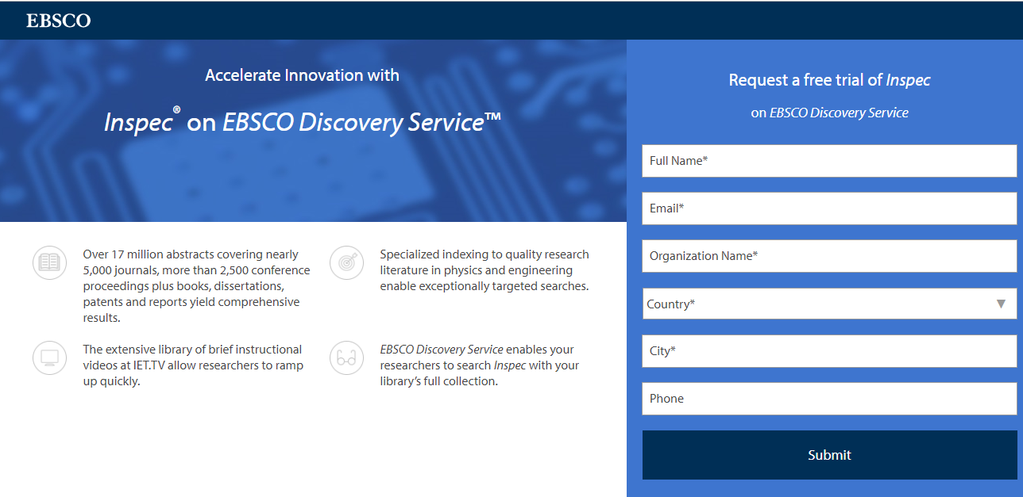
https://www.ebsco.com/promo2/engineers-trust-inspec

- EIFL (Electronic Information for Libraries) Publishes 2017 Annual Report
Filed by Gary Price on May 25, 2018
From the Report:
In 2017 EIFL reached more than 8.5 million people through our network of libraries in 53 developing and transitional countries. Read our annual report to learn how we made a difference in 2017.
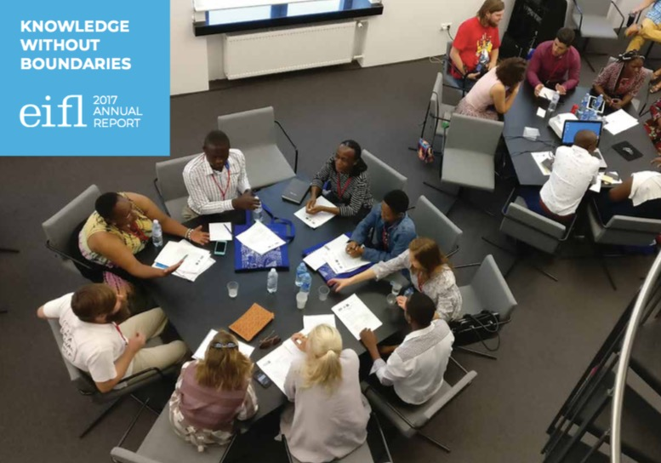
Direct to Full Text Report (Online)
Direct to Full Text Report (PDF)
24 pages; PDF.
About Gary Price
Gary Price (gprice@mediasourceinc.com) is a librarian, writer, consultant, and frequent conference speaker based in the Washington D.C. metro area. Before launching INFOdocket, Price and Shirl Kennedy were the founders and senior editors at ResourceShelf and DocuTicker for 10 years. From 2006-2009 he was Director of Online Information Services at Ask.com, and is currently a contributing editor at Search Engine Land.

https://www.infodocket.com/2018/05/25/eifl-electronic-information-for-libraries-publishes-2017-annual-report/

- Journal Article: “Getting Scientists Ready for Open Access: The Approaches of Forschungszentrum Jülich”
Filed by Gary Price on May 27, 2018
The following article was recently published in Publications (an MDPI journal).
Title
Getting Scientists Ready for Open Access: The Approaches of Forschungszentrum Jülich
Authors
Thomas Arndt
Forschungszentrum Jülich GmbH
Jülich, Germany
Claudia Frick
Forschungszentrum Jülich GmbH
Jülich, Germany
Source
Publications 2018, 6(2), 24
DOI: 10.3390/publications6020024
Abstract
Many scientific institutions are faced with the question of how they should inform their scientists and scientific coordinators about the option of publishing open access. This task is one that libraries have taken upon themselves: libraries are familiar with the market participants and have years of experience in teaching information and publication literacy. This case report looks at two approaches taken by the Central Library of Forschungszentrum Jülich in 2017. It highlights the motivation, strategy, resources and implementation, as well as the first evaluation of both approaches. The first approach was a redesign of the training courses offered by the Central Library with a focus on the target groups and new contents. The second approach was implemented as part of International Open Access Week and involved offering an information event tailored to each scientific institute. The event was customized to meet the needs of the target group defined by each institute, the institute itself, and was organized individually. As a result of these efforts, the open access rate increased over the last few months and at 48% open access in 2017, Forschungszentrum Jülich is well on its way to achieving the open access goals set by the Helmholtz Association.
Direct to Full Text Article ||| PDF Version (15 pages)
About Gary Price
Gary Price (gprice@mediasourceinc.com) is a librarian, writer, consultant, and frequent conference speaker based in the Washington D.C. metro area. Before launching INFOdocket, Price and Shirl Kennedy were the founders and senior editors at ResourceShelf and DocuTicker for 10 years. From 2006-2009 he was Director of Online Information Services at Ask.com, and is currently a contributing editor at Search Engine Land.

https://www.infodocket.com/2018/05/27/journal-article-getting-scientists-ready-for-open-access-the-approaches-of-forschungszentrum-julich/

- New York Public Library and HBO Partner on National #ReadingIsLit Campaign
Filed by Gary Price on May 29, 2018
From NYPL and HBO:
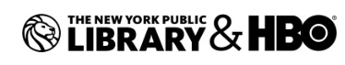The New York Public Library is joining forces with HBO on #ReadingIsLit, a national campaign to celebrate the written word, the power of storytelling and encourage people to read, talk about, and enjoy all things literary.
The campaign will feature writers, performers, and creators from popular HBO programs sharing what they’re reading, what stories inspire them, and what books they recommend. Through videos, interviews, social media interactions and more, they’ll also encourage members of the public to visit their local libraries and sign up for library cards.
Participants in the online component — which will take place across HBO and New York Public Library social media channels — include Reese Witherspoon, Laura Dern, and Shailene Woodley from “Big Little Lies;” Thandie Newton from “Westworld;” Mark Duplass, creator of “Room 104;” and Damon Lindelof, co-creator of “The Leftovers.”
The New York Public Library will also share a host of information at, including book recommendations from its team of expert librarians, information about applying for library cards, videos, and more.
Offline, the Library will offer special book displays at its 88 neighborhood branches in the Bronx, Manhattan, and Staten Island, featuring titles that have been adapted into HBO television shows and movies — such as the Song of Ice and Fire series (which became “Game of Thrones”), “Sharp Objects,” and “Fahrenheit 451” — as well as “read-alikes” chosen by librarians that should appeal to fans of HBO shows.
As part of the campaign, HBO will also donate a “bookshelf” of featured titles to 25 select libraries across the country.
“Being storytellers, everything we do at HBO begins with the written word. We have brought to life many phenomenal books over the years on the network, including current projects Fahrenheit 451, Big Little Lies, Sharp Objects and our biggest series ever Game of Thrones so the timing of this partnership with the New York Public Library couldn’t be better,” said Richard Plepler, Chairman & CEO, HBO. “NYPL is a wonderful institution and to play a role in getting more readers in those doors is a great win.”
“Great stories — no matter how they’re told — hold an almost magical power, captivating audiences and sparking incredible passion and creativity,” said New York Public Library president Anthony W. Marx. “This partnership with HBO is an amazing opportunity to encourage people who love and appreciate wonderful stories in all forms to drop by a library and find their next adventure on one of our shelves.”
#ReadingIsLit is the latest partnership in a longstanding relationship between The New York Public Library and HBO, including HBO’s long-time sponsorship of the Library’s Summer Reading program to keep kids and teens engaged with books and learning while away from school on break.
Direct to NYPL #ReadIsLit Web Page
Direct to HBO #ReadIsLit Web Page

https://www.infodocket.com/2018/05/29/new-york-public-library-and-hbo-partner-on-national-readingislit-campaign/

