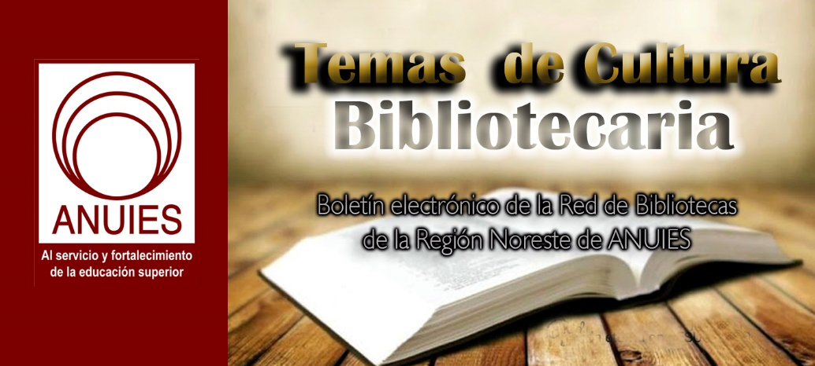
Año 3 Número 70 abril 2018

Contenidos de este número

- PITS - Disruptive Library Patron Incident Tracking System
PITS is an online Patron Incident Tracking System which allows staff to create online incident reports to assist in the management of disruptive patrons in a secure web-based application. PITS accommodates reporting of incidents, perpetrators, victims, and witnesses, using a customized set of priorities, incidents and individual physical descriptions. Lists of infractions are based on your local rules of conduct, as are follow-up actions. Automatic routing of incident notifications keeps key contacts in the loop. PITS can also store documents associated with an incident, such as letters of warning or suspension.
PITS allows libraries to collaborate with local agencies on the tracking of problem patrons to ensure greater security and safety for their staff and other patrons. A simple dashboard allows for an at-a-glance view of current reports, perpetrators, and suspensions.
Pleasecontact usfor information on pricing and customization options

http://www.quipugroup.com/PITS-patron-incident-tracking-system.php

- Susan Hildreth: Bridging LIS and Practice | Learning in Practice
By Lisa Peet on March 5, 2018 Leave a Comment
Hildreth brings extensive field experience
to the University of Washington’s iSchool
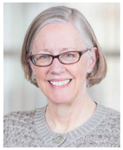
As the inaugural Distinguished Practitioner in Residence
(Professor of Practice) at the University of Washington Information School (UW iSchool), Susan Hildreth contributes a wealth of experience to her role connecting academia with the public library field. Hildreth stepped into the two-year position, funded by the
Bill & Melinda Gates Foundation, in August 2016 and has been teaching, helping develop the curriculum, and conducting
research on the future of libraries ever since. Hildreth, a former city librarian in Seattle and San Francisco and state librarian of California, served from 2011 to 2015 as director of the Institute
of Museum and Library Services (IMLS), and went on to head
the Peninsula Library System, Pacific Library Partnership,
and Califa Library Group in San Mateo, CA. She currently serves as American Library Association (ALA) treasurer and an Aspen Institute Fellow.
You’ve worked in so many sectors of the library world. How has your experience
informed your teaching practice?
It gives me a lot of opportunity to share experiences with the students that they wouldn’t necessarily hear about. Also, I spend a lot of time…in informal advising.
I [serve] on our MLIS program committee [composed of] a number of our faculty members who teach in the MLIS program, and we get together on a regular basis to review curriculum, policies, all kinds of things. We’re always trying to find the balance between theory and practice, an ongoing challenge. Theory, critical thinking, analytical research skills…are some of the most important skills that our students can develop, particularly [because] their roles in the library world change so quickly.
But it’s also important to be able to demonstrate how critical thinking skills can be applied in the workplace. I’ve been teaching a core course here, Management of Library and Information Centers. I try to help them understand some management theories and some approaches to administration and how that plays out in the workplace.
What are the barriers you see students encountering?
One of the barriers to many programs, not just [UW], is the cost. Are [applicants] in a position to be able to pay for their tuition? Do they have to go into debt? Are they going to get a job that allows them to pay those funds back? We don’t have a lot of scholarship funds here at UW, and other programs may have less.
The cost of graduate education is a big barrier to ensuring a diverse library workforce. The cost, and in some cases the time investment, is challenging. If we don’t have a lot of scholarship funds to be able to bring students into the program who don’t have a lot of resources, that’s going to impact the nature of the workforce.
What are you finding to be the biggest disconnects between how LIS programs
are taught and the realities in the field?
Part of the [research] project I’m doing is trying to work on aligning a curriculum that we’re providing with the identified needs of employers. [In] a preliminary literature review, I found that [Boston’s] Simmons School of Library and Information Science has been working in somewhat of a similar vein. The interesting thing is that the top core skill and knowledge area that was identified in both was interpersonal communication. To me, that really says emotional intelligence. What these employers and librarians who have been in the field for a while say is, we want people coming out of these programs who can deal with any situation and deal with it effectively.
Information about a certain specialization is not as critical as the ability to work with people, work in teams, identify best ways to communicate. And emotional intelligence is not always an easy thing to teach. It’s more about identifying it and talking about approaches.
There are other areas that were of importance as well. Writing was one. Teamwork, customer service skills, and also cultural competence. We are not as focused on driving people into specializations as giving them skills that could be used across the spectrum of library types.
How can LIS education best tap and integrate the expertise of midcareer library workers without a degree? Should competency-based degrees be an option?
That’s a tough question, because there are so many continuing education opportunities available. And there’s not a clear mechanism [for] evaluating all these opportunities and figuring out what’s the best match if you’re looking for a specific skill or transitioning. It could be that LIS programs could create some kind of suite of short courses, kind of like a boot camp, to bring folks up to speed in some of these areas of specialization. One challenge is that although many LIS programs have good working relationships with the field, not all programs are organized to provide continuing education.
We do have paralibrarians who enroll to get an MLS. Most of those folks are coming to us online and working a full-time job. That’s a huge commitment. In some cases, parapro-fessionals, depending on their work history and other kinds of education, can petition out of some elective courses.
Many of our state libraries have developed their own programs for competency-based certification, particularly for rural or small library staff, directors, leadership, or even rank-and-file librarians, because they’re not getting the kind of application pool they want, or because they have great folks who may have BAs or other kinds of experience and they are valuable in their community and doing a great job.
How do you feel about the role, now that you’re in your final semester?
I think I’m learning a lot. I think the school is learning a lot. It’s been a huge opportunity. I’ve also kind of been the guinea pig. I think we’ve made some great progress.
One thing I would like to mention is [the iSchool] Technology and Social Change group, otherwise known as TASCHA. [It has] done a lot of research in terms of U.S. and global librarianship over the years. The Distinguished Professor of Practice being hosted in the same organization that also hosts TASCHA is a great opportunity. We have an existing informal relationship, and I think for future Distinguished Practitioners, the integration of their research work with TASCHA’s research…could have more alignment…because TASCHA’s work…will have a lasting legacy for libraries globally. I would like the Distinguished Practitioner’s work to possibly be a part of that suite of resources. At [the Public Library Association 2018 conference in Philadelphia] and at ALA annual [in New Orleans], we’re presenting a program specifically on the work I’m doing in terms of curriculum alignment. We’re going toget the word out that way, and I’m really excited about that.
We’re very fortunate to have the kind of extra support and visibility that the Gates Foundation brought to the program. But I think these efforts are happening everywhere. We have to continue to support a relationship with the field and academy to effectively align curriculum and employer needs. We want to try to think about some out-of-the-box partnerships where the knowledge and research of the academy could be leveraged by the field.
This article was published in Library Journal. Subscribe today and save up to 35% off the regular subscription rate.

https://lj.libraryjournal.com/2018/03/library-education/susan-hildreth-bridging-lis-practice-learning-practice/

- Canada: Federal Government Commits $73 Million For New Ottawa Super Library (Public Library and National Library)
Filed by Gary Price on February 28, 2018
From The Ottawa Citizen:
The federal Liberals will to help fund a $168-million [$130.9-million/USD] super library, giving the City of Ottawa the confirmation it needs to start planning a facility on LeBreton Flats in collaboration with Library and Archives Canada.
The federal budget released Tuesday earmarks $73.3 million [$57.1-million] mover six years for the joint facility, which includes funding for operations.
[Clip]
The preliminary building plan calls for 215,458 square feet in a four-storey building, divided 61 per cent and 39 per cent between OPL and Library and Archives Canada, respectively. Shared amenities would include the entrance plaza, meeting rooms, outdoor programming space, an exhibition gallery and a genealogy centre.
“This new building will be an iconic community hub, a single door to the national library and archives, and a world-class public library in Canada’s capital city which will increase citizen participation in the community and improve access to Canada’s history, culture and collective knowledge,” the federal budget says.
The feds expect the building to open in 2023.
Read the Complete Article
See Also: In Partnership with National Library/Archives, New $168 Million “Super Library” Recommended for City Land (December 15, 2016)
See Also: City of Ottawa and Library and Archives Canada In Talks to Team Up For a New Central Library (January 13, 2016)

https://www.infodocket.com/2018/02/28/canada-federal-government-commits-73-million-for-new-ottawa-super-library-public-library-and-national-library/

- California State Library’s Rare Book Collection Damaged by Water Leak
From the California State Library (via Facebook)
A ceiling leak at the California State Library Building in Sacramento resulted in water damage to an estimated 250 volumes from the General Rare Book Collection, several of which were from the 1800s.
The leak was discovered this morning [Tuesday, February 27, 2018] and staff immediately began the process of securing the collection and mitigating damage.
The library has transported the damaged books to California State Parks’ Statewide Museum Collections Center to be to be freeze-dried. This is generally an essential step in the process of salvaging the books.
There is no current estimate for the total loss that resulted from this incident.
See Also: Four Photos Can Be Seen in the California State Library’s Facebook Photo Timeline

https://www.infodocket.com/2018/02/27/california-state-librarys-rare-book-collection-damaged-by-water-leak/

- Teaching to the Team | Learning in Practice
By Henrietta Verma on March 7, 2018 Leave a Comment
Library leaders share how LIS programs can prepare librarians
they’re eager to hire
By the time most library leaders reach their top management positions, they’ve been out of library school for a while and can take a long view on how their time there shaped their first job, their work supervising new librarians, and their experience at the helm. Others come from the business world and have a unique perspective on library education, often having taken a degree when already high up in a library organization to qualify for a director’s role. Either way, they can have strong views about what library schools should be doing to prepare the kind of employees they’re looking for, what graduates should know to transition successfully to library work, and how schools and libraries can collaborate to produce prosperous graduates. LJ spoke with leaders nationwide to get their opinions about today’s library education and wish list for the future.
SOFT SKILLS ARE KEY
When asked what skills they need in library school graduates, library leaders were apt to focus as much or more on soft skills and mind-set than specific duties. As Alysse Jordan, a former academic librarian and currently director of library and research services for the Council on Foreign Relations (CFR), New York, tells LJ, “Which specific skills are needed to be a successful librarian are constantly shifting because technology is constantly changing, so adaptability is more important than the ability to do a particular task.” She notes that aptitude to pivot quickly is more important than it was in the past. “Today’s graduates [must] thrive in a complex environment that can be unpredictable,” says Jordan.
Chicago Public Library (CPL) commissioner Brian Bannon (a 2009 LJ Mover & Shaker) also mentions adaptability as an important skill for graduates; he emphasizes curiosity as well and discusses the desirability of design thinking, using creativity and empathy to meet a customer’s needs. “Design thinking is the common vocabulary used by our most innovative and effective partners,” says Bannon. “In order for the library to creatively respond to emerging demands, our librarians must be comfortable with design skills like building empathy, creative problem-solving within constraints, [and] prototyping and iterating on an initial design before launching any new program or service.”
John Szabo, city librarian of the Los Angeles Public Library (LAPL), echoes the need to have the right mind-set. Szabo comments, “It’s very important for graduates to have a sense of the big picture—that they’re able to understand and grasp broadly what public library service is about and what it does for a community.”
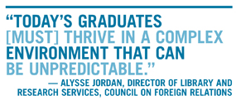Christopher Platt, chief branch library officer at the New York Public Library (NYPL), emphasizes a concentration on communicating outcomes. “We’re working on…empowering our staff to characterize their work in ways that reflect the intended impact,” notes Platt. “It’s nice to hear from an individual that they had 20 kids at a bilingual story hour. It’s nicer to hear them characterize it as 20 kids and their parents/caregivers had an experience that helped build confidence in communicating in a new language, added words to their vocabulary, and contributed to their understanding of diversity.” Communication skills are also top of the list for Paula Miller, director, Baltimore County Public Library (BCPL). “A lot of soft skills are important,” says Miller. “Conflict management, customer service, advocacy—all of them are related to communication, whether it’s among our staff, with our customers, or with our partners in the community.” Miller echoes Platt in discussing the ability to communicate data that is backed by a narrative. “Our libraries have changed; what we need to measure has changed. We need to rework the tools that we traditionally used to capture and use data, but we also encourage our staff to not only use the numbers that are available to them but also to tell the related stories so that we’re capturing the whole impact of what we do.”
THE CUSTOMER IS ALWAYS FIRST
Several library leaders mentioned customer service as an important soft skill that is too often overlooked. As Chicago’s Bannon comments, “Today’s public library careers are about community-embedded public services. [We] need to attract professionals with a service orientation, an understanding of community needs, and an entrepreneurial spirit that will allow them to creatively shape the libraries of the future.” Marcellus Turner, executive director and chief librarian, Seattle Public Library (SPL), says that his city is lucky in this regard. “As we’re in Seattle, we’re able to hire a lot of people who have experience in Starbucks and Nordstrom, so they’ve been taught customer service.”
Jim O’Donnell, university librarian at Arizona State University, Tempe, is also adamant that customer service training is vital in library education. “The first course taught in library school should be a customer service course.” While other library tasks must be accomplished with technical proficiency, says O’Donnell, those should be taught second. “First of all,” he says, “make the students people who focus on the interests, concerns, practices, and frustrations of users and help them think about how everything they do needs to have a strong link to assuring and improving customer satisfaction.”
TECHNICAL SKILLS STILL COUNT
While soft skills are essential, the library leaders interviewed say that, of course, it doesn’t end there. In the meantime, changes in libraries are already resulting in changes in library school. Ray Baker, director of the Miami-Dade Public Library System, FL, notes that, in his view, library schools have already undergone welcome transformations. “In general, it seems that most are maintaining a strong curriculum focused on the core principles of librarianship but are also providing substantial coursework in nontraditional subject areas such as coding, web design, digital libraries, and information management systems.” These are skills that he pinpoints as an increasing part of the daily life of librarians.
Turner also looks for graduates with a knowledge of project management because the library is having more librarians lead projects. His wish list also includes graduates with governmental or budgetary coursework, because, he says, many of SPL’s new hires move quickly into supervisory positions; it also includes facilitation training, as the library’s staff members increasingly must engage in and moderate community conversations. “Some degree of coursework or experience around management and leadership” is desirable to Szabo, too, who wants graduates to expect an eventual move into some kind of leadership role. “Someone who’s graduating and coming to work in a public library will inevitably, at some point in their career, be asked to supervise people, be in charge of a project, manage a library location or a group of libraries,” he says, also noting that a leadership attitude can be put to work even before that happens. “People can lead from any position, and those leadership skills will serve [even] an entry-level librarian very well.”
The ability to gather, manipulate, and present data effectively—in other words, proficiency in informatics—was brought up by several library leaders. As Szabo says, “Public libraries are increasingly focused on the ability to analyze and use data to inform planning and better target audiences that need and use our services. Graduates who understand data and how to use it, and have experience doing that, are very needed and will be assets to the libraries they join.” He also notes that librarians who can develop strong partnerships with school districts, sharing and analyzing data that relates to that partnership, will help their organization be more effective.
Baker tells LJ, “An area that could [do with] more attention are skills in data analysis and how to use that data to show what is happening in a branch location or to demonstrate the effectiveness of a program. Data analysis is important because numbers don’t always tell the whole story. What is learned from these analyses helps shape future programs and services.” Baker also mentioned skills working with vendor data as a plus. “The ability to aggregate data has become more in demand as more library content and corresponding usage data often live in the databases of third-party vendors,” he says. “It benefits us as a library system to not only be able to understand this data but to aggregate it on our own.”
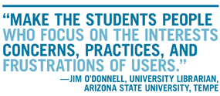Not everyone, however, is a data enthusiast. SPL’s Turner feels that the emphasis on working with data sometimes goes overboard and that a moderate background in data management is usually sufficient. “Everyone who joins us should have one or two classes in data management and how to use open data,” he explains. “The difficulty is that, even in a system our size, we might have only one or two opportunities to employ someone working at that full time, whereas I still need the traditional skills of working at a desk, knowing how to work with children’s literature, all those things.”
Turner laments that an emphasis on informatics is one of the factors working against diversity in his library system. “In Seattle…we get [people of diverse backgrounds] moving here and that shows up in the library school. The challenge is that the library may not go on to be the beneficiary of that diversity, because a lot of the students move into informatics instead of libraries.” Of course, it’s possible that reducing that emphasis would lead not to more diverse applicants for library positions but to those students enrolling in a different graduate program; since Seattle is a major tech industry hub, some students may deliberately seek programs with an informatics focus in hopes of well-remunerated employment in private industry. Turner also notes that where faculty are from the library field rather than from an informatics background, a school tends to produce a more well-rounded set of graduates.
BCPL’s Miller sees a need for graduates with coursework in urban librarianship, though she says that she doesn’t find many with that background. Such graduates will also need the ability to work with professionals outside of the library—social workers, for example, and individuals in agencies that help people experiencing homelessness. “We don’t have a social worker on staff,” in Baltimore, says Miller, “but we certainly wish we did. We are in discussions with the health department about whether their staff [can] be deployed to some of our branches. As libraries become more involved in their communities and more aware of community indicators and needs, we need to be ready to step up our part of that partnership.”
LIS SHOULD DRIVE DIVERSITY
The lack of diversity in the library profession was a problem much discussed by the interviewees. When asked what he would change about library school, the presence of students from a greater variety of backgrounds was Bannon’s top wish. “Library schools should recruit a more diverse set of students into our profession” he says.
“Libraries like [LAPL] and academic libraries not only want but need workforces filled with librarians who represent the communities they serve,” says Szabo, who emphasized that library schools must present the importance of diversity in their curriculum as well as their recruitment. He praises a partner in this work, labor unions. “Finding creative ways to work around employment issues and civil service rules is important for us,” he says. “We have found that labor leadership are eager to work on those kinds of things, to figure out solutions and break down those barriers to people joining the profession.”
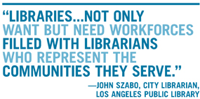CFR’s Jordan, meanwhile, says that library schools’ requirement of practical experience as part of the curriculum is a way for schools, and the profession, to become more diverse. “Requiring a practicum is a way of helping diversity in the field,” she notes. “If you’re required to do one for credit, it’s more fair than needing to do unpaid internships after graduating, which not everyone can afford.”
For BCPL’s Miller, internships are also crucial for assisting diversity, but she hopes that a push toward diversity can happen even before that. “We need to encourage librarianship as a possibility [for people] at a younger age,” she says. She also says that a way to increase the diversity of the profession is to recruit paraprofessionals who are already working in librarianship. Maryland, she says, has statewide library associate training institutes aimed to do just that.
SETTING EXPECTATIONS
Jordan says that because things change so quickly in the library world now, it is important for library schools to inform students that the career tracks of old are obsolete. “Graduates need an ability to think innovatively and creatively, not to allow themselves to get too stuck on a track they had for themselves that is not working out…. I see a lot of people who are coming out of library school and maybe haven’t been set up with the right expectations,” she continues. Jordan explains that when she entered the profession around 20 years ago, librarians generally had one job at a time and moved along on a specific, predictable track. Today’s economic climate has caused changes in how people have to look at their careers, she says. “A lot of the interns that I’ve supervised that were in library school weren’t able to find a full-time job when they graduated,” says Jordan. “They had to pull together two or three part-time jobs because, like a lot of industries, we’re in a gig economy. I don’t think their expectations matched what they found in the job market. They also weren’t clear [about] what they would have to do to distinguish themselves if they wanted a certain kind of leadership career.”
Practical experience can help graduates to have the right expectations, says Jordan, who notes that it is too often lacking. “When I was working in academic libraries and we would have library school students come in and we would talk about our library and our jobs, even though they were about to graduate, the visit was often the first time they had a frank, realistic idea of what it was like to be in a library setting,” she explains.
A practicum is required at many library schools for good reason, says Jordan. “At the end of the day, when people are going into tremendous debt, what they care about is being able to get gainful employment…. I don’t think you can be a librarian without having had library experience.” Jordan encourages library schools to prepare students for the budget realities in libraries. “If we can only have two people instead of five, you want to have two people whom you know are capable of doing the job that previously five people did. In that case I need to hire somebody who has the right skills, knowledge, ambition, and drive. Even if the person is fresh out of library school, if they have done internships and worked while they were in school and had a lot of exposure to different kinds of library experiences, that person will be interesting to me to hire.”
Practical experience is also highly valued at NYPL, says Platt, who explains that the library recently reinstated “a Librarian Trainee program that helps groom library science students for professional roles in NYPL…. Many leaders within our organization and the profession went through a previous iteration. It helps students apply new knowledge and ideas on a practical basis and learn how to fit within the culture and dynamics of a large, busy urban library system.”
Fortunately, many library leaders are proactive about communicating their evolving needs to library schools, often by sitting on the boards of local schools or their alma mater. As Szabo says, “The responsibility is also on us to reach out and connect to those programs and offer our assistance.”
This article was published in Library Journal's March 1, 2018 issue. Subscribe today and save up to 35% off the regular subscription rate.

https://lj.libraryjournal.com/2018/03/library-education/teaching-team-learning-practice/

- Governor Signs Law that Allows Florida School Librarians to be Armed
By Kara Yorio

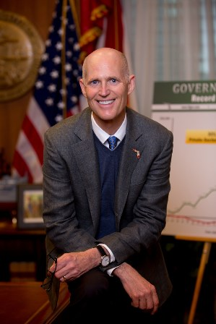
Florida Governor Rick Scott
Photo Credit Meredyth Hope Hall
The American Library Association (ALA) and American Association of School Librarians (AASL)–along with the Florida teachers union and superintendents association and NAACP—tried but failed to keep Governor Rick Scott from passing a law that will allow librarians and other school staff (excluding classroom teachers) to carry firearms in public schools.
Scott signed the bill Friday despite his opposition to the school guardian program in the bill that allows some school personnel to carry concealed weapons on campus, according to the Miami Herald, which reported that family members of all 17 Marjory Stoneman Douglas High School victims signed a statement supporting passage of the legislation that imposes new gun restrictions in the state.
The ALA and AASL did not publicly comment on the bill being signed into law. When asked for comment or an interview, a spokesperson emailed a copy of an earlier statement released the day before the bill’s signing and asking the governor to to listen to the recommendations of the state’s educators and not “undermine the sense of security that is critical to students.”
The presidents of the ALA and AASL had issued the joint statement. The Florida Education Association had asked the governor to use a line veto to keep the guardian program out of the law. The state superintendents association and NAACP also publicly opposed that portion of the bill.
“The ALA and AASL support the efforts of Florida Association for Media in Education (FAME) and Florida Library Association to provide safe and accessible learning spaces for students and learners of all ages,” Jim Neal (ALA) and Steven Yates (AASL) said in the statement released as educators and people on both sides of the gun control debate awaited Scott’s action.
“School librarians work with classroom teachers to provide instruction integral to the curriculum and offer additional informal learning opportunities for students. School librarians are invaluable teachers who offer an enriching learning environment for students and colleagues throughout the school. Firearms in our school libraries, as in any other classroom, will undermine the sense of security that is critical to students and divert school librarian attention away from the core focus of student learning.
“While we are all too aware of the gun violence that affects the communities that we serve, including our schools, we do not believe that allowing the arming of school librarians with guns is the answer to preventing violence and mass shootings. Schools need more resources, including the expertise of a certified school librarian for teaching and learning.
“We strongly encourage Governor Rick Scott and the Florida state legislature to honor the recommendations of FAME and other statewide teaching organizations regarding SB 7026.”
The “Coach Aaron Feis Guardian Program,” which is the part of the bill that would allow some teachers to volunteer to be armed, is named for the Majory Stoneman Douglas High School assistant football coach who was killed in the February 14 school shooting.
Enacting the program would be at the discretion of a local sheriff, according to the bill, and any staff members who volunteers to be a “school guardian” and carry a firearm must take more than 130 hours of training, pass a psychological evaluation and drug test and successfully complete at least 12 hours of a certified “nationally recognized diversity training program” before gaining the school guardian certificate.
There would then be ongoing training, weapon checks and annual firearm qualification, as well as random drug tests.
About Kara Yorio
Kara Yorio (kyorio@mediasourceinc.com, @karayorio) is news editor at School Library Journal.

https://www.slj.com/2018/03/industry-news/governor-signs-law-allows-florida-school-librarians-armed/

- How a Connecticut Library Became a Community STEM Hub
By Linda Rodgers on March 9, 2018 Leave a Comment
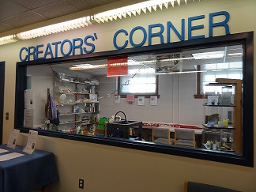It all started with Walter Isaacson’s biography of Steve Jobs. When the Trumbull (CT) Library selected Steve Jobs (Simon & Schuster, 2011) as its One Book, One Town community-wide reading choice in 2013, the Fairchild-Nichols Memorial Library Association saw a chance to make the library a STEM innovation hub. Thanks to the nonprofit association, which that funds activities for that branch, the library acquired a 3-D printer just in time to give weekly demonstrations during the One Book, One Town month of events.
The demonstrations were so popular that the library established a dedicated maker space, now known as Creators’ Corner, that brings people of all ages into the library.
“The original goal was to motivate people to become more involved and knowledgeable about technology, initially with 3-D printing,” says Jenny McLachlan, coordinator for Creators’ Corner. “We felt the best connection for collaboration would be with the local schools.”
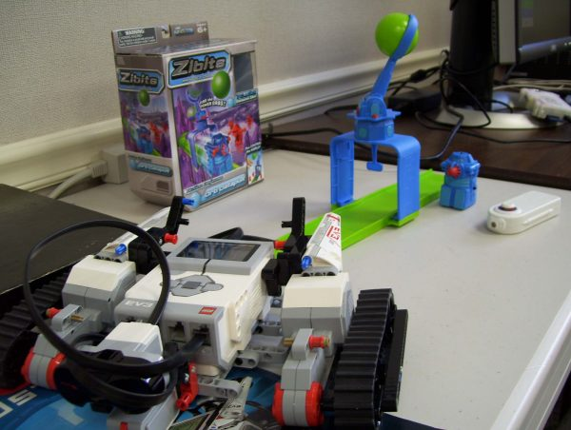
Robots at the Creators’ Corner.
In 2013 and 2014, McLachlan collaborated with the Trumbull Public Schools’ (TPS) math and science curriculum leaders to set up a 3-D printing demonstrations for fourth, fifth, and sixth grade teachers, providing 3-D printing samples the teachers took back and shared with students.
The kids became curious about creating prototypes for school projects and had their parents bring them to the library, says Floria N. Mallozzi, coordinator of TPS’ STEM K-8 curriculum.
As Creators’ Corner has added to its STEM learning collection, teachers can come for one-on-one instruction. One middle school tech education teacher, who arrived for training on the MakerBot 3-D printer, was also introduced to Ozobot robots for the first time. After a demonstration, she brought Ozobots to her classroom, says McLachlan. The library regularly shares updates on new developments in STEM learning, including where teachers can find free STEM resources.
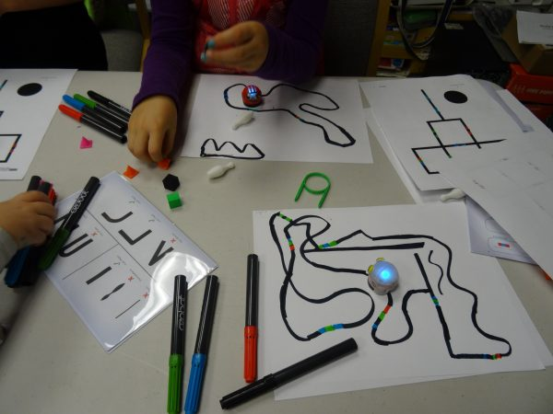
An Ozobot lesson.
To keep up to date, McLachlan participates in a Maker Roundtable for school and public library staff several times a year through the Connecticut Library Consortium. It has paid off.
“Jenny exposed our teachers to the world of Thingiverse, maker spaces, and other related digital and technology resources. She planted the seed for the information to grow, and it did,” says Mallozzi.
In small group workshops, students can learn about 3-D printing, coding, and robots in small workshops. During after-school drop-in hours they can get tutorials from trained high school volunteers, who earn community-service credits for helping out at the maker space. Patrons 10 and older can 3-D print on their own—as long as there is a staff person or volunteer there.
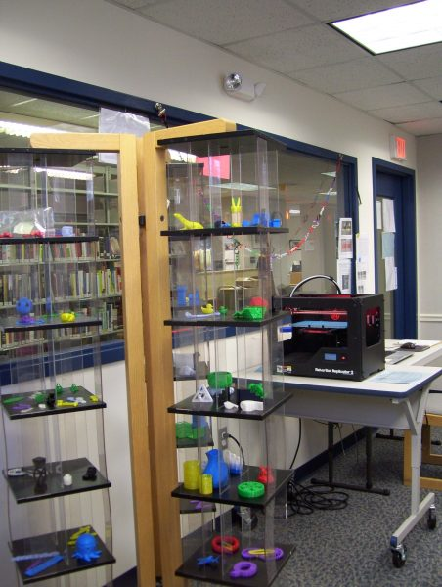
Tech supplies inside the Creators’ Corner space.
While initially aimed at students, now, “people of all ages and stages of life” stop in to see what’s happening whenever volunteers are on hand, says McLachlan.
During “Come Build With Us” evenings for families, building kits from LEGO and Duplos, Roominate kits and KEVA planks come out, and parents and kids can construct to their hearts’ content.
“We offer a non-threatening environment plus personal assistance—we don’t expect people to sink or swim,” adds McLachlan. “We remind them that results that don’t work out as expected still offer an opportunity to figure out why and to try again for a different outcome.”
For other public librarians wanting to connect more with the local school district, Mallozzi suggests inviting curriculum leaders to the library maker space so they can get the word out to teachers. McLachlan’s advice: cultivate any existing connections with the school district—and explore ways to work together.

https://www.slj.com/2018/03/technology/connecticut-library-became-community-stem-hub/

