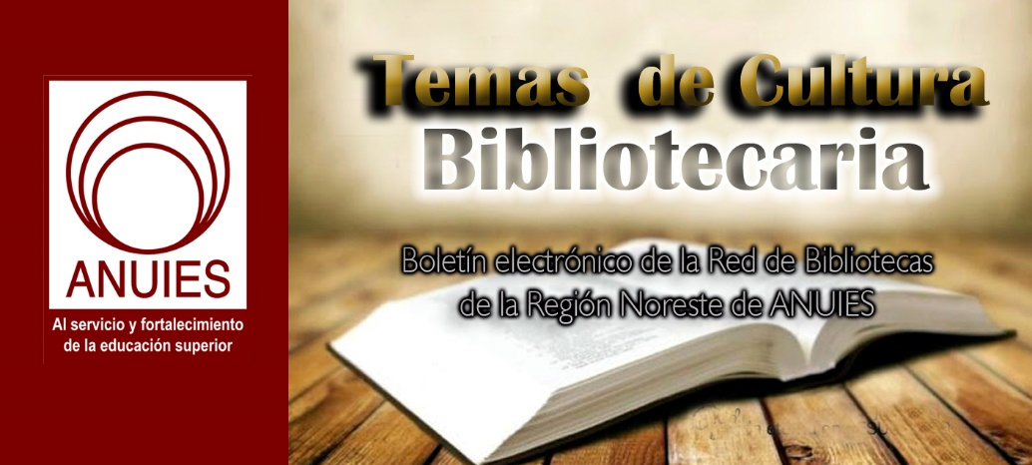
Año 3 Número 68 abril 2018

Contenidos de este número

- Nuevos recursos para estudiantes
B
Boletín Fundación Ciencias de la Documentación
DOCUFORUM@LISTSERV.REDIRIS.ES

Hola, buenas tardes:
iniciamos una nueva semana con algunas novedades interesantes dentro del Campus Online de la Fundación Ciencias de la Documentación, entre las que destacamos:
MODIFICACIÓN DE LA CAFETERÍA
https://documentalistas.org/campus/course/view.php?id=68
Siguiendo vuestras sugerencias, hemos actualizado por completo la cafetería, destacando más las comunidades profesionales, e incorporando el Glosario de términos (los cuales cuentan ahora con libros recomendados para profundizar en el concepto), así como una nueva sección de Fuentes Educativas (en constante crecimiento) que busca ayudar a los estudiantes a la hora de ampliar los conocimientos adquiridos en los cursos.
BUSCAR DOCUMENTACIÓN
Como novedad importante, ahora es posible desde todos los cursos y talleres disponibles en el Campus Online, buscar en WorldCat, el mayor catálogo en línea del mundo. Al estar integrado en el Campus, el estudiante dispone de datos, registros y fichas de más de 90.000 bibliotecas públicas y privadas de todo el mundo, con más de 175 millones de registros bibliográficos en 470 idiomas. Todo un mundo de conocimiento a un solo clic de distancia !!!!
NUEVOS CURSOS Y TALLERES EN EL PORTAFOLIO
https://documentalistas.org/web/portafolio/
Esta semana se han incorporado nuevos cursos y talleres de matrícula gratuita para profesionales de España e Iberoamérica, en concreto orientados a las tecnologías que dan soporte a la Transformación Digital en nuestras profesiones. Recordar consultar periódicamente el portafolio para conocer las novedades formativas que organiza la Fundación.
BECAS BIG DATA DOCUMENTAL
https://documentalistas.org/web/portfolio/bigdatadocu/
Ya se han otorgado 10 de las 20 becas disponibles para cubrir el 50% de la matrícula del curso de alta especialización profesional en Big Data Documental, que en su segunda edición estamos organizando. Recordamos a los profesionales que ya la han solicitado, terminar el proceso que se les ha indicado, para poder confirmarles como beneficiarios de
una de las 10 becas que quedan pendientes por asignar.
Esperamos que os haya sido de interés. Muchas gracias por la atención y feliz inicio de semana !!!
---
Dpto de Información
Fundación Ciencias de la Documentación
https://documentalistas.org/campus
Grupo Telegram: https://t.me/joinchat/HIogdRErNiBLE0PSklOiDQ

City of Library Love | PLA Preview 2018
By LJ on February 21, 2018 Leave a Comment

Philadelphia welcomes public librarians from across America to the biennial Public Library Association conference
This spring, the Public Library Association (PLA) biennial conference returns March 20–24 to one of the many birthplaces of the American library: Philadelphia, where Benjamin Franklin founded his Library Company (still extant and calling itself “America’s first successful lending library”) in 1731. Today’s city remains home to many thriving libraries, including the Free Library of Philadelphia (FLP), the city’s recently reinvigorated public library, led by Siobhan A. Reardon, LJ’s 2015 Librarian of the Year.
Below, LJ editors attending the conference call out a few sessions that caught their eye from the many compelling programs on offer, particularly those grappling with current social issues, from racism to the opioid epidemic, and drawing on the firsthand experience of librarians from Philadelphia, around the country, and beyond.

Barbara Hoffert
Editor, Prepub Alert
Millennials Take over the Library
Thurs., Mar. 22, 10:45–11:45 a.m.
Canada’s Calgary Public Library turned its oldest branch into a literary, music, and create space center for millennials.
Providing Immigration Services in Public Libraries: Making It Possible Is Not Impossible
Thurs., Mar. 22, 10:45–11:45 a.m.
Librarians are obtaining a credential from the Department of Justice to provide immigration services outreach, screenings, and referrals.
Top 5 of 5: A Current Affair
Thurs., Mar. 22, 4–5 p.m.
Readers’ advisory (RA) experts highlight titles about hot topics in the news, featuring top fives in science, international fiction, diversity in youth books, political issues, and pop culture.
Listen to This: Finding Audiobooks in Languages Other than English
Fri., Mar. 23, 10:45–11:45 a.m.
With audiobooks the big growth area in library materials and many libraries serving diverse populations, this guide to audiobooks beyond the English language should be invaluable. Presented by experts from the New Jersey State Library Talking Book & Braille Center.
The Opioid Epidemic: How Can My Library Help?
Fri., Mar. 23, 2–3 p.m.
With more than 20,000 of this country’s 64,000 drug overdose deaths in 2016 involving fentanyl and synthetic opioids, libraries are providing education, collaboration, and even first response. With presenters from libraries nationwide.
Drag Queen Story Hour: Reading Fabulously
Fri., Mar. 23, 2–3 p.m.
Not only is the Brooklyn PL’s initiative involving drag queens reading to children important for promoting acceptance and inclusivity, it’s fun for everyone.

Rebecca T. Miller
Editorial Director, LJ and School Library Journal
When the Mayor Calls: Answering the City’s Call for Support
Thurs., Mar. 22, 10:45–11:45 a.m.
Three urban library directors—Seattle’s Marcellus Turner, Detroit’s Jo Anne Mondowney, and Cleveland’s Felton Thomas—share how they connect to city priorities on social issues.
Voter Perceptions: Getting from Awareness to Funding in 2018
Thurs., Mar. 22, 4–5 p.m.
This promises an update, with new research findings, to 2008’s “From Awareness to Funding” report on library supporter attitudes, with takeaways advocates can use to help ensure future funding.
Ensuring the Future of Libraries: Connecting the Academy and the Profession
Fri., Mar. 23, 10:45–11:45 a.m.
Susan Hildreth, Distinguished Practitioner in Residence at the University of Washington iSchool; faculty; and working librarians on connecting the key dots between library schools and libraries.
To Connect and To Serve: Building Community with Law Enforcement
Sat., Mar. 24, 9:30–10:30 a.m.
Hear about Salt Lake County Library Services’ fresh approach to deep collaboration with law enforcement.
How To Start Training Your Staff To Be More Culturally Competent
Sat., Mar. 24, 10:45–11:45 a.m.
Two librarians from Oak Lawn PL, IL, will share how they work to improve staff cultural awareness and competence.

Lisa Peet
Associate Editor, News
Libraries Aren’t Neutral: Programming and Resources for the Political Climate
Thurs., Mar. 22, 4–5 p.m.
We live in polarizing times, and libraries are well positioned to take a proactive, frontline stance on civic engagement—but challenging the library’s role as “neutral” space is not always simple. Information services librarians will explore programming, resource, and service strategies for media literacy, political awareness, and facilitating community dialog.
Libraries Strengthening the Talent Pipeline
Fri., Mar. 23, 10:45–11:45 a.m.
This session will look at ways libraries can up their involvement with workforce development, meeting the changing needs of employers as well as potential employees and exploring opportunities for partnerships at the local, state, and national levels.
Breaking Barriers to Employment: Embedding Legal Services in Public Libraries
Sat., Mar. 24, 10:45–11:45 a.m.
DCPL and DC’s Neighborhood Legal Services Program have joined forces to help address roadblocks experienced by patrons with criminal records, bringing free legal services to participants in library job seeker clinics.
https://lj.libraryjournal.com/2018/02/shows-events/pla/city-library-love-pla-preview-2018/
- CONVOCATORIA ABIERTA- Información y Comunidades Indígenas-Septiembre 26-28
DI
Difusión IIBI

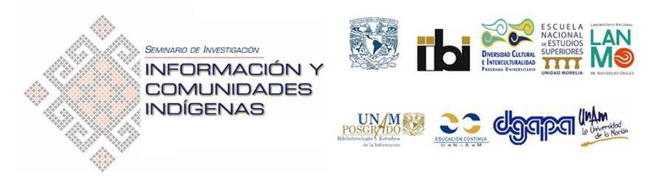
El Instituto de Investigaciones Bibliotecológicas y de la Información (IIBI), en colaboración con el Programa Universitario de Estudios de la Diversidad Cultural y la Interculturalidad (PUIC), el Laboratorio Nacional de Materiales Orales (LANMO) de la Escuela Nacional de Estudios Superiores, Campus Morelia (ENES, Morelia) y el Programa de Posgrado en Bibliotecología y Estudios de la Información (entidades académicas y de investigación de la Universidad Nacional Autónoma de México (UNAM)), convocan a enviar propuestas para la presentación de trabajos en el

COLOQUIO INTERNACIONAL SOBRE INFORMACIÓN Y COMUNIDADES INDÍGENAS:
“LA IMPORTANCIA DE LA INFORMACIÓN EN LAS CULTURAS ORIGINARIAS”
(Programa UNAM DGAPA PAPIIT - IG400417)

26 al 28 de septiembre de 2018
Sede: Auditorio “Mario de la Cueva”
Torre II de Humanidades, piso 14. Ciudad Universitaria, Ciudad de México

COORDINADORES:
- Dr. César Augusto Ramírez Velázquez,
- Dr. Hugo Alberto Figueroa Alcántara,
- Dr. Jaime Ríos Ortega,
- Dra. Perla Olivia Rodríguez Reséndiz
OBJETIVOS:
• Analizar la situación y problemas que afrontan las comunidades indígenas para obtener, organizar, analizar y aprovechar en su beneficio la información que requieren;
• Establecer puntos de coincidencia y vínculos entre los profesionales de las bibliotecas y áreas afines para la búsqueda de soluciones conjuntas en materia de información para las comunidades indígenas;
• Crear estrategias comunes que puedan beneficiar a las bibliotecas de las comunidades indígenas para brindarles servicios bibliotecarios y de información adecuados.
DIRIGIDO A:
• Bibliotecarios, documentalistas, archivistas, analistas de información, responsables de bibliotecas, centros de información y de documentación, investigadores, académicos y estudiantes interesados en los estudios e investigaciones inherentes al binomio información y comunidades indígenas;
• Investigadores, profesores y estudiantes de las áreas de bibliotecología y estudios de la información, ciencias de la información, archivos, documentación, historia, antropología, etnología, y áreas afines;
• Profesionales de diversos ámbitos del conocimiento y cualquier persona interesada en la temática del Congreso.
TEMAS:
Entre los temas que podrán ser abordados desde una perspectiva transversal que involucre a profesionales y especialistas en las mesas de debate y reflexión, se encuentran los siguientes:
I. La información como recurso indispensable para el desarrollo comunitario;
II. Rescate, organización y preservación de información de las comunidades;
III. Problemas comunes en la búsqueda y acceso a la información por parte de la población originaria;
IV. Bibliotecas y archivos digitales para pueblos originarios;
V. Servicios bibliotecarios y de información para comunidades indígenas;
VI. Tecnologías para la preservación digital de la información de las comunidades;
VII. Desarrollo de aplicaciones para el acceso a la información de las comunidades; y
VIII. Proyectos de colaboración para el desarrollo de bibliotecas indígenas
LUGAR Y FECHAS:
El I Coloquio Internacional de Información y Comunidades Indígenas se llevará a cabo del 26 al 28 de septiembre de 2018, en el Auditorio “Mario de la Cueva” ubicado en el piso 14 de la Torre II de Humanidades, Ciudad Universitaria y las instalaciones del IIBI.
¿CÓMO PARTICIPAR?:
Todos aquellos interesados en presentar ponencias en el Coloquio deberán enviar su propuesta (resumen) antes del viernes 27 de abril de 2018.
Las propuestas serán evaluadas en forma de doble ciego por un Comité Científico Internacional.
La notificación de aceptación se le hará llegar al responsable del proyecto, vía correo-e, durante la semana del lunes 14 al viernes 18 de mayo de 2018.
Las propuestas deben enviarse en archivo de Word, como documento adjunto al correo: coloquioici2018@gmail.com conforme a la información solicitada en cada rubro:
Requisitos para presentación de Ponencias:
• Título
• Nombre del autor o autores
• Institución
• Datos de contacto (correo-e y teléfono)
• Resumen (máximo 300 palabras)
• Currículo del ponente (200 palabras máximo)
• Foto del ponente en formato JPG a 300 dpi
• El texto completo de los trabajos aceptados deberá ser enviado a más tardar el viernes 3 de agosto de 2018, de acuerdo con las siguientes características:
• Texto (máximo 4,500 palabras, letra Arial de 12 puntos, espacio entre líneas de 1.5 y doble espacio entre párrafos; asimismo los márgenes de las páginas deberán ser de 3 cm. por lado); incluir imágenes y tablas.
• La estructura del texto debe considerar:
- Título
- Autor e institución
- Introducción
- Desarrollo
- Conclusiones
- Bibliografía en estilo Chicago parentético
Fechas importantes
•Fecha límite para presentar propuestas de ponencias: viernes 27 de abril de 2018
•Notificación de resúmenes seleccionados: del lunes 14 al viernes 18 de mayo de 2018.
•Entrega del texto completo: viernes 3 de agosto de 2018

Todo lo mejor,
Mtra. Kenya Y Olivera
IIBI-UNAM

Digital Humanities Find New Home at VA Tech Library
By Cate Schneiderman on February 20, 2018 Leave a Comment
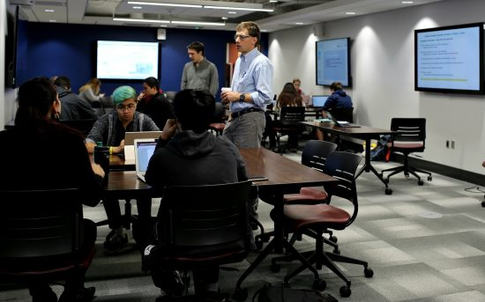There’s a new place to learn inside Virginia Tech’s Newman Library in Blacksburg, VA: a three-room suite and office known as the Athenaeum, which first started hosting digital humanities programs in November 2017. The library already had a number of very popular studio spaces, but the addition of the Athenaeum generated a fair bit of attention. The grand opening on January 26th was well attended and the space is regularly booked with speakers and workshops on podcasting and data visualization, as well as traditional classes.
UNIQUE SPACES
The suite contains a large modular classroom, a smaller boardroom, and a sound-isolated media studio. An advisory committee made up of faculty, library staff, and the director of the new Center for the Humanities schedule the rooms, choosing programs and classes that will make thoughtful use of the space and available technology.
The classroom, which can hold 54 students, is equipped with seven screens for projecting media and connected devices. Three or four undergraduate courses meet regularly in the space while others come for one-time visits. There are also plans to host special events including a Digital Humanities speaker series and the Douglass Day transcribe-a-thon, a national event held in honor of Frederick Douglass’ 200th birthday to transcribe the Freedmen’s Bureau Papers. For smaller groups, the boardroom seats 12 and is well suited for hands-on workshops and teleconferencing.
The media studio is already a boon to oral history projects on campus. Because of the sound isolation, it is easy to record interviews and other audio there. The Virginia Tech special collections, which are located nearby, house many oral histories including several related to Appalachian history and culture. An ongoing project started by the English department called “VT stories” collects oral histories from the college’s alumni.
ROLE OF THE LIBRARY
The Athenaeum was born out of conversations between the dean of libraries and the college provost. Although it falls under the jurisdiction of the College of Liberal Arts and Human Sciences, it is intended to be open to all students and faculty across the college. Digital Humanities coordinator Christopher Miller, who oversees the Athenaeum, says, “the conversation has been really balanced… I wouldn’t say there’s been any sort of dominant voice.” The Digital Humanities often overlap different academic departments, and therefore frequently find a home in the library. The University of Iowa Libraries, for example, contain a Digital Scholarship and Publishing Studio.
Miller’s role, which was created in 2017 to run the space, falls under the umbrella of digital publishing at the library. The department is deliberately multimodal in its outlook, and Miller says the Athenaeum “meets faculty and students at the point of aspiration.” He sees the changes in the publishing industry as running parallel to the way humanities faculty interact with new digital tools, like those provided in the new space. Furthermore, this new space fits into the ongoing conversation many librarians, include those at Virginia Tech, are having about changes in the profession and how the library can support people who make and create things in a variety of formats.

Cate Schneiderman is Outreach Coordinator & Reference Librarian, Iwasaki Library, Emerson College, Boston

https://lj.libraryjournal.com/2018/02/academic-libraries/digital-humanities-find-new-home-va-tech-library/

Elsevier is Collaborating with Hypothesis to Integrate Open Annotation
Filed by Gary Price on February 20, 2018
Wow, busy times at hypothesis and for the growth of open annotation in general. A wew collaboration announced today. Two weeks ago hypothesis announced a collaboration with the Center for Open Science.
From Today’s Announcement:
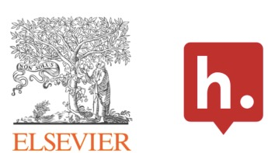Today, Elsevier and Hypothesis are announcing a collaboration to align annotation capabilities in Elsevier’s Research Products with the emerging ecosystem of interoperable clients and services for annotation based on open standards and technologies.
[Clip]
By working together, Elsevier and Hypothesis demonstrate two important shifts in scholarly communications: first, the growing role that annotation plays within the life cycle of research and publication; and second, that data standards and open frameworks are increasingly essential to scientific collaboration and progress.
[Clip]
Heather Staines, Director of Partnerships at Hypothesis said, “While the consensus achieved by the W3C Web Annotation standards recommendation last year was an essential first step, widespread adoption of interoperable annotation requires that major publishers incorporate it into their products and services. We’re thrilled that Elsevier is taking a leadership role in recognizing the potential benefits for researchers, and moving to integrate Hypothesis’ standards-based and open source annotation solution. We’re also delighted that they recognize the benefit of working with a nonprofit committed to an independent community platform.”
In 2015, Elsevier joined the Annotating All Knowledge (AAK) coalition, a group formed to promote interoperability between annotation products and services and to further the W3C’s standardization efforts among publishers and platforms. AAK members undertook a pledge to begin incorporating open annotation into their platforms and to be open in doing so. With the announcement today, Elsevier makes good on their AAK pledge to bring the annotation standard to their offerings.
Read the Complete Announcement
See Also: Hypothesis and the Center for Open Science Collaborate on Annotation (February 7, 2018)
See Also: Hypothesis Announces New Partnerships with bioRxiv, MIT Press, and AGU (September 16, 2017)
See Also: Hypothes.is Partners with NYU Libraries, NYU Press, Others to Bring Open Annotations to eBooks
See Also: Elsevier Joins the Hypothes.is Annotating All Knowledge Coalition (Jan. 26. 2016)
Presentation From December 2017
About Gary Price

https://www.infodocket.com/2018/02/20/web-annotation-elsevier-collaborates-with-hypothesis-to-integrate-open-annotation/

New From the Library of Congress: The Papers of President James Buchanan and Harriet Lane Johnston Digitized and Now Available From the Library of Congress
Filed by Gary Price on February 21, 2018
From LC:
The papers of President James Buchanan, who presided in the four years leading up to the Civil War, have been digitized and are now available online for the first time from the Library of Congress, along with the papers of his niece, Harriet Lane Johnston, who served as first lady in the White House. Buchanan was the nation’s only president who never married.
The Buchanan collection includes approximately 1,600 items dating from 1825 to 1887.
Buchanan’s papers include correspondence, notes, drafts of remarks and other records relating to his career in the U.S. Congress representing Pennsylvania, as secretary of state and as minister to Great Britain, along with his presidential years. Subjects include politics nationally and in Pennsylvania, sectional disputes in the country before the Civil War, the theory that states could nullify the U.S. Constitution, relations with Mexico and other issues of the time.
During Buchanan’s time as secretary of state, the U.S. annexed Texas, acquired California, negotiated borders for the Oregon Territory with Britain and fought the Mexican War. Buchanan served under President James K. Polk, whose papers are also held by the Library and also are available online.
When Buchanan became president, he was confronted with the question of slavery, the Dred Scott decision from the Supreme Court and whether popular sovereignty would determine if new states allowed slavery. Near the end of his presidency, Southern states began to secede from the Union – just before the inauguration of Abraham Lincoln, the first president from the new Republican Party.
For her part, Johnston may have proven to be a more popular figure than her uncle during a difficult time in the presidency. She was active in Washington’s social scene and had learned to navigate successfully in official circles during her time in London while her uncle served as America’s minister to Great Britain in the mid-1850s. Buchanan wrote about dining with Queen Victoria and Prince Albert and noted Johnston was clearly “a favorite of both.”
Johnston’s papers include correspondence about ladies’ fashions, romance and social affairs at a time when Washington was still dominated by Southern families. She also had a close relationship with Buchanan, who had become her guardian at a young age after her parents died. They wrote frequently to each other when they were apart. Buchanan’s writings show him to be affectionate but also offering advice to rein in her emotions and to encourage good conduct.
The Library has held the Buchanan-Johnston collection for a century, and additional materials have been added over the years. However, the bulk of Buchanan’s materials are located at the Historical Society of Pennsylvania.
The digitization of the Buchanan papers is part of a larger effort to make presidential materials accessible online. Other newly digitized collections include the papers of Presidents Ulysses S. Grant, Millard Fillmore, Franklin Pierce and James K. Polk.
Coming Online Soon
Additional Civil War-era materials include the papers of Joseph Holt, who served in Buchanan’s administration and later presided over the trial of the conspirators in Lincoln’s assassination as judge advocate general of the U.S. Army, and E.B. Washburne of Illinois, who served in Congress during the Civil War and later as minister to France during the Franco-Prussian War.

https://www.infodocket.com/2018/02/21/new-from-the-library-of-congress-the-papers-of-president-james-buchanan-and-harriet-lane-johnston-digitized-and-now-available-from-the-library-of-congress/

Report: “Sci-Hub Loses Domains and Access to Some Web Services”
Filed by Gary Price on February 20, 2018
From The Scientist:
Logs of publication downloads from 2017, released by Sci-Hub on January 18, show that, despite the lawsuits from ACS and Elsevier, the site experienced a growth in activity. An analysis of those data, published earlier this month in eLife, reveals that daily downloads on the pirate site steadily increased from approximately 200,000 per day in 2016 to around 600,000 per day by mid-2017.
Last December, however, downloads dropped significantly—to approximately 350,000 per day—around the time that Sci-Hub lost three of its domains, sci-hub.cc, sci-hub.io, and sci-hub.ac.
[Clip]
According to Doug Kramer, general counsel for Cloudflare, the company terminated its services to Sci-Hub after receiving a copy of the court order from ACS’s attorneys. The order, issued by US District Judge Leonie Brinkema last year, required organizations—including domain name registries, search engines, and Internet service providers—that were in “active concert or participation” with the site to censor it.
Read the Complete Article
See Also: Sci-Hub Provides Access to Nearly All Scholarly Literature (via elife)

https://www.infodocket.com/2018/02/20/report-sci-hub-loses-domains-and-access-to-some-web-services/

