Año 3 Número 66 marzo 2018

Contenidos de este número

- Carnegie Medals, Notable Books List Announced
BY BARBARA HOFFERT ON FEBRUARY 12, 2018 LEAVE A COMMENT
On Sunday, February 11, at the Midwinter Meeting & Exhibits in Denver, the American Library Association (ALA) announced that Jennifer Egan’s Manhattan Beach (Scribner) and Sherman Alexie’s You Don’t Have To Say You Love Me: A Memoir (Little, Brown) won the 2018 Andrew Carnegie Medals for Excellence in Fiction and Nonfiction, respectively. The announcement was made at the Reference and User Services Association (RUSA)’s Book and Media Awards (BMAs), sponsored by NoveList. The awards, established in 2012 to highlight quality reading material for adults, are made possible, in part, by a grant from the Carnegie Corporation of New York and are cosponsored by RUSA. Finalists and winners are chosen by an annually appointed selection committee, which includes a chair (Victoria Caplinger, 2017–18), one member of the American Booksellers Association, three Booklist editors or contributors, and three former members of the RUSA CODES Notable Books Council.
To collect the fiction medal, Egan’s expansive portrait of a female diver at the Brooklyn Navy Yard during World War II beat out some formidable competition: George Saunders’s Man Booker Prize winner Lincoln in the Bardo (Random) and Jesmyn Ward’s National Book Award winner Sing, Unburied, Sing (Scribner). Alexie’s heartbreaking memoir of his mother, an LJ Best Book, prevailed over Daniel Ellsberg’s The Doomsday Machine: Confessions of a Nuclear War Planner (Bloomsbury) and David Grann’s Killers of the Flower Moon: The Osage Murders and the Birth of the FBI (Doubleday), a National Book Award finalist and an LJ Best Book. The winning authors receive $5,000 each and the finalists $1,500, and all finalists will be honored during a celebratory event at ALA’s 2018 Annual Conference in New Orleans.
At the BMAs, RUSA also announced the 2018 picks for the Notable Books List, an annual compilation of top titles for adult readers in fiction, nonfiction and poetry. The fiction list ranged 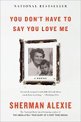from significant historical fiction like Sebastian Barry’s Days Without End(Viking) and Wiley Cash’s The Last Ballad (Morrow) to books grappling imaginatively with class, race, and global conflict, e.g., Omar El Akkad’s American War (Knopf) and Mohsin Hamid’s Exit West (Riverhead). A nice surprise: Mike McCormack’s Solar Bones (Soho), a multi-award-winning Irish novel that clearly yet daringly unfolds in a single sentence.
Nonfiction also touched on history, with books ranging from Ron Chernow’s Grant (Penguin Pr.) to Mark Bowden’s Hue 1968: A Turning Point of the American War in Vietnam (Atlantic Monthly) to Timothy Tyson’s The Blood of Emmett Till (S. & S.). But the arts were not ignored, as evidenced by Kay Redfield Jamison’s Robert Lowell Setting the River on Fire: A Study of Genius, Mania, and Character (Knopf). The poetry selections include William Brewer’s I Know Your Kind (Milkweed), which uses a small-town Appalachia setting to dramatize America’s opioid crisis, and Molly McCully Brown’s Virginia State Colony for Epileptics and Feebleminded (Persea), whose author, born with cerebral palsy, grew up near the titular institution and imagines the fate of inmates there. Both books are debuts.
Notable Books selections are chosen by the Notable Books Council, which comprises 12 expert readers’ advisory and collection development librarians who comb through standard library reviewing sources to find the strongest reviews. The Carnegie Medals longlist, from which the shortlist is chosen, is derived from Notable Books List.

http://reviews.libraryjournal.com/2018/02/prepub/carnegie-medals-notable-books-list-announced/

- Yale University: Project Revives Old Software, ‘Preserves Born-Digital’ Data (Emulation as a Service)
Filed by Gary Price on February 13, 2018
From YaleNews:
Digital preservationists at Yale University Library are building a shareable “emulation as a service” infrastructure to resurrect thousands of obsolete software programs and ensure that the information produced on them will be kept intact and made easily available for future access, study, and use.
Funded through a pair of $1 million grants from The Andrew W. Mellon Foundation and the Alfred P. Sloan Foundation, the project will enable access to at least 3,000 applications, including operating systems, scientific software, office and email applications, design and engineering software, and software for creative pursuits like video editing or music composition.
[Clip]
The project is scheduled for completion in June 2020. The library’s preservationists are collaborating on the project with the Software Preservation Network, an association of digital preservationists committed to ensuring long-term access to software. They will also work with OpenSLX, a firm that is widely considered a leading developer of the technology underpinning the shareable infrastructure the library is building.
Read the Complete Announcement
See Also: Mellon Foundation Funding Announcement
See Also: Sloan Foundation Funding Announcement
See Also: Emulation & Virtualization as Preservation Strategies (by David S. H. Rosenthal; 2015)

http://www.infodocket.com/2018/02/13/yale-university-project-revives-old-software-preserves-born-digital-data-emulation-as-a-service/

- Digital Collections: University of Iowa Libraries Makes Avant-Garde Works Accessible to the World
Filed by Gary Price on February 13, 2018
From the University of Iowa:
Forty years ago, the University of Iowa sponsored an international conference and exhibit on Dada, an avant-garde movement that arose as a reaction to World War I and swept Europe and America. This conference (Dada Spectrum) and exhibition (Dada Artifacts) led to the creation of the International Dada Archive at the UI Libraries in 1979.
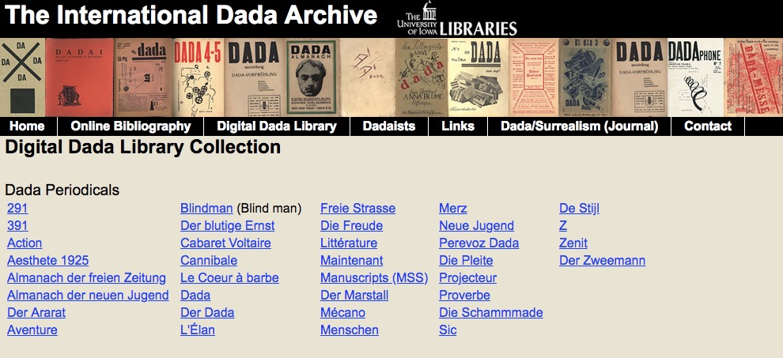
Even before the International Dada Archive was established, the UI’s holdings in the field were extensive, and the collection has since grown to include about 75,000 objects such as books, articles, magazines, broadsheets, drawings and sketchbooks, diaries, invitations, video recordings, and sound recordings.
[Clip]
Today, these works are able to travel farther and reach more viewers than their artists likely ever imagined, thanks to efforts that began in the late 1990s to digitize the collection. The Digital Dada Library provides links to scanned pages of original Dada-era publications, including books, pamphlets, broadsides, and periodicals.
“We receive hundreds of thousands of hits on this collection,” says Timothy Shipe, curator of the International Dada Archive. “I’ve had people from more than 30 countries contact me to say they couldn’t teach their classes without this digital collection.”
Stephen Voyce, associate professor of English and director of the Fluxus Digital Collection, which launched in 2015, says he frequently gets emails from high school and elementary school teachers who use the digital collections in their classrooms.
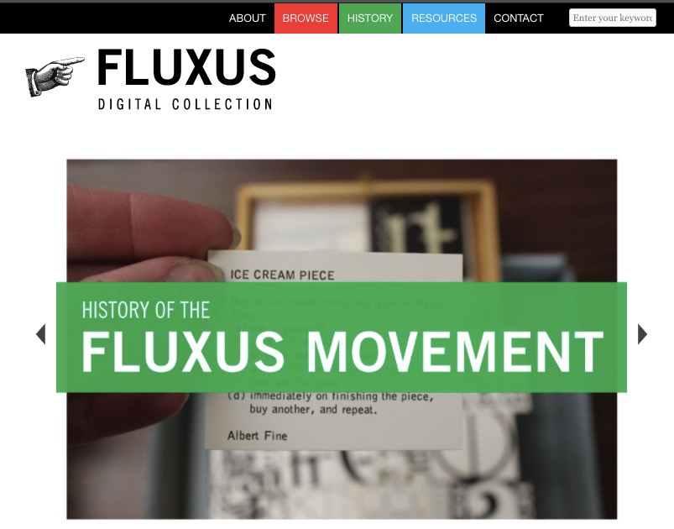
Fluxus was an international and interdisciplinary group of artists who worked primarily in the 1960s and ’70s and had roots in Dada. In fact, it’s often described as neo-Dada. The year after the Dada archive was founded, artist Ken Friedman donated the Fluxus West Collection to the UI, and the collection has grown to include drawings, paintings, sculptures, and writings by internationally acclaimed artists such as Friedman, Mieko Shiomi, Nam June Paik, George Brecht, and Yoko Ono.
Read the Complete Article, View Images (approx. 1050 words)
Resources
- Digital Dada Library
- Fluxus Digital Collection

http://www.infodocket.com/2018/02/13/digital-collections-university-of-iowa-libraries-makes-avant-garde-works-accessible-to-the-world/

- A Radical Archive Arrives at Harvard, Schlesinger Library Acquires Papers of Angela Davis
Filed by Gary Price on February 13, 2018
From the Harvard Gazette:
For almost 60 years Angela Davis has been for many an iconic face of feminism and counterculture activism in America.
Radcliffe’s Schlesinger Library has acquired Davis’ archive, a trove of documents, letters, papers, photos, and more that trace her evolution as an activist, author, educator, and scholar. The papers were secured with support from Harvard’s Hutchins Center for African & African American Research.
My papers reflect 50 years of involvement in activist and scholarly collaborations seeking to expand the reach of justice in the world,” Davis said in a statement. “I am very happy that at the Schlesinger Library they will join those of June Jordan, Patricia Williams, Pat Parker, and so many other women who have been advocates of social transformation.”
The acquisition is in keeping with the library’s efforts to ensure its collections represent a broad range of life experiences. In 2013 and 2014 an internal committee developed a diverse wish list, “and a foundational thinker and activist like Angela Davis was very naturally at the top,” said Kamensky.
Kenvi Phillips, hired as the library’s first curator for race and ethnicity in 2016, met with Davis in Oakland last year to collect the papers with help from two archivists. Together they packed 151 boxes of material gathered from a storage site, an office, and Davis’ home.
Read the Complete Article, View Images

http://www.infodocket.com/2018/02/13/a-radical-archive-arrives-at-harvard-schlesinger-library-acquires-papers-of-angela-davis/

- Research Article: “The State of OA: a Large-Scale Analysis of the Prevalence and Impact of Open Access Articles” (Peer-Reviewed Version)
Filed by Gary Price on February 14, 2018
Note: The peer-reviewed version of “The State of OA: a Large-Scale Analysis…” is now available online and liked below.
A preprint version of this article was released last August.
Title
The State of OA: A Large-Scale Analysis of the Prevalence and Impact Of Open Access Articles
Authors
Heather Piwowar​​
Impactstory
Jason Priem​​
Impactstory
Vincent Larivière
Université de Montréal
CIRST, Université du Québec à Montréal
Juan Pablo Alperine
Simon Fraser University
Public Knowledge Project
Lisa Matthias
Independent Scholar
Bree Norlander
University of Washington
Ashley Farley
University of Washington
Jevin West
University of Washington
Stefanie Haustein
University of Ottawa
CIRST, Université du Québec à Montréal
Source
PeerJ 6:e4375
doi: 10.7717/peerj.4375
Abstract
Despite growing interest in Open Access (OA) to scholarly literature, there is an unmet need for large-scale, up-to-date, and reproducible studies assessing the prevalence and characteristics of OA.
We address this need using oaDOI, an open online service that determines OA status for 67 million articles. We use three samples, each of 100,000 articles, to investigate OA in three populations: (1) all journal articles assigned a Crossref DOI, (2) recent journal articles indexed in Web of Science, and (3) articles viewed by users of Unpaywall, an open-source browser extension that lets users find OA articles using oaDOI. We estimate that at least 28% of the scholarly literature is OA (19M in total) and that this proportion is growing, driven particularly by growth in Gold and Hybrid. The most recent year analyzed (2015) also has the highest percentage of OA (45%).
Because of this growth, and the fact that readers disproportionately access newer articles, we find that Unpaywall users encounter OA quite frequently: 47% of articles they view are OA. Notably, the most common mechanism for OA is not Gold, Green, or Hybrid OA, but rather an under-discussed category we dub Bronze: articles made free-to-read on the publisher website, without an explicit Open license. We also examine the citation impact of OA articles, corroborating the so-called open-access citation advantage: accounting for age and discipline, OA articles receive 18% more citations than average, an effect driven primarily by Green and Hybrid OA. We encourage further research using the free oaDOI service, as a way to inform OA policy and practice.
Direct to Full Text Article
Note: Heather Piwowar and Jason Priem (two of the authors) are the founders of ImpactStory and the developers of the Unpaywall browser add-on and oaDOI API service, both of these services can make easy access open acces articles, preprints, etc. much easier for most users.
Priem was also a co-author of the altmetrics manifesto in 2010.

http://www.infodocket.com/2018/02/14/research-article-the-state-of-oa-a-large-scale-analysis-of-the-prevalence-and-impact-of-open-access-articles-final-version/

- University of Minnesota and Michigan St. University Launch SCOTUS Notes, Crowdsourcing Project Will Transcribe Supreme Court Justices’ Handwritten Notes
Filed by Gary Price on February 14, 2018
From the University of Minnesota:
If you have ever wanted to be a fly on the wall during deliberations by U.S. Supreme Court justices or travel back in time to witness Supreme Court decisions, a new crowdsourcing project led by researchers at the University of Minnesota and Michigan State University allows you to do just that.
The project, named SCOTUS Notes, is the newest citizen science project under the Zooniverse platform originated at the University of Minnesota. Zooniverse, the world’s largest and most popular people-powered online research platform, runs on support from volunteers that now number more than 1.5 million.
In this project, members of the public transcribe handwritten notes from U.S. Supreme Court justices. Unlike members of Congress, justices cast their votes in complete privacy during weekly conference meetings. Only justices are allowed in the Chief Justice’s conference room when they discuss, deliberate, and make initial decisions on cases that focus on some of the nation’s most pressing legal issues. The only record of what has been said, and by whom, is provided by the handwritten personal notes the justices themselves take during conference. These crucial documents detail the discussions and debates that took place in thousands of cases spanning multiple decades.
[Clip]
Together, the members of the general public will transcribe more than 25,000 pages of Supreme Court conference notes that have been digitized from archives at a variety of sites including the Library of Congress, Washington and Lee Law School, and Yale Law School. Those participating receive a tutorial on the Zooniverse platform before beginning their transcription work. If people are unsure about their classifications, the platform includes a discussion forum feature where they can talk with other participants and directly with the research team.
[Clip]
To join the SCOTUS Notes project and start transcribing, visit scotusnotes.org. Also follow the project on Twitter @SCOTUSNotes or its blog at scotusnotes.wordpress.com.
Read the Complete Announcement

http://www.infodocket.com/2018/02/14/university-of-minnesota-and-michigan-st-university-launch-scotus-notes-crowdsourcing-project-to-transcribe-supreme-court-justices-handwritten-notes/

- Guns in the Library | Safety & Security
By Jennifer A. Dixon on February 5, 2018 5 Comments

Libraries grapple with gun rights—and safety
Run. Hide. Fight. The video walking viewers through these steps for reacting to an active shooter in a public place has received 6.5 million YouTube views since 2012 and forms a key part of a new generation of safety training for libraries. Gun violence has recently impacted public spaces such as concerts, schools, and churches and hit particularly close to home for many library professionals and patrons when a 16-year-old killed two public library employees in New Mexico in 2017. In this environment, many library leaders are taking new steps to keep their staff and patrons safe.
KNOW THE DRILL
For some libraries, this means organizing “active shooter” trainings that prepare staff to react to dangerous situations. In 2016, the Clifton Park–Halfmoon Public Library (CPHPL) in upstate New York committed to providing such training and worked with the local Saratoga County Sheriff’s Office to offer a 45-minute presentation to staff. In addition to learning about the “run, hide, fight” protocol, staff took a walk through the library to consider how those steps would apply in their own building.
Following this presentation, staff applied what they learned in a drill one morning before the library opened. Jim Foster, CPHPL assistant director, notes that libraries are unique spaces in that they are by definition open to anyone from the public who wishes to enter. “It is trickier than an office building, where you lock your door and hide under your desk,” he says. Instead, staff learned, they should get to an exit if they can, or hide someplace like the stacks.
Realizing the value of the drill’s lessons, library staff next chose to provide training to their patrons and in fall 2017 offered an educational presentation similar to that received by employees. About 100 people attended, eager to learn about how to protect themselves in public spaces. Two days later, the library held a drill during open hours. It announced the drill in advance and required anyone remaining in the library when it started to participate. Staff applied what they had learned to help patrons hide and react in a safe manner. About 200 patrons participated in the lockdown drill, which was followed by a debriefing from a sheriff’s deputy. The library plans to have both staff-only and public drills annually to keep the knowledge fresh for all.
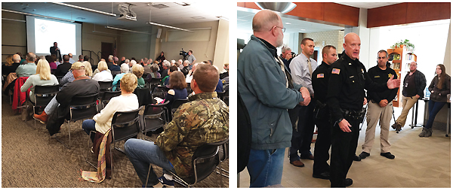
PARTNERS IN SAFETY Staff at the Clifton Park–Halfmoon Public Library, NY, attend a safety training presentation given by the local Sheriff’s Office; police officers then offered a debriefing after a librarywide drill. Photos courtesy of CPHPL
IMPROVING AWARENESS
The New Jersey State Library (NJSL) has held active shooter trainings for staff in multiple locations, all of which have been oversubscribed. NJSL worked with a local security association, primarily comprised of former state troopers, to prepare frontline staff for the chaos of an active shooter situation. Kathleen Moeller-Peiffer, deputy state librarian for library support services with NJSL, advises libraries to be “proactive” in training their staff, as preparation and awareness are key to making good decisions in tough circumstances. She notes that shortly after a training, a staff member at a New Jersey public library saw someone with a gun on the premises and called the police. “I would like to think that [was] someone who was at a training and was more aware,” she says.
Moeller-Peiffer brings a unique perspective, having come to NJSL from New Mexico, a state with much more liberal gun laws and that experienced a fatal shooting at the Clovis-Carver Public Library (CCPL) in August 2017. “It was interesting to see the conversations that went on in the wake of that,” she says. “People called for a ban on guns in public libraries—but just because there is a ban on guns doesn’t mean that people won’t bring them in.”
Margaret Hinchee, director of CCPL, tells LJ that while her staff had never conducted an active shooter training exercise in advance of August’s tragedy, they had reviewed policies and procedures such as knowing to exit the building. However, she notes, in the panic of an active shooter event unfolding, even the most detailed policies can be forgotten. “You just take it for granted that that kind of thing is not going to happen here at the library. Looking back at the whole incident, from beginning to end, it was less than ten minutes.”
Nevertheless, Hinchee explains, the “most important thing” is to have some form of policy in place and for staff to know where they should go for their own safety. Libraries should also make sure that first responders at a local police department and fire department know the layout of their building, she adds, including the location of exits and alarms.
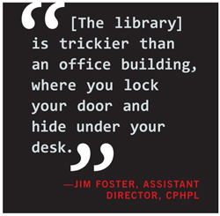STRICTER SECURITY
Moeller-Peiffer notes that officials at some libraries, such as Portales Public Library (PPL), near CCPL, reacted to the Clovis shooting by considering more aggressive security measures such as Plexiglas in front of the circulation and reference desks. However, aside from personnel and response training, says PPL director Denise Burnett, no other security changes have taken place to date; the estimate provided by the construction company was too high, and her request that the city hire an in-house contractor for the library remains in the works.
In November 2017, the New Mexico Library Association (NMLA) made recommendations to help prevent another violent event, including a focus on comprehensive building security such as limiting the number of entrances and exits in a library and never having an unlocked entrance at the rear of a building. The New Mexico presentation also featured suggestions for libraries with limited budgets, such as seeking out donations of discarded but still working equipment from larger agencies that are upgrading their own security systems; grants; and community partnerships with local security system contractors.
Major actions such as the use of metal detectors or full-time security guards remain rare in all but very large institutions or those in major metropolitan areas. Hinchee notes that a security guard may not be able to make a difference in preventing a shooter from entering and harming someone without additional barriers like metal detectors. Staff in Clovis are now required to carry walkie-talkies while on the library floor.
Academic campuses, including their libraries, are no stranger to gun violence. In 2010, a student at the University of Texas, Austin, started shooting with an AK-47 outdoors before running into a campus library and taking his own life. In 2014, three students were shot when a former student opened fire in the midst of the crowded Strozier Library at Florida State University (FSU), Tallahassee. Both incidents demonstrated the vulnerability of academic libraries.
In advance of the FSU shooting, the campus had already prioritized library security, with a security force of full-time staff, as well as student workers and public safety officers from the university, monitoring visitors in the library lobby. The library required all patrons and visitors to swipe through turnstiles before entering the main space. According to a report released by FSU in the aftermath of the shooting, security footage showed the gunman entering the lobby shortly after midnight during the busy exam period and staring at the turnstiles, “perplexed,” before exiting and opening fire on the library steps. Julia Zimmerman, dean of university libraries at FSU, notes that “[the shooter] could easily have jumped over, but it’s a psychological barrier. Had he actually breached the turnstiles and gone into the library,” where hundreds of students were studying for exams, “it could have been a disaster.”
Zimmerman adds, “One of the things that we really learned is just how vulnerable we all are…. You can’t prepare for every eventuality.” In the wake of the shooting, the university initiated a security audit of major buildings. The audit “made us a believer that putting those turnstiles in was absolutely the right thing to do,” says Zimmerman. While many students and employees ran for cover or fled the building the night of the shooting, others walked closer to check out the commotion or see what was happening. There is “only so much you can do” to prepare a very large and constantly revolving student body to make the best choices in a crisis, according to Zimmerman, so instead the library relies on regular active shooter training for all of its staff, including student workers. The library leadership also continue to work closely with FSU security to develop best practices.
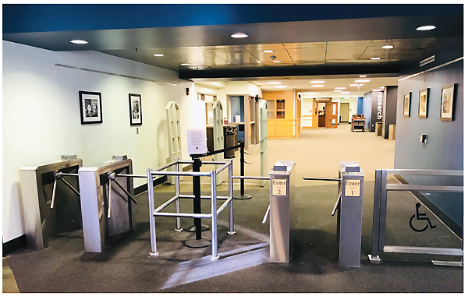
A DETERRENT Turnstiles at Florida State University’s Strozier Library helped prevent a more severe incident.
Photo courtesy of FSU
EXPERT TIPS
Steve Albrecht, a security expert who has worked with libraries throughout the United States on workplace violence prevention and has written for LJ on library security, emphasizes the importance of teaching staff to recognize danger signs in the context of their own community. In a state with more liberal gun laws, he notes, seeing a person carrying a gun may not merit an immediate call to the police. Staff should consider whether a person’s body language or demeanor suggests they are looking to threaten or harm someone. The NMLA presentation, similarly, advised “situational awareness” to look for people who appear uncomfortable or suspicious.
This is understandably a murky area that could lead to targeting of innocent patrons, such as homeless or mentally ill persons, or those fitting a particular racial profile. Instead, Albrecht gives the example of patrons in open carry states who are “showy” with guns rather than carrying them in a discreet holster, or who repeatedly refuse to make eye contact. Overall, trainings like the New Mexico presentation encourage employees to trust their instincts and remain aware of who is coming in and out of the building.
Albrecht also describes trainings—such as that organized by New York’s CPHPL and many other institutions—and staff meetings as key opportunities to have “difficult discussions.” Staff meetings may use role play to portray dangerous scenarios to help employees consider how they would respond to a stressful or frightening situation. Staff can also undertake a security assessment of their library building, identifying exits and safe hiding places. Items like carts or shelves can be used to block doors and keep shooters out, he notes, while thick books could potentially stop bullets.
Albrecht adds, “In a perfect world, libraries would have a good relationship with their local police or sheriff’s department. Police can be seen as partners for library staff and patrons.” As was the case in the CPHPL active shooter drills, local police or private security companies can also provide support for trainings and safety assessments. Some library/police collaborations are even more proactive and go beyond the institution itself: as this article went to press, Kansas City Public Library, MO, announced a partnership with the Kansas City police department and Moms Demand Action to offer gun safety presentations and free gun locks to library patrons.
However, library and local police collaborations can prove challenging in municipalities with limited resources. CCPL’s Hinchee notes that she has requested regular police visits to the library and, since the shooting, additional security tools such as panic buttons. These requests have been met with slow or sporadic response, and local police still do not have a detailed understanding of the library’s layout or a commitment to helping secure the building at vulnerable times such as opening or closing. Moreover, a police presence in the library can present other issues, making some patrons feel unsafe.
Many professionals who spoke to LJ are prioritizing preparedness and confidence for their staff over more rigid security procedures like additional guards or entry checkpoints. Overall, library administration and employees are doing their best to walk a fine line between keeping patrons safe and maintaining the openness that makes libraries such a vital part of their communities.
NO GUNS ALLOWED
Guns in the United States are regulated state by state, creating a patchwork of rules about who may own and carry a firearm and where they may carry it. Given these disparities, library administrators nationwide take varying approaches to addressing firearms in and around their buildings.

Advocating for Change
Confusing regulations have spurred librarians to take action in Missouri, where the law permits many residents to carry a gun legally without a concealed carry permit. The most recent concealed carry law provides 17 locations or instances where weapons may be prohibited, including those that serve large numbers of children, such as schools and churches. The law does not, however, include public libraries. According to president of the Missouri Library Association (MLA) Vicky Baker, “It is our belief that we were inadvertently left out of the law—there are always children in our building. We are now trying to get across to the legislature that we want to be able to decide what to do about this.”
In October 2017, MLA voted on a legislative agenda at its annual conference, expressing a desire to have the law changed so that library administrators may choose whether to prohibit or allow firearms on their premises. The association is working with a legislative advocate and communicating with individual legislatures to clarify its position on the topic. Librarians in Nevada encountered a similar issue in early 2017, with a bill going before the Nevada Assembly that would prohibit weapons from public library property, absent written permission from the governing board of the library. Before the bill died in committee in May, vehement Nevada gun rights supporters spoke out in opposition to the restriction of weapons in public libraries.
With respect to the MLA legislative agenda, the National Rifle Association (NRA) has published a response on its website that describes the position of MLA as vying to “opt out of allowing law-abiding citizens to defend themselves.” Baker admits that the topic of firearms is “contentious” and emphasizes that MLA is simply advocating for the ability of individual libraries to decide what approach to firearms is best for their location—appropriate rules may differ in rural areas vs. a city such as Kansas City or St. Louis, she says. While not all librarians and patrons across Missouri agree on the best restrictions for guns in their libraries, notes Baker, “I think we can all get on the same page…[by letting] the local community decide.”

Protecting an Open Campus
The University of Virginia (UVA) faces unique challenges, as it is home to a network of academic libraries but is also—as illustrated by the violent demonstrations of August 2017, when white nationalists clashed with counterprotesters on campus grounds—a historic space open to public visitors. UVA is also located in an open carry state, where concealed weapons and open carry without a permit for people over 18 are legal, although the university does have a carve out from state law, meaning its campus is an exception to open carry rules and firearms are prohibited.
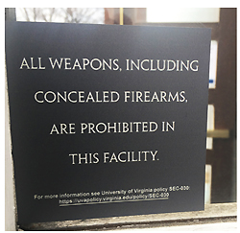
PUBLIC AWARENESS The permanent sign displayed at University of Virginia buildings stating the campus stance on guns. Photo courtesy of UVA
According to John Unsworth, dean of libraries at UVA, however, there is “no reason to believe that the general public” is aware of that carve out. In recent months, a working group at the university has started to address questions of policy and awareness around guns on campus, including developing signage that informs people they cannot bring guns into university buildings. Signs are now posted on buildings that receive regular traffic from the general public, including libraries. Unsworth explains, “I didn’t want the people who work at the desk to have to think about what they would do if someone walked in with a gun, wondering if they are aware of the policy. They can just call 911.”

Guns Outside the Library
Other libraries take compromise positions in order to comply with regional laws. In Ohio, the Dayton Metro Library (DML) policy prohibits visitors from bringing all dangerous weapons, including firearms, into library buildings. As of last year, there is an exception to the rule barring guns from library premises: concealed carry permit holders may store their firearms in locked vehicles on library property. DML instituted this change in response to a 2017 change in Ohio state law, permitting concealed carry permit holders to leave guns in secured vehicles. The bill represents a middle ground, much like the similar compromise attempted in Nevada.
Tim Kambitsch, DML executive director, describes the change as a “modest” one that addresses state law while also staying consistent with the view that “the library is no place for guns or other weapons.” As is the case with any shift on a hot-button issue such as guns, it did spark some controversy. Kambitsch recalls a member of a local gun group who came to a library board meeting in advance of the vote on the policy changes “to make a case that any restriction on open carrying of firearms outside of library buildings is in violation of state law and the Ohio constitution…. The local gun group representative returned the following day with a gun in his holster but did not enter our building.” The individual engaged with security guards and left of his own accord without incident, and since then the policy has garnered limited concern or reaction from staff or the public.
Regardless of local laws or standards, libraries around the country share the same priorities—creating a space that is open to the communities they serve and that provides patrons with a safe environment. As the recent American Library Association (ALA) statement on the effect of gun violence on libraries makes clear, libraries are meant to be “safe havens” and can serve a vital role in promoting conversations and progress about sensible gun policies.
Jennifer A. Dixon is Electronic and Serials Librarian, Maloney Library, Fordham University Law School, New York
This article was published in Library Journal. Subscribe today and save up to 35% off the regular subscription rate.

https://lj.libraryjournal.com/2018/02/public-services/guns-library-safety-security/

