

**Año 3 Número 65 marzo 2018**

**Contenidos de este número**

**1.**

OCLC Research Publishes Three New Reports on Descriptive Metadata for Web Archiving

Filed by [Gary Price](http://www.infodocket.com/author/gprice/) on February 8, 2018

The three reports linked below were just published by the OCLC Research Library Partnership Web Archiving Metadata Working Group (WAM).

**Overview**

The RLP Web Archiving Metadata Working Group working with Jackie Dooley, RLP Program Officer, has written three publications focused on descriptive metadata for web archiving.

The work arose in part from two recent surveys—one of end users of archived web content and the other of web archiving practitioners—both of which showed that lack of a common approach to creating metadata was the most widely shared challenge across the web archiving community.

In response, OCLC Research established the Web Archiving Metadata Working Group to develop recommendations for descriptive metadata. Their approach is tailored to the unique characteristics of archived websites, with an eye to helping institutions improve the consistency and efficiency of their metadata practices in this emerging area.

The working group recognized the importance of gaining a clear understanding of the needs of users of archived web content, and took this into account throughout the project. The work was done in consultation with the International Internet Preservation Consortium, the Society of American Archivists Web Archiving Section, and the Internet Archive’s Archive-It program, and with much community input and feedback.

**Report One**

**Title**

[Descriptive Metadata for Web Archiving: Recommendations of the OCLC Research Library Partnership Web Archiving Metadata Working Group](https://www.oclc.org/content/dam/research/publications/2018/oclcresearch-wam-recommendations.pdf)

**Authors**

Jackie Dooley and Kate Bowers

**About**

consistent metadata that address the unique characteristics of websites and collections. More specifically:

* Develop community-neutral, standards-neutral practices for descriptive metadata for archived web content, taking into account the needs of end users and metadata practitioners.
* Define a lean set of data elements with usage notes to guide the preparation of data content.
* Ensure that the data elements can be used in concert with other standards that have far more granular data element sets.
* Provide a bridge between bibliographic and archival approaches to description.  
  Use a scalable approach that requires neither in-depth description nor extensive changes to records over time.
* Enable practitioners to have confidence that they are contributing to the application of consistent practice in this emerging area.

WAM’s recommended practices can be used by any institution or person with a need to describe web content. Some potential use cases:

* Scholars building personal archives of websites for research purposes
* Libraries and archives using RDA/MARC that seek specific guidance on the element and content that are most pertinent to description of web content
* Archives and libraries having a need to map their DACS-based MARC records and/or EAD-encoded finding aids to the more simplified structure of a digital repository or a web tool such as Archive-It
* Digital repositories encoding metadata for web content in MODS without reference to any content standard
* Archive-It users seeking guidance on creating content for Dublin Core elements

Direct to [Full Text Report (58 pages; PDF)](https://www.oclc.org/content/dam/research/publications/2018/oclcresearch-wam-recommendations.pdf)

**Report Two**

[Literature Review of User Needs](https://www.oclc.org/content/dam/research/publications/2018/oclcresearch-wam-literature-review-user-needs.pdf)

**Authors**

Jessica Venlet, Karen Stoll Farrell, Tammi Kim, Allison Jai O’Dell, and Jackie Dooley

**About**

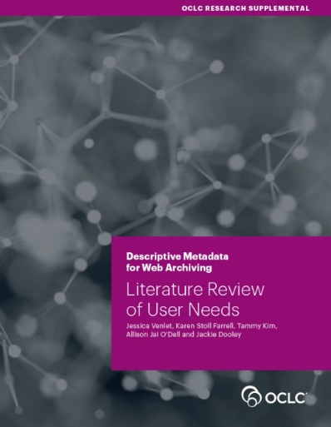The OCLC Research Library Partnership Web Archiving Metadata Working Group was formed to recommend descriptive metadata best practices for archived web content that would meet end-user needs, enhance discovery and improve metadata consistency. To that end, the group conducted a literature review to inform their development of best practices.

They selected readings that include, at minimum, a substantive section related to metadata, but most covered a wider swath of issues. This helped them learn much else about who the users of web archives are, the strategies they use and the challenges they face.

The literature falls into two clear categories: the needs of end users and the needs of metadata practitioners. This review characterizes types of end users, their research methodologies, barriers to use, discovery interfaces, and the need for support services and outreach. The review of practitioner literatures addresses the need for scalable practices, the standards and shared practices currently in use, the outcomes of a variety of case studies and other approaches to metadata.

Direct to [Full Text Report (50 pages; PDF)](https://www.oclc.org/content/dam/research/publications/2018/oclcresearch-wam-literature-review-user-needs.pdf)

**Report Three**

[Review of Harvesting Tools](https://www.oclc.org/content/dam/research/publications/2018/oclcresearch-wam-harvesting-tools.pdf)

**Authors**

Mary Samouelian and Jackie Dooley

**About**

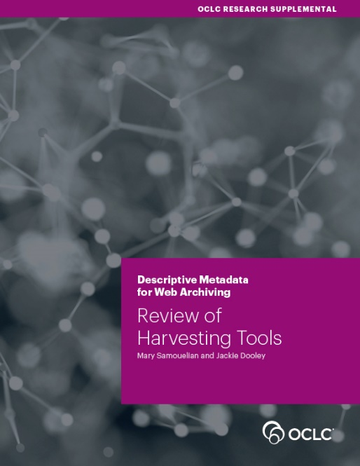The OCLC Research Library Partnership Web Archiving Metadata Working Group (WAM) was formed to recommend descriptive metadata best practices for archived web content. When the group began its work early in 2016, we discovered that metadata practitioners had high hopes that it would be possible to extract descriptive metadata from harvested content.

This report offers our objective analysis of 11 tools in pursuit of an answer to that question. We reviewed selected web harvesting tools to determine their descriptive metadata functionalities. The question we sought to answer was this: Can web harvesting tools automatically generate descriptive metadata that supports the discoverability of archived web resources? Auto-generation of descriptive metadata for archived web resources could result in significant gains in the efficiency of data entry and thus help enable metadata production at scale.

Our intent was twofold: 1) provide the web archiving community with a description of each relevant tool’s overall purpose and metadata-related capabilities, and 2) inform WAM’s overarching objective of preparing best practice recommendations for web archiving descriptive metadata based on an understanding of user needs.

Direct to [Full Text Report (26pages; PDF)](https://www.oclc.org/content/dam/research/publications/2018/oclcresearch-wam-harvesting-tools.pdf)

**About Gary Price**

Gary Price ([gprice@mediasourceinc.com](mailto:gprice@mediasourceinc.com)) is a librarian, writer, consultant, and frequent conference speaker based in the Washington D.C. metro area. Before launching INFOdocket, Price and Shirl Kennedy were the founders and senior editors at ResourceShelf and DocuTicker for 10 years. From 2006-2009 he was Director of Online Information Services at Ask.com, and is currently a contributing editor at Search Engine Land.

[**http://www.infodocket.com/2018/02/08/three-new-reports-from-oclc-research-on-descriptive-metadata-for-web-archiving/**](http://www.infodocket.com/2018/02/08/three-new-reports-from-oclc-research-on-descriptive-metadata-for-web-archiving/)

You are here: [Home](https://lj.libraryjournal.com/) / IFLA LGBTQ Group Protests Kuala Lumpur Conference Location

2. IFLA LGBTQ Group Protests Kuala Lumpur Conference Location

By [Lisa Peet](https://lj.libraryjournal.com/author/lpeet/) on February 27, 2018 [Leave a Comment](https://lj.libraryjournal.com/2018/02/organizations/ifla-lgbtq-group-protests-kuala-lumpur-conference-location/" \l "respond)

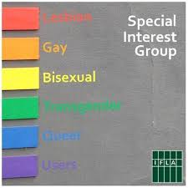As the [International Federation of Library Associations and Institutions](https://www.ifla.org/) (IFLA) prepares for its 84th annual World Library and Information Congress (WLIC), the chosen location—Kuala Lumpur—is sending up red flags because of Malaysia’s track record on civil rights. Since the conference location was announced at the closing session of the 2016 WLIC, IFLA’s LGBTQ (lesbian, gay, bisexual, transgender, queer) Users Special Interest Group (SIG), as well as the Association of Research Libraries (ARL), have written open letters to IFLA administration stating their concerns.

Malaysian law prescribes harsh measures for LGBTQ sexual activity, including corporal punishment and up to 20 years imprisonment. The current Malaysian prime minister, Najib Razak, has spoken out publicly against civil rights for LGBTQ people.

The conference, which has been hosted in locations from Cape Town, South Africa to Columbus, OH, is scheduled to take place August 24–30, celebrating the theme “Transform Libraries, Transform Societies.” The LGBTQ SIG will not be attending the gathering.

**TWO LETTERS, ONE ISSUE**

Members of the LGBTQ SIG had originally hoped that the group could be part of a satellite conference outside of Kuala Lumpur. When that option did not materialize, on November 28, 2017 the SIG, coordinated by group convenor Anne Reddacliff, librarian at the State Library of New South Wales, Australia, drafted an open letter to the IFLA Governing Board. “We are writing to express our severe disappointment at the choice to hold WLIC 2018 in Malaysia,” the letter read in part. “It is currently illegal to be gay in Malaysia, meaning that our Special Interest Group, the IFLA LGBTQ Users Special Interest Group, are excluded from participating in WLIC 2018. We are not willing to risk our personal safety to attend the conference.”

The letter also referenced IFLA’s commitment to the United Nations’ [Sustainable Development Goals](http://www.un.org/sustainabledevelopment/sustainable-development-goals/)(SDGs), as called for in its 2017 [Development and Access to Information](http://origin-da2i.ifla.org/sites/da2i.ifla.org/files/uploads/docs/da2i-2017-full-report.pdf) report, produced jointly with the University of Washington Information School’s Technology & Social Change Group. Noting that Goal 10 of the SDGs is “Reduced Inequalities,” the letter stated, “We are dismayed by the choice of a host country where LGBTQ people do not have equal rights and are, in fact, persecuted.”

It concluded, “We acknowledge the location for WLIC 2018 cannot be changed but we urge you to choose a location for WLIC2019 that is not prohibitive to LGBTQ people and will allow the IFLA LGBTQ Users Special Interest Group to participate.” The letter was signed by the LGBTQ SIG and an additional 25 SIGs and sections of IFLA: Academic and Research Libraries, Acquisition and Collection Development, Bibliography, Cataloguing, Continued Professional Development and Workplace Learning, Environment, Sustainability and Libraries, Government Information and Official Publications, Indigenous Matters, Latin America and the Caribbean, Law Libraries, Libraries Serving Persons with Print Disabilities, Library and Research Services for Parliaments, Library Services to People with Special Needs, Library Theory and Research, LIS Education in Developing Countries, Literacy and Reading, Metropolitan Libraries, New Professionals, News Media, Preservation and Conservation, Public Libraries, Reference and Information Services, School Libraries, Science and Technology Library, and Women, Information and Libraries. None of these groups plan to boycott the WLIC.

The letter from ARL, sent independently of the LGBTQ SIG’s and a month earlier, was addressed to IFLA president Glòria Pérez-Salmerón and also outlined the organization’s concerns with Kuala Lumpur as a conference site. In the letter, ARL president Mary Ann Mavrinac, chair of the ARL Diversity and Inclusion Committee Gerald Beasley, and chair of the ARL Advocacy and Public Policy Committee Ed Van Gemert stated, “We urge the IFLA governing board to consider local legislation and policy in the selection of future sites for the Congress. If IFLA honors its stated core values, then there must be diligence in selecting sites that allow for the safety of all attendees as well as full participation, without fear of reprisal.”

The location could pose a problem to attendees who do not identify as LGBTQ as well, ARL noted in a December 6 post on its website. “[T]he Malaysian government endorses and engages in censorship and does not honor confidentiality. Both freedom of expression and respect of confidentiality will be necessary to productive discussions at the upcoming WLIC. The potential dampening effect of censorship and lack of confidentiality should concern all WLIC 2018 participants.”

According to the 2016 U.S. Department of State Human Rights Report, other human rights problems in Malaysia include “deaths during police apprehension and while in custody; laws allowing detention without trial; caning as a form of punishment imposed by criminal and ‘sharia’ (Islamic law) courts; restrictions on the rights of migrants, including migrant workers, refugees, and victims of human trafficking; official corruption; violence and discrimination against women.”

In a second communication with IFLA, ARL also pointed out that an influx of attendees from around the world would benefit Malaysia economically, potentially fueling the country’s leadership to maintain repressive policies. The event is expected to attract 3,000–4,000 delegates from more than 100 countries, and to generate RM 444.4 million ($113.86 million U.S), according to the Malaysia Convention and Exhibition Bureau COO Datuk Zulkefli Sharif.

“We’ve expressed our concerns,” Beasley told LJ. “We’re very supportive of IFLA, its mission, and its goals. Our hope is that they will take into consideration the safety and security of a diverse and inclusive group of IFLA members who wish to convene in future [WLICs].”

**https://lj.libraryjournal.com/2018/02/organizations/ifla-lgbtq-group-protests-kuala-lumpur-conference-location/**

3.

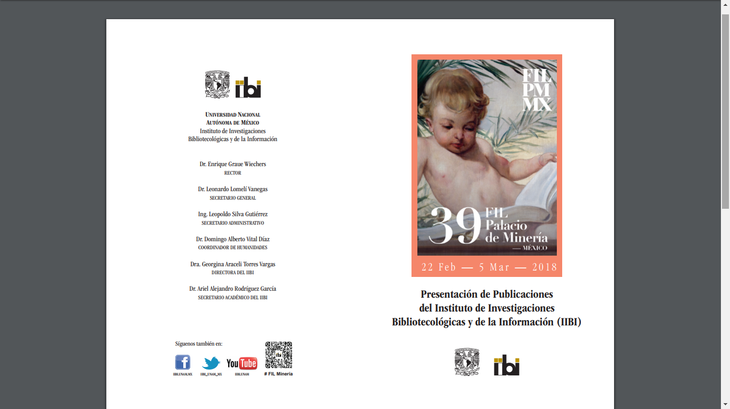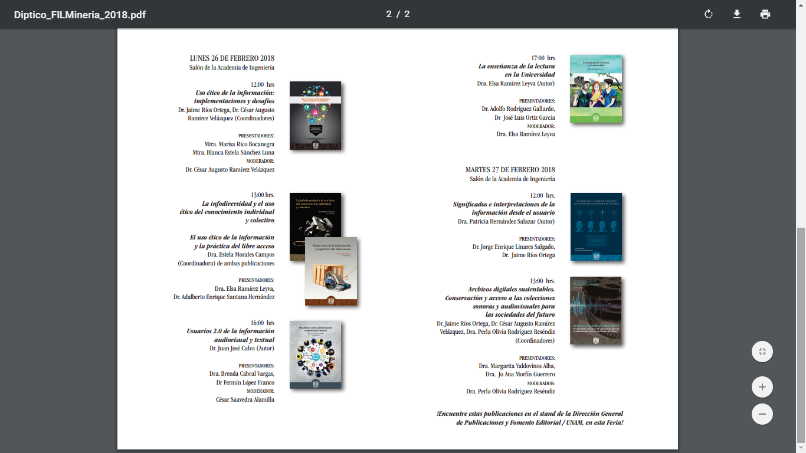

4.

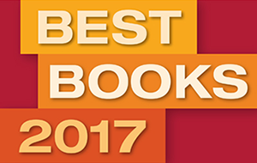

It's time again for LJ’s annual Top Ten Best Books of the year, selected by our editors, as well as Top Five lists for genre fiction, nonfiction, poetry and literature, graphic novels, and SELF-e titles.   [**SEE WHO MADE THE LIST**](http://lj.libraryjournal.com/bestbooks2017/)

Best Free Reference Websites & Apps of 2017

BY [LJ REVIEWS](https://reviews.libraryjournal.com/author/ljreviews/) ON FEBRUARY 28, 2018 [LEAVE A COMMENT](https://reviews.libraryjournal.com/2018/02/reference/best-free-reference-websites-apps-of-2017/" \l "respond)

[**Disaster Lit Resource Guide for Disaster Medicine and Public Health**](https://disasterlit.nlm.nih.gov/)  
A carefully curated collection—updated daily—of links to documents on disaster medicine and public health (research reports, guidelines, fact sheets, websites, etc.) from noncommercial sources. Users can also sign up for the Listserv to receive email updates.

[https://reviews.libraryjournal.com/wp-content/uploads/2018/02/econbiz-logo-px2-e1519838297754.png**EconBiz**](http://www.econbiz.de/)  
Created by the German National Library of Economics and the University and City Library of Cologne, this resource offers access to business- and economics-related literature, a calendar of scholarly conferences, a virtual reference desk, and more.

[**European Rail Schedule from Deutsche Bahn**](http://www.bahn.com/)  
From Germany’s National Railroad, this user-friendly site offers travelers a time­table for trains all over Europe—don’t leave home without bookmarking it.

[**Europeana Radio**](http://www.europeana.eu/portal/en/radio.html)  
Part of Europeana Collections, which offers access to digitized artwork, books, and more, Europeana Radio lets users stream more than 200,000 tracks, taken from archives from 12 European nations. Listeners are encouraged to aid classification efforts by tagging tracks by genre.

[**Global Edge**](http://globaledge.msu.edu/)  
Michigan State University’s International Business Center offers a resource with an international focus. Users can seek statistical information on 202 nations and each of the 50 states, plus material on a variety of different industries, and much more.

[**IKEA Place, Augmented Reality Furnishing**](http://itunes.apple.com/us/app/ikea-place/id1279244498?mt=8.)  
**iOS only.**Wondering how that chair or ottoman will look in your living space? There’s an augmented reality app for that. IKEA Place lets prospective buyers insert a 3-D, true-to-scale model of a piece into a photo of their room—taking the guesswork out of furniture shopping. Similar apps include Apple’s ARKit and Target’s See It in Your Place.

[**NHL.com**](http://www.nhl.com/stats)  
The National Hockey League marks its centennial by (how else?) digitizing its statistics archives—an endeavor six years in the making. Sports fans will be delighted with, for instance, stats on individual players, box scores for every game in history, and advanced searching and filtering.

[**NPR’s Fresh Air Available on WorldCat**](http://www.worldcat.org/)  
Through a grant from the Council on Library and Information Resources, WHYY-FM recently created a digital archive of episodes of Fresh Air (with streamable audio), the phenomenally popular radio show. Users can access this rich cultural trove, available via WorldCat.

[**PEN America’s Digital Archive**](http://archive.pen.org/)  
The organization known for defending freedom of expression and celebrating literature has launched an online archive with more than 1,500 hours of audio and video going as far back as 1966. These recordings of meetings, debates, and panel discussions offer a wealth of literary and cultural discourse.

[**Price the Vineyard**](http://ptv.library.ucdavis.edu/)  
The University of California (UC)–Davis Library has digitized more than 200 catalogs from wine distributor Sherry-­Lehmann, dating from the 1930s to the 1950s. Users are invited to transcribe the digitized data, making it more searchable. The library was also responsible for another crowdsourced wine-related project, Label This, a collection of wine labels from Maynard Amerine, a UC-Davis professor of viticulture and ecology.

[**Sanborn Maps at the Library of Congress**](http://www.loc.gov/collections/sanborn-maps)  
Last year, the Library of Congress (LC) made available approximately 25,000 Sanborn Fire Insurance Maps. These detailed historical documents contain information such as street names, building materials, and property boundaries and are a boon to genealogists, historians, urban planners, and many others. LC will continue to add maps every month until 2020.

[**The Social Welfare History Image Portal**](http://images.socialwelfare.library.vcu.edu/)  
History lovers, rejoice. Virginia Common­wealth University Libraries and seven partner institutions present a new resource that curates ads, pamphlets, placards, and other ephemera from social movements such as women’s suffrage.

**WanderU**  
Those with wanderlust have a new tool—this site (also available as an app for Android and iOS) lets users find and book trips by bus, train, or airplane. Specifics on hotels and car rentals is included. The “explore” option lets the intrepid see all trips available from a given location

https://reviews.libraryjournal.com/2018/02/reference/best-free-reference-websites-apps-of-2017/

5. Save the date! The IFLA Global Vision Report is coming soon

GV

Global Vision <GlobalVision@ifla.org>

*Save the date!*

IFLA Global Vision Report Launch

Watch our *Save the date* video!

<https://vimeo.com/256378039>

The wait is nearly over! Results from the world's first-ever global discussion across the library community will be revealed on **Monday 19 March 2018** when [*IFLA’s Global Vision Report*](https://www.ifla.org/node/11905)is launched during the [IFLA President’s Meeting](https://president2018.ifla.org/) in Barcelona, Spain.

Never before have so many librarians from every continent and almost every country in the world produced such a ground-breaking collection of ideas to connect and unite each other.

Library leaders, outstanding experts, young professionals and librarians from multiple generations have had their say, making this a unique and hugely influential document that will shape the library field's future.

Don't forget to **save the date** and **download** your copy soon!

[Click here for more details about IFLA Global Vision](https://www.ifla.org/globalvision)

6. Prepare your researchers for publishing success

LP

Library Journal Partner

|  |  |  |  |  |  |  |  |  |  |  |  |  |  |  |  |  |  |  |  |  |  |  |  |  |  |  |  |  |  |  |  |  |  |  |  |  |  |  |  |
| --- | --- | --- | --- | --- | --- | --- | --- | --- | --- | --- | --- | --- | --- | --- | --- | --- | --- | --- | --- | --- | --- | --- | --- | --- | --- | --- | --- | --- | --- | --- | --- | --- | --- | --- | --- | --- | --- | --- | --- |
| |  |  |  |  | | --- | --- | --- | --- | | |  | | --- | |  | |  | |  | |  |  | | --- | |  | | |  |  |  |  |  |  |  |  |  |  |  |  |  |  |  |  |  |  |  |  |  |  |  |  |  |  |  |  |  |  |  |  |  | | --- | --- | --- | --- | --- | --- | --- | --- | --- | --- | --- | --- | --- | --- | --- | --- | --- | --- | --- | --- | --- | --- | --- | --- | --- | --- | --- | --- | --- | --- | --- | --- | --- | | |  |  |  |  |  |  |  |  |  |  |  |  |  |  |  |  |  |  |  |  |  |  |  |  |  |  |  |  |  |  |  |  | | --- | --- | --- | --- | --- | --- | --- | --- | --- | --- | --- | --- | --- | --- | --- | --- | --- | --- | --- | --- | --- | --- | --- | --- | --- | --- | --- | --- | --- | --- | --- | --- | | |  |  |  |  |  |  |  |  |  |  |  |  |  |  |  |  |  |  |  |  |  |  |  |  |  |  |  |  |  |  |  | | --- | --- | --- | --- | --- | --- | --- | --- | --- | --- | --- | --- | --- | --- | --- | --- | --- | --- | --- | --- | --- | --- | --- | --- | --- | --- | --- | --- | --- | --- | --- | | |  |  |  |  |  |  |  |  |  |  |  |  |  |  |  |  |  |  |  |  |  |  |  |  |  |  |  |  |  |  | | --- | --- | --- | --- | --- | --- | --- | --- | --- | --- | --- | --- | --- | --- | --- | --- | --- | --- | --- | --- | --- | --- | --- | --- | --- | --- | --- | --- | --- | --- | | |  |  |  |  |  |  |  |  |  |  |  |  |  |  |  |  |  |  |  |  |  |  |  |  |  |  |  |  |  | | --- | --- | --- | --- | --- | --- | --- | --- | --- | --- | --- | --- | --- | --- | --- | --- | --- | --- | --- | --- | --- | --- | --- | --- | --- | --- | --- | --- | --- | | |  | | --- | | Transforming your researchers into published authors |  |  |  |  |  |  |  |  |  |  |  |  |  |  | | --- | --- | --- | --- | --- | --- | --- | --- | --- | --- | --- | --- | --- | | |  | | --- | | Wiley |  |  | | --- | | eBook |  |  | | --- | | Get Published: Your How-To Guide | | Download your free copy of the eBook. | | [Download Now](http://mediasource.actonservice.com/acton/ct/10574/s-16e1-1802/Bct/l-00ab/l-00ab:22523/ct2_1/1?sid=TV2%3A9rryl6Z0y) |      |  | | --- | | For early career researchers, the process of getting research published can be both frustrating and daunting. Not only must they understand the entire publishing workflow and how they fit into it, they must also be equipped with the skills necessary to take them from student researcher to published author.  As an information expert, early career researchers may look to you and the library’s resources to help navigate the publishing process and ensure that their research is prepared to stand up against the rigorous standards and the competitive nature of scholarly publishing.  [Download your free copy of Get Published: Your How-To Guide](http://mediasource.actonservice.com/acton/ct/10574/s-16e1-1802/Bct/l-00ab/l-00ab:22523/ct2_2/1?sid=TV2%3A9rryl6Z0y) to get an in-depth understanding of the journey your researchers are faced with and discover the areas in which your library could play a critical role. | | |  |  |  |  |  | | --- | --- | --- | --- | --- | | |  | | --- | |  |  |  |  | | --- | --- | | |  | | --- | | [**Download the eBook**](http://mediasource.actonservice.com/acton/ct/10574/s-16e1-1802/Bct/l-00ab/l-00ab:22523/ct2_3/1?sid=TV2%3A9rryl6Z0y) | |  |  | | --- | |  | | | |  |  | | --- | | **AMERICAS** | | John Wiley & Sons, Inc. 111 River Street, Hoboken, NJ 07030-5774 USA Phone: +1 877 762 2974 | | **CANADA** | | John Wiley && Sons, Inc. 90 Eglinton Avenue East, Suite 300 Toronto, Ontario M4P 2Y3 Canada Phone: +1 416 236 4433 | | **EUROPE, MIDDLE EAST & AFRICA** | | John Wiley & Sons, Inc. The Atrium Southern Gate, Chichester, West Sussex PO19 8SQ England Phone: +44 1243 843294 |  |  | | --- | | **AUSTRALIA** | | John Wiley & Sons Ltd 155 Cremorne Street, Richmond, Victoria 3121 Australia Phone: +61 7 3859 9611 | | **ASIA** | | John Wiley & Sons Pte Ltd 1 Fusionopolis Walk, #07-01 Solaris South Tower, Singapore 138628 Phone: +65 6643 8333 | | **Customer Service** | | Web: [www.wiley.com/help](http://mediasource.actonservice.com/acton/ct/10574/s-16e1-1802/Bct/l-00ab/l-00ab:22523/ct3_0/1?sid=TV2%3A9rryl6Z0y) Email: [wileycustomer@wiley.com](mailto:wileycustomer@wiley.com) |  |  | | --- | | [© John Wiley & Sons](http://mediasource.actonservice.com/acton/ct/10574/s-16e1-1802/Bct/l-00ab/l-00ab:22523/ct4_0/1?sid=TV2%3A9rryl6Z0y). All rights reserved. [Privacy Policy](http://mediasource.actonservice.com/acton/ct/10574/s-16e1-1802/Bct/l-00ab/l-00ab:22523/ct5_0/1?sid=TV2%3A9rryl6Z0y). |  |  | | --- | | Wiley | | | | | | | |

You are here: [Home](http://lj.libraryjournal.com/) / KY Governor’s Budget Would Eliminate Library Funds

7. KY Governor’s Budget Would Eliminate Library Funds

By Bob Warburton on February 7, 2018 [1 Comment](http://lj.libraryjournal.com/2018/02/budgets-funding/ky-governors-budget-eliminate-library-funds/" \l "comments)

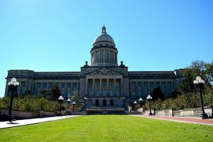

Kentucky State Capitol at Frankfort   
Photo credit: Seifler via Wikimedia Commons

Library Legislative Day in Kentucky on February 15 will give directors and advocates their first real chance to push back against Gov. Matt Bevin’s recent FY18–20 budget proposal, which seeks to eliminate every penny of the $2.5 million currently earmarked for direct state aid to libraries.

Kentucky’s FY17–18 budget contains $2,534,460 for state aid to libraries, just slightly less than the $2,534,500 projected for FY18–19 by Mark Adler, chairman of the [Kentucky Public Libraries Association](http://kpla.org/). Under Bevin’s plan, that money would be eliminated, [along with funding for 69 other programs](http://www.wkyt.com/content/news/Bevins-budget-would-strip-state-funding-to-these-70-programs-469746543.html), among them a variety of existing health and education initiatives.

Library officials’ annual trek to Frankfort to meet with and lobby legislators takes on greater significance during the biennial budget years. But Bevin’s call to zero out direct state aid has upped the stakes considerably. In his January 16 budget message, the governor cited a litany of fiscal challenges Kentucky faces, topped by a [severely underfunded pension](https://www.courier-journal.com/story/news/politics/2017/08/24/kentucky-pension-crisis-question-answers/549085001/) system.

At first glance, Bevin’s budget plan looks like a worst-case scenario for the state’s smallest public libraries. Each of Kentucky’s 120 county systems—some huge and others consisting of a single branch in a rural community—receive state aid. Three libraries—Ballard-Carlisle County Public Library in Wickliffe, Elliott County Public Library in Sandy Hook, and Hickman County Memorial Library in Clinton—depend on that money for 80 percent or more of their operating budgets. But none of them are preparing to close up shop quite yet.

Practically speaking, the budget Bevin [unveiled](http://www.wdrb.com/story/37280139/gov-bevins-proposed-budget-would-cut-most-state-agencies-by-more-than-6-percent) amounts to little more than a wish list. It’s nonbinding and designed merely to establish the governor’s spending priorities before the Kentucky House of Representatives and Senate get to work on the months-long budget process. Each house of the general assembly [will pass a budget](https://transparency.ky.gov/transparency/Pages/How-the-Budget-is-Made.aspx) before hammering out a final compromise through a joint conference. The current fiscal year ends June 1.

“Obviously things are pretty early in the game,” said Adler. “The legislative session just started fairly recently.… Generally, what we see is that proposals from the governor are not accepted carte blanche and everything is open for discussion.”

A statement from Woody Maglinger, the governor’s press secretary, seemed to offer some room for compromise as the budget making process unfolds.

“Gov. Bevin has worked closely with Cabinet leadership and the State Budget Office over many months to prepare 2018–20 budget recommendations,” Maglinger said. “With significant fiscal pressures exerted by the crippling pension burden and other escalating costs, tough decisions had to be made. The Commonwealth simply cannot spend money that it does not have. After a thorough review of state programs, the Governor’s budget proposal identified programs that should not be automatically perpetuated without a long-overdue analysis of their effectiveness during the legislative process.”

**STRENGTH IN NUMBERS**

Adler is director of the Paris–Bourbon County Public Library, a single-branch system that operates a large facility in the city of Paris. It relies on state aid for only 1.3 percent of its total budget. “But 1.3 percent of our budget is still a lot of books or a lot of videos or a lot of programs,” Adler said. “When you strip that out, it certainly represents a loss of funds that we have always anticipated would be there.”

Budget cuts won’t be the only agenda item library directors will address during their meetings with individual state representatives in Frankfort. But the visitors will certainly have their say on that matter, library officials told LJ.

“State aid is the main point,” said Lois Schulz, president of the nonprofit [Friends of Kentucky Libraries](http://friendskylibraries.org/), which plays a large role in organizing and developing talking points for Library Legislative Day. Most of the Friends and will wear yellow in Frankfort as a symbol of unity, as well as any other visitor who wants to take part and show solidarity.

Tara Griffith, president of the [Kentucky Library Association](https://www.klaonline.org/) (KLA), said, “It’s in times like these where strength in numbers is what we hope comes through for us.” She said it’s vital for library directors to “to give that personal story” to lawmakers about how such severe cuts “will affect them, their family, their work, their community as a whole.”

Griffith expressed dismay that academic, school and special libraries—all of which fall under KLA’s auspices—would also see a dramatic loss in services if the legislature ends up rubber-stamping cuts to all 70 of the programs targeted by the governor. “Our goal is to keep all libraries statewide funded at the current levels,” she said.

**DEPENDENT ON STATE AID**

State law [KRS 171.201](http://www.lrc.ky.gov/statutes/statute.aspx?id=4766) provides for a Public Library Services Improvement and Equalization Fund and uses a formula to determine how much county library systems can receive.

To begin with, each library system gets a lump sum grant: $9,000 for counties with a population of 22,000 or fewer, $8,000 for counties with a population between 22,001 and 45,000, and $7,000 for counties with more than 45,000 residents. The remaining aid is doled out at a rate of 73 cents per capita, to be used for a wide variety of purposes at the discretion of each library system.

The 2018–20 Executive Budget Recommendation posted online includes this notation: “Notwithstanding KRS 171.201, the Executive Budget provides no funding for non-construction state aid to local libraries.”

The vast majority of Kentucky libraries rely on [tax revenue](https://kdla.ky.gov/librarians/administrators/Pages/PropertyTaxRateCertification.aspx) to fund the bulk of their operations. State aid is usually a smaller, but not insignificant, piece of their budget, Adler said. But for the 20 or so small county systems that aren’t part of a library taxing district, state aid is the only thing between them and serious financial hardship.

[Ballard–Carlisle County Public Library](https://www.facebook.com/balcarlibrary/) in Wickliffe, located on the state’s western edge, is the most pronounced example of a county system that depends on state aid. The library is open just two days a week, and director Mary Silgals is an unpaid volunteer. She operates the facility on a budget of about $30,000 annually, she told LJ, with 94.4 percent of that supplied from state aid.

Silgals declined to comment specifically on Bevin’s budget proposal, but she said there’s enough money banked by the county to fund operations for one full year in the event all state aid is eliminated.

A retired library professional, Silgals won’t be attending Library Legislative Day, but she said two directors from nearby county systems plan on going and have pledged to lobby on Ballard–Carlisle’s behalf when they meet with their representatives.

[Hickman County Memorial Library](https://hickmancounty.ky.gov/County-Services/Pages/Hickman-County-Memorial-Library.aspx) in Clinton, which gets no funding from library taxes, depends on state aid for 82.5 percent of its total budget. Asked to comment on Bevin’s budget plan, director Laura Edwards Poole, said, “So far this is just a proposal and all the library directors are watching closely and paying attention to information we receive from Frankfort.” She declined further comment.

Adler, for his part, refused to play the alarmist. He cautioned that lawmakers, with one eye on their own future reelection concerns, would be hesitant to completely turn their backs on libraries.

“If we get closer toward the end of the session and the budget talks are going on and this is still in the budget, then certainly I’ll start to get a little bit more concerned,” he added. “But I would be very surprised, as popular as libraries are in their counties, to see that [these cuts] would stay in there.”

**http://lj.libraryjournal.com/2018/02/budgets-funding/ky-governors-budget-eliminate-library-funds/**