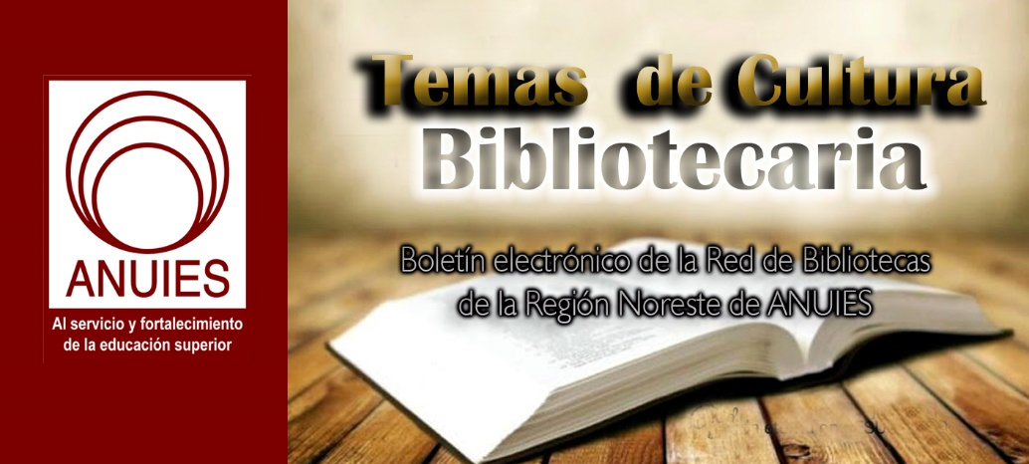
Año 3 Número 64 febrero 2018

Contenidos de este número

1.
[DOCUFORUM] Becas Big Data
B
Boletin Fundacion Ciencias de la Documentacion
Saludos cordiales
Profesionales de España e Iberoamérica
Antes de finalizar esta semana nos gustaría compartirles un par de noticias relacionadas con las actividades de la Fundación Ciencias de la Documentación, que igual les pueden resultar de interés:
CONVOCATORIA POR 2do. AÑO CONSECUTIVO DE LAS BECAS EN BIG DATA DOCUMENTAL
https://documentalistas.org/web/portfolio/bigdatadocu/
Debido al gran interés que el año pasado despertó el 1er curso online de especialización profesional en Big Data Documental, el cual fue completado por funcionarios y profesionales de empresas de distintos países de habla hispana, este año hemos decidido sacar una segunda edición. Se becarán a los 20 primeros profesionales que postulen, sean aceptados y abonen la matrícula en el plazo establecido. La beca cubre el 50% del costo total del curso. Interesados enviar CVitae y correo de solicitud a info@documentalistas.org
SISTEMAS DRM PARA LA PROTECCIÓN DE DERECHOS DE AUTOR EN LIBROS DIGITALES
NUEVO TALLER ONLINE CON MATRÍCULA GRATUITA
https://documentalistas.org/web/portfolio/sistemas_drm/
El desarrollo del comercio del libro digital se está sustentando fundamentalmente en la confianza en los sistemas DRM ¿pero son la mejor opción para el usuario? ¿realmente protegen los derechos de autor? y finalmente, ¿suponen una limitación a la libertad de uso de un bien cultural legítimamente adquirido? Lo analizaremos colaborativamente en este taller online disponible gratuitamente desde nuestro Campus virtual.
Muchas gracias por vuestra atención, un feliz fin de semana para todos/as.
---
Dpto de Información
Fundación Ciencias de la Documentación
https://documentalistas.org/campus
Grupo Telegram: https://t.me/joinchat/HIogdRErNiBLE0PSklOiDQ

2. Investigación Bibliotecológica: archivonomía, bibliotecología e información, número especial de bibliometría 2017, edita el Instituto de Investigaciones Bibliotecológicas y de la Información (IIBI)
JC
Jorge Castañeda <inforib@iibi.unam.mx>

Estimados colegas,
Tenemos el agrado de informarles que acaba de publicarse el número:
Especial de Bibliometria. 2017. México, ISSN: 2448-8321.
De la revista Investigación Bibliotecológica: bibliotecología, archivonomía e información, que edita el Instituto de Investigaciones Bibliotecológicas y de la Información (IIBI) de la Universidad Nacional Autónoma de México (UNAM). Este número lo puede consultar en texto completo, a través del actual sitio de la revista:
DOI:
http://dx.doi.org/10.22201/iibi.24488321xe.2017.nesp1
Reciban un cordial saludo y el agradecimiento por continuar al tanto de nuestra revista.
Atentamente,
Dr. Salvador Gorbea Portal
Director de la revista.

3. Plataformas de prestamo de libros electronicos
B
nos gustaría compartirles que siguiendo la misión de nuestra Fundación de ayudar a los profesionales de la información a afrontar los retos de la transformación digital, hoy hemos lanzado un nuevo taller online, con matricula gratuita, titulado "PLATAFORMAS DE PRÉSTAMO DE LIBROS ELECTRÓNICOS EN BIBLIOTECAS PÚBLICAS Y UNIVERSITARIAS".
El taller, de 15 días de duración, puede ser realizado desde nuestro Campus Online, para lo cual lo único necesario es estar registrado/a. El taller cuenta con el siguiente programa:
- Introducción. Breve panorama actual del tema.
- Módulo 1. eBiblio: Préstamo de libros electrónicos en bibliotecas públicas.
- Módulo 2. Otras plataformas de préstamo de libros electrónicos para bibliotecas públicas.
- Módulo 3. Plataformas de préstamo de libros electrónicos para bibliotecas universitarias.
- Examen final para la obtención del diploma digital.
Más información: https://documentalistas.org/web/portfolio/plataformasprestamo_ebook/
JUEVES 15/Febrero INICIAMOS CURSO ONLINE
LA CALIDAD EN LA GESTIÓN DOCUMENTAL
Profesora: Salomé Lendínez (todavía es posible matricularse)
Más información: https://documentalistas.org/web/portfolio/calidad-gdocu/
Muchas gracias por vuestro apoyo. Atentamente,
---
Dpto. de Información
Fundación Ciencias de la Documentación
https://documentalistas.org/campus
Usted ha recibido esta comunicación porque está inscrito/a en el Campus de la Fundación Ciencias de la Documentación, participa en alguno de nuestros proyectos o ha solicitado darse de alta en la lista Docuforum. Para darse de baja, por favor escriba a info@documentalistas.org con el asunto "Baja Docuforum".
4.
Cultural Literacy & Diversity Training >> New York City >> March 9
Bill Grover, School Library Journal <sljemail@schoollibraryjournal.com>

Good News!
The Early Bird Registration has been extended to Wednesday, February 7. You will now be able to take advantage of the lower rate for a little while longer.
After Wednesday, the standard registration rate will apply.
So don't delay, reserve your spot today!
Bill Grover
Senior Marketing Manager
School Library Journal Events
Cultural Literacy and Diversity Training for Librarians
March 9, 2018 | New York City
Register by February 7 to save 20% on the registration fee!

From: School Library Journal Events [mailto:sljemail@schoollibraryjournal.com]
Sent: Thursday, January 18, 2018 2:03 PM
Subject: Cultural Literacy & Diversity Training >> New York City >> March 9

Cultural Literacy and Diversity Training for Librarians
Registration is open for a special one-day workshop on Cultural Literacy and Diversity Training for Librarians presented by the editors of School Library Journal. Hosted on Friday, March 9 at Penguin Random House, this immersive, interactive day of learning will focus on evaluation of books and media, collection development practices, readers' advisory, and book marketing and promotion.

You will come away with an understanding of key concepts such as white privilege, implicit bias, and intersectionality. Librarians will learn how to recognize offensive stereotypes, tropes, and microaggressions within media and how to assess for authenticity and appropriation. You will also learn how to perform a diversity audit on existing collections and how to craft selection policies and guidelines that set benchmarks for diversity and inclusion.

Who should attend?  School librarians, public youth services librarians, educators.  Key skills/competencies that will be addressed:  - Understanding of key diversity and cultural literacy concepts such as white privilege, implicit bias, stereotypes and tropes, microaggressions, cultural appropriation, and intersectionality.  - Ability to recognize common problematic elements in text and art.  - Ability to assess the diversity and inclusiveness of current collection development, RA, and promotional practices.  - Tools, tips, and advice on how to better diversify collections and displays and how to advocate for inclusive books.  Register by February 7 to SAVE 20% on the registration fee!  Penguin Random House  1745 Broadway  New York, NY 10106 | Instructors include:  Mahnaz Dar  Assistant Managing Editor,  School Library Journal  Shelley Diaz  Reviews Manager,  School Library Journal  Kiera Parrott  Reviews Director,  Library Journal and  School Library Journal

Can't attend in-person on March 9?
Consider taking our online course—Diversity and Cultural Competency Training: Collections & RA. With live sessions on February 28 and March 14 from 2:00–4:00 PM ET, this immersive online course is bridged with homework, online workshops and discussions.

5. Cannabis Literacy | BackTalk
By Max Macias on February 7, 2018 Leave a Comment
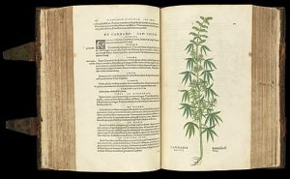
Cannabis plant from ‘De historia stirpivm commentarii insignes … ‘
Courtesty of Wellcome Images
Many states are legalizing the possession, use, and sale of cannabis for medical and/or recreational purposes, even as it remains illegal at the federal level. According to the National Organization for the Reform of Marijuana Laws (NORML), legalization has been adopted in Alaska, California, Colorado, Maine, Massachusetts, Nevada, Oregon, Washington State, and Washington, DC.
Whether or not your library is located in one of those states, the frequent presence of the substance in the news may be raising questions for your patrons, such as, is it a good alternative to opioids? Will it damage my body? Do I have to smoke it? In states where it is not yet legal, medical or recreational cannabis bills may be on the ballot. Our job is to help people find valid information—even if topics are controversial.
Normally, finding information about products, medicinal or otherwise, is straightforward. However, cannabis has a long history of misinformation campaigns and governmental persecution that can muddy the waters. To help meet patrons’ cannabis information needs, librarians should become familiar with the sources in their locales and regions.
LEGAL INFORMATION
- Ordinances: There are often local announcements and meetings about ordinances regulating the sale and use of cannabis. The library can maintain a binder, web page, or other resource.
- Governmental department websites: Some agencies have already packaged information. The Sacramento Cannabis Web Resource is a great example: www.cityofsacramento.org/marijuana.
MEDICAL INFORMATION
There has been a veritable windfall of data published on this topic in the last few years, for example:
- Dussault, Dee. Ganja Yoga: A Practical Guide to Conscious Relaxation, Soothing Pain Relief, and Enlightened Self-Discovery. (2017)
- Leinow, Leonard & Juliana Birnbaum. CBD: A Patient’s Guide to Health with Medicinal Cannabis. (2017)
- Oregon Health Authority. OMMP Plant Limits. (2017)
Reliable online resources include:
- National Conference of State Legislatures
- Oregon’s Medical Marijuana Program
Many insurance providers won’t cover, and some doctors refuse to issue, cannabis prescriptions. Therefore, patrons may need to search a resource such as Leafly’s medical marijuana doctor locator. (Leafly also features one of the most extensive cannabis strain lists in the world.)
You can even search for information in your area on medical cannabis doctors via Yelp. Several services charge users or require one to become a member; don’t buy into those. A local Facebook group can also be a good resource in your area, such as the Oregon Medical Marijuana Program Facebook group.
A GROWING BUSINESS
Business resources are another area librarians may not have considered. Cannabis-related businesses sell insurance, growing supplies, seeds, clones, edibles, flowers, concentrates, and associated equipment. Forbes reported over $6.7 billion in sales for 2016. Your library can prepare to serve these information needs by using the following:
- Cannabis Lawyers
- Small business information by state
LIBRARIES RESPOND
Libraries are rising to the challenge of providing reliable information. In October 2017, American Libraries cited Colorado’s Anythink, which not only circulates relevant books and movies but hosted a Careers in Cannabis speaking panel and librarian education nights, where librarians Jennifer Hendzlik and Aaron Bock “team with other Public Library Association (PLA) chapters to open a dialog about marijuana and literature.” Hendzlik and Bock also presented on the subject at the 2016 PLA conference in Denver. In a session titled “Puff, Puff, Lend: Cannabis Culture and the Library Collection,” they discussed selecting materials about growing, cultivating, and cooking marijuana, as well as business, use, science, law, and activism—plus “Book and Bud” pairings.
In January, the Oakland Public Library published a blog post titled “OPL Responds: The Legalization of Marijuana Use” that details the basics on the new law for California residents. Also, the Denver Public Library will hold a book event on the history of cannabis in the West in March.
With the advent of cannabis as big business, recreational legalization in several states, and the national opioid crisis, we can expect our patrons’ information needs to increase in this area. No matter where we live, librarians should prepare for requests and become familiar with reliable sources.

Max Macias, an independent librarian, teaches information literacy part-time for Portland Community College, OR. His interests include information and hip-hop, whiteness in education, racism in the United States, colonialism, cannabis resources for librarians, and education

http://lj.libraryjournal.com/2018/02/opinion/backtalk/cannabis-literacy-backtalk/

6. UC Berkeley Library to cut student, faculty resources
XIAOYE YAN/FILE
BY SRI MEDICHERLA | STAFF

The UC Berkeley Library is undertaking a $1 million reduction in expenditures for fiscal year 2019, a move that will primarily impact student and faculty access to scholarly resources.
The resources that will experience cuts include subscriptions to journals and book purchases. The cuts are a result of the increasing cost of these resources coupled with the decreasing funding the campus is receiving from the state, according to University Librarian Jeffrey MacKie-Mason.
Because there are cuts each year, the library staff is used to planning for the readjustment of resources each fiscal year, MacKie-Mason said. Typically, however, the cuts do not impact services for students and faculty.
“We have focused on improving efficiency (and) administrative services, for example,” MacKie-Mason said. “But this year, we couldn’t find enough of that sort, so we had to cut stuff to students and faculty.”
The decision to make these cuts was publicized to campus faculty through a campuswide email from Executive Vice Chancellor and Provost Paul Alivisatos.
“We cannot spend an ever increasing share of campus funds on journals and books unless we are willing to spend less in other areas (such as faculty compensation),” Alivisatos said in the email. “Thus, we continuously review, and necessarily reduce, our licensing of journals and acquisition of books.”
The cuts will affect all departments across campus, according to Mackie-Mason.
In the 24 hours after Alivisatos’ email was sent, faculty from the School of Public Health created a spreadsheet for student and faculty input, which includes a list of resources they want to save and the rationale for keeping them.
According to School of Public Health associate professor Amani Nuru-Jeter, students and faculty have expressed concern that a loss of certain resources would have a negative impact on their research. Some subject areas students and faculty are advocating to save resources for include pediatrics, diabetes and internal medicine, Nuru-Jeter said.
“My research is the intersection of education, sociology, and health services, thus the cuts would impact me at multiple angles,” health policy doctoral student Jung Kim said in an email. “My educational resources require content from an interdisciplinary lens, which unfortunately is not how content is published. … I can’t see how I would not be significantly impacted.”
Associate professor of history Victoria Frede said in an email that she is “dismayed” with the campus’s decision to make these cuts, which she believes will have long-term consequences for researchers at Berkeley.
“The announcement cast blame on publishers for raising the costs of publications, and publications are becoming more expensive,” Frede said in her email. “But surely that cannot explain why the university would choose to spend 1-1.5 million less on them.”
Despite acknowledging that the cuts may have negative impacts, Nuru-Jeter said she and her department understand the need for them and believe that campus has been handling the situation well.
MacKie-Mason said the library staff has tried to be as equitable as possible to all departments in implementing cuts and has tried to minimize impact that is felt by students and faculty.
The library has data on how many people use most journals, which is information they will use to determine what is cut, according to MacKie-Mason. Additionally, the library plans to reduce duplications and to switch to electronic-only editions of publications when it is possible.
Although resources will be removed from the UC Berkeley database, MacKie-Mason said there will be other ways for students and faculty members to access them — through other universities’ libraries, for example.
“I would like to reassure people that we don’t do this lightly. We wish this weren’t happening, but this is a campuswide thing,” MacKie-Mason said. “And we are constantly seeking advice so we don’t cut the important things.”
Contact Sri Medicherla at smedicherla@dailycal.org and follow her on Twitter at @sri_medicher

http://www.dailycal.org/2018/02/11/uc-berkeley-library-cut-student-faculty-resources/

