Año 3 Número 63 febrero 2018

Contenidos de este número

1.

Librarians and Journalists
JANUARY 25, 2018 BY ANNOYED LIBRARIAN 5 COMMENTS
The other AL linked to this article in its weekly mailing of mostly tedious stuff praising libraries. It compares two polls that show how much Americans love libraries and hate journalists. “What do librarians have that journalists don’t?” it asks.
It also covers the obvious answers: libraries are free to the public and they do a lot more than provide news and information.
After reading the article, I looked back at my post from a few months ago about how librarians are superior to clickbait journalists. Here were the ways I listed:
- Librarians don’t compromise themselves for money.
- Librarians serve the public good.
- Librarians educate people.
- Librarians have no reason to be ashamed of their work.
- Librarianship is an ancient profession
- Librarians care about what they do.
- People tax themselves to pay for libraries and librarians.
How many of those apply to “real journalists”? In general, they don’t compromise themselves for money in the direct way that clickbait writers do.
However, they do compromise themselves for ideology. Rare is the newspaper or magazine that doesn’t have a political bias of some kind, and stories that don’t fit the narrative don’t get published much.
They do serve the public good and educate people, mostly, and generally have no great reason to be ashamed of what they do. Far from it. Clickbait journalists won’t win Pulitzer Prizes.
There’s also no reason to think that journalists don’t care about what they do. I’ve seen both All the President’s Men and Spotlight, so I know they care!
The article suggests that journalists go into libraries and explain to people what they do and how they try to get information right. “In get-togethers or classes with librarians and patrons, journalists can show the work they do to provide accurate information. They could encourage patrons to follow them to a community meeting.”
That’s not so much journalists learning from librarians as journalists exploiting libraries to try to get some of the sheen of authority to rub off on them.
What could journalists really learn from librarians? Besides to stop sensationalizing the news, which everyone with an active brain hates?
Be as neutral as possible. The NYT may have all the news that’s fit to print, but they’re going to write puff pieces about how bad rich people feel about themselves and attack anything Republicans do even if they would praise the same actions from Democrats. Even the best newspapers too often present opinionating as news. The NYT is probably the worst of the respectable press in this regard, but they’re all guilty.
Libraries present all sides because they have the space that the motivation to.
But not too neutral. One sin of journalism these days is the foolish belief they should present “both sides,” and not passively like libraries do.
That makes some sense when reporting on politics, where so much of the “news” is just spin and talking points with no principles or intellectual coherence behind them. But astrology, homeopathy, vaccination policies, etc.? There aren’t two sides worth presenting fairly, and yet it happens.
Okay, libraries might be guilty of this, too, since books on astrology aren’t in the fiction section, but they’re unlikely to buy as many books on homeopathy as on actual medicine, or at least I hope so.
Slow down. The journalistic trope that annoys me the most is a sentence such as, “So-and-so didn’t respond immediately for comment.” For understandable reasons, journalists prize speed over accuracy, and as a result the news is often sloppy, incomplete, and biased.
A journalist on a deadline contacts someone for a comment, maybe even someone whose comment is essential to telling an accurate story, but if that person doesn’t answer the phone or reply to the email within an hour, the story goes on anyway.
Libraries are a place to slow down, read carefully, sit and contemplate information. And few groups move more slowly than librarians.
Do more research. Public librarians don’t tend to do much research, but they know how it’s done. If done well, it will involve books and articles, and it will be thorough.
Journalists usually don’t report research unless they can quote someone, so they have to find a live person to comment instead of just quoting reliable published sources. Libraries, by the way, are great for that kind of thing.
Contextualize information. This is a problem of space as much as sloppiness. Libraries allow people to contextualize information. Read about a new study? Do some research and find other studies to get a broader understanding of the subject.
Read about a new study as a journalist? Report that sucker as if it’s gospel truth. That’s how we find out that aspartame will give you cancer until it won’t, that sugar isn’t bad for you until it is, that some diet or other will prevent cancer until everyone on it dies of cancer, etc. Sloppy, sloppy, sloppy.
Librarians have their flaws, but they cover them up better.

http://lj.libraryjournal.com/blogs/annoyedlibrarian/2018/01/25/librarians-and-journalists/

2. Do Librarians have BS Jobs?
BY ANNOYED LIBRARIAN
What would the world of librarians look like in a world without work? Wait, I’m not even sure that question even makes sense. If we were in a “post work” world like the one described in this article, would there be librarians at all?
Or would there be librarians who worked 10-15 hours a week because that was all the work that they needed to do to make everything run?
Or are we already at that point, and the rest of the hours we put in are just for show?
In that case, maybe librarian jobs are BS jobs, as described in this article I somehow missed until the Guardian linked to it.
The author, an anarchist anthropologist, wonders why there are so many jobs that are mostly useless, employing so many people who hate their jobs? Why don’t we have less work now that we have so much productive technology? It’s not working out the way it’s supposed to if capitalism makes sense.
But rather than allowing a massive reduction of working hours to free the world’s population to pursue their own projects, pleasures, visions, and ideas, we have seen the ballooning of not even so much of the ‘service’ sector as of the administrative sector, up to and including the creation of whole new industries like financial services or telemarketing, or the unprecedented expansion of sectors like corporate law, academic and health administration, human resources, and public relations. And these numbers do not even reflect on all those people whose job is to provide administrative, technical, or security support for these industries, or for that matter the whole host of ancillary industries (dog-washers, all-night pizza delivery) that only exist because everyone else is spending so much of their time working in all the other ones. These are what I propose to call ‘bullshit jobs’.
As I’m reading the article, whether one has a BS job boils down to two questions:
- Do you really need 35-40 hours to do the actual work you need to do, or would 10-15 hours suffice (and thus you have many hours of meaningless busywork)?
- Do you hate your job because it’s filled with meaningless busywork?
Librarians jobs always vary, but there are plenty of librarian jobs that don’t really require 40 hours a week to do. Many libraries have taken advantage of that fact by reducing once full-time professional positions to part-time positions, with the accompanying reduction in pay, benefits, flexibility, and job security.
That might make it seem like librarian jobs often are BS jobs. However, if there are multiple part-time jobs, and assuming those part-time jobs are generally busy with actual work, that implies that there is plenty of work to be done, and could be done with fewer full-time librarians.
Thus, the drive to part-time work among librarians might not be motivated by a desire to reduce their BS busy work, but simply by the desire to save money at the expense of labor, in which case libraries are pretty much like every corporation in America.
The second question is related to the first. Do you hate your job because it’s meaningless busywork?
If you’re scheduled for 40 hours a week but really have about 10-15 hours per week of actual work, could you still love your job?
Some people might claim that would be their perfect job, but there are only so many hours a day one can surf the internet without being allowed to watch Netflix that people can handle.
Meaningless activities undertaken just to kill time might be enjoyable in the short run in one’s personal life, but to have a job that consists of little more than killing time is dispiriting.
But you could hate your job for lots of other reasons. Supposedly, librarians experience a lot of burnout, perhaps because they’re supposed to “do more with less” as they adapt to the “new normal” and whatever other corporate nonsense jargon has made its way into libraries.
Maybe I just hang out with lazy librarians, but I’ve rarely met a librarian who spends 40 hours a week applying themselves to their actual library work.
They shop online, they check Facebook, they go have some coffee, they sit at a reference desk doing nothing productive, they chat in the hallway, they attend endless rounds of endless meetings where nothing gets done. It’s not like most of them have billable hours.
That’s one of the good things about being a librarian. The pace of life is a lot less hectic than a lot of jobs, including a lot of BS jobs that are really busy producing nothing worthwhile.
Except for the tedious meetings, the jobs aren’t BS jobs at all, just jobs paced for the lives of people who have lives outside of work, and people don’t hate them.
Indeed, one of the complaints I’ve read many times over the years isn’t that librarians hate their jobs, but that librarians hate it that they can’t get full-time jobs. They’re stuck in part-time work.
Maybe it’s because librarians do have a purpose, even if it’s sometimes boring work like sitting in meetings.
So amidst all the bad news there’s at least some good news: most librarians don’t have BS jobs. Sometimes it’s the little things in life that matter.

http://lj.libraryjournal.com/blogs/annoyedlibrarian/2018/01/22/do-librarians-have-bs-jobs/

Springer Nature Launches an Enhanced Metadata Downloader For Book, Journal Updates and Title Lists
Filed by Gary Price
From Springer Nature:
An enhanced Metadata Downloader [first launched in 2011] which will replace the current MARC downloader has now been launched by Springer Nature. This improved web tool provides librarians and library cataloguers with easily downloadable metadata updates which can be embedded into library catalogues, as well as title lists for a library’s licensed content.
New features of the web tool include various download options for journal metadata, alongside the available metadata for eBooks. In addition, the Metadata Downloader allows users to bookmark their settings, which will help them to save time on repeated tasks performed with the Metadata Downloader.
With the launch of the Metadata Downloader, Springer Nature also increases the frequency of available data updates for books and journals hosted on its content platform SpringerLink. The records are updated on a daily basis which helps to further improve the metadata quality. In addition to using the web tool, the data can also be downloaded in static KBART format.
The Metadata downloader can also be accessed directly via: metadata.springernature.com.
About Gary Price
Gary Price (gprice@mediasourceinc.com) is a librarian, writer, consultant, and frequent conference speaker based in the Washington D.C. metro area. Before launching INFOdocket, Price and Shirl Kennedy were the founders and senior editors at ResourceShelf and DocuTicker for 10 years. From 2006-2009 he was Director of Online Information Services at Ask.com, and is currently a contributing editor at Search Engine Land.

http://www.infodocket.com/2018/01/31/springer-nature-launches-an-enhanced-metadata-downloader-for-book-journal-updates-and-title-lists/

Say Hello to The Metrics Toolkit! A New Resource to “Help Navigate the Metrics Landscape”
Filed by Gary Price
This new resource went live earlier today.
From the Metrics Toolkit About Page
The Metrics Toolkit provides evidence-based information about research metrics across disciplines, including how each metric is calculated, where you can find it, and how each should (and should not) be applied. You’ll also find examples of how to use metrics in grant applications, CVs, and promotion dossiers.
[Clip]
The Metrics Toolkit was developed thanks to the 2016 Force11 PitchIt! Innovation grant, as well as support from OHSU, IUPUI, and Altmetric.
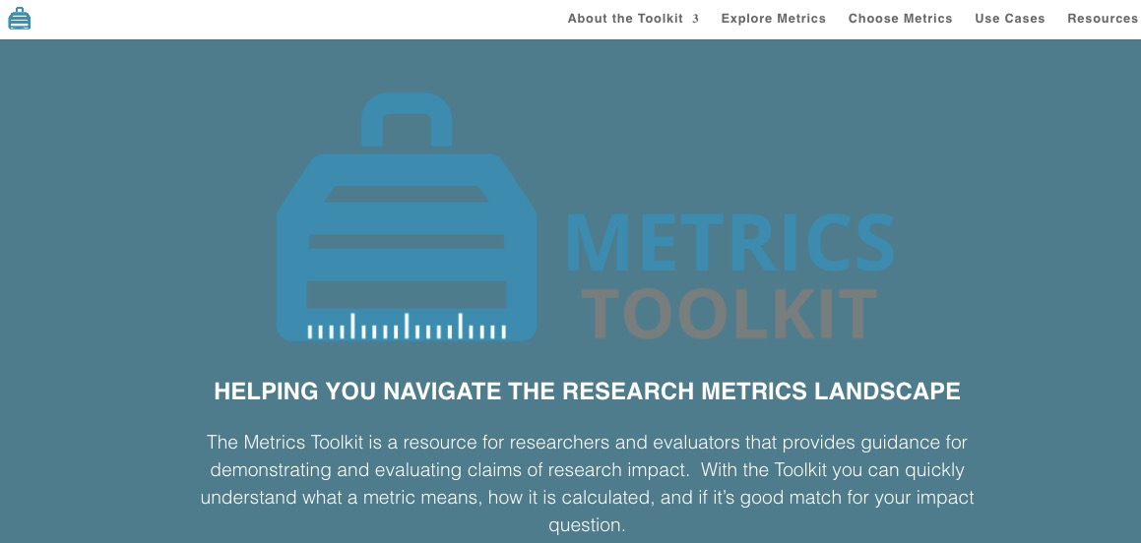
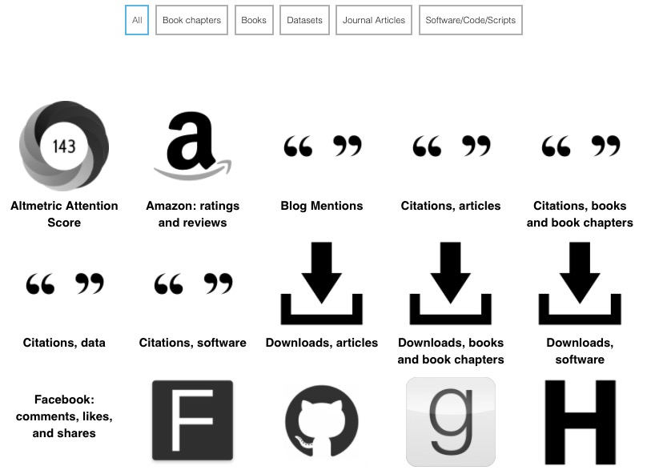
Toolkit Developers
- Robin Champieux
Research Engagement & Open Science Librarian, Oregon Health & Science University (OHSU)
- Heather Coates
Digital Scholarship & Data Management Librarian, IUPUI University Library Center for Digital Scholarship
- Stacy Konkiel
Director of Research & Education, Altmetric
Direct to Metrics Toolkit

http://www.infodocket.com/2018/01/30/say-hello-to-the-metrics-toolkit-a-new-resource-to-help-navigate-the-metrics-landscape/

B
- Boletin Fundacion Ciencias de la Documentacion
Aprovechamos para saludaros cordialmente y daros a conocer las novedades formativas de esta última semana:
CURSO ONLINE SOBRE CALIDAD EN LA GESTIÓN DOCUMENTAL
https://documentalistas.org/web/portfolio/calidad-gdocu/
El próximo 15/Febrero la reconocida experta española, Salomé Lendínez, impartirá desde nuestro Campus online este útil curso totalmente virtual que tiene como objetivo conocer la familia de Normas ISO 30300 como marco de gobierno para las organizaciones públicas y privadas | Está abierto el plazo de matriculación !!!
TRES NUEVOS TALLERES ONLINE GRATUITOS
Se han incorporado en el Campus online de la Fundación Ciencias de la Documentación tres nuevos talleres online con matrícula abierta, dentro de nuestra misión social de impulsar la formación de los profesionales de España e Iberoamérica.
1. DERECHO AL OLVIDO Y CÓMO AFECTA AL TRABAJO DE LOS PROFESIONALES DE LA INFORMACIÓN
https://documentalistas.org/web/portfolio/derecho_olvido/
2. GÉNERO Y DERECHOS HUMANOS (dentro del proyecto #MujeresLideresAmerica)
https://documentalistas.org/web/portfolio/generoddhh/
3. REDES SOCIALES Y EL PAPEL DE LAS MUJERES (dentro del proyecto #MujeresLideresAmerica)
https://documentalistas.org/web/portfolio/redessocialesmujer/
Esperamos os sean de utilidad para actualizar vuestro perfil profesional. Atentamente,
---
Dpto de Información
Fundación Ciencias de la Documentación
https://documentalistas.org/campus

Digitization Projects: University of Kentucky Special Collections Research Center Makes Available Records of Appalachian Social Justice Organizations, Access Online
Filed by Gary Price on January 29, 2018
From the University of Kentucky Libraries:
University of Kentucky Libraries Special Collections Research Center (SCRC) successfully completed work on its Council on Library and Information Resources (CLIR) Cataloging Hidden Special Collections and Archives grant, resulting in online access to the SCRC’s largest group of post-War on Poverty Appalachian primary sources.
“Action in Appalachia: Revealing Public Health, Housing, and Community Development records in the UK Libraries Special Collections Research Center” was a $156,439 grant to fully preserve, organize and make publicly available the records of seven community-driven organizations dedicated to improving quality of life for the Appalachian Region between 1965 and 1990.
All inventories generated by the project are available on the University of Kentucky Libraries digital library, ExploreUK.
Collections made available through “Action in Appalachia” include:
- Appalachian Leadership and Community Outreach, Inc. (ALCOR) records;
- Eastern Kentucky Health Services, Inc. (EKHS) records;
- Commission on Religion in Appalachia (CORA) records;
- Human/Economic Appalachian Development Corporation (HEAD) records;
- Marketing Appalachia’s Traditional Community Handcrafts (MATCH) records;
- Eastern Kentucky Housing Development Corporation (EKHDC) records; and
- Federation of Appalachian Housing Enterprises (FAHE) records.
Founded after the declaration of the War on Poverty, these organizations sought to meet the needs of a region suffering from increased outmigration, poor sanitation, inadequate medical facilities and increasing school dropout rates. These records document the life cycle of community-driven initiatives that fought poverty in the Appalachian region through improvements in public health, housing, education, economic development and community life.
[Clip]
The Bert T. Combs Appalachian Collection at UK Libraries SCRC includes collections of resources from several areas of Appalachian life, culture and history, including materials related to the coal industry; community; education and literacy; the lumber industry; medicine and public health; oil and iron; the railroad industry; regional and economic development; social reform; and the War on Poverty.

Read the Complete Announcement

http://www.infodocket.com/2018/01/29/digitization-projects-university-of-kentucky-special-collections-research-center-makes-available-records-of-appalachian-social-justice-organizations-access-online/

New Standard Published: ACRL/RBMS and SAA Release Standardized Statistical Measures and Metrics for Public Services in Archival Repositories and Special Collections Libraries
Filed by Gary Price on January 25, 2018
From ACRL/ALA:
The Association of College and Research Libraries (ACRL) Rare Books and Manuscripts Section (RBMS) and the Society of American Archivists (SAA) have developed a new standard, Standardized Statistical Measures and Metrics for Public Services in Archival Repositories and Special Collections Libraries.
To support increasing demands on archival repositories and special collections libraries and to demonstrate the value they provide their constituencies, archivists and special collections librarians have become increasingly mindful of the need to gather, analyze, and share evidence about the impact of their services and the effectiveness of their operations. Until now, the absence of commonly accepted statistical measures has impeded the ability of repositories to conduct meaningful assessment initiatives and to articulate and evaluate best practices.
Authored by the SAA-ACRL/RBMS Joint Task Force on Public Services Metrics, Standardized Statistical Measures and Metrics for Public Services in Archival Repositories and Special Collections Libraries provides normative guidance in these practical areas.
The new document was approved by the ACRL Board of Directors in October 2017 and by the SAA Council in January 2018.
Direct to Full Text Document: Standardized Statistical Measures and Metrics for Public Services in Archival Repositories and Special Collections Libraries
76 pages; PDF.

http://www.infodocket.com/2018/01/25/a-new-standard-acrlrbms-and-saa-release-standardized-statistical-measures-and-metrics-for-public-services-in-archival-repositories-and-special-collections-libraries/

