Año 3 Número 60 enero 2018

Contenidos de este número

1
[DOCUFORUM] Nuevos talleres online gratuitos
B
DOCUFORUM@LISTSERV.REDIRIS.ES
Estimados/as compañeros/as,
finalizamos la semana informándoles de 4 nuevos talleres virtuales que tienen ya disponibles de forma abierta y gratuita desde el Campus Online de la Fundación Ciencias de la Documentación. Recordar que se pueden realizar en cualquier fecha de este año, pero que una vez auto-matriculados en los mismos, se dispone ÚNICAMENTE de 8 días para completarlo y obtener - si se desea - el Diploma Digital del mismo.
Los 4 talleres forman parte del programa de Certificación Profesional en ADQUISICIÓN DE MOBILIARIO EN BIBLIOTECAS:
Taller 1. Recomendaciones para la adquisición de mobiliario en bibliotecas.
https://documentalistas.org/web/portfolio/recomendacionesmobi/
Taller 2. Adquisición de mobiliario fundamental en bibliotecas: Estanterías, mesas, sillas, carritos.
https://documentalistas.org/web/portfolio/mobiliariofundamental/
Taller 3. Adquisición de mobiliario complementario en bibliotecas: Soluciones de Autoservicio / Soluciones de Seguridad / Otras soluciones complementarias.
https://documentalistas.org/web/portfolio/mobiliariocomplementario/
Taller 4. Adquisición de mobiliario para niños en bibliotecas.
https://documentalistas.org/web/portfolio/mobiliariochildren/
Esperamos os sean de utilidad. Feliz fin de semana.
---
Dpto. de Información
Fundación Ciencias de la Documentación
Grupo Telegram: https://t.me/joinchat/HIogdRErNiBLE0PSklOiDQ

2. Eventos IIBI del primer trimestre 2018

Difusión IIBI

Estimad@ Colega,
Con el gusto de volver a ponernos en contacto, el Instituto de Investigaciones Bibliotecológicas y de la Información (IIBI) hace de su conocimiento la información de los eventos que se llevarán a cabo en este primer trimestre del año. Los esperamos!
Enero 30, 31 y febrero 1º.
Seminario de Lectura: De la lectura académica a la lectura estética en la biblioteca universitaria.
Coordinadora Académica: Dra. Elsa Ramírez Leyva
Presentación: El tema del vínculo entre la lectura académica y la lectura estética lo consideramos relevante ante la tendencia de fortalecer a la biblioteca universitaria como principal colaboradora al desarrollo de las capacidades de sus comunidades y con ello elevar el desempeño académico. En no pocas bibliotecas se están incorporando programas de habilidades informativas o alfabetización informativa y de promoción de lectura. Considerando que el análisis y la curaduría de la información son áreas que se están incorporando a las funciones de los bibliotecólogos, aunadas a la labor pedagógica y de mediación que realizan, es de gran importancia que los profesionales de la bibliotecología cuenten con esta formación, indispensable, para una integración transversal de la alfabetización académica. Es decir, estar preparados para atender a las bibliotecas que ya se están trasformando en espacios de aprendizaje, investigación, lectura y cultura.
Sede: Torre II de Humanidades, piso 13, seminario 1
Consulte programa en: http://iibi.unam.mx/f/SIL_Programa.pdf
Marzo 6 – 9 III Congreso Internacional de Documentación Fotográfica
Coordinador Académico: Dr. Héctor Guillermo Alfaro López
Presentación: El documento fotográfico se encuentra disperso en archivos, bibliotecas, instituciones, centros de documentación, empresas y colecciones públicas y privadas. En su consideración de patrimonio debe ser recuperado, conservado, analizado y difundido, tareas que implican una labor que en ocasiones resulta ardua. Su estudio e investigación, tanto en forma como en fondo, plantean la necesidad de una formación especializada para dar respuesta a la demanda de los centros. Por otra parte, la aplicación de la fotografía a la ciencia, el arte, la comunicación o la información hacen imprescindible adquirir conocimientos sobre su génesis y características, cuestiones que se abordarán en el Congreso.
Sede: Torre II de Humanidades, piso 13, seminario 1
Consulte programa en: http://iibi.unam.mx/f/CONGRESO_FOTODOC.pdf y http://iibi.unam.mx/f/Talleres_FOTODOC.pdf
Marzo 12-16 XIII Seminario de Investigación sobre Usuarios de la Información y I Congreso Internacional de Investigación sobre Usuarios de la Información
Coordinador Académico: Dr. Juan José Calva González
Presentación: Las investigaciones sobre los usuarios de la información y los resultados obtenidos contribuyen al desarrollo de aspectos archivísticos, bibliotecológicos, documentales y de la información no solo en el aspecto de marcos teóricos que permiten delinear los perfiles informativos de diferentes sino que además son un elemento clave para diseñar y desarrollar servicios archivísticos, bibliotecarios y de información, con el uso de las tecnologías de la información y la comunicación, que satisfagan adecuadamente las necesidades informativas de cada comunidad. Por lo tanto, es necesario plantear, desarrollar y discutir proyectos de investigación sobre los usuarios de la información en diferentes comunidades como las señaladas anteriormente.
Sede: XIII Seminario en: Universidad Autónoma de San Luis Potosí. Facultad de Ciencias de la Información. I Congreso en: Centro Cultural Universitario Bicentenario.
Consulte el programa: http://iibi.unam.mx/f/CIISUI_%20Carltel.jpg
Si desea hacer su inscripción envié al correo inscripec@iibi.unam.mx este formato http://iibi.unam.mx/f/registro.doc con sus datos indicando cómo realizará su pago para agilizar su trámite.
Mayores Informes con Lic. Jorge Castañeda: al teléfono 56 23 0652

3. EBSCO and BiblioLabs Announce OA Service for Theses, Dissertations
By Matt Enis on January 3, 2018 Leave a Comment
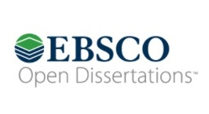EBSCO Information Services (EBSCO) and BiblioLabs will launch OpenDissertations.org, an open access (OA) initiative that will facilitate the discovery of electronic theses and dissertations (ETD), in early 2018. Students, researchers, and libraries can submit ETD for free. EBSCO will include metadata for the submitted ETD in EBSCO Discovery Service, as well as exposing it on the OpenDissertations.org website to enhance the discoverability of this OA content both within academia and in open web searches. User traffic will be driven to partnering sites, such as academic institutional repositories (IR), which will host full-text versions of the theses and dissertations.
“Universities have long provided theses and dissertations to companies that require libraries to subscribe to their products to gain the added value of aggregated access to this research output,” EBSCO explained in an announcement. “With more and more universities now hosting and distributing their own ETDs on the open web, EBSCO and BiblioLabs are seeking to add an enhanced service that freely aggregates and exposes this valuable content, extending access to any interested reader worldwide.”
At launch, the project will include the British Library’s EThOS Service, as well as ETD metadata from Cornell University, Florida State University, the University of Florida (UF), the University of Michigan, Michigan State University, and the University of Kentucky.
ENHANCED VISIBILITY
The project got its start through EBSCO’s work with the H.W. Wilson Foundation beginning in 2014, Kathleen McEvoy, EBSCO’s VP of communications, told LJ. “They came to us with an A&I [abstracting and indexing] database that they wanted to digitize—Doctoral Dissertations Accepted by American Universities, 1933–1955,” McEvoy said. “So, we put that online at opendissertations.com, and it really sparked a lot of interest from universities who said, ‘If I tie that to my institutional repository, my users could have full-text access’…. As we expanded it [with the addition of post-1955 content beginning in 2015] it really started to mushroom, with more and more people starting to say, ‘This is a great way to showcase our institutional repository.’”
BiblioLabs developed the ETD submission platform, following Open Archives Initiative Protocol for Metadata Harvesting (OAI-PMH) standards and ensuring future compatibility with the FOLIO open source library services platform, a separate project on which EBSCO, BiblioLabs, and several other major library vendors are collaborating.
Mitchell Davis, founder and CEO of BiblioLabs, said OpenDissertations.org will help graduate students increase the visibility of their own work while also offering access to OA research that might otherwise take months or even years to be published.
In discussions with graduate students while the platform was under development, Davis found that they “understood how slowly publishing works. And they had an awareness that having access to these theses and dissertations was [access] to the rawest and newest research that they can get their hands on…. The pace of their curiosity wasn’t necessarily going to track with the pace of academic publishing.”
Christine Swanson, a PhD student who helped organize some of the early feedback on the project as VP of UF’s graduate student council, noted that, as an OA platform, OpenDissertations.org could also help facilitate research and collaboration in countries where faculty and students don’t have comprehensive institutional access to subscription databases and journals. Her own work, for example, includes collaboration with international researchers in South America and elsewhere involved with the Amazon Dams Network.
“In general, science does need to move toward being open—to anyone who wants to read the science—especially when its funded by the government,” Swanson told LJ. “It’s extremely important, not just as a public service, but also for sharing science and moving science forward.”
EBSCO anticipates that more than 20 partner libraries will be participating in OpenDissertations.org by the time it goes live, likely early February. Over the course of 2018, the company expects to make announcements regarding innovations related to multimedia ETDs and research data sets.
About Matt Enis
Matt Enis (menis@mediasourceinc.com; @matthewenis on Twitter) is Senior Editor, Technology for Library Journal.

http://lj.libraryjournal.com/2018/01/industry-news/ebsco-bibliolabs-announce-oa-service-theses-dissertations/

4. Major CPU Security Flaw: What Libraries Need to Know
By Matt Enis on January 5, 2018 Leave a Comment
Intel Corporation this week acknowledged two serious, processor-level security vulnerabilities—named “Meltdown” and “Spectre”—that affect virtually all computers manufactured during the past decade that contain the company’s market-leading CPUs. Processors manufactured by ARM and AMD may also be affected by Spectre, reportedly the more difficult flaw to exploit.
Operating system (OS) developers, who have been aware of the vulnerabilities for several months, are pushing out security updates or including fixes in the latest versions of their OS to mitigate the flaw and urging individual and institutional users, such as libraries, to apply the patches or ensure their machines have been recently updated.
The vulnerabilities were patched for Linux in December, and a “major Linux redesign” is underway to further deal with the problem, according to reporting by ZDNet. Apple has reported that the issue was addressed in macOS High Sierra 10.13.2, also released last month. Windows 7, 8, and 10 users can apply updates released January 3 via Windows Update. Those updates also include fixes for Microsoft’s Edge and Internet Explorer 11 browsers.
Mozilla has reported that the latest version of its Firefox browser (Firefox 57 / Quantum) includes a fix, and longer-term solutions are being researched.
Google is advising users of the Chrome browser to consider enabling the browser’s experimental site isolation security mode (enter chrome://flags/#enable-site-per-process in the Chrome address bar). A permanent fix for the browser is scheduled for rollout with Chrome 64, on January 23, with additional mitigations planned for future versions.
IMPACT ON CHROME, ANDROID, CLOUD
The flaws were independently discovered by Google’s Project Zero security team, researchers at the Technical University of Graz in Austria, and Cerberus Security.
“The Project Zero researcher, Jann Horn, demonstrated that malicious actors could take advantage of speculative execution to read system memory that should have been inaccessible. For example, an unauthorized party may read sensitive information in the system’s memory such as passwords, encryption keys, or sensitive information open in applications,” Project Zero explained in a blog post on January 3. “These vulnerabilities affect many CPUs, including those from AMD, ARM, and Intel, as well as the devices and operating systems running on them.”
Google has posted a list of its products and their current status of mitigation against the flaws. Chromebooks and other devices with the Chrome OS were patched with version 63, released in December, although the company notes that many older Chrome OS devices are no longer receiving updates.
Users of Android devices supported directly by Google, such as the Nexus 5X and 6P, or Pixel C, XL, and 2/XL are protected by the monthly January update. Google released security patch changes to Android partners in December, and Android users are urged to update their devices as patches are released by other manufacturers, likely this month.
Google has updated the infrastructure of its Google Cloud Platform, although institutional users of Google Cloud Dataflow, Datalab, Dataproc, Launcher, Machine Learning Engine, Compute Engine, and Kubernetes Engine will need to take additional action to patch and update guest environments.
Amazon Web Services and Microsoft Azure issued statements that their cloud infrastructure had been updated as well, along with additional instructions for customers.
FIRMWARE UPDATES, SLOWDOWNS
The patches and updates listed above are software fixes that mitigate a hardware problem. To ensure system security, users and institutions will need to apply firmware updates to make systems immune to exploits made possible by the flaws. On January 4, Intel announced that it “has already issued updates for the majority of processor products introduced within the past five years. By the end of next week, Intel expects to have issued updates for more than 90 percent of processor products introduced within the past five years.” However, users will have to be on the lookout for these firmware updates, which will be rolled out by manufacturers such as Dell, HP, Asus, Acer, and others in the coming weeks.
Unfortunately, the flaws, as detailed by Ars Technica, involve speculative execution, an optimization technique in which CPUs pre-emptively perform tasks that may or may not be needed by the system. Linux creator Linus Torvalds told ZDNet that fixing the problem may cause minor to significant degradation in performance, particularly for CPU-heavy tasks.
“There’s no one number,” Torvalds said. “It will depend on your hardware and on your load. I think five percent for a load with a noticeable kernel component (e.g. a database) is roughly in the right ballpark. But if you do micro-benchmarks that really try to stress it, you might see double-digit performance degradation.”
It should be noted that these fixes are in their early stages. Later iterations of security patches and firmware updates will help move CPU performance toward prior levels.
Intel stated that the company “continues to believe that the performance impact of these updates is highly workload-dependent and, for the average computer user, should not be significant and will be mitigated over time. While on some discrete workloads the performance impact from the software updates may initially be higher, additional post-deployment identification, testing and improvement of the software updates should mitigate that impact.”

http://lj.libraryjournal.com/2018/01/technology/major-cpu-security-flaw-libraries-need-know/

5. Michigan State University Awarded $1.5 Million Mellon Foundation Grant to Build Massive Slave Trade Database/Linked Open Data Platform
Filed by Gary Price on January 9, 2018
From Michigan State University:
Michigan State University, supported by nearly $1.5 million from The Andrew W. Mellon Foundation, will create a unique online data hub that will change the way scholars and the public understand African slavery.
By linking data collections from multiple universities, the website will allow people to search millions of pieces of slave data to identify enslaved individuals and their descendants from a central source. Users can also run analyses of enslaved populations and create maps, charts and graphics.
The project, called “Enslaved: The People of the Historic Slave Trade,” is funded by a $1.47 million grant from the Mellon Foundation.
“’Enslaved’ brings new digital tools and analytical approaches to the study of African slavery and the Atlantic slave trade,” said project co-investigator Walter Hawthorne, professor and chair of MSU’s Department of History. “By linking data compiled by some of the world’s foremost historians, it will allow scholars and the public to learn about individuals’ lives and to draw new, broad conclusions about processes that had an indelible impact on the world.”
Dean Rehberger, director of Matrix: The Center for Digital Humanities and Social Sciences at MSU, will lead the project along with Hawthorne and Ethan Watrall, associate director of Matrix and assistant professor of anthropology.
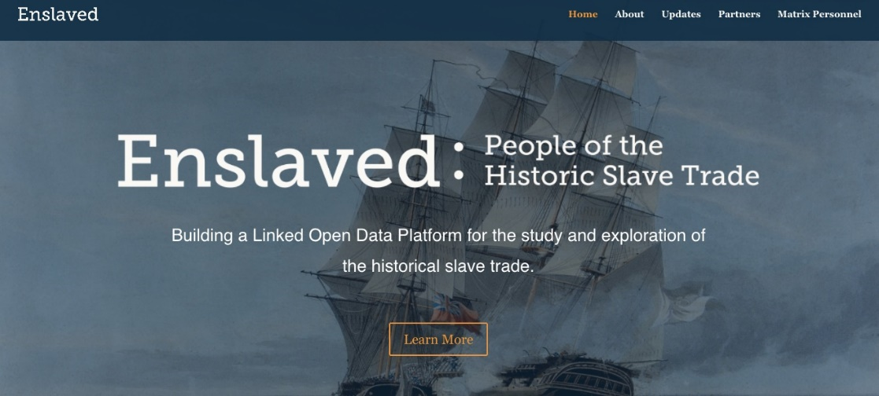
This project, which will take 18 months, is the first phase of a multi-phase plan. In phase one, MSU and partners will develop a proof-of-concept to show data can be linked across eight well-established online databases, including the collection at MSU’s Matrix.
[Clip]
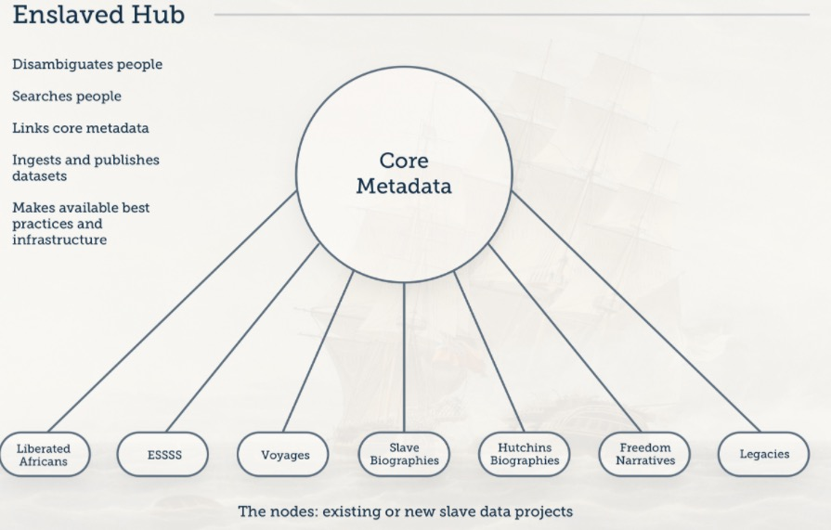
Source: Enslaved.org
The partner projects in phase one are :
- “African Origins and Voyages: The Trans-Atlantic Slave Trade Database” led by David Eltis, professor emeritus, Emory University, and Paul Lachance
- “The Slave Societies Digital Archive” led by Jane Landers, Vanderbilt University
- “Dictionary of Caribbean and Afro-Latin American Biography” and “Dictionary of African Biography and African American National Biography” led by Henry Louis Gates Jr., Steven Niven and Abby Wolf, Hutchins Center for African and African American Research at Harvard University
- “Freedom Narratives” led by Paul Lovejoy, York University
- “Legacies of British Slave-Ownership” led by Keith McClelland, University College, London;
- “The Liberated Africans Project” led by Henry Lovejoy, University of Colorado Boulder, and Daryle Williams, University of Maryland.
The funding follows a $19,450 Mellon grant for project planning.
Read the Complete Announcement

http://www.infodocket.com/2018/01/09/michigan-state-university-uses-1-5-million-mellon-foundation-grant-to-build-massive-slave-trade-database/

6. Depository Library Council Releases Comments and Concerns About Title 44 Draft Bill (Reform of Public Printing and Documents)
Filed by Gary Price on January 9, 2018
From the Federal Depository Library Program Website:
The Depository Library Council (DLC) released their comments on the Title 44 draft bill released by the Committee on House Administration on December 11, 2017. The DLC said that they felt several areas of the bill, where it related directly to the Federal Depository Library Program (FDLP), would considerably improve the program and answer issues the DLC and FDLP have raised in past years. However, the DLC also raised some concerns.

http://www.infodocket.com/2018/01/09/depository-library-council-releases-comments-and-concerns-about-title-44-draft-bill-reform-of-public-printing-and-documents/

7. Museum and Library Services Act of 2017 Introduced in Senate
By Lisa Peet on January 10, 2018 Leave a Comment
The Museum and Library Services Act (MLSA) of 2017 was introduced in the Senate on December 21 by Sen. Jack Reed (D-RI), along with Susan Collins (R-ME), Thad Cochran (R-MS), Kirsten Gillibrand (D-NY), and Lisa Murkowski (R-AK). The bipartisan bill, S. 2271, reauthorizes the core programs administered by the Institute of Museum and Library Services (IMLS): the Museum Services Act and the Library Services Technology Act (LSTA), which provides more than $183 million in funding through the Grants to States program; National Leadership Grants for Libraries; the Laura Bush 21st Century Librarian Program; and Native American Library Services. The agency has been a source of support for public, academic, research, special, and tribal libraries, as well as some 35,000 museums.
Federally funded agencies and programs typically call for periodical authorization to be passed by Congress to justify their work. Although not required for a program to continue to receive funding, authorization demonstrates congressional support to the necessary Appropriations Committees, and helps give direction as to how the agency should operate. Agencies that lack authorization risk being targeted for elimination, particularly—as now—when a contentious national budget may call for drastic cuts.
American Library Association (ALA) president Jim Neal said in a statement, “Today’s introduction of the bipartisan MLSA reauthorization is the first critical step toward ensuring federal support for our nation’s nearly 120,000 libraries. LSTA grants enable libraries in every state to innovate and meet the growing demand for services that meet the needs of our communities.”
UPDATING MLSA
The federal government has provided direct aid to libraries since 1964, when President Lyndon B. Johnson signed the Library Services and Construction Act (LSCA). After a number of reauthorizations, LSCA was replaced by LSTA when Congress passed the first Museum and Library Services Act in 1996. The new act combined the Library Programs Office—part of the Department of Education since 1956—and the Institute of Museum Services to establish IMLS. A second MLSA, signed into law by President George W. Bush in 2003, updated the original legislation and authorized federal funding for LSTA through FY09.
The most recent MLSA, signed by President Barack Obama in December 2010, was also written by Senator Reed, authorizing funding through FY16. In September 2016 Reed—LJ’s 2002 Politician of the Year—introduced S.3391, the MLSA of 2016, with Collins and Cochran as cosponsors, but it did not advance past the Senate HELP Committee—a typical fate of “lame duck” legislation in the months after the 2016 national election.
In the process of refining S. 2271 in 2017, Senator Reed’s office solicited feedback from the library and museum communities, including ALA and the American Alliance of Museums. Reed also solicited local input, hosting a round table with Rhode Island librarians in 2016. Reed also spoke with other legislators about what could be modified and improved on from the 2016 bill to gain further support, and was able to bring Murkowski and Gillibrand on board.
The legislation includes a number of updates, such as an emphasis on strengthening the use of data-driven assessment tools—particularly to help develop local services to better meet community needs—and providing for technical support and assistance in data collection, as well as enhancing IMLS’s abilities to collaborate with other federal agencies. The reservation of funds for Services for Native Americans will be adjusted to more closely match current appropriations. IMLS will also be provided with additional tools to better meet oversight and programmatic responsibilities.
The bill also amends LSTA to give prominence to libraries’ roles as community hubs, highlighting such services as education, lifelong learning, workforce development, economic and business development, digital literacy skills, critical thinking, financial literacy skills, services for community members like caregivers and veterans, and new and emerging technology—making sure to shape language open-ended enough to provide for libraries’ technology needs down the line, whatever those might be. The language around literacies has been updated, such as adding “developing digital citizenship and the responsible use of technology” to the definition of “digital literacy” in order to address such issues as cyberbullying.
Greater emphasis is given to recruiting and training the next generation of library and information science professionals from diverse and underrepresented backgrounds, and to leadership grant funds that serve a range of library types in geographically diverse areas. In addition, after the hurricanes and wildfires of 2017, the legislation clarifies that grant funds can be used toward helping libraries get back online in the event of disasters to help serve their communities.
Language has also been revised to create more consistency between the bill’s provisions for libraries and museums.
The bill was read twice and referred to the Committee on Health, Education, Labor, and Pensions. It must pass both the Senate and the House before it can be sent to the president to be signed into law.
CALL FOR COSPONSORSHIP
Although both chambers have recommended that the FY18 national budget provide funding for IMLS, final funding bills have not yet passed Congress. ALA’s Washington Office continues to advocate for support for IMLS, and in the meantime hopes to help bring in additional cosponsors in the Senate for MLSA to show support for the bill. (Reed’s office also wants to work with representatives to introduce companion legislation in the House.)
At the moment, debate and dialog in Congress are focused on the budget, health insurance, Deferred Action for Childhood Arrivals (DACA), and a possible government shutdown and sequester. This is a good moment for library advocates to generate enthusiasm for bipartisan support of MLSA, so that when those items are settled, the bill can move forward. Calls and email from library supporters helped a letter to the Appropriations Subcommittee on Labor, Health and Human Services, and Education written by Reed and Collins in May 2017, seeking $186.6 million for LSTA programs, garner 45 signatures from their fellow senators—a record level of support.
ALA encourages supporters to contact their senators and ask them to cosponsor S. 2271.
ALA’s Distract Dispatch asks supporters, “In your emails and calls to senators, tell them how LSTA funds enable your library to offer valuable services to your community. Invite them to visit your library to see for themselves the difference you are making in people’s lives. Ultimately, it is your story and your voice that will persuade your elected leaders to show their support for libraries and cosponsor the MLSA of 2017.”
“The goal of reauthorizing the MLSA is much larger than level funding for federal library programs,” Neal said in a statement to LJ. “It is also about providing certainty that IMLS has a mandate to carry out its mission – ‘to inspire libraries and museums to advance innovation, lifelong learning, and cultural and civic engagement.’ Passing the MLSA will be a vote of confidence for libraries—that we are vital community hubs for access to technology and information [and] that we spur innovation and development within our communities. Passing the MLSA will give us a foundation to build strong, long-lasting federal support for libraries.”
Senator Reed, in a statement to LJ, said, “Librarians and library patrons have been absolutely essential to getting these bills done in the past. They will be critical to getting it through this year too. It is so important for people to remind their elected officials how important libraries are in their communities today, including how they are responding to and meeting changing demands and essential community needs.”
Added Neal, “Asking members of Congress to sign onto the MSLA is one way to give voice to our values and to cultivate congressional support for libraries that extends well beyond one or two fiscal years.”
About Lisa Peet
Lisa Peet is Associate Editor, News for Library Journal.

http://lj.libraryjournal.com/2018/01/legislation/museum-library-services-act-2017-introduced-senate/

