Año 3 Número 59 enero 2018

Contenidos de este número

1
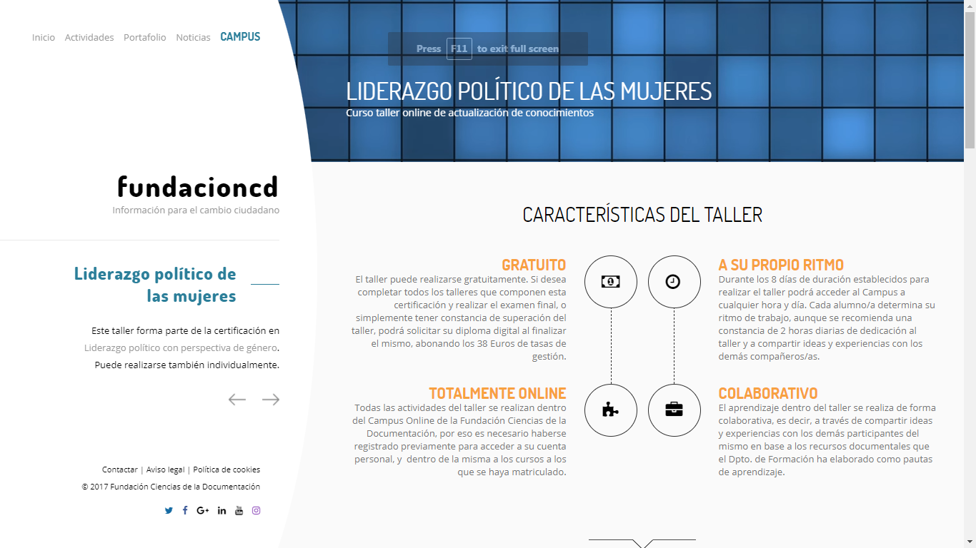

https://documentalistas.org/web/portfolio/liderazgopolitico_mujeres/

2. The Power of Youth Services

Transforming Public Library Impact

Miami-Dade Public Library System – Main Branch
101 Flagler Street
Miami, FL 33130
Presented by Library Journal and School Library Journal, the 2018 Public Library Think Tank will convene public library leaders and directors, youth services and young adult librarians, with other leading thinkers on the role of youth services, literacy, and learning trends. This two-day event will focus on the power of youth services—from tots to teens—inform healthy communities, help kids become readers and learners, and help them develop the skills that will serve them well throughout their lives.
Intimately connected to community needs, youth services departments, large and small, form a dynamic and increasingly relevant force that continues to transform the impact of public libraries. Think Tank participants will share strategies on programming, management, community engagement, and getting the word out.
Outcomes:
Attendees will learn about innovative programs and services from a series of insightful presentations and collaborative sessions, gain insight into superb youth services initiatives and their impact, and take home ideas on how to think strategically about leading with youth services to enhance library services. Attendees will leave with practical, applicable strategies with which to make a lasting impact in their libraries and library systems.
Register before December 29 and save 35% on the registration fee!
Special group pricing is available. Directors are encouraged to attend with their team or send a group for a unique team-building experience. Contact us for group rates.
There will also be an exciting, and optional, Thursday tour to points of interest. More details to follow, but mark your calendar.
More information about the program and presenters will be available soon, but don’t wait, register today! We’ll update you with program announcements as information becomes available.
Click here to view resources from the 2017 Public Library Think Tank.

In Partnership with:

http://lj.libraryjournal.com/public-library-think-tank/?utm_source=ljsnewsletter&utm_medium=newsletter&utm_content=mktgcolumn&utm_campaign=publiclibrarythinktank

3. How My Library Doubled Its Circulation
By Meghan Stigge
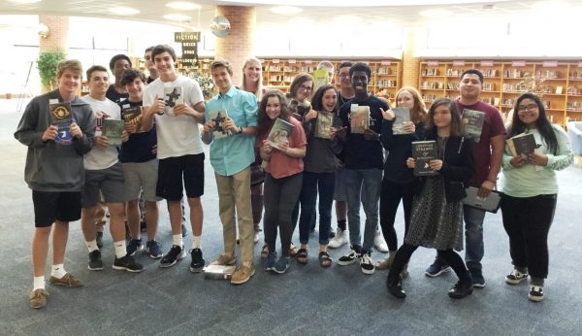
Students at the Shawnee Mission (KS) Northwest High School library with their selected reads.
Modern life tends toward snippets of attention: push notifications and buzzing phones; multitasking and productivity hacks. Sustained focus can feel impossible, for high school students and adults.
A year ago, the English language arts (ELA) teachers at Shawnee Mission (KS) Northwest High School, where I am a librarian, were dispirited by the difficulty they were experiencing in motivating students to read the longer narratives on the curricular lists. Students weren’t completing the assigned reading, and as a result, the related classroom activities and discussions were suffering. Teachers lamented that students weren’t experiencing the positive outcomes that research has shown comes from a healthy long-form reading habit.
In his book Deep Work (Grand Central, 2016), computer scientist Cal Newport argues that sustained focus on a challenging cognitive task is the most valuable skill in our economy. And yet neuroscience research suggests that our hyper-networked world—of tweet feeds, texts, notifications, and multitasking—has a measurable impact on focus and attention.
Our classroom observations confirmed the research. So we embarked on a collaborative effort to bolster our reading culture. In less than a year, we’ve seen an astounding turnaround in circulation statistics and enthusiasm for reading. Here’s how we did it.
THE MODEL
A handful of motivated ELA teachers and I met several times during the fall of 2016. We consulted the research and settled on a few foundational imperatives for our Reading Empathy Initiative.
- A revision of the required novel reading lists and the addition of high-interest, high-value contemporary works
- Student choice for independent reading—and instruction on how to find books of personal interest
- Time to choose and time to read
Teachers brought their classes to the library for instruction on how to find books of interest. I taught them how to use various digital tools: retailer recommendations based on similar books, our digital catalog, and online review sites such as Goodreads. I showed them how to find their selections, and students had browsing and checkout time.
Time is a critical piece of the process: time to search, time to browse, and time to read. We looked at a few accountability and evaluation models and let the teachers select what best met the needs of their particular students. Teachers chose from:
- Thematic IRP (Individual Reading Project): Students select fiction, based on an essential question. Students read in class on Fridays and respond in dialectical journals (a metacognitive tool), pulling quotes that address the question. At the end of the year, they synthesize their notes into an essay.
- Activities with Penny Kittle’s Book Love methods, including calculating reading rate and working toward improvement; a book conference with the teacher every three weeks; and a review or booktalk for the class.
- Open structure: Students get class time to read, and when they finish one book, they immediately return to the library for a new one. They create end-of-quarter written reviews or book talks.
THE RESULT
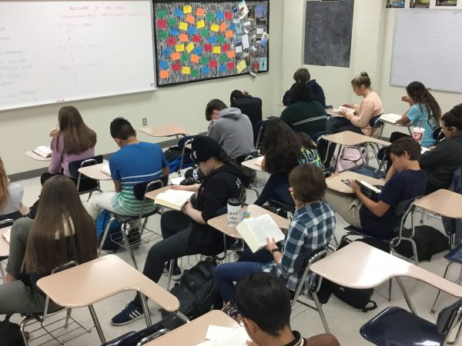
Free reading time in the classroom.
The semester we started, we saw a jump of only 200 circulations. But this year’s circulations demonstrate a nearly threefold increase, from the mid–500s in the first quarter of the past two years to 1,356 in the first quarter of this year. I’m struggling to keep up with the cycle of checkouts and the shelving of returns—a good problem to have!
One teacher’s students are averaging 386 independent reading pages for first quarter. “I am surprised at how much I have read in the last quarter and am proud of myself for the number of pages I read,” one of the teens wrote. “I was reading more outside of class than in class, which is very new to me….When I was bored at home I could just pick up my book and start reading.”
“This has definitely caused me to read loads more than I usually would,” wrote another. “I have been pushing myself to try and read books out of my comfort zone….I have swapped TV, social media, and sometimes homework for reading. I have noticed a difference with all my school work because I am already able to read a lot faster and understand everything.”
We hear authentic conversations about books before, during, and after class. Teachers report that students are making connections between what they are reading and real-life problems and situations. At conferences, parents say their kids now reading more than they have in years.
FIVE TIPS FOR SUCCESS
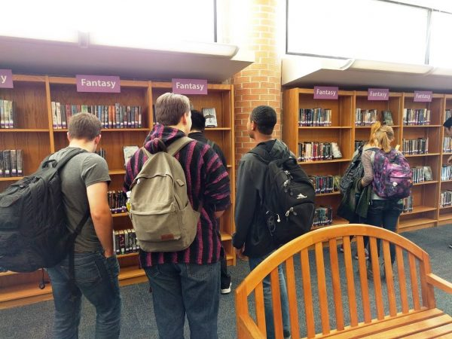
Browsing for choice reading material.
Nothing we are doing is new—all our methods have come from decades of research on reading and motivation. Our success comes from devotion to a few specific tenets:
- Teacher and librarian enthusiasm:Students respond to the care we give teaching them to find books. If educators aren’t enthusiastic, students won’t be either. Use a growth mindset: “I don’t like to read” means “You haven’t found the right book yet.” When students read, the teacher reads too.
- Freedom to choose: Students select books that they want to read, not ones based on reading level or any other constraint.
- Up front instruction: Show students how to find books of interest. They don’t intuitively.
- Time to search and browse, and time to read: It can be a challenge to carve out classroom reading time, but it pays off in spades.
- Evaluation and evolution: Continually evaluate the process and be willing to adapt as needed.
When we launched this initiative, we asked ourselves whether the rapid pace and distracted nature of modern life meant we needed to adjust our expectations. Researchers such as Newport and Nicholas Carr, author of The Shallows: What the Internet Is Doing to Our Brains (W.W. Norton , 2011), suggest that distraction is actively changing our brains and our habits. Since students are reading frequently—but in smaller bursts, such as text messages, tweets, and condensed articles with hyperlinked content—we wondered if focused long-form reading was still an attainable aim.
The answer is a resounding yes.

Meghan Stigge is a certified librarian at Shawnee Mission Northwest High School in Shawnee, KS.

http://www.slj.com/2017/12/teens-ya/doubled-library-circulation/

4. Creating Creative Spaces | Field Reports
By Antonella Giancarlo
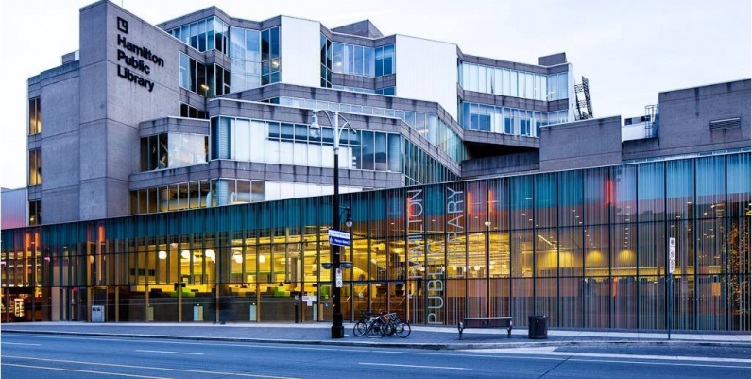
Hamilton Public Library Central Library
There was a clear need for collaborative and creative community spaces in the branches of Ontario’s Hamilton Public Library (HPL). We had two objectives: provide customers with the services and technology they couldn’t easily access at home and support the city’s growing arts and innovation community.
SCALE AND SEQUENCE
Our Digital Media Labs (DMLs) started as small-scale pilots at two locations. We looked at our full branch complement for the rollout, taking into consideration the locations, physical spaces, diverse populations, and user needs. Launching these small-scale DMLs allowed us to test the waters and gauge community response before committing to a larger, more permanent space at our Central location. In the end, we chose our Red Hill (in the east) and Terryberry (in the west) branches.
We started out small with the DMLs, then launched our flagship Maker space at Central (our largest and busiest location), and then scaled back again for the 13 (and counting!) branch Maker spaces across our system. This enabled HPL to incorporate valuable lessons learned from the initial rollouts, influencing the direction for both Central’s launch and the subsequent branch Maker spaces. Some were around better software choices, updated guidelines and procedures, more efficient training for staff, and standardized stations across the system. We also rebranded the DMLs to Maker spaces that, depending on size, feature different studios and resources.
All Maker locations have media studios with iMacs equipped with Adobe Creative Suite. The original two sites piloted in 2014, plus one more launched this summer, also feature sound and photo studios with microphones, pianos and drum kits, a green screen room, and cameras.
Timing for the initial rollouts took three months. Planning started in April 2014 with grand openings in July/August. Our flagship Maker space at Central took much longer because it was dependent on a larger renovation of the library’s fourth floor. Our Central Maker space has all the fun features listed above, as well as a Maker Studio with 3-D printers, a vinyl printer/cutter, large-format printing, an embroidery machine, VHS and audiocassette digitization, musical instruments and recording equipment, DSLR cameras, Wacom tablets, and Raspberry Pi. Community partnerships have enabled our Central Maker space to offer everything from programs targeting at-risk youth to live, in-the-round concerts.
TEAMING UP
The entire process involved many meetings with various stakeholders, such as management, the library board, and our digital technology/Maker space team. There were also visits to nearby libraries that had already launched such spaces to share ideas and best practices.
As with any big organizational change, concerns included staff training, support, and building a knowledge base. The digital tech team went to great lengths to put together reference materials, Q&As, “train the trainer” sessions, and help to launch the technology and programs in each location.
We experienced our share of bumps: adequate training for staff, ensuring the computers/equipment were ready in time and working properly, equipment maintenance (especially for the 3-D printers), soundproofing, proper coverage for stolen or broken items, and customer support expectations. HPL’s Maker spaces have truly been a collaborative effort with many individuals involved who have brought their own expertise to move the concept forward.
GETTING THE WORD OUT
To promote the openings, we leveraged a number of communication channels including social media, internal branch notices, our quarterly What’s Happening program guides, media releases, and pitches to local media. We’re constantly updating the messaging to highlight new openings, services, programs, and technologies at our Maker spaces, though word of mouth remains one of our strongest tools. Our big challenge now is figuring out how to reach nonusers who have no idea about the amazing services libraries have to offer.
Antonella Giancarlo is the Manager of Communications, Hamilton Public Library, Ont., with experience working and volunteering in both the public and private sectors
This article was published in Library Journal. Subscribe today and save up to 35% off the regular subscription rate.

http://lj.libraryjournal.com/2017/12/lj-in-print/creating-creative-spaces-field-reports/

5. New Job, New Country, New Literature: A librarian starts a new chapter in Singapore
By Susan K.S. Grigsby
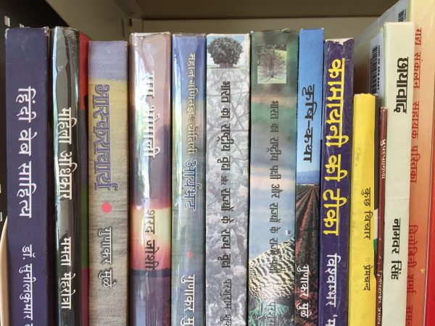
A selection from the Hindi shelf.
I was sitting in the baggage claim area of the airport in Frankfurt, Germany, waiting for the bus that would take me to my son’s family in Spangdahlem, when I got the email offering me a job as a teacher librarian at the United World College of Southeast Asia (UWCSEA) in Singapore. After the initial shock, I replied to the email with an enthusiastic yes. But on that two-hour bus ride, I started to wonder what I’d gotten myself into.
I knew no one in Singapore. Newly single after 27 years, I would be traveling to the other side of the planet alone. I had no international school experience and limited experience with the International Baccalaureate (IB). I had just four short months to separate the things I would take from the things I would store, find a foster home for my cat, sell my car, and attend to all the tiny details one must check off when absolutely everything is about to change. If my work with the Lilead Fellows Programhad taught me anything, it was this: Change is a constant, and landing on your feet is all about attitude, determination, and a solid sense of “I can do this!”
I was warmly welcomed when I arrived in Singapore, and before I’d been here a full 24 hours, I made my way to my new library to take a look around. There on the shelves were old “friends”: Sharon Creech, Gary Schmidt, J.K. Rowling, Kate DiCamillo, and so many more. I found myself smiling as I thought, “I’ve read that one!” over and over again. I felt like I really wasn’t so far from home if I was going to be surrounded with the books and stories I knew and could share with young readers.
A WHOLE NEW WORLD OF READING
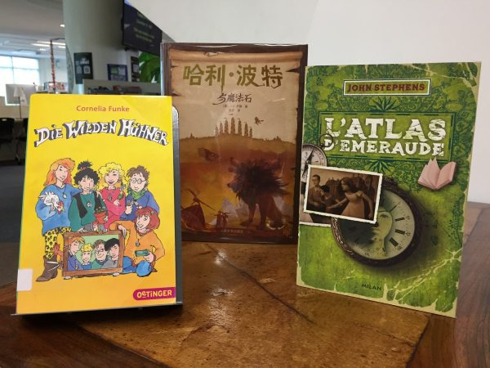
From left: Cornelia Funke’s “The Wild Chickens” in German; J.K. Rowling’s “Harry Potter” in Chinese; John Stephens’s “The Emerald Atlas” in French.
It was about that time that another reality snuck up behind me and tapped me on the shoulder. There were many, many books on the shelves I’d never seen. Characters I’d never met. Authors I didn’t know. I picked up a few to see they were published in Australia, New Zealand, Singapore, China, and a variety of other Asian countries. I realized that the scope of my experience with literature was heavily weighted with authors and publishers from the United States, Canada, and the U.K. I had a lot to learn.
I started by looking at the list of suggested purchases left by the previous librarian. She had years of international school experience and a vast knowledge of world literature. I combed through the lists, reading reviews and synopses to get a sense of the types of books she’d selected for the library. I followed my fellow teachers on Goodreads to see what they were reading and, most important, what they were saying about what they were reading. I spent time going through the library catalog to look at the books that were English translations to get more familiar with the authors writing quality literature for students in grades six through 12.
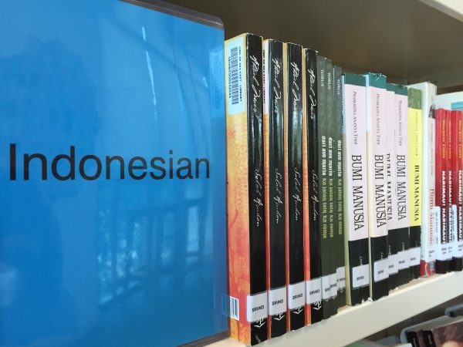
Signage for the Indonesian section.
I should note that UWCSEA has a strong reading culture, so the range of resources available to me is extensive. There is no reading incentive program here, nor restrictions on what students read or how many books they can borrow at a time. Students are coached in keeping reading notebooks to maintain a running list of what they’ve read, what they want to read, and titles that sound interesting and might be worth a second look. They are consistently reminded that not all books are for all readers, and teachers place a high level of trust in students to make appropriate selections based on their reading stamina, abilities, and sensibilities. As a result, it is not unusual for students to read 25 to 30 books every school year. I have been in schools where true readers are in the minority, so this is an enviable spot I find myself in. The beauty of it is that students are telling meabout books I don’t know and encouraging me to read a new author or title that is unfamiliar!
In a school in which everyone is from somewhere else, it is simply not appropriate to focus narrowly on particular authors, settings, languages, or cultures. To comply with IB standards, UWCSEA has made a conscious effort to collect a broad selection of titles in mother tongues. We have books in Chinese, Fijian, Russian, French, Spanish, Indonesian, Arabic, Finnish, Dutch, and more. While some of these are translations from the English, most are written by authors who speak the language and live within the culture represented by the book. Even so, finding YA fiction written by Southeast Asian authors is a challenge, and just the attempt has opened my eyes to the rich body of literature that is available outside the U.S.
THE RED DOT BOOK AWARDS
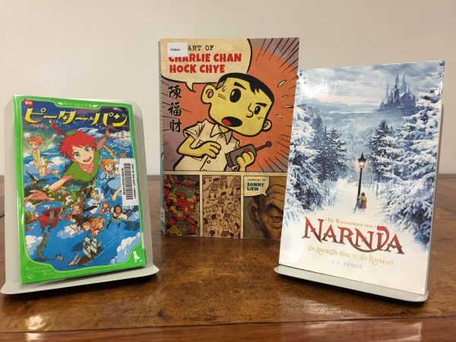
From left: A graphic novel “Peter Pan” in Japanese; “The Art of Charlie Chan Hock Chye” by Malaysian-born artist/illustrator Sonny Liew; C. S. Lewis’s “The Chronicles of Narnia” in Dutch.
Singapore librarians have a tradition of creating the Red Dot book list, a set of suggested titles for early years (ages 3–7), younger readers (7–10), older readers (10–14), and mature readers (14–adult) from children’s literature first published in English within the past four years. The goal is to offer “a range of books from around the world,” with a mix of genres, male and female protagonists, and nationalities. This year’s list has an interesting selection, some of which may be familiar to American librarians and some not.
I also recently had the good fortune to stumble across the Ubud Writers & Readers Festival in Bali at the end of October. I bought a day pass and went to conference sessions featuring Indonesian, Balinese, and Nepalese authors sharing their origin stories, journalists discussing the current distrust of legitimate news sources, Ian Rankin talking about his “Inspector Rebus” series, Madeleine Thien, author of Do Not Say We Have Nothing (Knopf Canada, 2016) discussing the idea of revolutionary idealism in her book, and a group of Iranian women authors, one of whom was jailed for her writing. The theme of the festival was origins, and each speaker had an original voice, a unique cultural point of view, and some very personal stories to tell.
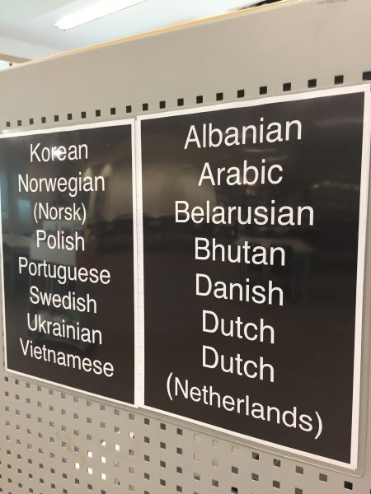
Some of the languages featured in the UWCSEA library.
I was able to pick up quite a few titles to bring back to Singapore, and I’m excited to share them with the English department. Author Shokoofeh Azar (Iran/Australia) said something during her panel’s discussion that stuck with me: If you want to know a culture, read its literature—not its history. History can be rewritten (and it is rewritten all the time), but the literature of a culture carries its soul.
With that I realize I have come full circle. My initial sense of belonging at seeing the stories I knew sitting on shelves halfway around the world from anywhere I’d ever been before came back to rest in my heart. Now I am moving beyond mystories and toward the stories being told by voices new to me. I am joining a larger body of work by reading the literature of other cultures so that I can come to a better understanding. I urge you to look deeper and further for the stories you will share with your students. Ask publishers for translated works. Look for small press titles that feature authors telling the stories of their cultures. Our human story is rich and colorful and there is room in it for many different voices.
SOME RECOMMENDED TITLES
Bohang, Lala. The Book of Forbidden Feelings. (Kompas Gramedia, 2016) ISBN 9786020331898. (Poetry, art)
Croggon, Alison. The River and the Book. (Walker Books, 2015) ISBN 9781406356021. (Magical realism, Red Dot short list)
Deswandhy, Andari. Enchanting Tales from Indonesia. (Kompas Gramedia, 2017. ISBN 9786020338743. (Indonesian folk tales – children)
Kumala, Ratih. Cigarette Girl. tr. by Annie Tucker. (Monsoon Books, 2017) ISBN 9789814625470. (Historical fiction)
Kurniawan, Eka. Vengeance Is Mine, All Others Pay Cash. tr. by Annie Tucker. (Pushkin Press, 2017) ISBN 9781782272441. (Realistic fiction – mature content)
Madasari, Okky. 86. (Kompas Gramedia, 2015) ISBN 9786020319612. (Realistic fiction)
Mohamad, Goenawan. On God and Other Unfinished Things. tr. by Laksmi Pamuntjak and author.(Kompas Gramedia, 2015) ISBN 9786020323121. (Poetry, literature)

Susan K.S. Grigsby has served as district media specialist in Forsyth County (GA) Schools. She is a 2015–16 Lilead Fellow.

http://www.slj.com/2018/01/opinion/new-job-new-country-new-literature-librarian-starts-new-chapter-singapore/

6. Micromanaging Library Leaders Rarely Know the Damage They Do | Leading from the Library
By Steven Bell
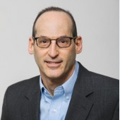Leaders are advised to relinquish control in favor of empowering staff. Giving up that control can be hard for some, especially when they are apt to micromanage workers. The key is to recognize it and then work on behavior change.
When librarians get together to talk about their organizations and how they are managed, the discussion often turns to the plague of the micromanaging supervisor. Library workers all too willingly express their disdain for leaders who constantly meddle in their work, telling them how to do their job and showing little respect for their talent. This behavior, in addition to insulting workers, undermines their commitment to the organization and likely lowers their confidence levels. It’s little coincidence that micromanaging bosses lack the basic self-awareness to know the damage they’re doing to staff morale, because they are often completely unaware of their own micromanaging behavior. The good news is that it may be possible for the habitual micromanager to do something about it, but recognizing it must the first step to change.
YOU’VE PROBABLY BEEN MICROMANAGED
In a previous position I was responsible for the access services operation. Things ran well enough except for the occasional and unexpected glitch that resulted in a disrupted workflow or a disgruntled community member. Whatever it was, the team dealt with and corrected the issue soon enough. That rarely kept the library director from stepping into the situation with some variation of “here’s how I used to handle that” or “why aren’t we doing X instead of Y?” These issues typically mattered so little to the overall success of the library, I wondered why the director even bothered to pay attention rather than trust my judgment and ability in leading the team to deliver a great service experience. Good leaders should ask questions, but the type of question and its intent makes a difference. Is it within the purview of a high-level library leader? If it’s substantively connected to strategic matters, then ask away, and get involved as needed. However, if the stakes are low and clearly of little consequence to the overall operation, let alone the future of the library, it sounds more like micromanagement.
IT’S A CONTROL THING
Why do leaders do it? Pick a reason. No one knows how to do the work as well as they do. Jobs will fail to get done without their direct involvement. Fear of delegation. Needing to oversee every team. Getting ego boosts by diving in to save the day. In her article “Signs That You’re a Micromanager,” Muriel Maignan Wilkins shares a list for leaders. It includes:
- Rarely satisfied with the work of employees
- Desire to step in and tell subordinates how to do their job
- Enjoy pointing out the need for corrections in a work process
- Demand to get constant updates from employees on their projects
- Paying attention to details when outcomes are of minor consequence
The reasons are myriad but in the end, micromanaging is largely about leaders being unable to relinquish control. They feel an undeniable urge to oversee every operation and the people in their portfolio, no matter how minor. Of course, leaders need to know what’s happening across the scope of the entire organization. But maintaining awareness and an irrational need for control are two different things. Leaders need to know when to relinquish control and allow their subordinates to do their jobs. They need to resist the urge to impact the outcomes—or even influence how tasks are ultimately accomplished—and instead accept that staff will do their jobs well and make the right decisions. When the outcomes are less than satisfactory, good leaders effectively provide guidance and support for better results in the future. Put simply, they treat staff like responsible, trusted adults.
TIME TO CHANGE
Library workers who have experience with a micromanaging boss can tell leaders everything they need to know about its dangers. Start with the destruction of trust. If leaders fail to demonstrate trust in their staff by constantly second guessing their work, how can they expect to gain trust? Rather than apply themselves earnestly to projects, staff will make a half-hearted effort waiting for their micromanaging boss to take over and tell them what to do and how to do it. Leaders whose followers have no trust in them need to change. It can be done, and Wilkins offers four strategies:
- Get over yourself. Micromanagers want to believe they are the organizational linchpin, that nothing gets accomplished without them. Recognizing and overcoming one’s own narcissism is a difficult first step, but instead of taking control, consider looking at the potential positive outcomes of relinquishing control to others.
- Let the “micro” go. Start with a basic to-do list and identify anything that’s below a strategic activity where your leadership is of less value and importance. Let direct reports know when they need your direct involvement, but that they are otherwise trusted to make the right decisions.
- Give the “what,” not the “how.” Leaders can certainly direct subordinates about expectations for outcomes and deliverables. It becomes micromanagement when leaders dictate how to get the results. If there are concerns about those results, leaders should ask staff how they plan to go about getting the job done, share thoughts if appropriate, then step back and allow them to go about their work.
- Anticipate something positive. Fear of failure underlies micromanaging. Taking control is the micromanager’s way to ensure success, even if a toxic workplace is the price to pay. Instead of being driven by failure, focus on a positive outcome based on leadership support rather than control.
Is it possible that something will go wrong? Absolutely. Stopping micromanagement behavior requires the ability to both relinquish control and accept that something may go differently than it would if the leader did it. Even in the worst-case scenario of project failure, I am unable to imagine anything much worse than the damage a micromanaging boss does to the culture of a team or entire organization. In the short run, micromanagers may get the desired results. Over time, though, micromanagement leads to a dysfunctional organization where there is no trust and the product suffers because staff take no pride or joy in their work. If this column’s depictions of a micromanager sound vaguely similar to your own leadership style, take time to ask serious questions about your inclination to exert control over people and projects. If you’re an aspiring leader who works for a micromanager, learn what not to do and make a personal commitment to do better with those you’ll be leading in the future.

http://lj.libraryjournal.com/2017/12/opinion/leading-from-the-library/micromanaging-library-leaders-rarely-know-damage-leading-library/

7. Texas university libraries renovate to keep student interest
By Lindsay Ellis
December 29, 2017 Updated: January 5, 2018 12:58pm

- 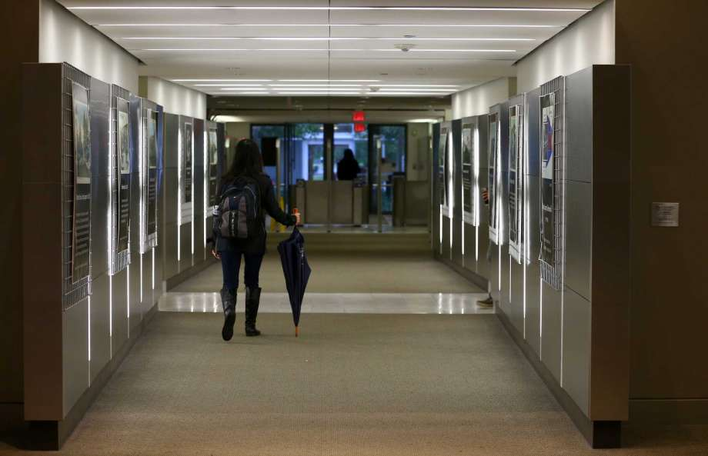
Photo: Godofredo A. Vasquez, Houston Chronicle
Fondren Library at Rice University Wednesday, Dec. 6, 2017, in Houston. ( Godofredo A. Vasquez / Houston Chronicle )
College students no longer need to hit the gym to pedal an elliptical or exercise bike. At Texas A&M and Rice universities, students can get their cardio at the campus libraries.
The colleges spent about $3,100 combined on desk bikes and under-desk pedals this year, part of a growing effort to keep libraries relevant to a generation of students for whom information never has been bound to a dusty book.
The adjustments are part of a dramatic reshaping of the very definition of a library for students and other visitors.
"Libraries typically used to be the gatekeepers to knowledge - in the olden days, the stacks were closed," said Susan Goodwin, associate dean for user services at A&M. "Now, I see us as a gateway. We are facilitators to bring (students) to other experts."

TRANSLATOR
To read this article in one of Houston's most-spoken languages, click on the button below.
Seleccionar idioma​▼
Campuses across the state are pouring money into renovating libraries, adding study rooms, café-like booths and, yes, exercise machines so students can multi-task while studying.
MORE: Good Brick Awards recognize San Jacinto College library restoration
Librarians have shuttled books off-site as circulation has dropped, opening up floor space for clubs to gather or for makerspace centers to build electronics or use a 3D printer.
A need for libraries to innovate, of course, is not exclusive to college campuses. Municipal and county libraries across Texas and the country have swapped bookshelves for computers, added cafes and provide a slate of community events in a bid to make them more attractive for today's consumers.
But universities have an added urgency to keep up: faster turnover in user demographics as each successive class enrolls and graduates.
"Every year, there's a new group of students coming in," said Debra Kolah, head of user experience at Rice University's Fondren Library. "You have to learn what these new students need to be successful."
Along with the under-desk ellipticals, Rice has added standing desks and a room for nursing mothers this year. Students low on cell phone juice can check out a charger from the library, and if it rains unexpectedly, umbrellas are available for loan.
Changing, too, are the functions of the library staff. The University of Texas at Austin hired a data management specialist to work with campus researchers. A&M's librarians no longer expect to answer questions that can be Googled. Now, they teach visitors how to navigate online databases or answer deep, subject-specific research questions.
So far, college libraries' efforts to stay relevant appear to be effective. Sixty-four percent of students surveyed in 2015 by EBSCO Information Services, a library consulting company, said they used library resources for research.
MORE: Harvey-damaged libraries win nearly $300,000 in recovery grants
Checking out books, however, no longer is a draw. Research libraries' circulation dropped 58 percent from 1991 to 2015, while the total number of students enrolled rose 40 percent, according to the Association of Research Libraries.
UT-Austin's libraries saw circulation, excluding e-books, drop from 1.9 million in 2007 to about 242,500 through early December. At the University of Houston, circulation - excluding course reserves, renewals and e-books - dropped from 129,403 in the 2006-07 academic year to 76,978 in 2016-17.

Luis Rodriguez, a 21-year-old UH junior, goes to the library to study.
It's often packed, he said, adding that he "can see the justification" for campuses' spending on libraries.
But he perceives the library's books as "old" and "outdated" and says he'd prefer to search for scientific articles online.
Open houses
The first step to encouraging library use is getting new students in the door, staff acknowledge.
Marketing campaigns, open houses, even integrating the library into the campus tour aim to teach students about resources they could find on-site. Campuses across the state have social media accounts for their libraries, posting photos and event listings.
MORE: Damaged elementary school was built in a flood pool - and Katy school officials didn't know
UH's library Twitter account earlier this month shared photos of dogs brought in for a pre-finals relaxation event.
About 3,000 students come to a Texas A&M library open house for food and beverages each fall, Goodwin said.
"It's anxiety-provoking to come into a building our size for the first time and ask a question," she said, adding that many A&M students come from small Texas towns.
During orientation, new UT-Austin students meet a first-year experience librarian,who explain what the library has to offer.
"I always encourage them to make a librarian their best friend forever," said Lorraine Haricombe, vice provost and UT libraries director. "It's a resource that will benefit them for the rest of their lives."
Some students don't receive the message.
Reagan Hahn, a 21-year-old junior at Rice who works as a library "ambassador," said many of her peers are "pretty unfamiliar" with what the library offers.
MORE: UH's indoor football facility another big step
Hahn, who studies kinesiology, said students use Fondren for group homework projects or as a meeting place.
The library needs to stay in tune with what students want to remain relevant, she said.
Value of space
Rice's efforts to renovate Fondren, perhaps typify the lengths to which universities will go to keep the facility in touch with student needs.
In 2005, Rice redesigned Fondren's west entrance, conceptualizing a "main street" through the center of the first floor to accommodate a high volume of student traffic.
Overhead is an art installation - glass blue, yellow and red boats form Lino Tagliapietra's "Endeavor," created in 2008.
Kolah later started leading user experience efforts at Fondren. Her office now surveys Rice's students and holds focus groups, asking how the library could better serve their needs.
A digital media center, complete with podcast stations and a graphics lab, nestled into the library's basement in 2014, the same year @fondrenlibrary sent its first tweet.
The reading room was renovated in December 2015. Administrators added cubicles with cushioned chairs and bar tables, scattered around the room.
MORE: Look inside Texas A&M basketball locker room after multi-million dollar renovation
Smaller changes came throughout. Students can scribble on new glass tables on the quiet sixth floor with dry-erase markers available for reserve from the library.
Elsewhere in the building, what once was a computer lab now is a conference room.
"If you are making sure you're creating spaces that are relevant to the next generation, you will continue to be utilized," Kolah said.
There still is work to do, she added.
The Asian reference alcove, for example, still holds stacks of books and journals.
"In the near future, will this change? Yes," she said, adding that one possible use could be a space for graduate student collaboration. "It doesn't mean the books are not important. (But) space is one of the most valuable commodities. What could this be to make our students more successful?"
Starting fresh
Texas Southern University is starting from scratch with $43 million in construction on a new library to replace its existing one. Janice Peyton, executive director of TSU's library, says it will be a "tech-rich" environment.
Tenants of the facility will be TSU's distance and online education divisions and tutoring. Administrative offices and a board room also will be in the new space, which is expected to be completed in summer 2019, she said.
"Traditionally libraries have been more one-fits-all," Peyton said. "Now, I think we're getting more into understanding that learners learn in a variety of styles at different times. That's what they're asking for."
Books will occupy parts of two of five stories in the new library. Staff members have weeded out 40,000 books as they prepare to move, Peyton said, looking at how frequently and recently they have been taken out.
TSU placed these books in a staging area for passersby to take on campus. Peyton said she is looking into remote storage but called that "expensive."
"It's a very emotional topic," Peyton said. "We are in a period right now where books and e-resources will coexist."

http://www.houstonchronicle.com/news/houston-texas/houston/article/Texas-university-libraries-renovate-to-keep-12462643.php

