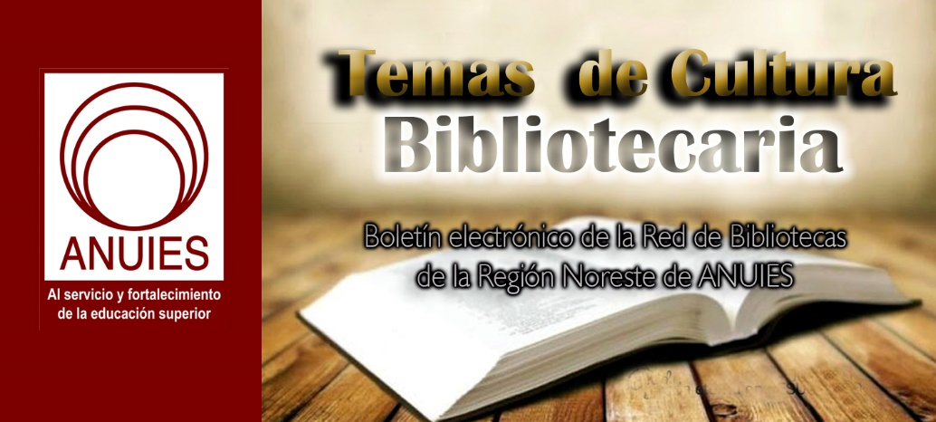
Año 3 Número 58 enero 2018

Contenidos de este número

- Patología laboral en archivos
B
Boletin Fundación Ciencias de la Documentación
on behalf of Fundacion CD

DOCUFORUM@LISTSERV.REDIRIS.ES
Estimados/as compañeros/as;
A unos días de finalizar el año desde el equipo de la Fundación Ciencias de la Documentación queremos aprovechar para enviaros nuestros más cordiales deseos de felicidad para estos días, y éxitos en todas las actividades que emprendáis el próximo año.
Igualmente queremos informaros que ya está disponible la certificación en PATOLOGÍA LABORAL EN ARCHIVOS en base a las recomendaciones de la Organización Mundial de la Salud (OMS) en materia de prevención de riesgos de la salud de los trabajadores en el ámbito laboral de los archivos documentales o generales.
El certificado cuenta con 4 talleres que pueden realizarse individualmente - de forma gratuita - en el orden y días que mejor convenga durante todo el 2018 (eso sí, dispone de 8 días por taller, una vez se matricule en el mismo). Si además se desea obtener la certificación de la Fundación Ciencias de la Documentación, será necesario conseguir los diplomas digitales de cada taller y superar, al finalizar los mismos, un examen de dominio de conocimientos en la materia.
TALLERES QUE COMPONEN LA CERTIFICACIÓN
TALLER 1. AGENTES AMBIENTALES EN ARCHIVOS Y SU INFLUENCIA EN LA SALUD DE LOS TRABAJADORES
Tema 1. Energía mecánica (ruido)
Tema 2. Energía térmica (temperatura y humedad)
Tema 3. Energía electromagnética (radiaciones no ionizantes y corriente eléctrica)
Tema 4. Contaminantes atmosféricos
TALLER 2. AGENTES BIOLÓGICOS EN ARCHIVOS Y SU INFLUENCIA EN LA SALUD DE LOS TRABAJADORES
Tema 1. Bacterias y Hongos
Tema 2. Insectos y otros antrópodos
Tema 3. Vertebrados
Tema 4. Medidas preventivas
TALLER 3. AGENTES ERGONÓMICOS EN ARCHIVOS Y SU INFLUENCIA EN LA SALUD DE LOS TRABAJADORES
Tema 1. Carga física y lesiones ocasionadas por malas técnicas e instalaciones
Tema 2. Carga mental y factores psicosociales
Tema 3. Equipo de protección de los trabajadores en archivos (para la cabeza, aparato respiratorio, extremidades superiores, tronco e inferiores)
TALLER 4. PROCESOS DE RIESGO LABORAL EN ARCHIVOS
Tema 1. Organización de archivos
Tema 2. Reprografía
Tema 3. Limpieza, desinfección y conservación de documentos
EXAMEN FINAL PARA OBTENER LA CERTIFICACIÓN (Opcional)
Más información: https://documentalistas.org/web/portfolio/patologia_archivos/

Lance Werner: LJ’s 2018 Librarian of the Year
By Lisa Peet
Photo by Adam Bird, Bird + Bird Studio

Executive Director, Kent District Library, MI
If you ask Lance Werner, executive director of the Kent District Library (KDL), MI, what makes him a strong leader, an effective legislative advocate, and a champion of access for his patrons, his answer is simple: it’s all about forming relationships—with his staff, legislators, local business owners and CEOs, county commissioners, Michigan Library Association (MLA) administrators, LIS educators, patrons, and anyone else in a 100-mile radius. Ask him again, and he’ll bring up words such as kindness and empathyand that he loves his job.
Underneath those soft skills lie persistence and passion. Werner gets the job done, whether that involves convincing KDL trustees to invest $400,000 in ebooks, testifying before the Michigan Senate and House committees to win tax capture amnesty for libraries, securing health care for part-time KDL employees, spearheading a countywide literacy initiative, or securing grant money to bring back the library’s bookmobile after a 30-year hiatus. It’s no surprise that he was named a 2016 LJ Mover & Shaker and the 2017 MLA Librarian of the Year. Add to those accolades the 2018 Library Journal Librarian of the Year, sponsored by Baker & Taylor. Ask Werner why, and he’ll tell you it’s just a matter of being a regular guy who cares about his constituents. Ask his constituents, and they’ll tell you there’s more to the story.
THE LONG ROAD TO THE LIBRARY
Werner’s path to KDL was, as he puts it, “meandering.” He initially wanted to become an FBI agent and enrolled in the Michigan State University College of Law in East Lansing. Halfway through law school, Werner met his wife, who had a young daughter, and “I decided maybe working for the FBI wasn’t such a great job for a new family man,” he recalls. He loved his part-time library job (following in the footsteps of his mother, a librarian), so he decided to pursue a master’s degree in library and information science—not instead of the law degree but in addition to it.
Werner enrolled at Detroit’s Wayne State University with the goal of becoming an academic law librarian. He graduated from law school, took off a semester from Wayne State to study for (and pass) the bar, and earned his MLIS in 2004. Although he liked his first job as a reference librarian in a law library, Werner says, “I wanted a new challenge.”
He took a job at the Michigan State Library, in Lansing, as a library law specialist. In the process, “I developed this profound respect and a greater understanding of the invaluable work that public libraries do,” says Werner. In 2009, he made the move to the Capital Area District Library, also in Lansing, where he served as director for two years.
Yet Werner had his sights set on the 18-branch KDL, which had a reputation for out-of-the-box thinking that appealed to him. When the director’s position opened up at KDL, longtime board member Shirley Bruursema encouraged Werner to apply; he stepped into the role in 2011.
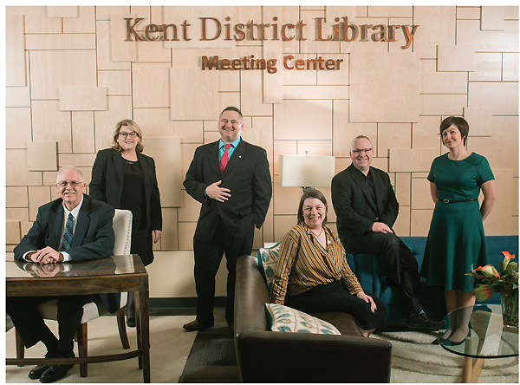
TEAMWORK Librarian of the Year Werner with his team (l.–r.): Kurt Stevens, IT director; Jane Saurman, chief financial officer; Werner; Michelle Boisvenue-Fox, director of innovation & user experience; Brian Mortimore, director of human resources & organizational development; and Lindsey Dorfman, director of branch services & operations.
Photo by Adam Bird, Bird + Bird Studio
WHERE THE PEOPLE ARE
At his first board meeting as KDL director—“before anyone knew my name”—Werner proposed that the board spend half a million dollars to build the library’s ebook collection. “I think the board thought I was insane,” says Werner. But he’d made his point, and at the next meeting the board approved a $400,000 investment. KDL was the first public library in the state to offer e-magazines, e-movies, e-comics, and, in early 2016, streaming video games. (Werner repaid the board’s trust—literally—in 2014, when he helped secure a 45 percent increase in library millage, convincing several antitax opponents to vote yes and securing library funding into the future.)
Still, content is only useful if it can be accessed. Much of Kent County’s 734 square miles are rural, and with the state’s savage winters, transportation is a major issue. Werner recognized the county’s access limitations as a digital divide issue and began circulating iPads and Wi-Fi hot spots. “It’s another philosophy of ours that we want to be wherever people are—we want to meet them on their own terms,” Werner explains.
In addition to ensuring that the library’s now-robust electronic collection could reach all customers, Werner had a series of Little Free Libraries installed around the county. There are currently 14, housed in community centers, senior centers, parks, and the local airport. And thanks to a recent $208,000 grant from the Steelcase Foundation, KDL’s new bookmobile will be hitting the streets in 2018.
In 2016, Werner worked with his team of directors to create a new manager of community outreach position to reach out to residents not adequately served by the library. The role was filled by Ruben
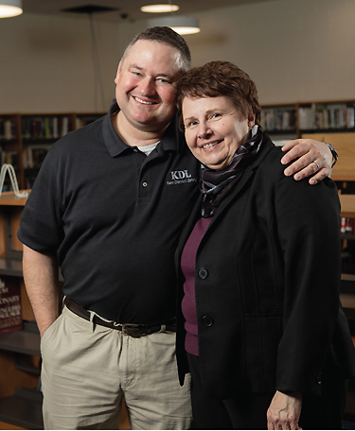
Werner with Gail Madziar, executive director of the Michigan Library Association.
Photo by Adam Bird, Bird + Bird Studio
Campos, who is fluent in Spanish; 6.55 percent of Kent County’s population is made up of native Spanish speakers. The library has since seen increased interest in Spanish materials and more Spanish entries in the Write Michigan writing contest it cosponsors.
A LEG UP ON LITERACY
Werner has also stepped up KDL’s literacy initiatives. Approximately one-third of Kent County’s third graders read below grade level, and the low literacy rate among adults hovers at about 14 percent. Under his watch, KDL instituted a multipronged early literacy resource, Play Grow Read, that provides information for parents and caregivers and features crafts, recipes, and other activities linked to reading.
Local organizations, including the Literacy Center of West Michigan (LCWM), the Kent Intermediate School District, and Steelcase Corporation, have actively partnered with the library to help implement the program, as well as a collaboration between Grand Rapids Community College and KDL to provide all-ages STEAM (science, technology, engineering, the arts, and mathematics) programming.
The Kelloggsville school district opened a new high school in October 2017, with a multilevel media center staffed by KDL librarians and stocked with materials from the library’s collection that will feature a rotation of KDL programs. Not only will the media center serve Kelloggsville High School students—71 percent of whom come from low-income families—but it will be open to the general public outside of school hours.
LEGISLATING FOR LIBRARIES
While shifting the culture both in and outside of his library, Werner has also been effecting top-down changes for libraries across the state. Since joining the MLA in 2009, Werner has been the organization’s president and chair of the legislative committee and an active advocate on its behalf.
In late 2015, the state was faced with an amended finance reform measure, SB 571, containing language that would have prevented libraries from communicating “by means of radio, television, mass mailing, or prerecorded telephone message if that communication references a local ballot question” for 60 days prior to an election. This would have effectively placed a gag order on libraries when they most needed to get the word out. Werner met with Lisa Posthumus Lyons, then a Republican member of the Michigan House of Representatives from Kent County’s district, to suggest alternate language for the bill.
“I understand you’re worried about this whole concept of electioneering, using public moneys to [advocate] for the yes vote, which is illegal,” he recalled telling Lyons. “But this legislation is going to hurt us.” Lyons agreed and adopted some of the wording Werner suggested. The bill eventually passed despite their efforts, although Gov. Rick Snyder provided clarifying language that worked in libraries’ favor.
Werner’s efforts on tax capture relief, however, were an unqualified win. For more than 20 years, the MLA and the library community had been fighting the use of a percentage of library millages to benefit various Michigan development organizations, often against the libraries’ wishes and without taxpayer approval, that took more than $10 million from library coffers annually.
Werner testified before the state House and Senate for a bill exempting libraries from the allocation as part of an extensive library-driven advocacy effort. In early 2017, SB 619-624, legislation redressing that appropriation, passed both chambers.
“This is what I said to the legislators,” Werner told LJ. “This is important to us because transparency’s important. When people come to me and [ask], ‘What’s my money being used for?’ I can’t tell them…. And that’s a crime.” Governor Snyder signed the bill into law on January 10, and Michigan libraries are now entitled to opt out of all new tax capture.
This was a major milestone for Michigan’s libraries, says MLA executive director Gail Madziar, who initiated Werner’s nomination, and much of its success had to do with Werner’s relationship with his elected officials. When he brought the issue up, she explains, “They already understood that he was a good spokesperson for the community and had his finger on the pulse of what the community wanted. I think when it’s time to ask for support from your representatives and senators, and they know that you are a knowledgeable source for reliable information about…their constituents, then they’re going to be much more open to listening to your requests.”
PUTTING THE “HUMAN” IN HR
Recently, Werner and the KDL human resources (HR) department unveiled a series of benefit programs for part-time staff members, including one that will provide primary health care at no cost to the employee. The service covers doctors’ visits and prescriptions in full. KDL has also instituted a four-year student loan assistance program for employees and in 2017 arranged a disability audit for the branches, conducted by Disability Advocates of Kent County (DAKC). As a result, the library became the first recipient of DAKC’s Community Champion Award.
“At any organization, it takes backing from the leadership to make change happen. It’s as simple as that,” says the library’s director of HR and organizational development Brian Mortimore. “At KDL, Lance has gone beyond simply backing these changes that have so positively impacted the lives of staff and patrons—he has embraced them in a profoundly passionate manner and helped take them to the next level.”
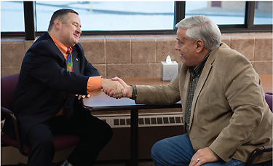
LEADER TO LEADER Werner’s ongoing relationships with his representatives, such as Rep. Tom Hooker (r.), Michigan House of Representatives 77th District, who supported the tax capture opt out vote, are a crucial part of his effectiveness at the state level.
Photo by Adam Bird, Bird + Bird Studio
Werner’s care extends far beyond the library walls. In October 2017, he helped organize a KDL fundraiser and book drive to help the Port Arthur Public Library, TX, reopen its doors after losing all its children’s materials, DVDs, and audiobooks to damage from Hurricane Harvey. The goal is to get the Texas library up and running again by March, but along the way KDL hopes to inspire other libraries to support one another.
“It’s evident…that Lance is passionate”—that word again—“about supporting other cultural institutions,” says Rich Baker, president and CEO of the Grand Rapids Area Chamber of Commerce, “whether it means bringing together a handful of local organizations to collaborate on a project or leveraging his resources to lend a helping hand to another library over 1,000 miles away.”
Werner also serves on the Lakeland Library Cooperative Board and on the advisory board of the Wayne State Capital Campaign Committee, fundraising and working on strategic planning and curriculum issues. This last is both service oriented and part of minding the shop, says Werner—he often hires Wayne State grads, and “I can ensure that I have great librarians by being involved at that level.”
“JUST LANCE”
How has Werner accomplished so much in his six years at KDL? “I made a point of getting to know everybody,” he says. “I wanted to hear their stories, I wanted to figure out what their concerns were, and figure out a way that the library can meet those concerns.” He adds, “Things I’ve been able to accomplish legislatively have all been based on the friendships that I have, real friendships, with the folks who represent this county.”
Fishing helps, too, explains Werner. “I go fishing with a lot of different people during steelhead season because it helps buttress our relationships, it’s a good time with friends, and it gives us the chance to talk about issues and have a genuine conversation.”
Werner’s spirit of generosity has also allied him with library leaders, users, and supporters well beyond his region. “Lance brings a passion for…all libraries, not just his,” says MLA’s Madziar. “When he’s working on an issue or he’s coming up with new ideas or some state-of-the-art technology that he wants to get into his library, he’s thinking of libraries across the state, across the country.”
“I preach the gospel of ‘don’t make it too complicated,’ ” says Werner. “Always act with kindness, love, and empathy. Try your hardest, be passionate, believe in what you’re doing, and things are going to work out fine.”
“This is the best time ever to work in the library,” Werner adds. Because we’re at a crossroads, and we can make changes that will impact how library service is offered for the next hundred years…we can do something that can change the trajectory and push us to a new level. And that’s the greatest gift at all.”
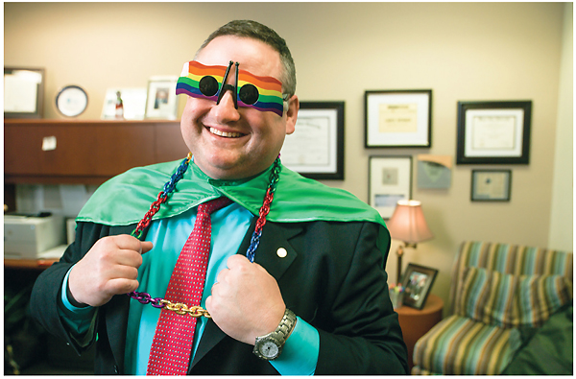
Photo by Adam Bird, Bird + Bird Studio
This article was published in Library Journal's January 1, 2018 issue. Subscribe today and save up to 35% off the regular subscription rate.
About Lisa Peet
Lisa Peet is Associate Editor, News for Library Journal.

http://lj.libraryjournal.com/2018/01/awards/lance-werner-ljs-2018-librarian-year/

Libraries Without Librarians
BY ANNOYED LIBRARIAN
When libraries turn up in the press the reports aren’t always confused. Sometimes they get libraries just right, like this opinion article about libraries being “for the homeless, the drifters and the snorers,” people like the author, who does his self-indulgent best to sing the praises of the public library. In this case it’s the British Library, so it’s not a typical public library, but it’s still public.
It’s a place where anyone is comfortable to sleep and even snore, which means the British Library isn’t one that has tried to combat the homeless using it as a shelter by creating rules against both sleeping and snoring.
It provides a good demonstration of male creepiness in libraries as well. For example, whether the author would wake up a snorer “all depends on how cute they are. That is, if he or she – OK, let’s not be silly here – she were cute, then I would gently wake her up and humorously suggest we go for a coffee to remedy the situation.”
That’s the sort of interaction women might hope to avoid in libraries, but libraries expose people to all the experiences and knowledge of the world.
It also demonstrates in concrete terms the class leveling that can go on in public libraries, as when the author remarks, “the only difference between me and the vagrant in the municipal library is that I have the TLS open in front of me rather than the Daily Express, and I smell better.”
Smelling awful might make the library staff wince slightly when interacting with you, but in most situations the aromatic and the malodorous will receive more or less equal treatment, just like the beautiful and the ugly.
However, the one thing absent from the article is a mention of librarians or library staff. Indeed, librarians are conspicuous by their absence: “Curiously, no one has ever reprimanded me for snoring.”
There can be little doubt that the British Library is a great library, and also little doubt that part of what makes it so is centuries of work by librarians, but what makes it great for readers is space and reading material.
The same can also be said of most public library locations. Provide places to sit and something to read and libraries have fulfilled a major part of their mission for most people who use libraries.
The desire to turn public libraries into community centers and other non-library endeavors should be accompanied by the realization that the existence of librarians is already marginalized even within libraries.
This fact can be interpreted in at least a couple of ways. First, librarians could understand and regret this marginalization.
They already know that the public usually has little idea what they do beyond shushing people, being sexy, and reading all day. Being that sexy and shushing that many people is a full time job in itself, so how they get a chance to read all day as well is probably a mystery to the public, but the public doesn’t really care.
Understanding their marginalization would thus be a bad thing.
On the other hand, if the public already doesn’t really care if librarians exist, if all they really want are some places to sit and stuff to read, it could make librarians feel better about turning libraries into community centers or whatever they want to do.
One doesn’t need librarians to create inviting spaces to sit and read, as bookstores and coffeehouses have known forever.
If the librarians don’t even want to enforce silence, then there’s even less need for them. Every librarian interviewed for an article about libraries emphasizes that they’re not about shushing and the library isn’t quiet anymore, even if that’s what library users actually want.
So this could all be a positive. As libraries transform into something else, librarians can go extinct or spend even more time reading about shushing sexy people, and the library can just go on existing without them.
As we know from the many librarians who have been asked if they’re volunteers, the general public seems to think that happens anyway.

http://lj.libraryjournal.com/blogs/annoyedlibrarian/2017/12/11/libraries-without-librarians-2/

Library of Congress introduces three new apps (and a reminder of some older goodies)
BY JOYCE VALENZA
Just a couple of weeks ago, the Library of Congress announced the launch of three new apps for Web and mobile, developed by educational organizations that were supported by an LOC grant for app development. The new interactive applications focus on citizenship, civic engagement, and exploration with primary sources.
Lee Ann Potter, director of Educational Outreach at the Library of Congress, shared in a press release:
We are delighted to see the creative ways in which these three interactives support students’ investigations of government, legislation and the role each of us can play in participating in our nation’s civic life. Primary sources are uniquely powerful teaching tools, and the Library’s education staff learned a great deal by watching the selected organizations use historical artifacts to illuminate key aspects of national institutions and citizen engagement.
The three new civics interactive apps are
1. Eagle Eye Citizen is all about taking a closer look. (Developed by the Roy Rosenzweig Center for History and New Media) engages middle and high school students in solving and creating interactive challenges on American history, civics, and government with Library of Congress primary sources in order to develop students’ civic understanding and historica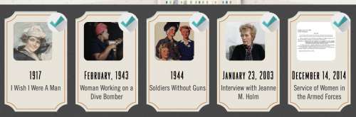l thinking skills.
- Time After Time challenges invite players to order a thematic group of primary sources chronologically to explore sequencing and change and/or continuity over time.
- Sort it Out challenges invite players to sort sources into categories to support contextual thought and reasoning.
- Big Picture challenges invite players to discover the meaning of a primary source by uncovering small tiles that comprise the larger image.
The community is invited to create their own challenges using these three challenge strategies. I can absolutely see engaging middle and high school students in this type of creation and having them lead their classmates in discovery! This is a nice way to prep for National History Day and it may present a new way to DBQ for APUSH!
A Teach Page offers videos, resources for lesson planning and assessment, differentiation, additional resources, in-a-pinch (for substitutes or surprise snow days) and achievements (badges, votes, and rankings) to promote engagement.
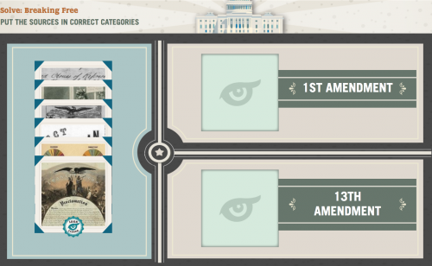

2. Engaging Congress Developed by the Indiana University Center on Representative Government, this game uses primary sources– documents, photographs, political cartoons, maps and other documents–to explore the challenges of sustaining our democracy. It is available for Android and iOS at the App Store.
Players choose from among four activities:
- Choose a Story–short theme-based videos introduce current issues and players select related challenges based on examining primary sources. The five thematic stories are:
– More Equal Than Others (Influencing the Political Process)
– Laws and Sausages (Separation of Powers)
– Vote Early, Vote Often (Voting Rights)
– A Balancing Act (The Federal Budget)
– Fair is not Always Equal (Federalism and States’ Rights)
- Primary Source Gallery–a collection of the documents used in the stories
- Trivia Challenge–a timed quiz with points
- Trivia Practice–tests your knowledge without the timer or scoring
An accompanying Engaging Congress site supports the app with these resources:
- Teacher Toolbox
- Curriculum Guide
- Correlation of content with Social Studies standards
- Bank of multiple-choice and discussion assessment questions
- Links to Library of Congress primary source analysis guides
- Downloadable PDFs and PNGs of all primary source documents
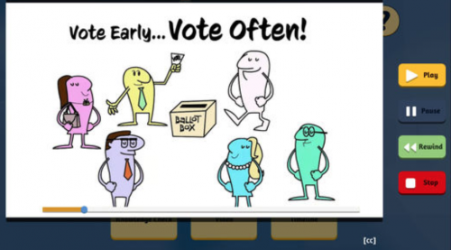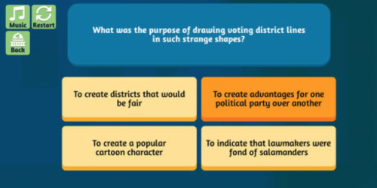
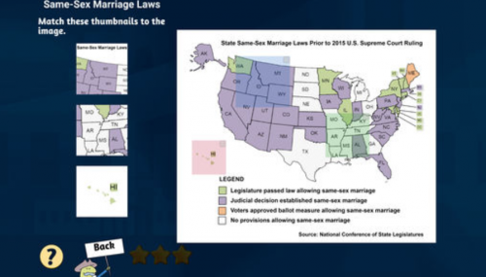
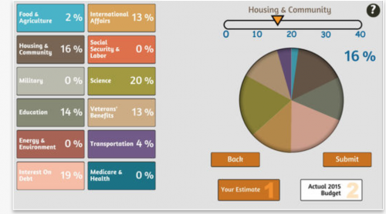
3. KidCitizen: Developed by Muzzy Lane Software, KidCitizen engages K-5 students in exploring with primary sources and connecting them to their daily lives through a growing collection of interactive episodes using Library of Congress primary source photographs.
Mentor character, Ella, leads children in a search for history clues to help solve historical mysteries. Students keep their collected clues in online journals. Each very hands-on episode trains young learners in careful observation and prepares them for detailed historical inquiry and visual literacy.
Episodes contain standards-aligned Teacher Guides complete with essential questions, historical background, links to additional images from the Library of Congress collection, recommended instructional materials, and a wide array of other resources. These are useful well beyond the game!
The platform also encourages educators to create and share their own episodes.
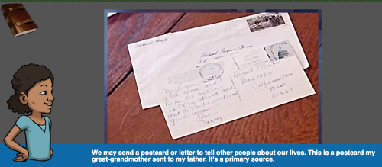
Current episodes include:
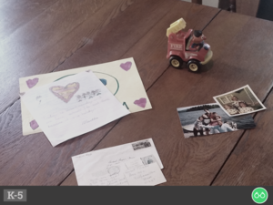
What are Primary Sources?: In this brief introductory episode, we find out what a primary source is and explore a few examples.
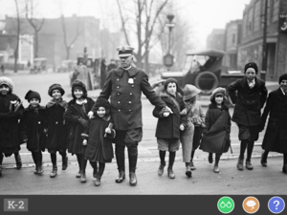
Community Helpers: Investigate who community helpers are, and how they have changed over time.
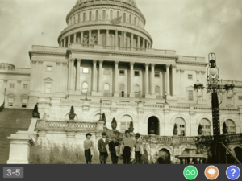
Congress and Child Labor: Long ago Congress decided that it was important to pass labor laws to protect children. Why did they think that child labor was a problem?
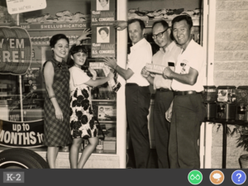
Welcome to Congress: Who represents us in Congress and where do they work?
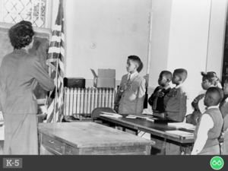
Capture the Flag: How is the American flag used as a symbol of our nation?
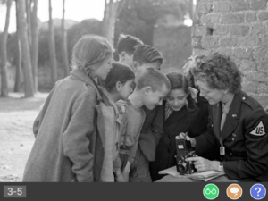
Snap a Photo: Agent of Change: How did photographers help convince Congress to pass child labor laws?
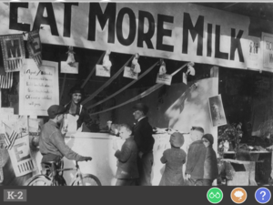
Congress and School Lunch: How does Congress affect our daily lives at school? (Coming soon!)
Together Our Voices Matter: What kinds of nonviolent protest activities have kids engaged in to get their ideas and voices heard? (Coming soon!)
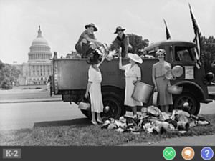
Kids in Action: How have kids demonstrated good citizenship and made a difference in their communities? (Coming soon!)
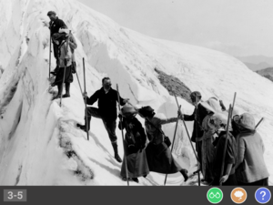
Adventure Awaits: Congress and the National Parks: Why did Congress create the National Parks? (Coming soon!)
The three selected projects for 2017 were chosen from among 33 proposals. A second group of organizations will launch their projects in 2018.
You’ll find many more effective strategies for teaching with primary sources on the Library of Congress Using Primary Sources page.
And . . .
These are not the first apps from the Library of Congress. In case you missed them, check out:
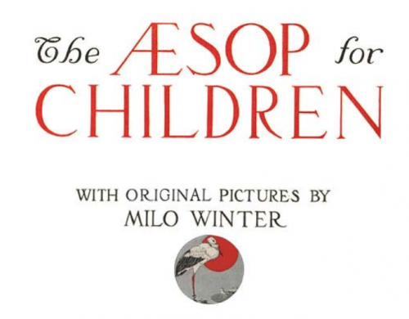

Aesop’s Fables Interactive Book app, with pictures by Milo Winter, is available for iPhone or iPad or Android. Click on the illustrations for little surprises. This could be fun on your IWB, as well as for individual reading and discussion.

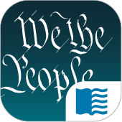
U.S. Constitution: Analysis and Interpretation (For iPhone or iPad) This mobile version of the Constitution of the United States of America: Analysis and Interpretation is a comprehensive analytical legal treatise prepared by attorneys of the Congressional Research Service at the direction of the United States Senate and presented using data provided by the GPO.
The Congressional Record (For iPhone or iPad) Includes the daily edition of the Congressional Record, Use with AP Gov and beyond.
BARD Mobile (foriPhone or iPad or Android and may be downloaded from Amazon) This continually growing service of the National Library Service for the Blind and Physically Handicapped contains nearly 50,000 books, magazines, and music scores in audio and braille formats.

http://blogs.slj.com/neverendingsearch/2017/12/07/library-of-congress-introduces-three-new-apps-and-a-reminder-of-some-older-goodies/

Reading challenges/resolutions for the new year
BY JOYCE VALENZA
This time of year is ripe for resolutions. It’s a good time to resolve to read and, perhaps, to resolve to change things up a bit.
The new year may be the perfect time to invite your kids to read a little differently–to suggest they build personal challenges based on their own passions, as well as an array of prompts or intriguing options you might imagine together.
Challenge inspirations
I was recently inspired by Laura Sackton’s Book Riot post: 50 DIY Reading Challenges to Make 2018 the Best Year of Your Reading Life, as well as Emma Nichols’ collection of 2018 Bookish Resolutions, Both are chock full of clever ways to rid anyone of a reading rut. Both lists reach well beyond the typical genre challenge.
Here’s a taste of Laura Sackton’s first five ideas:
1. Make a list of ten identities that are important to you and/or influence the way you experience the world. Now read ten books by ten different authors who share one of those identities, and/or ten different books that center and explore those identities.
2. Make a list of ten identities (race, religion, sexuality, gender, nationality, etc.) that are not yours. Now read ten books, each written by an author who holds one of those identities.
3. Pick ten countries you have always wanted to visit. Read one book that takes place in each of those countries.
4. Is there a genre you’ve always wanted to try but just haven’t gotten around to? Maybe your best friend has been telling you to try fantasy since forever but you’ve always shrugged her off. Pick the genre that’s always scared/baffled/bored you and challenge yourself to find one book in that genre that you absolutely love.
5. Read a book published each year between your birth and now. Goodreads by decade shelves can help.
BookRiot also gathers a wealth of #Must-Read lists, many would work well for high school. Goodreads offers Reading Challenge Groups, as well as Popular 2018 Reading Challenge Books, and, of course, oodles of lists to mine in Listopia–many of which are children’s and YA titles. Penguin Random House offers some fabulous lists in its series Challenge Your Shelf Reading Challenges. Last year Tanya Patrice of Girlxoxo gathered a Master List of 2017 Reading Challenges that will continue to spark a million ideas.
A Pinterest search reveals hundreds of possible reading challenges graphically. On Instagram, you might follow the #popsugerreadingchallenge.
Beyond personal reader’s advisory to personal research (or DIYRA):
Personal reading challenges might involve learners in more than simply setting goals and reading. What if we ensured the reading challenge experience also became a bit of a personal inquiry experience?
If you are planning to present a reading challenge or planning to have your kids create their own DIY challenges, give them a few tools. You may want to introduce resources that will feed them with reading inspiration well beyond the challenge.
In addition to your OPAC, these resources will help you and your students get started. Make them discoverable by listing those that work best on a library web page or a LibGuide or gather them on a curation platform.
Choose an appropriate handful of the following:

- Follett’s State Book and ALA Awards Lists
- Goodreads Lists
- YALSA’s Book Database
- ALSC’s Children’s Notable Lists
- ALA Youth Media Awards
- Database of Award-Winning Children’s Literature
- Children’s Book Council (Check out the Reading Lists and Round-ups as well as the Children’s & Teen Choice Book Awards Finalists & Winners
- Epic Reads (check out the variety of quirky lists, Like Try Why, and more for YAs!)
- Epic! (this digital service offers free accounts for educators and very searchable)
- EBSCO’s Novelist or Novelist K8 (available as part of many state database suites)
- Biblionasium (where you can both select books and create challenges)
- Diverse BookFinder (Identify & Explore Multicultural Picture Books)
- International Children’s Digital Library
- Common Sense Media Book Lists
- Resources and lists suggested by WeNeedDiverseBooks
- Book selection wizards, like:
  - WhatShouldIReadNext
  - Scholastic Book Wizard
  - A Book and a Hug
- Curate a list or link to feeds of age-appropriate book bloggers and reviewers.
- Amazon has so many lists of 100 Books to . . .
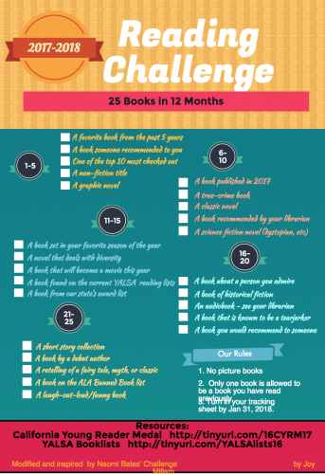
Keeping track of reading goals:
You can encourage kiddos to keep track of their reading challenges in their notebooks. They could share their challenge progress in your OPAC or in a tool like Biblionasium or Epic! that offer incentives/badges. [But please read the warning below!]
Joy Millam shares a Piktochart example in her Reading Challenge: 25 Books in 12 Months and her Padlet the includes posters and a customizable tracking sheet for readers. And Naomi Bates shared a Young Adult Novel Reading Challenge and a handy Google Doc for copying and editing. The Modern Mrs. Darcy (@annebogel) recently launched her 2018 Reading Challenge complete with reproducibles.
Setting up a Hyperdoc introduction/index page that leads to Slides, Docs or Sheets may be a perfect strategy for Google Classroom schools. You might also have kids post their reads on sharing spaces like Padlet.
Challenges come in a variety of flavors
Over the course of the year, semester, or a particular month, etc., you might encourage kiddos to participate in challenges of a few sorts:
- You might encourage them to choose to read 10 (or so) books of a certain genre or format or type and keep track of the titles list or digital shelf style.
- You might set up a passport system where kids can creatively design the path or perhaps, work to complete a Bingo card on which they might record the one-ofs they read from their own selected or invented challenge prompts.
- You might set up a collaborative whole-class or whole-school challenge. For instance, post or distribute maps of the states or countries of the world. Have kids collectively pin/ check-off books they’ve read that were either set in those places or by authors from those places. Try to avoid duplications!
- Reading resolutions may be as simple as handwritten sticky notes shared on a wall or a board.
Here are just a few ideas challenge ideas to get the ball rolling: (Fill in the number of titles or make them one-ofs):
- Don’t see a book movie in the coming year before you read the book.
- Read X different how-to books that challenge you to learn new skills
- Read X books narrated by non-human characters (animals, robots, aliens, plants).
- Read X books about social justice.
- Read a book recommended by each of your immediate (extended?) family members or teachers.
- Read X “unloved” books with particularly ugly covers.
- Read X interactive or transmedia books
- Read X graphic novels in multiple genres
- Read X novels in verse.
- Read X novels inspired by fairy tales
- Read X picture books with naughty of spunky princesses.
- Read X books that were on the best seller list the year you were born. (for high school)
- For your favorite event in history (or historical figure), read a connected biography/autobiography, nonfiction title, a memoir, a novel, a play.
Keep it fun!
IMHO, challenges are consequence-free zones. It’s okay to read in any format and on any device. We don’t need to count pages. It’s okay to put the book, or the challenge itself down.
Reading challenges should be fun and joyful and competition-free.
Before you start a challenge, read Donalyn Miller’s post, The 40 Book Challenge Revisited. As one of her many research-based strategies to engage children with books, the year-long genre-tasting challenge was meant to expand students’ reading lives, not limit or define it.
Referring to the misinterpretation of this challenge she described in The Book Whisperer, Donalyn addresses why we should and how we should not present a reading challenge:
The 40 Book Challenge is a personal challenge for each student, not a contest or competition between students or classes. In every competition or contest there are winners and losers. Why would we communicate to our students that they are reading losers? For some students, reading 40 books is an impossible leap from where they start as readers, and for others, it’s not a challenge at all . . .
Your reading life matters. Students’ personal reading goals have as much value as our academic goals . . .
Without these core beliefs in place, the 40 Book Challenge becomes another tedious reading assignment that drives kids away from reading. If students leave our classrooms hating to read or skate through without any positive reading experiences, we have failed. It doesn’t matter what they scored on the reading test. It doesn’t matter how many books they read if they stop reading when they leave our classrooms.
http://blogs.slj.com/neverendingsearch/2017/12/26/reading-challengesresolutions-for-the-new-year/
6.
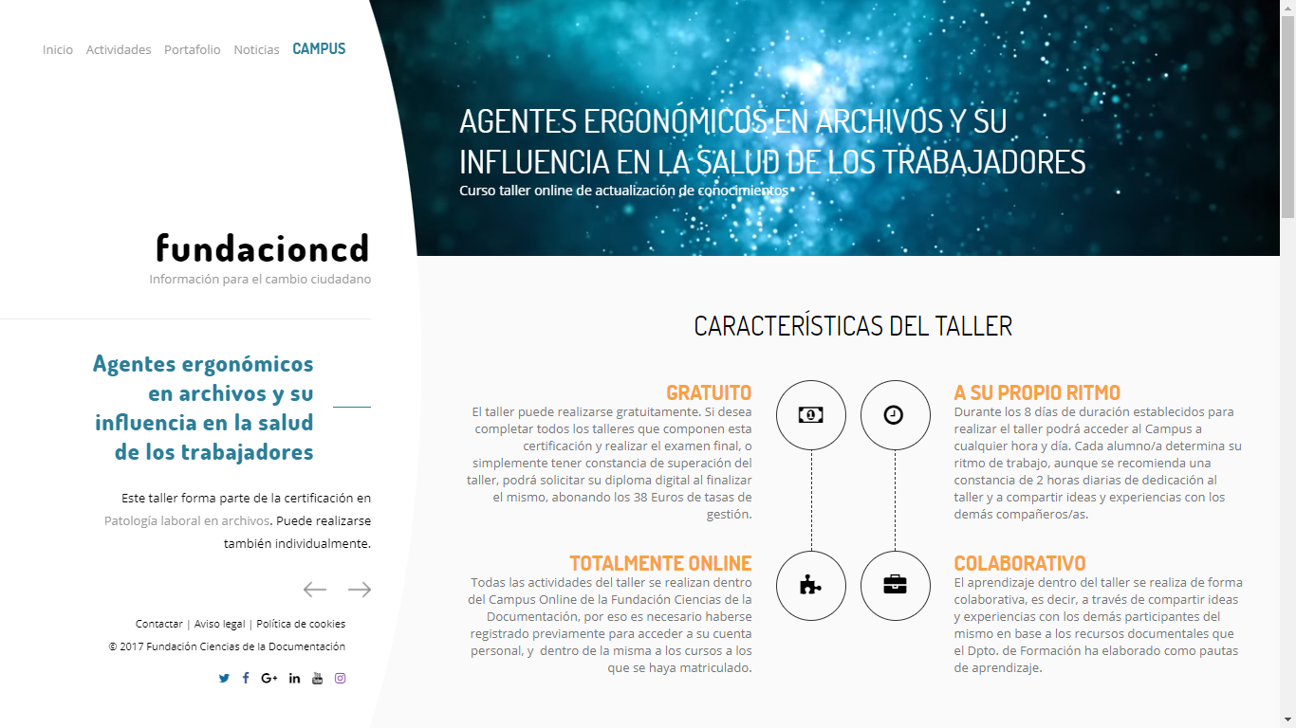

https://documentalistas.org/web/portfolio/agentes_ergonomicos/
7
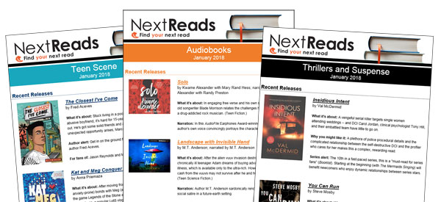
Your readers want book suggestions.
Keep their to-be-read lists full with NextReads newsletters.
NextReads newsletters deliver reading recommendations directly to patron inboxes and are the ideal solution for keeping TBR lists full of ideas--increasing your holds and circulation.
Why choose NextReads?
- Great book selections. Thoughtfully chosen books curated by the award-winning team of NoveList librarians, who do the work for you.
- Robust coverage. 20+ popular genres, nonfiction, New York Times bestseller lists, and LibraryReads lists means books for every reader.
- From newsletter to catalog. Titles and book jackets in your newsletters link automatically to your catalog.
- Limitless options. Unlimited subscribers, sends, users, templates, and custom newsletters means no additional fees.
- Access to millions of images and graphic elements (including book jackets). Never search for copyright free images again.
- Measured success. Detailed analytics with full reports on opens, clicks, and views.
SEE IT IN ACTION

Watch this 2-minute video

