Año 3 Número 57 enero 2018

Contenidos de este número

- Difusión IIBI Eventos:
ENERO:
Seminario de Lectura.
FECHAS: 30, 31 de enero y 1º de febrero 2018
OBJETIVO: Explorar las posibilidades de construir vínculos entre la lectura académica y la lectura estética, con el propósito de fortalecer el desarrollo de las capacidades y desempeño académico de las comunidades. Con ello la biblioteca universitaria podrá construir lazos de colaboración con docentes, investigadores, comunidades artísticas y culturales, lo que contribuirá a que las bibliotecas se mantengan como un espacio estratégico de aprendizaje, investigación, lectura y cultura, en suma, de formación.
INFORMACIÓN: http://iibi.unam.mx/f/SIL_Programa.pdf
INSCRIPCIONES: inscripec@iibi.unam.mx
CIERRE DE INSCRIPCIONES: 22 de Enero 2018
SEDE: IIBI; Seminario 1, Torre II de Humanid1ades, piso 13.
FEBRERO:
III Congreso Internacional de Documentación Fotográfica. FOTODOC.
FECHAS: Febrero 6 al 9, 2018.
OBJETIVO: Promover el encuentro entre investigadores y profesionales interesados en la fotografía como documento en todos sus aspectos (arte, patrimonio, información, aplicaciones, enseñanza o tecnología), con el fin de analizar el estado de la cuestión desde distintos puntos de vista, y contribuir a la investigación mediante la presentación de ponencias y comunicaciones sobre diversas temáticas.
INFORMACIÓN CONVOCATORIA: http://iibi.unam.mx/f/Convocatoria%20propiamente%20dicha.pdf
TALLERES: http://iibi.unam.mx/f/TALLERES.JPG
CONGRESO: http://iibi.unam.mx/f/CONFERENCIAS.JPG
INSCRIPCIONES: inscripec@iibi.unam.mx
CIERRE DE INSCRIPCIONES: 1o de Febrero del 2018
SEDE: IIBI; Seminario 1, Torre II de Humanidades, piso 13.
39 Feria Internacional del Libro del Palacio de Minería.
FECHAS: Febrero 22 al 5 de marzo, 2018
OBJETIVO: El IIBI participa en esta feria presentando en ella sus novedades editoriales.
ANOTA EN TU AGENDA
Lunes 26 de febrero: Salón de la Academia de Ingeniería
12:00 hrs. Presentación del libro “Uso ético de la información: implementaciones y desafíos”. Jaime Ríos Ortega y César Augusto Ramírez Velázquez coordinadores.
13:00 hrs. Presentación de los libros: “La infodiversidad y el uso ético del conocimiento individual y colectivo” y “El uso ético de la información y la práctica del libre acceso”. Estela Morales Campos, coordinadora.
16:00 hrs. Presentación del libro “Usuarios 2.0 de la información audiovisual y textual”. Juan José Calva, autor.
17:00 hrs. Presentación del libro “La enseñanza de la lectura en la universidad”. Elsa Ramírez Leyva, autora.
Martes 27 de febrero: Salón de la Academia de Ingeniería
12:00 hrs. Presentación del libro “Significados e interpretaciones de la información desde el usuario”. Patricia Hernández Salazar. Autora.
13:00 hrs. Presentación del libro: “Archivos digitales sustentables. Conservación y acceso a las colecciones sonoras y audiovisuales para las sociedades del futuro”. Jaime Ríos Ortega, César Augusto Ramírez Velázquez y Perla Olivia Rodríguez Reséndiz coordinadores.
SEDE: Palacio de Minería. Tacuba núm. 5. Centro Histórico.
MARZO:
XIII Seminario de Investigación sobre Usuarios de la Información. Ier Congreso Internacional de Investigación sobre Usuarios de la Información.
FECHAS: Marzo 12 al 16, 2018.
OBJETIVO: Analizar y discutir diversos proyectos de investigación sobre el fenómeno de las necesidades de información en distintas comunidades de usuarios. Propiciar la generación de proyectos de investigación sobre diferentes comunidades de usuarios. Dar seguimiento a las investigaciones que son parte del seminario. Promover la realización de nuevas investigaciones y su presentación a los docentes, investigadores, archivistas y bibliotecarios. Analizar la utilidad de las investigaciones sobre el fenómeno de las necesidades de información para el diseño de servicios archivísticos, bibliotecarios y de información y el desarrollo de colecciones en diferentes unidades de información como archivos, unidades de documentación e información, bibliotecas y hemerotecas.
TEMAS: Usuarios de la información. Comunidades de usuarios. Necesidades de información. Comportamiento informativo. Satisfacción de usuarios. Teoría sobre usuarios. Necesidades de formación de usuarios. Metodología para el estudio de los usuarios.
SEDE: El XIII Seminario se realizará en la Universidad Autónoma de San Luis Potosí. Facultad de Ciencias de la Información. El I Congreso se realizará en el Centro Cultural Universitario Bicentenario, San Luis Potosí.
INSCRIPCIONES: magdalenavazquez@hotmail.com
CIERRE DE INSCRIPCIONES: 5 de Febrero del 2018

- New Online: Ransom Center (U. of Texas at Austin) Releases Digital Archive with Material From Gabriel García Márquez’s Papers`
Filed by Gary Price

The just released Gabriel García Márquez’s digital collection includes about half (approx. 27,500 item) from the complete GGM papers collection. that the Ransom Center acquired in 2014. The project received funding from a CLIR (Council on Library and Information Resources) Digitizing Hidden Special Collections and Archives grant, uses OCLC’s CONTENTdm platform. Images can be viewed/compared using IIIF’s Mirador viewer.
From The NY Times:
The online archive, which is cataloged both in English and in Spanish, includes drafts and other material relating to all of García Márquez’s major books, including “One Hundred Years of Solitude,” which turned the Colombia-born writer into a global figure. There are also previously unseen photographs, notebooks, scrapbooks, screenplays and personal ephemera, like a collection of his passports.
Many archives are digitizing their holdings. But to make so much material from a writer whose work is still under copyright freely available online is unusual.
[Clip]
Seeing some items in the archive, which the Ransom Center bought for $2.2 million, will still require a trip to Texas. The digital collection does not include any of the 10 drafts of García Márquez’s final, unfinished novel, “We’ll See Each Other in August.” (One chapter of the novel was published in the Spanish newspaper La Vanguardia in 2014, shortly after García Márquez’s death at age 87; the estate said via email that it has no further plans for publication.)
From the Digital Collection’s Website:
The digital archive of Colombian-born writer Gabriel García Márquez includes manuscript drafts of published and unpublished works, research material, photographs, scrapbooks, correspondence, clippings, notebooks, screenplays, printed material, ephemera, and an audio recording of García Márquez’s acceptance speech for the Nobel Prize in Literature in 1982. The searchable, online archive is comprised of approximately 27,500 items from García Márquez’s papers…
From HRC:
The project, which includes text-searchable English- and Spanish-language materials, took 18 months and involved the efforts of librarians, archivists, students, technology staff members and conservators. The university’s Benson Latin American Collection provided guidance on how best to describe García Márquez materials in Spanish.
While accessing the online archive, scholars, fans, educators and students can choose to use the Mirador image viewer, which facilitates side-by-side comparisons of García Márquez’s evolving literary works. This capability is made possible by the International Image Interoperability Framework (IIIF); with the implementation of IIIF, all images from the online archive are accessible to an international network of IIIF-enabled digital image collections.
“This project is significant, fostering new methods of use and scholarship of archival materials,” said Liz Gushee, head of Digital Collections Services at the Ransom Center. “It provides rights-holder-approved online access to copyright-protected archival materials, opportunities for comparative research and interoperability with other IIIF-compatible online collections. The support from García Márquez’s family made this important project possible.”
Direct to Gabriel García Márquez Digital Collection
Direct to Gabriel García Márquez Digital Collection (in Spanish)
Direct to News Release (in Spanish)

http://www.infodocket.com/2017/12/11/new-online-ransom-center-u-of-texas-at-austin-releases-digital-archive-with-material-from-gabriel-garcia-marquezs-archive/

- Residents Sue Escondido Over Library Outsourcing
By Lisa Peet on December 6, 2017 2 Comments
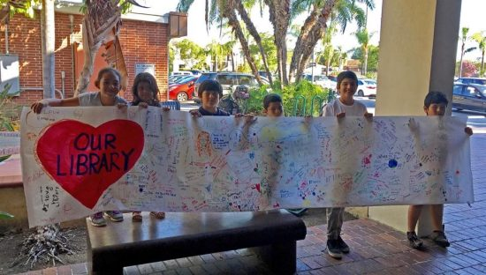
Escondido Public Library patrons rally around their library
Photo credit: Save our Escondido Library Coalition
Roy and Mary Garrett, residents of Escondido, CA, and longtime library patrons, are suing the city over its decision to privatize the Escondido Public Library (EPL). Officials voted in August to turn library operations over to Library Systems and Services (LS&S), a private for-profit company that manages public libraries, to forestall a projected citywide pension shortfall. In October, the city council voted to enter into a ten-year contract with the firm. Many residents have opposed the move from the beginning, noting that city officials pursued the plan without asking for input or presenting alternatives.
LS&S, originally a cataloging system and software provider, began managing libraries in 1997 with the Riverside County Library System, CA. The company’s practice of replacing unionized workers with non-union employees has generated controversy, as has its substitution of a remote reference service for local reference librarians in libraries it manages starting in 2000. The company currently manages nine library systems across California, and a total of 20 systems nationwide.
If the contract is enacted, Escondido would be the first community in San Diego County to privatize its public library.
COST-CUTTING MEASURES
The city administration first floated the idea of privatizing library operations in April at a budget meeting. Because Escondido maintains its own police department, rather than contracting for those services as do other cities in San Diego County—and therefore has to cover those pensions—and due to underperforming investments made by the city pension plan in recent years, Escondido was looking at a mounting pension liability projected to reach $15.5 million in 2021. More than 700 city employees are covered by the California Public Employees Retirement system, with another 900 former employees currently receiving pensions. According to Mayor Sam Abed, Escondido needed to come up with $40.3 million over the next five years to maintain city services at current levels.
Citing a San Diego County Grand Jury report filed in March stating that the library was not offering sufficient services to meet community needs, city council proposed to outsource EPL to LS&S. According to city manager Jeffrey Epp, the move would result in potential savings of some $400,000 a year, to be realized chiefly through cutting operating costs and eliminating pension obligations. Outsourcing proponents claim that the private company could run the library more efficiently and affordably than the present administration and staff.
Representatives from the firm had discussed a possible contract with Epp over several months, and presented a proposal to the library management team, the board of trustees, and the library foundation. If Escondido entered into the contract, explained LS&S chief financial officer and chief operating officer Todd Frager, the library would still be owned by the city but LS&S would provide all services. In addition, all current library employees would be given the option to continue as employees of LS&S. The current interim director would remain an employee of the city, and would serve as a liaison while LS&S conducted a national search for a permanent director. The library board, which is appointed by the mayor, would remain in place at will.
Library workers who stayed on with LS&S would, however, no longer have pensions paid into by their employers. “Employees who want to stay on the city pension system, [they] can find other jobs within the city,” noted Frager. At press time, Escondido listed nine open positions, four of which were for police officers; the library has 22 full-time and 22 part-time employees.
“Those who choose to make the move to LS&S, Frager said, “won’t lose [their pensions], it just doesn’t continue to accrue any further than it is at this point.” Instead, LS&S offers a company-matched 401K.
“The whole value of having LS&S [managing the] library system is that the libraries are still ultimately local,” said Frager. “Most libraries we run, you’d never even know we’re running them. Because [there are] still local people doing the local library functions. [Patrons] assume it’s the city who runs it because that’s who’s always run it. But because of our size…there’s certain efficiencies we can bring,” including the high-volume buying power of what is essentially the third-largest library system in the country.
As part of his case for privatization, Epp noted in an August 15 editorial in the San Diego Union-Tribune that “Google, Microsoft, and Facebook are not run by government workers. Our packages are now delivered as often by Federal Express or [UPS] as they are by the U.S. Post Office. Even most books we read are authored by private citizens and published by private companies.”

http://lj.libraryjournal.com/2017/12/funding/residents-sue-escondido-library-outsourcing/

- School, Teen Librarians Recognized at 2017 I Love My Librarian Awards
By Rocco Staino on December 7, 2017 1 Comment
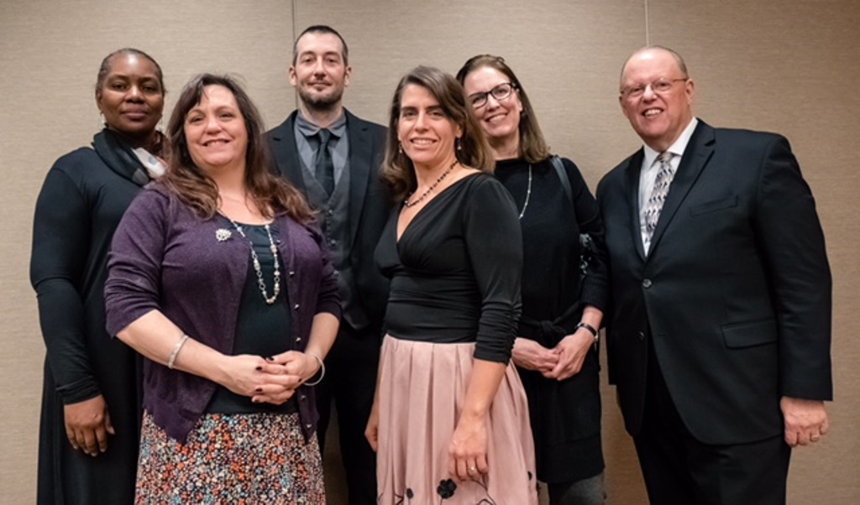
Left to right: I Love My Librarian Award recipients Sheikla Blount, Rita Platt, Timothy Ryan, Marcia Kochel, and Laurie Doan, with ALA president Jim Neal. Photo: Sarah Kelly Johns
Three school librarians and two who provide teen services in public libraries were among those honored by the American Library Association, the Carnegie Corporation of New York, the New York Public Library (NYPL), and the New York Times during the annual I Love My Librarian Awards. The 10 winners each received a $5,000 cash award, a plaque, and a travel stipend to attend the reception.
At the November 30 ceremony in New York, Anthony Marx, NYPL president and CEO, spoke of the importance of libraries and librarians, particularly in the current political climate.
“We are living in a moment when the core values of enlightenment are under threat,” he said, while Carnegie Corporation President Vartan Gregorian held up his cell phone and added, “All Greek literature is in here, but you still have to read it.”
Sheikla Blount, a librarian at Columbiana (AL) Middle School, was nominated for the award by a fellow teacher who described her library as serving “a unique and critical need that you might not understand unless you were from a rural environment.” Blount stretches a $600 budget to serve 440 students, gets books into the hands of students, and encourages diversity in her collection. For years on a “Battle of the Books” committee, she was the lone minority voice and often had to speak up for inclusion.
The nominators for young adult librarian Laurie Doan at the Tredyffrin (PA) Public Library traveled from Strafford, PA, to cheer for their hometown colleague. “Laurie is a builder, a presence in our community,” said nominator Anne Sprissler. “Laurie has created an environment at the library where all teens can find a place at the table.”
Described as the “guide on the side,” Doan has created a space in the library where teens can discover their passion. A reluctant award winner, Doan is donating her $5,000 prize to the library to build a stage for the teens.
Following her own advice to “move from what’s best for your children to what’s best for all children,” Marcia Kochel left private education to become the teacher librarian at Druid Hills Middle School in Decatur, GA.
She has transformed the library from a traditional book repository to a learning commons that engages kids in creative and inviting ways. Her nominators described the library as “buzzing with activity as a center of community, collaboration, and creativity.”
Kochel is also a catalyst for the implementation of technology in the school. “She is always willing to demonstrate and help implement the newest apps to help engage students in instruction. She helps teachers find efficient and effective ways to use technology in their teaching and helps make learning exciting,” the nominators wrote.
Rita Platt, teacher librarian at St. Croix (WI) Elementary School, began her acceptance speech with a good second grader joke: “What’s the tallest building in St. Croix Falls, Wisconsin, population 2,100?” she asked. “The library, because it has so many stories!”
One nominator said Platt “puts the ‘zing’ into amazing,” and St. Croix Elementary principal Jeff Benoy wrote, “I have learned more from Rita in the last four years than any other individual. She is my go-to teacher.”
Platt, who has previously been nominated for the award, works to develop a culture of achievement and a love of reading. One way she accomplishes this is with her Book Boutique, an entire room, formerly her office, filled with donated books and those she has purchased that students can earn for their hard work. Students read to earn “money” to shop.
Postman-turned-young adult services librarian Timothy Ryan said he appreciated the validation the award carries—and said he also receives validation every day from the smiles on the teens’ faces at the Sully Branch of the Rochester (NY) Public Library. The branch is located in the most poverty-stricken quadrant of the city, and Ryan and the library staff work to provide a safe environment for the teens and the rest of the community.

http://www.slj.com/2017/12/industry-news/school-teen-librarians-recognized-2017-love-librarian-awards/

- Ten Organizations Release Draft Version of Digital Preservation Declaration of Shared Values, Feedback Welcome
Filed by Gary Price on December 11, 2017
Here’s the Full Text of an Announcement From Educopia:
The digital preservation landscape is one of a multitude of choices that vary widely in terms of purpose, scale, cost, and complexity. Over the past year a group of collaborating organizations united in the commitment to digital preservation have come together to explore how we can better communicate with each other and assist members of the wider community as they negotiate this complicated landscape.
As an initial effort, the group drafted and that is now being released for community comment. The document is available here: https://docs.google.com/document/d/1cL-g_X42J4p7d8H7O9YiuDD4-KCnRUllTC2s…(link is external)
The comment period will be open until March 1st, 2018. In addition, we welcome suggestions from the community for next steps that would be beneficial as we work together.
Comments, suggestions and observations may be communicated to the group at comdigpres@googlegroups.com(link sends e-mail). We also welcome volunteer efforts to translate this declaration into additional languages.
Issued by representatives of
- Academic Preservation Trust (APTrust)
- Chronopolis
- CLOCKSS
- Coalition for Networked Information (CNI)
- Digital Preservation Network (DPN)
- DuraSpace
- Educopia/MetaArchive Cooperative
- Stanford University – LOCKSS
- Texas Digital Library (TDL)
- Council of Prairie and Pacific University Libraries (COPPUL)

About Gary Price
Gary Price (gprice@mediasourceinc.com) is a librarian, writer, consultant, and frequent conference speaker based in the Washington D.C. metro area. Before launching INFOdocket, Price and Shirl Kennedy were the founders and senior editors at ResourceShelf and DocuTicker for 10 years. From 2006-2009 he was Director of Online Information Services at Ask.com, and is currently a contributing editor at Search Engine Land.

http://www.infodocket.com/2017/12/11/ten-organizations-release-draft-version-ofdigital-preservation-declaration-of-shared-values-feedback-welcome/

- Emptying Libraries Weakens Democracy – IFLA Statement on the Destruction of Library Books in Turkey
The below statement was agreed by the IFLA Executive Committee on 5 December 2017:
IFLA is deeply concerned by the announcement of the destruction of 140 000 books held by public-controlled libraries in Turkey1.
As established in IFLA’s Statement on Libraries and Intellectual Freedom, decisions on the selection and availability of library materials and services should be governed by professional considerations and not by political, moral and religious views. Such broad and indiscriminate withdrawals of books from libraries risks challenging the principle that the right of freedom of access to information should be guaranteed in all but the most extreme circumstances. While such freedoms may not be absolute, any restrictions should be applied in a targeted and proportionate manner. This does not seem to be the case in Turkey.
IFLA also regrets the exclusion and destitution of librarians working at those establishments of higher education which have been closed. Preventing skilled information professionals from doing their jobs can only impoverish society as a whole, as they are unable to fulfil their mission to meet the human need – and right – to share information
Turkey successfully resisted an undemocratic coup attempt in 2016. It is therefore regrettable to see the government weakening, rather than strengthening democracy, by damaging the institutions and services that help uphold and sustain it.
1. See, in particular, Hurriyet Daily News (16 October 2017) 140,000 books collected from Turkish libraries over ‘Gülenist propaganda’ (link), Asianews.it (13 October 2017) 139K books removed from 1,142 public libraries since failed coup: ministry (link), dw.com (14 November 2017) Books come under suspicion in post-coup Turkey (link).

https://www.ifla.org/node/18602

- New Research Finds “‘Widespread Misattribution’ in Research Publications and Grant Proposals”
Filed by Gary Price on December 7, 2017
From the University of Alabama-Huntsville:
“Authorship and Citation Manipulation in Academic Research,” co-authored by Dr. Allen “Al” Wilhite and Dr. Eric Fong, has been published by PLOS ONE, a peer-reviewed open-access scientific journal published by the Public Library of Science. Both men are professors in the College of Business at The University of Alabama in Huntsville (UAH), where Dr. Wilhite teaches economics and Dr. Fong teaches management.
“This is a significant extension of a previous study about editors who insist that authors add citations to articles in the editor’s journal – even though they weren’t used in the research – as a condition of publication,” says Dr. Wilhite, referring to the pair’s 2012 paper “Coercive Citation in Academic Publishing,” which appeared in Science (DOI: 10.1126/science.1212540).
This one expands the previous work in two dimensions. “First, rather than focus on just business and related social science disciplines, we looked at 18 different fields that also include science, engineering, and medicine,” says Dr. Fong. “Second, along with coercive citation, we looked at the addition of false investigators to grant proposals as well as honorary authorship and padded citations.”
To carry out the study, the pair applied for and received a $212,000 grant from the Office of Research Integrity, which oversees and directs public health service research integrity activities for the U.S. Department of Health and Human Services. They then collected data via a series of surveys sent to more than 110,000 scholars across the academic universe.
[Clip]
As with their 2012 paper, what they found was a pattern of widespread misattribution in publications and in research proposals with significant variation by academic rank, discipline, sex, publication history, co-authors, and other factors. “Even though the majority of scholars disapprove of such tactics, many feel pressured to make such additions while others suggest that it is just the way the game is played,” says Dr. Wilhite.
Nevertheless, he is quick to add that all hope is not lost. “While it’s unlikely that this unethical behavior can be totally eliminated, most of our respondents say they want to play it straight,” he says. “By reducing the incentives of misbehavior, raising the costs of inappropriate attribution, and making some changes to the way we measure scientific contributions, we can expect a substantial portion of the community to go along.”
Read the Complete Research Article: “Authorship and Citation Manipulation in Academic Research”
Source: PLOS
doi:10.1371/journal.pone.0187394

http://www.infodocket.com/2017/12/07/new-research-finds-widespread-misattribution-in-research-publications-and-grant-proposals/

