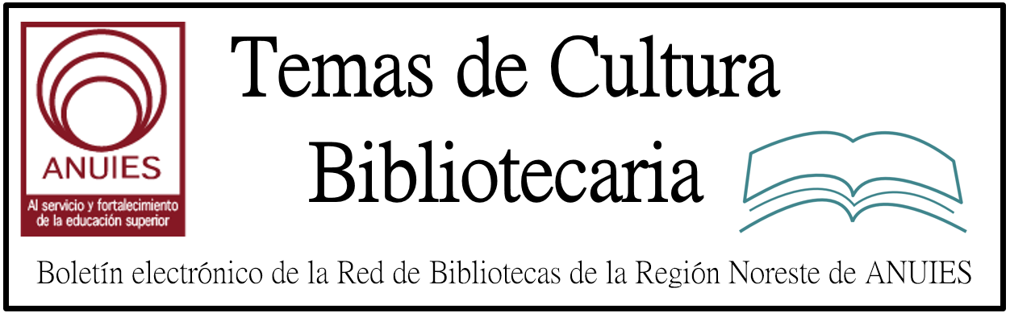

Año 2 Número 9 Enero 2017

Contenidos de este número

Hate Incidents in Libraries Spark a Renewed Commitment to Serve All
By Megan Cottrell

Working in the teen services department of a small town library in rural, mostly white Knox County, OH, Karen Jensen (SLJ’s “Teen Librarian Toolbox” blogger) has heard young people say racist things before. But in the last year, she’s noticed a change.
“We noticed an increase in racist conversations, particularly against black people, like using the ‘n word’,” says Jensen, young adult services coordinator at the Public Library of Mount Vernon and Knox County. “I think in the past, they wouldn’t have said it in front of adults. Now all of a sudden, they felt like they could.”

http://www.slj.com/2016/12/industry-news/hate-incidents-in-libraries-spark-a-renewed-commitment-to-serve-all/

ITHAKA’s Next Wave: How Macro Changes in Higher Ed Shape Strategy
By Lisa Peet
For its 2016 Next Wave conference, scholarly nonprofit organization ITHAKA brought together nearly 200 academic librarians, publishers, technology partners, and scholars at New York’s Roosevelt Hotel on November 30 to take a look at what may lie ahead for academia. “The Bigger Picture: How Macro Changes in Higher Education Should Shape Your Strategy” condensed what had previously been spread over two days into one all-day session, with a strong focus on academic professionals’ take on the landscape.
We are in a “time of great divide,” noted master of ceremonies Jeff Selingo, special advisor at Arizona State University and visiting scholar at Georgia Tech’s Center for 21st Century Universities, and author most recently of There Is Life After College: What Parents and Students Should Know About Navigating School to Prepare for the Jobs of Tomorrow (William Morrow)—not only between those who can and cannot afford higher education, but also between institutions themselves and what they represent to their constituents. “This era requires us to speak up,” Selingo said, “and present a vision for what the future of higher education should look like.”

http://lj.libraryjournal.com/2016/12/publishing/ithakas-next-wave-how-macro-changes-in-higher-ed-shape-strategy/

HighWire Press Acquires Semantico
By Matt Enis
Scholarly publishing company HighWire Press on December 12 announced the acquisition of Semantico, a UK-based technology provider for academic publishers. In addition to Semantico’s next-generation integrated content platform Scolaris, and its cloud-based identity and access management system SAMS Sigma, the company collaborates with major publishers on custom, UX-oriented projects, such as McGraw Hill Education’s DataVis data visualization tool, or the recent redesign and relaunch of The Royal Marsden Manual’s latest online edition for Wiley.

http://lj.libraryjournal.com/2016/12/industry-news/highwire-press-acquires-semantico/

Kansas City Public Library Investigates Swastika Graffiti
By KYLE PALMER • DEC 13, 2016
Kansas City Public Library officials say they plan on pressing charges after several marks of racist, misogynistic and anti-Semitic graffiti were found inside the Central Library location downtown Sunday.
A library statement says the graffiti was found in a men's bathroom stall, on a portrait of former First National Bank executive Taylor S. Abernathy, on a glass window near the library's main entrance, and on a stairwell leading down to the library's vault level.
All of the graffiti and the defaced portrait have been removed.
"Something of this magnitude has never happened at our library, and all of us our shaking our heads because we are so surprised," says Carrie Coogan, the Deputy Director of Kansas City Public Library.
http://kcur.org/post/kansas-city-public-library-investigates-swastika-graffiti#stream/0

The Ride of Your Life: ONE to the Power of 10
PLOS ONE Editors
This blog post is co-authored by PLOS ONE Managing Editor Iratxe Puebla and PLOS Advocacy Director Catriona MacCallum
PLOS ONE is turning 10 today. Back in 2005 when conversations about PLOS ONE really got going, the publishing landscape looked very different from what it does now. Open Access (OA) publications were a tiny fraction of publication output, the only quantitative metric available to assess a newly published piece of scientific work was the impact factor and the editorial process was still largely reliant on a subjective evaluation of whether the scope or ‘interest level’ of a manuscript matched the requirements of the specific journal or editor in place at that time.
By the end of 2005, PLOS had launched PLOS Biology, PLOS Medicine and the first Community Journals to demonstrate that Open Access was compatible with the most selective traditional journals and to dispel the myth that OA journals weren’t peer reviewed. It worked, and the PLOS brand was born.
But the founders’ aspiration was ultimately about changing the very notion of ‘quality’ in science.
During the planning stages of PLOS ONE, its working title was PLoS Reports. As we prepared for its launch, the PLOS founders – Harold Varmus, Pat Brown and Mike Eisen – concluded that ‘Reports’ captured neither the purpose nor the spirit of what we were trying to do. It had always been their intention to provide a publishing venue that was inclusive – a scientific home for everyone.
http://blogs.plos.org/everyone/2016/12/20/the-ride-of-your-life-one-to-the-power-of-10/

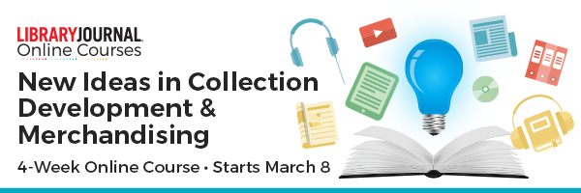
Registration is now open for New Ideas in
Collection Development & Merchandising
Are you ready to dazzle your patrons with attention-grabbing visual displays and signage? Learn how at the next installment of New Ideas in Collection Development & Merchandising. This online course will teach you everything you need to know to revamp your services and strategies to engage new and existing users, increase circulation and expand your readers' advisory.
Over four weeks, you will have direct access to live speakers via webcasts and be challenged to complete weekly assignments with the guidance of a dedicated advisor.
Check out the program here.

7.
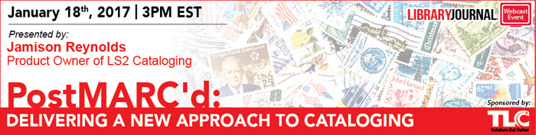

PostMARC'd: Delivering A New Approach to Cataloging
Wednesday, January 18, 2017
3-4 PM ET, 12-1 PM PT
Join TLC and Library Journal at 3pm Jan. 18 for a webcast on LS2 Cataloging, which introduces a linked data approach to the cataloging experience that moves libraries beyond a traditional MARC editor. The innovative use of glossaries to maintain data consistency, a new series service supplying titles linked to genres and audience level, and improvements to batch editing of bibliographic, item, and authority records deliver an improved user experience for library staff and a better discovery experience for library users. Make sure your library is ready for the advantages of LS2 Cataloging by registering for this free one-hour webcast

https://event.on24.com/eventRegistration/EventLobbyServlet?target=reg20.jsp&partnerref=LJEmailemail1tlc170118&eventid=1333136&sessionid=1&key=86E45590D4D4AF2DC54F07CF241CCEFC&regTag=&sourcepage=register

