Año 2 Número 56 diciembre 2017

Contenidos de este número

1, Número 73 de la revista Investigación Bibliotecológica: bibliotecología, archivonomía e información. IIBI-UNAM.
JC
Jorge Castañeda <inforib@iibi.unam.mx>
Estimados colegas,
Tenemos el agrado de informarles que acaba de publicarse el número 73 de la revista Investigación Bibliotecológica: bibliotecología, archivonomía e información, que edita el Instituto de Investigaciones Bibliotecológicas y de la Información (IIBI) de la Universidad Nacional Autónoma de México (UNAM). Este número lo puede consultar en texto completo, a través del actual sitio de la revista:
http://iibi.unam.mx/revista.html
Aviso importante:
Por este medio se informa que, a partir del 1º de septiembre de 2017, queda abierta la admisión de artículos a la revista a través de este portal, mediante el estricto cumplimiento de las directrices para autores/as.
Reciban un cordial saludo y el agradecimiento por continuar al tanto de nuestra revista.
Atentamente,
Dr. Salvador Gorbea Portal
Director de la revista.

2, Net Neutrality Fight Likely to Move to Courts, Congress

By Matt Enis
Library groups expressed disappointment following the Federal Communications Commission’s (FCC) release of a draft version of the Restoring Internet Freedom Order (RIFO) on November 21. RIFO aims to overturn the 2015 Open Internet Order, a regulatory framework established during the Obama administration that gave the FCC the power to enforce “net neutrality,” defining broadband Internet as a utility similar to electricity or water, and requiring Internet Service Providers (ISPs), such as Comcast, Verizon, and AT&T to treat all data traffic on the Internet equally. RIFO would also overturn a much older precedent (established by a Republican-led FCC during the George W. Bush administration) in which ISPs were fined for slowing or blocking customer traffic to websites or services offered by their competitors.
FCC Chairman Ajit Pai appeared determined to overturn the Obama-era regulations despite widespread public support of net neutrality rules and opposition to RIFO from major U.S. corporations including Amazon, Facebook, and Apple. The order is expected to be approved on December 14 via party-line vote by the FCC’s five-person board. Lawsuits to block the order are likely to follow.
“Preserving net neutrality is essential for equitable access to online information and services and thus a vital concern for our nation’s libraries,” American Library Association President Jim Neal said in a prepared statement. “Now that the Internet has become the primary mechanism for delivering information, services, and applications to the general public, it is especially important that commercial [ISPs] are not able to control or manipulate the content of these communications. Libraries, our patrons, and America’s communities will be at risk if the FCC repeals all protections contained in its 2015 Open Internet Order with no plans to replace with any enforceable rules. We strenuously disagree with the FCC’s actions and will continue to advocate for essential net neutrality protections.”
Mary Ann Mavrinac, president of the Association of Research Libraries (ARL) and dean of the University of Rochester Libraries, said that the organization “is disappointed that the FCC has reversed course just two years after its 2015 Open Internet Order. ARL will continue to advocate for an open Internet in the courts and in Congress.”
MAJOR OVERTURN
Pai’s frequently repeated assertion that the FCC is simply returning to the “light-touch regulatory framework” that enabled the Internet to grow and thrive during the two decades prior to 2015 is at least somewhat disingenuous. Not only will RIFO reverse the Open Internet Order, it would enable ISPs to block, throttle, or charge extra fees for normal delivery of content—as long as customers are notified—reversing an FCC precedent that is more than a decade old, Columbia Law School professor Tim Wu explained in a recent New York Times column. Basic FCC-enforced bans on blocking and throttling have been enforced since 2005 (under Republican-appointed chairman Michael Powell), when only about half of U.S. households had broadband Internet service.
In a “Myth vs. Fact” document published on the FCC’s website last week, the FCC argues that requiring ISPs to disclose any blocking or throttling practices will be sufficient protection for consumers, as ISPs would face “fierce consumer backlash as well as scrutiny from the Federal Trade Commission” for blocking or throttling. However, it is clear that consumer backlash is nothing new for ISPs: they for years have received the worst rankings among the 43 industries tracked by the American Customer Satisfaction Index, and the majority of U.S. households are currently limited to one or sometimes two choices. The document does not address ways in which additional consumer backlash might empower consumers to police the practices of these localized monopolies.
FULL COURT PRESS
Wu, who is credited with coining the term network neutrality, writes that the FCC may “have overplayed its legal hand. So drastic is the reversal of policy (if, as expected, the commission approves Mr. Pai’s proposal)…and so weak is the evidence to support the change, that it seems destined to be struck down in court.” Government agencies, Wu explains, are not free to reverse longstanding rules without a good reason. “Given that net neutrality rules have been a huge success by most measures, the justification for killing them would have to be very strong. It isn’t…. Mr. Pai’s rationale for eliminating the rules is that cable and phone companies, despite years of healthy profit, need to earn even more money than they already do.”
Given RIFO’s many prominent opponents, including companies such as Google and Netflix, as well as organizations such as the American Civil Liberties Union and the Electronic Frontier Foundation, lawsuits to block implementation of the order seem likely.
Gizmodo.com last week published an analysis of the near-term impact of RIFO, and how the issue would likely play out in the U.S. Courts of Appeals. Lawyers contacted for the story expect to see numerous lawsuits/petitions for review filed if the order is adopted. One or more litigants will probably request a preliminary injunction, or “stay,” to prevent the order from going into effect until the case is decided—which will take months. A successful request for a preliminary injunction requires a plaintiff to demonstrate the potential for imminent and irreparable injury while the case is heard. So these experts also anticipate that ISPs will avoid launching new business plans or blocking and throttling content in the near term. And, like Wu, other experts believe the order will be vulnerable in court.
“If the FCC order is consistent with what has been reported, and what the chairman statements suggest, it is likely to be very vulnerable on appeal,” Pantelis Michalopoulos, a telecom partner at the law firm Steptoe and Johnson LLP, told Gizmodo. “While it may take a long time, that’s the key fact about the appellate process. At the end of a long tunnel, there may well be a decision that disagrees with the order.”

http://lj.libraryjournal.com/2017/12/advocacy/net-neutrality-fight-likely-move-courts-congress/

3, How To Become a Copyright Expert
By Carli Spina on November 28, 2017 1 Comment
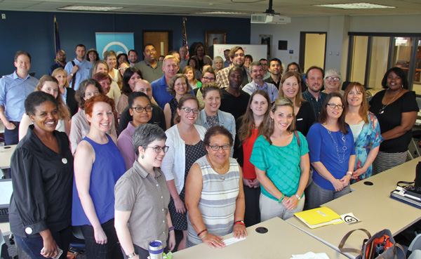
Participants in a Creative Commons certificate beta training session for the LOUIS
consortium of Louisiana libraries at the University of New Orleans Earl K. Long Library.
Photos courtesy of The University of New Orleans
Increasingly, librarians are relied upon to answer questions and engage in activities involving copyright—whether that means supporting teachers seeking free or low-cost materials for classroom use, developing resources for maker spaces, or helping students understand the legality of using content from the Internet.
However, building the expertise to confidently offer copyright advice can be challenging. Librarians often look to the nonprofit organization Creative Commons (CC) and other open-access resources to locate works they can legally, and affordably, use. To better support those who use, create, and advocate for their resources, CC is designing a certificate program with content tailored for librarians, educators, and government workers.
Through this free program, participants will build an in-depth understanding of CC resources and related copyright and intellectual property topics. They’ll also earn a credential that offers evidence of this expertise.
WHAT IS CREATIVE COMMONS?
Copyright protects the rights of those who create original works. But anyone who has tried to license rights to copyrighted material for their library knows that using them in certain settings can be difficult. Creative Commons licenses streamline this process. By licensing works under a CC license, a creator can grant anyone the right to use their material in specific situations for free without having to contact the creator.
The four CC licenses protect works in specific ways: by requiring that anything created with the work is also shared under a CC license; limiting use to noncommercial ends; prohibiting alterations of the work; and ensuring attribution. The licenses are standardized and offered in a machine-readable format, so that it’s easier to license material without the help of a lawyer. Creators can also share works on the CC site, reaching a wide audience.
Though these licenses facilitate the sharing and use of copyrighted works, there’s still a need in many communities for an individual who understands both copyright and CC licenses to serve as an advocate for the open sharing of resources.
THE FOUR WAYS
Core Certificate This will cover the “full breadth and depth of learning associated with acquiring comprehensive knowledge about all aspects of Creative Commons,” according to the site (ow.ly/WKVK30fPWiJ), and will serve as the basis for the curricula for other certificates.
Librarian Certificate Designed for librarians (and particularly academic librarians), this will cover topics of particular importance in libraries, including open access, open educational resources (OER), 3-D printing, and institutional open-access policies.
Educator Certificate This will focus on all aspects of OER and “aims to ensure all educators have the grounding and digital literacy associated with successfully using Creative Commons for open educational resources, open practices, open policy, and open pedagogy”.
Government Certificate The fourth certificate is for those who work in government and will include information about how to promote open sharing of content and build a culture that supports CC and open access.
GET CC CERTIFIED
Recognizing the importance of licensing expertise in a number of fields,C developed the certification program with support from the Bill & Melinda Gates Foundation and the Institute of Museum and Library Services. The idea grew from the work that CC completed as part of a grant program sponsored by the U.S. Department of Labor. That project provided money to community colleges to create educational materials licensed with CC. The endeavor led to the realization that “the best way to scale and sustain our support of those using [Creative Commons] licensing would be to create a certificate program designed to give people within educational institutions, government staffs, librarians, and others the tools they need to thoroughly understand how to use CC licensing in their own contexts,” says Sarah Hinchliff Pearson, CC senior counsel.
Because copyright is relevant to virtually every field, it was clear that there would be multiple audiences. Four certificates will be available next year, with each curriculum tailored to the specific needs of a discrete field.
In each case, the certificate program will consist of six modules, with five identical core modules and a sixth addressing the unique needs and interests of each group. The certificates will also feature different learning activities, called “Quests,” and relevant examples.
The organization is using a flipped classroom approach to teaching, with participants completing the learning modules online at their own pace. Kyle Courtney, program manager and copyright adviser at the Harvard Library Office for Scholarly Communication, had an opportunity to test the materials. Courtney describes them as “somewhere between a self-paced MOOC and a commonplace book [with] plenty of resources” and “plenty of time in between for interactivity, growth, using Creative Commons- designed exercises.”
Once participants complete the online content, they will attend a two-day in-person workshop to “generate evidence of learning completion, demonstrate mastery by completing a final assignment for each module, and learn from each other through shared learning activities and discussion.” The workshops will be offered in a variety of locations and could dovetail with professional meetings and conferences for librarians and educators. In total, the time required for certification will be about 40 to 50 hours.

http://www.slj.com/2017/11/resources/become-copyright-expert/

4, Predatory Journals: Researchers Propose Solutions to Stop the “Corruption of Science”
Filed by Gary Price on December 4, 2017
From The Ottawa Hospital in Ontraio:
The team of researchers behind a landmark study on predatory journals has now outlined the first concrete steps that stakeholders can take to combat the growing influence of these journals. Their pioneering work is published in Nature Human Behavior.
The team from The Ottawa Hospital and the University of Ottawa suggests:

- Researchers need to be educated on how to identify predatory journals and avoid submitting work to these unscrupulous outlets.
- Research institutions need to provide incentives for their researchers to publish in legitimate journals.
- Funding agencies need to audit where research they are funding is being published and disincentivize further submissions to predatory journals.
- Patients and participants need to apply pressure to other stakeholders to ensure clinical studies are published in the best possible outlets; they can also help identify publications in predatory journals that support ‘fake’ science.

“Predatory journals are corrupting science,” said Dr. David Moher, senior author of the paper. “Relevant policies and actions need to be taken by funders and institutions to fight them.” Dr. Moher is a senior scientist at The Ottawa Hospital and founder of the Hospital’s Centre for Journalology, which studies the science of publication. He is also a professor at the University of Ottawa.
“Predatory journals will remain problematic unless all stakeholders take specific, coordinated actions against them, some of which we have proposed,” said Larissa Shamseer, a PhD student at The Ottawa Hospital and the University of Ottawa and co-author of the study. “Better monitoring of the system of scholarly publishing is needed.”
“Data from millions of patients is being lost in predatory journals,” said Dr. Manoj Lalu, associate scientist and anesthesiologist at The Ottawa Hospital, assistant professor at the University of Ottawa and co-author of the study. “Patient advocacy groups, as well as patient organizations that fund research need to be aware of this massive problem. Policies need to be developed and enforced to fight the growing problem of predatory journals.”
The Centre for Journalology is a world-leader in understanding the importance of helping researchers publish their results transparently and avoid predatory journals. The Centre includes a full-time Publications Officer who provides training and consultations to researchers at The Ottawa Hospital.
“It can be difficult for researchers to stay up to date on publication best practices as the publishing landscape changes rapidly,” said Dr. Kelly Cobey, Publications Officer at The Ottawa Hospital, adjunct professor at the University of Ottawa and co-author of the study. “Institutions need to have support systems in place to guide their researchers in responsible publishing.”
The team has also developed the following resources to help researchers with this issue:
- Distinguishing features of predatory journals (BMC Medicine)
- Characteristics of predatory journal invitations to submit (BMC Medicine)

Learn More, Read the Complete Announcement
See Also: Predatory Journals: “Stop this Waste Of People, Animals And Money” (September 6, 2017)
See Also Supplementary Material (Research Article) Assessing the Scientific Content of Predatory Journals
55 pages; PDF
See Also: Retraction Watch Interview with David Moher

http://www.infodocket.com/2017/12/04/predatory-journals-researchers-propose-solutions-to-stop-the-corruption-of-science/

5. Stanford-Led Artificial Intelligence Index Tracks Emerging Field
Filed by Gary Price on December 4, 2017
From Stanford University:
In an effort to track the progress of this emerging field, a Stanford-led group of leading AI thinkers called the AI100 has launched an index that will provide a comprehensive baseline on the state of artificial intelligence and measure technological progress in the same way the gross domestic product and the S&P 500 index track the U.S. economy and the broader stock market.
[Clip]
The AI100 was set in motion three years ago by a charitable gift from Eric Horvitz, a Stanford alumnus and former president of the Association for the Advancement of Artificial Intelligence. Its first report, released in the fall of 2016, sought to anticipate the likely effects of AI in an urban environment in the year 2030.
[Clip]
The AI Index tracks and measures at least 18 independent vectors in academia, industry, open-source software and public interest, plus technical assessments of progress toward what the authors call “human-level performance” in areas such as speech recognition, question-answering and computer vision – algorithms that can identify objects and activities in 2D images. Specific metrics in the index include evaluations of academic papers published, course enrollment, AI-related startups, job openings, search-term frequency and media mentions, among others.
[Clip]
Although the authors say the AI Index is the first index to track either scientific or technological progress, there are many other non-financial indexes that provide valuable insight into equally hard-to-quantify fields. Examples include the Social Progress Index, the Middle East peace index and the Bangladesh empowerment index, which measure factors as wide-ranging as nutrition, sanitation, workload, leisure time, public sentiment and even public speaking opportunities.
Read the Complete Introductory Article
Direct to AI 100 Website/Report

http://www.infodocket.com/2017/12/04/reference-fyi-from-stanford-in-an-effort-to-track-the-progress-of-this-emerging-field-a-stanford-led-group-of-leading-ai-thinkers-called-the-ai100-has-launched-an-index-that-will-provide-a-compr/

6. America’s Star Libraries: Top-Rated Libraries | LJ Index 2017
By Keith Curry Lance on December 4, 2017 1 Comment
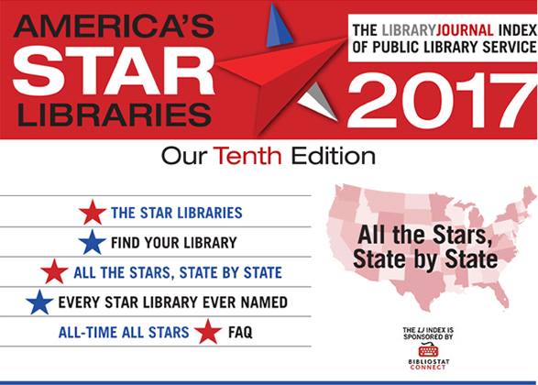
We are pleased to announce the results of the tenth edition of the LJ Index of Public Library Service, sponsored by Baker & Taylor’s CollectConnect. The LJ Index rates U.S. public libraries based on selected per capita output measures.
The 2017 Index derives from data recently released by the Institute of Museum and Library Services (IMLS) for FY15.
This year, 7,409 U.S. public libraries qualified to be rated in the Index. In this edition, there are 259 Star Libraries, each receiving three-Star, four-Star, or five-Star designations.
This year marks the tenth edition of the Star Library Ratings and the LJ Index of Public Library Service, sponsored by Baker & Taylor’s CollectConnect. The LJ Index compares U.S. public libraries with their spending peers based on per capita measures of service output. When my late colleague Ray Lyons and I conceived this project, we expected more new output measures to be developed and adopted on an ongoing basis. While it has taken longer than we would have wished, it is finally beginning to happen. Wi-Fi access usage should be added next year. Library website visits and uses of Maker spaces are being discussed. Also, we need to develop more measures of how residents rely on their libraries as gathering places in which to create and sustain community. It will be exciting to see how the addition of new output measures changes the composition of the Star Libraries group and how it better illuminates the increasing variety of ways in which libraries excel at serving their constituents.
From 2009 through 2015, the four measures included were circulation, library visits, program attendance, and public Internet computer use. LJ Index scores are produced by measuring the proportional relationships between each library’s statistics and the averages for its expenditure category.
Last year, circulation of electronic materials, or e-circ, became the fifth statistic to contribute to a library’s LJ Index score. While we had hoped to add Wi-Fi sessions this year, that was not to be.
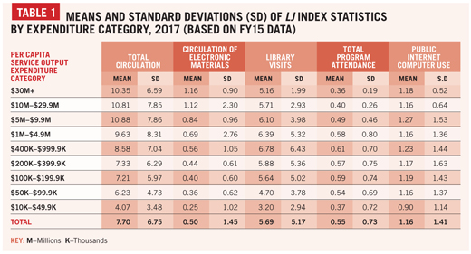
WHY NOT WI-FI?
When the 2016 LJ Index was released, we were optimistic about being able to add Wi-Fi sessions to the five existing per capita statistics in 2017. Unfortunately, that turned out not to be possible this year after all, because the percentage of responding libraries that reported it once again fell below the Institute of Museum and Library Services (IMLS) response rate standard of 80%.
For FY15, the data year on which the 2017 LJ Index is based, only the largest and best-funded libraries in the nation—those spending $30 million or more—met the 80% standard. For all of the other expenditure categories, only about three-fourths of libraries reported Wi-Fi sessions.
There are, however, significant differences in response rate for Wi-Fi sessions by state. For the FY15 data year, 100% response rates were achieved by ten states: Alaska, Arkansas, Delaware, Georgia, Nebraska, Nevada, New York, Ohio, Texas, and West Virginia.
Response rates exceeding IMLS’s 80% standard but falling below 100% were achieved by 13 states—in descending order by response rate: Michigan, Kentucky, Missouri, Louisiana, Pennsylvania, South Carolina, Mississippi, Indiana, North Dakota, New Mexico, South Dakota, Tennessee, and Alabama.
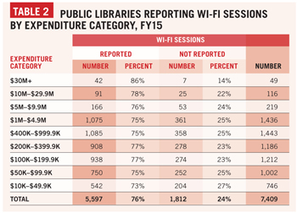
Response rates falling below the 80% standard but exceeding 50% were reported by 19 states—in descending order: Oregon, Idaho, Utah, Minnesota, Colorado, Oklahoma, New Jersey, California, Florida, Arizona, Massachusetts, Iowa, Wyoming, Montana, Wisconsin, Virginia, North Carolina, New Hampshire, and Kansas. Five other states—Washington, Illinois, Maine, Connecticut, and Rhode Island—had response rates between 40% and 6% for Wi-Fi sessions.
In FY15, over 1,800 libraries nationwide were still unable to report Wi-Fi sessions despite that being the second year of the category’s inclusion in the Public Library Survey. (Some states’ survey schedules make it impossible for them to adopt a new measure for the first year that other states report it.)
The issue here is not libraries that do not provide Wi-Fi service—they can simply report zero sessions. Doubtless, many libraries are finding it difficult to count Wi-Fi sessions. IMLS, the Chief Officers of State Library Agencies, individual state library agencies, and State Data Coordinators—particularly those with response rates below IMLS’s 80% standard—are encouraged to redouble their efforts to support libraries in finding ways to collect this important new measure. While public Internet computer use has long been included in the LJ Index, it no longer suffices when many, if not most, users bring their own devices to access digital resources.
As soon as the 80% standard is met nationally, Wi-Fi sessions will be considered seriously for addition to the LJ Index. At that point, libraries for which this data cannot be obtained may be disqualified from being rated and, thus, from being considered as Star Libraries.
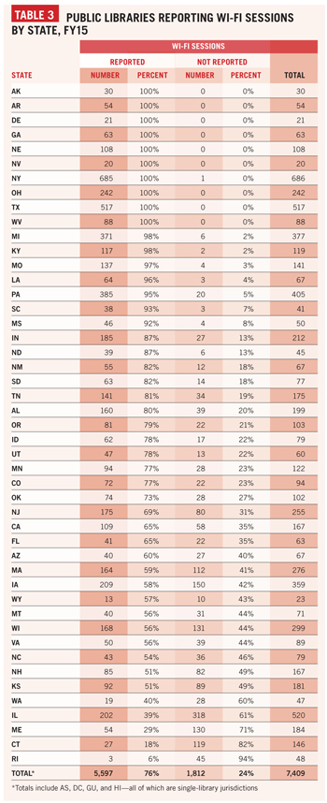

WHAT’S NEW?
For 2017, 7,409 U.S. public libraries were scored on the LJ Index of Public Library Service. This is somewhat higher than last year, in part owing to more libraries reporting the newest output measure, circulation of electronic materials.
Each year, the constellation of Star Libraries changes with the data reported (this year’s LJ Index derives from data that IMLS released this September for FY15), the movement of public libraries from one spending peer group to another, the relative fortunes of libraries in the same peer group, and the fortunes of individual libraries. Eligible libraries are grouped by total operating expenditures and, within each group, rated based on their differences from the means, or averages, of the five per capita statistics.
Therefore, increases or decreases in a library’s statistics relative to the previous year do not necessarily translate into higher or lower LJ Index scores or more or fewer Stars. LJ Index scores, even for the same expenditure category, cannot be compared meaningfully from year to year.
This year, there are 259 Star Libraries, about one-fifth of which, 54, were not Star Libraries last year. Some 205 of 2016’s Star Libraries retain Star status, though their number of Stars may have changed. Among libraries spending $30 million or more, there are no new Star Libraries for 2017.
Among libraries spending $10 million–$29.9 million, there are four new Star Libraries. The lone new four-Star library is Topeka and Shawnee County Public Library, KS. There are three new three-Star libraries: Birmingham Public Library, AL; Richland Library, SC; and Hartford Public Library, CT.
Among libraries spending $5 million–$9.9 million, there are eight new Star winners. Elmhurst Public Library, IL, is the one new five-Star library, while Palo Alto City Library, CA, is the lone new four-Star library. The remaining six are new three-Star libraries: Barrington Public Library District, IL; Glenview Public Library, IL; La Crosse Public Library, WI; St. Charles Public Library District, IL; Chester County Library, PA; and Genesee District Library, MI.
Among libraries spending $1 million–$4.9 million, there are five new Star Libraries. Westlake’s Porter Public Library, OH, is a new five-Star facility. In addition, four new three-Star libraries include Bronxville Public Library, NY; Oakwood’s Wright Memorial Public Library, OH; Bexley Public Library, OH; and Murray Public Library, UT.
Among libraries spending $400,000–$999,999, there are four new three-Star institutions: Chatham’s Eldredge Public Library, MA; Northeast Harbor Library, ME; Orleans’s Snow Library, MA; and Seward Community Library and Museum, AK.
Among libraries spending $200,000–$399,999, there are eight new Star Libraries. The three new four-Star libraries are Ely Public Library, MN; Fairport Harbor Library, OH; and La Grange’s Fayette Public Library, TX. The five new three-Star libraries are Cotuit Library, MA; La Junta’s Woodruff Memorial Library, CO; Petersburg Public Library, AK; Hot Springs Public Library, SD; and Ridgway Public Library District, CO.
Among libraries spending $100,000–$199,999, there are six new Star Libraries. The three new four-Star libraries are Altamont Free Library, NY; Gentry County Library, MO; and Todd County Public Library, KY. The three new three-Star facilities are Dennis Memorial Library Association, MA; Port Orford Public Library, OR; and Oakley Public Library, KS.
Among libraries spending $50,000–$99,999, there are nine new Star Libraries. Springlake’s Earth Community Library, TX, is the lone new five-Star library. The three new four-Star libraries are Marion City Library, KS; Grant’s Hastings Memorial Library, NE; and Moundridge Public Library, KS. The five new three-Star libraries are Columbus Village Library, NM; Baden Memorial Library, PA; Baudette Public Library, MN; Electra Public Library, TX; and De Smet’s Hazel L. Meyer Memorial Library, SD.
Among libraries spending $10,000–$49,999, there are ten new Star Libraries. The three new four-Star libraries are Lemmon Public Library, SD; Ogema Public Library, WI; and Saint Jo Public Library, TX. The seven new three-Star facilities are Guilford Memorial Library, ME; Ashley Public Library District, IL; Elk Horn Public Library, IA; Louisville Public Library, NE; Loxley Public Library, AL; Mammoth Public Library, AZ; and Parsons Public Library, TN.
MORE, FEWER, AND LOST STARS
Each year, some libraries that remain in the same expenditure categories earn additional Stars from the previous edition. In this 2017 edition, 59 such Star Libraries moved between the three-, four-, and five-Star ratings. Of those 59, 18 Star winners moved up from three Stars to four, 15 from four Stars to five, and two from three Stars to five.
Three libraries spending $30 million or more gained a Star between 2016 and 2017: East Baton Rouge Parish Library, LA, went from four to five Stars, and Multnomah County Library, OR, and San Francisco Public Library, CA, went from three to four Stars.
San Mateo County Library, CA, was the only library among those spending $10 million–$29.9 million to gain a Star this year—going from three to four.
This year, six libraries spending $5 million–$9.9 million gained Stars: Washington-Centerville Public Library, OH, and Oak Park Public Library, IL, went from four to five Stars, and Carmel Clay Public Library, IN; Cerritos Public Library, CA; Libertyville’s Cook Memorial Library, IL; and Pueblo City-County Library District, CO, went from three to four Stars.
Two libraries spending $1 million–$4.9 million gained Stars between 2016 and 2017: Cutchogue–New Suffolk Free Library, NY, went from four to five Stars, and Port Jefferson Free Library, NY, went from three to four Stars.
For 2017, four libraries spending $400,000–$999,999 libraries gained Stars: Dover Town Library, MA, and West Tisbury Free Public Library, MA, went from four to five Stars, and Lopez Island Library District, WA, and Shelter Island Public Library, NY, went from three to four Stars.
Three libraries spending $200,000–$399,999 gained Stars this year: Truro Public Library, MA, went from four to five Stars, and Anna’s Stinson Memorial Library, IL, and Roxana Public Library District, IL, went from three to four Stars.
For 2017, six libraries spending $100,000–$199,999 gained Stars over last year: libraries moving from four to five Stars include Atkinson Public Library, NE; Dryden’s Southworth Library Association, NY; Rock Creek Public Library, OH; and Tivoli Free Library, NY. Rogersville Public Library, AL, and Seven Points’ Library at Cedar Creek Lake, TX, moved from three to four Stars.
This year, five libraries spending $50,000–$99,999 gained Stars: Elbridge Free Library, NY, and Huachuca City Public Library, AZ, went from four to five Stars, and libraries moving from three to four Stars include Hubbard Public Library, IA; St. Paul Public Library, NE; and Tonto Basin Public Library, AZ.
Five libraries spending $10,000–$49,999 gained Stars over last year: Arma City Library, KS, and Ellinwood School Community Library, KS, went from three to five Stars; libraries moving from four to five Stars include Elgin Public Library, IA, and Springer’s Fred Macaron Library, NM; Lanark Public Library, IL, went from three to four Stars.
Other libraries lost Stars between the 2016 and 2017 editions. Without changing expenditure categories, 14 went from five to four Stars and nine went from four to three Stars. One library dropped from five Stars to three.
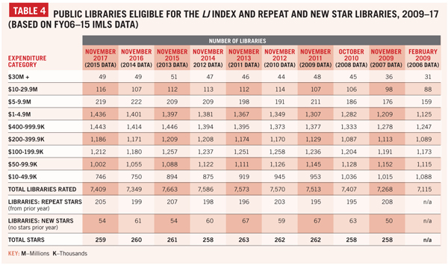
CHANGING CONSTELLATIONS
Between 2016 and 2017, 14 libraries moved from one expenditure category to another while retaining Star Library status. Of these, ten libraries retained Star Library status despite moving from a lower to a higher expenditure category and in two cases, the reverse.
In the latter case, two libraries retained their five-Star library status despite moving down one expenditure category: Hartington Public Library, NE, from $100,000–$199,999 to $50,000–$99,999, and Lincoln Public Library, NH, from $50,000–$99,999 to $10,000–$49,999.
Four libraries maintained their Star status while moving up one expenditure category this year: Cold Spring’s Julia L. Butterfield Memorial Library, NY, five Stars, from $200,000–$399,999 to $400,000–$999,999; Parker Public Library, AZ, five Stars, from $100,000–$199,999 to $200,000–$399,999; Double Springs Public Library, AL, five Stars, from $10,000–$49,999 to $50,000–$99,999; and Freeman Public Library, SD, four Stars, from $50,000–$99,999 to $100,000–$199,999.
Three four-Star libraries became five-Star institutions between 2016 and 2017 despite moving up one expenditure category: Richland Community Library, MI, four to five Stars, from $200,000–$399,999 to $400,000–$999,999; Haslet Public Library, TX, four to five Stars, from $100,000–$199,999 to $200,000–-$399,999; and Pembroke Public Library District, IL, four to five Stars, from $10,000–$49,999 to $50,000–$99,999.
STATES WITH THE MOST AND FEWEST STARS
The 2017 Star Libraries are found in 40 states. The top four states, ranked by their numbers of Star Libraries, are New York, 31; Ohio, 25; Illinois, 22; and California, 13. There is a tie for fifth place between Kansas and Massachusetts, 12 each. The top ten Star Library states are rounded out by Nebraska and Texas, 11 each; Alabama, ten; and Colorado, eight. The remaining 30 Star Library states are scattered across the nation and in every major geographical region.
There are no 2017 Star winners in the District of Columbia or ten states. Of those, four are the Southern states of Arkansas, Georgia, Mississippi, and North Carolina. Two other Star-less states are in the Rocky Mountain West—Idaho and Wyoming—and another two are Delaware and Hawaii.
In addition to the above, there were no Star Libraries from Maryland or Vermont, because circulation of electronic materials was not reported for all libraries in those states. Hopefully, both states will add this measure next year, so their libraries can once again be scored on the LJ Index of Public Library Service and be eligible to be designated as Star Libraries.
Most of the Star-less states have one notable thing in common: a relatively small number of public library jurisdictions. DC and Hawaii have only one each—DC’s being essentially a city library and Hawaii, having a single statewide system. Delaware and Idaho have relatively small numbers of libraries, owing to their relatively small populations.
COUNTING COUNTY LIBRARIES
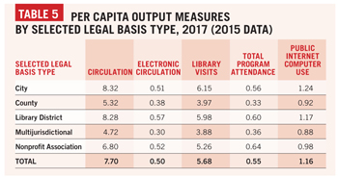A conversation with former Georgia deputy state librarian and retired Cherokee regional library director, GA, Diana Ray Tope revealed a major reason why the four Southern states listed above have no Star Libraries. All of those states have far more of certain types of large units of service than is the norm among all LJ Index–eligible libraries, or among Star Libraries.
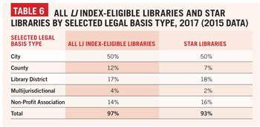Of the five major legal basis types, county and multijurisdictional libraries are at the greatest disadvantage in the Star Libraries ranking. Those legal basis types, on average, generate lower per capita service outputs—the basis of the Star Library ratings—because they are less well funded. In 2015, the data year for the 2017 ratings, county and multijurisdictional libraries averaged $29.40 and $23.87 per capita. By contrast, city libraries averaged $41.56; library districts, $54.29; and nonprofit associations, $38.49. It appears to be a simple matter of “you get what you pay for.” Why these legal basis types tend to be funded relatively poorly, and therefore generate lower per capita outputs, is an interesting question for further research.
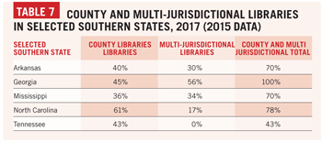In the meantime, those who work in a county or multijurisdictional library system might find it useful to consider the ranking of the library’s LJ Index score relative to other libraries of the same legal basis type in their expenditure category.
WHAT’S STILL MISSING?
As noted in last year’s article, one of the most conspicuously missing output measures is use of electronic collections, the term the Public Library Survey now uses for what were once referred to as databases. Despite the long-standing COUNTER standards for database usage statistics, a nationally standardized measure of this prominent service output is probably still a few years off. Early adopter states could do the rest of the public library community a tremendous service by testing alternative measures of the use of electronic collections.
Perhaps the newest and most unexplored area of public library service output measurement is Maker spaces. These are especially challenging to measure as they enable such a wide variety of creative endeavors, requiring different types of facilities:
- Traditional arts and crafts, drawing boards, calligraphy, kilns, looms, sewing machines, button makers, and laminators;
- Audio/music, video, or multimedia production, studios, still and video cameras, synthesizers, pianos and other instruments, microphones, and recording and editing equipment;
- Prototyping of inventions, computer assisted design (CAD) software, 3-D printers and scanners, and robotics;
- Visual arts, studios, canvasses, paints and brushes, and gallery space;
- Performing arts, rehearsal spaces, theaters, and sound and lighting equipment; and
- Writing, quiet spaces, computers, paper and writing instruments.
And doubtless, that list leaves something out.
Considering the wide range of Maker activities, it will probably be best to begin with the lowest common denominator: the number of visits to, or uses of, Maker spaces—regardless of the specific type of creative activity conducted. Although this has the disadvantage of failing to capture Maker activities not conducted in dedicated spaces, these would presumably already be counted, though not broken out, within the program attendance measure. In time, once there is more widespread experience with this relatively new service area, it might be workable to subdivide a single measure—say, between high-tech and low-tech types of Maker space activity. Again, the important thing is for early adopter states to begin experimenting with measurement options for this new and rapidly expanding facet of public library service. Development of new measures requires that someone be on the “bleeding edge,” designing and testing alternative measures until the most workable and useful one for most libraries can be found.
STANDOUT STATS
There are at least two dramatically different strategies for pursuing a higher LJ Index score. One is to excel as much as possible at all five types of service output; another is to focus on one or two specific types of output and excel exceptionally at those.
The LJ Index design makes no assumptions about the intended output of a library. It does not assume that a library must excel across the board. It allows a library to excel on one service output—even if at the expense of others—if that is the course that library’s decision-makers chart.
As a result, each of the five per capita statistics used to calculate an LJ Index score is given equal weight. Total circulation is not assumed to be any more important than program attendance. Library visits are not assumed to be any more crucial than uses of public Internet computers. Because the LJIndex formula uses standard scores, a library gets full credit for reporting an exceptionally high figure on a single statistic.
Sometimes, though, excelling on a single statistic does not suffice to earn a library Star status. In such cases, it may be useful to examine the per capita statistics for your library’s expenditure category peers. Perhaps your library reported the highest value for one of the per capita statistics without achieving Star status. Or perhaps your library reported the highest value on a statistic for some subset of libraries in its expenditure category.
Whether your library achieves Star status or not, the LJ Index offers a tremendous amount of data that could help to illuminate how your library stands out from the crowd.
» Next page: “All-Time All-Stars”
This article was published in Library Journal. Subscribe today and save up to 35% off the regular subscription rate.
About Keith Curry Lance

http://lj.libraryjournal.com/2017/12/managing-libraries/lj-index/class-of-2017/americas-star-libraries-top-rated-libraries-lj-index-2017/

7. #ownvoices Books: Enrich Your Collection’s Literary Landscape
Monday, November 13, 2017

by Jill Andreasen, MLIS, Collection Development
Last month I had the very good fortune to be able to attend SLJ’s first one-day Diversity Workshop – it was held in the extremely well-appointed conference room facilities in Nashville Public’s main downtown branch.
There were so many interconnected topics covered over the course of the day regarding diversity in literature, the library field, and the broader world around us: cultural competency, recognizing privilege, intersectionality, anti-oppression…I could keep going…they’re all important. But I want to focus on something we discussed that sits squarely in my area of expertise, collection development. Specifically, how to avoid cultural appropriation and promote authentic diverse narratives in a library’s collection. Let’s talk about #ownvoices.
What is the movement centered around #ownvoices? It’s highlighting and choosing books by and about cultural minority populations, written and/or illustrated by a cultural insider. A gifted storyteller can produce a beautiful novel outside her identity or culture, but can it be as authentic as a narrative from a cultural native?
Kayla Whaley, editor at Disability in Kidlit, puts it this way: “There’s a long history of majority-group authors (white, abled, straight, cisgender, male, etc.) writing outside their experience to tell diverse stories…many times, they’re rife with stereotypes, tropes, and harmful portrayals. Time and again, marginalized people have seen their stories taken from them, misused, and published as authentic, while marginalized authors have had to jump hurdle after hurdle to be published themselves.” Kayla has a very clear-eyed view of why diverse creators of literature are important—because the richness of our collective literary landscape is at stake, among other considerations—and I highly recommend reading her piece on it.
One of the Q&A topics that really resonated with me was how can librarians encourage publishers to put forth not only narratives with diverse characters, but those that are authentically #ownvoices? One of the day’s presenters and Simmons College Librarian Anastasia Collins had a very definitive answer to that question: librarians should vote with their budgets! Sure, talk to publisher reps at library conferences, but the most persuasive argument is financial. I started to consider how I can also facilitate getting these important titles in front of our library customers, and voilà! Here are some recent and forthcoming diverse stories: #ownvoices Juvenile & YA Fiction*.
I hope SLJ will do more of these workshops and would encourage anyone to attend; I left feeling like my horizons had been broadened, status-quo challenged, and feeling more connected to my fellow librarians in the field after sharing very personal stories and goals for our respective communities.

Learn More To Stay Up-To-Date!
Interested in learning more about libraries and their role within communities? Listen to the second series of our library podcast, Two Librarians and A Microphone, where we discuss how librarians can become a community hub of support for their adult patrons be integrating resources on trending and current events into their collections.
*Not an Ingram customer or do not have an ipage® (Ingram’s online order management system) account?

https://www.ingramcontent.com/blog/ownvoices-books-enrich-your-collection-s-literary-landscape#utm_campaign=icg-blog&utm_source=library_journal_reviews_newsletter&utm_medium=lets-taslk-about-ownvoices

