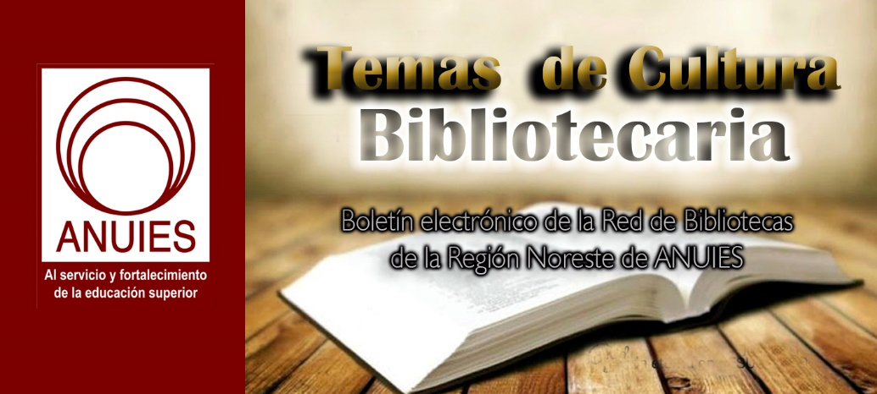
Año 2 Número 53 diciembre 2017

Contenidos de este número

- Amplifying Community Engagement
Tuesday, December 12, 2017
2-3 PM ET, 11 AM-12 PM PT
The advent and distribution of ebooks has reinvented the modern library. With SELF-e and other self-managed self-publishing programs, libraries have become a channel for ebook distribution and discovery while creating a positive and supportive environment for local writers and readers.
With geolocation technology, libraries can now get ebooks by local authors (and more) into the hands of their community – inside and outside of the library's walls – with just one click. Authors can use the same link to locally promote their book – available for unlimited, simultaneous reading – seamlessly driving traffic back to the library, creating a true win-win.
With self-published ebook programs living alongside emerging options for short story, poetry, YA writing and journalism contests, libraries have never been in a better position to engage their local community.
Register Now!
Panelists
A fantastic panel of leading library professionals paired with local authors to tell their stories about how this smart technology paired with community engagement has helped amplify their communities and readership.
Moderator
Rebecca Jozwiak, Library Journal

UX Specialist Iris Bierlein Has Real World Solutions for Librarians
Posted on October 23, 2017 Leave a Comment
As the User Experience Specialist at the New York University Division of Libraries, Iris Bierlein leads qualitative research for the UX Department. Bierlein has presented on UX-related topics for the Metropolitan New York Library Council and the Association of Information Technology, and she is currently co-leader of NYU’s UX community of practice. Here she shares insights and advice to help librarians simplify user journeys, enable usage of content and ultimately, promote the impact of research.
What’s your approach for content strategy and usability testing for websites and digital tools at NYU Libraries?
I promote a user-centered approach for the libraries’ digital products through user testing, content strategy, and workflow analysis in an agile development environment. I’m also a proponent of blending physical and digital wayfinding in libraries.
What advice do you have in terms of best practices when optimizing UX in a university library?
The UX community in libraries needs to remain aware of trends in the wider UX world. Remind yourself who your users are, what you’re serving, and what your university goals are, and that it should be as inclusive as possible.
What are the most common obstacles you’ve had to overcome?
Staffing, money, and time are the biggest challenges. There are some universities with UX departments that have many people, but those are not the norm. It’s possible to do good UX and keep it relatively lightweight with guerrilla testing though. It can be challenging to conduct good research with limited time because research and analysis, especially analysis, takes time, but it helps to get UX into the conversation from the start as part of the project planning.
When resources are limited, how do you continue to make more with less?
The benefit of having partners is they’ve thought about user experience. This means your users benefit from that. Someone else has done the work and done the work well, so you don’t have to try to patch it. The burden used to be on the library. Companies like Emerald are thinking about the full process and focus on making their portion of it better.
What’s the best way to get buy-in for UX?
You need to get stakeholders involved. If they’re observers and commenting, get them engaged in the experience with the A-ha moment, which helps to sell it.
What are some actionable solutions that are most easily implemented?
Whenever you do a UX study, ideally you have a report at the end, and I really like to provide three tiers of recommendations. Always make sure you give people something they can act on. Level one solutions like changing fonts and color schemes are a start, and cutting down on text can help. Level two may take a bit of time or money. Level three is a deeper change where you may need a developer and it may be stage two of your project.

Iris Bierlein participated in a Library Journal webcast on September 27th along with University of Michigan’s Rachel Vacek and Emerald Publishing’s Kat Palmer on the subject, Smoothing the Path of the Research Journey: Designing for User Experience Excellence in Academic Libraries. The webcast can be viewed on demand at:
http://lj.libraryjournal.com/2017/08/webcasts/smoothing-path-research-journey-ux-libraries/#_

http://lj.libraryjournal.com/2017/10/interviews/ux-specialist-iris-bierlein-real-world-solutions-librarians/?utm_source=ljnewsletter&utm_medium=newsletter&utm_content=sponsoredcolumn&utm_campaign=emerald#_

Explore the future of library science with Drexel

Drexel’s MS in Library & Information Science program offers you the opportunity to explore every nook of librarianship as you begin or continue your career in information and library science.
Whether you’re a die-hard bibliophile or a coding wizard – or even if you’re not sure yet – Drexel’s online MSLIS program offers three specializations to help you find your passion and success after graduation.
Online MSLIS alumna and ALA Emerging Leaders award recipient Tiffany Chow discovered her ambition was in research and archival studies. “The online MSLIS program at Drexel was about finding inspiration and implementing new ideas,” said Chow, now a research librarian at a university in San Diego.
The possibilities of a career as a librarian – whether it be in a library or a non-traditional role – are absolutely endless, and Drexel’s online MSLIS program will help you find a path that inspires you!
Learn more

- 2016 Impact Factor, CiteScore, SNIP and SJR
The latest metrics of Elsevier's Library and Information Science journals

Elsevier supports the academic community's need for more choice, accuracy and insight in journal performance for deciding where to publish. Therefore we are pleased to present the 2016 metrics for our Library and Information Science journals.
Visit the Library and Information Science journal metrics page to discover the latest CiteScore, SNIP, SJR and Impact Factor*. These metrics provide you valuable insight into the different ways a journal can perform.

METRICS
Is there another subject area you are interested in?
Visit the page to explore the metrics of journals in other subject areas.
* 2016 Journal Citation Reports®, Clarivate Analytics 2017

- 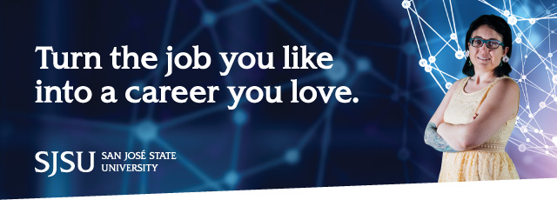
“Oh my gosh I’m home—this is where I was meant to be.” That’s how Erin Berman felt once she started volunteering at a public library.
For many of us, libraries do feel like home. Follow your passion and move your career forward by earning your Master of Library and Information Science (MLIS) degree from the San José State University School of Information.
With our award-winning online program, you can continue working at your current job while you prepare for your future career. The flexible, self-paced schedule allows you to have time for work, school and family.

6.

Be the first to try our new video collection
Sign up your library for a free trial in 2018
We’re happy to announce that we’re launching a new video collection - Practical Research and Academic Skills - on SAGE Research Methods in January 2018! Be the first to experience this new content – register your interest in an institution-wide trial today, and we’ll be in touch as soon as the collection goes live!
About the collection
The newest collection will offer support on the practical skills that researchers need to successfully complete their research. It will give researchers the confidence to successfully navigate their research work, take responsibility for their professional development and identify the transferable skills they need to progress their careers.
The collection includes video on:
- Writing a research proposal
- Planning & designing a research project
- Securing ethical approval
- Writing for publication
- Project management
- Essay writing
- Time management
- Computer applications
- Applied research
- Research careers & networking
- How to present at conferences
Register your interest in this trial >>

 | About the collection >> |  | Take a sneak peek at the platforml >>

7. Everyone’s Problem: Libraries Confront the Opioid Crisis
By Linda Jacobson and Megan Cottrell on November 1, 2017 2 Comments
Illustration by Scott Bakal
About six years ago, Doug Ute, superintendent of the Newark (OH) City Schools, says he began to see the effects of addiction among his students. Kids would show up to school hungry, not bathed, and wearing dirty and unkempt clothing.
Since then, the issues have intensified. Student survey responses confirm what educators had suspected—that students, especially as they get older, are feeling a sense of hopelessness related to substance abuse at home. “Addiction affects all family members [and can lead to] violent homes and the lack of basic necessities, such as food and clothing,” Ute says. While some students are coping with having a parent who has an addiction problem, others are seeing substance use issues among siblings.
Also read:
“Writing About Addiction for Kids”
To address the growing numbers of students affected, the district has created a Social Emotional Academic Success (SEAS) team to help better identify staff members with the expertise to respond to students experiencing a crisis at home. In addition to serving breakfast every morning, schools send home backpacks of food and toiletries on the weekends.
School librarians, Ute adds, participate in the “fight against this terrible disease” by helping students and staff members find information about addiction. They also form bonds with students and protect their privacy when they ask for help.
Oxford (ME) Elementary School kids read Kate Messner’s The Seventh Wish,featuring a character with a substance abuse issue, and discussed addiction.
Photo courtesy of Melissa Guerrette
As in Newark, communities throughout Ohio have been hard hit by the sharp increase in opioid abuse and overdoses. Some refer to the state as the “epicenter” of addiction. Between 2015 and 2016, overdose deaths in Ohio increased from 3,050 to 4,050, with many of those new cases attributed to the use of fentanyl and related drugs, according to the Ohio Department of Health.
Nonetheless, the epidemic level of opioid abuse extends well beyond Ohio and the Northeast. According to survey results released earlier this year by the Substance Abuse and Mental Health Services Administration (SAMHSA), almost 92 million adults in the United States misused prescription opioids in 2015. “The level of overdoses is a crisis, and it requires all of our efforts to turn the tide,” Kimberly A. Johnson, director of the Center for Substance Abuse Treatment at SAMHSA, said in a statement.
The library field is responding. As part of a broad plan to address the issue, the Public Library Association hosted a September virtual town hall meeting in partnership with WebJunction, which provides online courses and webinars related to libraries. During the event, one of the speakers, Hadi Sedigh, an associate legislative director for justice and public safety with the National Association of Counties (NACo), alluded to the role that school and children’s librarians can play in protecting more young people from substance abuse.
“There is not going to be a single solution that’s going to turn the tide. Not a switch to flip to make it go away,” said Sedigh, also a liaison to the National City-County Task Force on the Opioid Epidemic, a joint project of NACo and the National League of Cities. “It’s important to highlight the importance of doing your individual part even if it feels minuscule or even if it feels you are not turning the tide overall, and to focus on prevention and education and not lose sight of the [greater] importance of stopping the revolving door of individuals becoming addicted,” he said.
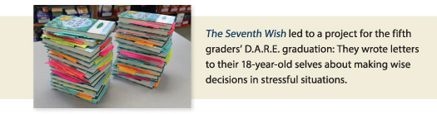SOCIAL EMOTIONAL LEARNING PROGRAMS
Across the country, while some school districts are stocking up on Narcan, a drug that reverses the effects of an opioid overdose, others are also deepening their efforts to implement social emotional learning (SEL) programs that support students who have a family member struggling with addiction and may help prevent students from following that same path.
“We know SEL can help young people learn to handle stressful situations in positive ways,” says James Vetter, executive director of the Social-Emotional Learning Alliance for Massachusetts (SEL4MA), a 1,200-member volunteer advocacy organization. “We know that when we help young people to be able to recognize and manage emotions, recognize the feelings and perspectives of others, and navigate problem situations, these go right along with the risk and protective factors that influence whether someone might be more likely to get involved with substance abuse.”
SEL4MA is now focusing on coordinating multiple agencies across the state to work together and look at “what are we doing well and what can we do better,” Vetter says, to get people access to treatment and to prevent drug use among youth. In some states, public libraries are also part of community-wide efforts to educate the public and direct people who are addicted toward services and give patrons opportunities to share their experiences.
In Ute’s district, the SEAS team is also forging “external bonds,” says Ute, with social service agencies and area businesses to help students and their families affected by addiction.

http://www.slj.com/2017/11/industry-news/everyones-problem-libraries-confront-opioid-crisis/

