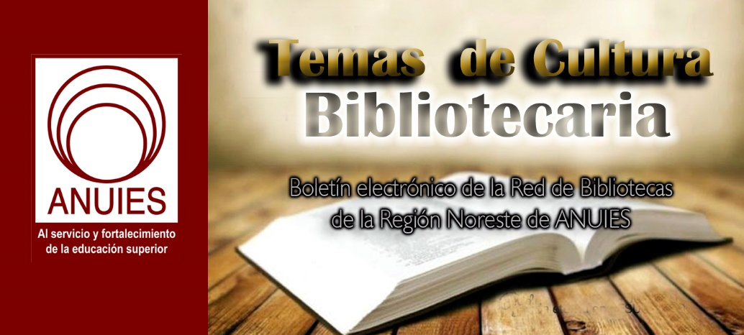
Año 2 Número 50 noviembre 2017

Contenidos de este número

- [DOCUFORUM] Novedades Noviembre 2017
B
Boletín Fundación Ciencias de la Documentación
on behalf of
Fundacion CD

Estimados/as compañeros/as,
compartimos las principales novedades acaecidas en la Fundación Ciencias de la Documentación:
AUSPICIAMOS EN REPÚBLICA DOMINICANA 2DO ENCUENTRO INTERNACIONAL DE EMPRENDEDORES EN TECNOLOGÍAS
https://documentalistas.org/plataforma/mod/forum/discuss.php?d=178
La Organización de Mujeres y Hombres en Emprendimientos de Tecnologías para el Mundo Met2/Het2 International, República Dominicana, con el auspicio de la Fundación Ciencias de la Documentación, celebrará el 2do Encuentro Internacional de Emprendedores en Tecnologías: “Te impulsamos al siguiente nivel”, el 17 y 18 de Noviembre de 2017 en las instalaciones del Hotel Napolitano ubicado en la avenida George Washington 51 de la ciudad de Santo Domingo.
PREPARANDO 1ER ENCUENTRO DE MUJERES LÍDERES AMÉRICA
https://www.linkedin.com/groups/5116572
Junto con destacadas mujeres del área política, empresarial y social estamos iniciando rondas de conversaciones para definir y poner en marcha en el 2018 el 1er Encuentro de Mujeres Líderes América, dentro de la iniciativa puesta en marcha con la Sección de Apoyo a las Instituciones Representativas de la Organización de los Estados Americanos (SAIR/OEA).
CURSO ONLINE SOBRE CONTENT CURATOR
https://documentalistas.org/plataforma/mod/forum/discuss.php?d=86
Del 14 de Noviembre al 5 de Diciembre tendrá lugar este importante curso totalmente virtual donde ya están matriculados alumnos/as de entidades públicas y privadas de España e Iberoamérica. El curso tiene un programa bien desarrollado, pero en esencia busca establecer las habilidades para la producción de contenidos que aporten valor agregado a nuestras unidades de información y entidades.
MIEMBROS DEL COMITÉ PANAFRICANO 50 AÑOS DE GUINEA ECUATORIAL
https://documentalistas.org/plataforma/mod/forum/discuss.php?d=184
La Fundación Ciencias de la Documentación, a través de su Dpto. África, es miembro del Comité Panafricano 50 años de Guinea Ecuatorial 1968 - 2018, coordinado por nuestro Director Abuy Nfubea, quien es además Pte del Comité de Coordinación y Alto Consultivo estatus ECOSOC ante las Naciones Unidas para el Decenio con los pueblos afrodescendientes 2014 - 2024.
ENTREVISTA A MARILU BRAJER (ARGENTINA)
https://youtu.be/vNXx9XJGAr8
Ya está disponible en el Canal TV de la Fundación Ciencias de la Documentación la entrevista en vídeo desde Argentina a Marilu Brajer, miembro del Comité #MujeresLideresAmerica con la OEA_Parlamentos, Vicepresidenta de la Asociación Latinoamericana de Consultores Políticos (ALACOP), Co-fundadora de B2R Consultoría con Perspectiva de Género, y por tercer periodo electivo Board’s Director of International Association of Political Consultants (IAPC).
CONFERENCIAS CON LA RED LATINOAMERICANA DE CONFERENCISTAS
https://documentalistas.org/plataforma/mod/forum/discuss.php?d=28
Todos los martes, a las 18h en España, tenemos una conferencia online en tiempo real con los Expertos compañeros/as de la Red Latinoamericana de Conferencistas. Consulte el link anterior para ver todas las conferencias realizadas.
ARTÍCULO: MARCA PERSONAL. TU MEJOR HERRAMIENTA
https://documentalistas.org/plataforma/mod/forum/discuss.php?d=183
Kathia Salazar, miembro del Comité Mujeres Líderes de las Americas, nos comparte lo que se debe de tomar en cuenta para que “nuestra marca personal trascienda”. Actualmente labora para BAC Credomatic y es coordinadora de la Junta de Control de Entidades de AIESEC Nicaragua.
MARÍA ALEJANDRA MENALDO (GUATEMALA) RECONOCIDA CON #MUJERESLIDERESAMERICA CERTIFICATION
https://documentalistas.org/plataforma/mod/forum/discuss.php?d=153
Es un honor informar que oficialmente María Alejandra Menaldo (Guatemala) ha obtenido el reconocimiento #MujeresLideresAmerica Certification.
GRUPO DE LA FUNDACIÓN EN WHATSAPP SIGUE CRECIENDO
https://documentalistas.org/plataforma/mod/forum/discuss.php?d=79
Prácticamente ya contamos en el grupo WhatsApp de la Fundación con profesionales de la información y documentación de todos los países miembros. Recuerda que para formar parte debes escribirnos indicando país y motivo por el que quieres formar parte.
NUEVA REVISTA DIGITAL SOBRE JÓVENES Y POLÍTICA
http://flip.it/SjSLot
Esta nueva revista online está coordinada por nuestro Presidente, José Raúl Vaquero Pulido, y se desarrolla bajo la plataforma Flipboard.
Muchas gracias. Saludos a todos/as.
---
Dpto de Información
Fundación Ciencias de la Documentación
https://documentalistas.org
http://www.twitter.com/fundacioncd

Recently Published: “Open Educational Resources: Global Report 2017″
Filed by Gary Price
Open Educational Resources: Global Report 2017 was published last month by the Commonwealth of Learning.
Global Report 2017 provide the outcomes of the six regional consultations and global surveys conducted prior to the 2nd World OER Congress [held last month in Slovenia].
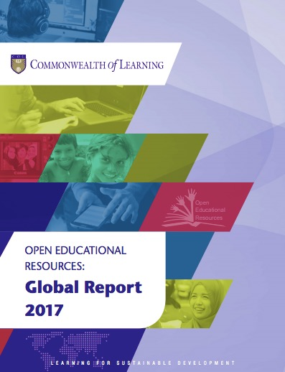
Direct to Full Text Report (92 pages; PDF)
See Also: 2nd World OER Congress Report
See Also: About the Commonwealth of Learning
The Commonwealth of Learning (COL) is an intergovernmental organisation created by Commonwealth Heads of Government in 1987 to promote the development and sharing of open learning and distance education knowledge, resources and technologies.
Hosted by the Government of Canada with headquarters in Burnaby, British Columbia, COL is the world’s only intergovernmental organisation solely concerned with the promotion and development of distance education and open learning.

http://www.infodocket.com/2017/10/17/recently-published-open-educational-resources-global-report-2017/

Opportunities: Library of Congress Announces Librarians-in-Residence Pilot Program For Recent LIS Master’s Graduates
Filed by Gary Price
Here’s the full text of an announcement we received from LC today.
The Library of Congress is launching a Librarians-in-Residence pilot program to offer early career librarians the opportunity to develop their expertise and contribute to building, stewarding and sharing the institution’s vast collections.
The application period is Nov. 1 to Nov. 30, 2017. The Library will select up to four applicants for a six-month residency beginning in June 2018. The program is open to students who will complete their master’s degrees in an American Library Association-accredited library/information science program no later than June 2018 or who completed such a degree no earlier than December 2016.
“I am so excited to invite early career librarians to bring their intellectual engagement, technological prowess and theoretical concepts of library and information science to bear on practical challenges here at the world’s largest library,” said Librarian of Congress Carla Hayden. “The Library of Congress will benefit from their energy and creative thinking, and they will benefit from the hands-on experience of working with the scale and variety of the national collections, side-by-side with top innovators on the Library’s staff.”
The program gives early career librarians the opportunity to receive on-the-job training and undertake assignments that contribute to the ongoing mission and work of the Library of Congress in at least one of the following tracks:
- Acquisitions and collection development
- Cataloging and metadata
- Collection preservation
- Reference and instruction
- Systems and standards
The program will offer compensation at the GS-9 pay level. For more information, please visit loc.gov/librarians.
The program complements other education and training programs at the Library, such as the Junior Fellows program offering summer internships for college students and the summer Teacher Institutes program offering workshops for K-12 teachers to learn strategies for utilizing primary source materials in the classroom.

http://www.infodocket.com/2017/10/17/opportunities-library-of-congress-announces-librarians-in-residence-pilot-program-for-recent-lis-masters-graduates/

IEEE Spectrum Publishes Special Section Devoted to Understanding Blockchain
Filed by Gary Price
The special section is titled “Blockchain World” and includes 10 articles and one video.
From the Blockchain World Website:
When Bitcoin was unleashed on the world, it filled a specific need. But it wasn’t long before people realized the technology behind Bitcoin—the blockchain—could do much more than record monetary transactions. That realization has lately blossomed into a dazzling and often bewildering array of startup companies, initiatives, corporate alliances, and research projects. Billions of dollars will hinge on what they come up with. So you should understand how blockchains work—and what could happen if they don’t.
All Articles/Video Can Be Accessed on this Page
and/or Direct to Specific Articles
Blockchains: How They Work and Why They’ll Change the World
How Blockchains Work
How Smart Contracts Work
The Ridiculous Amount of Energy It Takes to Run Bitcoin
Do You Need a Blockchain?
Wall Street Firms to Move Trillions to Blockchains in 2018
Blockchain Lingo
Why the Biggest Bitcoin Mines Are in China
Illinois vs. Dubai: Two Experiments Bring Blockchains to Government
Blockchains Will Allow Rooftop Solar Energy Trading for Fun and Profit
Video: The Bitcoin Blockchain Explained

http://www.infodocket.com/2017/10/16/ieee-spectrum-publishes-special-section-devoted-to-understanding-blockchain/

Challenged by Change: The Most Difficult, and Important, Part of the Job | Blatant Berry
By John N. Berry III
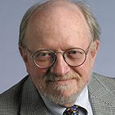
It takes me a day or more to adjust to and relearn my computer systems after they are automatically “upgraded” or “improved” by the vendors. When they decide to replace an old system totally with a new one, I get lost in dysfunction for months. In some cases, I never master all the bells and whistles, and I always end up wondering why some of my favorite features needed to be “improved.”
These reactions are probably owing to my advanced age and my experience back when most systems were processes we executed with typewriters, pens, and, gasp, even pencils. When I began as an editor, our first digital system delivered the characters in shining green from a black screen. Once we completed the editorial end of things, the whole shebang was sent off to typesetters and printers, who sent it back on paper. Today, we do it all on our computers, and when we’re done, we click the mouse and the pages appear on the screen exactly as they will on the web or in print. I’m still impressed by this modern magic.
These technological transitions have been the most difficult and yet the most exciting part of my library and journalistic career. I am constantly amazed at how much more I can do digitally than I could before the new technology.
Change comes much more frequently in this digital era. Sometimes it is expected and invited, sometimes not. Nearly every change brings opportunities to work better in our personal and professional lives. It is difficult and challenging to keep up with change, but it is also necessary. Librarianship as we know it is about to be transformed into something that would be unrecognizable to my early mentors in the profession as they moved from rubber stamps on the end of pencils to machine-based circulation systems. At the time, I didn’t believe the machines were better. I thought they were attempts by our managers to be current and “cool.” I was wrong.
I recently wrote about the little Boundary County Library District (BCLD), in Bonners Ferry, ID, named the Best Small Library in America 2017 (“A Culture of Opportunity”). Due to the vision of Sandra Ashworth, director of BCLD until she retired last year, that institution leaped over years of digital progress to re-create itself in ways that make it far more connected and vital to the community it serves today. Ashworth saw the opportunity in change. BCLD is still a library we would all recognize, but down in the basement is the library of the future, using the newest technologies to create opportunity in Boundary County.
I don’t suggest that this is the only model for the future of libraries, but it is definitely one version of where we are headed. Personally, I wouldn’t quite know what to do in BCLD’s FAB Lab, with its 3-D printers, milling machines, and vinyl cutters, but I know I would undertake the struggle to find out and understand how it all functions and why it is transforming Bonners Ferry.
Now, as always, keeping up with change is possibly the most difficult task of a librarian. The traditional view of what a library is suggests a quiet, unchanging, pleasant place to seek knowledge. But I learned way back in that library with the rubber stamps that change is rarely quiet, and often unpleasant, but it is the key to survival and progress. Clearly crucial to a successful career in librarianship is not only keeping up with and accepting change but getting involved with and mastering it. It isn’t always easy or fun, but it is what keeps us and our libraries alive and growing.
This article was published in Library Journal's October 1, 2017 issue. Subscribe today and save up to 35% off the regular subscription rate.

http://lj.libraryjournal.com/2017/10/opinion/john-berry/challenged-change-difficult-important-part-job-blatant-berry/

Sexual Harassment @ Your Library
OCTOBER 16, 2017 BY ANNOYED LIBRARIAN LEAVE A COMMENT
If you’ve seen any news in the past couple of weeks, you might have heard of a guy named Harvey Weinstein. It’s hard to make out any details from the dearth of news coverage, but he’s allegedly sexually harassed or raped numerous women over many years.
I don’t see how that was a big secret. It’s right on his Wikipedia page and everything.
He’s the stereotypical Hollywood casting couch producer who for some reason Hollywood decided to suddenly declare its concern about.
Weinstein is perhaps typical of men in powerful positions surrounded by vulnerable people they desire to exploit. What’s to stop them when everyone’s afraid of them or wants something from them?
By an odd coincidence, the library world got its own sexual harassment scandal last week. It didn’t receive quite the news coverage of Weinstein, but you might have seen this story about sexual harassment at the Wagner College library in Staten Island, NY.
It’s a sordid tale of a librarian being allegedly quite openly and even physically harassed by his supervisor, and the college doing nothing to stop it.
The headline is remarkable on its own: “Explosive lawsuit: Male boss at Wagner College library sexually harassed male worker.”
From what I could tell, the lawsuit was just a sexual harassment lawsuit, nothing “explosive” about it other than the usual dealing with the grimy behavior of sexual harassers. I’m speculating that the “explosive” part was the male on male sexual harassment.
I find that angle offensive. The implied notion is that sexually harassing women is so common it’s hardly worth bothering about, but when the victim is a man suddenly it’s “explosive.”
It’s as if even in the domain of sexual harassment, being a harassed man makes the charge worth taking more seriously, sort of like the difference between how police shooting deaths of unarmed people get treated when one is a black man and the other a white woman.
Maybe if it’s a woman being harassed by a man, it’s just “boys being boys.”
Unlike the Weinstein type of case, this wasn’t a gatekeeper sort of power. The supervisor in question wasn’t saying “have sex with me and I’ll make you a famous access services librarian.” He was just, allegedly, very persistent in his fondling, verbal suggestions, and verbal abuse.
Although there’s a Weinsteinian feel to the complaint that the harassment was typically “between the hours of noon and 1 p.m. when they were alone in the office.” Perhaps the harasser also went out to slip on a bathrobe.
Predators know when their victims are the most vulnerable, and alone is often the most vulnerable of all.
If you’ve worked in situations more or less free of sexual harassment, it hard not to agree with the victim’s lawyer that, “It is amazing how an academic institution in this day and age could tolerate such egregious conduct and not protect the plaintiff the way he is entitled to be protected under the law.”
I’ve heard stories of sexual harassment in libraries, but nothing as little as egregious as this or the Weinstein story. They are probably a lot out there, though.
On the other hand, if you keep up at all with news about colleges and universities, this sort of behavior isn’t that unheard of. It just usually occurs in the typical gatekeeping relationship of male adviser and female graduate student. There have been numerous such scandals around the country the past few years.
The hard part is the proof, which might be why the librarian’s initial complaint was dismissed by HR. Maybe the only solution is that those of us with the potential to be harassed, which includes all of us except the predators, should wear recording devices at all times.
That, and maybe be a little more willing to believe victims of assault than we normally are.
Oh, and if someone texts you “a sexually suggestive picture of himself,” as the alleged harasser here did, save it. That’s going to look great in court. And maybe on Twitter.

http://lj.libraryjournal.com/blogs/annoyedlibrarian/2017/10/16/sexual-harassment-your-library/

- Get the Most Targeted Results for Life Sciences Research
Library Journal Partner

How Do You Get the Most Targeted Results
for Life Sciences Research?

You can retrieve the most targeted results by using an expertly-indexed database created by life scientists for life scientists. BIOSIS Previews® is an expansive index to life sciences and biomedical research from journals, meetings, books, and patents. The database covers pre-clinical and experimental research, methods and instrumentation, animal studies, and more. Provide your researchers with the data they need to prepare research projects, grant proposals and follow trends in the life sciences.

