

**Año 2 Número 49 noviembre 2017**

**Contenidos de este número**

**1.**

|  |  |  |  |  |  |  |  |
| --- | --- | --- | --- | --- | --- | --- | --- |
| |  |  |  | | --- | --- | --- | | |  |  | | --- | --- | | |  | | --- | | [Bloomsbury Food Library logo](http://mediasource.actonservice.com/acton/ct/10574/s-149b-1710/Bct/l-00ab/l-00ab:22523/ct1_0/1?sid=TV2:dOyhAis6r) | | | | |  |  |  | | --- | --- | --- | |  | [**Request a Trial Today!**](http://mediasource.actonservice.com/acton/ct/10574/s-149b-1710/Bct/l-00ab/l-00ab:22523/ct2_0/1?sid=TV2%3AdOyhAis6r) |  | | |

|  |  |
| --- | --- |
| |  | | --- | | Help Yourself to a Delicious Serving of our Newest Online Resource!  [Bloomsbury Food Library](http://mediasource.actonservice.com/acton/ct/10574/s-149b-1710/Bct/l-00ab/l-00ab:22523/ct3_0/1?sid=TV2%3AdOyhAis6r)! | |
| |  |  |  |  |  |  |  |  |  |  |  |  |  |  |  |  |  |  |  | | --- | --- | --- | --- | --- | --- | --- | --- | --- | --- | --- | --- | --- | --- | --- | --- | --- | --- | --- | | |  | | --- | |  | | Providing an extensive collection of content, Bloomsbury Food Library offers students, researchers, and scholars an unprecedented insight into this diverse field of study. | | |  |  |  | | --- | --- | --- | |  | [**Find out more**](http://mediasource.actonservice.com/acton/ct/10574/s-149b-1710/Bct/l-00ab/l-00ab:22523/ct5_0/1?sid=TV2%3AdOyhAis6r) |  | | | **What will I find in Bloomsbury Food Library?**  * Global coverage including **Ken Albala’s Food Cultures of the World Encyclopedia**and the **Cambridge World History of Food** * Major reference works including Bloomsbury’s ***A Cultural History of Food*** in six volumes and key chapters from **Food History: Critical and Primary Sources** * **Over 60 eBooks** by key authors in the field including Warren Belasco, Carol J. Adams, Anne Murcott, Rick Wilk, Fabio Parasecoli, Marion Nestle, and many more! * **Image collections** from leading institutions around the globe including The Metropolitan Museum of Art, USA | | **How will Bloomsbury Food Library benefit my institution?** It will give students, scholars, and researchers the tools to:   * **Explore**the global history of food from pre-history to present day through renowned reference works and cutting-edge academic research[http://bloomsbury-publishing.msgfocus.com/i/amf_bloomsbury_publishing/project_544/BFoL_email_2.jpg?size=580x0&w=B56Dbx-_GCS3-MhFVraIc0xdF3zI](http://mediasource.actonservice.com/acton/ct/10574/s-149b-1710/Bct/l-00ab/l-00ab:22523/ct4_0/1?sid=TV2:dOyhAis6r) * **Discover**more about food in different cultures, time periods, and places with numerous interactive features to navigate the site seamlessly * **Understand**the history of food in its social, political, and economic context through an illustrated interactive timeline and world map feature | | **What kind of updates will be coming to Bloomsbury Food Library** Additional content from Bloomsbury's field-leading Food Studies list, image collections from partner institutions, lesson plans, annotated bibliographies and much more! | | **What are the next steps for arranging a free trial or purchasing?** Bloomsbury Food Library is available to institutions for a 60-day free trial. For more information on pricing or to arrange a trial please follow the link below. | | |  |  |  | | --- | --- | --- | |  | [**Librarians - request a free trial**](http://mediasource.actonservice.com/acton/ct/10574/s-149b-1710/Bct/l-00ab/l-00ab:22523/ct6_0/1?sid=TV2%3AdOyhAis6r) |  | | | |  |  |  | | --- | --- | --- | |  | [**Academics - discover more**](http://mediasource.actonservice.com/acton/ct/10574/s-149b-1710/Bct/l-00ab/l-00ab:22523/ct7_0/1?sid=TV2%3AdOyhAis6r) |  | | | |

**2. XXXV Coloquio de Investigación Bibliotecológica y de Información.**

Estimado Colega,  
  
Con el gusto de saludarle, le recordamos que este 13, 14 y 15 de Noviembre, se llevará a cabo el  
  
XXXV Coloquio de Investigación Bibliotecológica y de Información.   
  
El coloquio es uno de los eventos más importantes del IIBI, a través de él se presenta el trabajo de nuestros investigadores a la comunidad académica y público interesado. Este año el coloquio mostrará los temas más relevantes para nuestra disciplina en la “Agendas Internacionales de Información” y:  
  
Su repercusión en las comunidades BAM (Bibliotecas, Archivos y Museos).   
  
La sostenibilidad del programa 20/30.   
  
La preservación del patrimonio cultural y documental.  
  
La declaración de Río, Art. 10.  
  
Uniendo la investigación con la realidad social, este Coloquio presenta:  
  
Información en Tiempos de Guerra: Compromisos Ético-Sociales.   
  
Participan: Lic. José Luis Arévalo (Noticieros TELEVISA) Dra. Estela Morales Campos (IIBI/UNAM)  
  
Más información: <http://iibi.unam.mx/index.html>  
  
La cita es en la Casa de las Humanidades (Presidente Carranza 162, Col. Villa Coyoacán, Delegación Coyoacán, Ciudad de México)  
  
CUESTIONES ADMINISTRATIVAS  
INSCRIPCIÓN: [inscripec@iibi.unam.mx](mailto:inscripec@iibi.unam.mx)  
Teléfonos: +52 55 56230352  
  
CUOTA DE RECUPERACIÓN:  
Comunidad UNAM: $800.00  
Otras instituciones: $1,200.00  
Estudiantes UNAM (licenciatura/posgrado), inscritos y con credencial vigente: $150.00

# 3. Riders’ Advisory: Bike-related programs expand in libraries

By [Linda Jacobson](http://www.slj.com/author/ljacobson/) on October 3, 2017 [Leave a Comment](http://www.slj.com/2017/10/industry-news/riders-advisory-bike-related-programs-expand-libraries/#respond)

[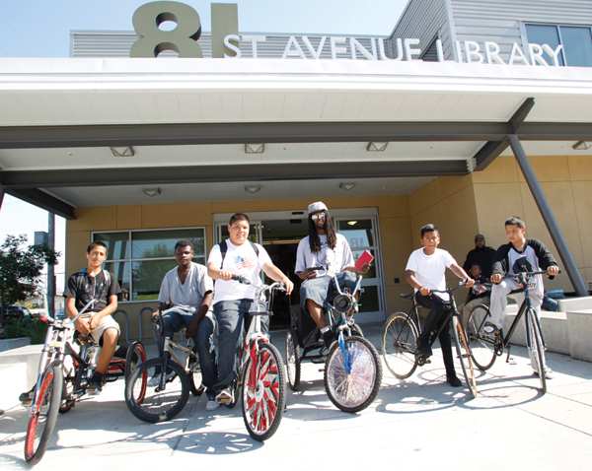](http://www.slj.com/2017/10/industry-news/riders-advisory-bike-related-programs-expand-libraries/attachment/1710-bikes-oakland/)

Oakland (CA) Public Library aide Reginald Burnette Jr. (third from right) and participants in a Bike Fix-it Clinic at the library’s 81st Avenue branch.  
Photo courtesy of Oakland Public Library

When a bicycling advocacy group in Albany, NY, began pushing for bike repair stations at the city’s libraries, Scott Jarzombek, executive director of the Albany Public Library, was initially reluctant. He was primarily concerned about what it would take to maintain the stations.

But then the organization “won me over,” he says, adding that he now views the stations as an extension of the library’s existing services to the community.

“What I like about the bike fix-it stations is that they are a 24-7 service,” Jarzombek says. “I like anything that we can do that is accessible when our doors are closed.”

Libraries across the country not only are making it easier for patrons to fix their bikes but are also running bike-lending programs for children and adults—further evidence that libraries are providing families and communities with much more than just books and information. Bringing bike owners together to discuss cycling routes, build bikes, and even make jewelry out of used parts are a few of the creative ways that libraries are connecting with the bike-riding community. [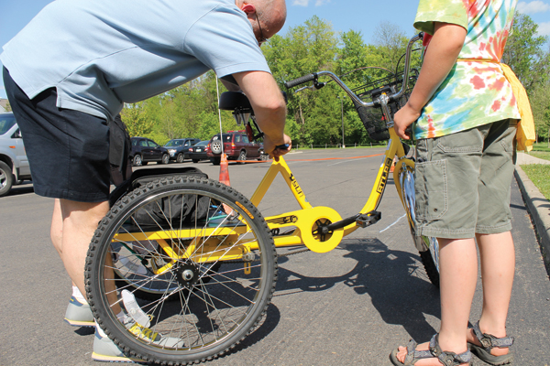](http://www.slj.com/2017/10/industry-news/riders-advisory-bike-related-programs-expand-libraries/attachment/1710-bikes-athens/)

Checking out a bike through the Book-a-Bike  
program at the Athens County (OH) Public Libraries.  
Photo courtesy of Athens County Public Libraries

A bike program can be as simple as storing a tire pump on-site and loaning bicycle locks—or as complex as loaning out bikes, says Emily Weak, a librarian at the Oakland (CA) Public Library (OPL), which has a variety of bike-related activities. These services include a shipping container–turned–bike repair shop behind OPL’s Martin Luther King Jr. branch where the members of the Original Scraper Bike Team—an East Oakland youth mentoring organization—meet to fix and decorate their bikes. Reginald Burnette Jr., who runs the team, was named a [2017 Library Journal Mover & Shaker](http://lj.libraryjournal.com/2017/03/people/movers-shakers-2017/reginald-burnette-jr-anthony-propernick-movers-shakers-2017-innovators/#_), along with Anthony Propernick, manager of OPL’s 81st Avenue branch, for their positive contributions to teens in the neighborhood.

Bike programs, Weak says, “help expand the idea that the library is a place where you hang out with your community.”

In Ohio, east of Columbus, the Athens County Public Libraries started a Book-a-Bike program four years ago with grant funds from the Charles O’Bleness Foundation in Columbus and the state and local health departments. The library purchased a variety of models, such as cargo trikes, a recumbent bicycle, and a hand-pedaled bike, that can be checked out for up to three hours.

“Most of our patrons are young people who just want a bike for a few hours without the expense, maintenance, or upkeep of having their own,” says Amy Drayer, manager at the Nelsonville branch, where more 12- to 17-year-olds check out more bikes than at the other branches that loan them. Other patrons use them to ride on the nearby bike path or run errands, Drayer says.

**JOINING COMMUNITY INITIATIVES**

As with other services libraries have added in recent years, some systems began offering bicycle programs because of larger initiatives in their communities. Albany, for example, was in the midst of implementing a “road diet”—reducing lanes on a major road to relieve congestion or encourage other forms of transportation—and conducting a “Complete Streets” study strategizing ways to accommodate cars, pedestrians, and bicycles, Jarzombek explains. Organizations working on the project were using the library meeting spaces, which led to a conversation about how libraries could support the overall goals of the initiative.

“We always want to respond to patron feedback,” he says, “but we also look outside of our walls and examine trends in the surrounding community.”

The San Diego Public Library’s [Bike Kitchen](https://www.sandiego.gov/blog/learn-bicycle-repair-and-maintenance) program, in which residents can access “shop-grade” bicycle tools two Saturdays a month and courses taught by bike experts, developed after the library ran a pilot bike clinic program in partnership with a local bike advocacy group.

“Our original outcome goals were to get people access to bicycle tools and help them to become more mechanically literate,” says Robert Surratt, an assistant in the library’s art, music, and recreation section.

During the pilot, however, the library staff realized that it was difficult for the mechanics to drag their tools to the library each time. Surratt then submitted a proposal to the California State Library for a Staff Innovation Fund grant and the library received funds to purchase professional tools and to create instructor-led classes in which bicycle owners can learn everything from basic maintenance to “front-to-back overhauls,” Surratt says.

[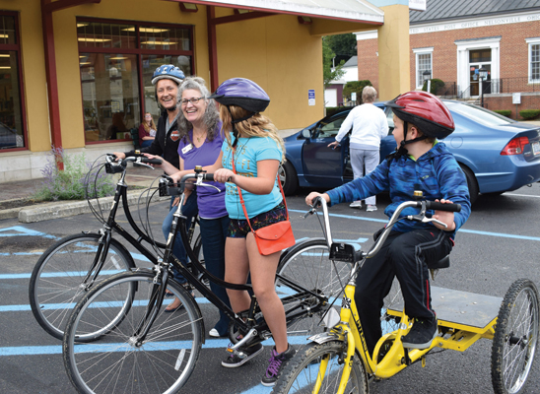](http://www.slj.com/2017/10/industry-news/riders-advisory-bike-related-programs-expand-libraries/attachment/1710-bikes-book-abike-athens/)

Book-a-Bike program participants with Amy Drayer  
(second from left), manager of the Athens County Public Libraries Nelsonville branch.

**LESSONS ABOUT BEING BIKE-FRIENDLY**

Even with the growing popularity of bike services, library leaders say there are a few lessons that might benefit other systems interested in offering similar programs. Jarzombek, for example, says that library staff members sometimes have to remind patrons that the library must remain in compliance with the Americans with Disabilities Act and lock bikes up outside the library rather than bringing them inside. “Being bike-friendly doesn’t mean bikes everywhere,” he says.

Since the Athens County Public Libraries loan bikes, maintenance is an ongoing concern. It “takes a dedicated staff” to keep the bikes on the road, Drayer says. Space to store the bikes can also be a challenge.

Bike programs also tend to grow out of strong partnerships between libraries and bicycle shops or advocacy organizations. Surratt says because his partners at Hub + Spoke Cycleworks in National City, CA, have such a positive attitude, he’s learned “that with dedication and a little imagination, you can make a big difference in the community with a relatively small amount of money.”

Jarzombek recommends that library leaders reach out to their local planning commissions, which can lead to some successful partnerships.

Bike-lending programs, however, are not always easily integrated into a library’s services. In Ontario, Canada, the Hamilton Public Library (HPL) launched its Start the Cycle program to encourage “physical literacy” for students in the seven- to 15-year-old range as part of a Healthy Kids Community Challenge grant. The program coincided with the library’s summer reading program and was intended to give students who didn’t have bikes access to them. But after the pilot, the program was turned over to the city’s recreation department.

“The transition over to the city recreation department basically came down to day-to-day logistics that Rec was better suited to take on,” says HPL spokesperson Antonella Giancarlo. “For the library, loaning bikes was more of an anomaly that required unique procedures.”

[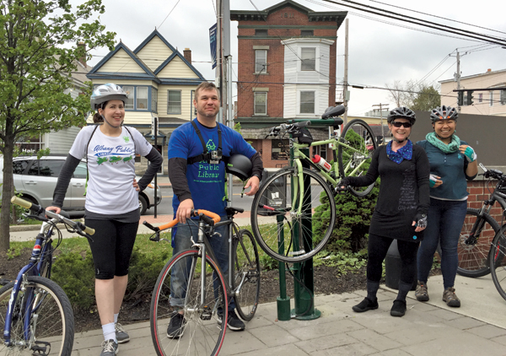](http://www.slj.com/2017/10/industry-news/riders-advisory-bike-related-programs-expand-libraries/attachment/1710-bikes-albany/)

Albany (NY) Public Library staff (from left): Assistant director Melanie Metzger; director Scott Jarzombek; former trustee Donna Dixon; and Rossana Coto-Batres, from Capital Region Complete Streets. Library branches offer bike repair stations.  
Photo courtesy of APL staff

**BOOSTING THE LIBRARY’S PROFILE**

While Jarzombek isn’t sure whether the fix-it stations are driving users to other library services, he says he’s sure that the “service has put the library on a few people’s radars.” The initiative has also created a “substantial amount of goodwill between the library and the cyclist community” and resulted in the library playing a larger role in community issues.

Steve Babb, an Albany resident and father of a 10-year-old girl, has found the branch repair stations to be especially helpful to his weekend hobby of picking up broken, discarded bicycles and repairing them for children in the neighborhood.

“Every time they see me, they keep asking me for bikes,” he says. Plus, he has definitely seen “more bikes parked out in front of the library.”

In San Diego, Surratt says those who frequent the Bike Kitchen often discover other services that they might not have known existed in their local libraries, such as guitar lessons and a teen gaming center. “Folks are still amazed to find that we aren’t just books and Internet computers,” he says.

The Bike Kitchen program has been so popular that the local Friends of the Central Library group will provide funding for the next fiscal year. Surratt says that while the library is not yet loaning bikes, he would certainly be open to the possibility, especially for parents who might not want to invest in an expensive bike if their child is only going to “grow out of it in a year or two.”

“I see a lot of possibilities for bicycle-related services through libraries,” he says. “Hopefully, we can continue to harness those possibilities and keep pushing the envelope.”

[](http://www.slj.com/forms/SLJsub.php)

This article was featured in our free ***Extra Helping*** enewsletter.[***Subscribe today***](http://www.slj.com/forms/SLJsub.php) to have more articles like this delivered to you twice a week.

**This article was published in School Library Journal's October 2017 issue.**[***Subscribe today***](https://subscribe.pcspublink.com/sub/subscribeform_msi.aspx?t=JWECNT&p=SLJL)**and save up to 35% off the regular subscription rate.**

**About Linda Jacobson**

SLJ contributor Linda Jacobson is an education writer and editor based in the Los Angeles area.

**http://www.slj.com/2017/10/industry-news/riders-advisory-bike-related-programs-expand-libraries/#_**

# 4. A New Pilot Project From SPARC: First-of-Its-Kind Professional Development Program for Open Education Librarians

Filed by [Gary Price](http://www.infodocket.com/author/gprice/)

From [Nicole Allen at SPARC:](https://sparcopen.org/news/2017/sparc-launches-open-education-leadership-program/)

Today, SPARC announced the pilot of the [SPARC Open Education Leadership Program](http://web.archive.org/web/20171005153817/https:/sparcopen.org/our-work/open-education-leadership-program/), a first-of-its-kind professional development initiative aimed at empowering open education leaders within academic libraries. The program offers intensive training for library professionals to support the use, development, and advocacy of open educational resources and practices in North American higher education, with emphasis on leadership skills. [Open educational resources](http://web.archive.org/web/20171005153817/https:/sparcopen.org/open-education/) (OER) are freely available academic materials that can be downloaded, edited, and shared to better serve all students.

“Interest in open education has grown exponentially among academic and research libraries, and open education librarianship is beginning to gain traction as a field,” said Nicole Allen, Director of Open Education for SPARC. “As more libraries seek to add open education capacity to their staff, the goal of our program is to empower a new wave of library professionals as leaders for open education on campus.”

The SPARC Open Education Leadership Program spans two semesters, beginning with an eight-week intensive online course in the fall to build open education subject matter expertise, followed by a mentored capstone project in the spring to build leadership skills. The pilot cohort consists of [fourteen fellows](http://web.archive.org/web/20171005153817/https:/sparcopen.org/our-work/open-education-leadership-program/2017-pilot/) selected from SPARC member libraries who will participate both as students and creators, helping to improve and hone the curriculum between now and April 2018. The pilot will be conducted primarily online, although the entire cohort will meet face-to-face next week at the 14th Annual [Open Education Conference](http://web.archive.org/web/20171005153817/http:/openedconference.org/) in Anaheim, CA.

[Clip]

SPARC plans to fully launch the Open Education Leadership Program in the fall of 2018 following the conclusion of the pilot. The program will be open to library professionals at higher education institutions in the U.S. and Canada, with priority enrollment and a tuition discount for SPARC member libraries.

**About Gary Price**

Gary Price ([gprice@mediasourceinc.com](mailto:gprice@mediasourceinc.com)) is a librarian, writer, consultant, and frequent conference speaker based in the Washington D.C. metro area. Before launching INFOdocket, Price and Shirl Kennedy were the founders and senior editors at ResourceShelf and DocuTicker for 10 years. From 2006-2009 he was Director of Online Information Services at Ask.com, and is currently a contributing editor at Search Engine Land.

**http://www.infodocket.com/2017/10/05/a-new-pilot-project-from-sparc-first-of-its-kind-professional-development-program-for-open-education-librarians/**

5. 

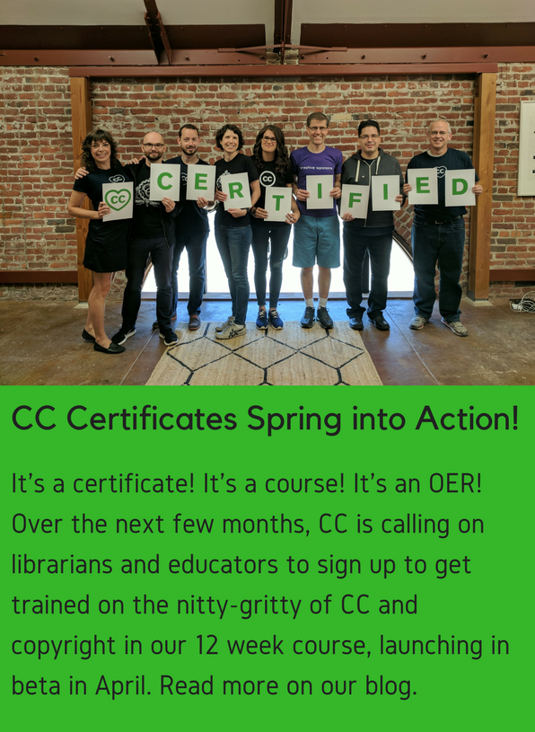**https://gallery.mailchimp.com/4051250396fe81f55034e2d49/images/be31b36a-1ab6-4fd9-8529-5bec99214c8b.png**

**6. The Stationers’ Company Archive Now Digitised By Adam Matthew Digital**

Library Journal Partner

|  |  |  |  |  |  |  |  |  |  |  |  |  |  |  |  |  |  |  |  |  |  |  |  |  |  |  |  |  |  |  |  |  |  |  |  |  |  |  |
| --- | --- | --- | --- | --- | --- | --- | --- | --- | --- | --- | --- | --- | --- | --- | --- | --- | --- | --- | --- | --- | --- | --- | --- | --- | --- | --- | --- | --- | --- | --- | --- | --- | --- | --- | --- | --- | --- | --- |
| |  |  |  | | --- | --- | --- | | |  | | --- | |  | |  | |  |  | | --- | |  | | |  |  |  |  |  |  |  |  |  |  |  |  |  |  |  |  |  |  |  |  |  |  |  |  |  |  |  |  |  |  |  |  |  | | --- | --- | --- | --- | --- | --- | --- | --- | --- | --- | --- | --- | --- | --- | --- | --- | --- | --- | --- | --- | --- | --- | --- | --- | --- | --- | --- | --- | --- | --- | --- | --- | --- | | |  |  |  |  |  |  |  |  |  |  |  |  |  |  |  |  |  |  |  |  |  |  |  |  |  |  |  |  |  |  |  |  | | --- | --- | --- | --- | --- | --- | --- | --- | --- | --- | --- | --- | --- | --- | --- | --- | --- | --- | --- | --- | --- | --- | --- | --- | --- | --- | --- | --- | --- | --- | --- | --- | | |  |  |  |  |  |  |  |  |  |  |  |  |  |  |  |  |  |  |  |  |  |  |  |  |  |  |  |  |  |  |  | | --- | --- | --- | --- | --- | --- | --- | --- | --- | --- | --- | --- | --- | --- | --- | --- | --- | --- | --- | --- | --- | --- | --- | --- | --- | --- | --- | --- | --- | --- | --- | | |  |  |  |  |  |  |  |  |  |  |  |  |  |  |  |  |  |  |  |  |  |  |  |  |  |  |  |  |  |  | | --- | --- | --- | --- | --- | --- | --- | --- | --- | --- | --- | --- | --- | --- | --- | --- | --- | --- | --- | --- | --- | --- | --- | --- | --- | --- | --- | --- | --- | --- | | |  |  |  |  |  |  |  |  |  |  |  |  |  |  |  |  |  |  |  |  |  |  |  |  |  |  |  |  |  | | --- | --- | --- | --- | --- | --- | --- | --- | --- | --- | --- | --- | --- | --- | --- | --- | --- | --- | --- | --- | --- | --- | --- | --- | --- | --- | --- | --- | --- | | |  |  |  |  |  |  |  |  |  |  |  |  |  |  |  |  |  |  |  |  |  |  |  |  |  |  |  |  | | --- | --- | --- | --- | --- | --- | --- | --- | --- | --- | --- | --- | --- | --- | --- | --- | --- | --- | --- | --- | --- | --- | --- | --- | --- | --- | --- | --- | | |  |  |  |  |  |  |  |  |  |  |  |  |  |  |  |  |  |  |  |  |  |  |  |  |  |  |  | | --- | --- | --- | --- | --- | --- | --- | --- | --- | --- | --- | --- | --- | --- | --- | --- | --- | --- | --- | --- | --- | --- | --- | --- | --- | --- | --- | | The Stationers’ Company Archive Digitised   |  |  |  |  |  |  |  | | --- | --- | --- | --- | --- | --- | --- | |  | http://i.emlfiles.com/cmpimg/t/s.gif | |  | | --- | | http://i.emlfiles.com/cmpimg/t/s.gif |  |  | | --- | | [http://i.emlfiles.com/cmpimg/3/8/1/0/1/1/files/431971_adammathewlogomasterrgb.png](http://mediasource.actonservice.com/acton/ct/10574/s-14b8-1710/Bct/l-00ab/l-00ab:22523/ct1_0/1?sid=TV2:ssZqwiikb) | | http://i.emlfiles.com/cmpimg/t/s.gif |  |  |  | | --- | | http://i.emlfiles.com/cmpimg/t/s.gif |  |  | | --- | | [http://r1-scaler.ddglib.com/vedimage/cmpimg/3/8/1/0/1/1/files/1032763_lpcheader.jpg?w=613&cid=1920812&uid=110183](http://mediasource.actonservice.com/acton/ct/10574/s-14b8-1710/Bct/l-00ab/l-00ab:22523/ct2_0/1?sid=TV2:ssZqwiikb) |  |  | | --- | | http://i.emlfiles.com/cmpimg/t/s.gif |  |  | | --- | | [*Literary Print Culture*](http://mediasource.actonservice.com/acton/ct/10574/s-14b8-1710/Bct/l-00ab/l-00ab:22523/ct3_0/1?sid=TV2%3AssZqwiikb), the latest primary source collection from Adam Matthew Digital, makes available The Stationers’ Company Archive with material from 1554 to the 21st Century.    Students and scholars of English literature, Renaissance theatre, and print culture from the early modern period to the twentieth century can now access one of the most important sources for the history of the book, publishing and copyright. |  |  | | --- | | http://i.emlfiles.com/cmpimg/t/s.gif |  |  |  |  |  |  |  |  |  |  |  |  |  |  |  | | --- | --- | --- | --- | --- | --- | --- | --- | --- | --- | --- | --- | --- | --- | | |  |  |  |  |  |  |  |  |  |  |  |  |  | | --- | --- | --- | --- | --- | --- | --- | --- | --- | --- | --- | --- | --- | |  | http://i.emlfiles.com/cmpimg/t/s.gif | |  |  | | --- | --- | | |  | | --- | | [Price Enquiry >](mailto:info@amdigital.co.uk?subject=Literary%20Print%20Culture%20Price%20Request%20LJ) | | | http://i.emlfiles.com/cmpimg/t/s.gif |  | http://i.emlfiles.com/cmpimg/t/s.gif | |  |  | | --- | --- | | |  | | --- | | [Trial Request >](mailto:trials@amdigital.co.uk?subject=Literary%20Print%20Culture%20Trial%20Request%20LJ) | | | http://i.emlfiles.com/cmpimg/t/s.gif |  | | | | | | | | | | |

**7.**

# ALA Launches Policy Corps

By [Lisa Peet](http://lj.libraryjournal.com/author/lpeet/)

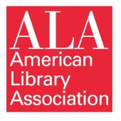On October 3 the American Library Association (ALA) launched the [ALA Policy Corps](http://www.ala.org/advocacy/ala-policy-corps), an initiative that will bring together a core group of library practitioners from across the field and help them develop a deep expertise in public policy issues.

The Corps had its roots in the ALA 2015 midwinter meeting, where ALA’s Office for Information Technology Policy (OITP) led a forum discussing the goals of the Policy Revolution! Initiative (PRI). PRI, a three-year program funded by the Bill & Melinda Gates Foundation’s Global Libraries initiative from 2013–16, was designed to advance library policy at the national level. One of PRI’s major objectives was to “build library advocacy capacity for the long-term.”

Led by ALA president Jim Neal, the Policy Corps will initially consist of a cohort of 10–12 participants representing a diversity of library types, geographies, and backgrounds. This core group will be offered a series of educational and developmental opportunities to strengthen their policy knowledge and advocacy skills, as well as the support offered by senior leadership and a networked cohort.

In addition to a March workshop, the pilot class will also be expected to participate in National Library Legislative Day on May 7–8, 2018, with a series of Corps-specific meetings taking place beforehand on May 6. In addition, they will be included in conference calls, webinars, a Listserv, and other sessions and meetings at ALA conferences.

[Applications for the 2018 Policy Corps](http://www.ala.org/advocacy/ala-policy-corps-application) will be accepted through Friday, November 3. ALA members with at least five years of library experience, some advocacy experience, a desire to develop and apply policy advocacy skills, solid speaking and writing skills, an awareness of policy issues, the ability to sustain a five-year commitment, and support from their institution are encouraged to apply.

**MULTI-SECTOR REPRESENTATION**

The Policy Corps is an extension of the Libraries Transform campaign begun in 2015, and is part of Neal’s presidential initiative, grounded in ALA’s four strategic directions: advocacy; information policy; professional and leadership development; and equity, diversity, and inclusion.

“I have felt for a long time that we as a library community needed to be better prepared to participate in national level policy discussions and forums,” Neal told LJ. Because members of the field are often called on to sit on panels in front of congressional committees, are interviewed on policy matters by the national press, or are called on to partner with key organizations in the library and technology sectors, said Neal, “you want individuals available who have deep knowledge of a particular policy area, and a commitment to keep current on that.”

To that end, Neal and OITP assembled a working group consisting of 15 representatives from Neal’s Presidential Advisory Committee, the American Association of School Librarians (AASL), Association of College & Research Libraries (ACRL), OITP, Public Library Association (PLA), and United for Libraries. Each association contributed funding to the initiative, and working group members brought advocacy expertise from school, public, academic, and special library sectors.

The working group members are currently looking at candidate applications, exploring directions and goals for the group, developing assessment measures as activities progress, and working on the curriculum for a two- to three-day workshop in March 2018, which will provide an overview of key issues, major players in the legislative and policy processes, and paths to engaging national decision makers and influencers; the group will also bring in a consultant to help define and develop the curriculum.

“The policy corps really spoke to me,” said Clara N. Bohrer, director of West Bloomfield Township Public Library, MI; PLA past president; and a member of Neal’s Presidential Advisory Committee and the Policy Corps curriculum subcommittee. “I work firsthand in policy advocacy here in the state. I know how important it is, and I know if it is a strong collected effort you can really get things done. I’ve seen that recently in an initiative we did here in Michigan”—a concerted effort earlier this year to fight a state taxing initiative that would have taken funding from libraries and applied it toward local development. “With our initiative we went out and spoke to our legislators on [how] funds that came directly to libraries…should be kept with libraries, and should not be captured into these other areas.”

This library-led advocacy resulted in [legislation](http://www.milibraries.org/governor-snyder-signs-library-tax-capture-relief-bills/) that would allow dedicated library millages to be exempt from a number of tax captures. “I thought, that is so powerful,” Bohrer told LJ, “and it’s because our librarians, advocates, and public policy committee under our state library association made that concerted effort and we were successful…. We need strong advocates that can speak up for our nation’s libraries.”

Audrey Church, professor of school librarianship and coordinator of the school librarianship program at Longwood University, Farmville, VA, and immediate past president of AASL, is one of the working group’s two AASL representatives (Sylvia Knight Norton, AASL executive director, is the other). Over the past several years she has seen firsthand what strong advocacy has accomplished for school librarians, she said, from providing language about school libraries in the Every Student Succeeds Act (ESSA) to making sure that the Institute of Museum and Library Services’ (IMLS) impact on K–12 schools was part of the message about the agency’s FY18 funding. Any future federal legislation, she noted, will need to include school libraries and acknowledge their importance for student learning.

**http://lj.libraryjournal.com/2017/10/organizations/ala-organization/ala-launches-policy-corps/**