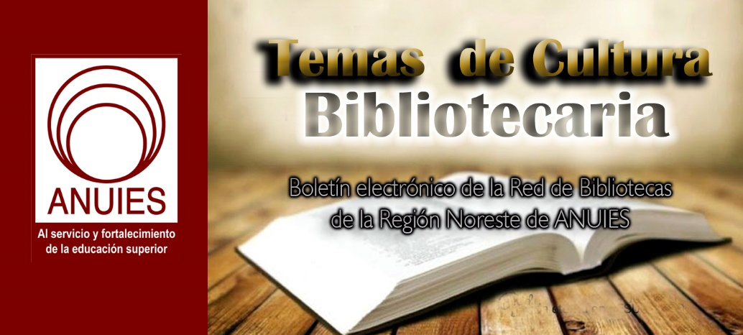
Año 2 Número 48 noviembre 2017

Contenidos de este número

Great Outdoor Spaces | Library Design
By Emily Puckett Rodgers on September 20, 2017 Leave a Comment

Promote learning, wellness, environmental benefits, and economic opportunity for patrons and communities outside
The best libraries don’t stop at the front door. Gardens and green roofs alike are beautiful and inspiring. The benefits of exposure to nature are much more than cosmetic: for individuals, research has related it to reduced stress, inflammation, and mortality; improved memory, job satisfaction, and eyesight; and greater social capital. For communities, successful public outdoor spaces not only improve the physical and mental health of residents, they have been shown to aid the environment, create a stronger sense of community, and even boost the economy.
When libraries get involved in developing them—whether gardens, parks, or plazas—they can become places of rich engagement, learning, and community celebration: witness the example of a pioneering system like Colorado’s Anythink and LJ’s 2014 Best Small Library in America Pine River. Following in those footsteps, a variety of recent projects and initiatives illustrate how libraries are using outdoor spaces to promote literacy, celebrate diversity, and bolster economic development within their communities, says Susan Benton, CEO of the Urban Libraries Council (ULC). Fostering gardens and other outdoor spaces, she says, are part of how libraries can lay “the foundation for something someone will take forward with them and be stronger” for it.
PETALS, POLLEN—AND PARTNERS
It all started with bees and butterflies. In Princeton, IL, there is now a constellation of library-supported pollinator gardens citywide. In 2014, Ellen Starr, a biologist with the U.S. Department of Agriculture (USDA) Natural Resources Conservation Service, reached out to the city to consider hosting a garden on public grounds. She connected with the Princeton Public Library (PPL) with impressive results. The resulting garden “complements our vision,” says PPL director Julie Wayland. “Our patrons in many instances look to us to provide a forum for what is happening in the community. We work closely with our city government, local groups, and community organizations to provide an opportunity for them to expound on any programs or projects [on which] they are working. In this way we feel we are providing an educational benefit to the community.”
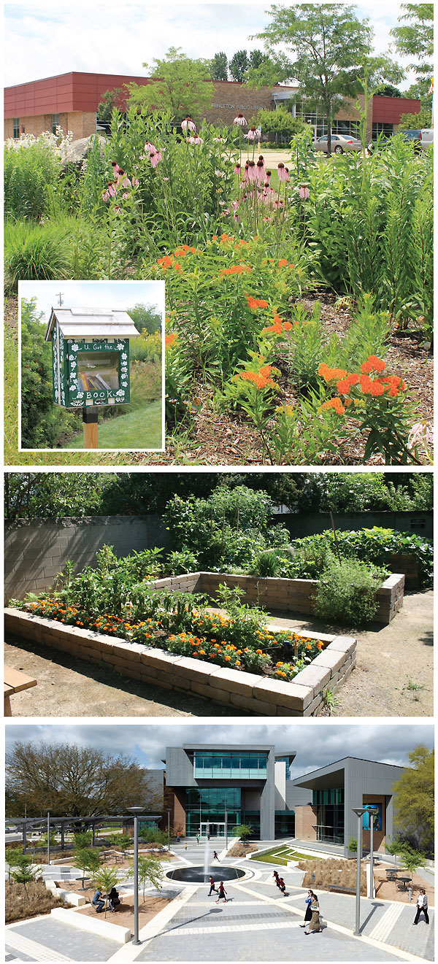
LEARNING IN BLOOM Top: the pollinator garden in Princeton, IL, supports ecology and education; a Little Free Library in the garden at the Princeton PL encourages visitors to read outside (inset). Middle: the Read and Feed Teaching and Demonstration Garden, Colonial Heights Library, Sacramento, CA, teaches food literacy and healthy eating. Bottom: the East Baton Rouge Parish Library Main Library at Goodwood, LA, features bioswales, which remove pollution from water runoff while highlighting the landscape.
Princeton photos vourtesy of Princeton PL; Colonial Heights photo courtesy of Sacramento PL
The garden is lush with a well-kept path, winding through bushes with striking yellow, red, and purple flowers. It serves as a thriving outdoor classroom. The library has used the garden as a catalyst to connect with additional community partners: along with the city and the USDA, the library has collaborated with Voices from the Prairie, a local think tank, and the Illinois Clean Energy Community Foundation. Together they have developed an array of programs, initiatives, and activities for residents of all ages.
This past Earth Day, the library unveiled a second pollinator garden on the other side of town, focused on butterflies. (Each garden has a Little Free Library managed by PPL.) This garden sits at the site of a center serving people with intellectual and developmental disabilities. Wayland says that it has been a great reflection of Princeton and its people, who are “involved in the beautification of the city” and “have dedicated time and effort to maintaining the historical homes and buildings in town.” The library, and its garden, is one of the first buildings seen when entering the city from the east. It “sets the tone” and serves to emphasize how important maintaining insect populations are in a changing environment. Local gardeners volunteer their time to maintain the garden and share their expertise with other community members who visit. “They know how important honeybees are to our environment and the effect of the decline of their population,” says Wayland.
LEARNING, NATURALLY
When librarians at the Middle Country Public Library (MCPL), in Centereach and Selden, NY, began a collaboration with the Long Island Nature Collaborative for Kids (LINCK) to think about how to support nature-based education, the result was a transformative program and space called the Nature Explorium. It’s an outdoor environment designed to connect literacy, active learning, and an appreciation for nature. Library staff were introduced to the idea of creating “nature explore classrooms” through a workshop organized by the Dimensions Educational Research Foundation, a nonprofit whose work introduces children to nature through meaningful connections. “It was during this session that we had the idea that libraries—in addition to child-care centers, youth centers, churches, schools—could provide another community place for outdoor classrooms,” says Tracy LaStella, assistant director for youth services at MCPL.
The library followed the introductory workshop with a two-day training session that brought together landscape architects, library staff, and LINCK members to imagine and begin to design the Nature Explorium. In June 2010, the space, designed with expertise from the U.S. Forest Service, opened to the public.
The Nature Explorium isn’t simply a garden, it’s a multisensory outdoor learning environment with planted spaces, paths, an outdoor stage, and play sets featuring a variety of themes and designed for patrons of a variety of ages to interact with one another and library resources. It provides a striking, playful, and inviting example of the concept of placemaking. By creating spaces that maximize shared value and strengthen connections between people and place, placemaking emphasizes the sociability, variety of uses, access, connections, and comfort in physical, publicly accessible areas within towns, cities, or communities.
The Nature Explorium illustrates maximized shared value in a variety of compelling ways. Bright colors pop from both the built and natural environment in the space. Garden beds are appropriately sized for children of all ages, and a “build it” station hosts wooden blocks to spark the imagination. A “read it” station offers space for both formal and informal story times.
PARTNERS WITH PERSPECTIVE
An advisory committee, composed of members from the local school district, gardening experts, and local and national nonprofits, helps to create programming for the space. “Partnering with other organizations broadens our perspective, helps change the image of the library, integrates the library into the larger community of similar interests, and, over the years, has helped us to transform into a dynamic community center,” LaStella says.
The Nature Explorium offers a choice of activities that ranges from unstructured play and reading a book with a caregiver to deep, sustained learning experiences. Programming doesn’t only cover topics on the environment or sustainability. The library has created opportunities for community members to collaborate on art projects, such as “Crochet It! A Creative Community Project.” Over the summer of 2017, local artist Carol Hummel led a community-focused crochet project, featuring instructional workshops, kits, and over 200 volunteers participating in the art installation. Thousands of colorful crocheted circles wrapped around trees will culminate in two unique art pieces completed in time for September’s dedication ceremony honoring the space, volunteers, and artists’ vision. The Nature Explorium will host the exhibit.
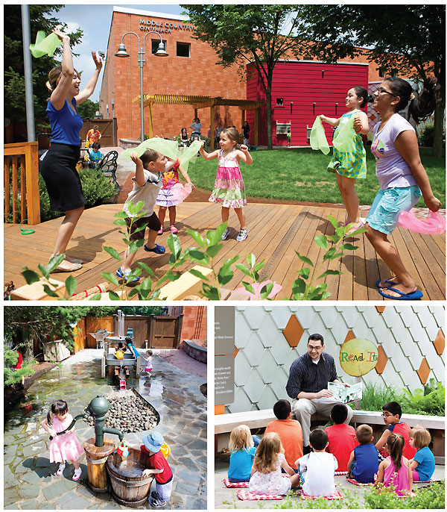
MORE TO EXPLORE The Nature Explorium at the Middle Country Public Library in Centereach and Selden, NY, offers a range of activities, including unstructured outdoor active play at the Play It stage (top), water learning (and fun) in the Splash It area (bottom l.), and more traditional library offerings such as story times held in the Read It space (bottom r.).
Photos by Dutch Huff Photography
The “Gardening Crew” is a program that partners youth grades five to nine with master gardeners and educators to grow vegetables at both the Nature Explorium and Hobbs, a local community farm. According to LaStella, this is a “multisensory educational [experience] related to basic gardening and nutrition as part of a service learning project that benefits the local community. [Much] of the produce grown at the farm is donated to local food pantries.” During part of the programming, families and K–2 children work alongside the crew to harvest vegetables, tasting them along the way and taking some home.
FOOD FOR THOUGHT
Gardening or otherwise interacting with biodiversity provides a powerful vehicle for other forms of literacy or library resources and expertise. Seed collections and exchanges, in public libraries from Nashville to the Florida Department of State’s Division of Library and Information Services, “create community [and] teach nourishment and help people understand [how] to grow their own food. It’s a win-win for the library and the community,” ULC’s Benton says.
In urban settings, programs that connect gardens, biodiversity, and health and wellness are showing just how effectively libraries can create, support, and catalyze healthy and sustainable communities, with what Benton calls “agility and practiced engagement.” The Read and Feed Teaching and Demonstration Garden at the Colonial Heights Library is located in South Sacramento, CA. It emphasizes nutrition, healthy choices, and service learning through its garden and is a key partner in the area’s Building Healthy Communities initiative. The raised, waist-high beds were built by more than 600 volunteers of all ages, and the garden serves to strengthen nutritional literacy and access to healthy food in an urban environment classified as a food desert.
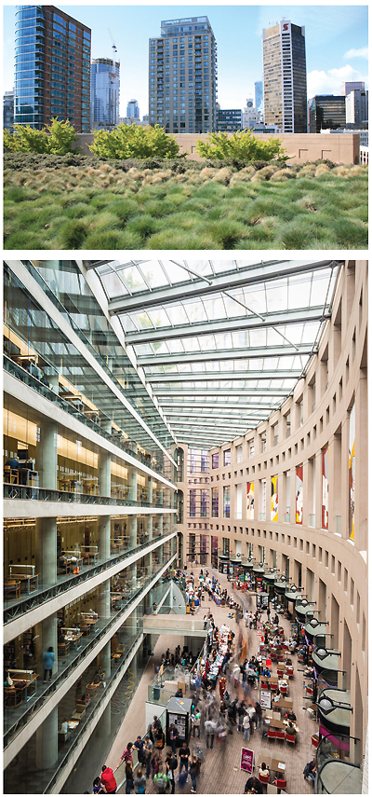
TOP PRIORITY The main branch of the Vancouver Public Library, BC, features a green roof with multiple plantings (top). The atrium bridges indoors and out with abundant natural light, even before renovation adds still more outdoor access to the building (bottom).
Top photo courtesy of Vancouver Pl; Bottom photo by Paul Joseph
SUSTAINABLE CONNECTIONS
When libraries have the opportunity to renovate or build new, they can create settings that connect the library to its environment functionally as well as aesthetically and connect patrons both to nature and to one another. The East Baton Rouge Parish Library (EBRPL) Main Library at Goodwood, LA, one of LJ’s 2015 New Landmark Libraries, is sited within a park, connecting visitors to natural light, fresh air, biodiversity, and community. The outdoor plaza links the library to the Baton Rouge Parks and Recreation Commission teaching building, which hosts a small collection of library resources. By using flora- and fauna-inspired fabrics and designs, the library thematically brings the outdoors in and celebrates its location. By situating the building within the park, the library helps to make the park that much more convenient, walkable, and useful. It complements the park with its own great outdoor spaces, from the plaza to the parking lot.
EBRPL features bioswales, which resemble miniature gardens in and around the parking areas and the building site. In reality, they’re landscaped elements that can remove or concentrate pollution from water runoff. Often planted with vegetation, bioswales also soften the contours and features of the built infrastructure. Many people don’t even realize the swales’ functionality, though they notice their beauty.
Outdoor spaces can combine natural and built elements that draw people to the site, encourage them to connect with each other, and provide a variety of functions. The largest capital project for the City of Vancouver, BC, at the time, the Library Square and the central branch, designed by world-renowned architect Moshe Safdie, opened in 1995. The Library Square is an exemplar of great outdoor (and indoor) spaces that serve to support community members whether they are accessing library resources, meeting over coffee, shopping, or using city services.
A true piazza, the two plazas offer both urban outdoor space with café seating and horizontal platforms for people to congregate. The library also features a multifunctional green roof, visible from the upper floors of the Library Square. By planting regional grasses in different colors and flowing patterns, the roof becomes a painting-like interpretation of the region’s natural resources: the forest, the Fraser River, and the shoreline. The grasses are tough and drought-resistant and help offset what are known as “heat islands” often present in dense urban areas with plenty of concrete and hard surfaces. Finally, the roof is fundamentally functional, providing habitats for birds, bees, and butterflies. Vancouver Public Library is about to add even more outdoor space in its current renovation of the two top floors. Scheduled for completion in spring 2018, the work will open more space to the public and include a garden high above the plazas where people can gather.
From pollinator gardens to massive urban plazas, green roofs to bioswales, libraries all across North America excel at developing and maintaining great outdoor spaces. These not only serve as beautiful examples of our natural landscape but offer ways for libraries and their partners to invest in the health and wellness of communities, connect residents to library resources, and enhance literacies. Great outdoor spaces provide opportunities for libraries to showcase their capacity to strengthen communities and be true placemakers—inside and out.

http://lj.libraryjournal.com/2017/09/buildings/lbd/great-outdoor-spaces-library-design/

University of North Texas Digital Library Adds Hurricane Harvey Twitter Dataset (7 Million Tweets)
Filed by Gary Price on September 25, 2017
From the University of North Texas Digital Library:
This dataset contains Twitter JSON data for Tweets related to Hurricane Harvey and the subsequent flooding along the Texas gulf region. This dataset was created using the twarc package that makes use of Twitter’s search API.
A total of 7,041,866 Tweets make up the combined dataset. Collected between August 18, 2017 and September 22, 2017.
Direct to Info and Link to Download
About Gary Price
Gary Price (gprice@mediasourceinc.com) is a librarian, writer, consultant, and frequent conference speaker based in the Washington D.C. metro area. Before launching INFOdocket, Price and Shirl Kennedy were the founders and senior editors at ResourceShelf and DocuTicker for 10 years. From 2006-2009 he was Director of Online Information Services at Ask.com, and is currently a contributing editor at Search Engine Land.

http://www.infodocket.com/2017/09/25/datasets-university-of-north-texas-digital-library-adds-hurricane-harvey-twitter-dataset-7-million-tweets/

Sharing The Story | LJ 2017 Marketer of the Year Award
By Lisa Peet
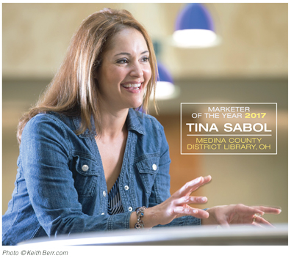With its current levy due to expire at the end of this year, Medina County District Library (MCDL), OH, began plotting the strategy for its ten-year ballot cycle early in 2016. A yes vote would renew the existing 1.25-mill levy with a 0.25-mill increase, generating about $5.6 million annually for the six-branch system, allowing the district to maintain operations and expand services.
MCDL community engagement manager Tina Sabol saw the campaign as an opportunity not only to mobilize voters but also to reinforce ties to the library by enlisting community members to work on the campaign. The result: secure funding for another ten years, a robust relationship with all corners of the community, and the well-deserved honor of LJ’s 2017 Marketer of the Year award, sponsored by Library Ideas.
STRATEGIC APPROACH
MCDL, LJ’s 1998 Library of the Year, serves a diverse population of 150,000 some 40 miles south of Cleveland. In addition to its library buildings, the system maintains a bookmobile and outreach services at facilities such as the local juvenile detention center and county jail. The levy, last renewed in 2007, comprises more than 60 percent of the library’s revenue.
Sabol began campaign prep in January 2016, engaging a marketing firm to help design phone and online surveys to help MCDL find out more about users’ opinions. The library hosted a series of town hall meetings, inviting both patrons and nonusers. “We gave the community many mediums and many chances to tell us what they wanted,” explains Sabol—“we didn’t just assume.”
The board approved Sabol’s plans to wage a campaign over the following eight months that would promote the levy—and the library. MCDL and its employees could not legally advocate outright for the levy, but they could provide information through social media and outreach. By mobilizing volunteers, the library found an effective voice.
Sabol took a deep dive into researching her strategy, gathering information from large and small libraries, marketing firms, and “every Ohio Library Council thing I could find that had anything to do with levies…. I wanted to take what I saw as the best in all the other libraries…and try to figure out what would work for our community.”
STAYING ON MESSAGE
MCDL’s marketing push featured the standard components of a library campaign: print advertising and postcards, yard signs, T-shirts, newsletters, and car signs. But it was Sabol’s four-pronged strategy—a robust social media effort, YouTube videos featuring library users, strong outreach led by a speakers’ bureau made up of library administrators and managers, and an all-volunteer Citizens for the Library political action committee (PAC)—that ultimately won the day.
Once MCDL’s community engagement team—Jessica Giurbino, Connie Stanton, Jennifer Ransbury, Monica Heath, and Stephanie Sanford—had settled on the strategy, Sabol organized the library’s social media messaging efficiently. The team put together a Word document with every point prioritized. A billboard, which could support the least amount of information, would list the top three items. A brochure would have the top five on the cover, more inside. For Facebook, Sabol would choose one item per week and post details throughout that week.
“It was very much a formula,” she explains. “We were not going to rewrite one word of anything. We were just…going to say the same thing over and over, in as many mediums as possible.” While that may sound redundant, Sabol notes that the average library user probably saw library messaging four or five times over the whole course of the campaign. Instead of repetition, they would see consistency.

http://lj.libraryjournal.com/2017/10/marketing/sharing-story-lj-2017-marketer-year-award/

Stavros Niarchos Foundation Gives $55 Million Toward Mid-Manhattan Library Renovation
By Lisa Peet
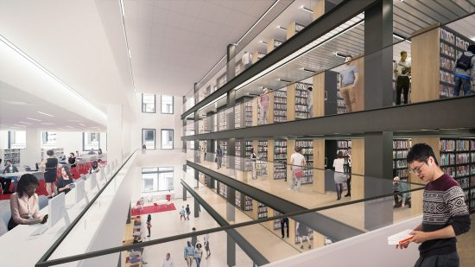

Rendering of future Long Room at Mid-Manhattan Library
Credit: Mecanoo with Beyer Blinder Belle
The New York Public Library (NYPL) announced September 13 the receipt of $55 million from the Stavros Niarchos Foundation to support the complete renovation of the Mid-Manhattan Library, NYPL’s largest circulating branch. Combined with the recent boost in funding for FY18 capital projects from the city of New York, the Niarchos Foundation’s gift will enable the $200 million gut renovation of the 105-year-old building into a modern circulating branch that will offer programs for children, teens, and adults; meeting spaces; a business library; and a rooftop terrace, designed by the Dutch architecture firm Mecanoo in coordination with architects of record Beyer Blinder Belle. The Mid-Manhattan Library closed on August 1; NYPL plans to reopen it as the Stavros Niarchos Foundation Library in early 2020.
“This gift is a culmination of the Stavros Niarchos Foundation’s long-standing and unwavering commitment to libraries around the globe,” said NYPL president Tony Marx in a statement. “We are so appreciative of the Foundation’s generosity, vision, and support as we transform our largest central branch into the library New Yorkers deserve and have never had. The project—also supported by our partners in New York City government—will allow for more use and a better flow of ideas and learning back and forth across Fifth Avenue” to NYPL’s main Stephen A. Schwarzman Building, where the research collection is housed.
The Niarchos Foundation, founded in 1996, makes grants to support arts and culture, education, health, and social welfare. It is a longtime contributor to NYPL, particularly its Out-of-School Time and early literacy programs. Foundation copresident Andreas Dracopoulos served as an NYPL trustee from 2003–10, and is now an honorary trustee. “The whole area of libraries within education has been a very important one for us,” stated Dracopoulous in a video. “I think this is an amazing opportunity to bring together the main research building and the circulating Mid-Manhattan to create this hub, this campus.”
For the past three years the foundation has also teamed up with the Charles H. Revson Foundation to cosponsor the NYC Neighborhood Library Awards, which recognize New Yorkers’ favorite libraries from all three systems with cash prizes and professionally produced videos celebrating each branch’s unique character. The short films have become important marketing components in fundraising advocacy.
CHANGED PLANS FOR MIDTOWN CAMPUS
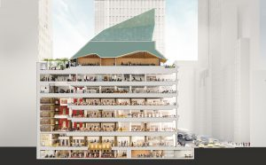

Section of future Mid-Manhattan Library
Credit: Mecanoo with Beyer Blinder Belle
The gift constitutes the second largest gift in NYPL’s history; financier Stephen A. Schwarzman gave the system $100 million in 2008 to lead the transformation of its main branch, which now bears his name. Together the two buildings, located on either side of Fifth Avenue at 40th Street, form NYPL’s “Midtown Campus,” bridging the research functions of the Schwarzman Building and the Mid-Manhattan Library’s circulation and programming capabilities.
Plans for the Midtown Campus renovation date back to 2007, when then–NYPL president Paul LeClerc spearheaded an initiative known as the Central Library Plan (CLP). Under the original CLP, the Mid-Manhattan Library and the Science, Industry, and Business Library (SIBL) would have been sold to help finance a massive transformation of the Schwarzman building, demolishing the historic stacks that form the core of the building and rebuilding modern facilities in their place. Some three million books would have been relocated to an offsite storage facility. However, a coalition of library users and supporters objected loudly—and with the economic downturn of 2008, the library was unable to sell the Mid-Manhattan building for the needed sum.
Faced with new economic realities and a public that had emphatically made its wishes known, NYPL—now led by Anthony Marx—abandoned the CLP in 2014 and began rethinking plans for the two buildings. NYPL decided that the Mid-Manhattan Library would be renovated, rather than sold, eventually folding in the collections, staff, and programs now at SIBL (that building was sold to a division of Vulcan real estate in 2016, with the understanding that the Library will continue to operate in that space until the new Mid-Manhattan is ready to open). The Schwarzman Building’s stacks and collections will remain in place and a future project will expand that building’s public space. NYPL chief operating officer Iris Weinshall will manage the Midtown Campus project.
After an eight-month selection process, in September 2015 NYPL chose Mecanoo as design architects and Beyer Blinder Belle as architects of record for the Midtown Campus project. Mecanoo, well-known for its library work worldwide, designed the Library of Birmingham in the UK and the DC Public Library’s flagship Martin Luther King Jr. Memorial Library, currently under construction. The New York–based Beyer Blinder Belle has a strong track record of standout historical renovations, including New York’s Grand Central Station and City Hall. Mecanoo principal and project lead Francine Houben is “a library whisperer,” Weinshall told LJ. “She really understands the essence of libraries….We felt very strongly that not only did we want a firm that lived and breathed libraries, but also a firm like Beyer Blinder Belle to be able to really translate that design into a buildable building.”
Houben spent a year collecting usage data and conducting interviews with staff, users, and community stakeholders. Preliminary designs were released in the fall of 2016. By August 1, 2017, all Mid-Manhattan collections and staff had moved to their temporary home in the Schwarzman Building, in a space previously used for storage. Care was taken with the swing space as well, installing new lighting and signage, restoring some of the historic flooring, and adding a women’s restroom. The space is dramatically smaller—8,000 square feet as opposed to Mid-Manhattan’s 100,000—but the staff is happy with it.
“I go down there often just to check what’s going on,” Weinshall recalled, “and one of the staff members came over to me—she was very excited—and she said, ‘As a librarian, I always dreamed of working in this building, and I’ve just got to tell you, I bought a whole new wardrobe because now I’m working in the main branch…. You’ve got to look the part in this library.”

http://lj.libraryjournal.com/2017/10/buildings/stavros-niarchos-foundation-gives-55-million-toward-mid-manhattan-library-renovation/

Balancing Connections and Collections | Library Design
By Audrey Barbakoff

Making space for users to interact with materials—and one another
It’s a regular day at a regular not-so-quiet library. The tables are full
of groups collaborating on projects. All the study rooms are booked
solid with small meetings and individuals seeking a quiet refuge.
Large gathering spaces are bustling with programs, classes, and
community events. More than ever, users crave places to collaborate, interact, build community, and contemplate.
It’s therefore no surprise that in many types of libraries nationwide, staff are trying to make more space for people. Increasingly, libraries support learning that is social and emotional as well as intellectual, carving out room for Maker spaces, learning commons, flexible spaces, quiet contemplation, and active collaboration. Row upon row of tall bookshelves are not conducive to these emerging uses. “People do not hang out in the stacks,” says Dri Ralph, facilities design coordinator at Washington’s King County Library System (KCLS), who has been involved in 46 library building and renovation projects. Not only is the area for stacks being reduced, what shelves remain are often being lowered to allow for natural light and improved sight lines.
In a 2016 ProQuest survey, 82 percent of academic librarians and 64 percent of public librarians said that “space reclamation” was already or would soon be a priority for their institution. It’s almost a truism that newly constructed or redesigned 21st-century libraries are centered on people rather than, as in the last century, starting with the books.
Yet most of the time, libraries must accomplish this transformation without expanding the building’s footprint. A 2017 LJ survey found that 56 percent of public libraries with a dedicated Maker space converted an existing open area, and 21 percent reduced stacks to make room for it.
At the same time, collections remain essential to libraries’ mission. The flow of newly available print materials is constant and growing. Digitization is a long way from replacing the bulk of library books, if it ever does, and trends back toward print indicate that even where digital versions are available, many patrons will continue to prefer the print version—and that preference may not fade with younger generations, as many once assumed. As shelving is condensed to accommodate other activities, physical collections can become overcrowded and hard to use. Libraries want their collections and learning activities to be partners in creating meaningful learning environments, not rivals. Sometimes it may feel like one or the other gets shortchanged when two essential components of library service compete for limited room. How are successful libraries balancing space for collections and connections?
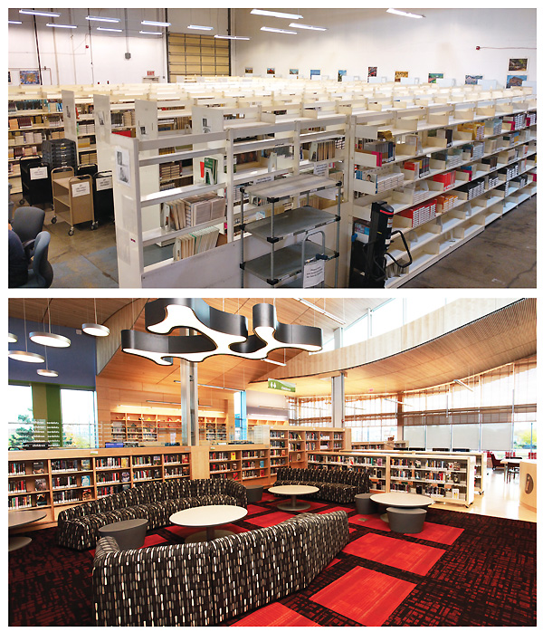
JUST IN TIME, JUST ENOUGH (L.–r.) King County Library System, WA, fills holds on high-demand titles from off-site storage, freeing up branch copies for browsing. The East Boston Branch, Boston PL, dramatically cut its collection—and circulation soared.
KCLS photo by Steve Albert; East Boston Branch photo by Ty Bellitti

http://lj.libraryjournal.com/2017/09/buildings/lbd/balancing-connections-collections-library-design/

- You are here: Home / News / New Report re: Public Libraries: “The Experiential Library: The Future of Family Learning”

New Report re: Public Libraries: “The Experiential Library: The Future of Family Learning”
Filed by Gary Price on October 3, 2017
The new report linked below was published by two organizations located in the UK:
- Society of Chief Librarians (SCL)
- Common Vision
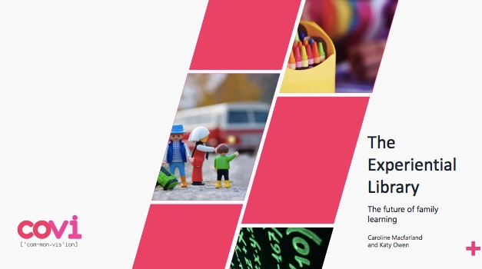
From the SCL:
Interactive game experiences such as treasure hunts, mystery trails and Pokemon Go type apps have huge potential to enhance family learning, finds a new report The Experiential Library.
Storycise, where families act out stories to improve their fitness in Bournemouth, a digital literacy course for 3-4 year olds in Norfolk and a Big Draw arts workshop in Kirklees are just some examples of the range of family learning taking place in local libraries discussed in the report by the Society of Chief Librarians (SCL) and think tank, Common Vision.
‘Family learning in libraries is not new but this report demonstrates the positive impact that family learning experiences can have on educational achievement, health and well-being, and the encouragement of lifelong learning.’ said Neil MacInnes, President of SCL.
Key findings include:
The benefits of family learning include increased confidence, improved communication, new life skills and better relationships with teachers and other professionals for both adults and children.
The creative use of games can increase families’ engagement with libraries by making the process fun and interactive.
Men are still much less likely to participate in family learning than women however, evidence indicates that, with the rise of shared parenting, there are opportunities to engage men in activities that are geared specifically to them.
Most family learning activities are aimed at children under four but there is clear potential and benefits to extending these activities to older children and even young adults
Inter-generational learning, where children may have skills that adults lack (such as digital or language skills) or where both child and adult are learning a new skill at the same time, should be viewed as a key area for growth.
Family learning can help to address digital divides, not only between those who access the internet and those who do not, but also between those who primarily use technology for entertainment and those who also use it to develop their skills and knowledge.
Funded by the Arts Council, the study surveyed 30 local libraries and interviewed five local library authorities in England to find out what family learning activities they delivered and what the outcomes of these activities were. The report also outlines a six step approach for libraries that are looking to develop their family learning offer in the future.
Direct to Full Text Report
41 pages; PDF.

http://www.infodocket.com/2017/10/03/new-report-re-public-libraries-the-experiential-library-the-future-of-family-learning/

- Introducing the new peer-reviewed guide to information databases
Library Journal Partner

Chances are you're well acquainted with the quality review coverage and content that have been Choice hallmarks for over 50 years. Now we are pleased to announce the launch of a brand-new resource, ccAdvisor, a ground-breaking online tool for the discovery and evaluation of academic databases, websites, and tools.

ccAdvisor is a collaboration between Choice and The Charleston Company, the highly respected publisher of The Charleston Advisor. But make no mistake, ccAdvisor is not a compilation of previously published materials. It is an entirely new product, building on the strengths and reputations of both organizations. Like The Charleston Advisor, ccAdvisorfeatures lengthy (2,000+ word) reviews written by subject-area experts and peer reviewed to ensure the quality and integrity of the evaluation. And like Choice Reviews, ccAdvisor is a true database, allowing users to search, filter, build lists, and set alerts. ccAdvisor even lets you build side-by-side comparison tables of related works. Because it is a database, not simply an archive of reviews, the information in ccAdvisor will be continuously updated and will remain current through round after round of product upgrades and successor versions of standing works.

Introductory pricing of $349* for the first year of ccAdvisor is available now for academic libraries! Note promo code WNEWA when subscribing.
Want a free trial? Please visit www.choice360.org/products/ccAdvisor or call 860/347-6933 x5 to speak with a customer service representative.

* Single-site pricing. Ask about multi-site pricing. Current Choice Reviews and/or Charleston Advisor subscribers adding ccAdvisor may be eligible for an additional discount. Ask about pricing for public libraries and other organizations.

