

**Año 2 Número 47 octubre 2017**

**Contenidos de este número**

1. **Handwritten Text Recognition For Manuscript Materials: A Revolution in Primary Source Publishing**

LP

Library Journal Partner

|  |  |  |  |  |  |  |  |  |  |  |  |  |  |  |  |  |  |  |  |  |  |  |  |
| --- | --- | --- | --- | --- | --- | --- | --- | --- | --- | --- | --- | --- | --- | --- | --- | --- | --- | --- | --- | --- | --- | --- | --- |
| |  |  |  |  | | --- | --- | --- | --- | | |  | | --- | | Email not displaying properly? [View it in your web browser](http://mediasource.actonservice.com/acton/ct/10574/s-1411-1709/Bct/l-00ab/l-00ab:22523/ct0_0/1?sid=TV2%3A3qWp4Qis4). | | For customer support, or to stop receiving future offers from Library Journal, please scroll to the bottom for instructions. | |  | |  |  | | --- | |  | | |  |  |  |  |  |  |  |  |  |  |  |  |  |  |  |  |  | | --- | --- | --- | --- | --- | --- | --- | --- | --- | --- | --- | --- | --- | --- | --- | --- | --- | | |  |  |  |  |  |  |  |  |  |  |  |  |  |  |  |  | | --- | --- | --- | --- | --- | --- | --- | --- | --- | --- | --- | --- | --- | --- | --- | --- | | |  |  |  |  |  |  |  |  |  |  |  |  |  |  |  | | --- | --- | --- | --- | --- | --- | --- | --- | --- | --- | --- | --- | --- | --- | --- | | |  |  |  |  |  |  |  |  |  |  |  |  |  |  | | --- | --- | --- | --- | --- | --- | --- | --- | --- | --- | --- | --- | --- | --- | | |  |  |  |  |  |  |  |  |  |  |  |  |  | | --- | --- | --- | --- | --- | --- | --- | --- | --- | --- | --- | --- | --- | | |  |  |  |  |  |  |  |  |  |  |  |  | | --- | --- | --- | --- | --- | --- | --- | --- | --- | --- | --- | --- | | |  |  |  |  |  |  |  |  |  |  |  | | --- | --- | --- | --- | --- | --- | --- | --- | --- | --- | --- | | Full-Text Search Technology Released for Primary Sources from The National Archives, UK   |  |  |  |  |  |  |  | | --- | --- | --- | --- | --- | --- | --- | |  | http://i.emlfiles.com/cmpimg/t/s.gif | |  | | --- | | http://i.emlfiles.com/cmpimg/t/s.gif |  |  | | --- | | http://i.emlfiles.com/cmpimg/3/8/1/0/1/1/files/431971_adammathewlogomasterrgb.png | | http://i.emlfiles.com/cmpimg/t/s.gif |  |  |  | | --- | |  |  |  | | --- | | http://i.emlfiles.com/cmpimg/t/s.gif |  |  | | --- | | Adam Matthew Digital is the first primary source publisher to offer full-text search capabilities with**Handwritten Text Recognition** (HTR) for its manuscript collections.    Using **artificial intelligence** to determine possible combinations of characters in handwritten documents, HTR enables relevant text to be identified at document level and highlighted within search results, enhancing discoverability for the academic community.    Released within [*Colonial America, Module III: The American Revolution*](http://mediasource.actonservice.com/acton/ct/10574/s-1411-1709/Bct/l-00ab/l-00ab:22523/ct3_0/1?sid=TV2%3A3qWp4Qis4), HTR can now be used across thousands of manuscripts on North America from 1606-1822, sourced from **The National Archives UK.**  http://r1-scaler.ddglib.com/vedimage/cmpimg/3/8/1/0/1/1/files/1021827_htr2.jpg?w=613&cid=1910234&uid=110183 | | | | | | | | | |

Google Search Results Now Include Direct Links to Borrow Ebooks From (Some) Libraries

Filed by [Gary Price](http://www.infodocket.com/author/gprice/) on September 18, 2017

From [Search Engine Land:](http://searchengineland.com/google-search-lets-readers-find-e-books-via-their-local-library-282827)

Google just made it easier for readers to find an e-book at their local library.

Per the following tweet from Google, mobile search results for a book now include a “Borrow e-book” option under the “Get Book” section.

Read the [Complete Article](http://searchengineland.com/google-search-lets-readers-find-e-books-via-their-local-library-282827)

**Notes:**

1. We were able to trigger this feature using a desktop browser.

**UPDATED (See Bel0w)**

2. In some cases (especially when the book is also a movie), consider adding the word BOOK to the query. For example, [The Spy Who Came in From the Cold](https://www.google.com/search?client=opera&biw=1224&bih=644&q="The+Spy+who+came+in+from+the+cold"&oq="The+Spy+who+came+in+from+the+cold"&gs_l=psy-ab.3..0j0i7i30k1l2j0.822.941.0.1532.2.2.0.0.0.0.118.212.1j1.2.0....0...1.1.64.psy-ab..0.2.211....0.imIimrUNbto) vs. [The Man Who Came in From the Cold book](https://www.google.com/search?client=opera&biw=1224&bih=644&q="The+Spy+who+came+in+from+the+cold"+book&oq="The+Spy+who+came+in+from+the+cold"+book&gs_l=psy-ab.3..0l4.19101.19897.0.20093.5.5.0.0.0.0.75.333.5.5.0....0...1.1.64.psy-ab..0.5.333....0.8m-gfbn3obg). Note the text “Borrow ebook” in the box Onebox display.

3. Not all libraries appear to be included.  This is both troubling, potentially confusing, and we hope will be explained sooner than later. Perhaps opening day jitters?

For example, when using a New York City Zip Code (10036) the NY Public Library does not appear. This seems to also be the case with 60611 (Chicago) and not finding Chicago Public Library listed. Finally entering “Houston, TX” does not show the Houston Public Library listed. We also tried the Zip Code 60076 (Skokie, IL) and came up empty.

**UPDATE (September 19)** We have reached out to Google with a number of questions about this feature and will report back if we learn more.

**UPDATE 2 (September 19)** No response from Google. However, we’ve noticed two things (unofficial):

A local library will only appear if the book is available at the time of the search and available on the OverDrive platform. In other words, no opportunity for a potential user to reserve the book and to learn if available from another provider the library is partnering with.

It sure would be useful if there was a link near the library box to learn more about how this service works.

**About Gary Price**

Gary Price ([gprice@mediasourceinc.com](mailto:gprice@mediasourceinc.com)) is a librarian, writer, consultant, and frequent conference speaker based in the Washington D.C. metro area. Before launching INFOdocket, Price and Shirl Kennedy were the founders and senior editors at ResourceShelf and DocuTicker for 10 years. From 2006-2009 he was Director of Online Information Services at Ask.com, and is currently a contributing editor at Search Engine Land.

**http://www.infodocket.com/2017/09/18/google-search-now-includes-direct-links-from-results-pages-to-borrow-ebooks-from-some-libraries/**

1. **ANUIES: Diplomado en Saberes Digitales para Profesores de Educación Superior.**

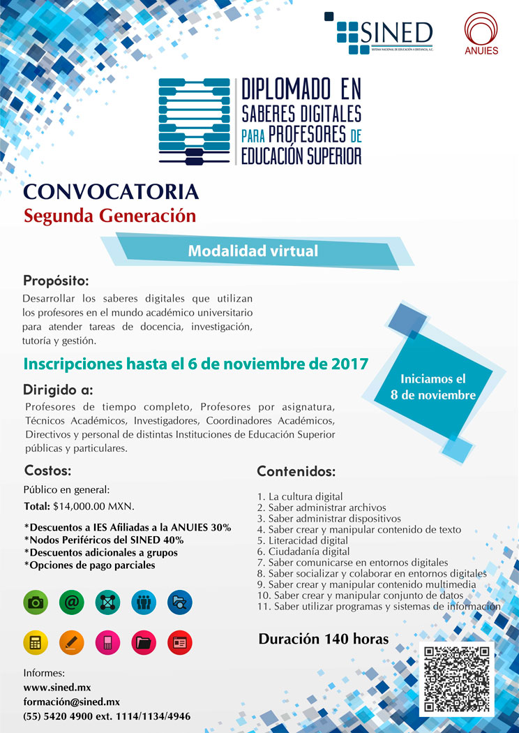

Este contenido es informativo, favor de**no responder a esta dirección de correo electrónico** (avisos_uadec@uadec.edu.mx), ya que esta no se encuentra habilitada para recibir mensajes.

Para dudas o aclaraciones contactar al responsable de esta información:

M.C. Josefina Gpe. Rodríguez González.  
Secretaria Técnica del CRNE.  
[josefina_rodriguez@uadec.edu.mx](mailto:josefina_rodriguez@uadec.edu.mx)

<http://www.anuiescrne.uadec.mx/>

1. **Movers & Shakers 2018 – Now Accepting Nominations**

Brazil Adopts Open Licensing in National Textbook Program, Requirement Will Begin in 2019

Filed by [Gary Price](http://www.infodocket.com/author/gprice/) on September 17, 2017

From [Nicole Allen at SPARC:](https://sparcopen.org/news/2017/brazil-adopts-open-licensing-national-textbook-program/)

Brazil’s Programa Nacional do Livro Didático (PNLD) is one of the largest national textbook programs in the world. Each year, the program procures curricula for a set of primary or secondary school subjects, including textbooks and digital supplemental resources for teachers. In 2017, PNLD spent R $1.3 billion (approximately US $400 million) to purchase more than 150 million textbooks for nearly 30 million students.

Starting in 2019, the program will for the first time incorporate an open licensing requirement. The PNLD 2019 call for proposals, released last month, requires that publishers license the set of digital supplemental resources that come with textbooks—including lesson plans, graphic material, and assessments—under a Creative Commons Attribution-NonCommercial (CC BY-NC) license. Publishers also are given the option to negotiate a purchase price for the copyright of the full textbook, so that the Ministry of Education can make the book available under CC BY-NC as well.

Lean [More, Read the Complete Blog Post (781 words)](https://sparcopen.org/news/2017/brazil-adopts-open-licensing-national-textbook-program/)

**About Gary Price**

Gary Price ([gprice@mediasourceinc.com](mailto:gprice@mediasourceinc.com)) is a librarian, writer, consultant, and frequent conference speaker based in the Washington D.C. metro area. Before launching INFOdocket, Price and Shirl Kennedy were the founders and senior editors at ResourceShelf and DocuTicker for 10 years. From 2006-2009 he was Director of Online Information Services at Ask.com, and is currently a contributing editor at Search Engine Land.

**http://www.infodocket.com/2017/09/17/brazil-adopts-open-licensing-in-national-textbook-program-requirement-to-begin-in-2019/**

1. Bathroom Book Blurbs: Reading Recommendations in Every Stall

By Jaime Leroy on September 13, 2017 [4 Comments](http://www.slj.com/2017/09/books-media/bathroom-book-blurbs-reading-recommendations-every-stall/" \l "comments)

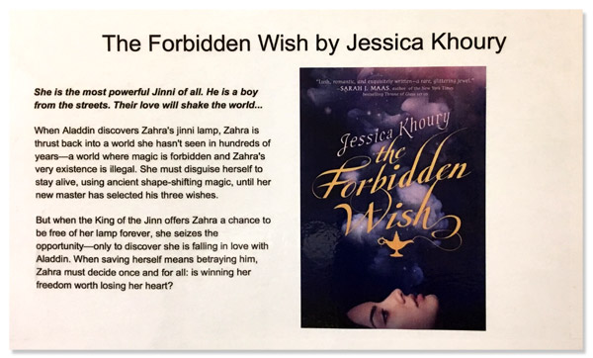We all have students who love to read, tolerate reading, or avoid it at all costs. But they all have one thing in common—they go to the bathroom. I use this to my advantage.

Much to the dismay of the custodial staff at my school, I use restrooms to advertise the library to students. In every stall and above every urinal, I’ve placed a Bathroom Book Blurb. People read anything when using the restroom—so why not advertise books? Here’s how.

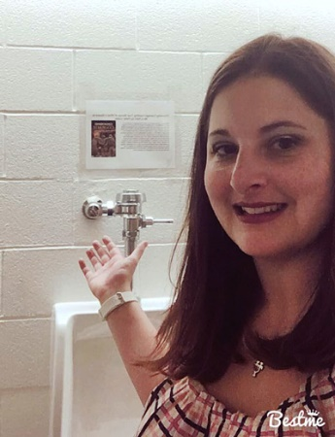

Jaime LeRoy

**1: Pick surefire books!**

This is critical. In my experience, most students are not going to get excited about Anne of Green Gables, no matter how much we may have liked it as children. I begin with state reading lists. The Texas Lone Star Reading List for middle schoolers is full of diverse, exciting choices. From there, I look at new titles that everyone’s talking about. Make sure you have a gauge on what’s popular in your school. High fantasy and science fiction titles were hot in past years; more recently, it’s realistic fiction.

**2: Make the blurb enticing.**

I usually use Goodreads blurbs, but sometimes revise them to make them more engaging. I can’t read all the books I advertise, so I look at different reviews on blogs or websites such as Titlewave or Barnes and Noble. Then, I add information I know will draw students’ attention. Keep the blurb concise and give readers just enough to pique their interest.

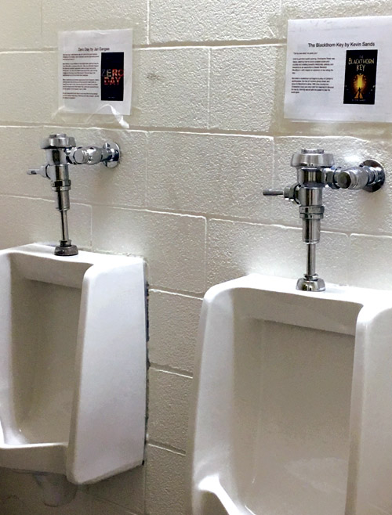

**3: Include the book cover and print in color.**

We’re told not to judge a book by its cover, but we do. Having a clear image of the cover will catch a reader’s eye. If it’s unattractive, I try to find a different edition or use a copyright-free image that relates to the book. Be sure to print your blurbs in color to draw attention. I laminate my blurbs so they last a longer and usually change them once a month.

When I started my Bathroom Book Blurbs, I saw immediate results. The next day, students asked for the “book they saw in the bathroom.” Kids who’d never come to the library were showing up. I had to buy more copies to meet the demand.

When by Victoria Laurie (Disney-Hyperion, 2015) and Sweet by Emmy Laybourne (Feiwel & Friends, 2015) were the most popular last year. At one point, more than 20 students had holds on each. This year, I hope to form Bathroom Book Clubs, based on the blurbs. Of course, the clubs would meet in the library—but the name is bound to draw attention.

I’m also planning a faculty newsletter, Potty Mouth, for faculty-only restrooms. I’ll have information about library events, tech tips, and books that are currently popular with the students. I may add a “Letter to the Librarian,” responding to teacher questions. I hope it will be as beneficial for teachers as the blurbs have been for kids.

**http://www.slj.com/2017/09/books-media/bathroom-book-blurbs-reading-recommendations-every-stall/**

|  |
| --- |
|  |
| |  |  |  |  |  |  |  |  |  |  |  |  | | --- | --- | --- | --- | --- | --- | --- | --- | --- | --- | --- | --- | | |  |  |  |  |  |  |  |  |  |  |  | | --- | --- | --- | --- | --- | --- | --- | --- | --- | --- | --- | | |  |  |  |  |  |  |  |  |  |  | | --- | --- | --- | --- | --- | --- | --- | --- | --- | --- | | |  |  |  |  |  |  |  |  |  | | --- | --- | --- | --- | --- | --- | --- | --- | --- | | |  |  |  |  |  |  |  |  | | --- | --- | --- | --- | --- | --- | --- | --- | | |  |  |  |  |  |  |  | | --- | --- | --- | --- | --- | --- | --- | | |  |  | | --- | --- | | |  | | --- | | Playaway Pre-Loaded Products | |  |  |  | | --- | --- | | |  | | --- | | Playaway Lock: The eReader that recommends the next great read. | |  |  | | --- | | Hundreds of titles. | | Curated collections. Made for circulation. | | | | | | | |

1. How to Hot Spot | TechKnowledge

By Christina Vercelletto

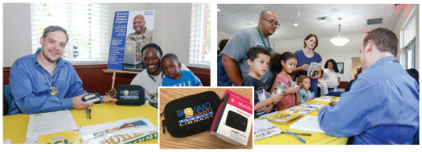

BROADBAND IN BROWARD Broward County Library recently launched a hot spot lending program that offers broadband Internet access to members of the local military community and their families

**Spearhead a successful Wi-Fi hot spot lending program with advice from those who led the way**

**Wi-Fi hot spot lending** can help bridge the digital divide by addressing a persistent problem: lack of Internet access at home among low-income families. Without such access, students are often unable to complete homework with an online component, and parents can’t effectively job hunt or apply for government and other ­services.

While Wi-Fi in school and library buildings has alleviated the problem somewhat, there are too many hours when those facilities are closed for that to be a total solution. Also, patrons with disabilities may face additional hurdles in getting back and forth to other locations to use the Internet.

Wi-Fi hot spots—small, portable devices that connect laptops and mobile devices to the Internet—are well suited to be part of an answer that libraries can offer to their communities. These devices can be checked out like any other item in the library’s collections, and they don’t require installation in the home, as they rely on a cellular signal.

**POPULAR PROGRAMS**

Several libraries have launched successful hot spot lending programs recently. The New York Public Library (NYPL) has the ConnectED Library Hot Spot Loan Program, which began as a Knight Foundation–funded pilot in 2014. “Even in New York City, arguably the media capital of the world, Internet is not something everyone can afford,” says Luke Swarthout, director of adult education services for NYPL. “We had two main objectives: helping some of the two million New Yorkers without home Internet gain access and demonstrating that connecting all Americans is within our grasp.”

Chicago Public Library’s (CPL) Internet To Go program was also piloted in 2014. At both NYPL and CPL, the programs have been well received by patrons, with checkouts running at or near capacity since launch.

In order to determine the success of its program, CPL studied circulation data, conducted follow-up email surveys, and had conversations with individual patrons during the early stages of the rollout.

Among the encouraging insights gained from CPL’s surveys: 11 percent of hot spot borrowers were first-time library users, 70 percent used the hot spot to apply for jobs (and 17 respondents reported they had found one), seven percent used the hot spot to do their own homework or to help someone in their household with homework, one group of college students reported using a hot spot to complete an online class together, 59 percent said using the hot spot made them more comfortable trying new technologies, and 23 percent said they had subscribed to home Internet service since using the hot spot.

In June 2017, Broward County Library (BCL), Fort ­Lauderdale, FL, launched the Veterans Connect Hot Spot Program for veterans, active military, and their dependents. The program encourages education, self-development, and career advancement through technology. It also promotes use of all BCL services by members of the local military community.

Before proceeding with a hot spot lending program, however, especially when developing a program in a rural area, remember this: “There must be a solid cell phone signal associated with the anticipated high-speed service in a given territory. Not all signals are equal!” stresses ­Sharon Strover, a professor at the University of Texas (UT) at Austin’s department of radio-television-film, who led an Institute of Museum and Library Services (IMLS)–funded study in 2016: “[At the Edges of the National Digital Platform: Rural Library Hot Spot Lending Programs](http://www.dlib.org/dlib/may17/strover/05strover.html).” If there are issues with connectivity or coverage across your library’s communities, a Wi-Fi hot spot lending program may not be feasible until those infrastructure issues are addressed.

[ED Note: UT, in partnership with the Technology & Information Policy Institute, Simmons College, and Oklahoma State University have also published a general guide to launching a Wi-Fi Hot Spot lending program, [available here](http://sites.utexas.edu/imlsedgesgrant/files/2017/02/How-to-Hotspot.pdf)].

**http://lj.libraryjournal.com/2017/09/lj-in-print/hot-spot-techknowledge/**

1. Middle Schoolers Help Transcribe, Digitize Rare Historical Newspapers

By [Lisa Peet](http://lj.libraryjournal.com/author/lpeet/) on September 22, 2017 [Leave a Comment](http://lj.libraryjournal.com/2017/09/academic-libraries/middle-schoolers-help-transcribe-digitize-rare-historical-newspapers/" \l "respond)

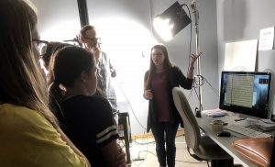

John Jeremiah Sullivan and Joel Finsel’s class with NC Digital Heritage Center digitization support technician Kerry Bannen

After a group of middle schoolers from Wilmington, NC had the chance to share in the discovery of some rare primary source documents, transcribe them, and get an up-close look at the digitization process, North Carolina may have a few more aspiring archivists ready to help preserve its past.

Working with two Wilmington-based writers, John Jeremiah Sullivan and Joel Finsel, the students spent part of their spring semester transcribing what may be the only three surviving original issues of the Wilmington Daily Record, as well as working with four copies on microfilm. They then traveled to the [North Carolina Digital Heritage Center](http://www.digitalnc.org/about/) (DHC) at the University of North Carolina (UNC)–Chapel Hill’s Wilson Library to watch staff make high-resolution scans of the papers for archival preservation. All seven digitized copies of the paper, along with the students’ transcriptions, are now hosted by DHC’s [Digital North Carolina](https://www.digitalnc.org/newspapers/the-daily-record-wilmington-n-c/)archive, and will eventually be available through the Library of Congress’s “Chronicling America” archives. And a class full of eighth-graders learned firsthand about the excitement of discovering rare original material and sharing it with the world.

**A PIVOTAL PUBLICATION**

Sullivan and Finsel signed on to collaborate with Williston Middle School and Friends School of Wilmington as part of the Williston Legacy Project, an initiative based at the middle school—which was, until its integration in 1968, a high-performing, segregated black high school. Part of the project’s focus is a curriculum built around the city’s and the school’s history, with units taught by professors from UNC–Wilmington, where Sullivan is on the creative writing faculty. Their plan was to explore a chapter of Wilmington’s complex past through copies of the Wilmington Daily Record. Sullivan—a journalist, essayist, and editor—has long had an interest in the history of journalism and newspaper culture, and the paper’s story is closely tied to that of the city.

In the 1890s, the Daily Record was the community’s only newspaper owned, run, and read by African Americans. Late 19th-century Wilmington was “the richest, most populated city in the state and the best place in the state to be if you were an African American,” Sullivan told LJ. “Those two things changed overnight, as dramatically as anything could change.”

In August 1898, an editorial by Alex Manly, the paper’s coeditor, took on the subject of interracial sexual relationships. Manly challenged the stereotype, perpetuated by whites, of black men raping white women—when, he asserted, the attraction was usually consensual and no worse than the involvement of white men with black women. Racial tensions were simmering at the time, with local Democrats trying to regain the state legislature from Republican and Populist “fusion” candidates, and the article added fuel to an already volatile situation. On November 10, 1898, a mob of nearly 2,000 white men set on Wilmington’s black neighborhoods, attacking people and destroying property and businesses, and burned the offices of the Daily Record to the ground. Alex Manly and his brother (and coeditor) Frank fled the town, and white Democrats went on to overturn the elected biracial city government in an effective coup.

The Wilmington Race Riot permanently changed the racial profile of the city. The fact that the rioters destroyed the Daily Record, Sullivan added, was telling: “The first thing the mob did was go to the newspaper building and burn it down. They understood the power of those documents.”

Sullivan thought it would be interesting to read back issues of the paper to get a feeling for the time, but he and Finsel soon discovered that there were none. “We started hunting for it and realized that it was unavailable in about as radical a way as it’s possible to get these days, with digital everything,” he recalled. “We were going to have to find it if we wanted to read it.”

**http://lj.libraryjournal.com/2017/09/academic-libraries/middle-schoolers-help-transcribe-digitize-rare-historical-newspapers/**