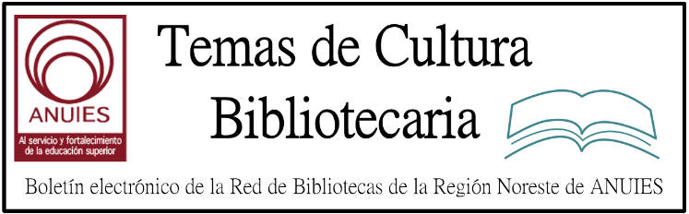

Año 2 Número 45 octubre 2017

Contenidos de este número

- Measure the Future Enters Next Phase
By Matt Enis

Measure the Future, an open source, open hardware project that enables libraries to collect and analyze data regarding how their physical space is being used, will soon deploy new sensors at libraries participating in its public beta launch, including the Meridian Library District (MLD), ID; the State University of New York, Potsdam; the New York Public Library; the University of Boston Law Library; and the Carnegie Library of Pittsburgh. Developer Clinton Freeman and project lead Jason Griffey (a 2009 LJ Mover & Shaker) recently changed the sensor hardware from Intel Edison to Raspberry Pi 3 single board computers, delaying the beta rollout, which was originally announced in late June. The switch will ultimately help ensure the project’s long-term sustainability on a more powerful, less expensive, and more widely available hardware platform.
User observation studies are, by nature, time limited and labor intensive. And most new techniques for analyzing the movement and behavior of users, such as Wi-Fi or beacon positioning systems, can raise privacy concerns, as well as excluding anyone who isn’t carrying a Wi-Fi- or Bluetooth-enabled device.
By contrast, the computer vision sensors developed by Measure the Future use “blob detection” methods to collect completely anonymous data about patron behavior: counting people, determining where they are moving and how quickly, and how long they linger in a location. This information is stored in a database; the “blob” photos are not retained.
“I think there’s a lot to be learned from movement patterns, and how your spaces can be [made] better for the people who are using them,” Griffey told LJ. “The big difference between this and classic sociological observation is that it collects mounds of data that can be carved in different ways…. We have the ability to answer many of the same sorts of questions that sociological observation answers, like where do people stop? How long to they stop there? Are they stopping on the left side or right side of your new book display?”
However, Griffey added, using computer vision sensors to collect all of this data, for an extended period of time, can reveal patterns that may not be detectable within the limitations of a human observer, but build up or change over time.
“There’s a big difference between spending a week hand counting people and having a month, a semester, [or] a year” of data, he said. “It’s a much more thorough, and a much more robust set of data” than human observation could collect.
And ultimately, Griffey plans for the data collected by the system to be mineable via web portal, enabling libraries to analyze patron behavior after the fact, comparing foot traffic patterns during different special events at a public library or analyzing finals week heat maps from different semesters at an academic library, for example. Griffey describes this as a “Google-Analytics-style dashboard for your library building.”
“You [won’t] have to have the questions ready before you measure,” he said. “You can passively measure [using the sensors] and then choose to ask questions. What was the traffic like during that author event? How did it compare to the traffic at this other author event?… You can ask questions of the data that you might not think to ask before you have the data.”

http://lj.libraryjournal.com/2017/09/buildings/measure-the-future-enters-next-phase/

- X-ray Fluorescence Offers Clues to Cornell Library’s Medieval Manuscripts
By Andrew Gerber
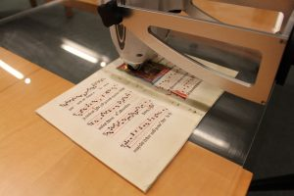
A portable-point X-ray flourescence (p-XRF) scanner is used on an illuminated manuscript fragment.
Photo credit: Cornell University Library
Librarians know there are many tools to classify items—subject matter, date, geographic region, and old-fashioned alphabetical order—but there is a newer method that can help classify manuscripts based on features invisible to the naked eye. X-ray fluorescence (XRF) can non-invasively find traces of chemical elements, offering clues about the origins of centuries-old paintings, manuscripts, ceramics, and stained glass. For example, researchers at the library at Saint Catherine’s Monastery, a 1,452-year-old institution at the foot of Mount Sinai, Egypt, use x-ray technology to discover once hidden text and discover lost characters from extinct languages.
“Scanning x-ray fluorescence is a relatively new technique to study illuminated manuscripts,” according to Louisa Smieska, a researcher at Cornell University’s Cornell High Energy Synchroton Source (CHESS). CHESS is using XRF to examine medieval documents in Cornell’s collections. “What’s different about our work is the use of higher-energy x-rays, generated at a synchrotron source, compared to the lower-energy x-rays that have been used in laboratory-based experiments. The higher-energy x-rays gave us greater sensitivity to heavy trace elements.”
CHESS has been a cross-discipline program, using technology to determine findings of interest to history, literature, and the arts. Therefore, the researchers come from both the scientific and humanities worlds.
Smieska, who has a PhD in chemistry, explained, “XRF detects which chemical elements…are present in each spot we analyze. If we know which elements are present, we can often infer what the compound is—for example, the presence of mercury in a red area strongly suggests the use of vermilion, a pigment that contains mercury and sulfur. XRF works by shining x-rays onto an object and measuring the secondary x-rays that the object emits in response. These secondary x-rays have energies that are precisely specific to the elements they come from.”

http://lj.libraryjournal.com/2017/08/academic-libraries/x-ray-florescence-offers-clues-to-cornell-librarys-medieval-manuscripts/

- Library of Congress Announces Winners of 2017 Literacy Awards
Filed by Gary Price on September 2, 2017
Note: A video recording of the last night’s Library of Congress National Book Festival gala is embedded at the bottom of this post.
The video includes the presentation of the 2017 Literacy Awards along with presentations by:
- Fantasy-sci-fi novelist Diana Gabaldon (“Outlander” series)
- Historian David McCullough (“The American Spirit”)
- Children’s book author Reshma Saujani (“Girls Who Code”),
- Nonfiction writer Margot Lee Shetterly (“Hidden Figures”)
- Triller writer Scott Turow (“Testimony”).
From LC:
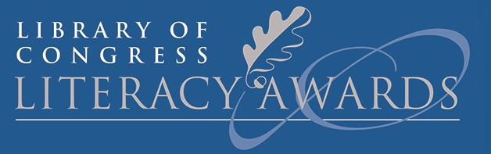Librarian of Congress Carla Hayden announced the winners of the 2017 Library of Congress Literacy Awards [last night] at the Library of Congress National Book Festival gala.
Three organizations received awards from Hayden and philanthropist David M. Rubenstein: the Children’s Literacy Initiative; the National Center for Families and Learning; and Pratham Books.
Originated by Rubenstein in 2013, the Literacy Awards honor organizations working to promote literacy and reading in the United States and worldwide. The awards recognize groups doing exemplary, innovative and replicable work, and they spotlight the need for the global community to unite in striving for universal literacy.
“Literacy is the first line of defense against so many problems—unemployment, hunger, poor health—and gives people a foundation for a brighter future,” Hayden said. “Through the generosity of David M. Rubenstein, the Library of Congress is proud to honor these exemplary organizations for their continued efforts to raise reading levels. Their work is moving and truly life-changing, and it is our privilege to recognize them here tonight.”
Rubenstein is the co-founder and co-chief executive officer of The Carlyle Group. He is a major benefactor of the Library of Congress and the chairman of the Library’s lead donor group, the James Madison Council.
Prizes and Recipients
- David M. Rubenstein Prize ($150,000): Children’s Literacy Initiative, Philadelphia
Children’s Literacy Initiative (CLI) works with pre-K through third-grade teachers to improve early literacy instruction so children become powerful readers, writers and thinkers. CLI creates a sustainable, school-wide culture of literacy that introduces students to the joys of reading, writing and lifelong learning. The organization coaches teachers one-on-one and in small groups in the classroom—providing demonstrations and feedback that help teachers incorporate effective literacy practices into their daily work with students. It stocks classrooms with learning materials and collections of high-quality children’s literature and extends its services with online professional development resources. CLI provides workshops and seminars to build a teacher’s knowledge of literacy content and pedagogy.
- American Prize ($50,000): National Center for Families Learning, Louisville, Kentucky
Established in 1989 by its current president, Sharon Darling, the National Center for Families Learning (NCFL) works to eliminate poverty through educational solutions for families. Throughout its 28-year history, NCFL has changed the lives of millions of families across the country by providing literacy strategies, programming and resources. Engaging multiple generations together has been a fundamental and distinguishing aspect of NCFL’s work, because it knows this creates a stronger impact and greater success for families.
- International Prize ($50,000): Pratham Books, Bangalore, India
Established with the mission of “a book in every child’s hand,” Pratham Books has helped millions of children have access to engaging, affordable, multilingual books. In order to scale the creation and distribution of multilingual content, Pratham Books launched StoryWeaver, India’s first open-source, digital repository of multilingual stories. All content on StoryWeaver is openly licensed. Users can read, download, print and share stories for free as well as use tools embedded on the platform to create and translate content into local languages.
The Library of Congress Literacy Awards program is also honoring 15 organizations for their implementation of best practices in literacy promotion. These organizations are:
- The Asia Foundation, San Francisco
- Canadian Women for Women in Afghanistan, Calgary, Alberta, Canada
- Center for Teaching and Learning, Edgecomb, Maine
- Centre for Knowledge Assistance and Community Development, Hanoi, Vietnam
- CODE, Ottawa, Ontario, Canada
- CommonLit Inc., Washington, D.C.
- Louisiana Endowment for the Humanities/PRIME TIME, New Orleans
- Reading Partners, Oakland, California
- Reading Works Inc., Albuquerque, New Mexico
- Sealaska Heritage Institute, Juneau, Alaska
- Serve Minnesota, Minneapolis
- State Library of Western Australia – Better Beginnings Family Literacy Program, Perth, Australia
- Story Share Inc., Boston
- Tales and Travel Memories, Elgin, Illinois
- Yayasan Sulinama, Ambon, Maluku, Indonesia

http://www.infodocket.com/2017/09/02/library-of-congress-announces-winners-of-2017-literacy-awards/

- A Culture of Opportunity | Best Small Library in America 2017
By John N. Berry III on September 12, 2017 Leave a Comment

Idaho’s Boundary County Library District is the Best Small Library
in America, 2017
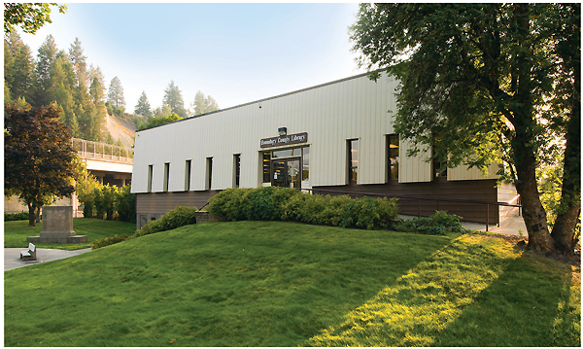
For 30 years, Sandy Ashworth, the just-retired director of Idaho’s Boundary County Library District (BCLD), developed the library’s vision and community connections and identified the county’s new needs. She saw that openings would have to be created to encourage residents to innovate and build businesses that could strengthen the shrinking farming and timber economy. Ashworth worked to get new resources and repurpose library space to develop practical educational programs at BCLD, to help upgrade and modernize skills and opportunities in the county, and to inspire confidence that this progress is coming.
Bonners Ferry, BCLD’s hometown, is a small community straddling the Kootenai River; the northern county border touches Canada. The nearly 12,000 residents of Boundary County include the indigenous people of the Kootenai Tribe, seniors—some who arrived from the dustbowl in the 1930s—their offspring, and millennial grandchildren.
When Ashworth retired last year, the BCLD board hired innovative educator Craig Anderson to run the library and continue its progress.
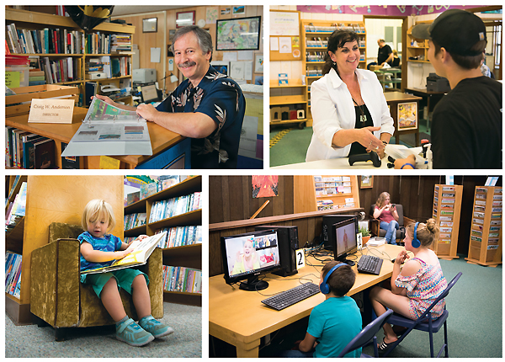
Top photo: Boundary County Library District’s welcoming exterior. Middle row, l.-r.: BCLD’s Director Craig Anderson; Lynn Silva assists a patron with checkout, and teens take advantage of the computers in their area.
Photos ©2017 J. Craig Sweat Photography
Anderson, whose record includes decades teaching high school in Bonners Ferry, now works to strengthen and expand the BCLD vision and services.
“I am the next generation of Sandy’s vision,” Anderson says. “I let the board know that I share that vision to take the library far beyond a traditional library.”
The result is a dynamic BCLD, a model for all of America’s libraries and winner of the 2017 Best Small Library in America Award, with the support of sustaining sponsor Junior Library Guild (a division of LJ’s parent company, Media Source, Inc.).
MAKING OPPORTUNITY
Ashworth identified the need to raise residents’ tech skills and saw that the library could be positioned to respond. “The library’s goal is to provide people with a toolbox to allow them access to new ideas and technologies that they can use to make Bonners Ferry a more successful place,” Ashworth explains.
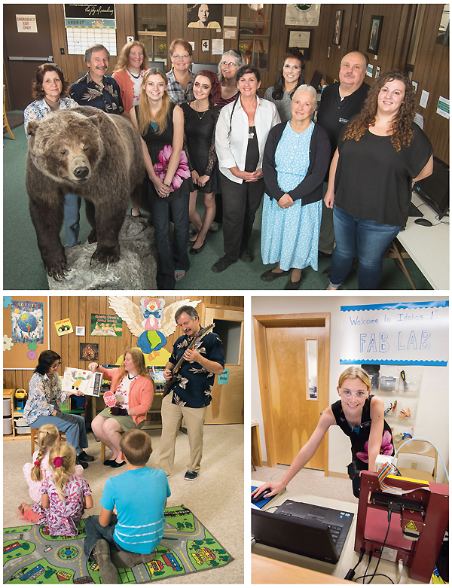 “This sort of innovative library service is unique in Idaho and is an inspiration for other communities,” writes Bette Ammon, director of the neighboring Coeur d’Alene Public Library. “The staff at the library have definitely created a ‘culture of opportunity.’ ”
Ashworth had read about Massachusetts Institute of Technology (MIT) professor Neil Gershenfeld, director of MIT’s Center for Bits and Atoms and his FAB program that is now global. FAB empowers local invention, engineering education, entrepreneurship, and the philosophy that anyone can make almost anything. Ashworth was so taken with the idea that she decided BCLD needed a FAB Lab, what Anderson calls “a Maker space on steroids.” After an attempt to get a new building didn’t work out, Ashworth reinvented the library basement; garnering $80,000 in two GEM grants and another from the USDA (U.S. Department of Agriculture) to help pay for it.
“With the help of a very supportive board and budget, we went on to get the machines for the new project. It was all fit into three little rooms,” says Anderson.

PUSHING THE BOUNDARIES of what a small library can do, BCLD can bear-ly contain all of its offerings. Top photo: the BCLD team, including Selkirk, the grizzly bear, and front row (l.–r.): Amy Maggi, Jessy Trocke, Lynn Silva, Sandy Ashworth (former director), and Katherine Boger. Back row (l.–r.): Neumayer, Anderson, Haarstick, Dianna Zills, Ruth Loveland, Maria Porter, and Derrick Grow. Bottom row, l.-r.: Welcome to BCLD; Director Craig Anderson (standing)
in tune with a story time program featuring original on-the-spot compositions, as staffers Neumayer (l.) and Haarstick perform. Maggi’s ready for Maker action in the FAB Lab. Photos ©2017 J. Craig Sweat Photography
A local doctor donated a printer. Other items came from additional sources. One woman, at the library with her grandchild, said to Anderson, “This is so great. What do you guys need?”
“The FAB Lab gets heavy use, and its machines and the 3-D printer fire up people’s imagination…. It is neat to watch someone who has never seen it before. It turns their universe on edge,” Anderson reports.
“Since FAB Lab classes opened in November 2016, a whole new demographic has [found] BCLD: The Makers. Traditionally, libraries were a place for ‘old school’ learners, but now a population of ‘Ideas to Reality’ patrons have arrived,” says an excited Anderson. “Artisans, inventors, builders, and innovators come to Boundary County Library to create what has never been made before. Sandy built the shop, then retired. It was my job to open it and develop the needed procedures to use it.”
Users have fabricated all sorts of models at BCLD, from a car with gears and differentials to three-dimensional log cabins to illustrate how real ones would look in all settings.
“I found the focused approach to solving a community need in a remote area of Idaho compelling,” writes award judge Kent Oliver, director of the Nashville Public Library, the 2017 Gale/LJ Library of the Year. “Providing opportunities in technology is a key to communication, education, and workforce development. These programs have the potential to significantly impact their region.”
For those who aren’t focused on hands-on tinkering, BCLD also uses inventive technological solutions to provide other STEM (science, technology, engineering, and mathematics) offerings beyond what most small libraries can muster. Twice a month, BCLD offers educational programs for children and adults on its wall-mounted wide-screen monitor, connected to the world through Polycom. Biologists from the Toledo and Alaska zoos demonstrate animal adaptation in real time. NASA astronauts teach about life on the International Space Station and discoveries about the sun.
GETTING DOWN TO AND WITH BUSINESS
In concert with Bonners Ferry High School, BCLD has developed a youth entrepreneur program. Junior and senior high school technical writing students work to answer the questions: If you could have your own business, what would it be? How would you develop it? Students form partnerships and create portfolios that demonstrate most major aspects of business development and marketing. BCLD supports the project by providing community judges, procuring prize money donations, and hosting the Youth Business Fair, where the prizes are awarded. During the project’s 17 years, at least seven of the students have gone on to launch their own businesses. In fact, Under the Sun, a student-run restaurant and gift shop, was voted Most Innovative Small Business in the State of Idaho.
Applying that same blend of commercial and library savvy internally as well, staff used BCLD’s Lynda.com subscription to learn more about marketing and to complete a total rebranding of the library.
To gain support and inspiration for its services, BCLD has joined with an impressive number of community agencies, businesses, and institutions, including local nonprofits such as the county’s 4-H, museum, hospital, homeschool association, Fraternal Order of Eagles, and the town food bank. Collaborations have been made with local schools and governmental organizations including the Bonners Ferry City Council, economic development committee, and chamber of commerce; the county school district, Head Start (of which BCLD was a founder), and the Kootenai Tribe of Idaho; and local businesses from day cares to stores and farms, as well as the Idaho Department of Labor, Idaho Department of Commerce, Idaho Fish & Game, and, of course, the Idaho Commission for Libraries (ICL). For tech support, BCLD turns to Alpha Robotics FIRST Team 2130-FAB Lab and the Fab Foundation Global Community.
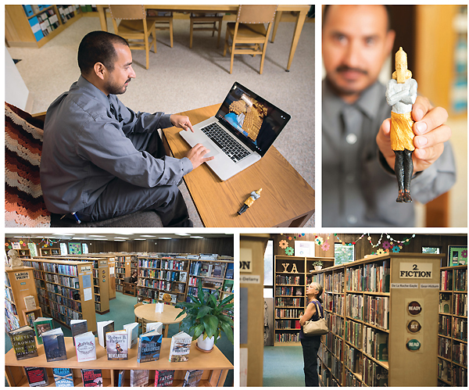
Top row: Local church group member and patron Salvador Gomez tapped into the FAB Lab
to create BCLD’s first painted 3-D figure, related to a research project on Nebuchadnezzar.
Bottom row: plenty of offerings in the library for patrons. Photos ©2017 J. Craig Sweat Photography

http://lj.libraryjournal.com/2017/09/lj-in-print/bestsmalllibrary2017/

- PITS - Disruptive Library Patron Incident Tracking System
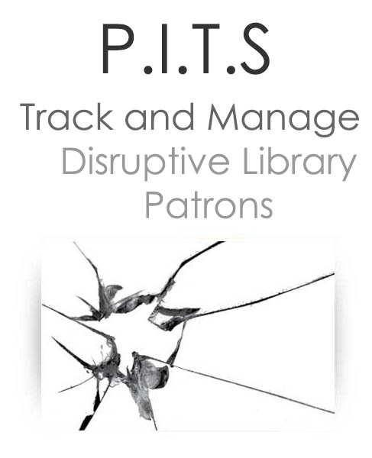
PITS is an online Patron Incident Tracking System which allows staff to create online incident reports to assist in the management of disruptive patrons in a secure web-based application. PITS accommodates reporting of incidents, perpetrators, victims, and witnesses, using a customized set of priorities, incidents and individual physical descriptions. Lists of infractions are based on your local rules of conduct, as are follow-up actions. Automatic routing of incident notifications keeps key contacts in the loop. PITS can also store documents associated with an incident, such as letters of warning or suspension.
PITS allows libraries to collaborate with local agencies on the tracking of problem patrons to ensure greater security and safety for their staff and other patrons. A simple dashboard allows for an at-a-glance view of current reports, perpetrators, and suspensions.
Pleasecontact usfor information on pricing and customization options

http://quipugroup.com/PITS-patron-incident-tracking-system.php

- Interview/Video: Dr. Carla Hayden Named to Time’s “FIRSTS: Women Who are Changing The World” List
Filed by Gary Price on September 8, 2017
Librarian of Congress, Dr. Carla Hayden, has been named to Time’s “FIRSTS: Women Who are Changing The World” list.
From the Introduction to the FIRSTS List:
What a jagged image we use for women who achieve greatly, defining accomplishment in terms of the barrier rather than the triumph. There she is up where the air is thin, where men still outnumber women, but where the altitude is awesome.
Our goal with Firsts is for every woman and girl to find someone whose presence in the highest reaches of success says to her that it is safe to climb, come on up, the view is spectacular.
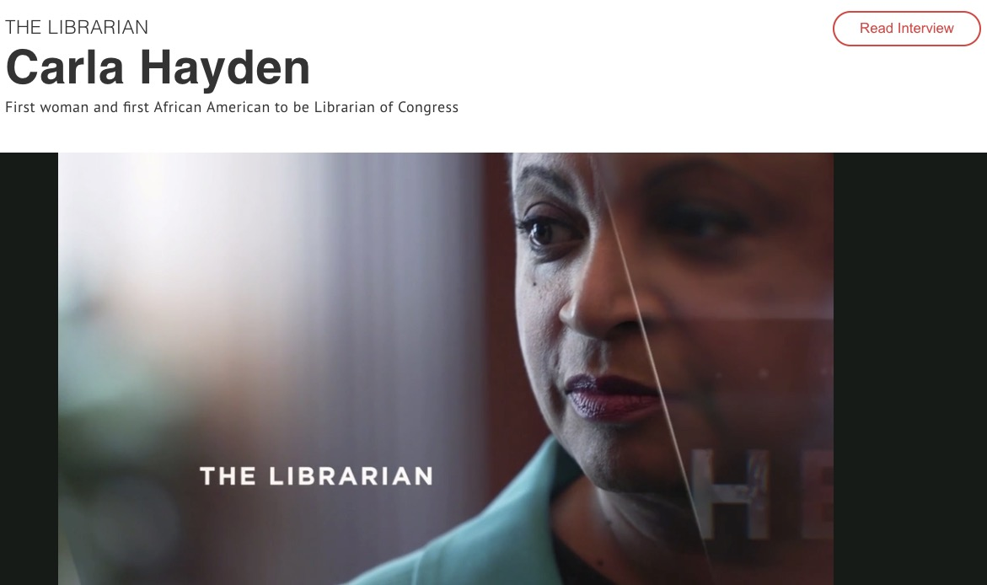
Direct to Dr. Hayden’s FIRSTS Page (Video and Interview)
We’ve also embedded the video below.
Direct to Complete FIRST List (Video/Interviews) For Each Recipient
About Gary Price
Gary Price (gprice@mediasourceinc.com) is a librarian, writer, consultant, and frequent conference speaker based in the Washington D.C. metro area. Before launching INFOdocket, Price and Shirl Kennedy were the founders and senior editors at ResourceShelf and DocuTicker for 10 years. From 2006-2009 he was Director of Online Information Services at Ask.com, and is currently a contributing editor at Search Engine Land.

http://www.infodocket.com/2017/09/08/interviewvideo-dr-carla-hayden-named-to-times-firsts-women-who-are-changing-the-world-list/

- Research Data: Canada’s Portage Network Releases Report on Metadata Standards for Research Data Discovery
Filed by Gary Price on September 12, 2017
From The Portage Network:
T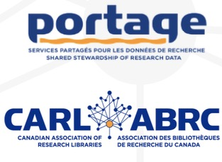he Metadata Working Group of the Portage Data Discovery Expert Group has released a report about discovery standards for research data in repositories. The report includes an overview of the discovery metadata profile for the Federated Research Data Repository (FRDR) and a crosswalk covering major disciplinary research data standards.
The purpose of the Portage Data Discovery Expert Group is to support research data creators and curators in planning, producing, and managing descriptive metadata for effective discovery and reuse. The group facilitates discussions about data discovery in Canada and promotes the use of metadata standards for research data that support both machine-to-machine and human-to-machine discovery activities. The Metadata Working Group works to define the scope of metadata standards for discovery and to provide recommendations for managing and harvesting metadata from data repositories, with the goal of increased discovery of Canadian research data.
Portage is a national research data management initiative to assist researchers and other research data management stakeholders through a library-based network of expertise on RDM and national platforms for planning, preserving, and discovering research data. Portage is managed by the Canadian Association of Research Libraries (CARL).
Direct to Full Text Report

http://www.infodocket.com/2017/09/12/research-data-canadas-portage-network-releases-report-on-metadata-standards-for-research-data-discovery/

