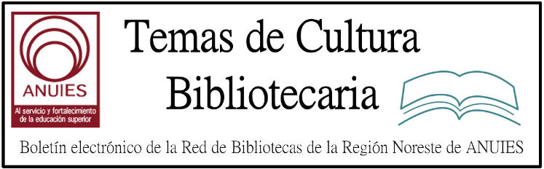

Año 2 Número 44 octubre 2017

Contenidos de este número

Two Killed, Four Injured in NM Library Shooting
By Lisa Peet on August 31, 2017 Leave a Comment
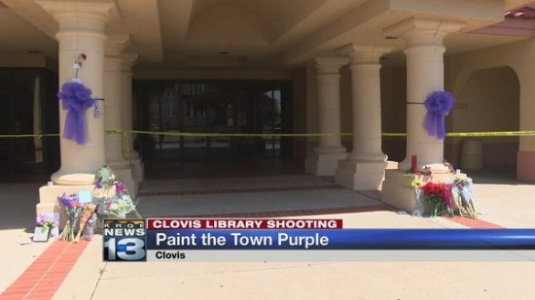
Purple memorial bows on Clovis-Carver Public Library
Courtesy of KRQE News 13
On the afternoon of Monday, August 28, a gunman opened fire in the Clovis-Carver Public Library(CCPL) in Clovis, NM. Kristina “Krissie” Carter, a youth service librarian, and Wanda Walters, a circulation assistant, were killed, and four others wounded, including a second CCPL circulation assistant. The shooter was taken into custody at the scene.
Nathaniel Jouett, a 16-year-old high school sophomore at Clovis High School, surrendered at the time of the shooting and was taken into custody by Clovis Police.
RANDOM SHOTS, SURRENDER
The single branch CCPL serves the city of Clovis, about 200 miles east of Albuquerque, with a population of just under 40,000.
According to court documents, Jouett, who had been suspended from school the Friday before the incident for fighting, had taken two handguns from his father’s safe. Originally he planned to target his school, he told police; instead, he went to the library, although he said he knew no one there. According to reports taken by the police, Jouett entered the library around 4 p.m. and began shooting randomly as parents, children, and other patrons hid
under tables or behind doors.
Circulation supervisor Scott Jones called 911 and gave a description of the shooter, he told the Eastern New Mexico News. Police arrived quickly and Jouett surrendered immediately. He is currently being held at Clovis Juvenile Detention Center. Police have not released a motive.
The victims were taken to University Medical Center in Lubbock, TX, 120 miles southeast of Clovis. At press time, two of the injured—CCPL employee Jessica Thron and Alexis Molina—were in serious condition. Library patrons Howard Jones and Alexis’s ten-year-old brother, Noah Molina, are in satisfactory condition. All are expected to survive.
On the afternoon Wednesday, August 30, a number of bomb and mass shooting threats were called in to the Eastern New Mexico News, Plains Regional Medical Center, and local retail outlets and restaurants, but none proved to be actual threats, although the hospital evacuated some personnel and locked down most entrances and exits until Wednesday night. “The citizens of this community are on edge with the recent events, as would be any community,” police said in a news release. “We encourage citizens to report any unusual activity.”
NATIONWIDE CONDOLENCES
Carter lived most of her life in Clovis, raising her two daughters there and leading the local Girl Scout troop. She had worked at the library since 2002, and was known to the children as Miss Krissie. “She loved her job. Even more, she loved the kids that came with it,” her daughter, Chelsey Jorde, told the Albuquerque Journal.
Walters had worked in the library since 2010. She was described by one library patron on a KOAT newscast as “a lovely woman, and she helped me anytime I needed help. She was there for me, asked how I was doing.” On the same newscast, Suzette Duran, who worked across the street from the library, added, “It’s just going to be so hard for me to walk in there now and not see their faces anymore.”
In a statement issued August 29, the American Library Association (ALA) offered its sympathies and support to the CCPL community. “We are shocked and saddened by the shooting at the Clovis-Carver Public Library in New Mexico,” said ALA president Jim Neal. “We mourn those who were killed, and we offer our thoughts and prayers for the wounded, the families of the victims, library staff, and the community. ALA offers its full support to Clovis-Carver Public Library, the New Mexico Library Association, and the New Mexico State Library as they deal with this senseless violence.”
Neal added, “Unfortunately, we must all be prepared for violence in public places. The ALA encourages its members to work closely with local law enforcement and officials to prepare and train for violence prevention and response.” ALA also provided a series of links to library emergency and violence prevention resources, as well as ALA’s Resolution on Gun Violence Affecting Libraries, Library Workers, and Library Patrons. At the 2016 ALA annual meeting in Orlando, in the wake of the Orlando Pulse nightclub shooting, BreAnne Meier of the North Dakota State Library provided a program on Active Shooters in Libraries.
Libraries across the country have echoed and added to these statements on CCPL’s Facebook page with condolences and messages of support.

http://lj.libraryjournal.com/2017/08/industry-news/two-killed-four-injured-in-nm-library-shooting/

2.
3. Teaching the Internet of Things in Libraries >> TechKnowledge Virtual Conference
Library Journal

Click here to view this message in a browser window.

Every autumn since 2010 Library Journal and School Library Journalhave presented an all-day, all-virtual learning event devoted to technology and libraries. This year we have reimagined the event asTechKnowledge: Creating Equity Through Technology and focused attention on how the nation’s libraries and library staff can and do support equity and inclusion within and among our libraries’ diverse communities.
This event will deliver the most relevant and up-to-the-minute content to help drive libraries and stakeholders into a pro-active future, user-centric future—with a wide variety of sessions focused on academic, public, and school libraries.

4. Boletín Fundación Ciencias de la Documentación

Apreciados profesionales de la información y disciplinas relacionadas, un gusto saludaros nuevamente e informar que todo el equipo de la Fundación Ciencias de la Documentación está ya de vuelta después de las vacaciones. Muchas son las novedades con las que regresamos, algunas de las cuales resumimos a continuación:
NUEVA PLATAFORMA ELEARNING
https://documentalistas.org/plataforma
El Dpto. Técnico de la Fundación ha terminado el diseño y edición de la nueva plataforma para la formación e intercambio de experiencias entre profesionales de España e Iberoamérica. Entre sus novedades - además del diseño y nuevas funcionalidades - destacamos la presencia de una CAFETERÍA donde de forma abierta y gratuita todo el mundo registrado podrá compartir mensajes.
DIPLOMA DIGITAL PARA NUEVOS MIEMBROS NUMERARIOS
https://goo.gl/ohj5Uu
Comenzamos el mes de Septiembre con una promoción especial para todos aquellos profesionales que se registren como miembros numerarios de la Fundación. Sólo por hacerte antes del 20 de Septiembre podrás solicitar GRATUITAMENTE la emisión del diploma digital del curso online Mooc que elijas realizar entre los que se impartan a partir de Septiembre y antes de finalizar el 2017.
TRES NUEVAS REVISTAS DIGITALES
Con el inicio del mes el Dpto. de Publicaciones de la Fundación ha puesto en marcha tres revistas digitales bajo la plataforma Flipboard. Las revistas son REVISTA CIENCIAS DE LA DOCUMENTACIÓN https://goo.gl/KqbDoZ / REVISTA GOVERNMENT AND TECHNOLOGY (en Inglés) https://goo.gl/iH5cVV y la REVISTA MUJERES LÍDERES AMÉRICA (en colaboración con la SAIR/OEA) https://goo.gl/T991gW
PRÓXIMO CURSO INICIA EL 18/SEPTIEMBRE
https://goo.gl/V1BYd8
Con el título “Educación no Formal e Innovación Tecnológica aplicada a Procesos Educativos de Autogestión Comunitaria” el profesor Marco A. Cubillo impartirá desde Costa Rica este curso online de 24 horas académicas que busca conocer los procesos educativos que la educación no formal y las tecnologías impactan dentro de las comunidades que necesitan mejorar sus condiciones de vida.
ABIERTO PROCESO DE CERTIFICACIÓN EN INFORMACIÓN Y DOCUMENTACIÓN
https://goo.gl/8jFm6P
A partir del 4 de Septiembre está abierto el plazo para solicitar ser incluido/a en la segunda edición 2017 del proceso de certificación para profesionales de la información y documentación de habla hispana. Muy importante consultar las bases de la convocatoria.

5.
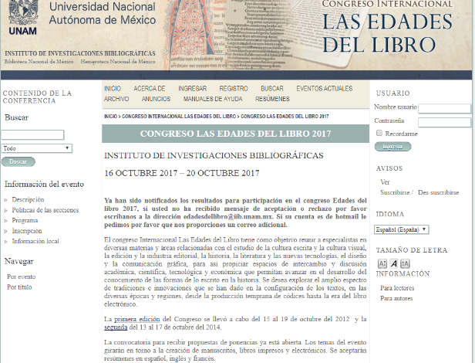

6. Concursos de becas de investigación Walsh - Sabor
Biblioteca Nacional Mariano Moreno

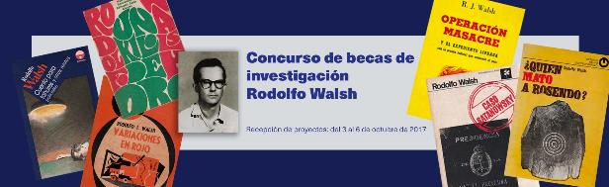

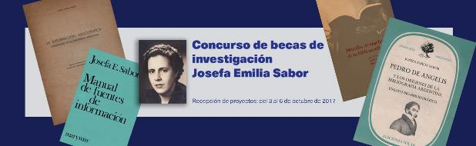

7. The Academic Mainstream | Streaming Video
By Jennifer A. Dixon

Streaming video is becoming a mainstay on college campuses,
but discovery and walled-off content create their own challenges
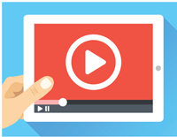
Recent trends in technology are dramatically reshaping academic library collections, and while the use of video in higher education isn’t new, the move toward streaming brings a new array of benefits and challenges for academic librarians. LJ recently explored the ways in which libraries are addressing interest in streaming video services.
In April 2017, LJ conducted a blind survey of academic librarians in the United States and Canada, sponsored by Swank Motion Pictures, receiving 330 responses. Most respondents—221—are in four-year colleges and university programs, serving an average of 10,392 students,while the remainder are at community colleges or graduate schools. Slightly over half of the schools were in public university systems.
STREAMING FROM THE OUTSIDE
The vast majority of responding libraries—95 percent—offered some sort of streaming video content, with a particular focus on documentaries, full-length movies and television programs, and historical archive footage. Of those that offer streaming, 83 percent license their video content from multiple vendors’ video streaming platforms, particularly Films on Demand, Kanopy, Alexander Street, and Swank Motion Pictures. Other notable platforms included Ambrose Digital, Swank Digital Campus, Docuseek2, Film Platform, Intelliform, JOVE, and MedCOM.
Alexander Street is the vendor from which libraries license the most content, though Films on Demand is the vendor with which they spend the most money. Kanopy was selected as the “most valuable” streaming platform for both students and faculty.
Over 90 percent of respondents rely on IP address authentication to access these platforms. About a third use single sign on, while others work with proxy servers, geolocation authentication, or multiple logins.
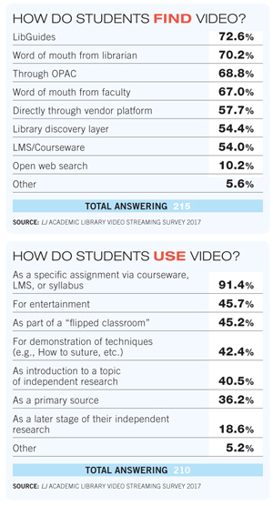
HOSTING AT HOME
Once you get beyond commercially available content, the numbers drop significantly, though a substantial minority are streaming other content as well: 61 percent of responding libraries provide access to streaming faculty- or student-produced videos. Of those that do, 76 percent host them locally, while 32 percent offer them through a vendor platform. Christine Fischer, head of technical services for the University of North Carolina (UNC), Greensboro, Library, described working with a faculty member who inquired about posting his own film to make it more widely available. The library connected him with vendor Kanopy, and the film is now not only available to UNC students, it is part of the Kanopy catalog. Making that happen was an “interesting and different” library service, she said.

Hosting streaming video comes with its own concerns. As a community college librarian in Illinois explained, content from commercially available sources “is vetted for copyright compliance. As such, we do not rip anything in its entirety.” Multiple respondents emphasized the importance of taking into account legal restrictions, particularly copyright, when hosting videos. A librarian at a private postgraduate Massachusetts library said in response to this topic, “We are very careful about not ripping commercially available DVDs as that violates copyright. The locally streamed content is content taped at [the] university that is produced by the university.”

http://lj.libraryjournal.com/2017/09/academic-libraries/academic-mainstream-streaming-video/#_

