Año 2 Número 41 septiembre 2017

Contenidos de este número

 | Browse our website |  |  |  |  | Forward email

Discover the complete New Oxford Shakespeare online
We are very pleased to announce that the Critical Reference Edition has just published online, completing The New Oxford Shakespeare online project.
This ground-breaking project is accessed via Oxford Scholarly Editions Online, and consists of three major new works:
- The Modern Critical Edition – complete works with modern spelling, for students and teachers
- The Critical Reference Edition – complete works with old spelling, for scholars involved in literary and bibliographic research
- The Authorship Companion – essays on questions of authorship and chronology
Your patrons can now explore the texts with side-by-side scrolling of the Modern Critical and Critical Reference editions, access links to images of the appropriate folios and quartos in libraries worldwide – including the Bodleian and Folger libraries, and browse the lists of Shakespeare’s collaborators and their contributions.
Explore The New Oxford Shakespeare online »

2.
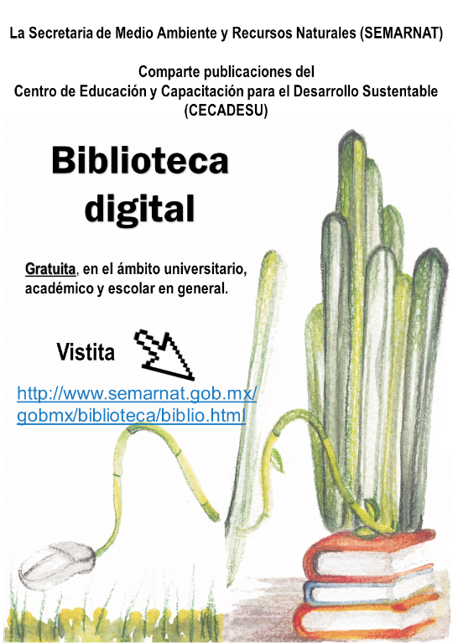

El libro electrónico: propiedad intelectual, derechos de autor y bibliotecas
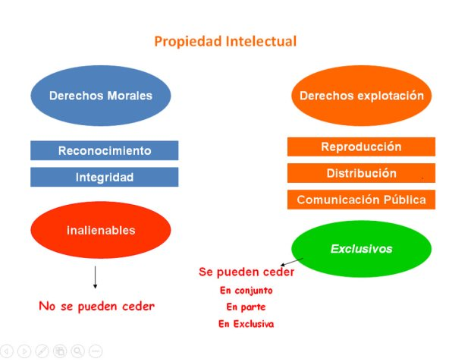
El libro electrónico: propiedad intelectual, derechos de autor y bibliotecas / José Antonio Cordón García, Fernando Carbajo Cascón y Julio Alonso Arévalo
Capítulio 12
En
El copyright en cuestión Diálogos sobre propiedad intelectual
Javier Torres Ripa, José Antonio Gómez Hernández (coords.). Bilbao: Deusto, 2011 ISBN: 978-84-9830-301-8 (Edición digital) 202 págs. 15×22 cm.
Descargar libro
Las posibilidades que facilitan las tecnologías actuales han permitido el surgimiento de diferentes modalidades de puesta a disposición de la información a través de servicios en red. En este “maremagno” de información que es Internet los derechos de propiedad de los diferentes autores que concurren en la realización de una obra quedan diluidos en un laberinto de hiperenlaces. Vivimos un momento de progresiva adaptación de la industria editorial al nuevo entorno. Nuevas formulas de difusión : autoedición, streming … Progresivo proceso de sustitución del soporte papel al soporte digital.
La ley de Propiedad intelectual establece un modelo extraño, desde el punto de vista salarial, según el cual el autor recibe una retribución por unidad vendida, no por el desarrollo de su trabajo. El argumento subyacente en esta práctica consiste en hacer partícipe al autor del mayor o menor éxito de su obra en el mercado. Y si la obra vende por debajo de su inversión en autor no tiene que compartir perdidas. Otorga un capital simbólico y una medida de calidad.

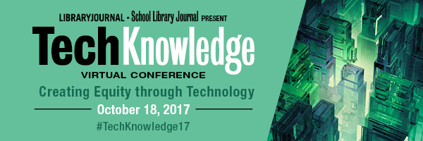
Dear Colleague,
From one librarian to another, I am excited to announce the full program for the 2017 TechKnowledge virtual conference (formerly The Digital Shift)!
On October 18, 2017, join LJ and SLJ in a dynamic, day-long, FREE virtual conference that brings together thousands of library professionals and thought leaders from around the globe to discuss this year's theme, Creating Equity Through Technology.
This virtual conference will address how technology solutions are supporting equity and inclusion within and among libraries' diverse communities. Our expert speakers and panelists will present innovative ideas and tools for and from libraries of all types—school, public, and academic.
Explore emerging technologies, exciting service models, innovative programming, new ways of sparking learning and engagement, and the evolving tech ecosystem through four high-content learning tracks. Register today to secure your place.

Take a look at some of the exciting presentations
in this year's lineup:
- An opening panel on the mission-critical topic of Building Equity and Access in a Challenged Net Neutrality Landscape, convened by American Library Association President Jim Neal and key advocates for Net Neutrality
- From the Newsroom to the News Feed: How do we investigate forces shaping news production and distribution and respond to them? curated by Electronic Resources and Libraries (ER&L) and featuring presenters from the Data and Society Research Institute
- Good Chemistry: Building Equity and Inclusion Through Creative Partnerships, curated by the Knight Foundation
- All Means All: Technology Levels that Level the Playing Field in School Libraries, Monica Cabarcas and Erica Thorsen, librarians at Albemarle High School (VA)
- An inspiring, call-to-action closing presentation on Curating Information Collections for the Public Good by Marnie Webb, CEO, Caravan Studios, a division of TechSoup

(Programa UNAM DGAPA PAPIIT - IN402016) Escuela Nacional de Estudios Superiores, Unidad Morelia 8, 9 y 10 de noviembre de 2017 OBJETIVOS: • Exponer y analizar la situación y problemas que afronta la preservación de colecciones digitales en bibliotecas, archivos, museos y galerías; • Establecer puntos de coincidencia y vínculos entre los profesionales de bibliotecas, archivos, museos y galerías para la búsqueda de soluciones conjuntas en materia de preservación digital; • Crear estrategias comunes que puedan ser aprovechadas por las bibliotecas, archivos, museos y galerías.

http://iibi.unam.mx/micrositio/CIADII/convocatoria.html

GPO Requests Recommendations to Update Federal Deposit Library Rules
By Lisa Peet on August 24, 2017 Leave a Comment
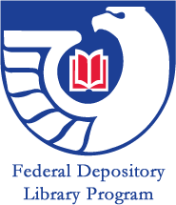
U.S. Government Publishing Office (GPO) director Davita Vance-Cooks has asked the Depository Library Council (DLC) to recommend changes to Chapter 19 of Title 44 of the U.S. Code, a request that has some members of the government information community concerned and others encouraged. Chapter 19 codifies GPO’s Federal Deposit Library Program (FDLP) into law, guaranteeing that the government will provide its information for free to the general public, and has not been significantly revised since the early 1990s.
DLC is asking the public to submit comments and suggestions for modernizing FDLP through August 31, after which it will disseminate draft recommendations at the fall 2017 Depository Library Council Meeting and Federal Depository Library Conference on October 16–18 in Arlington, VA. James R. Jacobs, government information librarian at Stanford University, CA, has posted a Change.org petitionthat interested parties can sign “to assure that any changes to the law strengthen the FDLP and free public access to and preservation of government information regardless of physical or digital format.”
Vance-Cooks, who has been GPO director since 2012, is hoping for revisions that provide depository libraries more flexibility, and update Title 44’s language, which dates back to the early 1960s. However, many in the government information community have expressed apprehensions that opening up Title 44 to revision could threaten the core values of FDLP mandated by Chapter 19: free, ongoing public access to government information.
FDLP, which was established by an 1813 Congressional Joint Resolution, is overseen by the GPO—formerly the Government Printing Office—which is in turn overseen by the Congressional Joint Committee on Printing.The Depository Library Act of 1962 established the system of regional depository libraries and provided for the distribution of all federal government publications among them.
GPO also designates federal depository libraries in all 50 states. Each state may have up to two regional depository libraries, which retain a copy of all government publications received and provide interlibrary loans to other depository libraries. Congressional districts may each contain up to two elective depository libraries, which choose to receive certain classes of government documents, depending on the needs of their constituents. All federal depository libraries, even those that are part of private academic institutions, are required to offer free, public access to these collections.
The 15-member DLC advises GPO on issues related to FDLP, with the development, management, and dissemination of electronic information being a current critical issue.

http://lj.libraryjournal.com/2017/08/legislation/gpo-requests-recommendations-to-update-federal-deposit-library-rules/

Library Leaders Need to Get Humor Right | Leading from the Library
By Steven Bell on August 24, 2017 Leave a Comment
Library leaders have their share of celebratory and difficult moments. Sometimes it seems like the bad news outweighs the good, and that’s when leaders may use humor to cope with organizational stress. Those who do humor well know how to get it right.
In between opportunities for celebration, library leaders inevitably have moments when things go badly. Some are entirely unexpected, like when a corporation with questionable motives suddenly acquires a friendly, trusted vendor. Other times it is simply a matter of waiting for the axe to fall: for example, when budget cuts are on the horizon for our financially struggling institution. Knowing how to cope in these situations, to keep staff morale from plummeting, is the type of thing leaders learn from experience. What’s rarely learned from books, leadership programs, or even other leaders who are good at it, is the effective use of workplace humor. Properly applied, the ability to make colleagues laugh or draw on the lighthearted aspect of any situation is of inestimable value.
DELICATE BALANCE
If employees were asked if they’d rather work for a leader with a good sense of humor or one without, or worse, a sourpuss, you know what the answer would be. SmartBrief on Leadership did ask its 210,000 readers. Nearly half of the respondents said humor was more than just a desirable quality, it was critical for success. Another 43 percent indicated that humor was a core leadership trait. The reasons are obvious. Leaders who bring humor to a tense situation alleviate stress, make tedious meetings more enjoyable, and communicate that we can occasionally take ourselves less seriously—or even be downright silly. Here’s the catch: As much as employees enjoy a leader with a sense of humor, they unequivocally dread the ones whose attempts at humor consistently fail. All leaders desire to attain these valued core traits, but getting humor wrong is downright dangerous. If it offends, is poorly timed, or comes at someone else’s expense, at a minimum it could erode trust and at worst could signal the start of the end.
HUMOR THEORY
Given the precariousness of leadership humor, what’s the best way to incorporate it into our skill set with the wisdom to apply it judiciously? It’s a difficult trick to pull off because a good laugh often comes spontaneously. Preparation is rarely possible. It just happens. If it’s the right time and situation, telling a joke could actually work. The Humor Code by Peter McGraw and Joel Warner seeks to assemble a unified theory of humor by studying what’s funny across cultures and settings. They advise leaders to aim for more “aha” than “ha-ha.” It’s painful when leaders try too hard for laughs. But a clever remark or observation at the right moment, demonstrating keen wit, can work well. They conclude that having a good sense of humor is the ability to achieve “benign violation.” That means provoking laughter when something is not quite right or unsettling, but is also acceptable or safe. Easy, right?

http://lj.libraryjournal.com/2017/08/opinion/leading-from-the-library/library-leaders-need-to-get-humor-right-leading-from-the-library/

A Data-Driven Approach to Electronic Resources Collections
Posted on August 22, 2017 Leave a Comment
By, Karen Phillips
SVP Global Learning Resources
SAGE Publishing
In a new series that celebrates innovators in academic libraries across the U.S., I have the great privilege of diving deeper into the work of a segment of the 2017 Movers & Shakers announced by Library Journal in the spring. I’m kicking off the series by sharing some electronic resource collection insight from Lindsay Cronk, who was recently made Head of Collection Strategies at the University of Rochester in Rochester in New York. Read some of her shared wisdom below.

You’ve implemented some successful, outside-the-box approaches to building your electronic resources library. Can you tell us more about this?
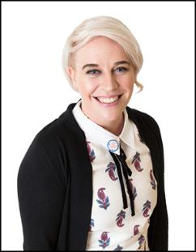

CURRENT POSITION
Coordinator of Online Resources & Collections, University of Houston, TX

DEGREE
MLIS, Valdosta State University, GA, 2012

FOLLOW
@linds_bot (Twitter); LindsayTheLibrarian.com; litablog.org
Photo by Patrick Heagney
I think that academic libraries are at a critical collections moment—with online subscription content dominating our budgets, the way we approach acquisitions and collection development needs to be rethought. We are lucky in that we have more data than ever before such as usage stats, cost data, coverage data, and bibliographic data collected from disparate sources like ILS and usage reports. I collect, process, interpret, and combine the data where possible to improve our decision making and demonstrate the value of our collections. I would say my essential strategy boils down to content assessment—can we figure out what is valuable and special and parse it from the clutter of big packages and aggregators? In some ways it’s old school, but I think of it as a kind of format-agnostic weeding.
How did you get your library colleagues and other admin on board with these strategies?
I am an enthusiastic person, and enthusiasm and data will make a lot of headway in any situation. At the University of Rochester, I am particularly lucky to be supported by talented and eager colleagues and administration who continually wow me with their kindness and ability. It’s an amazing team—and we’re hiring.

http://lj.libraryjournal.com/2017/08/people/movers-shakers-2017/a-data-driven-approach-to-electronic-resources-collections/?utm_source=ljsnewsletter&utm_medium=newsletter&utm_content=sponsoredcolumn&utm_campaign=sage

