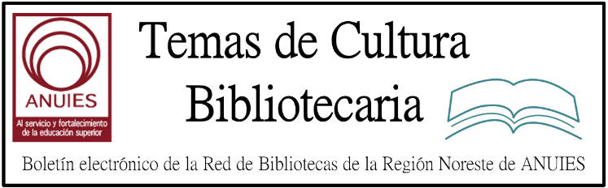

Año 2 Número 40 septiembre 2017

Contenidos de este número

2. Roberto “el Negro” Fontanarrosa: archivos clasificados. Muestra en la BNMM

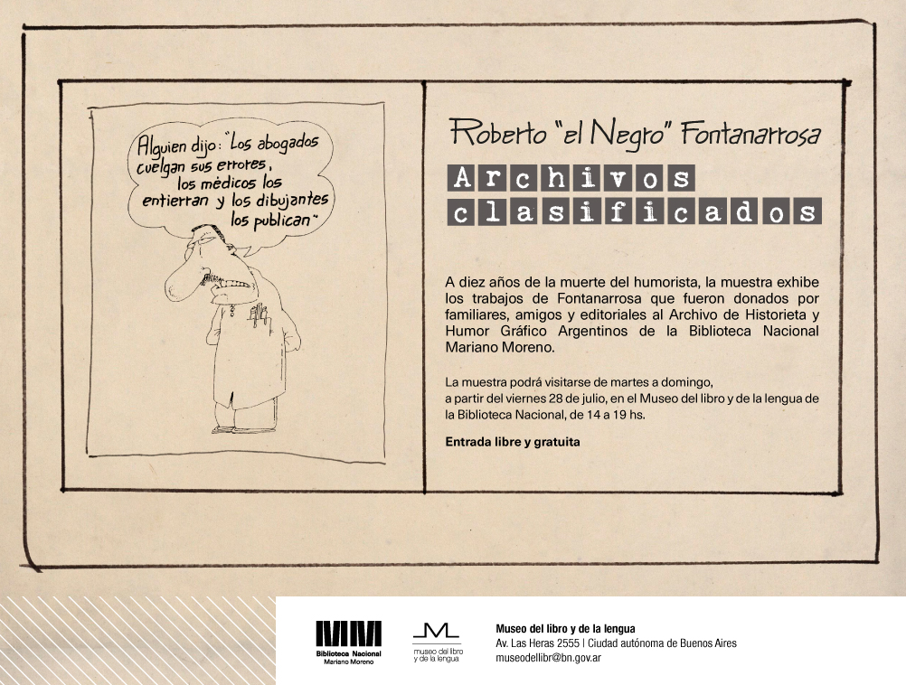

3. Hiring is Recruting: A Career Often Begins in a Low-level Library Job | Blatant Berry
By John N. Berry III
Many of my closest librarian friends found their way into our profession much as I did. We had no idea what a librarian did, nor how or why anyone would become one. In my case, just out of the U.S. Army after two years as a draftee and badly in need of a livelihood, I followed up on an advertisement from a local library. Apparently, I was the only able-bodied male who applied and the only applicant they thought might be able to deal with the rowdy adolescents who invaded the place every afternoon (see “Listening to the Young“). The rest, as they say, is history.
Recently, teenage Patrick Robertson, one of my next-door neighbors whom I pay each spring to mow my lawn, stopped by to tell me he had decided to pursue a career as a librarian. He is a very smart young man and had been considering his options for the future. He found librarianship, much as I had, by taking a position in the local library. He enjoyed the work so much he decided to look to it as a career. I was delighted at his decision and enjoyed knowing that he discovered our profession as I had, albeit some six decades later.
I am very familiar with that very small library, the Richards Free Library in my hometown of Newport, NH, and its librarian, Andrea Thorpe. She is one of those paragons of our field whose enthusiasm for the work is highly contagious. Young Patrick has apparently been captured by her professional powers.
I have witnessed stories such as his literally hundreds of times, many of them from students in classes I have taught in LIS programs. It strikes me that while many of us know how working in a library attracts people to this field, we need to develop more organized ways to use that exposure to recruit new librarians.
There is no doubt that experiencing various aspects of librarianship can make someone want to enlist in it. Our academic and public libraries are staffed by thousands of students and young folks who came for temporary employment and discovered a future as a result.
We haven’t always used these recruits well and have probably lost many because of the menial chores we offered, the low rate of pay, and the tediousness they had to endure. Yet in smaller libraries, where pages and clerks often have to interact with library users, younger library workers get at least a taste of what a professional librarian’s job encompasses. For many, it is an inspiration and suggests a course they had never considered.
Clearly, it would make these initial jobs even more attractive if we add to them meaningful and varied tasks, especially those that require interacting with the public. It would also be helpful if we librarians would connect more with these recruits, sharing inspirations and professional highlights and suggesting ways they could find out more about our industry and its opportunities.

http://lj.libraryjournal.com/2017/07/opinion/john-berry/hiring-is-recruting-a-career-often-begins-in-a-low-level-library-job-blatant-berry/

4. [DOCUFORUM] Nueva plataforma ya ACTIVA
B
Boletin Fundacion Ciencias de la Documentacion <DOCUFORUM@LISTSERV.REDIRIS.ES>
on behalf of
Fundacion CD <contacto@DOCUMENTALISTAS.ORG>

DOCUFORUM@LISTSERV.REDIRIS.ES
Estimados profesionales,
ya está activada la nueva plataforma eLearning de la Fundación Ciencias de la Documentación.
Al ser nuevo diseño y contenidos, invitamos matricularse nuevamente en la plataforma a quienes deseen realizar los cursos y certificaciones que iniciamos en septiembre, así como a quienes deseen participar en la nueva CAFETERÍA que hemos habilitado para compartir ideas y experiencias entre todos los alumnos y profesores (no es necesario estar en ningún curso para participar en la cafetería).
REGISTRO AUN MÁS SENCILLO
Si no se ha registrado en la nueva plataforma (es decir, si no lo ha hecho después del 1 de Agosto) lo puede hacer ahora de forma mucho más sencilla, ya que incluso se puede hacer sin usar ninguna clave, sólo con su cuenta de Google o Facebook. El proceso no lleva más de 2 minutos ;-) Para hacerlo sólo hay que ir a https://documentalistas.org/plataforma/login/index.php
Como siempre, nuestro Dpto. Técnico está a su disposición para resolver cualquier duda que pueda surgir.
Muchas gracias, y bienvenidos nuevamente.
----
Dpto. de Información
Fundación Ciencias de la Documentación
www.documentalistas.org

5. Albany Public Library Partners with Transportation Authority
By Lisa Peet
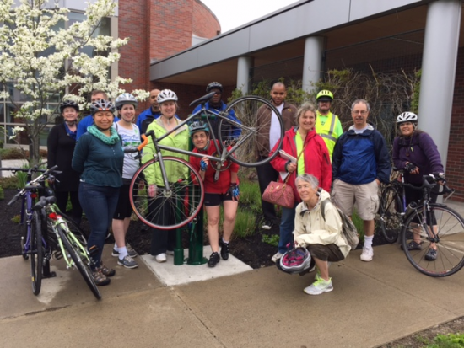
Members of library staff, board, and partners celebrate the unveiling of Albany Public Library’s Bike Fixit Stations with a cross-city ride.
Photo credit: Dana Willbanks, APL
New York’s Albany Public Library (APL) has partnered with Hudson Valley Community College; the city’s public school system; Youth FX, a filmmaking program for teens in Albany’s underserved areas; and local musicians for its “Reading Music” challenge. But over the past couple of years, APL has also formed an alliance with a city agency that isn’t often associated with the library—the Capital District Transportation Authority (CDTA)—on several innovative programs designed to bring library workers and patrons to its branches by bus and bike.
In addition to establishing a series of bike repair stations partially funded by the Capital District Transportation Committee (CDTC)—the designated Metropolitan Planning Organization for the Albany-Schenectady-Troy and Saratoga Springs metropolitan areas, which writes policy and disburses grants—and an upcoming bike share program in which the library is a partner, APL helped CDTA pilot its new Navigator smart cards and became a vendor of the cards once they were instituted. Together, APL and CDTA subsidize cards for library staff members so they can ride the bus to work free of charge.
NAVIGATING THE NAVIGATOR
In 2010, seven-branch APL completed its $29.1 million Branch Improvement Plan, renovating three buildings and constructing two new branches. For all five buildings, access to public transportation was a critical part of the planning process. Every branch currently has a bus stop in front of it, and a significant portion of cardholders and staff are bus riders.
Shortly before former APL librarian Scott Jarzombek returned as executive director in 2014, the library had applied for a grant to redo the sidewalk leading up to its main library, the Washington Avenue Branch. At the same time, CDTA was discussing relocating the bus stop serving the library—at one of the city’s busiest and most dangerous intersections—to the front of the building. CDTA was holding a series of public forum meetings about recent work and asked to hold them at the library.
“And that started the conversation,” Jarzombek recalled. As it turned out, he had known CDTA director of planning Ross Farrell for years, and the two started talking—not only about the bus stop but also about other ways the library and CDTA could work together.
“People may not think immediately of transportation and libraries coming together as a partnership, but for us it makes good sense,” CDTA communications manager Jaime Watson told LJ. “The main branch is on one of our main routes…. A lot of our customers are their customers. But also they’re just a great partner to have in the community, because they share the same values that we do when it comes to community partnerships, they understand the value of it.”
One of the authority’s projects in development at the time was the Navigator, a multiuse prepayment bus pass that lets customers load cash onto cards either online or at a register, then tap the card on a reader in the bus to pay their fare. CDTA was looking for a few organizations to pilot the program before it went live, and Jarzombek pointed out that library staff would be ideal test run subjects: many of them commute by bus, and librarians are comfortable rolling out new technology.
Library staff beta tested the Navigator card for several months beginning in November 2015, providing CDTA with detailed feedback—most of it positive. All pilot participants, including those from other organizations, were sent to APL locations to “recharge” their Navigator cards at library service desks.
The Navigator card program was successfully launched in January. Library workers have continued to use their cards at no cost as part of a “Universal Access” partnership between the library and CDTA: APL covers the cost of the passes, which CDTA offers at a reduced rate. The library sees 300–400 bus pass uses a month, said Jarzombek.

http://lj.libraryjournal.com/2017/08/public-services/albany-public-library-partners-with-transportation-authority/

6. 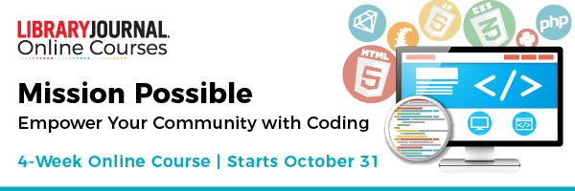
Register by September 1 to receive your 25% early bird discount!
You don't need tech chops to put together a progressive coding program at your library. Learn from leading companies, organizations, and libraries in this online event and workshop—and launch a coding program in your library that supports digital literacy with the power to transform your community.
Over four weeks, Mission Possible participants will explore all facets of building coding programming, such as hosting code clubs and hackathons, acquiring funding, and curating free resources and technologies available online.
Whether you're serving children or adults, you will build an actionable blueprint for a coding program that fits your budget and serves the specialized needs of your community, without needing to know how to code!
LEARN MORE

7. Penn State Libraries Launch Short Story Dispensers
By Matt Enis
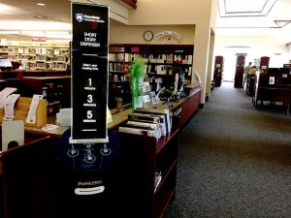Students returning to Pennsylvania State University (PSU) this fall will find four new short story dispensing kiosks installed at libraries across campus, along with a website for submitting their own original stories for distribution through the kiosks. Developed by Short Édition of Grenoble, France, the kiosks’ simple interface allows users to select a story that takes one, three, or five minutes to read. Their story is then printed out on a narrow piece of sustainably-sourced thermal paper the size of a large receipt.
“Libraries are a pretty logical fit for this,” Joseph A. Salem, associate dean for learning, undergraduate services and Commonwealth Campus Libraries for Penn State, told LJ, noting that part of the goal is to foster creative expression on campus and in the broader community. In addition to units at Penn State’s Paterno, Pattee, Architecture, and Physical and Mathematical Sciences Libraries, a fifth kiosk is installed at the public Schlow Centre Region Library in downtown State College.
Short Édition was “really willing to partner with us to get student and community contributions into the platform” and is expected to launch PSU’s custom-developed submission site by the fall, Salem said. Stories submitted to the site and approved for publication after screening/review by staff or faculty will be available both online and from the five local dispensers, along with translated stories from Short Édition authors in France.
The university’s Department of French and Francophone Studies may also translate stories from French to English for the platform, he added.
Although students will be able to access and read submitted stories using smartphones or laptops once the custom website is up, Salem noted that the kiosks are an “attention getter” that will help raise awareness of the underlying program. And, paper—even in small strips—is a medium that gives readers a break from their screens and helps focus their attention, he said.
“The platform will have an online version that renders well on smartphones,” Salem said, noting that he is “a very big proponent for digital content and digital interactions” in academia. However, he added, “I also do feel that there’s something appealing about physical media, especially with art or contemplative work. Maybe that’s just my experience, but there’s a necessary engagement that physical media requires that mitigates the distraction that [can occur] with digital media.”
Launched as an online, participatory writing platform in 2011, Short Édition describes itself as “the community publisher for short literature” on its English site. The platform has generated over 13 million readings of original submissions and public domain classics, and collected more than 200,000 reader/writer subscribers, according to the company. The short stories included in the dispensers in France are finalists and winners of Short Édition’s Grand Prix du Court, a quarterly evaluation and selection process managed by a readers’ committee composed of Short Édition subscribers. Authors of these selected works are offered publishing contracts with Short Édition, and receive small royalty payments when their work is printed on one of the short story dispensers, according to the company.
To avoid repetition, a regularly updated selection of between 300 and 600 stories are stored on the Internet-connected devices at all times, and the stories are distributed in random order, communications chief Manon Landeau said in a recent interview with Publishing Perspectives.
In France, the rollout of eight prototype units in the city hall, tourism office, libraries, and social centers in Short Édition’s hometown of Grenoble in October 2015 was covered by The New Yorker, and French companies including Hermès, Galeries Lafayette, Total, GÉMO, Butagaz, VINCI Autoroutes, Transdev, and others have since partnered with the company to roll out short story dispensers throughout the country, including locations such as train stations, airports, malls, retail stores, and corporate headquarters.
Richard Riccardo, associate director, facilities planning and construction, told Salem about the kiosks after hearing about the concept on a news segment.
“He and I started brainstorming,” Salem said, noting that the concept struck them as an innovative way to engage students at the university’s libraries. “As we think about libraries being a bigger part of the lifecycle of information—engaging students not only in the consumption and evaluation of information, but also in creating their own story—this is a really fun way to facilitate that.”
Riccardo currently monitors Penn State’s five units with an online admin platform, and oversees maintenance including paper replacement when needed, using thermal paper provided by Short Édition.
In May, Penn State became the first to install these short story dispensers in a North American library, although Café Zoetrope in San Francisco debuted the first unit in the United States—and the first to print stories translated from French into English—a year earlier in May 2016. Subculture Coffee in Miami’s West Palm Beach neighborhood and the Prudential Center in Boston also installed Short Édition dispensers shortly after Penn State.
http://lj.libraryjournal.com/2017/08/publishing/penn-state-libraries-launch-short-story-dispensers/

