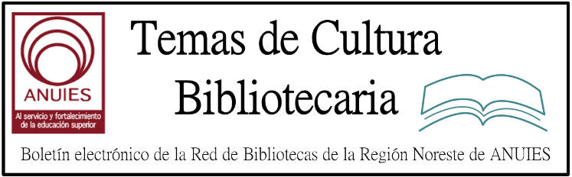

Año 2 Número 39 agosto 2017

Contenidos de este número

Engaging Reluctant Readers in Your Library
Wednesday, August 30, 2017
3-4 PM ET, 12-1 PM PT
Reaching all young readers can be challenging. Attend this live one-hour webcast to explore ways to help increase interest in all YA and middle readers in your public or school library. You will hear from public and school librarians on how they reach their reluctant and struggling readers and how they work together to ensure every reader is engaged. Large print will be an area of focus and a brief readers’ advisory of new titles will be shared.
Register Now!
Panelists
Sabine McAlpine, Strategic Account Manager, Thorndike Press
Sandra Carswell, Librarian, Copperas Cove Independent School District
Michelle Grice, Director of Materials Management, Gwinnett County Public Library
Mary Smith, Editorial Director, Thorndike Press
Moderator
Allison Denny, Librarian, Arlington Public Library

2.

- Researchers Demand More Diversity in Content Sources
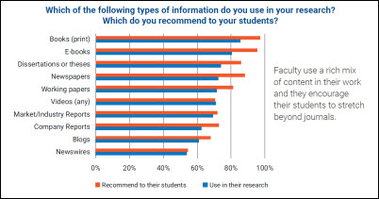
Research and teaching increasingly depends on a mix of content types beyond traditional scholarly journals, survey finds
While traditional peer-reviewed journal content remains a staple resource for researchers, a recent ProQuest survey indicates that research and teaching is informed by an increasingly diverse mix of content types. The survey demonstrates that library collections with a variety of content sources align more closely to changes in user needs and expectations – with the most dramatic shift is in demand for multimedia content.
The evolution in demand for video resources
The 2017 ProQuest survey is a follow-up to a similar one conducted in 2014 that asked a global population of graduate level through faculty researchers what types of content they used in their research and what types of content they recommended to their students. In the two years between surveys, video content showed the biggest spike in popularity among researchers.
In 2015, only 39% of respondents were incorporating video as part of their information gather. In 2017, use has rocketed up to 71%.
Requests for other resources on the rise
Additionally, Open Access journals are rising in credibility, with 72% respondents tapping them and a whopping 89% of faculty recommending these journals to their students.
Additionally, as the research community crosses ever more geographic boundaries, non-English language scholarly journals are valued by more researchers -- about 60% of survey respondents use them.
Other major changes were also related to the impact of relatively new technology: ebooks climbed from 69% to 80% of respondents using them. Usage of blog content also increased from 37% to 61% of respondents citing them. While still the most popular source for research, there was a significant decline in the use of print books, which has dropped from 95% to 83% of researchers citing their use.
Solutions: Libraries can match research and teaching trends by:
- Incorporating both print and ebooks as an important backbone of non-journal content
- Adding video collections to meet researcher needs for vetted, authoritative multimedia content
- Providing access to emerging research and voices with collections that include dissertations and working papers
- Ensuring access to company, industry and market reports for collections that support business researchers
- Staying ahead of journal trends by organizing and including OA and non-English materials in their collections or in their acquisition of aggregated materials
To balance budget requirements with researcher demands, libraries can consider building their foundational collections through acquisition of aggregated resources that embrace content diversity.
To find out more, review the whitepaper.

Research and teaching increasingly depends on a mix of content types beyond traditional scholarly journals, survey finds
While traditional peer-reviewed journal content remains a staple resource for researchers, a recent ProQuest survey indicates that research and teaching is informed by an increasingly diverse mix of content types. The survey demonstrates that library collections with a variety of content sources align more closely to changes in user needs and expectations – with the most dramatic shift in the demand for multimedia content.

The evolution in demand for video resources
The 2017 ProQuest survey is a follow-up to a similar one conducted in 2014 that asked a global population of graduate level through faculty researchers what types of content they used in their research and what types of content they recommended to their students. In the two years between surveys, video content showed the biggest spike in popularity among researchers.
In 2014, only 39% of respondents were incorporating video as part of their information gather. In 2017, use has rocketed up to 71%.
- Requests for other resources on the rise
Additionally, Open Access journals are rising in credibility, with 72% of respondents tapping them and a whopping 89% of faculty recommending these journals to their students.
Additionally, as the research community crosses ever more geographic boundaries, non-English language scholarly journals are valued by more researchers – about 60% of survey respondents use them.
Other major changes were also related to the impact of relatively new technology: ebooks climbed from 69% to 80% of respondents using them. Usage of blog content also increased from 37% to 61% of respondents citing them. While still the most popular source for research, there was a significant decline in the use of print books, which has dropped from 95% to 83% of researchers citing their use.

Solutions
Libraries can match research and teaching trends by:
- - Incorporating both print and ebooks as an important backbone of non-journal content
- - Adding video collections to meet researcher needs for vetted, authoritative multimedia content
- - Providing access to emerging research and voices with collections that include dissertations and working papers
- - Ensuring access to company, industry and market reports for collections that support business researchers
- - Staying ahead of journal trends by organizing and including OA and non-English materials in their collections or in their acquisition of aggregated materials
To balance budget requirements with researcher demands, libraries can consider building their foundational collections through acquisition of aggregated resources that embrace content diversity.
To find out more, review the whitepaper.

http://www.proquest.com/blog/pqblog/2017/Researchers-Demand-More-Diversity-in-Content-Sources.html

4.

Drexel University’s nationally-ranked online Master of Science in Library & Information Science (MSLIS) offers students transformative insight into the future of librarianship.
Taught by the College of Computing & Informatics faculty, Drexel’s online MSLIS offers students the knowledge and skills they need to help their communities access and use information more efficiently and effectively.

Drexel's Online MS in Library & Information Science
Customize your degree toward your area of professional practice with a specialization in:
- Digital Technology Services
- Information and Data Services
- User and Community Services

ALA members receive exclusive partnership benefits:
- New student partner rate – 10-40% tuition savings
- No application fee, deferred billing options available
- Dedicated support from enrollment to graduation
- Additional benefits for military servicemembers, veterans and their immediate family
Learn more

5. Denver News Report Spurs Library Crime Crackdown
By Bob Warburton

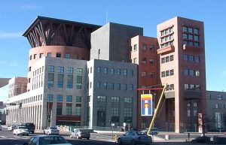
Denver Public Library Central Library
Photo credit: KM Newnham via Wikimedia Commons
A stepped-up effort to curb unwanted and illegal activities, including the sale and use of drugs, at the sprawling downtown Denver Central Library, CO, is starting to yield results, the city librarian said recently, after a particularly troubling few months that saw 14 drug overdoses on the premises since February, along with dozens of arrests.
New security cameras, a ramped-up and more visible police presence, specialized staff training, and targeted physical modifications inside the building are part of a coordinated effort among city agencies to make the 540,000 square foot main branch safer for patrons and library staff, city librarian Michelle Jeske explained in an interview with Library Journal.
Jeske made no attempt to downplay the seriousness of a problem that has plagued the Central Library for more than a year and became a serious public relations problem for the entire city following a local news report in May. But, she said, the situation has improved. That progress, Jeske said, has taken place even as Denver Public Library (DPL) has remained steadfast to its core mission of providing a welcoming place for all.
“I think that things look a lot better here than they did a month ago,” Jeske said. “I think we’re moving very quickly in the right direction. I also am not naïve enough to think that we’re just going to turn around and focus on something else and this will just go away. We’re going to continue to work closely with our city partners to make sure that we’re hopefully keeping the library a safe and welcoming place and hopefully not just moving the problem somewhere else.”
Drug use, trespassing, and other behavioral issues have been a problem for more than a year, according to statistics provided by DPL. Library security keeps a thick book with photos of patrons banned from the premises. In 2016, 911 calls made from the library totaled 262, a 30 percent jump from the previous year. But the flashpoint for the recent security crackdown was the local TV news report in May that gave the general public a startling glimpse of how widespread the problem had become.

http://lj.libraryjournal.com/2017/07/library-services/denver-news-report-spurs-library-crime-crackdown/

6.
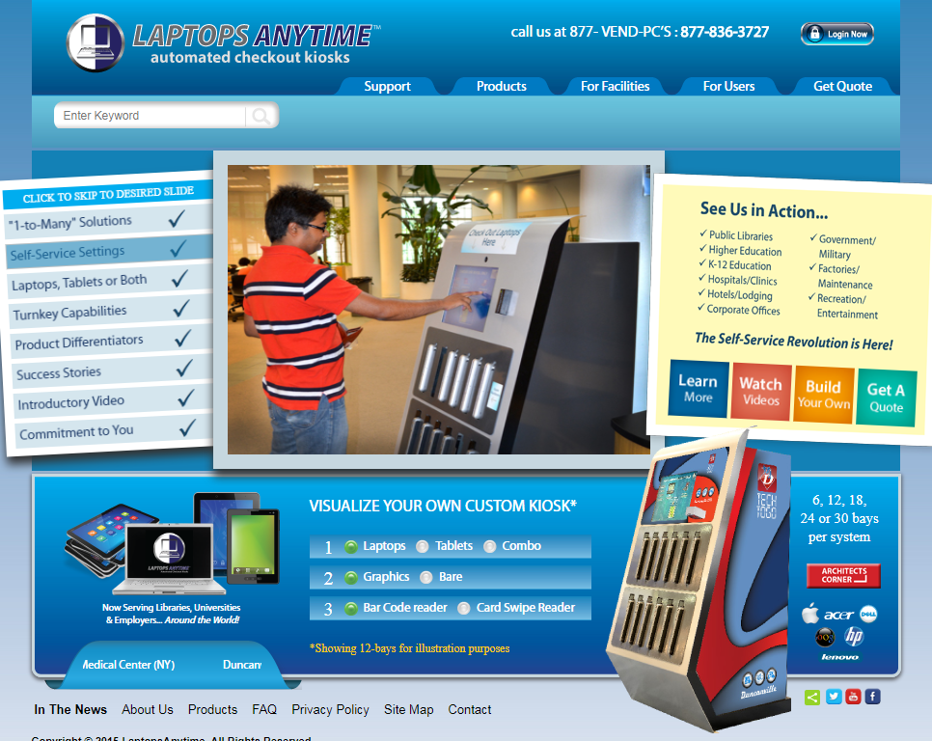

http://laptopsanytime.com/

7. New ISTE Standards for Educators Highlight Librarians’ Role
By Jennifer Hanson on July 21, 2017 Leave a Comment
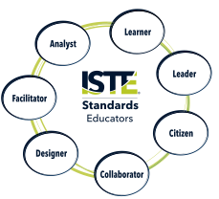Educators should continually participate in professional learning, advocate for equitable access to technology, and model positive and ethical use of technology, according to the Empowered Professional qualities named in the International Society for Technology in Education’s (ISTE) newly revised and updated Standards for Educators.
ISTE CEO Richard Culatta introduced the standards during the opening keynote session at the ISTE 2017 conference in San Antonio in June. Organized into the two categories—Empowered Professional and Learning Catalyst—the newly updated standards shift from the previous Standards for Teachers, which emphasized supporting student learning with technology, to focusing on the roles of educators in “using technology to empower learners.”
As Learning Catalysts, educators should be collaborators, designers, facilitators, and analysts, according to the standards. In these roles, they are expected to collaborate with other educators as well as students. They design and facilitate student-centered learning opportunities, and as analysts, collect and use data to inform instruction and assessment.
While the standards are not specifically written for librarians, we librarians and media specialists have long embraced these roles in our schools and communities. As learners, we have have created many networks to connect with other library professionals. From state library associations to the American Library Association, ISTE, Twitter, and Facebook, opportunities for connecting are endless.
Librarians have one of the largest and most active ISTE professional learning networks: conference rooms at ISTE were not large enough to hold all of us who wanted to attend the Future Ready Librarians and the Hack Your School Library panel discussions.
We are often leaders in our schools—advocating for student access to resources and technology; curating and sharing the top websites, apps, and databases with teachers and students; and finding opportunities to participate in and lead committees that keep our students at the center of teaching and learning.
As collaborators, designers, and facilitators, we work closely with teachers and students to create meaningful learning opportunities, whether through local and global partnerships or maker spaces and Hour of Code activities.
As analysts, we collect and use data about how our materials and spaces inform decision-making, and we advocate for more and better resources for students and teachers. As citizens, we teach students about information, digital, and media literacy.

http://www.slj.com/2017/07/technology/new-iste-standards-for-educators-highlight-librarians-role/

