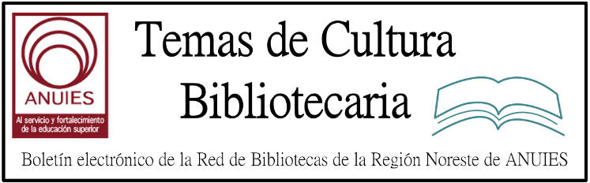

Año 2 Número 35 julio 2017

Contenidos de este número

- Within the Pages of a Book: Professional Media Information
BY LJ REVIEWS
Open Book: A Librarian’s Guide to Academic Publishing. Mission Bell Media. Sept. 2016. 240p. ed. by James Wiser & Rolf A. Janke. index. ISBN 9780997175714. pap. $49.95. PRO MEDIA
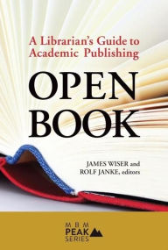This edited volume contains chapters from publishers, vendors, librarians, and directors in an attempt to present an “authoritative perspective” on the present and future of academic publishing. Editors Wiser (Community Coll. League of CA) and Janke (CEO and founder, Mission Bell Media) draw distinctly from their own experiences in the library and publishing industries in shaping the book’s overall arc, which strongly argues for a more collaborative, mutually beneficial relationship between academic librarians and publishers, particularly in the face of recent changes in scholarly communication. Contributors effectively support this argument by providing practical and personal details related to either the “macro” or “micro” aspects of scholarly publishing, including the role of librarians, publisher business strategies, realities of globalization, and processes related to acquisitions, ebooks, and copyright. “Top Takeaways” at the start of most chapters lend the work a sense of consistency that might otherwise be lost along the way. VERDICT A quick and practical look at academic publishing from those “on-the-ground” and leading the way. Recommended for librarians and LIS students interested in collection development, acquisitions, or scholarly publishing.—Robin Chin Roemer, Univ. of Washington Lib., Seattle
Smith, A. Arro. Capturing Our Stories: An Oral History of Librarianship in Transition. ALA. Jan. 2017. 202p. illus. bibliog. index. ISBN 9780838914618. pap. $45. PRO MEDIA
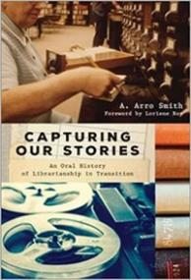Smith (technical services manager; San Marcos P.L, TX) contends the library profession is losing a significant number of professional librarians owing to retirement. To save their stories from being lost, Smith’s doctoral research captured their stories via oral history interviews. Smith reworks his dissertation to produce this volume, providing the stories of 35 librarians whose careers encompassed the latter half of the 20th century. School, public, academic, and special librarians from large and small, urban and rural libraries are represented. Collective themes emerge from the stories, as Smith discusses the relationship subjects have with choosing the profession, battling and embracing stereotypes, adjusting to technology, coping with career regrets, and serving patrons. In writing that is clear and fluid, the author includes an introduction to oral-history theory and methodology and offers practical advice for budding researchers, although at times he retells the same story. A substantive bibliography is provided, but more detailed analysis would have added depth. However, the librarians’ words shine through and give life to this volume. VERDICT The stories contained in this volume will appeal to those interested in the history of librarianship, the history of occupations, the role of women in the workplace, and oral histories.—Lydia Olszak, Bosler Memorial Lib., Carlisle, PA

http://reviews.libraryjournal.com/2017/05/lj-in-print/within-the-pages-of-a-book-professional-media-information/

- Repositories: Update About Next-Gen arXiv Initiative Posted
Filed by Gary Price
From a Post by Oya Rieger on the arXiv Public Wiki:
Currently, we are in the process of assessing various technology components as well as identifying collaboration and partnership options. We will put in place initial testing and implementation of some key technology components and develop new organizational and staffing models to ensure continuity in operations. The completion of the arXiv-NG initiative is anticipated to take approximately three years. Although the funding streams are separate, the arXiv team will take an integrated approach to consider the current operational system (Classic arXiv) and the next-gen system as a unified program.

http://www.infodocket.com/2017/05/31/an-update-about-next-gen-arxiv-initiative-posted/

- Au Cameroun, en France : bibliothèques pour tous !
BF
Bibliothèques Sans Frontières <info@news.bibliosansfrontieres.org>

Reply all|
Sat 10/06, 02:04
Horacio Enrique Cardenas Zardoni
Unsubscribe
Bibliobus Cameroun | Elections législatives | Ideas Box France
Si vous avez des difficultés pour visualiser ce message, consultez la copie web

UN BIBLIOBUS AU SERVICE DES POPULATIONS
ISOLÉES AU CAMEROUN

L'HISTOIRE DU PROJET

A la fin de l’année 2015, une belle histoire commence : le Ministère de l’Art et la Culture camerounais contacte BSF pour mettre en place un projet de Bibliobus qui sillonnerait les périphéries de Yaoundé. L’objectif : aller à la rencontre des populations éloignées géographiquement ou socialement des bibliothèques.

Jean-Dorien Kampoer, responsable du projet bibliobus à Yaoundé, nous raconte l’histoire de 2 utilisateurs :
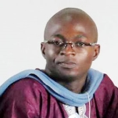

"C’était à Mfou, après l'inauguration du bibliobus, un petit enfant est allé consulter un document en couleur présentant plusieurs espèces d'oiseaux. Il était obnubilé par l’ouvrage ! Il est ensuite venu nous voir en nous parlant des oiseaux qu’il avait identifié autour de lui. Il était très satisfait et semblait heureux d’avoir découvert cela. Je me souviens d’un élève qui m’avait accosté à Okola et avait décidé de nous suivre toute la journée, pendant nos déplacements dans la ville. C’était très touchant, les enfants s'accrochaient à nous et nous demandaient à quelle heure nous revenions le lendemain avec le bibliobus. Nous devions leur expliquer que le bibliobus allait dans plusieurs villages et que nous ne pouvions pas revenir ici dès le lendemain."
Lire l'interview complète

- Five College Consortium Opens $14 Million Remote Storage Facility in Hatfield, Massachusetts
Filed by Gary Price
From MassLive:
The Five College Consortium is celebrating the opening of its $14 million annex in Hatfield with a ribbon-cutting ceremony Friday and tours of the 35,000-square-foot facility.
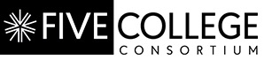The annex provides shelf space for up to 2.5 million items from the Five College Repository Collection and from libraries of the campuses of the consortium –Amherst, Hampshire, Mount Holyoke and Smith colleges and the University of Massachusetts Amherst. That frees up space on the campuses for new materials and other academic needs.
Read the Complete Article
See Also: Additional Info About the New Facility
See Also: Construction Begins on Five Colleges Library Annex in Hatfield, Massachusetts (September 18, 2016)
UPDATE May 30, 2017: Five Colleges Library Annex Set to Take 2.5 Million Volumes (via Greenfield Recorder)
The 26,000-square-foot storage module is a concrete-floored room with 24-foot-high green shelving, where the books will eventually be stacked, waiting for students and researchers to request them from the building’s depths. The property has enough space for the construction of up to four future modules of similar size.
The sheer weight of the room — tens of thousands of pounds of concrete, 1 million pounds of steel shelving, plus the weight of 2.5 million volumes — meant that engineers had to make sure the ground beneath was sturdy before beginning.

http://www.infodocket.com/2017/05/27/five-college-consortium-opens-14-million-remote-storage-facility/

- 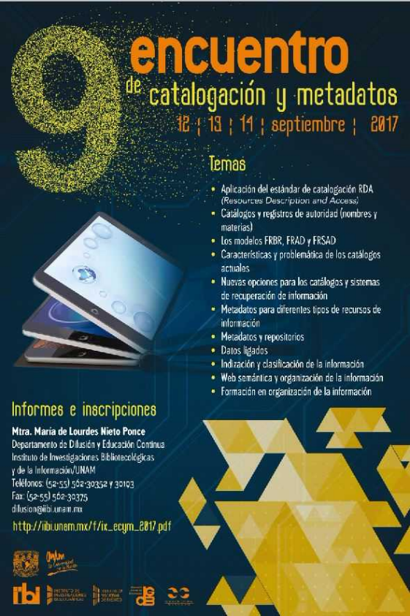
- Boletin Fundacion Ciencias de la Documentacion
Fri 23/06, 15:01
DOCUFORUM@LISTSERV.REDIRIS.ES
RECIBIENDO TESTIMONIALES MUJERES LIDERES AMERICA
http://documentalistas.com/cursos/mujereslideres
El 3 de Julio dará inicio el Mooc gratuito y abierto que reúne los testimoniales de más de 30 Mujeres Líderes de las Américas unidas para lograr el empoderamiento y mejora de la calidad de vida de millones de niñas y mujeres de todo el mundo.
Dos ejemplos de este compromiso son el vídeo testimonial publicado por la Diputada de Guatemala, Carolina Regalado - https://youtu.be/ghZZPGWb8rE -, y el vídeo con la entrevista a la Senadora de México, Angélica de la Peña - https://youtu.be/9IHmt_7cXBY -.
XXI CONGRESO INTERNACIONAL DE BIBLIOTECOLOGIA MEMORIA, PATRIMONIO Y AGENDA 2030 – VALPARAISO 2017
http://www.congresobibliotecarios.cl/
La Fundación Ciencias de la Documentación es entidad Sponsor de este importante Congreso Internacional de Bibliotecología que organizan el Colegio de Bibliotecarios de Chile A.G. y su filial Región Valparaíso, con el fin de generar un espacio de intercambio de saberes con la intención de enriquecer el diálogo respecto al tema memoria y patrimonio.
CONSERVACION DOCUMENTAL DIGITAL
http://documentalistas.com/cursos/conservacion-digital
Para todos aquellos interesados, recordar que el próximo martes 27/Julio dará comienzo la 3era. edición de este curso online donde expertos de España e Iberoamérica analizarán y repasarán conceptos importantes para la conservación y preservación de los soportes y contenidos de los documentos digitales. Todavía es posible formalizar la matrícula.

7.

Entrevista a Mariana Méndez: Bibliotecarios y Bibliotecas en los Museos de Arte
Mariana González Sánchez
Colegio de Bibliotecología. Facultad de Filosofía y Letras.
Universidad Nacional Autónoma de México.
Inscrita al octavo semestre. 2016-2
Contacto: mariana.exlibris@gmail.com
Palabras clave: Mariana Méndez, Bibliotecas en los Museos de Arte, Biblioteca Erik Larsen, entrevista.

DESCARGAR PDF

