Año 2 Número 32 julio 2017

Contenidos de este número

- LSU and Elsevier: A Tale of Two Contracts | Peer to Peer Review
By Kyle K. Courtney

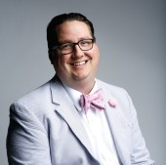In a May 2 statement, the Association of Research Libraries (ARL) announced that Louisiana State University (LSU) filed a lawsuit against academic publishing company Elsevier for breach of contract on February 27. According to the complaint, Elsevier cut off the LSU School of Veterinary Medicine’s (SVM) access to content that was legally licensed by LSU Libraries. For many reasons, especially Elsevier’s often contentious relationship with libraries, this will be one of the more interesting cases to watch unfold.
THE FACTS
LSU Libraries has a large and expensive subscription to Elsevier content—at least $1.5 million dollars annually. The license covers LSU’s Baton Rouge campus and the associated Internet protocol (IP) ranges for access. LSU’s veterinary school, the focus of the current lawsuit, is located on the Baton Rouge campus. SVM had previously held its own license with Elsevier; when that license expired, vet school users continued to access Elsevier content, as licensed by the LSU Libraries agreement, since the LSU Library license states that it covers LSU’s entire Baton Rouge campus, including SVM’s IP range.
In October 2016, Elsevier took action to block access to users at SVM. Shortly after, LSU wrote Elsevier and had that IP range reactivated.
However—as yet unexplained in the lawsuit—Elsevier again blocked SVM’s access in January. This time, when LSU reached out to clarify the situation, Elsevier refused to respond to its requests to reactivate the vet school IP range.
After Elsevier had shut off and then restored the licenses, LSU Libraries tried to license 19 additional veterinary titles from the publisher. Elsevier’s representative provided the requested quotes and LSU confirmed its acceptance of those terms, but later Elsevier refused to honor the agreement, or to license any of the agreed-upon titles to LSU.

http://lj.libraryjournal.com/2017/05/opinion/peer-to-peer-review/lsu-and-elsevier-a-tale-of-two-contracts-peer-to-peer-review/

- Drag Queen Story Hours Flourishing on Both Coasts
By Rocco Staino on June 5, 2017 2 Comments
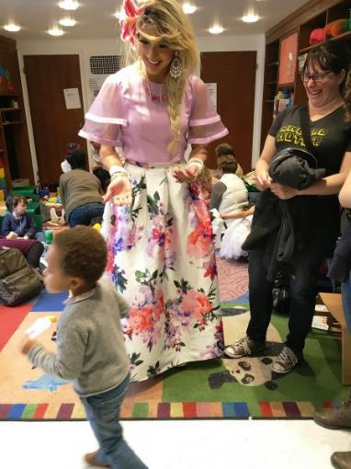
Drag queen Cholula Lemon presides over a story time at the Brooklyn Central Library branch of the Brooklyn Public Library.
A special type of storytime is springing up in libraries and book stores in California and New York, thanks to a non-profit group called Drag Queen Story Hour. The organization states on its website that readers in drag can “capture the imagination and play of the gender fluidity of childhood and give kids glamorous, positive, and unabashedly queer role models.”
Storytimes featuring drag queens started in San Francisco in December 2015, first with celebrity drag queens, such as Honey Mahogany, who was featured on the TV show RuPaul’s Drag Race. The San Francisco-area events are usually held at the Eureka Valley (CA)/Harvey Milk Memorial Library.
“The Drag Queen Story Hour demonstrates the dynamic wit and ingenuity of the queer community and the power of a good story to forge positive personal connections,” says William Johnson, program director for LAMBDA Literary.
The concept moved to the East Coast in August of 2016, when Brooklyn’s Greenlight Bookstore hosted a story hour. That event caught the eye of local public librarians. Both the New York Public Library and the Brooklyn Public Library (BPL) have recently held them. Boston Public Library has one coming up.
“Those of us who work with young children on a regular basis know that children can dress and act in a variety of ways, and supporting their choices builds self-confidence and can help avoid serious problems later in life,” says Judy Zuckerman, director of youth and family services for BPL. “By creating an atmosphere of acceptance, and reading stories about acceptance of differences, we are hoping to stave off teasing and bullying.”
The drag queens read inclusive books, such as Christine Baldacchino’s Morris Micklewhite and the Tangerine Dress (Groundwood, 2014); Todd Parr’s It’s OK to Be Different (Little Brown, 2009); and J.J. Austrian’s Worm Loves Worm (Balzer & Bray, 2016) .

http://www.slj.com/2017/06/diversity/drag-queen-story-hours-flourishing-on-both-coasts/

- Why Social Justice in the Library? | Outreach + Inreach
By Margo Gustina and Eli Guinnee

The case for shifting library policy, practice, and culture toward radical inclusivity
While the American Library Association (ALA) Code of Ethics positions libraries to elevate purposefully the voices and aspirations of all people in their service area, whatever the individual’s social, economic, legal, or citizenship status, many libraries have found that work to be impractical. Historically, libraries have shown a low tolerance for risk and a strong tendency to allocate limited resources of time, money, and energy in areas that yield the greatest results (or, at least, the highest numbers in areas that are easy to measure) and perhaps the least potential for problems.
Some libraries of all types, however, are reevaluating the role they play in their community, questioning whether it is still good enough to provide equal access, or if it is time to pursue an active equitable access that focuses on empowering the less powerful and amplifying the voices of the unheard.

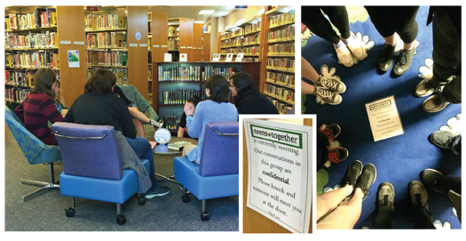
ORGANIC GROWTH Chili Public Library’s teen Gay Straight Alliance developed
out of a process of learning patron needs
BRIDGING THE GAP
In November 2015, a group of Simmons College, Boston, undergraduates released “Ten Demands” of the administration for equitable treatment of students of color. The students expressed frustration with treatment that was at face value equal but did not seek to understand and support populations that have faced historic systemic bias.
We demand that Simmons College live up to its core values by: putting students first, preparing students for life’s work, creating opportunities, and investing in community.
These values cannot be met unless Simmons financially commits to meeting the needs of students of color.
When the Ten Demands were released, Simmons librarian Dawn Stahura immediately felt that the library should play a role in the response: “I personally felt that the library needed to provide information on protests, demonstrations, knowing their rights as citizens, etc. I didn’t ask permission, I literally just did it.”

http://lj.libraryjournal.com/2017/06/library-services/why-social-justice-in-the-library-outreach-inreach/

- Bookmobile for a Day | Programs That Pop
By Kristi Smith
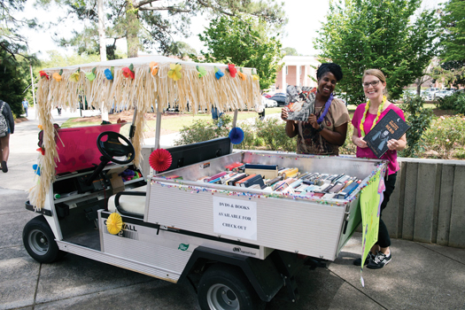
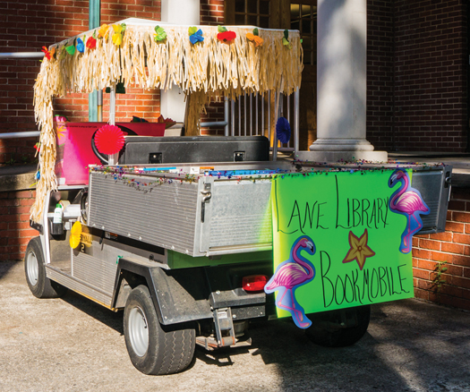
The Lane Library at Armstrong State University (ASU) does not have a bookmobile, but on April 12, four librarians fashioned one out of a golf cart for National Bookmobile Day. The location was the entire ASU campus in Savannah. The weather was perfect, with a high of 79°.
Our story started on March 9 at a Savannah-area meeting of local library workers. A National Library Week brainstorming session ensued: ideas were flying, pens were jotting, and pages were filling up. Then, seeds began to germinate. After one librarian mentioned possibly using a golf cart as a bookmobile on her campus, I thought, “Hey, we could totally do that at my library!” I forgot to consider that Lane Library doesn’t actually own a golf cart. Small matter. Surely, there was a golf cart to be found on campus.
I came to work the next day buzzing with excitement over the prospect of our library being able to turn another department’s golf cart into our very own bookmobile for a day. The first hurdle? Recruiting my coworkers to go down this crazy road with me. I was able to persuade three of them to join in my goofy plan. The second hurdle? Asking my bosses for permission. They both said, “Yes.” Score!
The third hurdle? Procuring the golf cart from ASU’s facilities department. It couldn’t be just any golf cart. It had to have a cargo bed, with walls, not so deep that students couldn’t reach over the sides to grab a book, yet not so shallow that the books would topple out when we hit the gas. The result came in the form of wonderful, couldn’t-be-more-perfect golf cart #56. Hurdle 3.5; my coworkers and I had to take a mandatory golf cart driving safety course.
No big deal! We had this in the bag.

http://lj.libraryjournal.com/2017/06/opinion/programs-that-pop/bookmobile-for-a-day-programs-that-pop/
- U. Chicago Undergrad Library Workers Unionize
By Jennifer A. Dixon
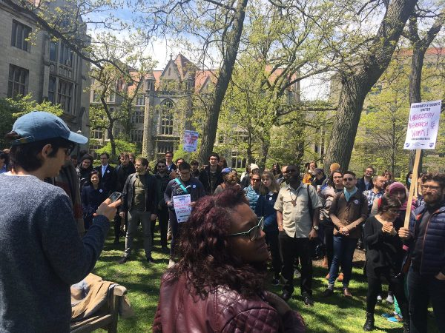
U. Chicago student library workers rally at petition filing
Photo credit: Anna Wood
Undergraduate library workers at the University of Chicago (UC) have voted to unionize, forming the first union of its kind at a private U.S. university. The new Student Library Employees Union (SLEU) could represent up to 220 members, the majority of them undergraduates, and will negotiate with UC on wages, hours, and third-party legal representation.
On May 7, 2017, a coalition of student workers in the UC libraries filed a petition for union recognition. The student library employees worked with local union Teamsters Local 743, which currently represents full-time library employees at UC, to file their petition with the National Labor Relations Board (NLRB). These employees work in many roles throughout UC’s library system, including circulation, special collections, the stacks, and the maps collection.
The vote on unionization took place from June 2 through June 8, with voting booths placed in several UC libraries.
On June 8, the UC student union announced that over 80 percent of voters supported unionization and affiliation with Teamsters Local 743. Of the 93 student library employees who voted, 67 favored unionization while 13 voted against. Thirteen of the 93 votes were cast by graduate students and have been challenged by the university due to potential overlap with the separate graduate student unionization process; SLEU discussions occurred at the same time as sometimes-contentious discussions concerning UC’s Graduate Students United (GSU), which is seeking official union recognition from the university and the NLRB.
http://lj.libraryjournal.com/2017/06/academic-libraries/u-chicago-undergrad-library-workers-unionize/

- What Academic Librarians Can Learn from Retail’s Meltdown | From the Bell Tower
By Steven Bell
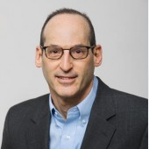For many years the newspaper industry served as the cautionary tale for libraries. But as even the biggest brick-and-mortar stores fall, retail may be an even better example for libraries looking for new ways to provide a better experience for community members.
Businesses of all types have redesigned their service delivery models over the years to respond to changing customer expectations. They want to deliver a new experience that better fits with the on-the-move, convenience-driven lifestyles of consumers. Academic librarians are no strangers to adopting and adapting some of these new models to their own operations. Chat with a live operator for assistance? Check. Use an automated self-service machine for faster service? Check. Stop in the café to grab a coffee or snack on the way to the stacks? Check. Responsive website? Check. Personal librarian? Check.
All good ideas, but even retailers, particularly the ones still maintaining a brick-and-mortar presence, are fighting for survival. Losses to online retailers—mostly Amazon—are taking their toll. Although they too support expansive online content and service operations, academic libraries still mostly focus on a physical campus presence. But it’s no longer a given that students and faculty will come, even if we improve the quality of the experience. What can we learn from the retail world, both the failures and successes, which might lead us to implement some new strategies?

http://lj.libraryjournal.com/2017/06/opinion/steven-bell/what-academic-librarians-can-learn-from-retails-meltdown-from-the-bell-tower/

- The Midcareer MLIS | LIS Education
By Lisa Peet

Going back to school can take a library career to the next level, or enable entry in midstream, but it presents its own challenges
When it comes to what makes a good librarian, the first requirement is experience—whether in the library, working with records, or talking to patrons and students. LJ’s Paralibrarian of the Year Award is one of many testaments to the work done by those who learned libraries through hands-on labor. But sometimes there is no substitute for earning a Master of Library and Information Science (MLIS) degree—either to meet the benchmarks necessary to further a career already in progress, or to shift from an (often already successful) path in another profession.
Earning an MLIS in midcareer brings particular concerns: keeping up with a demanding curriculum on top of job and family responsibilities often needing to stay in place rather than relocating to the program that best fits; taking on tuition costs on top of existing student debt; and mastering new technology at an age when many are comfortably settled into their current skill sets. But as the library field offers a plethora of opportunities for those earning their master’s in midcareer—or midlife, or both—the consensus is that the degree opens doors at any stage of the work cycle, and the additional work is well worth the effort.
MORE THAN A PIECE OF PAPER
The decision to enter an MLIS program in the middle of a busy working life is rarely undertaken lightly, but often it is a library worker’s best path to advancement. For those wishing to transition into a staff position at an academic or government library, or many public library jobs, the degree is a requirement. Even in an economy still digging out of the recession, and a field still smarting from Forbes Magazine’s 2012 ranking of the MLIS as the worst master’s degree for getting employment, increasing numbers of career changers and career boosters have opted to pursue an MLIS throughout the 2010s. Tracy Legaspi, now a contract law librarian at the U.S. Department of Justice (DOJ), was working in an asset management firm when she decided to pursue a library degree. She recalls, “In law school I practically lived in the library, and I always sought out the help of the librarians…. I just felt the pull.”

http://lj.libraryjournal.com/2017/06/library-education/the-midcareer-mlis-lis-education/

