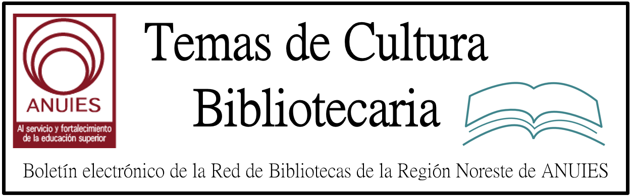

Año 2 Número 30 junio 2017

Contenidos de este número

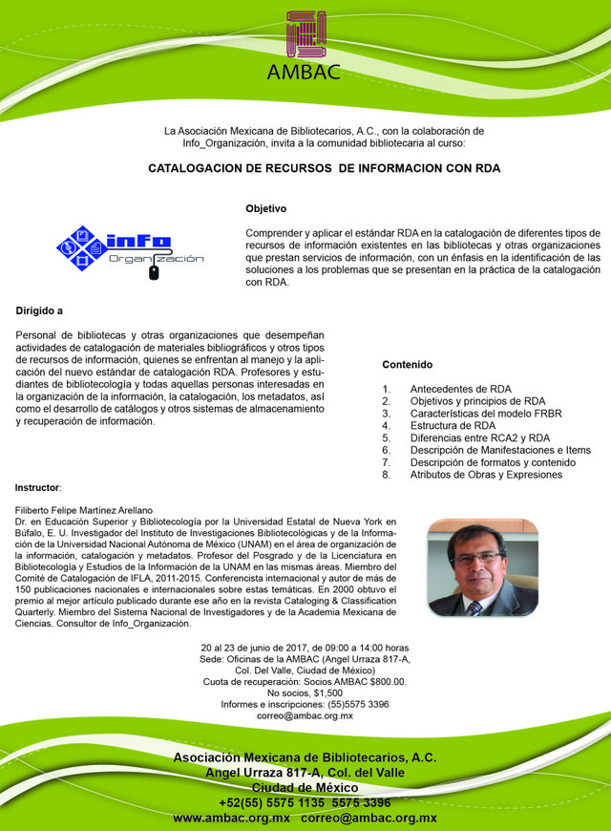

- El préstamo de audiolibros en bibliotecas ha crecido un 27% mientras que los ebooks han crecido un 12%
#bookexpo17 @Storytel_ES

SF/Fantasy’s Best: Nebula Award Winners, Arthur C. Clarke Award Nominees
BY WILDA WILLIAMS ON MAY 25, 2017 LEAVE A COMMENT
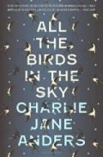
At the 51st Annual Nebula Conference in Pittsburgh last week, Charlie Jane Anders, the cofounder and former editor of the sf/fantasy blog io9, took home the top literary prize granted by members of the Science Fiction and Fantasy Writers of America (SFWA) when her near-future apocalyptic sf/fantasy mashup, All the Birds in the Sky, was named Best Novel of 2016. More possible honors await for Anders’s work, as it is also nominated for a Hugo Award and a Locus Award. [In an interesting side note, Annalee Newitz, who cofounded io9 with Anders, will be appearing at Library Journal‘s May 30 Day of Dialog program to discuss her first novel, Autonomous.]
Seanan McGuire’s acclaimed fantasy Every Heart a Doorway, won the Nebula for Best Novella; it, too, is nominated for a Hugo in the same category. Amal El-Mohtar’s “Seasons of Glass and Iron,” from the anthology of unconventional fairy-tale retellings The Starlit Wood, was honored as Best Short Story, and the Andre Norton Award for Young Adult Science Fiction and Fantasy went to David D. Levine’s steampunk fantasy Arabella of Mars.
LJ sf/fantasy co-columnists Megan McArdle and Kristi Chadwick were delighted by the winners. Chadwick raves, “I am thrilled for McGuire, of course, and Levine and El-Mohtar. Anders was a surprise win in such a fabulous list, but no less deserving.” McArdle agreed. “The Nebula win for Anders was a great choice for a unique book that should have appeal outside of the genre.”
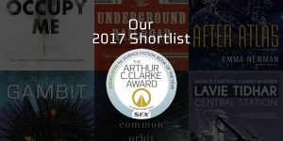Across the pond, the 2017 short list for the Arthur C. Clarke Award, now in its 31st year and the most prestigious literary prize for sf in Britain, was released, honoring the six novels published in 2016. Nominees included Colson Whitehead’s Pulitzer Prize–winning The Underground Railroad, Lavie Tidhar’s Central Station, Tricia Sullivan’s Occupy Me, Emma Newman’s After Atlas, Yoon Ha Lee’s NInefox Gambit, and Becky Chamber’s A Closed and Common Orbit. The winner will be announced July 24 in London.
Chadwick had high praise for the Clarke nominees as incredibly diverse. “This has really been an exciting year for sf awards, and I am hoping the drama we have seen with lists the last couple of years [is] coming to an end and nominations are obviously going to works that speak to the breadth of the universe.”

http://reviews.libraryjournal.com/2017/05/in-the-bookroom/post/sffantasys-best-nebula-award-winners-arthur-c-clarke-award-nominees/

Librarians To Be the Stars of a 2018 Calendar
By Jennifer Kelly Geddes on May 26, 2017 Leave a Comment
Firefighters have a calendar. So do cute puppies. But when do you see a beaming librarian presiding over the month of April? Capstone, publisher of children’s books and digital products, is changing that. For the first time, the company is putting the winners of a national photo contest, touted as “The Power of Librarians,” into calendar form.
“We’re inspired by our customers’ stories every day, plus we see librarians sharing their triumphs and challenges with each other in various social media groups, so we thought the calendar would be a fun way to celebrate those stories,” explains Amy Cox, marketing director at Capstone. “It’ll be a daily reminder of the power librarians have to make a difference.”
The easy part was the nominating process—most of the librarians were suggested by their colleagues and/or the parents of their students. But selecting the 13 winners was far tougher. “A small group within the company reviewed the nominations. The [librarians] that rose to the top all shared a passion for connecting with their students and their communities,” reports Cox. What wasn’t a factor was location, she adds. “Small towns, urban areas, schools with lots of resources, or ones that struggle…it didn’t matter because each of the winning librarians is a fierce student advocate,” she adds.
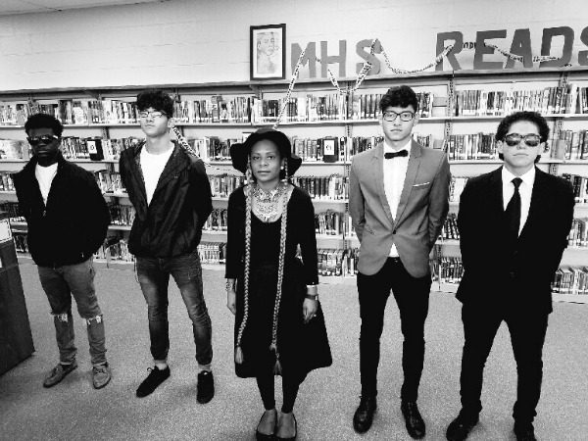
Cicely Lewis, dressed as Beyoncé for a video she made about reading
Honoring powerful librarians was only part of Capstone’s goal. Another aspect of the project was to debunk the myth of the stereotypical librarian: women in glasses and buns shushing patrons. “Real librarians are as diverse as the students they serve—and some of them have quite the flair for good costume, too,” Cox says.
One prime example is Cicely Lewis, media specialist at Meadowcreek High School Media Center in Norcross, GA. She sported Beyoncé-esque garb in a video advertising her library’s books. Brenda Delcid, her library science student, took the winning shot of Lewis dressed as the pop diva in the “Formation” video. Lewis, who works with teens, felt like a rock star when she was chosen as a winner. “I am elated. This honor has motivated me to do more, because I know that other people now recognize the importance of the library media specialist,” she says.
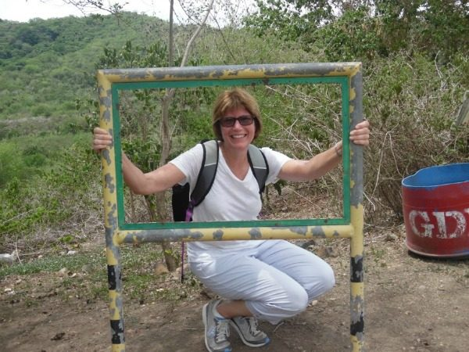
Anne Mlod, hiking Taal Volcano in the Philippines
The winning photo of Anne Mlod, a school librarian at Genesee Elementary School in Auburn, NY, was taken in the Phillippines. She spent three weeks in the country last summer learning about its education system as the first elementary librarian to participate in the Teachers for Global Classrooms Fellowship program. “I was so surprised to be chosen [for the calendar]! I know many amazing librarians, so I’m honored to represent them,” Mlod relates. Her hope is that the picture might inspire other librarians to take on new adventures.
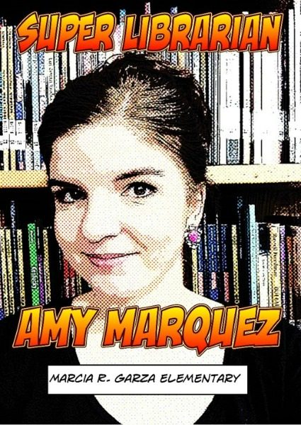
Amy Marquez was also featured on the cover of the Texas Library Association Journal.
Another winning shot, this time of Amy Lynn Marquez, was taken on the job. At the time, she was in a staff development meeting training colleagues to use apps to generate comics. “We were preparing for a super hero themed summer reading celebration,” recalls the librarian from Marica R. Garza Elementary School in Alamo, TX. The win was incredibly special, she reports. “I’m very passionate about the importance of librarians, and the impact [we] make in the field of education. I hope the calendar communicates how essential funding is for the fine arts in schools,” she adds.
The calendar will be available starting in August on CapstonePub.com, with points accrued through the Capstone rewards program able to be applied to the purchase. All of the lauded librarians are heartened by the fact that this project will highlight how exciting read can be. “And in a time when the purpose of the library is being challenged, this award is so relevant—everybody needs to get information!” concludes Lewis.

Jennifer Kelly Geddes is an editor and writer whose work has appeared on the sites of Parents, Highlights, Fisher-Price, and Celebrations.

http://www.slj.com/2017/05/industry-news/librarians-to-be-the-stars-of-a-2018-calendar/

Mission Possible

Empower Your Community with Coding
October 31–November 21, 2017
Live Sessions on Tuesdays at 3:30 PM ET: October 31, November 7, 14 & 21
REGISTER
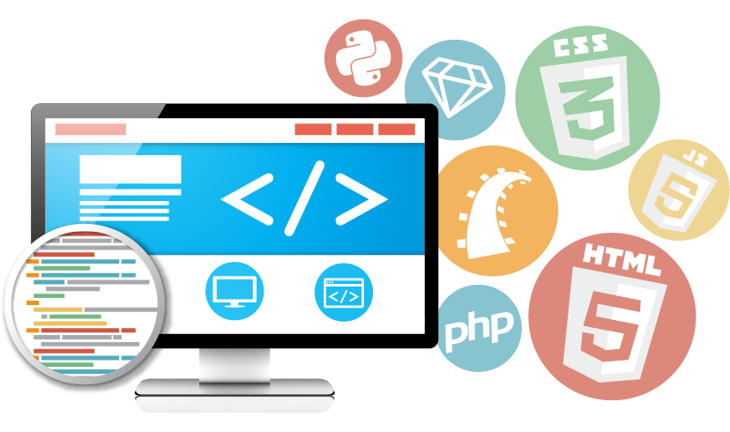
In this interactive workshop, you’ll learn how to launch a coding program in your library that will promote digital literacy and impact your community. You’ll learn how to run computer programming courses that will introduce your patrons to new career paths and technologies. We’ll give you the tools you need to create library programs around coding languages (e.g. HTML, CSS, Python), career development software (e.g. Adobe Creative Suites, WordPress), and early learning (e.g. Scratch and robotics) without having to know how to code.
We’ll explore all facets of building coding programming for your library such as making your case for funding, hosting Code Clubs and Hackathons, and curating free resources and technologies available online.
Over the course of four weeks, participants will listen in on live keynote sessions and receive personal attention and resources from a dedicated advisor in an online coaching environment. Participate in online discussion groups to gather resources and best practices and with peers from across the country.
By the end of this course you will have developed a blueprint for developing a coding program that fits within a variety of budgets and crosses a spectrum of patrons ranging from children to adults.

http://learn.libraryjournal.com/courses/empower-your-community-with-coding/?utm_source=ljsnewsletter/&utm_medium=newsletter/&utm_content=mktgcolumn/&utm_campaign=coding/

- Cursos de Inteligencia de la Información. Junio 2017

El IMAC en junio ofrece el curso de "Derecho de Autor en Ambientes Digitales", En este se identificarán los elementos legales que le facilitarán la toma de decisiones a partir de reconocer la propiedad intelectual propia y ajena. Además se dirigirán a los participantes en la elaboración de políticas y guías de derecho de autor en su institución.

En este mes se llevará a cabo el Foro: Los Archivos en la Sociedad Digital, el próximo 8 de junio de 2017 en el auditorio “Alonso Lujambio” del INAI en la Ciudad de México. Consulta todos los detalles y nuestra oferta de cursos:

Neil Gaiman: Why our future depends on libraries, reading and daydreaming
A lecture explaining why using our imaginations, and providing for others to use theirs, is an obligation for all citizens
- Authors condemn £4m library fund as a ‘sop’ and a ‘whitewash’

‘We have an obligation to imagine’ … Neil Gaiman gives The Reading Agency annual lecture on the future of reading and libraries. Photograph: Robin Mayes

Neil Gaiman
Tuesday 15 October 2013 14.51 BSTFirst published on Tuesday 15 October 2013 14.51 BST
It’s important for people to tell you what side they are on and why, and whether they might be biased. A declaration of members’ interests, of a sort. So, I am going to be talking to you about reading. I’m going to tell you that libraries are important. I’m going to suggest that reading fiction, that reading for pleasure, is one of the most important things one can do. I’m going to make an impassioned plea for people to understand what libraries and librarians are, and to preserve both of these things.
And I am biased, obviously and enormously: I’m an author, often an author of fiction. I write for children and for adults. For about 30 years I have been earning my living through my words, mostly by making things up and writing them down. It is obviously in my interest for people to read, for them to read fiction, for libraries and librarians to exist and help foster a love of reading and places in which reading can occur.
So I’m biased as a writer. But I am much, much more biased as a reader. And I am even more biased as a British citizen.
And I’m here giving this talk tonight, under the auspices of the Reading Agency: a charity whose mission is to give everyone an equal chance in life by helping people become confident and enthusiastic readers. Which supports literacy programs, and libraries and individuals and nakedly and wantonly encourages the act of reading. Because, they tell us, everything changes when we read.
And it’s that change, and that act of reading that I’m here to talk about tonight. I want to talk about what reading does. What it’s good for.

Sign up for the Bookmarks email

Read more
I was once in New York, and I listened to a talk about the building of private prisons – a huge growth industry in America. The prison industry needs to plan its future growth – how many cells are they going to need? How many prisoners are there going to be, 15 years from now? And they found they could predict it very easily, using a pretty simple algorithm, based on asking what percentage of 10 and 11-year-olds couldn’t read. And certainly couldn’t read for pleasure.
Advertisement
It’s not one to one: you can’t say that a literate society has no criminality. But there are very real correlations.
And I think some of those correlations, the simplest, come from something very simple. Literate people read fiction.
Fiction has two uses. Firstly, it’s a gateway drug to reading. The drive to know what happens next, to want to turn the page, the need to keep going, even if it’s hard, because someone’s in trouble and you have to know how it’s all going to end … that’s a very real drive. And it forces you to learn new words, to think new thoughts, to keep going. To discover that reading per se is pleasurable. Once you learn that, you’re on the road to reading everything. And reading is key. There were noises made briefly, a few years ago, about the idea that we were living in a post-literate world, in which the ability to make sense out of written words was somehow redundant, but those days are gone: words are more important than they ever were: we navigate the world with words, and as the world slips onto the web, we need to follow, to communicate and to comprehend what we are reading. People who cannot understand each other cannot exchange ideas, cannot communicate, and translation programs only go so far.
The simplest way to make sure that we raise literate children is to teach them to read, and to show them that reading is a pleasurable activity. And that means, at its simplest, finding books that they enjoy, giving them access to those books, and letting them read them.
I don’t think there is such a thing as a bad book for children. Every now and again it becomes fashionable among some adults to point at a subset of children’s books, a genre, perhaps, or an author, and to declare them bad books, books that children should be stopped from reading. I’ve seen it happen over and over; Enid Blyton was declared a bad author, so was RL Stine, so were dozens of others. Comics have been decried as fostering illiteracy.

No such thing as a bad writer... Enid Blyton’s Famous Five. Photograph: Greg Balfour Evans/Alamy
It’s tosh. It’s snobbery and it’s foolishness. There are no bad authors for children, that children like and want to read and seek out, because every child is different. They can find the stories they need to, and they bring themselves to stories. A hackneyed, worn-out idea isn’t hackneyed and worn out to them. This is the first time the child has encountered it. Do not discourage children from reading because you feel they are reading the wrong thing. Fiction you do not like is a route to other books you may prefer. And not everyone has the same taste as you.
Advertisement
Well-meaning adults can easily destroy a child’s love of reading: stop them reading what they enjoy, or give them worthy-but-dull books that you like, the 21st-century equivalents of Victorian “improving” literature. You’ll wind up with a generation convinced that reading is uncool and worse, unpleasant.
We need our children to get onto the reading ladder: anything that they enjoy reading will move them up, rung by rung, into literacy. (Also, do not do what this author did when his 11-year-old daughter was into RL Stine, which is to go and get a copy of Stephen King’s Carrie, saying if you liked those you’ll love this! Holly read nothing but safe stories of settlers on prairies for the rest of her teenage years, and still glares at me when Stephen King’s name is mentioned.)
And the second thing fiction does is to build empathy. When you watch TV or see a film, you are looking at things happening to other people. Prose fiction is something you build up from 26 letters and a handful of punctuation marks, and you, and you alone, using your imagination, create a world and people it and look out through other eyes. You get to feel things, visit places and worlds you would never otherwise know. You learn that everyone else out there is a me, as well. You’re being someone else, and when you return to your own world, you’re going to be slightly changed.
Empathy is a tool for building people into groups, for allowing us to function as more than self-obsessed individuals.
You’re also finding out something as you read vitally important for making your way in the world. And it’s this:
The world doesn’t have to be like this. Things can be different.
I was in China in 2007, at the first party-approved science fiction and fantasy convention in Chinese history. And at one point I took a top official aside and asked him Why? SF had been disapproved of for a long time. What had changed?
Advertisement
It’s simple, he told me. The Chinese were brilliant at making things if other people brought them the plans. But they did not innovate and they did not invent. They did not imagine. So they sent a delegation to the US, to Apple, to Microsoft, to Google, and they asked the people there who were inventing the future about themselves. And they found that all of them had read science fiction when they were boys or girls.
Fiction can show you a different world. It can take you somewhere you’ve never been. Once you’ve visited other worlds, like those who ate fairy fruit, you can never be entirely content with the world that you grew up in. Discontent is a good thing: discontented people can modify and improve their worlds, leave them better, leave them different.
And while we’re on the subject, I’d like to say a few words about escapism. I hear the term bandied about as if it’s a bad thing. As if “escapist” fiction is a cheap opiate used by the muddled and the foolish and the deluded, and the only fiction that is worthy, for adults or for children, is mimetic fiction, mirroring the worst of the world the reader finds herself in.
If you were trapped in an impossible situation, in an unpleasant place, with people who meant you ill, and someone offered you a temporary escape, why wouldn’t you take it? And escapist fiction is just that: fiction that opens a door, shows the sunlight outside, gives you a place to go where you are in control, are with people you want to be with(and books are real places, make no mistake about that); and more importantly, during your escape, books can also give you knowledge about the world and your predicament, give you weapons, give you armour: real things you can take back into your prison. Skills and knowledge and tools you can use to escape for real.
As JRR Tolkien reminded us, the only people who inveigh against escape are jailers.

Tolkien’s illustration of Bilbo’s home, Bag End. Photograph: HarperCollins
Another way to destroy a child’s love of reading, of course, is to make sure there are no books of any kind around. And to give them nowhere to read those books. I was lucky. I had an excellent local library growing up. I had the kind of parents who could be persuaded to drop me off in the library on their way to work in summer holidays, and the kind of librarians who did not mind a small, unaccompanied boy heading back into the children’s library every morning and working his way through the card catalogue, looking for books with ghosts or magic or rockets in them, looking for vampires or detectives or witches or wonders. And when I had finished reading the children’s’ library I began on the adult books.
Advertisement
They were good librarians. They liked books and they liked the books being read. They taught me how to order books from other libraries on inter-library loans. They had no snobbery about anything I read. They just seemed to like that there was this wide-eyed little boy who loved to read, and would talk to me about the books I was reading, they would find me other books in a series, they would help. They treated me as another reader – nothing less or more – which meant they treated me with respect. I was not used to being treated with respect as an eight-year-old.
But libraries are about freedom. Freedom to read, freedom of ideas, freedom of communication. They are about education (which is not a process that finishes the day we leave school or university), about entertainment, about making safe spaces, and about access to information.
I worry that here in the 21st century people misunderstand what libraries are and the purpose of them. If you perceive a library as a shelf of books, it may seem antiquated or outdated in a world in which most, but not all, books in print exist digitally. But that is to miss the point fundamentally.
I think it has to do with nature of information. Information has value, and the right information has enormous value. For all of human history, we have lived in a time of information scarcity, and having the needed information was always important, and always worth something: when to plant crops, where to find things, maps and histories and stories – they were always good for a meal and company. Information was a valuable thing, and those who had it or could obtain it could charge for that service.

https://www.theguardian.com/books/2013/oct/15/neil-gaiman-future-libraries-reading-daydreaming?CMP=share_btn_tw

