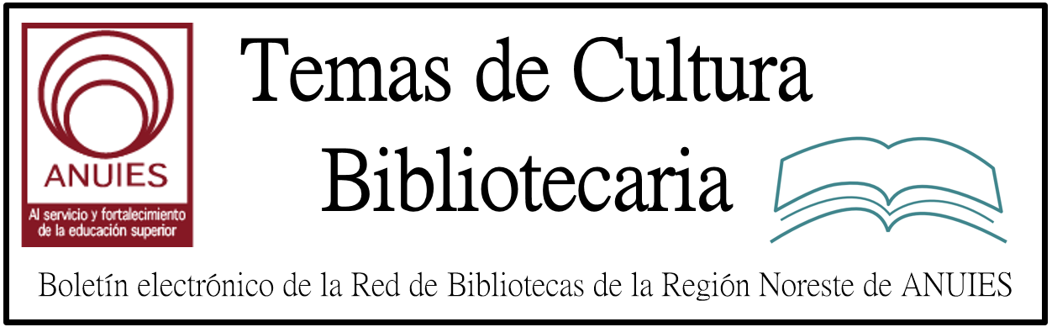

Año 2 Número 29 junio 2017

Contenidos de este número

Sip & Spell: An Adult Spelling Bee | Programs That Pop
By Bonnie Brzozowski and Lindy Brown on May 25, 2017 Leave a Comment
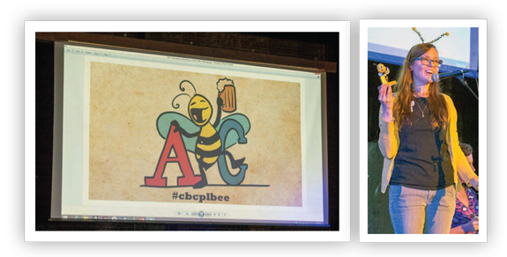
The Corvallis–Benton County Public Library, OR, has partnered with its Friends of the Library for the last two years to offer a spelling bee for adults 18 years and older. The event, called Sip & Spell, helps us reach a wide audience, particularly younger adults age 21–35. Sip & Spell also projects a fun, playful side of the library.
Adult spelling bees in other cities prompted the idea. Corvallis is a college town with a well-educated populace; however, a recent survey found that public library services are predominantly used by senior citizens and families with young children. A bee for adults seemed like a natural way to attract that missing audience.
P-L-A-N-N-I-N-G
Partners were essential to making an event of this scale happen. In addition to staffers, members of our Friends and library advisory board, a librarian from Oregon State University (OSU), and the emcee/local newspaper editor joined the planning committee.
To help limit the number of participants, a registration fee for contestants was established. These and fees for cheats (discussed below) benefited the Friends of the Library.
Funds raised at Sip & Spell are put directly back into the adult programs budget. As costs were higher with the need for a larger venue our second year, this arrangement made it possible for us to continue producing the event. After fundraising, we broke even the first year, and it cost us roughly $1,000 the second year.
We examined rules at other bees, including the Scripps National Spelling Bee, to develop a game plan. They allow for contestants to purchase cheats and include optional championship rounds that can be used if the competition runs long. The cheats add an element of whimsy and allowed us to raise more money. Ranging from $3 to $15, cheats include ask a friend; rewind—having made an error midway through, they get one chance to start over; and a mulligan, whereby a contestant may remain in the contest after misspelling the word.

http://lj.libraryjournal.com/2017/05/opinion/programs-that-pop/sip-spell-an-adult-spelling-bee-programs-that-pop/

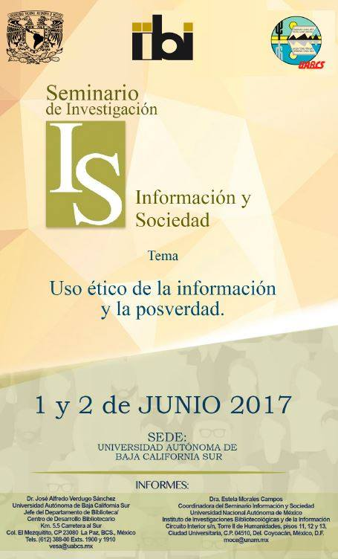

Designing a People-Focused Library

From Shelf Space to Social Space
June 7–July 12, 2017
4 Live Sessions Over 6 Weeks
Live Sessions on Wednesdays at 11:00 AM ET: June 7, 14, 28 & July 12, 2017
Designing a great library used to start with the books. Now, it starts with users and their needs. Learn what people want from their library and how to translate that into spaces that are flexible enough to adapt to rapidly changing technologies, and enable today’s learning, creation, and community connections.
Craft your roadmap for creating a future-facing building for your public or academic community—aligning your priorities with your community’s perspectives, goals, and aspirations. Learn strategies from leading librarians and design thinkers in live keynote sessions and get personalized feedback on your plans from a dedicated advisor that will provide one-on-one feedback for your plan. You will also participate in online discussion groups, where you can share resources and best practices with peers from across the country.
Identify and build your network of stakeholders who will be integrally involved in the design process, including your board, administration, staff, funders, and more. Expand your influence by learning to build additional buy-in from traditional library supporters around a vision that balances access to collections with actively engaging with that knowledge in new ways.

Register before May 26th to take advantage of our special advanced pricing.

By the end of the course, participants will learn
- User-centered design strategies to engage your community in the process of envisioning your library space.
- Space planning techniques to help you imagine flexible spaces for community connection, creation, and engagement, while still housing the right collections–including off-site, shared, electronic, or high-density storage solutions to reclaim space and still maximize access.
- Build new or renovate: Understand whether your existing space can be reclaimed or augmented to meet new user demand or whether it’s time to invest in a new building.
- Fund-raising strategies: How to approach fundraising as an integral part of community participation in the design process.
- Find the right design team: How to choose the right professionals to make your library vision a reality.

By the end of the workshop, participants will have
- A roadmap outlining the actions you need to create a library space suited to the unique needs of your community and flexible enough to serve the community as it grows and evolves in the future.
- Inspiring ideas, concepts, and perspectives from leading architects, designers, and librarians working in the field of library design.

Online course features
- Instructor-led online courses feature personalized interaction over four weeks
- Real-time guest speakers and conversation via live webcast (with recordings available afterward)
- Weekly homework assignments to help you make progress on your goals
- Individualized attention from course facilitators who work with you in a coaching environment to help sort out challenges
- Ongoing group conversation via discussion forums
- Articles, videos and other resources

Blueprint for Resilience: Toward Libraries that Give Back | Editorial
By Rebecca T. Miller on May 22, 2017 Leave a Comment
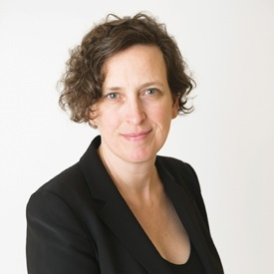Sometimes, just envisioning something can set change in motion. That’s what’s happening at the Belgrade Community Library in Montana. That little library was named LJ’s Best Small Library in America in 2015 and effectively leveraged the honor for local interest and investment. A few years later, the library, under the leadership of Director Gale Bacon, continues to make the most of its opportunities, now via design that is helping to set the community’s sights on a possible future. To make something real, you first must be able to see it clearly—and bring others to see it, too.
The design process helps do just that. For Belgrade, with little resources but plenty of will, the dream to expand took form through a partnership with fifth-year architecture students at Montana State University’s (MSU) School of Architecture, Bozeman, who embraced the library as part of an annual design challenge the school conducts under the guidance of Tom McNab, director of MSU’s Community Design Center. (See one rendering from the effort below, and read more at “Community Vision.”) The process and results, while so far only theoretical, have prompted vital conversation among stakeholders and the public about what they imagine when they dream on the library Belgrade needs and desires.
The outcome of such a process can be seen in Calgary, Arizona State University, and the communities that built the AIA/ALA winners, where people have come together to bring their ambitious imaginings to fruition—or close to it, for those still in progress.
At LJ, we are serious about strong library design—which inherently means, in our view, sustainable design. The emergence of the Living Building Challenge (LBC) takes the concept of a sustainable facility a significant step further, driving us to conceptualize how to create regenerative buildings—those whose impact on the environment is not just net zero but net positive. They give back instead of simply minimizing negative impact, though that, in itself, is already a huge accomplishment. This is so exciting to me, as someone committed to pushing the envelope on sustainability in libraries and as a human being on this amazing planet.
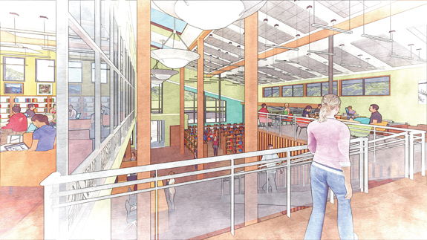
Imagine if libraries could help raise the level of sustainability by reenvisioning our structures this way. We know that libraries sustain and contribute to our communities. Why not expect the same from our buildings?
We’ve had LBC on our minds for a while (for instance, see my editorial “Living Buildings: Green That Gives Back). The “challenge” aspect is significant, with an emphasis on a materials gap, but as King County GreenTools’ Patti Southard says, there is movement in the industry, and the combination of demand, collaboration with vendors, and the pioneering work of early adopters will continue to spur development and, ultimately, drive prices down.
The global library community has the opportunity to help lead the way on ever-deeper sustainable design. One library still in the dream phase is already doing so: the Obama Presidential Library aims to be a Living Building.
What would happen if library leaders as a group were to dream on the Living Building Challenge and help make it real, one library at a time? Talk about collective impact. I can almost see it. Can you?
This article was published in Library Journal's May 15, 2017 issue. Subscribe today and save up to 35% off the regular subscription rat

http://lj.libraryjournal.com/2017/05/opinion/editorial/blueprint-for-resilience-toward-libraries-that-give-back-editorial/

Library Design 2017
By LJ

Furnishings of note from recent library projects
ALONE IN LONE TREE
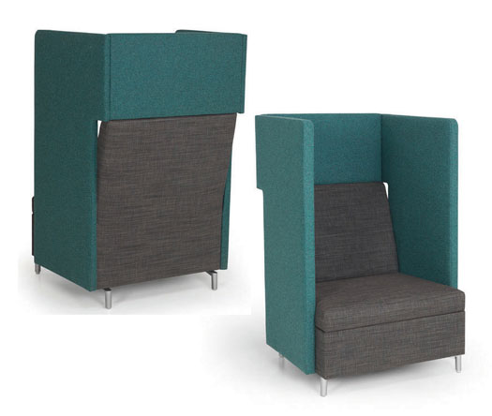
The Lone Tree branch of Douglas County Libraries, CO, more than doubled in size with its new 2016 building. More space, more options. The high-sided Ziva Lounge Chairs provide patron privacy along with plug-in capability. In the middle of the bustling library, patrons can enjoy a bit of solitude. JSI Furniture, www.jsifurniture.com/jsi_product_ziva_ls_gallery.php
EXPEDITIONARY FUN
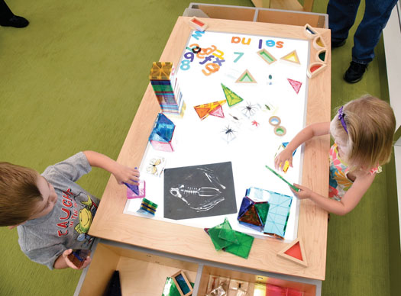
Each of the renovated or new branches of the St. Louis County Library includes a fun Discovery table in the children’s area. There are three activity tops to choose from—a LEGO table, a train track, or a light table—which can easily be swapped out. 3branch Product Design Solutions, www.3branch.com/discovery.html
NESTLE FOR A NAP?
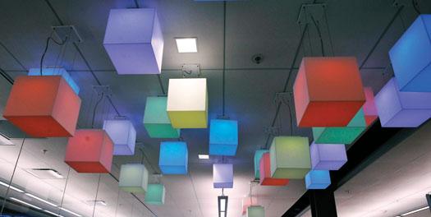
The children’s area at the Grant’s View Branch of the St. Louis County Library spotlights an array of color-changing pendant luminary LED lights. Square and linear, they feature white sandblasted acrylic diffusers hand fabricated with mitered corners for a “dazzling” addition to any space. 3G Lighting, www.3glighting.com

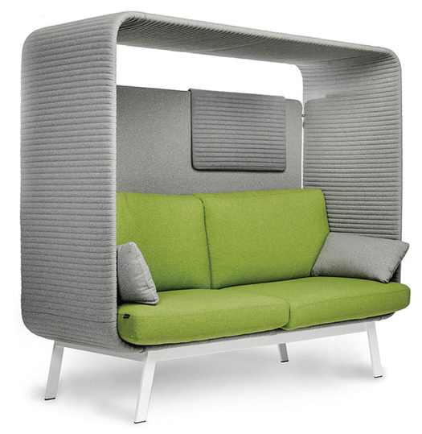
The new Hewitt Public Library, TX, has surprises around every corner. Nestled between stacks are lighted reading areas in which patrons can tuck away and enjoy a good book or a catnap. The Privée canopied lounge sofa bench is inviting, ensuring privacy and acoustic comfort. Swivel tables can be incorporated into the unit for a multipurpose surface to support one’s work. Borgo, borgo.com/corporate/privee
MY PRIVATE HIDEAWAY
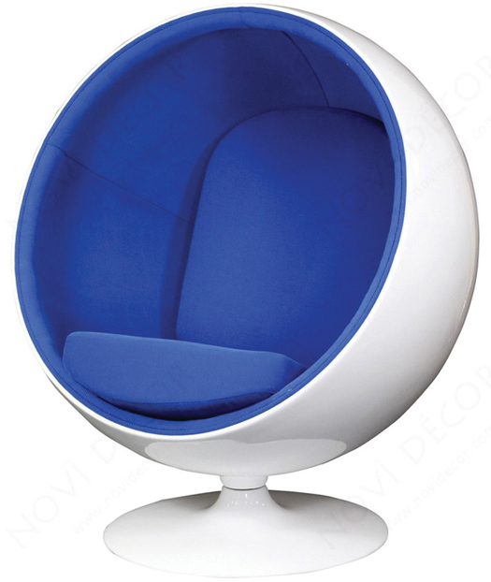
Even in a 3,500 square foot room in the Florida Institute of Technology’s Evans Library, a bit of serenity is now possible. In such a large open space, Eero Style Ball Chairs offer just the seclusion students need for study and contemplation. The chairs are so popular that students have asked if they can reserve them. Novì Décor, www.novidecor.com
SITTING/STORAGE SOLUTIONS
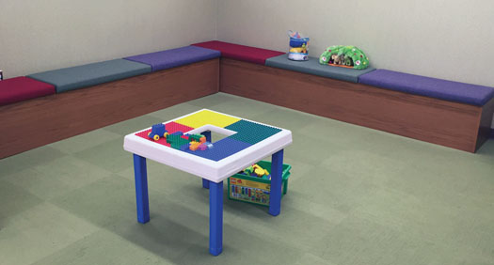
The bench seating at the Ardmore Library, PA, is colorful, comfortable, and inviting. At this member of the Lower Merion Library System, children use the padded benches during story time and for play in the newly built soft play area. The bench lifts up, providing ample storage, which allows for easy and quick cleanup. Worden, www.wordencompany.com
HIDDEN TREASURES
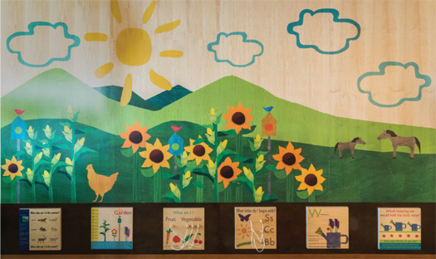
The overarching theme at the Haymarket Gainesville Community Library, VA, is its rural setting. This wooden structure/mural features educational manipulative structures at the bottom. While parents are at the checkout area, the children are within sight and happily engaged. RRMM Lukmire was the architect and designer, while manufacture and installation fell to TMC Furniture-TMCkids. TMC Furniture, www/tmcfurniture.com/product-kids
SWOOPING IN ON COMFORT
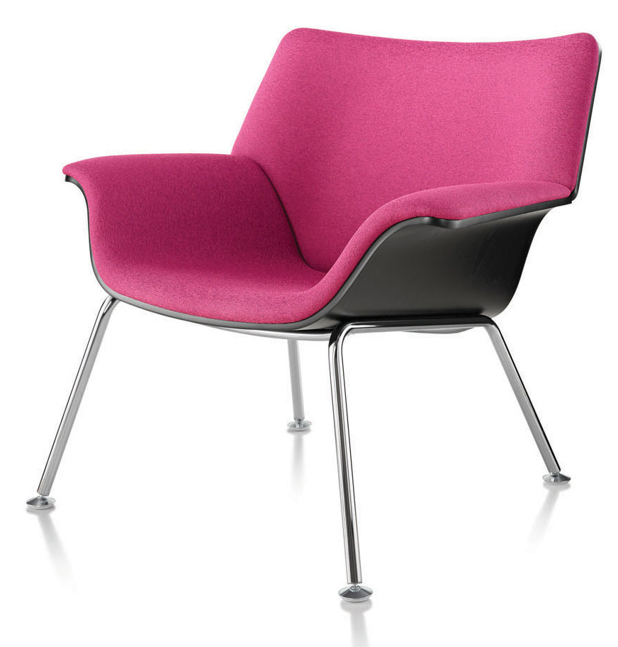
Students using the Gottesman Library, Yeshiva University, New York, can form their own seating patterns with Brian Kane’s Swoop lounge furniture. The chairs come as either molded plywood with metal legs, in a variety of fabrics, or fully upholstered lightweight sectional units. Herman Miller, www.hermanmiller.com
BEDAZZLING SKY SHOW
ALL ABOARD FOR LEARNING
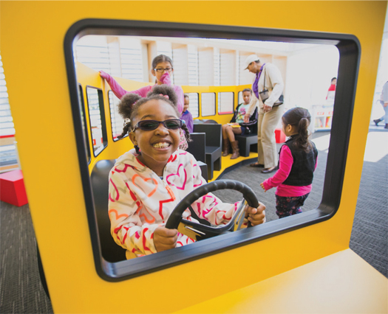
The Columbus Metropolitan Library, OH, has Ready for Kindergarten spaces at many of its branches and the recently reimagined Main Library. Each area houses a custom-designed miniature school bus as a place where youngsters and their caregivers can engage in kindergarten readiness. The buses also encourage free play and conversation. Conte Custom, www.contecustom.com
CONTRIBUTORS
Melissa Anciaux, Douglas County Libraries, CO
Waynette Ditto, Director of Library Services, Hewitt Public Library, TX
Paul Glassman, Director of University Libraries, Yeshiva University, New York
Jane Quin, Head Librarian, Ardmore Library, PA
Jessica Scalph, Library Administrator, Haymarket Gainesville Community Library, VA
Lauren Striebel, Special Projects Analyst, St. Louis County Library
Angela Taylor, Director, Enabling Infrastructure, Evans Library, Florida Institute of Technology, Melbourne
Ben Zenitsky, Marketing & Communications Specialist, Columbus Metropolitan Library, O

http://lj.libraryjournal.com/2017/05/buildings/lbd/librarians-picks-library-design-2017/

- AMBAC - CURSO "CATALOGACION DE RECURSOS DE INFORMACION CON RDA"
del 20 al 23 de junio se realizará el curso CATALOGACION DE RECURSOS DE INFORMACION CON RDA, impartido por el Dr. Filiberto Felipe Martínez Arellano en las oficinas de la AMBAC. Cupo limitado.

- Capacitación en línea - Hablemos de RDA, el debate.
Biblioteca Nacional Mariano Moreno <consultas@bn.gov.ar>

