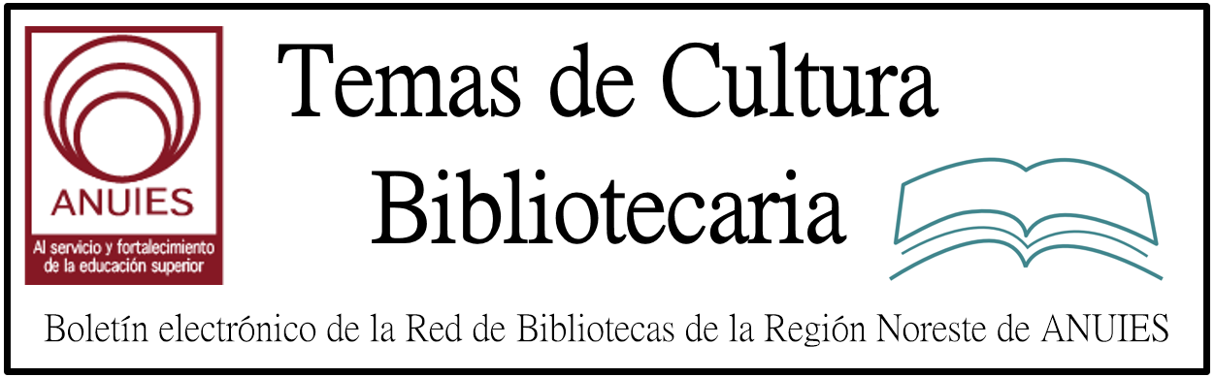

Año 2 Número 28 junio 2017

Contenidos de este número

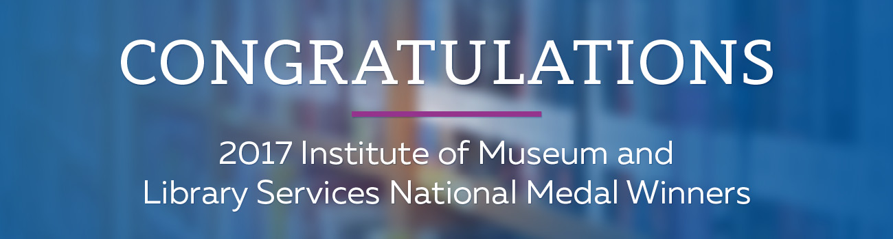
Every year, the Institute of Museum and Library Services honors outstanding institutions that make significant and exceptional contributions to their communities. And every year, the Institute of Museum and Library Services also provides extraordinary support for communities through libraries and their patrons. So, this year, we’d like to send our special congratulations to this year’s winners and a show of support for libraries.
The 2017 National Medal Library Winners
- Cedar Rapids Public Library (Cedar Rapids, Iowa)
- Long Beach Public Library (Long Beach, California)
- Richland Library (Columbia, South Carolina)
- University of Minnesota Libraries (Minneapolis, Minnesota)
- Waterville Public Library (Waterville, Maine)
It takes time, dedication, and hard work to receive such an honor. Each winner embodies what we should all aspire towards: to strengthen and bolster our communities nationwide. For that, they have our highest respect and admiration.
And while the Institute of Museum and Library Services has played a major role in supporting our shared mission for more than 20 years, they are on the verge of losing vital federal funding.
Please join in our effort to support those who help us all go above and beyond
for our communities. Ask your U.S. Senators to sign the FY 2018 LSTA and IAL
Dear Appropriator letters.

http://marketing.ingramcontent.com/MRKNG/2017/1535_7848/images/hero.jpg

- 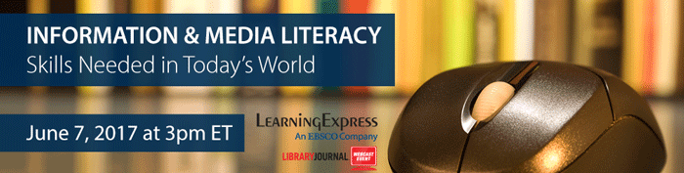

Information & Media Literacy: Skills Needed in Today’s World
Wednesday, June 7, 2017
3-4 PM ET, 12-1 PM PT
True or False? Information and media literacy skills have never been more important than in today’s digital world. Between fake news and social media, it's crucial to know how to filter out unreliable online information, and being deficient in this skill can lead to poor educational and professional practices. Fortunately, libraries are in a position to offer access to research tools and help educate students and the public on information literacy.
Join LearningExpress, an EBSCO company, as they present a webinar on the skills necessary to obtain reliable information for effective research and for navigating daily digital life. They will review the meaning of information and media literacy, look at some of the challenges patrons face when acquiring these skills, and suggest possible solutions to help patrons build information and media literacy skills.
Register Now!

- 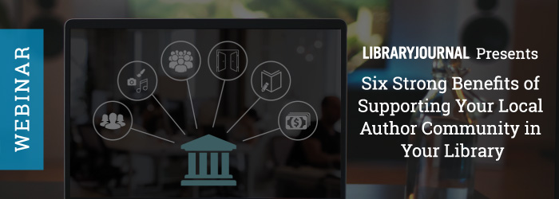

Six Strong Benefits to Supporting Your Local Author Community in Your Library
Thursday, June 8, 2017
3-4 PM ET, 12-1 PM PT
While they may start in the library, the benefits of programs that serve local writers stretch far beyond the stacks. Join the SELF-e team and a panel of leading librarians who are innovatively answering the American Library Association’s call for programs that support the literary arts. Discover evidence-based benefits of offering writing programs in the library and hear firsthand how librarians are making their libraries the center of the indie book movement and models of community engagement.
Register Now!

- Endangered Data Week Highlights Need for Digital Preservation of Government Data
By Matt Enis on May 19, 2017 1 Comment
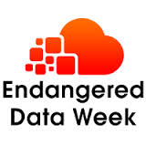Aiming to raise awareness and maintain momentum for preservation efforts focused on publicly administered data, the inaugural “Endangered Data Week” kicked off on April 17 and ultimately featured more than 50 presentations, panels, and projects in the United States, Spain, and Australia.
The initiative was led by Brandon Locke, digital social science and humanities specialist with Michigan State University’s (MSU) history department, in collaboration with Jason A. Heppler, academic technology specialist for Stanford University’s department of history; Bethany Nowviskie, director of the Council on Libraries and Information Resources’ (CLIR) Digital Library Federation (DLF); and Wayne Graham, technical director for CLIR.
The project was spurred into action by recent political events—the Trump administration ordering the U.S. Environmental Protection Agency to remove climate change information from its website, and the passage of H.Res.5 by the House of Representatives, excluding changes to the Affordable Care Act from mandatory long-term cost data analysis, to name two.
Locke said that recent Data Rescue events—organized by groups such as DataRefuge and the Environmental Data & Governance Initiative (EDGI) to back up data sets, documents, images, and other content from government websites believed to be vulnerable to takedown by the Trump administration—got him thinking about ways to help. The project was inspired by events such as Banned Books Week and International Open Access Week.

http://lj.libraryjournal.com/2017/05/industry-news/endangered-data-week-highlights-need-for-digital-preservation-of-government-data/

- FIRMADO CONVENIO CON LA ASOCIACIÓN LATINOAMERICANA DE CONSULTORES POLÍTICOS
https://documentalistas.org/campus/mod/forum/discuss.php?d=166
Las dos entidades de ámbito internacional han firmado un Memorandum de Entendimiento por el cual ofertarán a los profesionales registrados en la plataforma #eLearning cursos online en el ámbito político, basados en metodología MOOC y algunos de ellos serán impartidos por miembros del Comité de Mujeres Líderes de las Américas.
DIPLOMAS DIGITALES PARA INCLUIR EN CVITAE
http://documentalistas.com/cursos-tipos/mooc/
Recordamos a todos los alumnos/as que han terminado esta semana los cursos mooc, y que han abonado la cuota de 22Euros, que debido al número de solicitudes iremos enviando los certificados digitales por orden de pago. Pero no más tarde de mediados de la próxima semana ;-)
MARTES 30/MAYO. TELECONFERENCIA CON LA RED LATINOAMERICANA DE CONFERENCISTAS
http://documentalistas.com/cursos/rlc/
A las 18hs en España tendrá lugar en la plataforma eLearning la segunda teleconferencia online gratuita dentro de la colaboración con la RLC, y que en esta ocasión será dictada desde Colombia por Luisa Fernanda Pinzón con el titulo "Del profesional tradicional al profesional estratégico".
CONVOCATORIA EXPERTOS EN TECNOPOLITICA
http://documentalistas.com/cursos/tecnopolitica
El próximo 3 de Octubre, y dentro de las actividades del MOU con la OEA, la Fundación Ciencias de la Documentación organiza un mooc abierto online y gratuito titulado "Tecnopolítica: Diseñando nuevas formas de participación política". Estos días está abierta la convocatoria para expertos/as que deseen postularse a coordinar un módulo temático (dentro del área de la Tecnopolítica) en el mooc. Como expertos están ya confirmados de España Ramón Ramón, y Rafa Ayala.
#SABERMAS CON DAMIAN GUTIERREZ (ARGENTINA)
https://documentalistas.org/campus/mod/forum/discuss.php?d=154
Damián Gutierrez, Técnico Superior en Recursos Humanos y Analista del comportamiento humano en las organizaciones, con amplio conocimiento en reclutamiento y selección de personal, compartirá sus experiencias y conocimientos con los alumnos de la plataforma eLearning a través de videoconferencias en tiempo real desde Argentina, dentro de los cursos de actualización denominados #SaberMás. La primera videoconferencia será impartida el próximo día 21 de Junio, a las 13hs en España - 9am en Argentina -, con el título "El proceso de capacitación en la empresa". Matrícula gratuita.
IGOR MORALES (CHILE), NUEVO MIEMBRO NUMERARIO
https://documentalistas.org/campus/mod/forum/discuss.php?d=151
Igor Morales Villena es Especialista Senior en Compras y Contrataciones desde hace 26 años en las áreas administrativas de soporte, con conocimientos acabados de Compras, Licitaciones, Administración, Administración de Inventarios, Logística de Ingreso y Salida, Logística Inversa, Seguimiento de Procesos, Normativa Administrativa y Contable. Acreditado con éxito en forma continua como Auditor, Supervisor y Comprador en las Pruebas de Acreditación del Sistemas de Contratación Pública Chileno.
90 PROFESIONALES INICIARON CURSO SOBRE GOBIERNO ABIERTO
http://documentalistas.com/cursos/fundamentosga
El curso online mooc "Fundamentos del Gobierno Abierto" ha sido esta semana el más demandado, con alumnos de 90 países trabajando conjuntamente para definir los fundamentos que definen a las políticas de gobierno abierto en sus países, con especial atención al papel de los Sistemas de Gestión Documental para lograrlo. El curso tiene matrícula abierta gratuita todo el 2017.
CONSERVACIÓN DOCUMENTAL DIGITAL
http://documentalistas.com/cursos/conservacion-digital/
Conservar el material digital es más complejo de lo que a primera vista pueda parecer. A la caducidad de los medios de almacenamiento se suma la caducidad de las tecnologías empleadas para codificar la información digital. De todo ello trata este interesante curso online orientado a profesionales de la información y documentación

12 y 13 de Junio FORO DE ARCHIVOS UNIVERSITARIOS

La cita es el 12 y 13 de junio del presente año de las 09:00 a 14:00 el primer día
y de las 10:00 a 14:00 hrs. el segundo día en la Coordinación de Humanidades Auditorio “Dr. Jorge Carpizo” Mario de La Cueva s/n, Cd. Universitaria.
Invitan el Instituto de Investigaciones sobre la Universidad y la Educación (IISUE), la Dirección General de Servicios generales y Movilidad (DGSGM) de la Secretaria de Atención a la Comunidad Universitaria y el Instituto de Investigaciones Bibliotecológicas y de la Información.
Incríbase HOY MISMO!
Cuotas de recuperación:
Comunidad UNAM = $900.00
Otras Instituciones = $1,100.00

- Students Gain Valuable Insight with Access to Genocide Testimonies
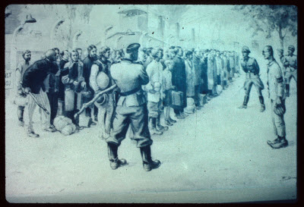
“These testimonies take the historical stories out of the realm of history and place them in the realm of the human.” – Amy Simon, Michigan State University
Michigan State University is one of a growing number of institutions using video testimonies from genocide survivors to inspire new learning and research insights across multiple academic disciplines. The University is providing its students, faculty and researchers with access to University of Southern California (USC) Shoah Foundation’s Visual History Archive,* the world’s largest collection of eyewitness accounts from genocide witnesses and survivors, available through ProQuest.
“Moving forward into an era in which we will no longer be able to speak with Holocaust survivors personally, oral testimonies provide essential historical and emotional truths about the Holocaust,” said Amy Simon, William and Audrey Farber Family Endowed Chair in Holocaust Studies and European Jewish History at Michigan State University (MSU).
“Faculty from a range of disciplines are interested in furthering their research through this archive,” added Simon. “All of us hope to complement our printed sources with these oral testimonies as we write about history, language, economics, trauma studies, literature, and more. Many of us have also begun using these testimonies in the classroom, encouraging our students to delve into them in their own research.”
We asked Dr. Simon to elaborate on some of the unique ways research and learning are enhanced for students at MSU as the result of having access to this unparalleled primary source material.
Q: Faculty from a range of disciplines at MSU are interested in furthering research and learning through the Visual History Archive. What are a couple of unique examples of how these testimonies ae being used?
A: One example is a professor in the Department of Agricultural, Food & Resource Economics
who is using the testimonies to examine the economics of genocide. Another professor in the Department of Linguistics and Languages uses them in her German classes.
Q: How have you been using the testimonies in the classroom to encourage your students to use into them in their research?
A: I brought my students to the library where they participated in an introductory session in which librarians showed them how to access and use the archive.
Since then, many students have developed research projects that use these testimonies as primary sources. Topics include religion after the Holocaust and the impetus for writing Holocaust memoirs.
Q: What are some examples of situations where you have used the archive in your teaching?
A: Early last semester, I showed testimony given by an American soldier who was part of a group of soldiers who liberated Buchenwald. The soldier described the horror of the situation, explaining sights and smells and the incredulous reactions of many of his fellow soldiers.
Seeing and hearing an individual who had actually witnessed the concentration camps had a powerful emotional impact on students and brought them closer to understanding the absolute monstrosity of the Holocaust.
Q: “How have the VHA testimonies impacted your students? How are students connecting to the material?”
A: These testimonies take the historical stories out of the realm of history and place them in the realm of the human.
Experiencing the emotional reactions of the survivors and witnesses has an emotional impact on the students. As a result, students are connecting on a personal level to the testimonies. They are also affected by stories of ongoing trauma that family members often reveal at the end of the interviews.
Additionally, students appreciate the richness of both the obvious and more subtle aspects of the testimonies. Students have noticed not only the words and emotions expressed by survivors, but also respond to the settings of the testimonies and family members included in the videos. Students comment on objects such as pictures in the backgrounds, usually in the survivor's living room. From these intimate observations, students draw conclusions and make personal connections with what they see.
*Visual History Archive
Survivors and witnesses of the Holocaust (1939-1945), Armenian Genocide (1915-1923), Nanjing Massacre (1937), Rwandan Tutsi Genocide (1994), and Guatemalan Genocide (1978-1996) have shared their stories and experiences in a collection of 54,000 two-hour audio-visual interviews with USC Shoah Foundation Institute for Visual History.
ProQuest is honored to be in partnership with USC Visual History Archive to offer this material in its entirety to a broader audience and to contribute archival-quality transcripts of all of the testimonies.
Watch the videos, and learn more.

“These testimonies take the historical stories out of the realm of history and place them in the realm of the human.”
– Amy Simon, Michigan State University
Michigan State University is one of a growing number of institutions using video testimonies from genocide survivors to inspire new learning and research insights across multiple academic disciplines. The University is providing its students, faculty and researchers with access to University of Southern California (USC) Shoah Foundation’s Visual History Archive,* the world’s largest collection of eyewitness accounts from genocide witnesses and survivors, available through ProQuest.
“Moving forward into an era in which we will no longer be able to speak with Holocaust survivors personally, oral testimonies provide essential historical and emotional truths about the Holocaust,” said Amy Simon, William and Audrey Farber Family Endowed Chair in Holocaust Studies and European Jewish History at Michigan State University (MSU).
“Faculty from a range of disciplines are interested in furthering their research through this archive,” added Simon. “All of us hope to complement our printed sources with these oral testimonies as we write about history, language, economics, trauma studies, literature, and more. Many of us have also begun using these testimonies in the classroom, encouraging our students to delve into them in their own research.”
We asked Dr. Simon to elaborate on some of the unique ways research and learning are enhanced for students at MSU as the result of having access to this unparalleled primary source material.

http://www.proquest.com/blog/pqblog/2017/Students-Gain-Valuable-Insight-with-Access-to-Genocide-Testimonies.html

- Sip & Spell: An Adult Spelling Bee | Programs That Pop
By Bonnie Brzozowski and Lindy Brown on May 25, 2017 Leave a Comment
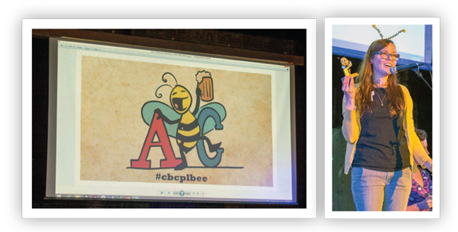
The Corvallis–Benton County Public Library, OR, has partnered with its Friends of the Library for the last two years to offer a spelling bee for adults 18 years and older. The event, called Sip & Spell, helps us reach a wide audience, particularly younger adults age 21–35. Sip & Spell also projects a fun, playful side of the library.
Adult spelling bees in other cities prompted the idea. Corvallis is a college town with a well-educated populace; however, a recent survey found that public library services are predominantly used by senior citizens and families with young children. A bee for adults seemed like a natural way to attract that missing audience.
P-L-A-N-N-I-N-G
Partners were essential to making an event of this scale happen. In addition to staffers, members of our Friends and library advisory board, a librarian from Oregon State University (OSU), and the emcee/local newspaper editor joined the planning committee.
To help limit the number of participants, a registration fee for contestants was established. These and fees for cheats (discussed below) benefited the Friends of the Library.
Funds raised at Sip & Spell are put directly back into the adult programs budget. As costs were higher with the need for a larger venue our second year, this arrangement made it possible for us to continue producing the event. After fundraising, we broke even the first year, and it cost us roughly $1,000 the second year.
We examined rules at other bees, including the Scripps National Spelling Bee, to develop a game plan. They allow for contestants to purchase cheats and include optional championship rounds that can be used if the competition runs long. The cheats add an element of whimsy and allowed us to raise more money. Ranging from $3 to $15, cheats include ask a friend; rewind—having made an error midway through, they get one chance to start over; and a mulligan, whereby a contestant may remain in the contest after misspelling the word.

http://lj.libraryjournal.com/2017/05/opinion/programs-that-pop/sip-spell-an-adult-spelling-bee-programs-that-pop/

- Blueprint for Resilience: Toward Libraries that Give Back | Editorial
By Rebecca T. Miller on May 22, 2017 Leave a Comment
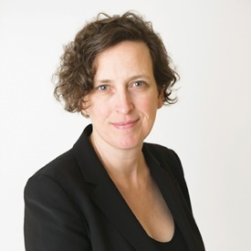Sometimes, just envisioning something can set change in motion. That’s what’s happening at the Belgrade Community Library in Montana. That little library was named LJ’s Best Small Library in America in 2015 and effectively leveraged the honor for local interest and investment. A few years later, the library, under the leadership of Director Gale Bacon, continues to make the most of its opportunities, now via design that is helping to set the community’s sights on a possible future. To make something real, you first must be able to see it clearly—and bring others to see it, too.
The design process helps do just that. For Belgrade, with little resources but plenty of will, the dream to expand took form through a partnership with fifth-year architecture students at Montana State University’s (MSU) School of Architecture, Bozeman, who embraced the library as part of an annual design challenge the school conducts under the guidance of Tom McNab, director of MSU’s Community Design Center. (See one rendering from the effort below, and read more at “Community Vision.”) The process and results, while so far only theoretical, have prompted vital conversation among stakeholders and the public about what they imagine when they dream on the library Belgrade needs and desires.
The outcome of such a process can be seen in Calgary, Arizona State University, and the communities that built the AIA/ALA winners, where people have come together to bring their ambitious imaginings to fruition—or close to it, for those still in progress.
At LJ, we are serious about strong library design—which inherently means, in our view, sustainable design. The emergence of the Living Building Challenge (LBC) takes the concept of a sustainable facility a significant step further, driving us to conceptualize how to create regenerative buildings—those whose impact on the environment is not just net zero but net positive. They give back instead of simply minimizing negative impact, though that, in itself, is already a huge accomplishment. This is so exciting to me, as someone committed to pushing the envelope on sustainability in libraries and as a human being on this amazing planet.
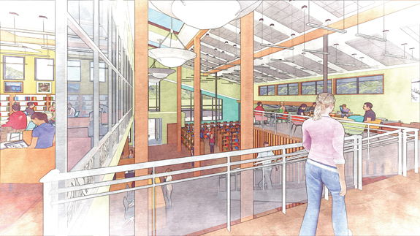
Imagine if libraries could help raise the level of sustainability by reenvisioning our structures this way. We know that libraries sustain and contribute to our communities. Why not expect the same from our buildings?
We’ve had LBC on our minds for a while (for instance, see my editorial “Living Buildings: Green That Gives Back). The “challenge” aspect is significant, with an emphasis on a materials gap, but as King County GreenTools’ Patti Southard says, there is movement in the industry, and the combination of demand, collaboration with vendors, and the pioneering work of early adopters will continue to spur development and, ultimately, drive prices down.
The global library community has the opportunity to help lead the way on ever-deeper sustainable design. One library still in the dream phase is already doing so: the Obama Presidential Library aims to be a Living Building.
What would happen if library leaders as a group were to dream on the Living Building Challenge and help make it real, one library at a time? Talk about collective impact. I can almost see it. Can you?
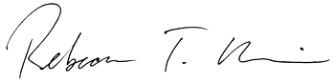
This article was published in Library Journal's May 15, 2017 issue. Subscribe today and save up to 35% off the regular subscription rat

http://lj.libraryjournal.com/2017/05/opinion/editorial/blueprint-for-resilience-toward-libraries-that-give-back-editorial/

Librarians’ Picks | Library Design 2017
By LJ

Furnishings of note from recent library projects
ALONE IN LONE TREE
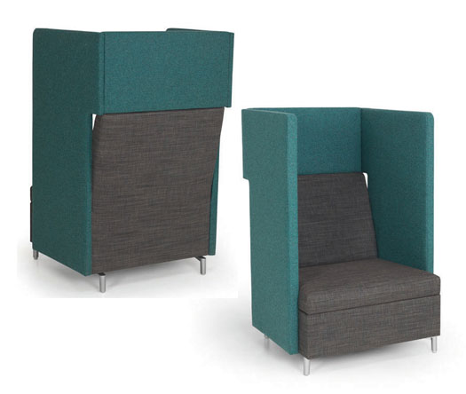
The Lone Tree branch of Douglas County Libraries, CO, more than doubled in size with its new 2016 building. More space, more options. The high-sided Ziva Lounge Chairs provide patron privacy along with plug-in capability. In the middle of the bustling library, patrons can enjoy a bit of solitude. JSI Furniture, www.jsifurniture.com/jsi_product_ziva_ls_gallery.php
EXPEDITIONARY FUN
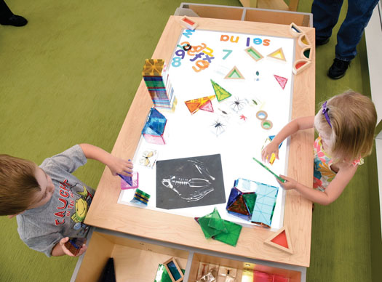
Each of the renovated or new branches of the St. Louis County Library includes a fun Discovery table in the children’s area. There are three activity tops to choose from—a LEGO table, a train track, or a light table—which can easily be swapped out. 3branch Product Design Solutions, www.3branch.com/discovery.html
NESTLE FOR A NAP?
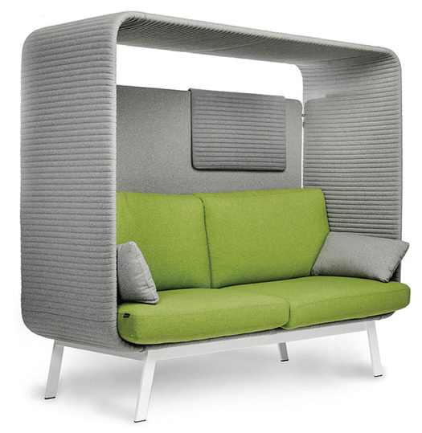
The new Hewitt Public Library, TX, has surprises around every corner. Nestled between stacks are lighted reading areas in which patrons can tuck away and enjoy a good book or a catnap. The Privée canopied lounge sofa bench is inviting, ensuring privacy and acoustic comfort. Swivel tables can be incorporated into the unit for a multipurpose surface to support one’s work. Borgo, borgo.com/corporate/privee
MY PRIVATE HIDEAWAY
Even in a 3,500 square foot room in the Florida Institute of Technology’s Evans Library, a bit of serenity is now possible. In such a large open space, Eero Style Ball Chairs offer just the seclusion students need for study and contemplation. The chairs are so popular that students have asked if they can reserve them. Novì Décor, www.novidecor.com
SITTING/STORAGE SOLUTIONS
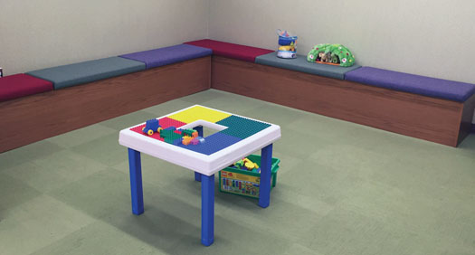
The bench seating at the Ardmore Library, PA, is colorful, comfortable, and inviting. At this member of the Lower Merion Library System, children use the padded benches during story time and for play in the newly built soft play area. The bench lifts up, providing ample storage, which allows for easy and quick cleanup. Worden, www.wordencompany.com
HIDDEN TREASURES
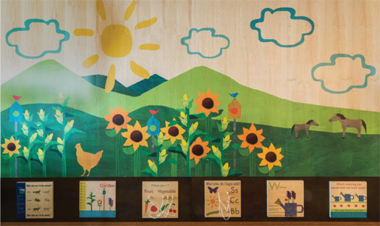
The overarching theme at the Haymarket Gainesville Community Library, VA, is its rural setting. This wooden structure/mural features educational manipulative structures at the bottom. While parents are at the checkout area, the children are within sight and happily engaged. RRMM Lukmire was the architect and designer, while manufacture and installation fell to TMC Furniture-TMCkids. TMC Furniture, www/tmcfurniture.com/product-kids
SWOOPING IN ON COMFORT
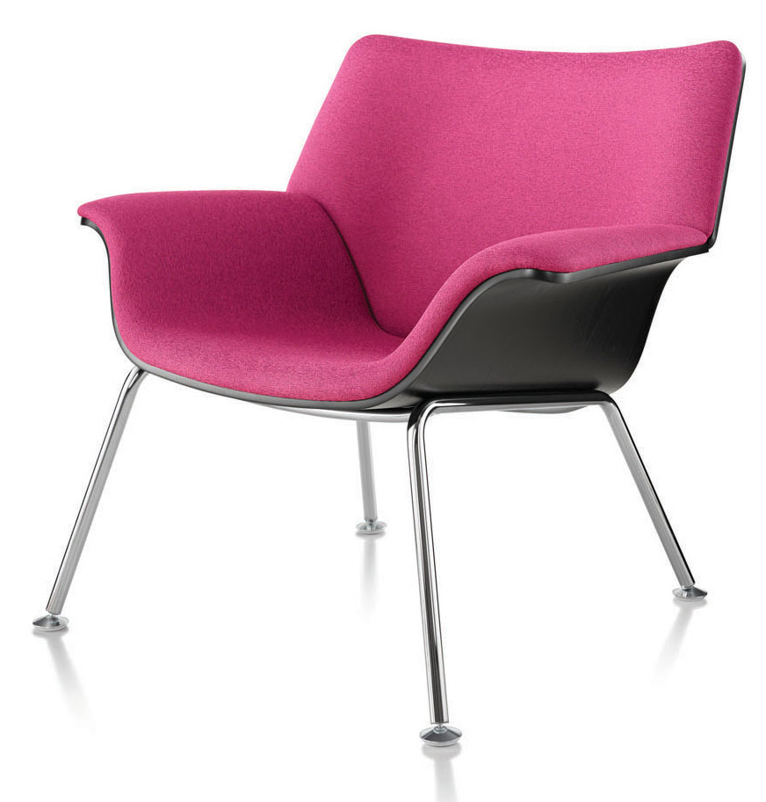
Students using the Gottesman Library, Yeshiva University, New York, can form their own seating patterns with Brian Kane’s Swoop lounge furniture. The chairs come as either molded plywood with metal legs, in a variety of fabrics, or fully upholstered lightweight sectional units. Herman Miller, www.hermanmiller.com
BEDAZZLING SKY SHOW
The children’s area at the Grant’s View Branch of the St. Louis County Library spotlights an array of color-changing pendant luminary LED lights. Square and linear, they feature white sandblasted acrylic diffusers hand fabricated with mitered corners for a “dazzling” addition to any space. 3G Lighting, www.3glighting.com
ALL ABOARD FOR LEARNING
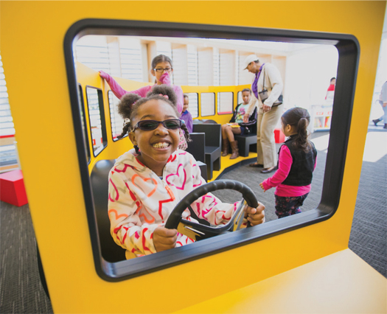
The Columbus Metropolitan Library, OH, has Ready for Kindergarten spaces at many of its branches and the recently reimagined Main Library. Each area houses a custom-designed miniature school bus as a place where youngsters and their caregivers can engage in kindergarten readiness. The buses also encourage free play and conversation. Conte Custom, www.contecustom.com
CONTRIBUTORS
Melissa Anciaux, Douglas County Libraries, CO
Waynette Ditto, Director of Library Services, Hewitt Public Library, TX
Paul Glassman, Director of University Libraries, Yeshiva University, New York
Jane Quin, Head Librarian, Ardmore Library, PA
Jessica Scalph, Library Administrator, Haymarket Gainesville Community Library, VA
Lauren Striebel, Special Projects Analyst, St. Louis County Library
Angela Taylor, Director, Enabling Infrastructure, Evans Library, Florida Institute of Technology, Melbourne
Ben Zenitsky, Marketing & Communications Specialist, Columbus Metropolitan Library, O

http://lj.libraryjournal.com/2017/05/buildings/lbd/librarians-picks-library-design-2017/

