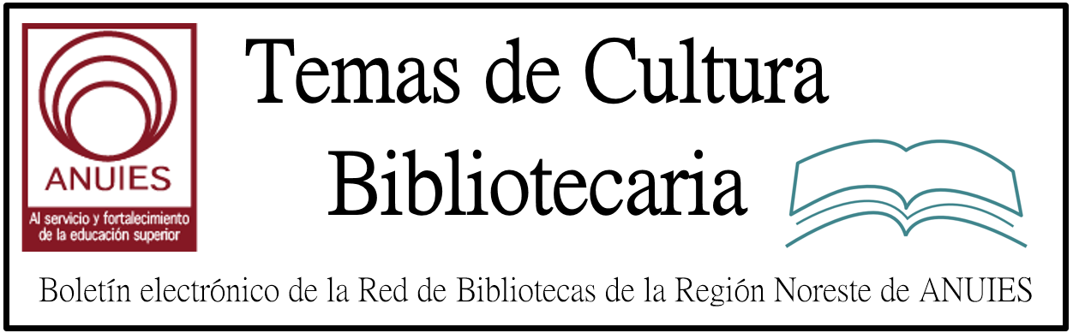

Año 2 Número 27 mayo 2017

Contenidos de este número

1 Two U.S. Senators Introduce Bill to Keep Government Research Data Publicly Available (Preserving Data in Government Act)
Filed by Gary Price
UPDATED May 2, 2017 The Text of S.960 (Preserving Data in Government Act) Now Available via GovTrack.us and/or Congress.gov
UPDATED April 28, 2017 The bill has been given the number S.960 (A Bill To Amend Title 44, United States Code, to Protect Open, Machine-Readable Databases)
From Senator Cory Gardner (Full Text):
U.S. Senators Cory Gardner (R-CO) and Gary Peters (D-MI) today introduced bipartisan legislation to help federal agencies maintain open access to machine-readable databases and datasets created by taxpayer-funded research.

The Preserving Data in Government Act would require federal agencies to preserve public access to existing open datasets, and prevent the removal of existing datasets without sufficient public notice. Small businesses rely on a range of publically available machine-readable datasets to launch or grow their companies, and researchers and scientists use data to conduct studies for a variety of fields and industries.

“Once data has been published and made available to the public, it should remain available to the public,” said Senator Gardner. “Whether it’s a technology entrepreneur working on their next innovation or a retailer seeking better weather forecasting to help organize shipments, data is utilized to achieve numerous goals and plays a critical role in improving processes and our daily lives. I’m proud to work with Senator Peters on legislation that ensures government data remains readily accessible in an appropriate manner and that we continue to prioritize government transparency.”

“Research data that has been collected using taxpayer dollars should be publically accessible and easily searchable,” said Senator Peters. “Small businesses and individuals rely on federally produced information for everything from long-term planning to innovative product development to help grow their companies and create jobs. I’m proud to introduce this bipartisan legislation with Senator Gardner that will help ensure that taxpayer-funded data remains publically and openly available for innovators to use as they work to solve our country’s toughest challenges.”

http://www.infodocket.com/2017/04/27/two-u-s-senators-introduce-bill-to-keep-government-research-data-publicly-available-preserving-data-in-government-act/

Support Your Local Authors
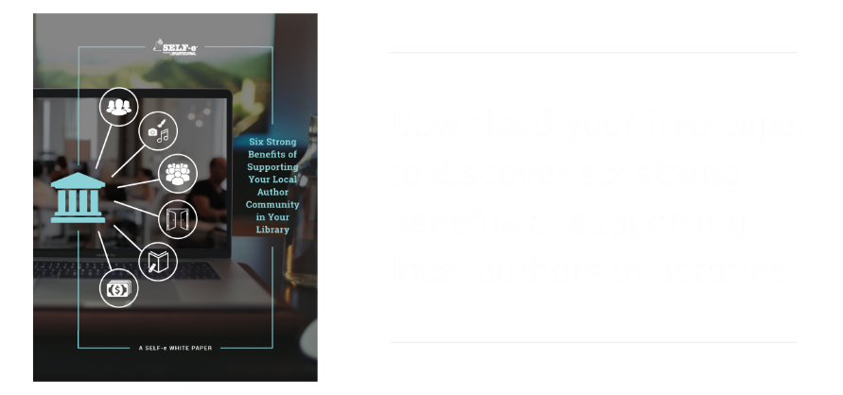
Library Journal and BiblioBoard partner to bring you SELF-e, your library's solution to becoming a community center for local author discovery and support. SELF-e's mission is to make libraries the focal point for patrons to connect with indie and self-published authors in your community.
If you're ready to learn more about evidence-based reasons for libraries to support local indie authors, SELF-e is proud to provide you with this complimentary download of "Six Strong Benefits of Supporting Your Local Author Community in Your Library: A SELF-e White Paper."
You can find additional thoroughly researched white papers like these on SELF-e's website, and expect more to come throughout 2017. We look forward to helping your library make informed decisions about the best ways to connect local authors and patrons at your library.

DOWNLOAD YOUR FREE WHITE PAPER

3. Back to the Basics: Establishing a Good Foundation in Your Library
BY LJ REVIEWS ON MAY 8, 2017 LEAVE A COMMENT
Pratchett, Tracey & Gil Young. Practical Tips for Developing Your Staff. Facet. Nov. 2016. 277p. illus. index. ISBN 9781783300181. pap. $95. PRO MEDIA
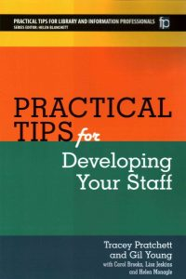A common challenge for all managers is how to offer training and development opportunities to their staff that actually teaches something useful and won’t break the bank. This title is aimed at helping both managers and individuals in the library and information services profession understand the range of activities and tools that exist for the purpose of training and development as well as the basics of learning and behavior theory. Pratchett (knowledge & library svcs. manager, Lancashire Teaching Hosps.) and Young (NHS Library and Knowledge Svcs.) include a section on infrastructure, where they discuss management basics that should exist alongside training and development in order to build and maintain a healthy team. The emphasis of the book is on practical matters, with the activities and tools section making up the majority of the content. The examples come mostly from the UK, where the authors are based, but the content is applicable to librarians everywhere. VERDICT Sound advice that will appeal to new managers and mentors of information professionals.—Sara Holder, Univ. of Illinois Libs., Champaign

http://reviews.libraryjournal.com/2017/05/lj-in-print/back-to-the-basics-establishing-a-good-foundation-in-your-library/

4. Little Free Libraries are Bad Because We Don’t Like Them
MAY 8, 2017 BY ANNOYED LIBRARIAN
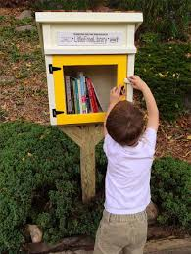
You might think the Little Free Library movement would be about an innocuous a subject as one can find related to books. That’s because you’re not aware that they’re “neoliberal politics at street level,” at least according to the “radical” Canadian librarians interviewed in this article sent in by Kind Reader.
They also wrote a whole article about this in the Journal of Radical Librarianship, if you just can’t get enough of the subject.
Fortunately, there aren’t any serious library problems in Canada or anywhere else that might take up the attention of serious people. It’s not like school libraries are dying, public library funding is often under attack, or anything like that.
Thus, it’s really, really important to focus our attacks on boxes people put in their front yards so neighbors can exchange books, or not, depending on whatever they feel like doing. The horror!
It’s hard to know where to start here, so let’s just look at some representative quotations. For example:
“There was something that kind of irked me about the title…. As a librarian, my gut reaction to that was, ‘You know what else is a free library? A regular library.’”

http://lj.libraryjournal.com/blogs/annoyedlibrarian/2017/05/08/little-free-libraries-are-bad-because-we-dont-like-them/

5. Library of Congress Hosts Bibliodiscotheque
By Lisa Peet on May 10, 2017 Leave a Comment
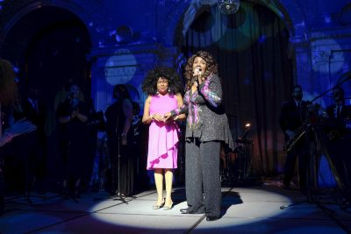
Carla Hayden and Gloria Gaynor
Photo by Shawn Miller/Library of Congress
On May 6, the Library of Congress (LC) was transformed into a disco for one night. Librarians from the Washington, DC, area (as well as 23 other states, Australia, Mexico, and Switzerland) dressed up in their finest ’70s vintage duds and danced the night away under a mirror ball in the Great Hall of LC’s Thomas Jefferson Building. DJs spun tunes, disco diva Gloria Gaynor belted, and—to everyone’s delight—Librarian of Congress Carla Hayden donned a formidable afro wig and mirror ball earrings.
The dance party, and the day-long symposium that preceded it, capped off more than three weeks of Bibliodiscotheque, an in-depth exploration of disco culture and music at the library. Inspired by the induction of Gaynor’s classic “I Will Survive” into LC’s National Recording Registry in 2016, the eclectic range of programming included a live interview with fashion consultant and author Tim Gunn by Deputy Librarian of Congress Robert Newlen, lectures on music from ABBA to African dance, a panel discussion on disco and Vietnam veterans, and a film series.

http://lj.libraryjournal.com/2017/05/events/library-of-congress-hosts-bibliodiscotheque/

6. “You’re In the Wrong Bathroom!” | Professional Shelf
By Alicia Eames
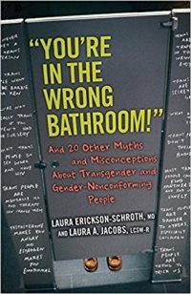
Even as transgender and gender-nonconforming children and adults gain acceptance, trans students are likely to face unwarranted hurdles. Just this past February, the U.S. Department of Justice and Department of Education rescinded federal guidelines that called for schools to allow access to bathrooms and locker rooms based on gender identity rather than biological sex. A recent Gay, Lesbian and Straight Education Network (GLSEN) report, Separation and Stigma: Transgender Youth and School Facilities, found that “when transgender students are forced to use bathrooms that do not match their gender, or when they are barred from communal facilities altogether and told to use a separate facility, they are singled out for discrimination and harassment.”
In “You’re in the Wrong Bathroom!”: And 20 Other Myths and Misconceptions About Transgender and Gender-Nonconforming People (Beacon, May 2017), Laura Erickson-Schroth, a psychiatrist and editor of Trans Bodies, Trans Selves (Oxford University, 2014), and Laura A. Jacobs, a trans psychotherapist and writer, confront pervasive misinformation, including unfounded fears about bathroom use, with a straightforward approach. The book is divided into four themes: “Identity,” “Sex and Relationships,” “Health and Safety,” and “History and Community.” Under each, brief but cogent entries work to dispel a particular myth, for example, “Trans People Are Trapped in the Wrong Body,” “Trans People Are a Danger to Others, Especially Children,” and “The LGBTQ+ Community Is United.” Throughout, the authors dispense commonsense guidance, reminding readers that gender identity goes beyond genitalia and that everyone is entitled to privacy and respect. Names and pronouns matter, so when in doubt, the authors advise simply asking politely about personal preferences. While entries can be read separately, together they offer a succinct introduction to important transgender issues, including the need for better medical care and coverage, the lack of legal protections, and the social and emotional impact of discrimination based on appearance. Useful for personal and professional development, this title should reach a wide audience.

Selected Related Web Resources
Gay, Lesbian and Straight Education Network (GLSEN) is a clearinghouse of information on the research, legislation, and initiatives of interest to and in support of every member of a school community “regardless of sexual orientation, gender identity, or gender expression.” Downloadable lesson plans and other educator resources, including a “safe space kit” (in English and Spanish), are available.
The National Center for Transgender Equality (NCTE) is an important go-to source. A “newly revamped resource hub” features clearly written, printable articles, such as “Understanding Transgender People: The Basics” and “Questionable Questions About Transgender Identify” as well as information on aging, employment, families, identity documents, travel, voting rights, and more.
The Human Rights Campaign (HRC), an established LGBTQ advocacy group, coproduced Schools in Transition: A Guide for Supporting Transgender Students in K-12 Schools, a downloadable resource for administrators, teachers, and parents that contains recommendations for addressing school-related concerns, including student confidentiality and records, names and pronouns, sex-separated facilities, discrimination, and bullying.
Gender Spectrum works “to create a gender-inclusive world for all children and youth.” Among the many resources for educations is a downloadable “Gender Inclusive Schools Toolkit,” which encourages schools to examine the impact of gender-defined limitations.

http://www.slj.com/2017/05/reviews/youre-in-the-wrong-bathroom-professional-shelf/

7. New Report from ACRL: “Academic Library Impact on Student Learning and Success: Findings From Assessment in Action Team Projects”
Filed by Gary Price on May 10, 2017
From the Association of College and Research Libraries (ACRL):
Through a new report issued by the Association of College and Research Libraries (ACRL), “Academic Library Impact on Student Learning and Success: Findings from Assessment in Action Team Projects,” the higher education community now has compelling assessment findings that tell a strong story about the multiple ways that academic libraries are contributing to student learning and success.
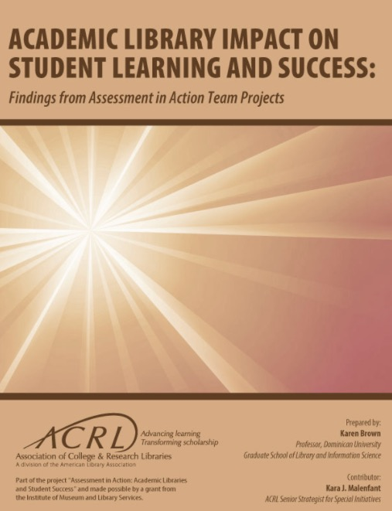The report focuses on projects completed during the third and final year as part of the program Assessment in Action: Academic Libraries and Student Success (AiA) from April 2015 to June 2016. Teams from more than 50 campuses completed assessment projects and reported on them individually (fully searchable online), and this synthesis builds on past findings from an additional 150 projects completed during the first and second years of the AiA program as context.
Positive connections between the library and aspects of student learning and success in five areas are particularly noteworthy:
- Students benefit from library instruction in their initial coursework. Information literacy instruction provided to students during their initial coursework helps them perform better in their courses than students who do not.
- Library use increases student success. Students who used the library the library in some way (e.g., circulation, library instruction session attendance, online database access, study room use, interlibrary loan) achieved higher levels of academic success (e.g., GPA, course grades, retention) than students who did not use the library.
- Collaborative academic programs and services involving the library enhance student learning. Academic library partnerships with other campus units, such as the writing center, academic enrichment, and speech lab, yield positive benefits for students (e.g., higher grades, academic confidence, retention).
- Information literacy instruction strengthens general education outcomes. Library instruction improves students’ achievement of institutional core competencies and general education outcomes such as inquiry-based and problem-solving learning, including effective identification and use of information, critical thinking, ethical reasoning, and civic engagement.
- Library research consultations boost student learning. One-on-one or small-group reference and research assistance with a librarian enhances academic success, as documented by such factors as student confidence, GPAs, and improved achievement on course assignments.

http://www.infodocket.com/2017/05/10/new-report-from-acrl-academic-library-impact-on-student-learning-and-success-findings-from-assessment-in-action-team-projects/

