Año 2 Número 26 mayo 2017

Contenidos de este número

University of Michigan Library Acquires New Set of Orson Welles Materials Including Completed But Unproduced Scripts
Filed by Gary Price on April 24, 2017
From the U. of Michigan Library:
A new set of materials from Beatrice Welles will make the University of Michigan Library’s Orson Welles collection the world’s most comprehensive resource for Welles scholars and fans.
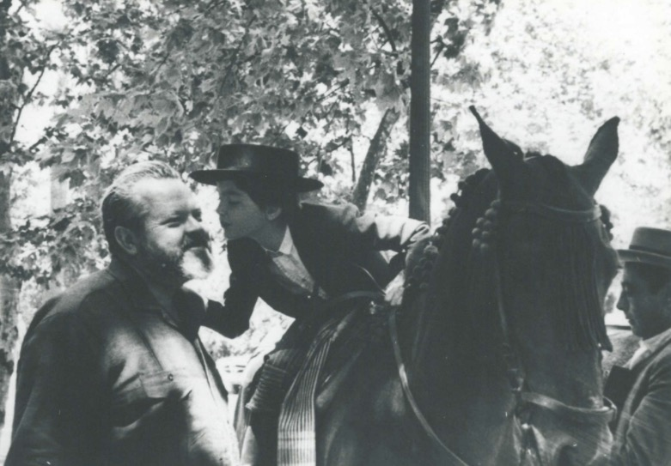
Beatrice Welles and her father, Orson Welles, at the Feria de Sevilla, Spain in April 1964 (Agencia Gráfica Prensa Lara, Madrid). Image courtesy: University of Michigan Library, Special Collections
The daughter of renowned indie filmmaker Orson Welles and Italian actress Paola Mori, Beatrice Welles had a particularly extraordinary childhood. She was brought up jetsetting to different countries, playing on various film sets, interacting mostly with adults (her parents and their friends), and falling asleep to the rhythmic sounds of her father working on his typewriter late into every night.

http://www.infodocket.com/2017/04/24/a-university-of-michigan-library-acquires-new-set-of-orson-welles-materials-including-completed-scripts-never-produced/

A Cuban Book Trip: Reading Flourishes at the Havana Book Fair
BY BARBARA CONATY
The captivating country of Cuba has welcomed readers, authors, publishers, and librarians to the Havana International Book Fair since 1982. Organized by the Ministry of Culture and the Cuban Book Institute, this standout cultural extravaganza, which originated as part of a government campaign to boost literacy on the island, celebrated its 26th anniversary this past February with a family-oriented festival dedicated to the pleasures of reading under the motto, “To read is to grow.”
In 2016, after the decades-old U.S. embargo of Cuba was partially lifted, the American Library Association (ALA) sponsored a tour of about 30 people whose goal was to attend the fair as well as to visit major Cuban libraries and other cultural and social institutions. Traveling from New York, Virginia, Illinois, New Jersey, California, the District of Columbia, Massachusetts, Texas, New Hampshire, Arizona, and the Virgin Islands, tour group members included professionals from an array of libraries, three library schools, two professional associations, and a consulting firm.

http://reviews.libraryjournal.com/2017/04/books/fiction/a-cuban-book-trip-reading-flourishes-at-the-havana-book-fair/

15 Libraries Named IMLS National Medal Finalists
By Julia Lee Barclay-Morton
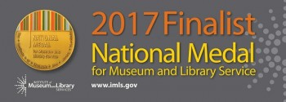The Institute of Museum and Library Services (IMLS) announced its 30 finalists for its National Medal for Museum and Library Service on March 20, including 15 public, academic, and special libraries from Maine to Alaska. The depth and breadth of the work of the nominees demonstrate not only the worth of libraries to our social fabric, but also IMLS’s importance for aiding the vital missions of the libraries across the country: a timely reminder, considering that IMLS is one of multiple federal agencies that the current administration’s preliminary budget proposes to dismantle.
The 15 finalist libraries included: Haines Borough Public Library, AK; Long Beach Public Library, CA; Sacramento Public Library, CA; Cedar Rapids Public Library, IA; Illinois Fire Service Institute Library, Champaign; Evansville Vanderburgh Public Library, IN; Terrebonne Parish Library System, LA; Waterville Public Library, ME; University of Minnesota Libraries; Rochester Public Library, MN; Charlotte Mecklenburg Library, NC; Tulsa City-County Library, OK; James V. Brown Library, Williamsport, PA; Richland Library, SC, and George and Cynthia Woods Mitchell Library, Montgomery County Memorial Library System, TX.
“As the nation’s primary source of federal support for museums and libraries, IMLS is uniquely positioned to shine a spotlight on the extraordinary ways museums and libraries bring about transformative community change,” said IMLS director Kathryn K. Matthew. “The highly selective National Medal award, now in its 23rd year, is one of the leading ways we promote the work of exceptional institutions to a broader audience that includes Congress, policymakers, the media, and the public. These awards exemplify the types of strategic partnerships, community service, and public engagement museums and libraries foster in their roles as catalysts for vibrant communities.”

http://lj.libraryjournal.com/2017/04/industry-news/15-libraries-named-imls-national-medal-finalists/

Local Heroes: Librarians Address Inequity Where They See It
By Marva Hinton
What does it take to empower young patrons, remove barriers, and help them succeed? Determination. Imagination. A solution-oriented outlook.
The individuals who spearheaded these bold library initiatives were driven by a goal to improve service for all users. They tackled big projects head-on to further equity in their schools and communities: a GED program at a tribal library; resources for children who are neurodivergent; free food and programs for kids during the summer; eliminating discriminatory policies; and more. Here’s how they did it.
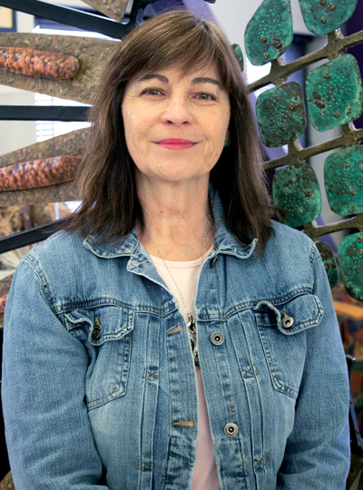
Sandy Tharp-Thee
Photo by Madison Horrocks
GED AT A TRIBAL LIBRARY
When Sandy Tharp-Thee took the helm of the Iowa Tribal Library in Perkins, OK, in 2009, she found very few resources: a donated set of encyclopedias that was 15 years old—and no budget to purchase newer materials. She quickly got to work. To start, the Oklahoma Department of Libraries shared resources with her. Tharp-Thee also identified a pressing need for a GED program in this community of 2,000, so she started looking for someone willing to provide this service for free. She located a volunteer who would offer the classes if Tharp-Thee could guarantee that at least 10 students would show up. However, when Tharp-Thee called to say that she had gathered enough students, the would-be volunteer changed her tune. “She said, ‘Native people don’t finish what they start,’” says Tharp-Thee. “It was hurtful.”

http://www.slj.com/2017/05/industry-news/local-heroes-librarians-address-inequity-where-they-see-it/

Tolerance Is Not Good Enough | BackTalk
By Nicole A. Cooke
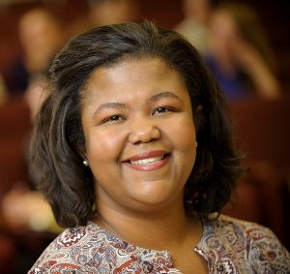In early 2017, a call for chapter proposals began circulating on library Listservs for a forthcoming book titled Tolerance: Social Justice and Activism in Libraries, Moving Beyond Diversity to Action. The aim of the book is to discuss how librarians can take diversity, social justice, and social change to the next level and promote tolerance in libraries. As a librarian, scholar, and educator who specializes in issues of diversity and social justice, and how to integrate them into LIS pedagogy and education, I was instantly taken aback by the use of the word tolerance. Tolerance and diversity are not words I regularly put together; in fact, I view them in opposition to each other.

http://lj.libraryjournal.com/2017/05/opinion/backtalk/tolerance-is-not-good-enough-backtalk/

Report: Louisiana State University is Suing Elsevier For Breach of Contract
Filed by Gary Price
UPDATE: May 3, 2017 We’ve added a comment about the lawsuit from Elsevier and a blog post by ARL’s Krista Cox with additional background. They’re both found at the bottom of this post.
—
The news about the lawsuit filed on Feb. 27, 2017 comes today via an announcement from the Association of Research Libraries (ARL).
The complaint was filed in the Parish of East Baton Rouge (19th District Circuit Court, State of Louisiana). Primary documents are linked at the bottom of this post.
Here’s a portion of the news release written by ARL’s Director of Public Policy, Krista Cox.
Louisiana State University (LSU) filed a lawsuit on February 27, 2017, against international science publisher Elsevier B.V. for breach of contract resulting from the publisher’s exclusion of the LSU School of Veterinary Medicine from accessing content licensed by the LSU Libraries. In filing the lawsuit, LSU exercised sound financial stewardship of its public resources.
According to the LSU Libraries, Elsevier blocked access in January 2017 to its research materials from the Internet protocol (IP) ranges that correspond to the LSU School of Veterinary Medicine. The LSU Libraries’ license with Elsevier provides for unlimited, simultaneous access by all LSU faculty, staff, and students of the main campus in Baton Rouge, including the School of Veterinary Medicine. LSU requested that access be restored, and Elsevier refused.
LSU’s complaint states, “Elsevier is well aware that LSU, like other universities, is heavily reliant upon the various types of research and educational content for which Elsevier enjoys monopolistic market powers
Elsevier is unfairly abusing its leverage to coerce LSU into paying additional and unnecessary subscription fees for research and educational content that LSU has already contracted for.

http://www.infodocket.com/2017/05/02/report-louisiana-state-university-is-suing-elsevier-for-breach-of-contract/

U. of Texas at Austin Libraries Will Administer New $700,000 Mellon Foundation Grant For “Cultivating a Latin American Post-Custodial Archival Praxis” Project
Filed by Gary Price
Along with the grant discussed below, U. of Texas at Austin also received a $2 million grant from Mellon Foundation that, “will provide training for doctoral students working across disciplines in the humanities.”
From the U. of Texas at Austin:
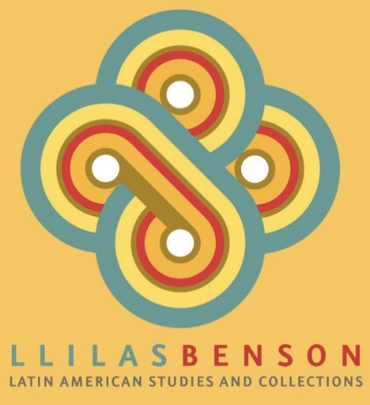The $700,000 grant to fund an LLILAS Benson Latin American Studies and Collections project, Cultivating a Latin American Post-Custodial Archival Praxis, focuses on vulnerable human rights documentation from Latin America. The UT Libraries will administer it.
The grant builds on a previous Mellon Foundation project through which LLILAS Benson collaborated with archives in Central America, which led to the creation of the Latin American Digital Initiatives, a repository providing access to unique archival collections, with an emphasis on human rights, race, ethnicity and social exclusion in the region.
The new grant will support post-custodial initiatives with partners in Brazil, Colombia and Mexico. As practiced by LLILAS Benson, post-custodial archiving enables the preservation of archives in the places they are created, while at the same time facilitating global online access to the collections.
Professor Virginia Garrard, director of LLILAS Benson, will serve as principal investigator (PI), and post-custodial archivist Theresa Polk will serve as co-PI.

http://www.infodocket.com/2017/05/01/u-of-texas-at-austin-libraries-will-administer-new-700000-mellon-foundation-grant-for-cultivating-a-latin-american-post-custodial-archival-praxis-project/

