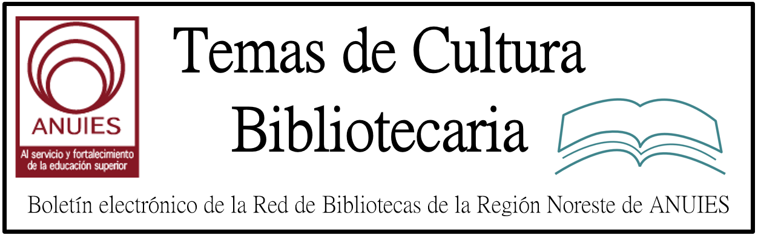

Año 2 Número 24 mayo 2017

Contenidos de este número

REGISTER FOR THIS FREE PREVIEW WEBCAST
In this free course preview webcast of our Designing a People-Focused Librarycourse, host and presenter Emily Puckett Rodgers, Space Design and Assessment Librarian at University of Michigan Library and LJ course advisor, will explain what it means to have a user-focused library from shelf to social space.
She'll discuss how building changes provide opportunities for organizational change; address how to employ user-centered design approaches to programs, partnerships, and collection development; give examples of great design; and provide an overview of this interactive six-week workshop.
At the end of the live webcast, participants will be able to ask Emily questions about the course and presentation. Participants will also be provided a unique discount code to gain access our steepest discount available.
(The webcast will be available on-demand following the live session but live Q&A will not be available).

- 3 Must Haves for Any and All Librarians
BY LJ REVIEWS ON APRIL 11, 2017 LEAVE A COMMENT
Kowalsky, Michelle & John Woodruff. Creating Inclusive Library Environments: A Planning Guide for Serving Patrons with Disabilities. ALA. Nov. 2016. 218p. index. ebk. ISBN 9780838914854. $62; ebk. ISBN 9780838914885. PRO MEDIA
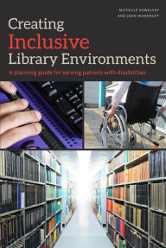Kowalsky (librarian, Rowan Univ., NJ) and Woodruff (director, Academic Success Ctr. & Disability Resources, Rowan Univ.) have constructed a guide for libraries to implement immediate and long-term strategies to address the needs of patrons with disabilities. From writing policies and training library staff to programming and outreach, the authors provide answers for a number of questions and challenges that may arise during the process. In addition, each chapter contains a list of resources for readers interested in investigating the topics further. Some may become overwhelmed by the amount of information within these pages, but this seems anticipated as the book features checklists to support the various topics, as well as examples of programming schedules. While the market is full of professional development literature for libraries, Kowalsky and Woodruff’s contribution thoroughly addresses an underrepresented yet worthwhile topic. Demonstrated through their experiences and research, their expertise on the subject makes this work a valuable and credible resource. VERDICT Highly recommended for librarians and library staff looking to provide the best service for their communities.—Katie McGaha, County of Los Angeles P.L.
Library Information and Resource Sharing: Transforming Services and Collections. Libraries Unlimited. Dec. 2016. 174p. ed. by Beth Posner. index. ISBN 9781440849688. pap. $55; ebk. ISBN 9781440849695. PRO MEDIA
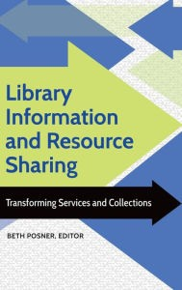In a world of diminishing budgets and dwindling resources, library resource sharing and interlibrary loan (ILL) services have never been more important. Here, editor Posner (Graduate Ctr., City Univ. of New York) compiles eight chapters exploring resource sharing in-depth, examining such topics as discovery, sharing policies, collection development, consortia borrowing, sharing digital content, and library staffs’ evolving role in providing access. Because no library can afford to acquire everything its users need, resource sharing can be a necessity, directly contributing to sustainability while utilizing emerging technologies to expand access. Included are thorough examples of resource-sharing practices and a few case studies; librarians and ILL staff can use this book to help develop and shape their own methods. This text proves that even with restrictions on collection development, libraries can offer patrons access to ever-expanding collections by leveraging their connections and maximizing resource sharing among libraries. VERDICT A solid foundation for those learning about and seeking to improve resource sharing, this work will most benefit ILL specialists and emerging librarians.—Cori Wilhelm, SUNY Canton Coll. of Tech. Lib.

http://reviews.libraryjournal.com/2017/04/lj-in-print/3-must-haves-for-any-and-all-librarians/

- ALA President-Elect Loida García-Febo: Holding On To ALA’s Core Values
By Lisa Peet
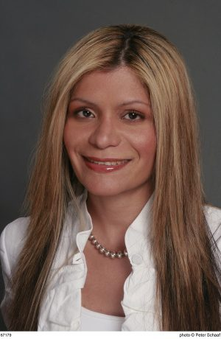Voting for the American Library Association (ALA) 2018–19 presidential election closed on April 5, with Loida García-Febo winning the role of president-elect. A total of 9,123 ballots were cast among the candidates—García-Febo, Terri Grief, and Scott Walter—significantly down from last year’s 10,230.
García-Febo has worked as a librarian domestically and internationally, having begun her career at the University of Puerto Rico library and continuing as coordinator for special services, Queens Library, NY, from 2006–12. She is currently president of Information New Wave, an international nonprofit organization working to bring access to information to underserved populations.
A 2007 LJ Mover & Shaker, García-Febo also has a long history of service with library associations. In addition to serving on ALA Council since 2011 and a 2015–18 term on the ALA Executive Board, she sits on the governing board of IFLA (the International Federation of Library Associations) and served on the executive board of REFORMA (the National Association to Promote Library and Information Services to Latinos and the Spanish-Speaking), including a term as president from 2009–10. She is the recipient of the 2015 REFORMA Elizabeth Martinez Lifetime Achievement Award and was named a Notable Member of ALA’s International Relations Round Table, receiving the Elizabeth Futus Catalyst for Change Award in 2010. García-Febo was also awarded an ALA/IFLA Fellowship for the 2004 IFLA Congress, where she co-established the IFLA New Professionals Special Interest Group

http://lj.libraryjournal.com/2017/05/interviews/ala-president-elect-loida-garcia-febo-holding-on-to-alas-core-values/

Les samedi 20 et dimanche 21 mai,
Bibliothèques Sans Frontières et le Centre des monuments nationaux
vous invitent à un événement inédit :

LA GRANDE BIBLIOTHÈQUE DU PANTHÉON

Sous le regard des Grands Hommes, nous célébrerons l’accès de tous, en particulier des plus fragiles, à la lecture, à l’information et à la culture sous toutes ses formes.

L’entrée du monument sera gratuite pour toute personne faisant le don d’un ou plusieurs livres, qui contribueront à la création de bibliothèques dans les hôtels et centres sociaux du Samu social en région parisienne.

Le samedi de 18h à 20h,
Un forum autour de la culture accueillera Fatou Diome, Abd Al Malik,
Geneviève Brisac, Agnès Desarthe,
Christophe Deloire, Patrick Weil, Michel Deguy, Eric Pliez.
Réservations conseillées sur helloasso.com.
Réserver

Tout au long du week-end, vous pourrez également découvrir l’Ideas Box, notre médiathèque en kit, qui sera déployée à l’intérieur du Panthéon. Le public et particulièrement les enfants pourront y participer à des animations culturelles et ludiques.

La Grande Bibliothèque est ouverte à tous ! Parlez-en autour de vous, transférez l’invitation à vos contacts ou partagez l’événement Facebook !

------------------------------ PROGRAMME ------------------------------
  - Lancement – 20 mai à 12h30
  - Grande Collecte de livres – 20 & 21 mai de 10h à 18h
  - Forum – 20 mai de 18h à 20h
  - Animations autour de l’Ideas Box – 20 & 21 mai de 10h à 18h

- Live from the Library
By Jennifer Koerber
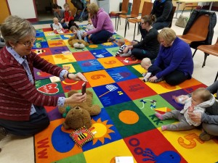At Pennsylvania’s Peters Township Public Library (PTPL), the lobby is a light-filled atrium often occupied by special events. We know this because it’s a frequent setting for PTPL’s Facebook Live videos, often hosted by library director Myra Oleynik. During a poster session, “six students from a Forensic Science Club spoke about their exhibits [on topics like] fingerprinting and forensic anthropology. They had lots of props so it was very easy to shoot. Plus the students…were very relaxed in front of the camera,” Oleynik said. With the participants of Preschool-a-Palooza, a preschool provider fair for parents, Oleynik had to be more encouraging. “I visited each table and asked the director to say hello and introduce the preschool, then personally invited viewers to come to the library because [the providers would] be there for the rest of the afternoon.”
VIDEO WHERE THE VIEWERS ARE
Facebook Live is video streamed over Facebook and archived there afterwards. All you need to get started is a smartphone/tablet and the Facebook app, or a webcam attached to a computer running the Google Chrome browser. (You can’t create a Facebook Live video using a mobile web interface or other browsers.) Click into the “What’s on your mind?” field, choose Live Video, choose your audience/privacy level, then point the camera, and go. Carrie Weaver, Public Relations Coordinator at PTPL, admits it’s a little nerve-wracking the first time. “To get up the courage to try Live, I first shot some video of my dog at home using the ‘Only Me’ privacy setting. Once I saw how easy it was, I was all in.”
There are other live video options–Snapchat, Periscope on Twitter, Instagram Stories, UStream and more traditional streaming platforms, of course. The primary advantage to Facebook Live is an existing audience. Hailey Roberts, Digital Services Librarian at Idaho’s Meridian Library District (MLD), explains, “[MLD] has a steady following on Facebook, and we market through this tool frequently, so it made sense to take advantage of the Live video feature. We offer two weekly virtual reference sessions [that used to be static posts; now] we can interact more with patrons.”

http://lj.libraryjournal.com/2017/04/marketing/live-from-the-library/

- Revista Investigación Bibliotecológica # 71. IIBI-UNAM

Estimados colegas,
Tenemos el agrado de informarles que acaba de publicarse el número 71 de la revista Investigación Bibliotecológica: bibliotecología, archivonomía e información, que edita el Instituto de Investigaciones Bibliotecológicas y de la Información (IIBI) de la Universidad Nacional Autónoma de México (UNAM). Este número lo puede consultar en texto completo, a través del actual sitio de la revista:
http://iibi.unam.mx/revista.html
Aprovechamos para recordarles que hasta nuevo aviso queda temporalmente suspendida la recepción de artículos para su publicación en esta revista, agradecemos su comprensión y prometemos informarle de inmediato en cuanto quede abierto el nuevo período de admisión.
Reciban un cordial saludo y el agradecimiento por continuar al tanto de nuestra revista.
Atentamente,
Dr. Salvador Gorbea Portal
Director de la revista.

- Impactstory Launches Browser Extension for OA Discovery
By Matt Enis on April 21, 2017 Leave a Comment
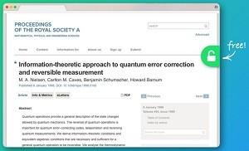Nonprofit altmetrics pioneer Impactstory has launched Unpaywall, a free extension for Google Chrome and Firefox browsers that helps users obtain free full-text copies of open access (OA) research papers. Powered by ImpactStory’s oaDOI index of 90 million OA articles drawn from the Directory of Open Access Journals, CrossRef’s license metadata, DataCite, the BASE OA search engine, institutional repositories (IR), and other sources, the extension displays a green tab on a browser’s border when users are visiting an article download page if an OA copy of the article is available elsewhere. Clicking on the tab then seamlessly redirects users to the OA copy. Impactstory claims that the extension will find full-text OA for 65 percent to 85 percent of articles, depending on topic and year of publication.
Unpaywall.org’s FAQ notes that the extension is somewhat similar to the Open Access Button, which also helps facilitate discovery of legally uploaded OA content. Both differ from sites such as Sci-Hub, which has courted controversy by hosting and transmitting non-OA, copyrighted content.
Impactstory cofounder Jason Priem wrote in a January blog post that Sci-Hub “gives us a glimpse of what [it] will look like when universal, legal OA becomes a reality.” But he told LJ that the copyright and legal issues surrounding the resource would always present a barrier to its growth and utility.
“There’s just always going to be a cap on the usefulness of a service like Sci-Hub, because institutional stakeholders can’t afford to touch it,” Priem said. “It’s hard to do big things and make big changes in that situation. Napster was a big deal, but in the end it didn’t change the music industry—iTunes and Spotify did.”
Similarly, workarounds such as emailing researchers to ask for a copy of a paper or using #icanhazpdf on Twitter can be “lifesavers when you’re really desperate,” Priem said. “But we think people shouldn’t have to be desperate to access a paper, and so we’re trying to fix that. We’re not done yet, but we’re making progress, thanks to the millions of researchers who’ve made their work free to read online by uploading it to open repositories.”
The extension currently includes a simple set of features. Users can choose to have the tab color coded to visually illustrate the type of OA content and its source. If this setting is applied, the standard green tab will indicate content from an institutional repository or preprint server, a gold tab will indicate journal-hosted content with an Open license, and a blue tab will indicate journal-hosted articles with no license. (If a full-text OA copy cannot be found, the extension always displays a gray tab.)

http://lj.libraryjournal.com/2017/04/oa/impactstory-launches-browser-extension-for-oa-discovery/

