Año 2 Número 22 abril 2017

Contenidos de este número

The First Year Experience Innovation Awards
Sponsored by Case Western Reserve University and Credo Reference
Recognizing that effective First Year Experience (FYE) programs can impact everything from retention rates to overall student success, Credo has partnered with Case Western Reserve University to honor libraries and librarians who are innovating in the field. As libraries are tasked with supporting FYE initiatives, enterprising librarians have emerged with creative ways to teach academic skills to first year students, build connections between students and their institutions,and orient students to institutional resources.
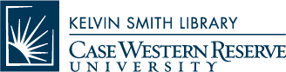Case Western Reserve University and Credo Reference, as active participants in the FYE space, seek to recognize a librarian and library who are innovating new and interesting ways to impact first year students. Every year, one library and one librarian will receive a prize of $1,500 and award plaque in honor of their outstanding achievement. The first awards will be presented at the 2018 Personal Librarian & FYE Library Conference in Cleveland, OH hosted by the Kelvin Smith Library of Case Western Reserve University. Subsequent awards will be presented at ACRL and the Personal Librarian & FYE conference, which occur on alternating years.
New to or interested in the first year experience space?Visit the Credo FYE blog to read about interesting first year trends, tips for programming and more.
Submit your nomination today!

http://mktg.credoreference.com/fye-innovation-award
- Finding and Filling Needs | 2017 LibraryAware Community Award
By John N. Berry III on March 27, 2017 Leave a Comment

From books to bikes to banks, Mississippi Valley Library District steps up to address critical service gaps
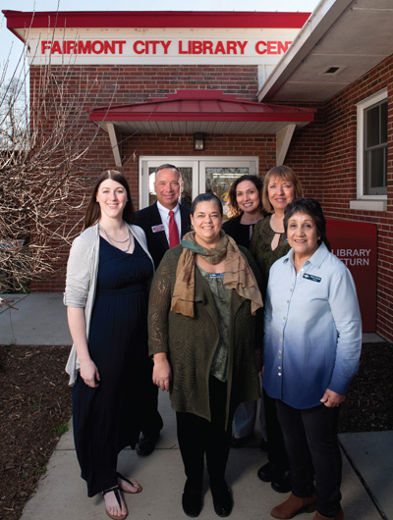
Mississippi Valley Library District (MVLD): (l.–r.) Kyla Waltermire, Collinsville Memorial Public Library manager; Rob Schwartz, senior VP, TheBANK of Edwardsville; Vicky Hart, MVLD executive director; Sandy Smith, assistant VP, TheBANK of Edwardsville; Katie Heaton, manager, Fairmont City Library Center; and Marie Johnson-Walker, MVLD trustee. Photo ©2017 Sid Hastings
Of the 2,635 people who live in the Village of Fairmont City, IL, 71.4 percent are immigrants who speak Spanish as their first or only language. Most of the adults migrated from Mexico and have a fourth to sixth grade reading level. Some youngsters are “dreamers,” undocumented children who were brought here from Mexico, so termed because they are eligible for deferred action under the Development, Relief, and Education for Alien Minors (DREAM) Act. Their younger siblings, born in the United States, are U.S. citizens.

http://lj.libraryjournal.com/2017/03/lj-in-print/finding-and-filling-needs-2017-libraryaware-community-award/#_
- APA Style CENTRAL®
Learn. Research. Write. Publish.
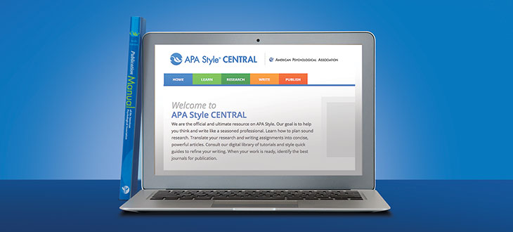
APA Style CENTRAL® is the only authoritative and complete online environment for teaching, writing, and publishing in APA Style.
Designed to help users develop their writing and professional research skills, APA Style CENTRAL combines sophisticated learning and teaching tools, advanced writing and content management technology, and full integration of APA's best-selling Publication Manual of the American Psychological Association® to create an unparalleled web-based suite of integrated services and tools.
All of the tools within APA Style CENTRAL have been created by a team of APA Style experts, which assures users and instructors a level of accuracy, consistency, and confidence not available from any other source.

http://www.apastyle.org/products/asc-landing-page.aspx?utm_source=library_journal&utm_medium=direct_email&utm_campaign=whats_new&utm_content=29Mar17

- PsycINFO®
A world-class resource for abstracts and citations of behavioral and social science research
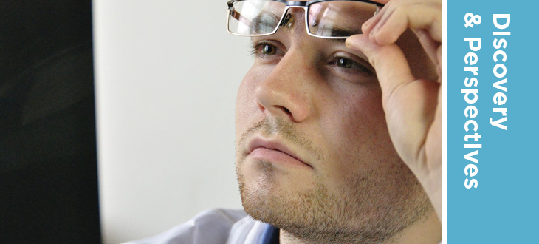

Highlights
With more than 4 million bibliographic records centered on psychology and the behavioral and social sciences, the interdisciplinary content in PsycINFO® makes it one of the most highly utilized databases by students, researchers, educators, and practitioners worldwide.

http://www.apa.org/pubs/databases/psycinfo/index.aspx?utm_source=library_journal&utm_medium=direct_email&utm_campaign=whats_new&utm_content=29Mar17

- First Impressions: LJ’s First Year Experience Survey
By Jennifer A. Dixon on April 13, 2017 Leave a Comment
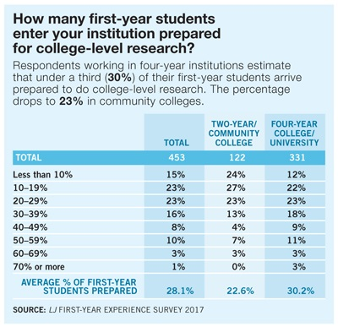First-year college and university students enter with widely varying levels of information literacy, particularly in light of the funding crisis that has left so many K–12 public schools without functioning school libraries and trained school librarians/media specialists. LJ recently set out to understand what information literacy instruction entering students need, what they’re getting, and what impact it has on their experience as first-year students.
In January and February, LJ circulated a survey, sponsored by Credo, to 12,000 college and university libraries, both two-year and four-year institutions. Some 543 schools (144 two-year and 399 four-year) responded. Credo presented a first look at the data at the Association of College and Research Libraries (ACRL) conference in Baltimore, with commentary and takeaways from Ray Pun, first-year student success librarian at California State University, Fresno, and a 2012 LJ Mover & Shaker.

http://lj.libraryjournal.com/2017/04/academic-libraries/first-impressions-ljs-first-year-experience-survey
- 2017 Anisfield-Wolf Book Awards | Reading Responsibly
BY BARBARA HOFFERT ON MARCH 24, 2017 LEAVE A COMMENT
On March 23, the Cleveland Foundation (CF) announced the winners of the 82nd annual Anisfield-Wolf Book Awards, established in 1935 by Cleveland poet and philanthropist Edith Anisfield Wolf to honor literary works that confront racism and celebrate diversity. This year’s winners include Isabel Allende, Lifetime Achievement; Peter Ho Davies, The Fortunes (Houghton Harcourt), Fiction; Tyehimba Jess, Olio (Wave), Poetry; Karan Mahajan, The Association of Small Bombs (Viking), Fiction; and Margot Lee Shetterly, Hidden Figures (Morrow), Nonfiction. It’s 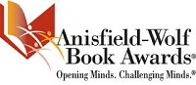heartbreaking to realize that the awards are still necessary but heartening to know that the foundation continues its mission, fielding the only juried prize of this type in the nation.
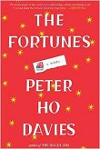
“The new Anisfield-Wolf winners broaden our insights on race and diversity,” said Henry Louis Gates Jr., who chairs the jury, which includes longstanding members Rita Dove, Joyce Carol Oates, Steven Pinker, and Simon Schama. “This year, we honor a breakthrough history of black women mathematicians powering NASA, a riveting novel of the Asian American experience, a mesmerizing, poetic exploration of forgotten black musical performance and a spellbinding story of violence and its consequences. All is capped by the lifetime achievement of Isabel Allende, an unparalleled writer and philanthropist.”

http://reviews.libraryjournal.com/2017/03/prepub/2017-anisfield-wolf-book-awards-reading-responsibly/

- Librarians Providing Safe Havens as Deportation Fears Loom
By Addie Matteson on March 22, 2017 Leave a Comment
Schools are frequently called upon to be safe havens. Caring and determined faculty, staff, and administrators do everything in their power to keep students safe, happy, and healthy while they are in school, and to send them out into the world equipped to meet its many challenges. This is why the recent executive orders pertaining to immigration, and the subsequent expanding of deportation regulations, have hit school communities particularly hard. But the news has not just stirred up fear and worry, it has also spurred many schools and districts to take action. (Learn more about the executive orders from the Department of Homeland Security and its memos on deportation, explained here by NPR).
Annie McCullough, an elementary school librarian in San Marcos, CA, describes the feeling in her school as anxious and stressed. Discussion of how best to calm and address students who are worried about their families has consumed the two most recent staff meetings. Some students in McCullough’s building are reluctant to come to school, for fear that their parents will be taken away while they are gone.

http://www.slj.com/2017/03/diversity/librarians-providing-safe-havens-as-deportation-fears-loom/

