Año 2 Número 21 abril 2017

Contenidos de este número

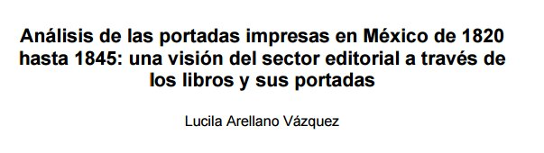
http://www.tdx.cat/bitstream/handle/10803/1382/04.LAV_CAP_3.pdf?sequence=5

2017 Scholastic Reading Report Reveals Extent of Book Ownership Divide
By Linda Rodgers on March 9, 2017 2 Comments
Scholastic has unveiled its sixth Kids and Family Reading Report, its biannual look at the habits of young readers ages 0–17 and their families. Among the biggest takeaways for librarians are the issues of access and discovery, according to Scholastic’s senior library manager, Deimosa Webber-Bey.
THE BOOK OWNERSHIP DIVIDE
One of the key findings of the report is just how important reading is to all kids. But there’s a big divide in book ownership among families. The average home has 104 kids’ books—but that number jumps to 127 books in households with an income over $100,000 and falls to 69 books for families making less than $35,000. A similar discrepancy exists among Latinos and African Americans. On average, Hispanic families have 91 children’s books in their homes and African American families report having 67.

http://www.slj.com/2017/03/research/2017-scholastic-reading-report-reveals-extent-of-book-ownership-divide/#_

“Bridging Worlds” with Librarians Pun, Collard, and Parrott
BY STEPHANIE SENDAULA ON MARCH 20, 2017 LEAVE A COMMENT
Librarians (l.–r.) Raymond Pun (a 2012 LJ Mover & Shaker; First Year Student Success Librarian, California State Univ., Fresno), Scott Collard (head of specialized research svcs. & social sciences, New York Univ.), and Justin Parrott (acquisitions & research svcs., New York Univ., Abu Dhabi) are the editors of Bridging Worlds: Emerging Models and Practices of U.S. Academic Libraries Around the Globe (ALA; LJ 3/15/17, p. 129). Here, they discuss the inspiration for their new book, the role of academic libraries in global initiatives,the challenges facing librarians today, and getting started in an international career.
How did you plan the idea for your book?
RP: Over the past decade, the three of us were seeing universities partner with other entities or launching full-fledged campuses abroad to create new opportunities for research and teaching, and we felt that academic libraries have also played a critical role in supporting these initiatives. At the time, Scott, Justin, and I worked at New York University [libraries] in different locations, and we wanted to include [in a new book] our experiences along with other universities’ collaborative efforts.

http://reviews.libraryjournal.com/2017/03/in-the-bookroom/authors/bridging-worlds-with-librarians-pun-collard-and-parrott/

A Better Ladder: Fostering the Leaders Libraries Need | Editorial
By Rebecca T. Miller on March 20, 2017 Leave a Comment
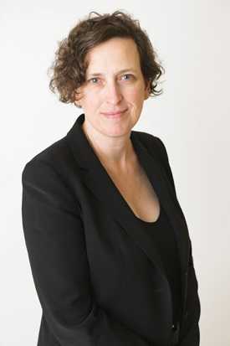The talent at work in libraries should make anyone optimistic for the future—not only of libraries but of the varied communities they serve. As the latest class of LJ Movers & Shakers demonstrates, the field is rippling with energetic, committed, innovative people addressing issues to create ever better service. It’s important that today’s leaders guarantee an institutional dynamic that will keep up-and-coming visionaries like these happy in libraries, allow them to flourish, and enable the best to step forward into larger roles.
We also need to continue to develop institutional cultures that these high achievers want to be in as they choose where to contribute their time and skills. Look within: Is your library attracting innovators, spurring their success, and offering paths to advancement and new challenges? Building out a setting that attracts and retains innovative thinkers is critical to the future of our libraries.
Succession planning must happen against the org chart, yes, but also against the larger organizational design and the realities people experience on the job. People who have the chops will go where they know they are valued and can make an impact. Look at catastrophic examples from Silicon Valley to consider how distracting and gutting a toxic environment can be to the most brilliant and enthusiastic workforce. Conversely, consider how organizational culture that helps people to thrive fosters growth and dynamism. Building a better work culture could mean reexamining policies or confronting in-house politics to ensure that the environment is healthy and supportive. Ideally, such a culture ensures a nimble institution better positioned to sustain its relevance and influence.

http://lj.libraryjournal.com/2017/03/careers/a-better-ladder-fostering-the-leaders-libraries-need-editorial/

7.
