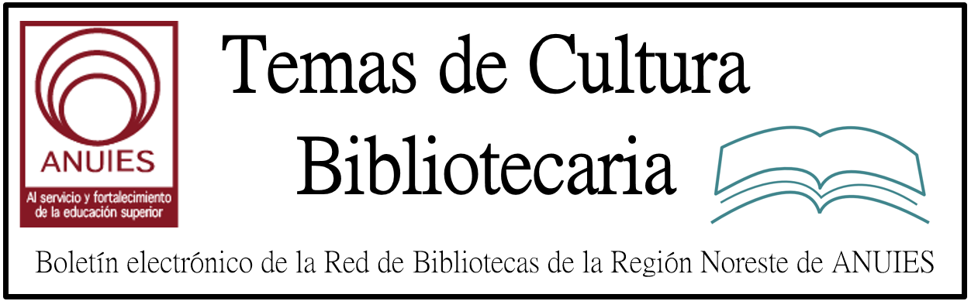

Año 2 Número 20 marzo 2017

Contenidos de este número

What Your Homeless Patrons Can Do For You
Feb 24, 2017 6:00:00 AM Jared Oates Library Education, The Future of Libraries, Homelessness
The common mode, especially in large urban public libraries, is to speak of the challenges presented by our homeless patrons. They make other patrons feel uncomfortable, there are stories of staff confrontations, bad odors, and property damage... All of these are valid concerns. This article, however, will make the case that your library's response to homeless patrons can let you shine a bright light on the relevance and power of a 21st century library in a way that few other issues can. And at the best-run libraries all around the country, it already is.

http://www.nicheacademy.com/blog/what-your-homeless-patrons-can-do-for-you

Best Reference Titles of 2016
BY MAHNAZ DAR, MAGGIE KNAPP, PATRICIA LOTHROP, GARY MEDINA, KIERA PARROTT, DAVE PUGL, LAURIE SELWYN, STEPHANIE SENDAULA, & ROBERT TENCH ON MARCH 2, 2017 LEAVE A COMMENT
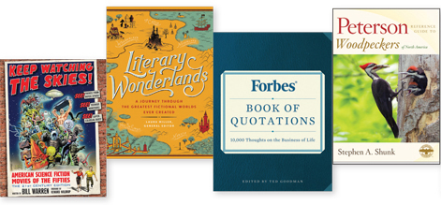
THIS YEAR’S LIST, compiled by a group of LJ’s top reference reviewers and editors, spans a wide range of subject areas, from a dictionary of Shakespearean vocabulary and a journey through classic sf films to an encyclopedia of cheese and a collection of the year’s best infographics. Several prescient titles published in 2016 will continue to see strong usage in 2017, such as a guide to fact-checking, an in-depth look at the history of surveillance in America, an encyclopedia of Islam and the Muslim world, and a work on the history and evolution of protest movements. While some selections are more relevant for scholars working in colleges and universities, several works also bring great appeal for more casual browsers and public library users. Included is a roundup of the best databases reviewed in LJ this past year as well as a listing of excellent—and free—online resources that should be bookmarked and at the fingertips of every reference librarian.

http://reviews.libraryjournal.com/2017/03/best-of/best-reference-titles-of-2016/

Best Free Reference Websites & Apps
BY GARY PRICE ON MARCH 2, 2017 LEAVE A COMMENT
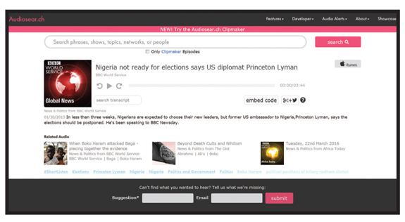
AAPB: American Archive of Public Broadcasting
americanarchive.org
A collaboration between the Library of Congress and WGBH in Boston “to preserve for posterity the most significant public television and radio programs of the past 60 years.” Both audio and video from around the country are archived and searchable, with more than 17,000 clips. Curated collections on special topics include the First Amendment, Freedom of Speech, and the right to protest.

http://reviews.libraryjournal.com/2017/03/best-of/best-free-reference-websites-apps/

4.
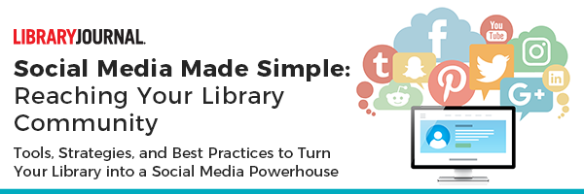

Registration now open for
Social Media Made Simple: Reaching Your Library Community
This 4-week online course beginning on May 17 will teach you the tools and tactics to help you use social media to build your outreach to current and future patrons.
Join school, public, and academic librarians from across all areas of the library—from front line-staff to management—and learn how to use social media as a powerful outreach and engagement tool.
Download the Course Agenda
Attendees will participate in live keynote presentations, complete hands-on projects, and receive one-on-one guidance from an experienced social media library luminary.Register by April 7 to save 25% off the standard rate of the course!

5. Do more with APA Style CENTRAL
Library Journal Partner

For customer support, or to stop receiving future offers from Library Journal, please scroll to the bottom for instructions.

As an academic, you understand the important role scholarly communication plays in preparing the next generation of professionals. APA recently launched APA Style CENTRAL®, an online, template-based writing tool rooted in APA Style® that helps students and educators improve scholarly communication across many disciplines.

APA Style CENTRAL is a campus-wide resource that provides expertly created guides, forms, instructional aids, and more–all of which engages the user to facilitate the proper application and mastery of APA Style rules.

Interested in seeing how APA Style CENTRAL can help writers at your institution? Contact an APA representative to schedule a demonstration or set up a free 30-day trial for your institution.

6. APA Style CENTRAL
Learn. Research. Write. Publish.>

http://lj.libraryjournal.com/movers/

7. Mastering Marketing | Library Promotion
By Laurie Russo on March 9, 2017 Leave a Comment
Libraries are always looking for ways to engage and connect with patrons. But understanding the shift from traditional public relations (PR) to today’s customer-centric digital marketing landscape has become a key to successful engagement. So said Heather Pemberton Levy, VP, content strategy and publishing for research/advisory firm Gartner, during her keynote presentation leading off “Successful Library Marketing: A Masterful Approach to Strategies, Best Practices, and Tools To Turn Your Library into a Powerhouse,” an online course hosted by LJ Professional Development in November 2016. Content marketing is about building personal connections via moments and stories and showing your audience “why to care” about your product, according to Levy, who is also author of Brand, Meet Story: How To Create Engaging Content To Win Business and Influence Your Audience (Routledge).
Levy explained that traditional PR is dependent on traditional media. A company, or an institution like a library, makes a story pitch to a magazine or newspaper, but, ultimately, the publication’s editors decide whether a story will run. Social media has changed this dynamic, enabling companies to engage with their customers directly. But maintaining engagement requires quality content.

http://lj.libraryjournal.com/2017/03/lj-in-print/mastering-marketing-library-promotion/

